**NAME:** Rabail Rauf

**ID:** F2023065109

**SUBJECT:** Software Engineering

**SECTION:** W6

**APP PROPOSAL**

**JobConnect**: Job Search and Career Management App

**Project Overview:**

JobConnect is a mobile app designed to help people find jobs, improve their job search, and manage their career. The app offers personalized job suggestions, tools to build resumes, interview help, and career advice. It also helps users connect with other professionals, mentors, and recruiters to expand their network.

1. **Problem:**

Job seekers often find it difficult to keep track of job opportunities, organize their job search, and prepare for interviews. Many job boards show too many results, and candidates may not know how to make their resumes stand out. JobConnect solves these problems by offering tailored job recommendations, resume help, and networking opportunities

**2. Objectives:**

* **Job Suggestions:** Provide users with job recommendations based on their skills, experience, and career goals.
* **Resume Builder:** Allow users to easily create and update their resumes.
* **Interview Help:** Offer tips, mock interview tools, and common questions to help users prepare for interviews.
* **Career Advice:** Give personalized advice to help users improve their careers.
* **Networking:** Let users connect with professionals, mentors, and recruiters to grow their network.
* **Job Alerts:** Notify users about job openings and application deadlines.

**3. Goals:**

* **Help Job Seekers:** Make it easier for users to find relevant job opportunities.
* **Create Strong Resumes:** Help users create professional resumes that stand out.
* **Prepare for Interviews:** Give users the tools and tips to do well in interviews.
* **Encourage Networking:** Help users build their professional network and connect with mentors.
* **Measure Success:** Track user engagement, job application success rates, and user satisfaction to see how well the app is working.

**4. Scope:**

* + Personalized job recommendations based on user preferences.
  + A resume builder to create and store resumes.
  + Tools for interview preparation, including common questions and tips.
  + A platform for networking with professionals and recruiters.
  + Career resources such as articles, videos, and skill-building courses.
  + Notifications for job application deadlines and interview reminders.
  + AI-driven career advice and skills analysis to help users improve their job prospects.
  + Integration with LinkedIn to enhance networking.
  + Job application tracking to keep users updated on their application status.

**5. Stakeholders:**

* **Users:** Job seekers looking for better ways to find jobs and build their careers.
* **Recruiters:** Employers looking to hire qualified candidates.
* **Career Coaches and Mentors:** Professionals offering guidance and advice to job seekers.
* **Employers and Job Boards:** Companies that post job openings on the app.
* **Developers:** The team responsible for building and maintaining the app.

**6. Customers:**

JobConnect’s target audience includes:

* **Job Seekers:** Individuals looking for new job opportunities or career changes.
* **Career Advancers:** People who want to improve their resumes, interview skills, and overall career prospects.
* **Employers & Recruiters:** Companies looking to find and hire talented people.
* **Mentors and Coaches:** Professionals who want to offer career advice and mentorship to others.

**7. Tools and Techniques:**

* **App Development:**
  + **Flutter** for creating a mobile app that works on both iOS and Android.
* **Back-End Technology:**
  + **Firebase** for storing job postings, user profiles, and resume data.
* **AI and Data Analytics:**
  + **Job Matching:** Use AI to recommend the best jobs based on users’ skills, experience, and goals.
  + **Resume Optimization:** AI can help optimize resumes for job applications to ensure they are seen by employers.
* **Notifications:**
  + **Push Notifications:** Send reminders for job application deadlines, interview prep, and new job postings.
  + **Email Alerts:** Notify users about important job updates and tips.
* **Security & Privacy:**
  + Protect user data with encryption and comply with privacy laws to keep personal information safe.

**8. Deployment:**

* **App Stores:** The app will be available for download on the **Apple App Store** and **Google Play Store**.
* **Beta Testing:** A test version will be released to gather feedback from early users and improve the app.
* **User Feedback:** In-app surveys and feedback options will allow users to share their thoughts on the app’s features and performance.
* **Web Version:** A web version of the app will be released in the future for desktop users.

**PROTOYPES**

WELCOME SCREEN LOGIN SCREEN

 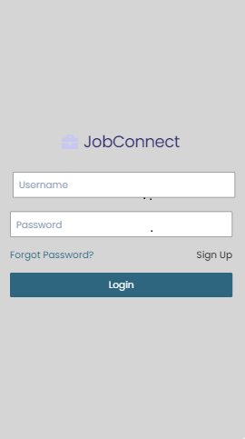

HOME SCREEN MESSAGES SCREEN

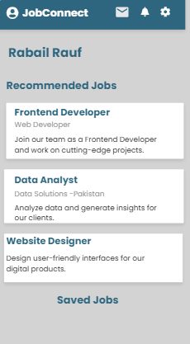 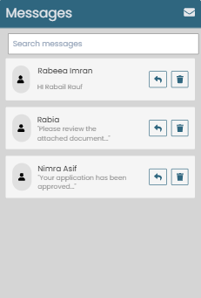

NOTIFICATION SCREEN POST JOB SCREEN

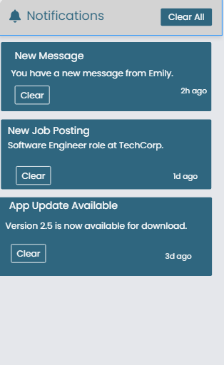 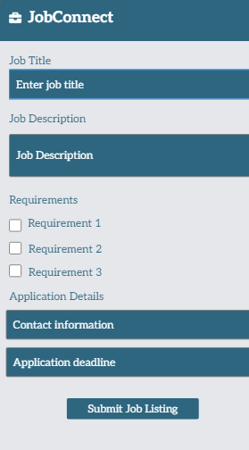

SETTING SCREEN PROFILE SCREEN

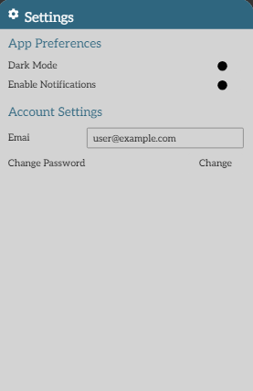 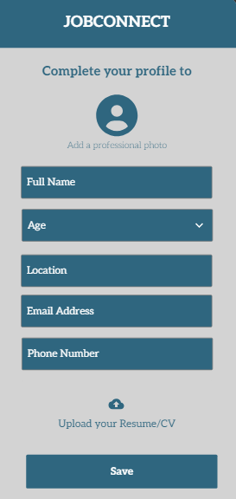

**GANT CHART**

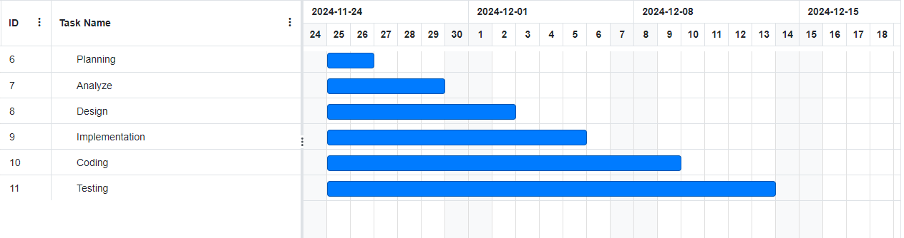

**APP PROPOSAL**

**JobConnect**: Job Search and Career Management App

**Requirement Analysis for JobConnect**

* **Functional Requirements**

**F.R 1) Proceed to login:**

Allow users to access the login screen.

**F.R 2) Login:**

Enable users to log into their accounts securely.

**F.R 3) Forget Password:**

Provide an option to reset a forgotten password if they forgot their password.

**F.R 4) Profile Screen:**

Display the user’s profile information.

**F.R 5) Upload Previous CV:**

Let users upload their existing CV.

**F.R 6) Complete Profile:**

Guide users to fill in all required profile details.

**F.R 7) Save:**

Save changes or updates made by the user.

**F.R 8) Home Screen:**

Show the main screen with key features and information.

**F.R 9) Job Recommendations:**

Suggest jobs based on the user’s profile or preferences.

**F.R 10) Saved Jobs:**

Display jobs that the user has saved for later.

**F.R 11) Click Setting:**

Allow access to the settings menu.

**F.R 12) Setting Screen:**

Show options to customize app settings.

**F.R 13) App Appearance (Dark/Light):**

Provide themes for dark or light mode.

**F.R 14) Enable Notifications:**

Allow users to turn notifications on or off.

**F.R 15) Account Settings (Change e-mail/password):**

Enable updates to email or password.

**F. 16) Notification Screen:**

Display all notifications received by the user.

**F. 17) Necessary Message (Seen):**

Mark important messages as seen.

**F.R 18) Unecessary (Clear):**

Remove or clear unimportant messages.

**F.R 19) Message Screen:**

Show all user messages in one place.

**F.R 20) Search Messages by Name:**

Let users find messages using a name search.

**F.R 21) Share the message:**

Allow sharing of messages with others.

**F.R 22) Delete the message:**

Provide an option to delete specific messages.

**F.R 23) Post Job Screen:**

Enable posting of new job openings.

**F.R 24) Enter Job Title:**

Let users specify the title for a job posting.

**F.R 25) Job Description:**

Add detailed information about the job.

**F.R 26) Requirements:**

List the qualifications or criteria for the job.

**F.R 27) Application Details:**

Include how applicants can apply

**F.R 28) Submit:**

Confirm and finalize the job posting or application.

**F.R) Feedback**

* **Non-Functional Requirements:**

1. **Security:**

Keep user data safe with encryption and follow privacy laws like GDPR.

1. **Performance:**

The app should load job suggestions and resumes quickly without delays.

Notifications should be sent on time and work reliably.

1. **Scalability:**

The app should handle more users and job posts as it grows.

1. **Usability:**

Make the app easy to use, simple to understand, and accessible for everyone.

1. **Compatibility:**

The app should work smoothly on both iOS and Android, using Flutter.

1. **Availability:**

The app should work 24/7 with only small breaks for updates or maintenance.

* **List of Actors:**

**Primary Actors**:

**Job Seekers**

* **Creates and manages their profile** (including resume and job preferences).
* **Searches for and applies to jobs** based on criteria like location, job type, etc.
* **Tracks application status** (shortlisted, interview, rejection, etc.).
* **Receives notifications and updates** about new job postings and application progress.
* **Provides feedback and support requests** related to the app.

**Employers/Recruiters**

* **Creates and manages employer profile** (company details, culture, etc.).
* **Posts job openings** with required qualifications and responsibilities.
* **Reviews applications** and shortlists candidates for interviews.
* **Schedules interviews** and communicates with candidates.
* **Provides feedback and support requests** related to app usage.

**Secondary Actors:**

### ****Career Coaches/Mentors****

* **Gives career advice** (like resume tips and job search strategies).
* **Provides interview coaching** to help job seekers prepare.
* **Connects job seekers** with useful networks or professionals.

### ****App Administrators****

* **Manages user accounts** (creating, updating, and deleting profiles).
* **Keeps the app running smoothly** (solving technical issues and ensuring security).
* **Moderates content** (checks job posts and handles user problems).

### ****Tertiary Actor:****

### ****Job Application Tracking System****

* **Tracks application status** (notifies users about deadlines and updates).
* **Sends reminders** to job seekers about interview schedules or application deadlines
* **List of Use Cases:**

### ****Register/Login****

* **Create an account** or **log in** to access the platform.
* **Save login details** for easy access next time.

### ****2. Create/Update Resume****

* **Build a resume** by adding skills, experience, and education.
* **Update resume** to keep it current with new information.

### ****3. Get Job Recommendations****

* **Receive job suggestions** based on profile and preferences.
* **Explore new opportunities** that match your skills and location.

### ****4. Apply for Jobs****

* **Submit applications** to selected job openings.
* **Attach resume** and cover letter when applying.

### ****5. Communicate with Candidates****

* **Send messages** to candidates to discuss job roles.
* **Schedule interviews** or ask for more information from candidates.

### ****6. Offer Advice****

* **Provide career tips** and guidance to job seekers.
* **Help with interview prep** and job search strategies.

### ****7. Connect with Job Seekers****

* **Send invitations** to job seekers to connect or network.
* **Build relationships** with candidates for future opportunities.

### ****8. Manage Users****

* **Create, update, or delete user accounts** as an admin.
* **Monitor user activity** and ensure a safe platform experience.
* **System Use Case Diagram:**

1. **Actors:**

* Job Seeker
* Employer/Recruiter
* Career Coach/Mentor
* Admin
* Job Application Tracking System

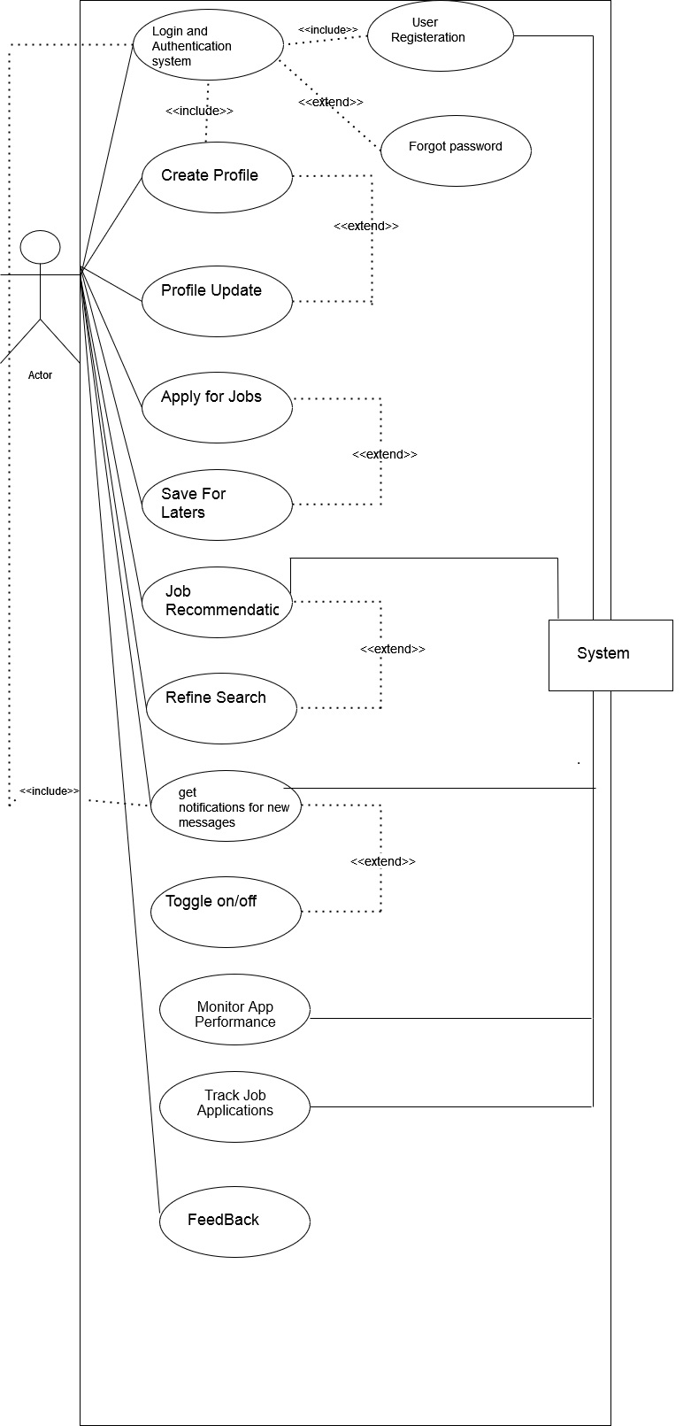

**System use case diagram**

Employer

User/Job Seeker

Employer

User/Job Seeker

**Login Use Case**

**User**

**Use Case Table for Login Process**

|  |  |
| --- | --- |
| **Field** | **Details** |
| **Use Case Name** | Login |
| **Created By** | Rabail Rauf |
| **Date Created** | 5-06-24 |
| **Last Updated By** | 05-07-24 |
| **Last Revision Date** | 30-07-24 |
| **Actors** | **Primary**: User, Employer **Secondary**: Mentors , App administrator |
| **Description** | This use case allows a user to register by creating a new account with an email and password, log in using their credentials (email and password), and reset their password if forgotten. The system handles login authentication by verifying the user's email and password, and facilitates password recovery when necessary. |
| **Trigger** | |  | | --- | |  |  |  | | --- | | The user attempts to log in, register, or reset their password | |
| **Preconditions** | 1. The user must have a valid email for registration. 2. The user must be logged in or attempt to reset their password if they forgot it. |
| **Post conditions** | 1. The user is successfully logged in or redirected to the password reset page. 2. If password reset is triggered, the user receives a password reset link. |
| **Normal Flow** | 1. The user navigates to the login page. 2. The user enters their email and password. 3. The system verifies the credentials (email and password). 4. If credentials are valid, the user is granted access to the dashboard. 5. If credentials are invalid, the system displays an error message prompting re-entry. |

|  |  |
| --- | --- |
| **Alternative Flows** | 1. **Forgot Password**: The user clicks "Forgot Password", enters their email, and receives a reset link. 2. **Re-Login**: If the user logs out and returns later, they enter their email and password to log back in. |
| **Exceptions** | 1. If the email/password is invalid, the system displays an error message. 2. If the email is not registered, the system prompts the user to check their credentials or register. |
| **Includes** | |  | | --- | |  |  |  | | --- | | 1. Register Account (for first-time users). 2. Forgot Password (if user cannot remember password) | |
| **Frequency of Use** | |  | | --- | | High (frequent use by users logging in and out of the system). |  |  | | --- | |  | |
| **Special Requirements** | 1. Password must meet security criteria (e.g., minimum length, complexity). 2. Email must be unique for each registration. |
| **Assumptions** | 1. The user has internet access. 2. The email entered by the user is valid. |
| **Notes and Issues** | 1. The system must securely hash passwords before storing them. 2. Ensure email verification for registration and password reset to avoid fraudulent activity. |
| **Use Case ID** | UC-1 |

**Profile Creation Use Case**



**User**

**Use Case Table for Profile Creation:**

|  |  |
| --- | --- |
| **Field** | **Details** |
| **Use Case Name** | Create/Update Resume |
| **Created By** | Rabail Rauf |
| **Date Created** | 24-05-24 |
| **Last Updated By** | 03-06-24 |
| **Last Revision Date** | 24-06-24 |
| **Actors** | **Primary**: User, Employer **Secondary**: Mentor, App adminstrator |
| **Description** | |  | | --- | | This use case allows a user to create and update their resume by adding relevant details like skills, experience, and education. | |
| **Trigger** | |  |  | | --- | --- | |  | The user initiates the resume creation or update process by accessing the resume section of the platform. | |
| **Preconditions** | |  |  | | --- | --- | |  | 1. The user must be logged in. 2. The user must have access to the resume creation or update section. | |
| **Post conditions** | |  |  | | --- | --- | |  | 1. The user's profile is successfully created with all the entered details. 2. The profile data is stored securely in the system. | |
| **Normal Flow** | |  |  | | --- | --- | |  | 1The user navigates to the resume creation or update page. 2. The user enters relevant information (skills, experience, education). 3. The system validates and stores the data. 4. A success message is displayed upon completion. | |
| **Alternative Flows** | |  |  | | --- | --- | |  | 1. If the user misses any required field, the system prompts them to fill in the missing information. 2. If the user decides to skip a section (e.g., skills or experience), the system saves the data entered up to that point and allows the user to complete it later. | |
| **Exceptions** | |  |  | | --- | --- | |  | 1. Invalid or incomplete data (e.g., incorrect experience format or missing skills) leads to an error message and prompts the user to correct the information. 2. If the user is not logged in or doesn’t have access, the system redirects them to the login page or shows an access error. | |
| **Includes** | Includes: 1. Resume Update (if the user wants to update their resume later). |
| **Frequency of Use** | |  | | --- | | Medium (primarily used when creating or updating resumes). | |
| **Special Requirements** | |  |  | | --- | --- | |  | 1. The data entered by the user should be validated for format (e.g., experience dates, skills). 2. Ensure that personal data is stored securely and in compliance with privacy regulations (e.g., GDPR). | |
| **Assumptions** | |  |  | | --- | --- | |  | 1. The user has access to the internet. 2. The user will provide accurate and relevant information for their resume. | |
| **Notes and Issues** | |  |  | | --- | --- | |  | 1. Ensure that no sensitive information (e.g., password) is stored unencrypted. 2. There should be a mechanism to handle large input data (e.g., multiple skills or job experiences). | |
| **Use Case ID** | UC-2 |

**Job Recommendation Use Case**



**User**

**Use Case Table for Job Recommendations:**

|  |  |
| --- | --- |
| **Field** | **Details** |
| **Use Case Name** | Get Job Recommendations |
| **Created By** | Rabail Rauf |
| **Date Created** | 24-05-24 |
| **Last Updated By** | 03-06-24 |
| **Last Revision Date** | 24-06-24 |
| **Actors** | **Primary**: User, Employer **Secondary**: Mentors, App Administrater |
| **Description** | |  | | --- | | This use case allows the user to receive job suggestions based on their profile and preferences. It helps explore new opportunities that match the user’s skills and location. | |
| **Trigger** | |  | | --- | | The user navigates to the job recommendations section or updates their preferences to trigger job suggestions. | |
| **Preconditions** | 1. The user must be logged in. 2. The user must have a completed profile with skills, experience, and preferences set. |
| **Post conditions** | |  | | --- | | 1. The user receives a list of recommended job opportunities. 2. The job recommendations are displayed according to the user's profile and preferences. | |
| **Normal Flow** | |  |  | | --- | --- | |  | 1. The user navigates to the job recommendations section. 2. The system fetches job listings based on the user’s profile and preferences (skills, location, etc.). 3. The system displays a list of recommended job opportunities. 4. The user reviews the list and selects jobs to apply for. | |
| **Alternative Flows** | |  |  | | --- | --- | |  | 1. **No Recommendations**: If no jobs match the user's preferences, the system notifies the user and suggests updating preferences. 2. **Update Preferences**: The user updates preferences to refine job recommendations and gets a new list of jobs. | |
| **Exceptions** | |  |  | | --- | --- | |  | 1. If the user’s profile is incomplete, the system prompts them to complete their profile before showing recommendations. 2. If there is a system error while fetching job listings, the system displays an error message and prompts the user to try again later. | |
| **Includes** | |  |  | | --- | --- | |  | Includes: 1. Profile Completion (if the user has an incomplete profile that needs to be completed for job recommendations). | |
| **Frequency of Use** | |  |  | | --- | --- | |  | Medium to High (used frequently as users search for job opportunities). | |
| **Special Requirements** | |  |  | | --- | --- | |  | 1. The recommendations should consider multiple factors such as skills, location, and experience. 2. The recommendations should be personalized and updated regularly.. | |
| **Assumptions** | |  | | --- | | 1. The user has completed their profile with up-to-date skills, experience, and preferences. 2. The user has access to the internet. | |
| **Notes and Issues** | |  |  | | --- | --- | |  | 1. Ensure that the recommendations algorithm respects privacy settings. 2. Ensure job listings are accurate and up-to-date. | |
| **Use Case ID** | UC-3 |

Apply Jobs Use case

**User**

**Use Case Table for Apply Job:**

|  |  |
| --- | --- |
| **Field** | **Details** |
| **Use Case Name** | Apply for Jobs |
| **Created By** | Rabail Rauf |
| **Date Created** | 24-05-24 |
| **Last Updated By** | 03-06-24 |
| **Last Revision Date** | 24-06-24 |
| **Actors** | **Primary**: User, Employer **Secondary**: Mentors, App Administrater |
| **Description** | |  | | --- | | This use case allows the user to receive job suggestions based on their profile and preferences. It helps explore new opportunities that match the user’s skills and location. | |
| **Trigger** | |  | | --- | | The user selects a job and decides to submit their application with required documents. | |
| **Preconditions** | 1. The user must be logged in. 2. The user must have a valid resume and cover letter ready for submission. |
| **Post conditions** | |  | | --- | | 1. The job application is successfully submitted to the employer. 2. The system stores the application and sends a confirmation to the user. | |
| **Normal Flow** | |  |  | | --- | --- | |  | 1. The user navigates to the job they want to apply for. 2. The user uploads their resume and cover letter. 3. The user clicks "Apply" to submit the application. 4. The system confirms the successful submission of the application. | |
| **Alternative Flows** | |  |  | | --- | --- | |  | 1. **Missing Documents**: If the user does not upload a resume or cover letter, the system prompts them to upload the necessary documents. 2. **Incomplete Application**: If the user’s application form is incomplete, the system prompts them to fill in the missing fields. | |
| **Exceptions** | |  |  | | --- | --- | |  | 1. If there is a technical issue (e.g., document upload failure), the system displays an error message and asks the user to try again. 2. If the user is not logged in, the system prompts them to log in before they can apply. | |
| **Includes** | |  |  | | --- | --- | |  | Includes: 1. Resume and Cover Letter Upload. | |
| **Frequency of Use** | |  | | --- | | High (used frequently by job seekers applying to various job openings). | |
| **Special Requirements** | |  |  | | --- | --- | |  | 1. The system should allow the user to attach multiple file types (e.g., PDF, Word). 2. Ensure that all documents are submitted in the correct format. | |
| **Assumptions** | |  | | --- | | 1. The user has completed their profile and is actively seeking jobs. 2. The user has internet access and can upload necessary documents. | |
| **Notes and Issues** | |  |  | | --- | --- | |  | 1. Ensure that document uploads are secure and in compliance with privacy regulations. 2. Ensure confirmation is sent after a successful application. | |
| **Use Case ID** | UC-4 |

**Communication with Job seekers:**



**Employer**

| **Field** | **Details** |
| --- | --- |
| **Use Case Name** | Communicate with Job Seekers |
| **Created By** | Rabail Rauf |
| **Date Created** | 24-05-24 |
| **Last Updated By** | 03-06-24 |
| **Last Revision Date** | 24-06-24 |
| **Actors** | **Primary**: User, Employer  **Secondary**: Job Seeker, App Administrator |
| **Description** | This use case allows employers to communicate with job seekers through the JobConnect app. Employers can send messages to discuss job roles, schedule interviews, and request additional information from candidates. |
| **Trigger** | The employer initiates communication by sending a message to a job seeker. |
| **Preconditions** | 1. The employer must be logged into the JobConnect app.  2. The employer must have access to the job seeker’s profile. |
| **Post conditions** | 1. The job seeker receives the message and can respond.  2. The system records the communication for future reference. |
| **Normal Flow** | 1. The employer logs into the JobConnect app.  2. The employer navigates to the job seeker’s profile.  3. The employer sends a message to the job seeker.  4. The system delivers the message to the job seeker. |
| **Alternative Flows** | 1. **No Response from Job Seeker**: If the job seeker does not respond, the employer can send a follow-up message or schedule a call.  2. **Schedule Interview**: The employer schedules an interview through the app. |
| **Exceptions** | 1. If there is a technical issue (e.g., message delivery failure), the system notifies the employer and prompts them to resend the message.  2. If the employer is not logged in, the system prompts them to log in. |
| **Includes** | 1. Message Sending and Receiving  2. Interview Scheduling |
| **Frequency of Use** | High: Frequently used by employers to communicate with potential job candidates. |
| **Special Requirements** | 1. The system should support secure messaging.  2. Employers should be able to attach documents (e.g., job descriptions) to messages. |
| **Assumptions** | 1. The employer has internet access.  2. Both the employer and job seeker are active users of the JobConnect app. |
| **Notes and Issues** | 1. Ensure communication is secure and complies with privacy regulations.  2. Provide notifications for new messages to ensure timely communication. |
| **Use Case ID** | UC-5 |

**Application Check Use Case:**



**Employer**

|  |  |
| --- | --- |
| **Field** | **Details** |
| **Use Case Name** | Application Check |
| **Created By** | Rabail Rauf |
| **Date Created** | 24-05-24 |
| **Last Updated By** | 03-06-24 |
| **Last Revision Date** | 24-06-24 |
| **Actors** | **Primary**: User, Employer **Secondary**: Mentors, App Administrater |
| **Description** | |  | | --- | | This use case enables the employer to review job applications, check resumes, shortlist candidates, or reject them. The employer makes decisions based on the suitability of the applicant. | |
| **Trigger** | |  | | --- | | The employer selects a job application to review and decide whether to reject or shortlist the candidate. | |
| **Preconditions** | 1. The employer must be logged in. 2. The job seeker’s application, resume, and profile must be available for review. |
| **Post conditions** | |  | | --- | | 1. The job application status is updated as shortlisted or rejected. 2. The system stores the updated status and sends notifications to the job seeker. | |
| **Normal Flow** | |  | | --- | | 1. The employer reviews the job seeker’s resume and application. 2. The employer decides whether to reject or shortlist the candidate. 3. The system updates the status of the job seeker accordingly. | |
| **Alternative Flows** | |  |  | | --- | --- | |  | 1. **Request More Information**: If the employer needs more details, they can request additional information from the job seeker. 2. **Schedule Interview**: The employer schedules an interview for the shortlisted candidate. | |
| **Exceptions** | |  |  | | --- | --- | |  | 1. If the employer cannot access the application, the system displays an error message. 2. If the employer is not logged in, the system prompts them to log in before reviewing applications. | |
| **Includes** | |  | | --- | | ReviewingResume. 2. Sending Messages. 3.Shortlisting or Rejecting Candidates. 4.Requesting Additional Information. | |
| **Frequency of Use** | High (employers frequently review job seekers' applications). |
| **Special Requirements** | |  |  | | --- | --- | |  | 1. The system should allow the employer to easily view resumes and applications. 2. The system should support communication between employers and job seekers for clarification or feedback. | |
| **Assumptions** | |  | | --- | | 1. The employer has access to the job seeker’s profile and application. 2. The employer has internet access and the capability to manage candidate interactions. | |
| **Notes and Issues** | |  |  | | --- | --- | |  | 1. Ensure that the job seeker’s privacy is protected when reviewing applications. 2. Ensure that rejection or shortlisting notifications are sent to the job seekers. | |
| **Use Case ID** | UC-6 |

**Listing Case:**



**Employer**

**Use Case Table for Listing:**

|  |  |
| --- | --- |
| **Field** | **Details** |
| **Use Case Name** | Listing Jobs (New Listing, Edit, Update) |
| **Created By** | Rabail Rauf |
| **Date Created** | 24-05-24 |
| **Last Updated By** | 03-06-24 |
| **Last Revision Date** | 24-06-24 |
| **Actors** | **Primary**: User, Employer **Secondary**: Mentors, App Administrater |
| **Description** | |  | | --- | | This use case allows the employer to list new job openings, edit or update job postings, and manage job listings to attract suitable candidates. | |
| **Trigger** | |  | | --- | | The employer wants to create a new job listing or edit an existing one. | |
| **Preconditions** | 1. The employer must be logged in. 2. The employer must have a job description and other necessary details for the job listing. |
| **Post conditions** | |  | | --- | | 1. The new job listing is posted or updated successfully. 2. The system stores the job listing and makes it visible to job seekers. | |
| **Normal Flow** | |  | | --- | | 1. The employer selects the option to create or edit a job listing. 2. The employer enters job details, such as title, description, salary, location, and requirements. 3. The employer saves or publishes the listing. | |
| **Alternative Flows** | |  |  | | --- | --- | |  | 1. **Missing Information**: If any required fields are missing, the system asks the employer to fill in the missing details. 2. **Error in Listing**: If the listing can't be saved, the system shows an error message. | |
| **Exceptions** | |  |  | | --- | --- | |  | 1. If there is a technical issue (e.g., unable to save the job posting), the system displays an error message. 2. If the employer is not logged in, the system prompts them to log in. | |
| **Includes** | |  |  | | --- | --- | |  | Includes: 1. Job Description Submission. 2. Job Listing Editing. 3. Job Post Update. | |
| **Frequency of Use** | Medium (Used regularly by employers to post and manage job listings). |
| **Special Requirements** | |  |  | | --- | --- | |  | 1. The system should allow the employer to attach relevant documents or media (e.g., company logo). 2. The system should allow editing of posts at any time. | |
| **Assumptions** | 1. The employer has completed the job posting details and is ready to create or update the listing. 2. The employer has internet access and can upload necessary files. |
| **Notes and Issues** | |  |  | | --- | --- | |  | 1. Ensure that the job listing is displayed correctly and is visible to job seekers. 2. Ensure that the job listing contains all necessary and accurate information. | |
| **Use Case ID** | UC-7 |

**Notification Use Case**

**User**

Employer

|  |  |
| --- | --- |
| **Field** | **Details** |
| **Use Case Name** | Listing Jobs (New Listing, Edit, Update) |
| **Created By** | Rabail Rauf |
| **Date Created** | 24-05-24 |
| **Last Updated By** | 03-06-24 |
| **Last Revision Date** | 24-06-24 |
| **Actors** | **Primary**: User, Employer **Secondary**: Mentors, App Administrater |
| **Description** | |  | | --- | | This use case allows the system to send notifications to users regarding important events (e.g., job applications, updates, reminders, etc.). | |
| **Trigger** | |  | | --- | | An event occurs that requires the system to notify the user (e.g., new message, application status update). | |
| **Preconditions** | 1. The user is logged in.  2. The user has opted to receive notifications or has a valid communication channel (e.g., email or push notifications). |
| **Post conditions** | |  | | --- | | 1. The user receives the notification as expected.  2. The system logs the notification delivery. | |
| **Normal Flow** | |  | | --- | | 1. The system identifies an event that requires notification (e.g., new job listing, job status update).  2. The system sends the notification to the user. | |
| **Alternative Flows** | |  |  | | --- | --- | |  | 1.Notification Failed: If the notification cannot be delivered, the system retries or shows an error message. | |
| **Exceptions** | |  |  | | --- | --- | |  | 1. If the user is not logged in, the system prompts the user to log in to receive notifications.  2. If there’s a technical issue, an error message is displayed. | |
| **Includes** | |  |  | | --- | --- | |  | Includes: 1. Push Notification Delivery.  2. Email Notification.  3. Notification Preferences Update. | |
| **Frequency of Use** | High (Notifications are sent regularly to users about various system activities and updates). |
| **Special Requirements** | |  |  | | --- | --- | |  | 1. The system should allow users to customize notification preferences (e.g., type of notifications, frequency).  2. The system should ensure timely delivery of notifications. | |
| **Assumptions** | 1. The user has an active internet connection.  2. The user has provided valid contact information (e.g., email address or phone number). |
| **Notes and Issues** | |  |  | | --- | --- | |  | 1. Ensure that notifications are relevant to the user.  2. Monitor the frequency of notifications to prevent overload. | |
| **Use Case ID** | UC-8 |

**Feedback and Support System**:

User

**Use Case Table for feedback and support:**

|  |  |
| --- | --- |
| **Field** | **Details** |
| **Use Case Name** | Listing Jobs (New Listing, Edit, Update) |
| **Created By** | Rabail Rauf |
| **Date Created** | 24-05-24 |
| **Last Updated By** | 03-06-24 |
| **Last Revision Date** | 24-06-24 |
| **Actors** | **Primary**: User, Employer **Secondary**: Mentors, App Administrater |
| **Description** | |  | | --- | | This use case allows users (job seekers or employers) to submit feedback, view feedback, and respond to feedback regarding the system, jobs, or user interactions. | |
| **Trigger** | |  | | --- | | A user decides to submit feedback, or an event occurs that prompts feedback collection (e.g., completed application, job posting). | |
| **Preconditions** | 1. The user is logged in.  2. The user has interacted with the system (e.g., applied for a job, posted a job) to provide relevant feedback. |
| **Post conditions** | |  | | --- | | 1. The feedback is successfully submitted or updated.  2. The feedback is visible to relevant parties (e.g., employers or system administrators). | |
| **Normal Flow** | |  | | --- | | 1. The user navigates to the feedback section.  2. The user submits their feedback (rating, comments, suggestions).  3. The system stores and displays the feedback. | |
| **Alternative Flows** | |  |  | | --- | --- | |  | 1. Missing Information: If the feedback form is incomplete, the system prompts the user to fill in required fields.  2. Feedback Update: If the user needs to update their feedback, they can modify it before submission. | |
| **Exceptions** | |  |  | | --- | --- | |  | 1. If the user is not logged in, the system prompts them to log in to submit feedback.  2. If there’s a technical issue, the system displays an error message. | |
| **Includes** | |  |  | | --- | --- | |  | Includes: 1. Feedback Submission.  2. Feedback Viewing.  3. Feedback Response. | |
| **Frequency of Use** | Medium (Feedback is submitted periodically by users, often after specific interactions like applying for jobs or completing job postings). |
| **Special Requirements** | |  |  | | --- | --- | |  | 1. The system should allow users to provide both quantitative (e.g., ratings) and qualitative (e.g., text) feedback.  2. The system should support anonymous feedback if desired. | |
| **Assumptions** | 1. The user has completed relevant actions that warrant feedback (e.g., job application, job posting).  2. The user has internet access and can submit feedback. |
| **Notes and Issues** | |  | | --- | | 1. Ensure that feedback is processed and stored securely.  2. Provide a mechanism for users to respond to or engage with feedback if applicable. | |
| **Use Case ID** | UC-9 |

**Class Diagram:**

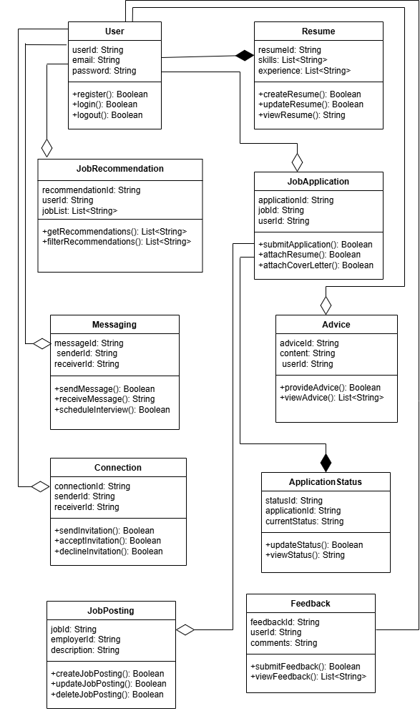

**DFD Level 0:**

**User**

**Employer**

**Job Preferances Activity Reports**

**Search For Jobs Approve Jobs**

**Notifications/Job Suggestions Manage User Data**

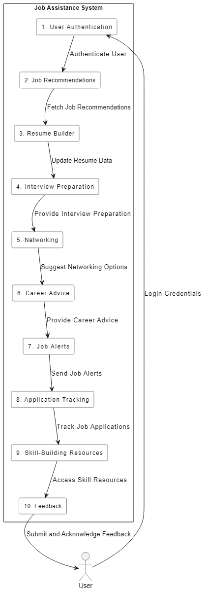**DFD Level 1**

**Sequence Diagram:**

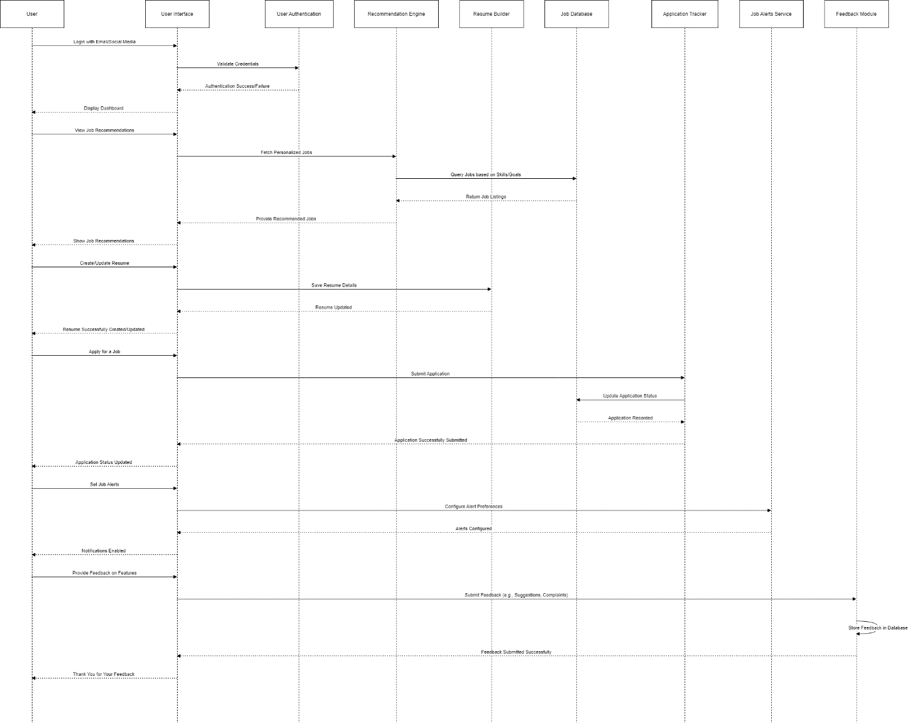

**Testing:**

**Black Box Testing** is a type of testing where we focus on checking if the system works correctly from the user's point of view, without worrying about how the system works internally (the code or structure).

|  |  |  |  |  |
| --- | --- | --- | --- | --- |
| **Requirement** | **Test Case** | **Expected Outcome** | **Pass/Fail Criteria** | **Remarks** |
| **1. User Authentication** | Test registration with email and social media (LinkedIn, Google) | User successfully registers and logs in via email or social media | Registration is successful and login works for all methods | Ensure valid and invalid inputs are tested |
| **2. Job Recommendations** | Test personalized job suggestions based on profile and preferences | Job recommendations match user's skills, experience, and goals | Job suggestions are relevant and updated correctly | Check for variation in job preferences |
| **3. Resume Builder** | Test resume creation and editing functionality | User can create, edit, and save a resume | Resume is saved and editable | Check with different templates |
| **4. Interview Preparation** | Test mock interview feature | Mock interview runs with AI-generated questions | AI generates relevant questions based on job preferences |  |
| **5. Networking** | Test ability to connect with other professionals | User can send and receive connection requests | Connection requests can be sent/received | Ensure no restrictions in network interactions |
| **6. Career Advice** | Test AI career advice based on profile | The app should suggest career advice based on the user’s profile and goals. | Advice aligns with user profile and job goals | Check that the advice is relevant. |
| **7. Job Alerts** | Test setting job alert preferences (job type, location, etc.) | User receives notifications based on set preferences | Alerts should match the user’s selected criteria | Ensure valid and invalid alerts are tested |
| **8. Job Application Tracking** | Test job application tracking functionality | User can see the current status of job applications | Status of applications is displayed correctly | Track status for various application stages |
| **9. Skill-Building Resources** | Test accessing articles, videos, and courses | Resources are available and accessible for learning | Content loads correctly without issues | Test with different resource types |
| **10. Feedback** | Test feedback submission functionality | User can submit feedback successfully | Feedback is submitted and confirmation is received | Verify feedback form submission and acknowledgment |

**Architectural Diagram:**

