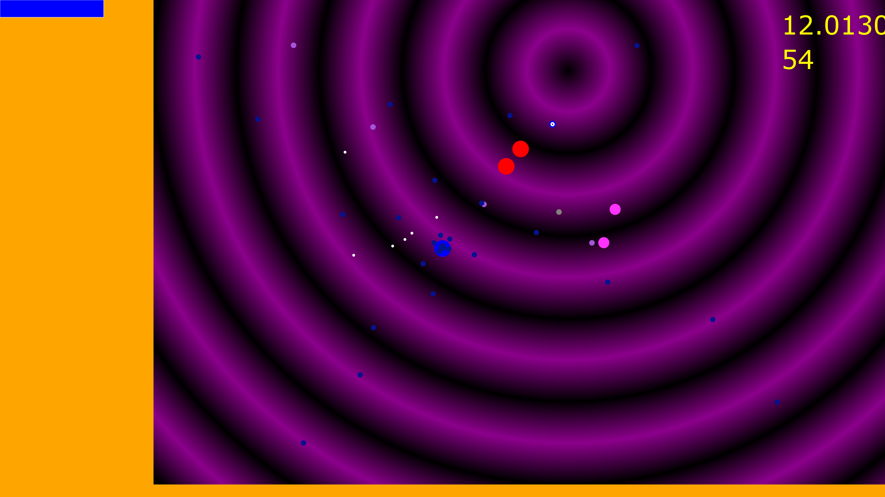

A typical run where the basic weapon has been modified by the random generation to fire in a 5-way split pattern. The player is the large blue circle, with the two red and two pink circles being different enemy types. The remaining smaller dots are a mixture of friendly and enemy projectiles.

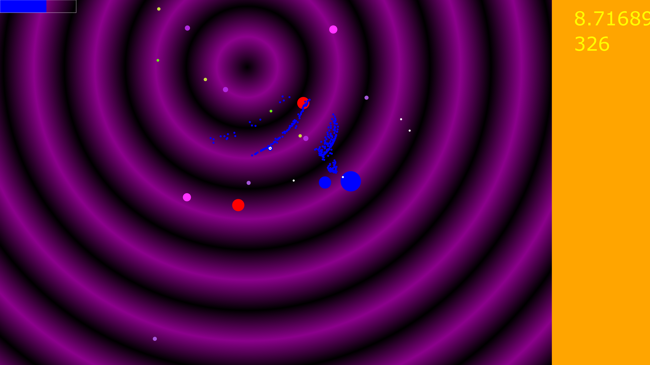

The very large blue circle here is a boss-type enemy that releases waves of projectiles when damaged.

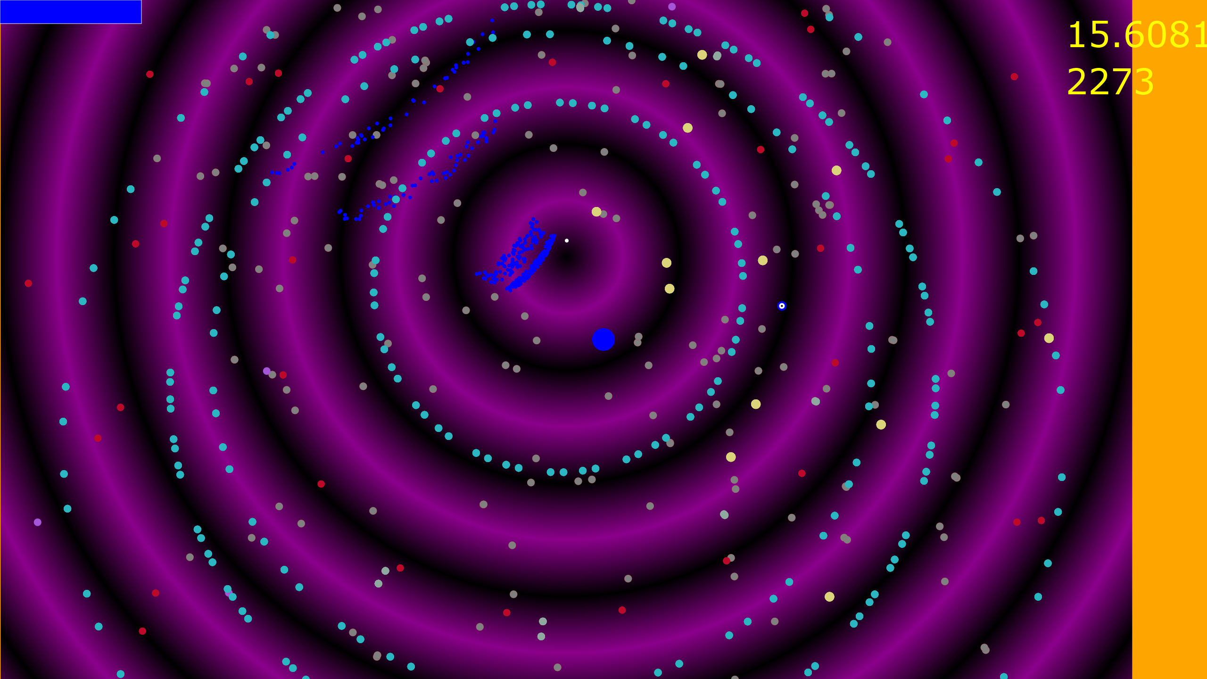

An exceptionally powerful run – the player’s base projectiles here are the larger beige circles, which on enemy contact cause a ring of the red bullets to be fired, which themselves on enemy contact cause the dense rings of pale blue bullets to be fired. The small grey circles are resource pickups which refill health and ammo – these drop from defeated enemies. In the top leftyou can see the small blue projectiles from a recently obliterated boss enemy.