**Make a new request**

1. Can you make the CSS like this instead:

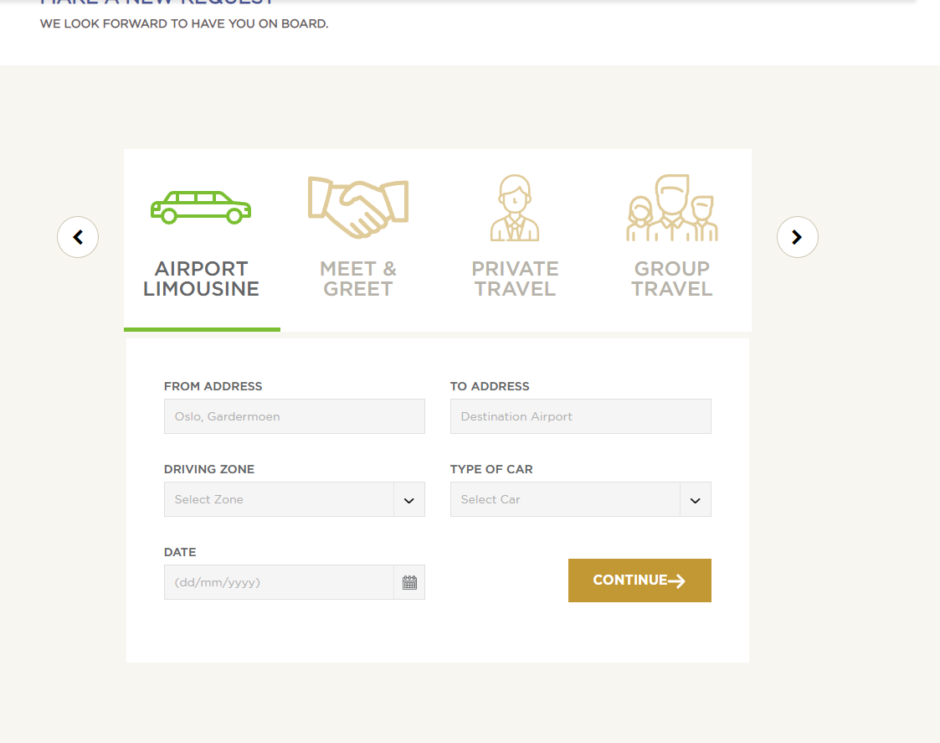

**Aircraft Handling:**

1. Add a dropdown for “Airport” field:

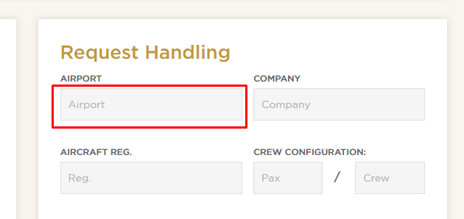

This dropdown should have these options:

ENGM (OSL) Oslo, Gardermoen  
ENTO (TRF) Sandefjord, Torp  
ENAL (AES) Ålesund, Vigra  
ENAN (ANX) Andøya, Andenes  
ENAT (ALF) Alta  
ENBL (FDE) Førde, Bringeland  
ENBN (BNN) Brønnøysund, Brønnøy  
ENBO (BOO) Bodø  
ENBR (BGO) Bergen, Flesland  
ENBS (BJF) Båtsfjord  
ENBV (BVG) Berlevåg  
ENCN (KRS) Kristiansand, Kjevik  
ENDU (BDU) Bardufoss  
ENEV (EVE) Harstad/Narvik, Evenes  
ENFL (FRO) Florø  
ENHD (HAU) Haugesund, Karmøy  
ENHF (HFT) Hammerfest  
ENHK (HAA) Hasvik  
ENHV (HVG) Honningsvåg  
ENKB (KSU) Kristiansund, Kvernberget  
ENKR (KKN) Kirkenes, Høybuktmoen  
ENLK (LKN) Leknes  
ENMH (MEH) Mehamn  
ENML (MOL) Molde, Årø  
ENMS (MJF) Mosjøen, Kjærstad  
ENNA (LKL) Lakselv, Banak  
ENOL (OLA) Ørland  
ENOV (HOV) Ørsta-Volda  
ENRA (MQN) Mo i Rana, Røssvoll  
ENRM (RVK) Rørvik  
ENRO (RRS) Røros  
ENRS (RET) Røst  
ENSB (LYR) Svalbard, Longyearbyen  
ENSD (SDN) Sandane, Anda  
ENSG (SOG) Sogndal, Haukåsen  
ENSH (SVJ) Svolvær, Helle  
ENSK (SKN) Stokmarknes, Skagen  
ENSO (SRP) Stord, Sørstokken  
ENSR (SOJ) Sørkjosen, Nordreisa  
ENSS (VAW) Vardø, Svartnes  
ENST (SSJ) Sandnessjøen, Stokka  
ENTC (TOS) Tromsø, Langnes  
ENVA (TRD) Trondheim, Værnes  
ENVD (VDS) Vadsø  
ENZV (SVG) Stavanger, Sola

1. Add a new field here called “Aircraft type”

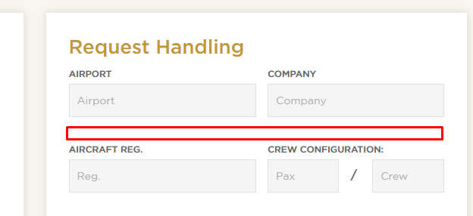

The place holder for this field will be: “Type of a/c”

1. Change the label name for these fields:

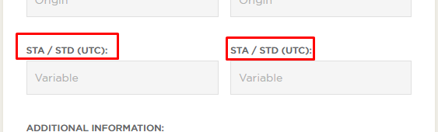

* Left field should be: STA (UTC)
* Right field should be: STD (UTC)

1. Add a button here for uploading files:

“Upload documents, e.g handling request, GENDEC etc... “

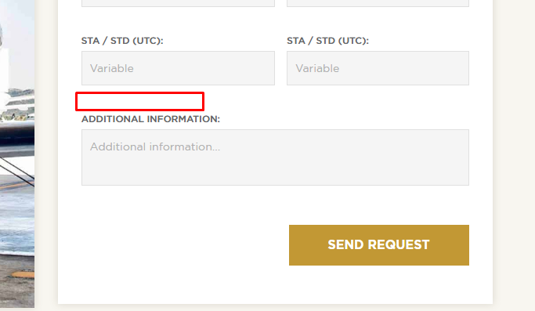

**Partners:**

1. On Partners page we need to change category to “Air Charter” and “Norway Partners”
2. Remove this content here from frontend and from adminpanel:

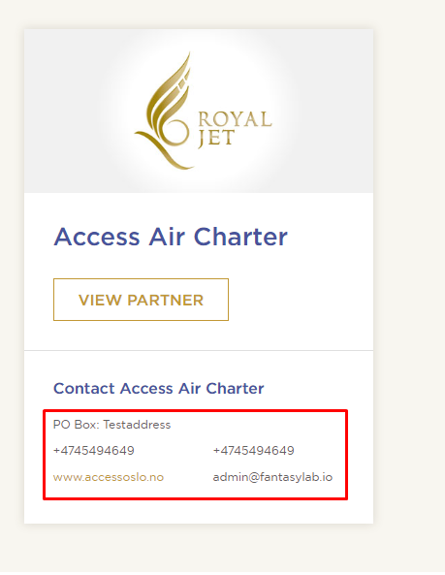

Instead of this data we will make it like this instead:

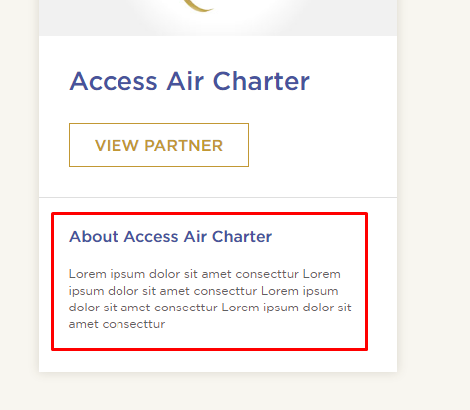

So in adminpanel we will only have one field for adding text for About section. It shuld be max 80 words you can add from adminpanel

**Email functionality**

* Customer should not receive booking confirmation for these emails>
  + Booking-cargo-confirmation
  + Booking-confirmation
  + Booking-travel-confirmation
  + Handling-confirmation
  + Limousine-booking-confirmation
  + Meet-confirmation
  + Passenger-tax-confirmation

We are removing this because there are to many emails being sent out.

**Other changes**

1. **This loader is too ugly. Completely remove it. We don’t need it.**

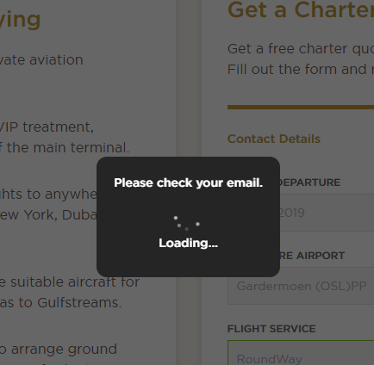

1. When you are logged in 🡪 Login button should not show in header:



1. For all forms which redirect you to PayPal and shows the price in real time 🡪 we need to add excl. vat. After the price. Like this:

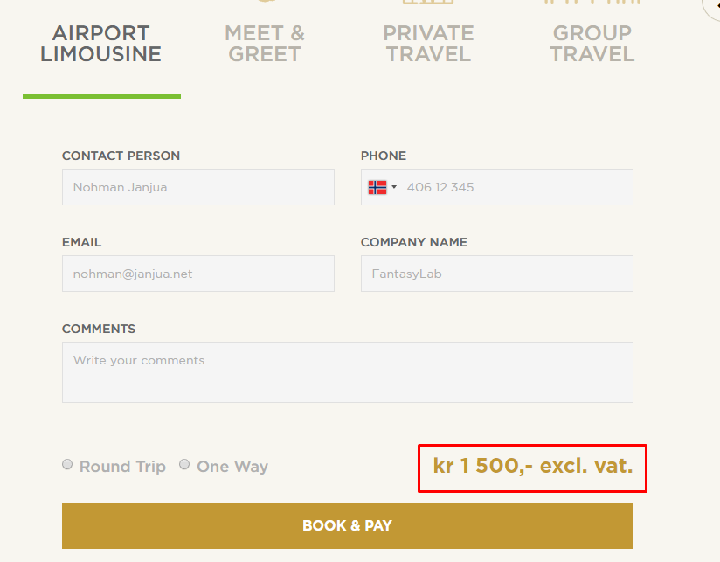

1. IN adminpanel 🡪 pages 🡪 when you add meta title and click save 🡪 the meta title gets updated in frontend. But if you go back to same page and click publish 🡪 meta title gets removed from front-end. Meta title and meta description are very important and you need to make sure they work 100%.
2. Issue with sticky header. If you scroll down and scroll up again, you can see the top content is getting hidden:

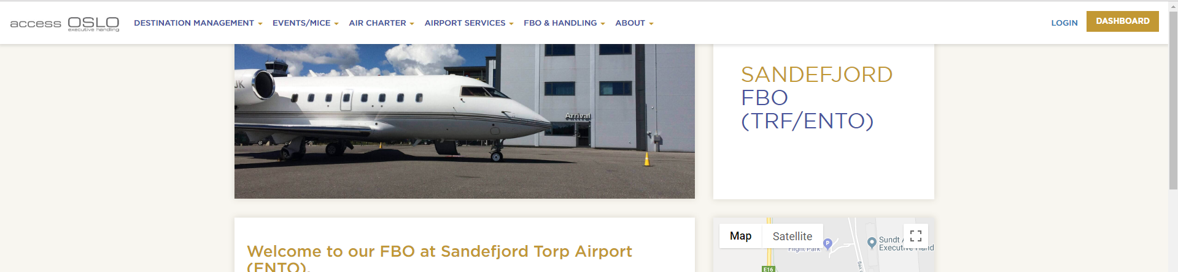

**Upcoming requests:**

1. When you change to other option in this dropdown, and the option doesn’t have any data to show 🡪 it gets redirected to “You currently have no requests” page. This is wrong. The message should look like this:

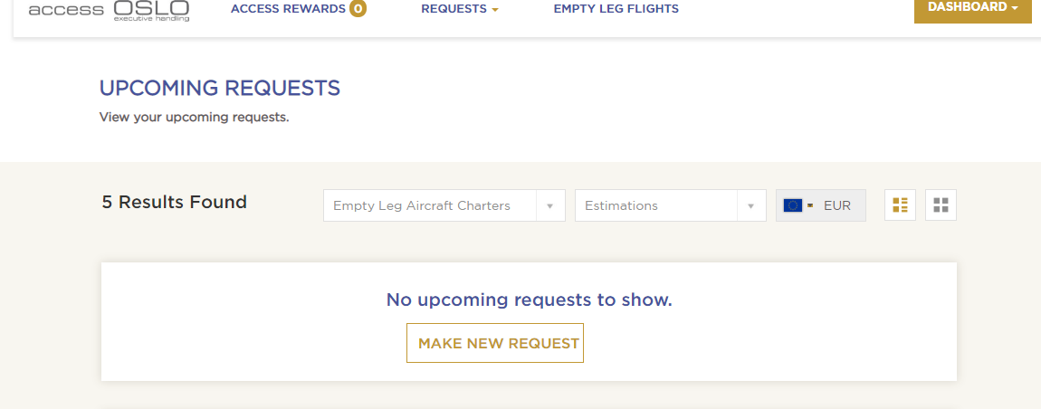

1. Center ths on page and change colors to gold:

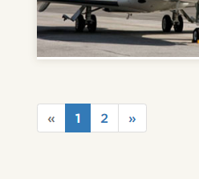

1. When you click this you get redirected to error page:

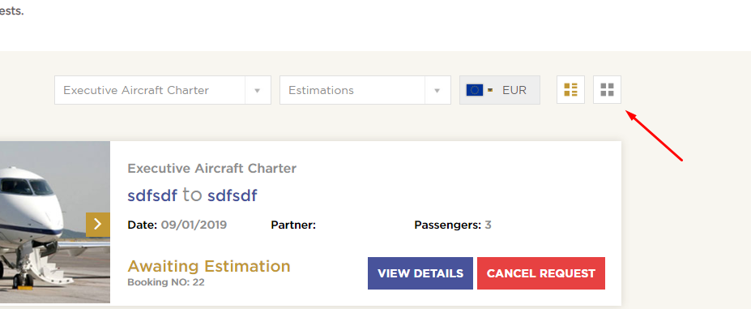

1. Thee numbers must be dynamic:

