1. In the frontend “the what price” only shows in advertiser but general user can’t see it. Example <http://panerio.stage01.obdemo.com/ads/view/hair-removal-in-sw3-and-sw5> it should show (indicative price for one session for underarms area)

Owebest 15-11-2017 : has been completed. Please check the changes and send us your feedback.

1. In the advertiser frontend in the advertiser goes to **edit** the ad the what price again doesn’t appear.   
   Owebest 15-11-2017 : has been completed. Please check the changes and send us your feedback.
2. In <field management> please add a field named price table which will have the following structure:

|  |  |  |  |  |  |
| --- | --- | --- | --- | --- | --- |
| Prices | 15 min | 30 min | 1 hour | 2 hours | 10 hours |
| in |  |  |  |  |  |
| out |  |  |  |  |  |

1. by default 30 ads will be shown in each subcategory. At the moment they are 10.  
   Owebest 15-11-2017 : has been completed. Please see the changes and send us your feedback.
2. At the moment although only 1 country is active the message chose country appears. If only 1 country is active then no message should appear  
   Owebest 15-11-2017 : has been completed. Please check the changes and send us your feedback.
3. In the backend admin has put in review types a review but it doesn’t appear on users frontend 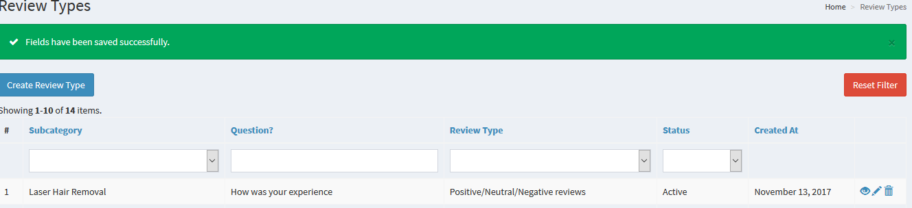

If the reviewer was logged in then it should show something like this

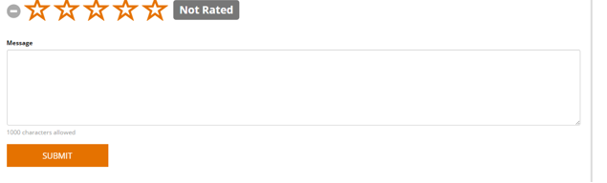

If the reviewer is not logged in then register/login to submit a review

1. In the backend when admin goes to post an ad he can’t upload pictures.  
   Owebest 15-11-2017 : When we post an ad from backend all images are uploaded perfectly. We also solved the ad blockers problem so we don't understand what error occurs to you. If you have shown an error so please send us the screenshot.
2. On admin please put a section terms and conditions  
   Owebest 15-11-2017 : had already completed (Please see the link below <http://panerio.stage01.obdemo.com/admin/pages/update/4>)
3. And the most difficult part is the equivalent of this <http://www.friday-ad.co.uk/london/animals/pets/dogs-puppies/?item__distance=2>

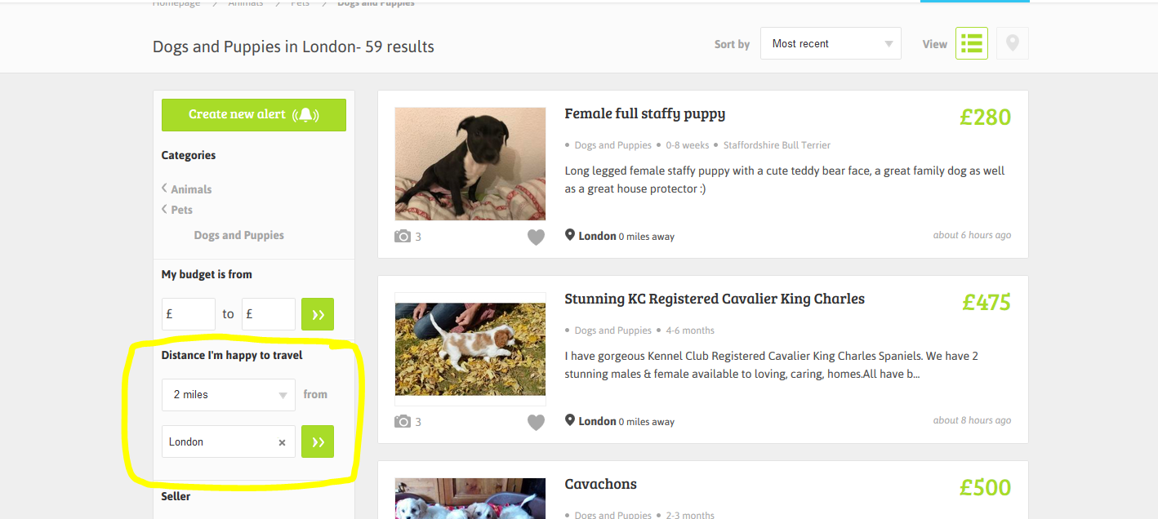

The advertiser enters the postcode and here ads shat show are correlated with the distance of the post code. Please put this in search

