Design:

Our application will let user choose different levels in the beginning. There are several pre-created levels stored in our application. Each level will contain four elements. The first element will be the background. It will show some fascinating colors or patterns to arouse user’s concentration. The second element will be level structure. These structures will present as some obstacles. They can be having different shape and color as time changed. The third element will be a tiny ball or square controlled by user. User will have to use gravity to let this element pass different levels. The forth element will be the winning area. When small ball contact with this area, this level will end.

Goal:

Our application aims at helping kids keep away from their cell phones and enjoy real life. We have some strategy to achieve this goal. First, our game will be very attractive to young kids and kind of addictive to them. However, as difficulties increase, player’s life points can quickly run out. To gain these valuable life points, players have to turn off their screen as trade off. This strategy force player keeps away from screen and to do something without their cell phones. As long as our game keeps attractive, our goal is guaranteed. This will be the prime goal of our application. We want to tell players to enjoy their real life instead of wasting their daily time on cell phones.

Class Diagram:

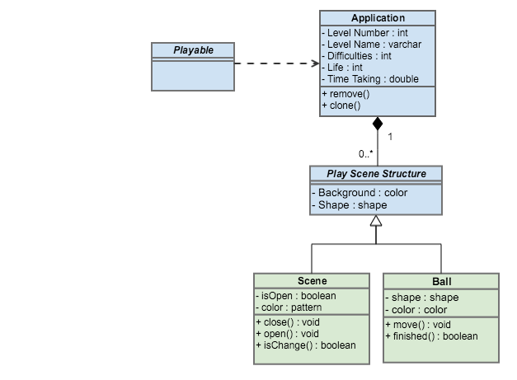

User Journey Diagram:

