STAT 571B - Homework 1
Brian Hallmark

1. Two types of fertilizer mixture A and B are used to feed six bean plants with each randomly applied to three plants. The yields of the plants (in pounds) are given below. We want to test whether A and B have different effects on the yield of bean plants.
A | B | B | A | B | A
3 | 5 | 4 | 2 | 7 | 4

- Construct the randomization distribution.

For the list of permutations you provided in email, the sorted list of differences in means (i.e. mean(A)-mean(B)) is:

-2.33 -2.33 -1.66 -1.66 -1.00 -1.00 -1.00 -0.33 -0.33 -0.33 0.33 0.33 0.33 1.00 1.00 1.00 1.66 1.66 2.33 2.33

b) Calculate the p-value based on the randomization test.

In the table above, the mean for A is (3+2+4)/3=3 and the mean for B is (5+4+7)/3=5.33 so the difference in means is -2.33

Since there are 2 values in the sorted list whose value is less than or equal to -2.33, the p-value is 2/20=0.1

c) Calculate the p-value based on two-sample t-test.

t = -2.2136, df=4 and the p-value = 0.09126

d) Compare the results from b) and c).

In this case the p-values for the two tests are very similar

NOTE: I did this problem by first mapping A->1 and B->2 and then using the following R code:
data=c(3,5,4,2,7,4)
A=c(3,2,4)
B=c(5,4,7)
for (i in 1:20) {
meanA[i]=sum(data[fac[i,]==1])/3
meanB[i]=sum(data[fac[i,]==2])/3
}
temp=sort(meanA-meanB)
print(sum(temp<=(mean(A)-mean(B)))/20)
print(t.test(A,B))
2. Montgomery 2.15

- H₀: μ = mean number of days <= 120
H₁: μ > 120

- mean=(108+124+124+106+115+138+163+159+134+139)/10=131

the 0.99 cutoff for the t distribution with df=9 is 2.8214
so since 1.7797<2.8214, we do not reject H₀ at the 0.01 level

- the probability that t₉ > 1.7797 = 0.9455947
so the p-value = 1-0.9455947 = 0.05441

- since this is a one-sided test the CI is given by:
131-(2.8214 * 19.5448)/√10 <= μ <= ∞

so the 99% CI = [113.5618, ∞)

3. Montgomery 2.16

In the case of 2.15, the data suggests that a normal distribution may be an okay approximation for shelf life, but the sample size is very small. The Shapiro-Wilk normality test has p = 0.5152 (i.e. don’t reject the null of normality). The qqplot of the data is:

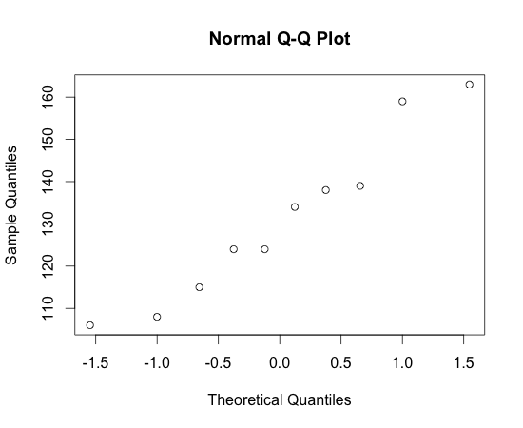

which appears to look okay. The one sample t-test assumes normality so if there is a large deviation from this assumption the test result will not be valid and another procedure such as a randomization test should be used.
4. Montgomery 2.24

- Yes, using a two-sample t-test the results (computed in R) are:

t = 2.6751, df = 14, the critical t value is 1.76131 so we can reject the null hypothesis of equal thickness

- p-value = 0.01812

- The 95% CI = [0.4995743 4.5404257]
This indicates that 95% of the time the true difference in means is within this interval. Since the interval does not include zero, it also provides another (equivalent) confirmation of the results in a) and b)

This is all I have had time to complete before class, but I will make sure to work through the rest on my own. -bh

