STAT 571B - Homework 2
Brian Hallmark

3.3. A computer ANOVA output is shown below. Fill in the blanks. You may give bounds on the P-value.

One-way ANOVA
Source | DF | SS | MS | F | P
Factor | 3 | 36.15 | 12.05 | 1.21 | 0.662
Error | 16 | 159.89 | 9.99
Total | 19 | 196.04

3.5. The tensile strength of Portland cement is being studied. Four different mixing techniques can be used economically. A completely randomized experiment was conducted and the following data were collected.

Mixing Technique | Tensile Strength (lb/in²)
1 | 3129 | 3000 | 2865 | 2890
2 | 3200 | 3300 | 2975 | 3150
3 | 2800 | 2900 | 2985 | 3050
4 | 2600 | 2700 | 2600 | 2765

- Test the hypothesis that mixing techniques affect the strength of the cement. Use α = 0.05.

We proceed with a one-way ANOVA to test the null hypothesis of equal means
R code:
p2<-read.table("hw2_p2.txt",header=TRUE)
attach(p2)
fit1<-aov(Strength~factor(Technique))
summary(fit1)

ANOVA table:
 | df | Sum Sq | Mean Sq | F value | Pr(>F)
Technique | 3 | 489740 | 163247 | 12.728 | 0.0004887
Residuals | 12 | 153908 | 12826

The p-value is 0.0004887 < 0.05 so we reject the null hypothesis of no effect of mixing technique on tensile strength.

- Construct a graphical display as described in Section 3.5.3 to compare the mean tensile strengths for the four mixing techniques. What are your conclusions?

- Use the Fisher LSD method with α=0.05 to make comparisons between pairs of means.

R code:
library("agricolae")
df<-df.residual(fit1)
MSerror<-deviance(fit1)/df
LSD.test(Strength,Technique,df,MSerror)

Output:
LSD t Test for Strength

Mean Square Error: 12825.69

Technique, means and individual ( 95 %) CI

Strength std.err replication LCL UCL
1 2971.00 60.27852 4 2839.664 3102.336
2 3156.25 67.98820 4 3008.116 3304.384
3 2933.75 54.13621 4 2815.797 3051.703
4 2666.25 40.48534 4 2578.040 2754.460

alpha: 0.05 ; Df Error: 12
Critical Value of t: 2.178813

Least Significant Difference 174.4798
Means with the same letter are not significantly different.

Groups, Treatments and means
a 2 3156.25
b 1 2971
b 3 2933.75
c 4 2666.25

This procedure suggests that techniques 1 and 3 are not different, but techniques 2 and 4 are different.

- Construct a normal probability plot of the residuals. What conclusion would you draw about the validity of the normality assumption?

Note: in R the command plot(fit1) generates 4 diagnostic plots including the two below.

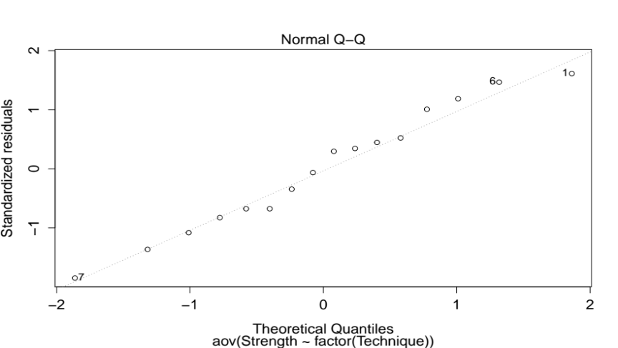

In this case the residuals look approximately normal and the normality assumption is probably okay since ANOVA is robust to slight departures from normality, especially for balanced designs.

- Plot the residuals versus the predicted tensile strength. Comment on the plot.

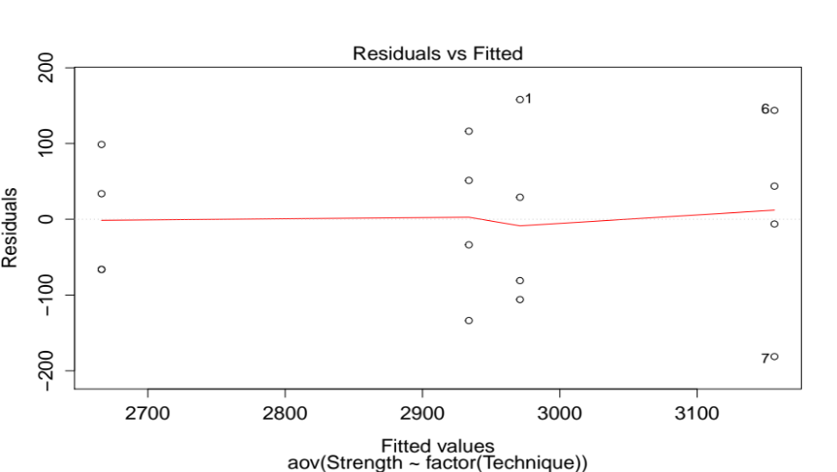

The residuals do not show a pattern with the 4 levels of Technique so further procedures are not necessary.

- Prepare a scatter plot of the results to aid the interpretation of the results of this experiment.
plot(Technique, Strength)
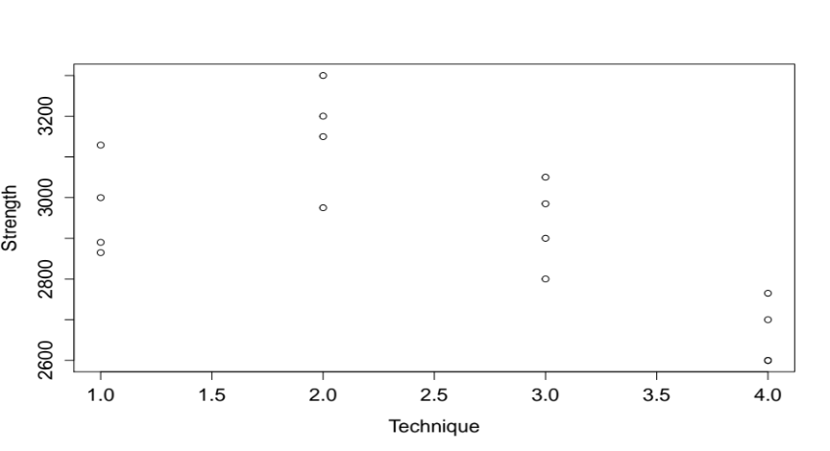

3.22. Four different designs for a digital computer circuit are being studied in order to compare the amount of noise present. The following data have been obtained:

Circuit Design | Noise Observed
1 | 19 | 20 | 19 | 30 | 8
2 | 80 | 61 | 73 | 56 | 80
3 | 47 | 26 | 25 | 35 | 50
4 | 95 | 46 | 83 | 78 | 97

- Is the amount of noise present the same for all four designs? Use α = 0.05.

R code:
p3<-read.table("hw2_p3.txt",header=TRUE)
attach(p3)
fit2<-aov(Noise~factor(Design))
summary(fit2)
plot(fit2)

ANOVA table:

 | df | Sum Sq | Mean Sq | F value | Pr(>F)
factor(Design) | 3 | 12042 | 4014 | 21.78 | 6.80E-06
Residuals | 16 | 2948.8 | 184.3

The p-value = 6.8E-06 << 0.05 so we can reject the null hypothesis that the noise is the same for all designs.

- Analyze the residuals from this experiment. Are the basic analysis of variance assumptions satisfied?

The Q-Q plot looks okay (perhaps outliers at the ends?) and the residuals vs fitted looks okay (perhaps #17 is anomalous?). It appears the basic assumptions are okay.

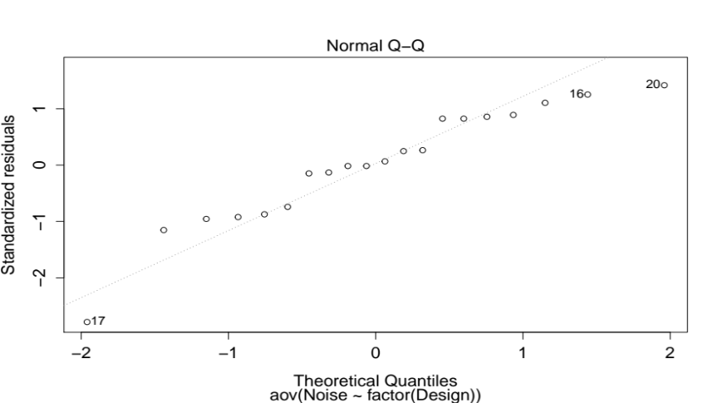

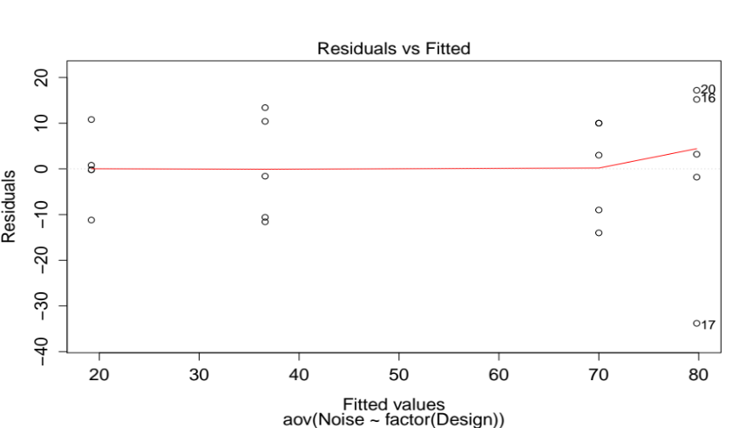

- Which circuit design would you select for use? Low noise is best.

I would choose design #1 since it has the lowest mean and median Noise.
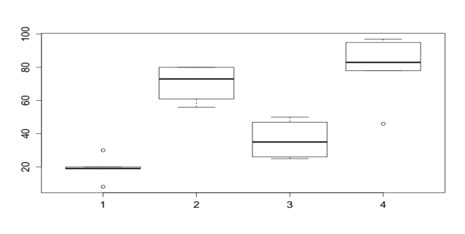
3.26. An experiment was performed to investigate the effectiveness of five insulating materials. Four samples of each material were tested at an elevated voltage level to accelerate the time to failure. The failure times (in minutes) are shown below:
Material | Failure Time (minutes)
1 | 110 | 157 | 194 | 178
2 | 1 | 2 | 4 | 18
3 | 880 | 1256 | 5276 | 4355
4 | 495 | 7040 | 5307 | 10,050
5 | 7 | 5 | 29 | 2

- Do all five materials have the same effect on mean failure time?

p4<-read.table("hw2_p4.txt",header=T)
attach(p4)
Material=factor(Material)
fit3<-aov(Failure_Time~Material)
summary(fit3)

 | df | Sum Sq | Mean Sq | F value | Pr(>F)
Material | 4 | 103191489 | 25797872 | 6.1909 | 0.003786
Residuals | 15 | 62505657 | 4167044

We can reject the null hypothesis that the materials have the same mean failure times.

- Plot the residuals versus the predicted response. Construct a normal probability plot of the residuals. What information is conveyed by these plots?
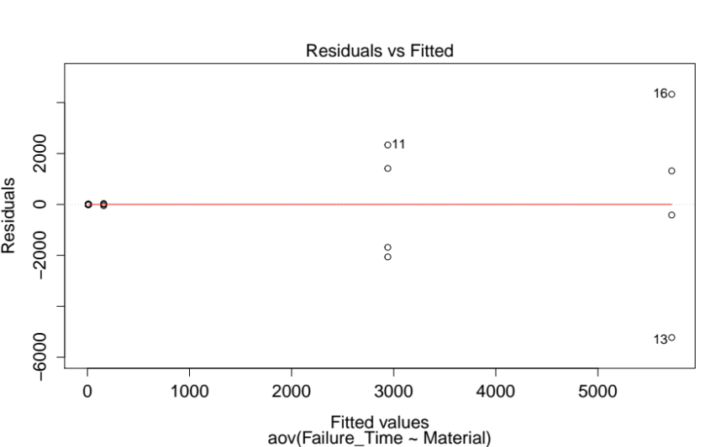
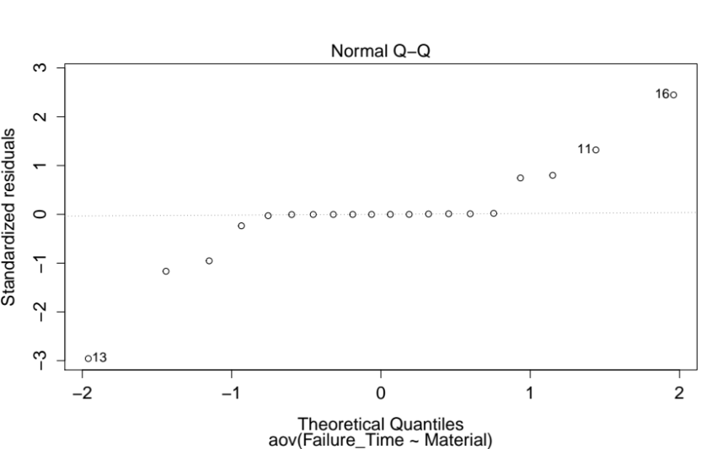

The variance grows with the size of the predicted values and the distribution does not appear normal at all on the Q-Q plot. A transformation is needed.

- Based on your answer to part (b) conduct another analysis of the failure time data and draw appropriate conclusions.

Tried log transformation:
fit4<-aov(log(Failure_Time)~Material)
plot(fit4)
summary(fit4)

 | df | Sum Sq | Mean Sq | F value | Pr(>F)
log(Material) | 4 | 165.056 | 41.264 | 37.657 | 1.18E-07
Residuals | 15 | 16.437 | 1.096

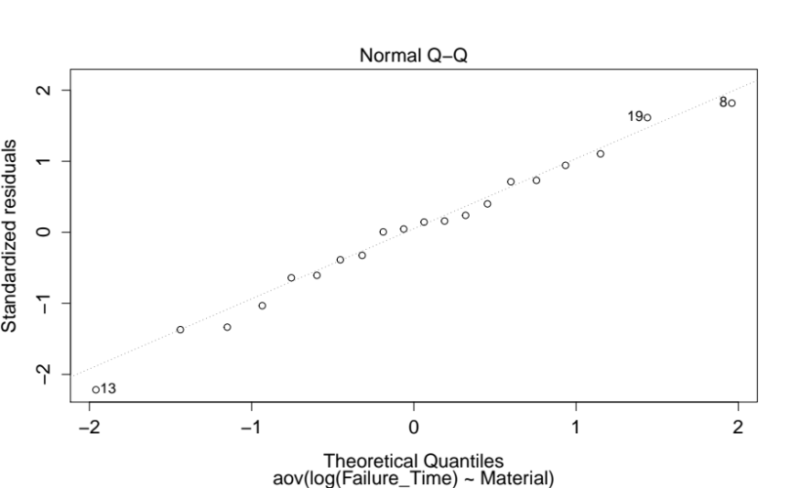
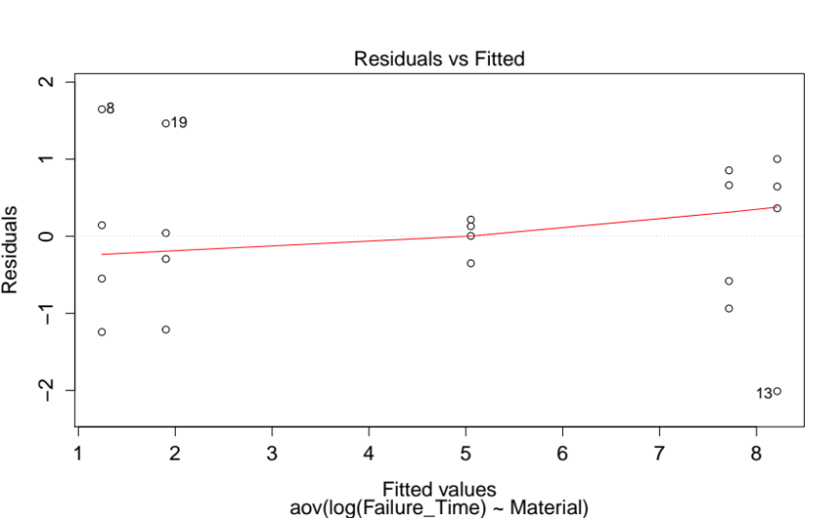
The conclusion (reject the null hypothesis) is the same. The residuals look better but there is something suspicious with the values in the middle of the plot (it looks like the variance is still not uniform. The Q-Q plot looks much better and more normal.

3.36. Suppose that four normal populations have means of μ₁=50, μ₂=60, μ₃=50, and μ₄=60. How many observations should be taken from each population so that the probability of rejecting the null hypothesis of equal population means is at least 0.90? Assume that α=0.05 and that a reasonable estimate of the error variance is 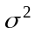=25.
=>

We use the OC curve in Appendix Chart V for a-1=3 with 4(n-1) error degrees of freedom and α=0.05.

n | Φ² | Φ | 4(n-1) | β | Power
3 | 3 | 1.73 | 8 | 0.35 | 0.65
4 | 4 | 2.00 | 12 | 0.18 | 0.82
5 | 5 | 2.24 | 16 | 0.09 | 0.91

So it appears a sample size of at least 5 is required.
3.44. Use the Kruskal-Wallis test for the experiment in Problem 3.22. Compare conclusions obtained with those from the usual analysis of variance?

R code:
kruskal.test(Noise~Design)

Output:
Kruskal-Wallis rank sum test

data: Noise by Design
Kruskal-Wallis chi-squared = 14.931, df = 3, p-value = 0.001877

The Kruskal-Wallis test also produces a p-value < 0.05 so that we can again reject the null hypothesis that all circuit designs have equal noise.

