STAT 571B - Homework 3
Brian Hallmark

4.1. The ANOVA from a randomized complete block experiment output is shown below.

Source | DF | SS | MS | F | P
Treatment | 4 | 1010.56 | 252.65 | 29.84 | <0.001
Block | 5 | 323.82 | 64.765 | 7.649 | <0.001
Error | 20 | 169.33 | 8.467
Total | 29 | 1503.71

(a) Fill in the blanks. You may give bounds on the P-value.

(b) How many blocks were used in this experiment?
6 blocks were used

(c) What conclusions can you draw?
The treatments are significantly different. We must include the blocks because they are also significantly different (otherwise we could pool all the data).

4.12. An aluminum master alloy manufacturer produces grain refiners in ingot form. The company produces the product in four furnaces. Each furnace is known to have its own unique operating characteristics, so any experiment run in the foundry that involves more than one furnace will consider furnaces as a nuisance variable. The process engineers suspect that stirring rate impacts the grain size of the product. Each furnace can be run at four different stirring rates. A randomized block design is run for a particular refiner and the resulting grain size data is as follows.

 | Furnace
Stirring Rate | 1 | 2 | 3 | 4
5 | 8 | 4 | 5 | 6
10 | 14 | 5 | 6 | 9
15 | 14 | 6 | 9 | 2
20 | 17 | 9 | 3 | 6

a) Is there any evidence that stirring rate impacts grain size?

R code:
p2=read.table("hw3p2.txt", header=T)
attach(p2)
Furnace=factor(Furnace)
Rate=Factor(Rate)
fit1<-aov(GrainSize~Rate+Furnace)
summary(fit1)
plot(fit1)

Results:
Df Sum Sq Mean Sq F value Pr(>F)
Rate 3 22.19 7.40 0.853 0.4995
Furnace 3 165.19 55.06 6.348 0.0133 *
Residuals 9 78.06 8.67

Conclusion: There is not a significant difference between stirring rates

b) Graph the residuals from this experiment on a normal probability plot. Interpret this plot.
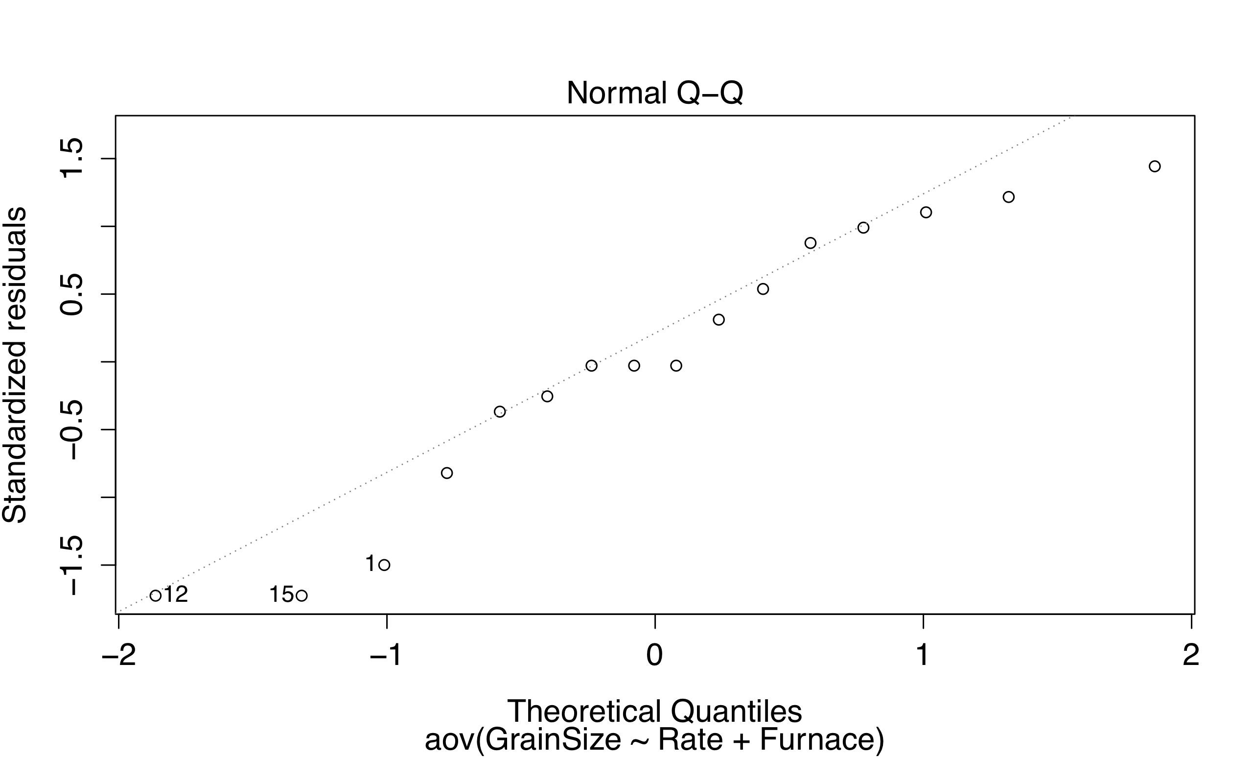

This QQ plot seems okay though there are a few outliers

c) Plot the residuals versus furnace and stirring rate. Does this plot convey any useful information?
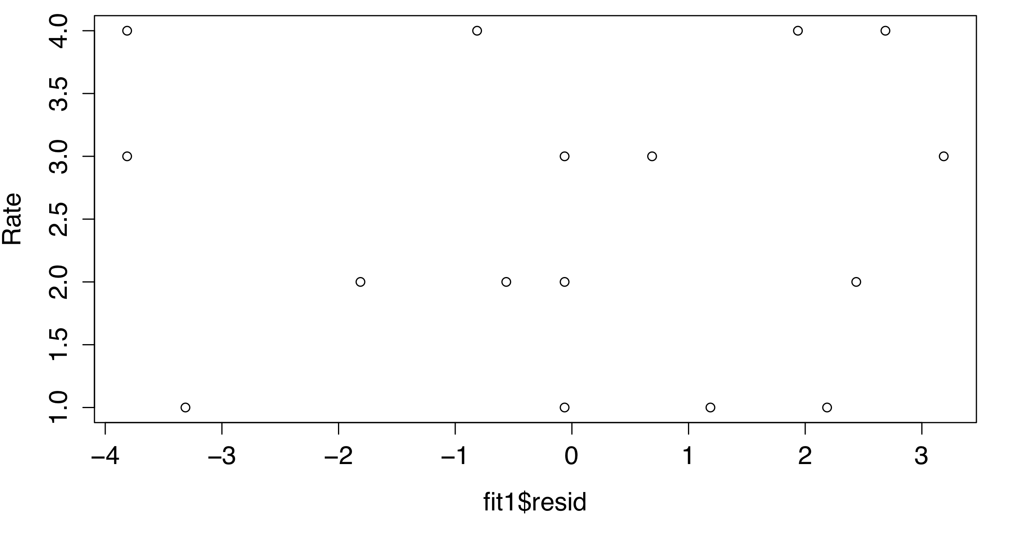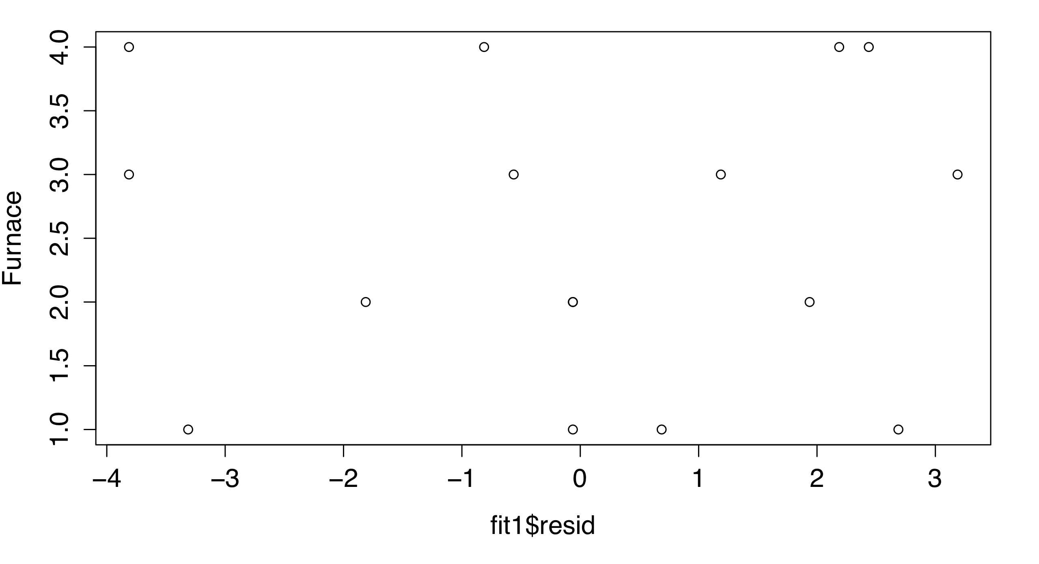
These plots both indicate that the residuals do not show any worrisome patterns
- What should the process engineers recommend concerning the choice of stirring rate and furnace for this particular grain refiner if small grain size is desirable?

I would recommend that although there does not appear to be a big difference between rates, Rate=5 has the lowest mean and median. I would also recommend against using Furnace #1 since it has a much higher mean and median grain size than the other furnaces.

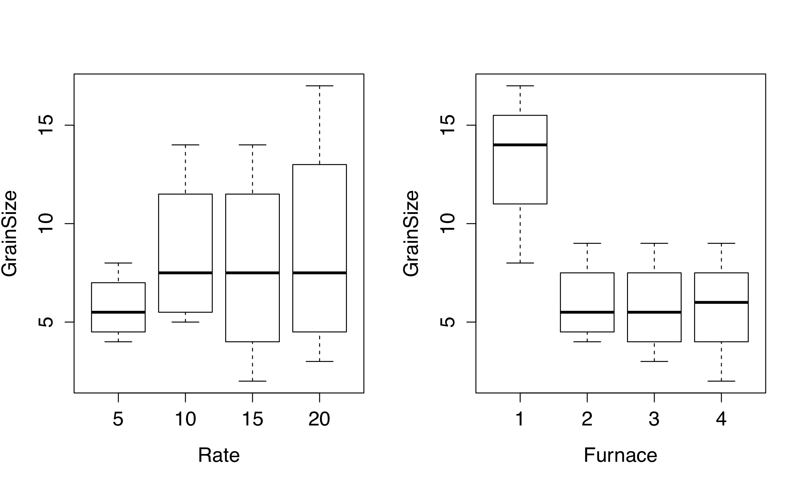
4.16. Suppose that the observation for chemical type 2 and bolt 3 is missing in Problem 4.3. Analyze the problem by estimating the missing value. Perform the exact analysis and compare the results.

a) Estimating missing value
 | Bolt
Chemical | 1 | 2 | 3 | 4 | 5
1 | 73 | 68 | 74 | 71 | 67 | 353
2 | 73 | 67 | x | 72 | 70 | 282
3 | 75 | 68 | 78 | 73 | 68 | 362
4 | 73 | 71 | 75 | 75 | 69 | 363
 | 294 | 274 | 227 | 291 | 274 | 1360

=> x = (4(282)+5*(227)-1360)/(3*4) = 75.25

Plug in 75.25 for x and run ANOVA in R (this is now a balanced design)

NOTE: R by default calculates Type I SS. Have to set it to calculate Type III SS for b) which is an unbalanced design.

R code:
options(contrasts = c("contr.sum","contr.poly"))
fit3=aov(strength~chemical+bolt,data=p3)
summary(fit3)

ANOVA results:
Df Sum Sq Mean Sq F value Pr(>F)
bolt 4 158.89 39.72 21.90 1.92e-05 ***
chemical 3 12.78 4.26 2.35 0.124
Residuals 12 21.76 1.81

b) Exact analysis (similar R code)

ANOVA results:
Df Sum Sq Mean Sq F value Pr(>F)
chemical 1 14.92 14.92 1.565 0.229
bolt 1 13.22 13.22 1.388 0.256
Residuals 16 152.49 9.53

In the first case, the ANOVA results indicate that the bolt matters, while in the second case the F test suggests that bolt is not important.

Neither method suggests we should reject the null hypothesis of significantly different means between chemicals.

4.20. The effect of five different ingredients (A, B, C, D, E) on reaction time of a chemical process is being studied. Each batch of new material is only large enough to permit five runs to be made. Furthermore, each run requires approximately 1 1/2 hours, so only five runs can be made in one day. The experimenter decides to run the experiment as a Latin square so that day and batch effects can be systematically controlled. She obtains the data that follow. Analyze the data from this experiment (use α = 0.05) and draw conclusions.

 |  |  | Day
Batch | 1 | 2 | 3 | 4 | 5
1 | A=8 | B=7 | D=1 | C=7 | E=3
2 | C=11 | E=2 | A=7 | D=3 | B=8
3 | B=4 | A=9 | C=10 | E=1 | D=5
4 | D=6 | C=8 | E=6 | B=6 | A=10
5 | E=4 | D=2 | B=3 | A=8 | C=8

R code:
batch<-c(rep("batch1",1),rep("batch2",1),rep("batch3",1),rep("batch4",1), rep("batch5",1))
day <- c(rep("day1",5), rep("day2",5), rep("day3",5), rep("day4",5), rep("day5",5))
ingredient<-c("A","C","B","D","E", "B","E","A","C","D", "D","A","C","E","B", "C","D","E","B","A", "E","B","D","A","C")
time <- c(8,11,4,6,4, 7,2,9,8,2, 1,7,10,6,3, 7,3,1,6,8, 3,8,5,10,8)
p4<-data.frame(day,batch,ingredient,time)
par(mfrow=c(2,2))
plot(time~batch+day+ingredient,data=p4)
fit4<-aov(time~batch+day+ingredient,data=p4)
summary(fit4)
plot(fit4)

Results:
Df Sum Sq Mean Sq F value Pr(>F)
batch 4 15.44 3.86 1.235 0.347618
day 4 12.24 3.06 0.979 0.455014
ingredient 4 141.44 35.36 11.309 0.000488 ***
Residuals 12 37.52 3.13

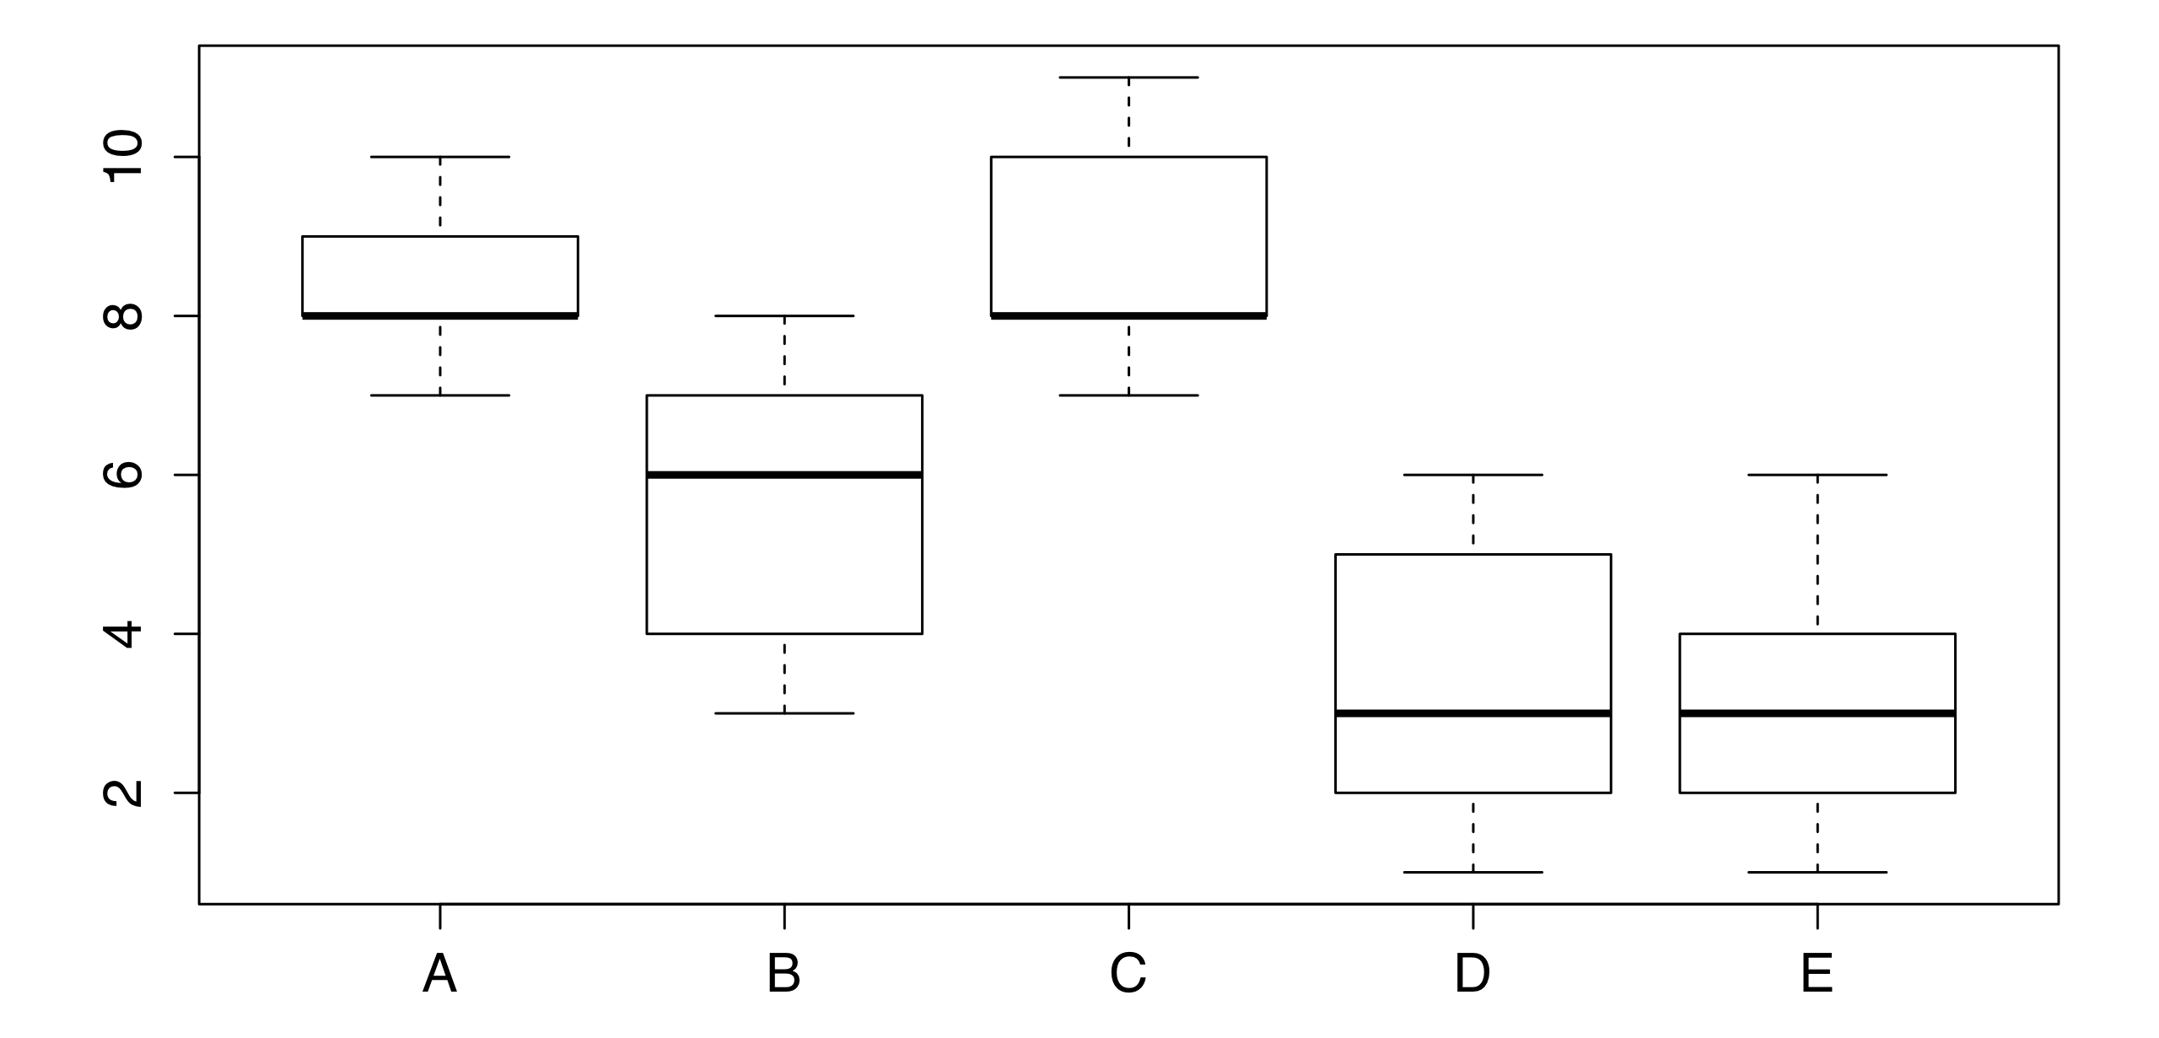

Conclusion:
The ingredients are not equivalent – we can reject the null hypothesis. Ingredients D and E appear to have the lowest reaction times.

