STAT 571B - Homework 4
Brian Hallmark

4.28. The yield of a chemical process was measured using five batches of raw material, five acid concentrations, five standing times, (A, B, C, D, E) and five catalyst concentrations (α, β, γ, δ, ε). The Graeco-Latin square that follows was used. Analyze the data from this experiment (use α = 0.05) and draw conclusions.

First, I transformed the data in excel so that it could be easily imported into R.
R code:
p1<-read.table("hw4p1.txt",header=T)
attach(p1)
batch=factor(batch)
acidconc=factor(acidconc)
fit1<-anova(lm(yield~batch+acidconc+time+catconc))
fit1

R output:
Analysis of Variance Table
Response: yield
Df Sum Sq Mean Sq F value Pr(>F)
batch 4 10.0 2.50 0.4274 0.785447
acidconc 4 24.4 6.10 1.0427 0.442543
time 4 342.8 85.70 14.6496 0.000941 ***
catconc 4 12.0 3.00 0.5128 0.728900
Residuals 8 46.8 5.85

The F test results indicate that we can only reject the null hypothesis of equivalent yields for standing time. The box plots below show that this is reasonable and that the standing time corresponding to A (little a below) has the highest yield.

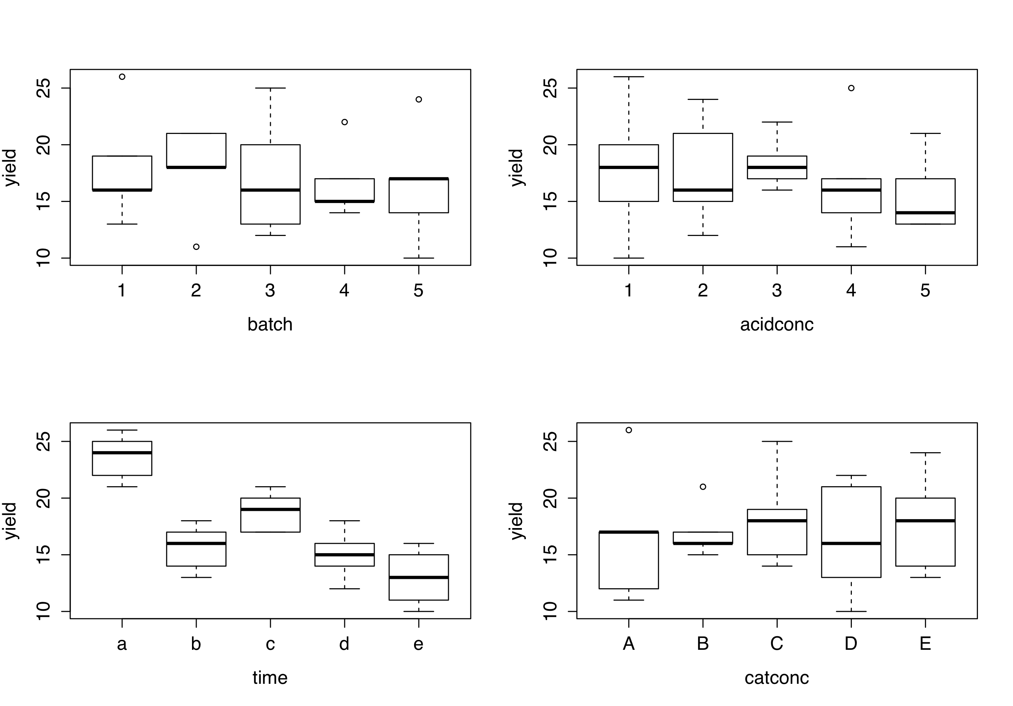
4.33. An engineer is studying the mileage performance characteristics of five types of gasoline additives. In the road test he wishes to use cars as blocks; however, because of a time constraint, he must use an incomplete block design. He runs the balanced design with the five blocks that follow. Analyze the data from this experiment (use α = 0.05) and draw conclusions.

 |  |  | Car
Additive | 1 | 2 | 3 | 4 | 5
1 |  | 17 | 14 | 13 | 12
2 | 14 | 14 |  | 13 | 10
3 | 12 |  | 13 | 12 | 9
4 | 13 | 11 | 11 | 12
5 | 11 | 12 | 10 |  | 8

R code: as far as I can tell, I need to use Type III SS here – IS THAT CORRECT??
p2<-read.table("hw4p2.txt",header=T)
attach(p2)
additive=factor(additive)
car=factor(car)
fit3=aov(mileage~additive+car)
options(contrasts = c("contr.sum","contr.poly"))
summary(fit3)
drop1(fit4,~.,test="F")

R output:
Using Type I SS I get this:
Df Sum Sq Mean Sq F value Pr(>F)
additive 4 31.70 7.925 8.703 0.00203 **
car 4 35.23 8.808 9.673 0.00132 **
Residuals 11 10.02 0.911

But the order matters (aov(mileage~additive+car) ≠ aov(mileage~car+additive)). Using Type III SS I get this:
Model:
mileage ~ additive + car
Df Sum of Sq RSS AIC F value Pr(>F)
<none> 10.017 4.1704
additive 4 35.733 45.750 26.5492 9.8103 0.001247 **
car 4 35.233 45.250 26.3294 9.6730 0.001321 **

Thus we reject the null hypothesis for both additive and car (i.e. mileage is not the same for all levels). Additive 1 has the highest mean mileage (over cars) and car 2 has the highest mean mileage (over additives).

4.42. Verify that a BIBD with the parameters a = 8, r = 8, k = 4, and b = 16 does not exist.

Using the equation on page 149:
we find that λ is not an integer. Thus a BIBD does not exist for these parameters.
5.1. The following output was obtained from a computer program that performed a two-factor ANOVA on a factorial experiment.

Two-way ANOVA: y versus A, B
Source | DF | SS | MS | F | P
A | 1 | 0.322 | 0.322 | 0.0367 | 0.851
B | 2 | 80.554 | 40.2771 | 4.59 | 0.033
Interaction | 2 | 45.348 | 22.674 | 2.583 | 0.117
Error | 12 | 105.327 | 8.7773
Total | 17 | 231.551

- Fill in the blanks in the ANOVA table. You can use bounds on the P-values.

- How many levels were used for factor B?
3 levels

- How many replicates of the experiment were performed?
a=2, b=3, 6(n-1)=12 -> n=3
so 3 replicates

- What conclusions would you draw about this experiment?
The levels of factor A are not significantly different. The interaction is not significant. We can reject the null that the levels of factor B produce equivalent responses.

5.7. Johnson and Leone (Statistics and Experimental Design in Engineering and the Physical Sciences, Wiley 1977) describe an experiment to investigate the warping of copper plates. The two factors studied were the temperature and the copper content of the plates. The response variable was a measure of the amount of warping. The data were as follows:

 |  | Copper | Content (%)
Temperature (°C) | 40 | 60 | 80 | 100
50 | 17,20 | 16,21 | 24,22 | 28,27
75 | 12,9 | 18,13 | 17,12 | 27,31
100 | 16,12 | 18,21 | 25,23 | 30,23
125 | 21,17 | 23,21 | 23,22 | 29,31

- Is there any indication that either factor affects the amount of warping? Is there any interaction between the factors? Use α = 0.05.

R code:
p5<-read.table("hw4p5.txt",header=T)
attach(p5)
temp=factor(temp)
copper=factor(copper)
p5fit1<-aov(warping~copper*temp)
summary(p5fit1)

Results:
Df Sum Sq Mean Sq F value Pr(>F)
copper 3 698.3 232.78 34.327 3.35e-07 ***
temp 3 156.1 52.03 7.673 0.00213 **
copper:temp 9 113.8 12.64 1.864 0.13275
Residuals 16 108.5 6.78

The interaction term is not significant but we can reject the null hypotheses for both factors, copper content and temperature.

- Analyze the residuals from this experiment.

R code:
par(mfrow=c(1,2))
plot(warping~copper*temp)
plot(p5fit1)
plot(as.numeric(copper),p5fit1$residuals,type="p",xlab="Copper",ylab="Residuals")
plot(as.numeric(temp),p5fit1$residuals,type="p",xlab="Temp",ylab="Residuals")

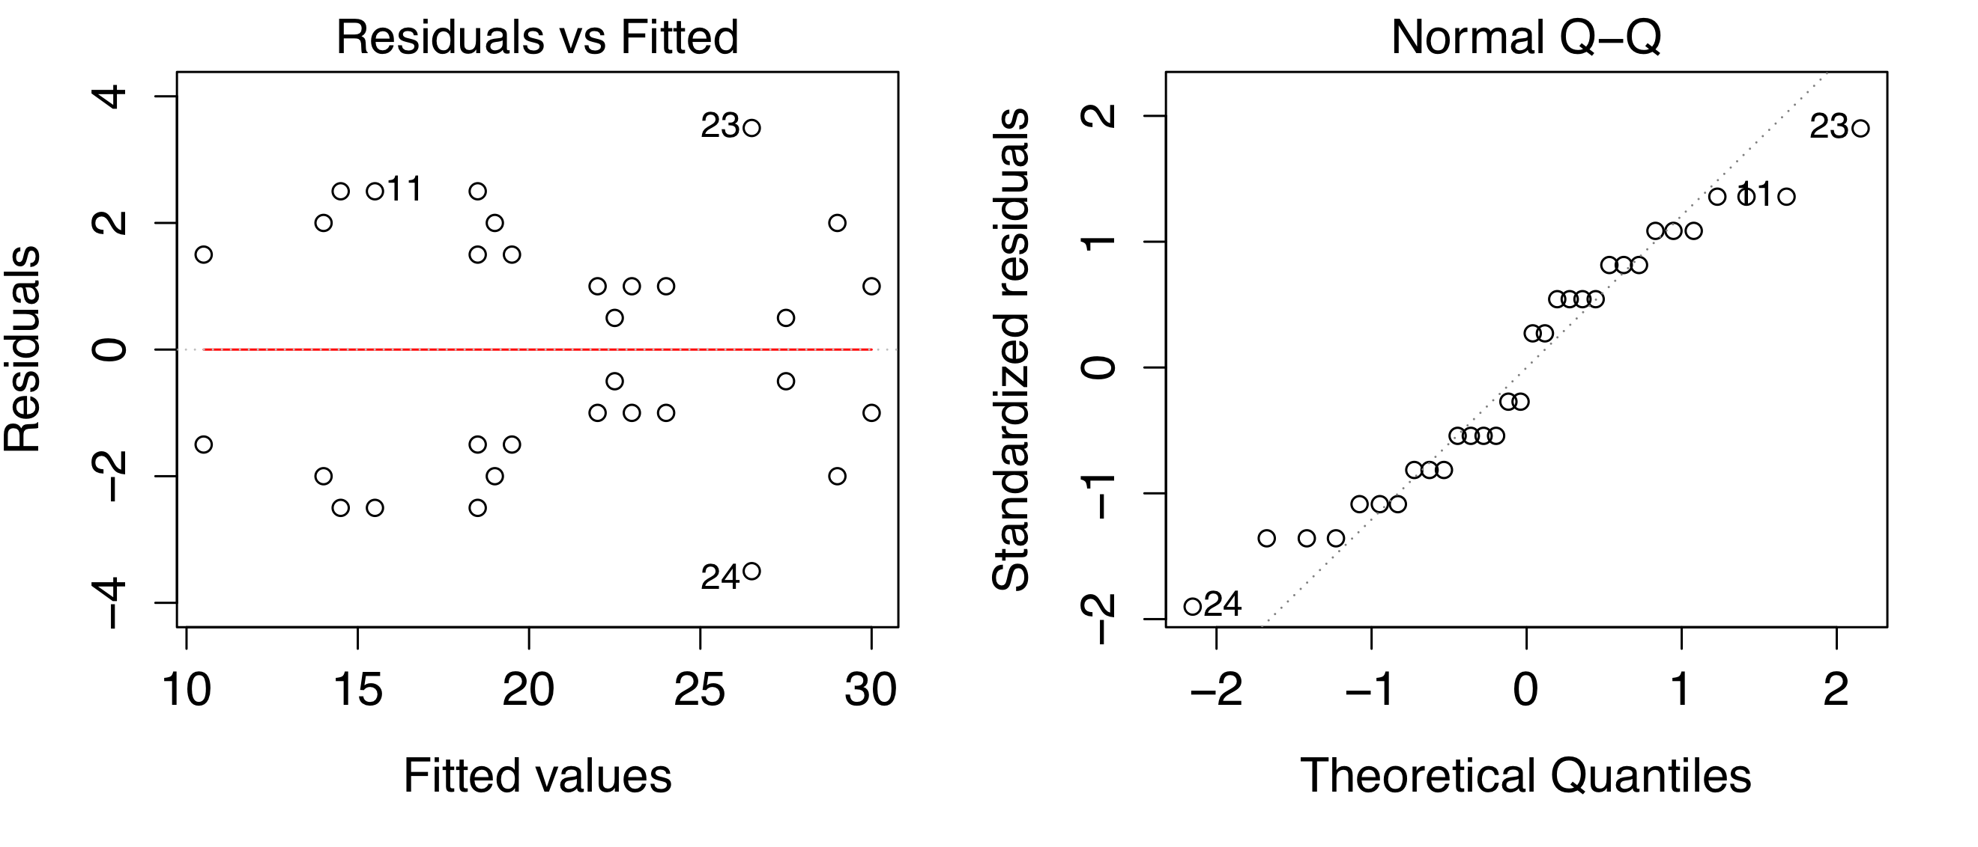

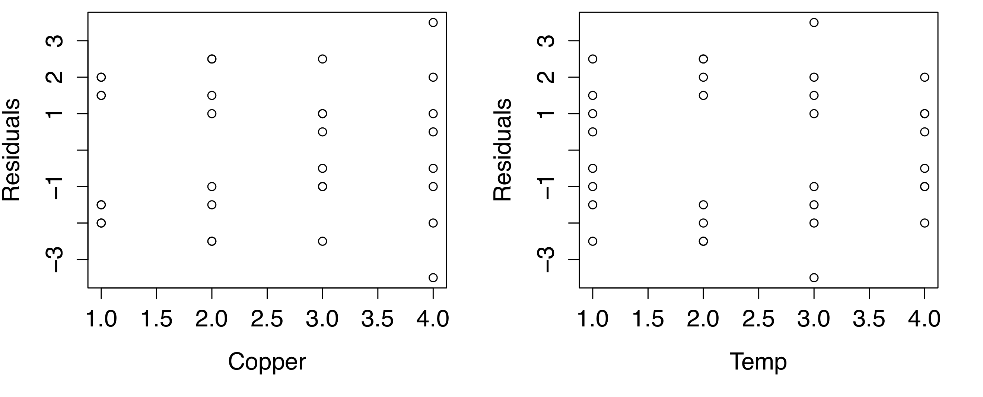

These plots do not indicate anything unusual. The residuals are approximately normally distributed and there is no pattern with either factor or with the fitted values.

- Plot the average warping at each level of copper content and compare them to an appropriately scaled t distribution. Describe the differences in the effects of the different levels of copper content on warping. If low warping is desirable, what level of copper content would you specify?

The R command:

aggregate(p5,by=list(copper),FUN=mean)
Group.1 temp copper warping
1 40 87.5 40 15.500
2 60 87.5 60 18.875
3 80 87.5 80 21.000
4 100 87.5 100 28.250

tells us that the lowest average warping is for a copper content of 40 (=15.5).

The two plots below were made with:
plot(aggregate(p5,by=list(copper),FUN=mean)[4])
interaction.plot(temp,copper,warping)

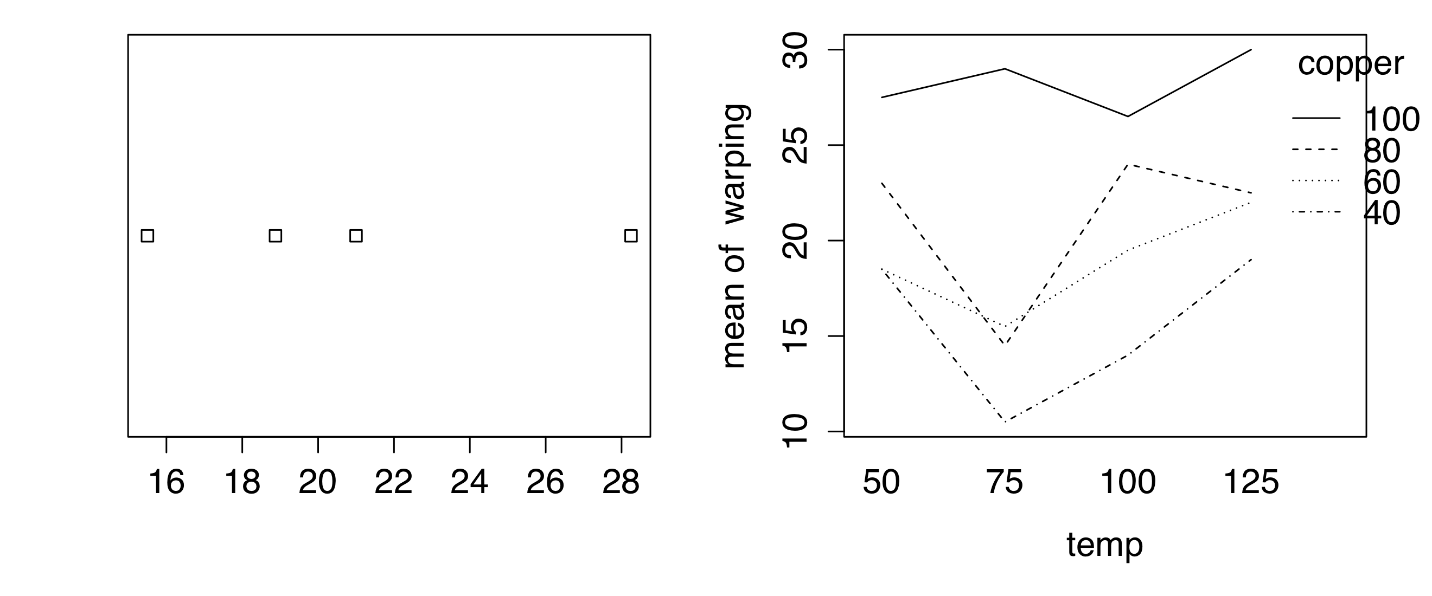

(d) Suppose that temperature cannot be easily controlled in the environment in which the copper plates are to be used. Does this change your answer for part (c)?

This does not change the answer, we would still use 40 since it is lowest for all temps as seen in the plot above.

