STAT 571B - Homework 7
Brian Hallmark

13.2.
- Is there significant variation in calcium content from batch to batch? Use α = 0.05.
R code:
p1=read.table("hw7p1.txt",header=T)
p1$batch=factor(p1$batch)
p1.lmer=lmer(calcont~1+(1|batch),data=p1)
summary(p1.lmer)
p1.lm=aov(calcont~Error(batch),data=p1)
summary(p1.lm)

R output:
Linear mixed model fit by REML
Formula: calcont ~ 1 + (1 | batch)
Data: p1
AIC BIC logLik deviance REMLdev
-46.16 -42.51 26.08 -57.29 -52.16
Random effects:
Groups Name Variance Std.Dev.
batch (Intercept) 0.0039729 0.063031
Residual 0.0043800 0.066181
Number of obs: 25, groups: batch, 5

Fixed effects:
Estimate Std. Error t value
(Intercept) 23.44360 0.03114 752.8

Error: batch
Df Sum Sq Mean Sq F value Pr(>F)
Residuals 4 0.09698 0.02424

Error: Within
Df Sum Sq Mean Sq F value Pr(>F)
Residuals 20 0.0876 0.00438

Thus, we have that F = MS(batch)/MSE = 0.02424/0.00438 = 5.5342. We compute the probability of observing an F statistic that large by chance: 1-pf(5.5342) = 0.0036 < 0.05
So yes, there is significant variation between batches.

- Estimate the components of variance.
These are computed by the lmer function but can also be computed using the MSE terms:

- Find a 95 percent confidence interval for 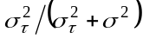.

- Analyze the residuals from this experiment. Are the basic analysis of variance assumptions satisfied?
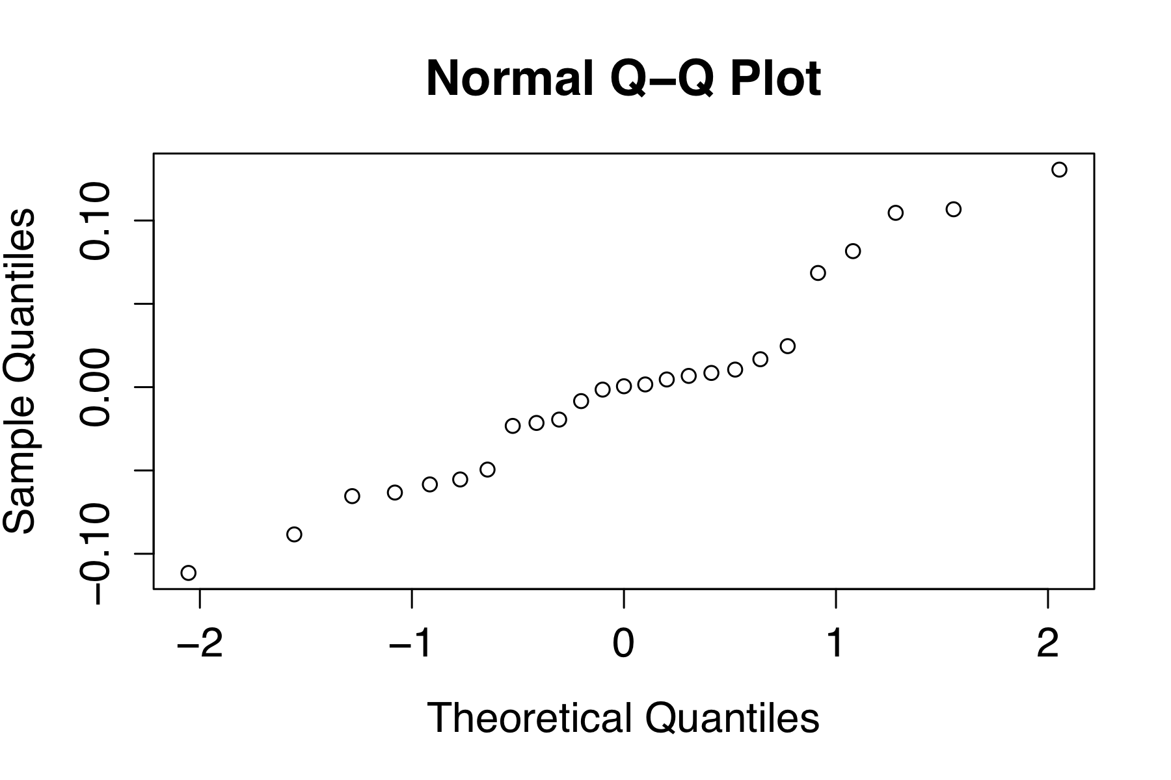

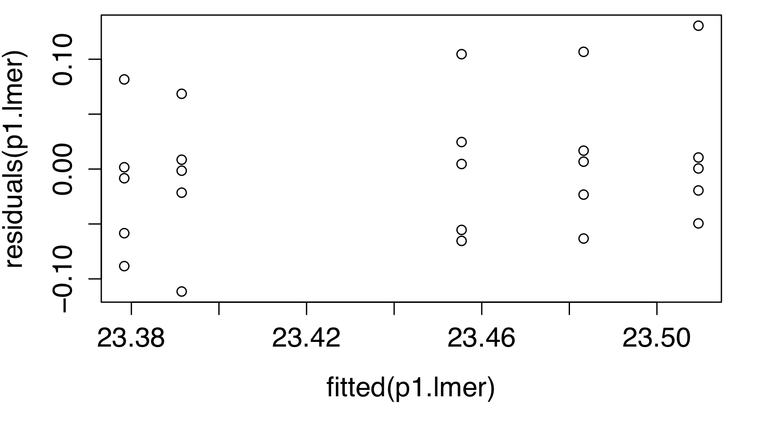

The QQ plot has a few points that look suspicious in the upper right, but the residuals vs fitted plot looks okay.

13.11. Reconsider the data in Problem 5.8. Suppose that both factors, machines and operators, are chosen at random.

(a) Analyze the data from this experiment.

R code:
p2=read.table("hw7p2.txt",header=T)
p2$operator=factor(p2$operator)
p2$machine=factor(p2$machine)
p2.lmer=lmer(y~1+(1|operator)+(1|machine)+(1|operator:machine),data=p2)
p2.lmer

R output:
Linear mixed model fit by REML
Formula: y ~ 1 + (1 | operator) + (1 | machine) + (1 | operator:machine)
Data: p2
AIC BIC logLik deviance REMLdev
119.8 125.7 -54.92 112.9 109.8
Random effects:
Groups Name Variance Std.Dev.
operator:machine (Intercept) 1.2778 1.1304
machine (Intercept) 0.0000 0.0000
operator (Intercept) 9.2274 3.0377
Residual 3.7917 1.9472
Number of obs: 24, groups: operator:machine, 12; machine, 4; operator, 3

Fixed effects:
Estimate Std. Error t value
(Intercept) 112.292 1.828 61.44

(b) Find point estimates of the variance components using the analysis of variance method.

The output of lmer() gives the variance component estimates:
σ²_{Machine} = 0
σ²_{Operator} = 9.2274
σ²_{Operator x Machine} = 1.2778
σ² = 3.7917

NOTE: the output of the R function lmer() is different than SAS mixed. As far as I can tell the differences are subtle and complicated. lmer() does not report MS terms to use the ANOVA method of moments method, but instead used REML (or ML).

14.1. A rocket propellant manufacturer is studying the burning rate of propellant from three production processes. Four batches of propellant are randomly selected from the output of each process and three determinations of burning rate are made on each batch. The results follow. Analyze the data and draw conclusions

R code:
p3=read.table("hw7p3",header=T)
p3$process=factor(p3$process)
p3$batch=factor(p3$batch)
p3.lm=aov(rate~process+Error(process/batch),data=p3)
summary(p3.lm)
1-pf(338/230.8,2,9)
1-pf(230.8/18.92,9,24)

Output:
Error: process
Df Sum Sq Mean Sq
process 2 676.1 338

Error: process:batch
Df Sum Sq Mean Sq F value Pr(>F)
Residuals 9 2078 230.8

Error: Within
Df Sum Sq Mean Sq F value Pr(>F)
Residuals 24 454 18.92

We compute the F statistics and the p-values by dividing the MS terms and get:
F = MS(process)/MS(batch) = 338/230.8 -> p = 0.2814
F= MS(batch)/MSE = 230.8/18.92 -> p = 5.495079e-07
Thus we can conclude that different processes don’t have different burning rates, but that batches from the same process have significantly different burning rates.

14.20.
This is a split-plot experiment. The whole plot is the mix. The subplots are the 3 application methods. The days are replicates (blocks).

R code:
p4=read.table("hw7p4.txt",header=T)
p4$mix=factor(p4$mix)
p4$day=factor(p4$day)
p4$method=factor(p4$method)
p4.lm=aov(resp~(mix+day+method)^2+Error(day/mix/method),data=p4)
summary(p4.lm)

Output:
Error: day
Df Sum Sq Mean Sq
day 2 2.042 1.021

Error: day:mix
Df Sum Sq Mean Sq
mix 3 307.48 102.49
mix:day 6 4.53 0.75

Error: day:mix:method
Df Sum Sq Mean Sq F value Pr(>F)
method 2 222.09 111.05 151.677 3.04e-09 ***
mix:method 6 10.04 1.67 2.285 0.105
day:method 4 1.96 0.49 0.670 0.625
Residuals 12 8.79 0.73

The p-value for mix is found from F=MS(mix)/MS(mix:day)=136 => p-value < 0.0001
The p-value for method is 3.04e-09
The p-value for the interaction mix:method is 0.105

Thus both mix and method are significantly different but the interaction is not.

