Caitlyn Hall

Assignment 3

29 February 2016

STAT 571B

**4.1**

|  |  |  |  |  |  |
| --- | --- | --- | --- | --- | --- |
| Source | df | SS | MS | F | P |
| Treatment | 4 | 1010.56 | ? | 29.84 | ? |
| Block | ? | ? | 64.765 | ? | ? |
| Error | 20 | 169.33 | ? |  |  |
| Total | 29 | 1503.71 |  |  |  |

|  |  |  |  |  |  |
| --- | --- | --- | --- | --- | --- |
| Source | df | SS | MS | F | P |
| Treatment | (b-1) = 4 | 1010.56 | SSTreatment/(a-1) = 1010.56/5 = **252.64** | 29.84 | **<0.0001** |
| Block | (a-1) = 29-20-4 = **5** | 1503.71-169.33-1010.56 = **323.82** | 64.765 | MSBlock/MSE = 64.765/8.467 = **7.649** | **0.0004** |
| Error | (b-1)(a-1) = 20 | 169.33 | SSE/(b-1)(a-1) = 169.33/20 =**8.467** |  |  |
| Total | 29 | 1503.71 |  |  |  |

Used a p-value calculator to calculate p-value

b) 6 blocks were used in experiment

c) Since the p-value is below 0.05, then there is a significant difference between the 5 treatment effects.

**4.12**

a) Do the treatments differ?

H0: treatments are not different

H1: treatments are different



The p-value for the treatments is 0.0457, where our threshold is 0.05; therefore, H0 is rejected since they are significantly different.

However, when I ran this as a one-way ANOVA and got a different p-value; but, considering the chapter focus, I assumed that the observation was the block since the treatment can’t be a block, since it’s the variable that’s being tested.

b) Check normality assumption

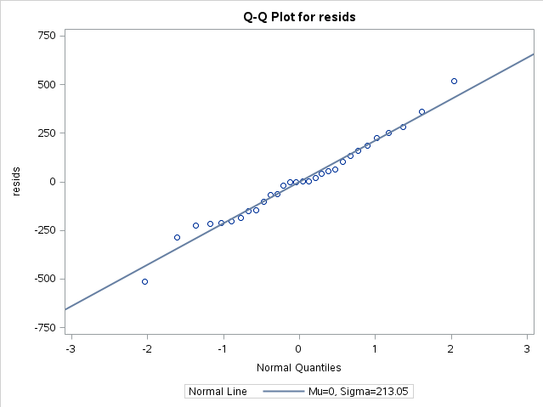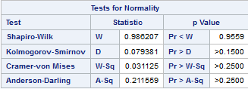

As shown by the QQ plot and the objective normality tests, the data is normal.

c) After taking the log of the raw data, do the treatment means differ from the transformed data?



Since the p-value of the log of the treatment is 0.07, then taking the log of the raw data de-emphasized the difference in the treatments. Therefore, we do not reject H0, since the p-value is larger than 0.05.

d) Using the residuals of the log data, comment on model accuracy.

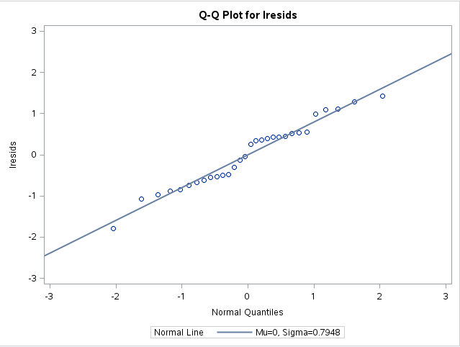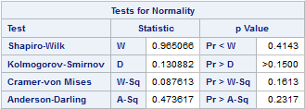

Visually from the QQ plot, it looks like the residuals of the log transformation are slightly different from the line, implying that the model might not be accurate. However, looking at the p-value of the objective table, it looks like the log data is mostly normal, therefore implying that the model is accurate.

**4.16**

Equations needed:

$$\hat{μ}=\overline{y..}=\frac{1435}{20}=71.75$$

$${\hat{τ}}_{i.}=\overline{y_{i.}}-\overline{y_{..}}$$

$${\hat{β}}_{.j}=\overline{y_{.j}}-\overline{y_{..}}$$

|  |  |  |  |
| --- | --- | --- | --- |
| Chemical | ∑ $y_{i.}$ | $$\overline{y_{i.}}$$ | $${\hat{τ}}_{i.}$$ |
| 1 | 353 | 70.6 | -1.15 |
| 2 | 357 | 71.4 | -0.35 |
| 3 | 362 | 72.4 | 0.65 |
| 4 | 363 | 72.6 | 0.85 |

|  |  |  |  |
| --- | --- | --- | --- |
| Bolt | ∑ $y_{.j}$ | $$\overline{y_{.j}}$$ | $${\hat{β}}_{.j}$$ |
| 1 | 294 | 73.5 | 1.75 |
| 2 | 274 | 68.5 | -3.25 |
| 3 | 302 | 75.5 | 3.75 |
| 4 | 291 | 72.75 | -1.0 |
| 5 | 274 | 68.5 | -3.25 |

**4.20**

**4.28**

$${\hat{σ}}_{β}^{2}=\frac{{MS}_{Blocks}-{MS}_{E}}{a}=\frac{102292.395-73130.148}{3}=9720.747$$

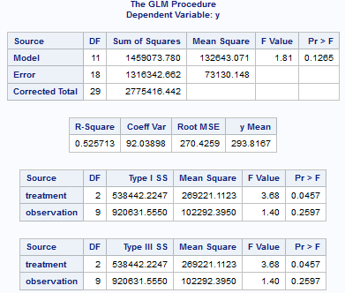

**SAS Code**

**4.12/4.28**

data montgomery412;

input treatment observation y @@;

cards;

1 1 334.5 1 2 31.6 1 3 701 1 4 41.2 1 5 61.2 1 6 69.6 1 7 67.5 1 8 66.6 1 9 120.7 1 10 881.9

2 1 919.4 2 2 404.2 2 3 1024.8 2 4 54.1 2 5 62.8 2 6 671.6 2 7 882.1 2 8 354.2 2 9 321.9 2 10 91.1

3 1 108.4 3 2 26.1 3 3 240.8 3 4 191.1 3 5 69.7 3 6 242.8 3 7 62.7 3 8 396.9 3 9 23.6 3 10 290.4

;

run;

/*ANOVA Analysis*/

proc glm data=montgomery412;

class treatment observation;

model y = treatment observation;

output out=mont412 r=resids p=pred;

run;

/*Normality checking*/

proc univariate data=mont412 normal;

var resids;

qqplot resids / normal (L=1 mu=est sigma=est);

run;

/*taking the log of the data, then ANOVA analysis*/

data logmontgomery412;

set montgomery412;

logy = log(y);

run;

proc glm data=logmontgomery412;

class treatment observation;

model logy = treatment observation;

output out=logmont412 r=lresids p=lpred;

run;

/*Normality checking the log data*/

proc univariate data=logmont412 normal;

var lresids;

qqplot lresids / normal (L=1 mu=est sigma=est)

run;