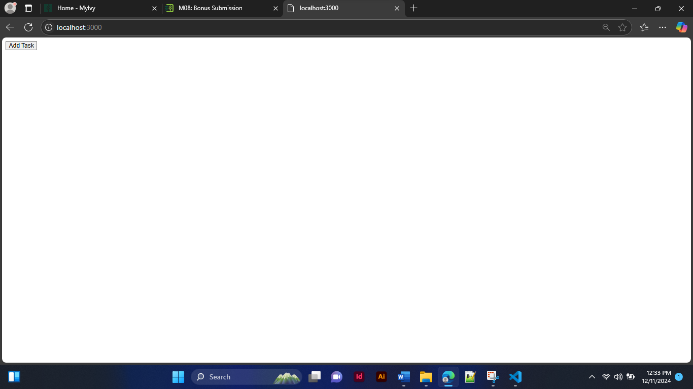Fig 1 – Launching the application

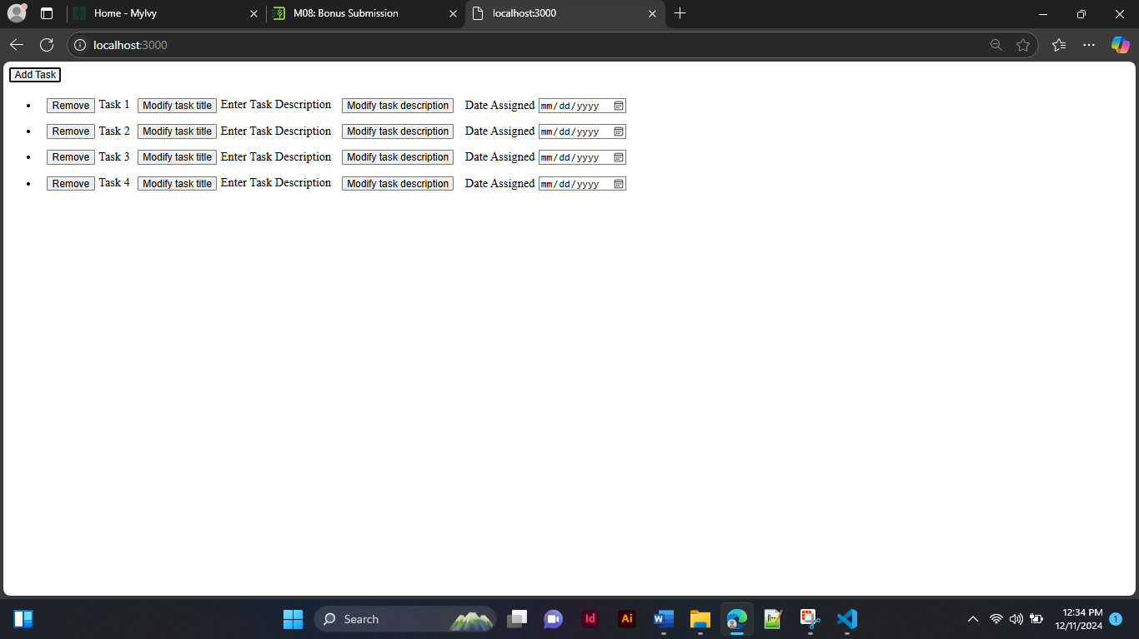  
Fig 2 – After clicking four times on the “Add Task” button

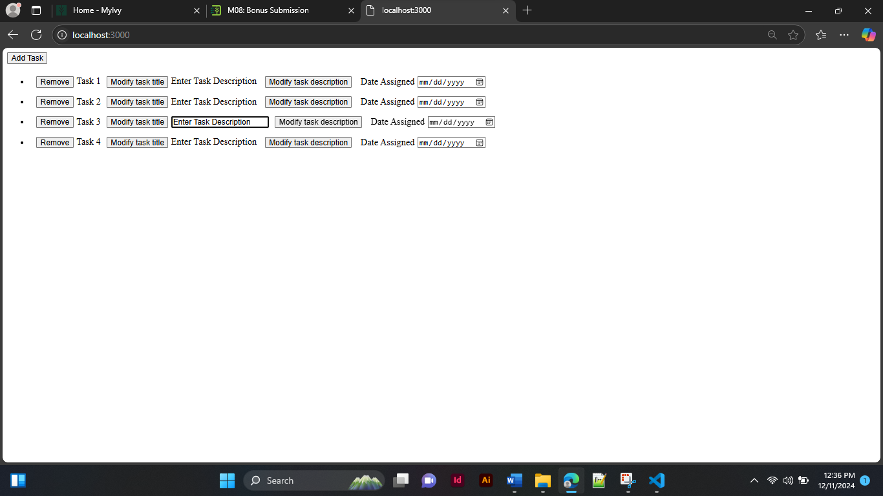

Fig 3 – Modifying the “task description” of the third element

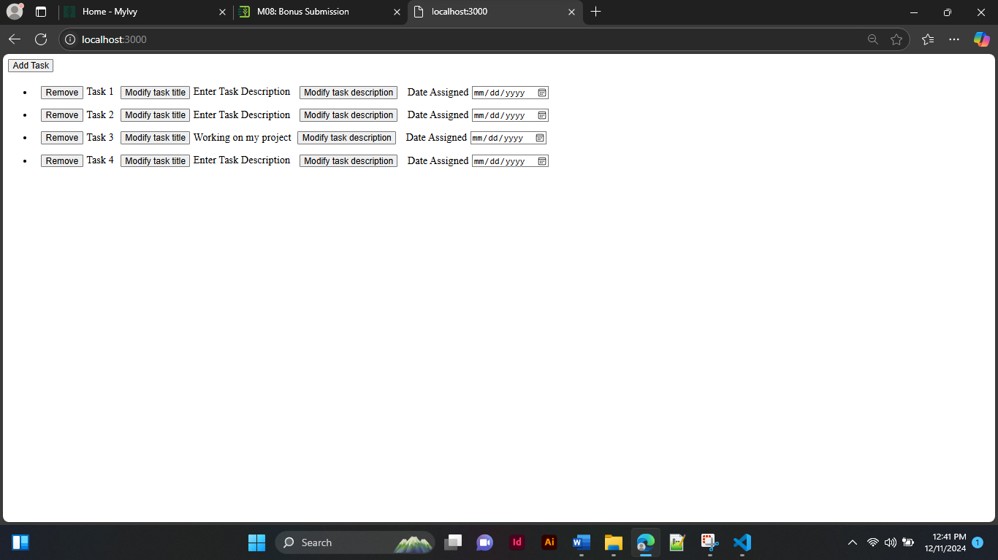  
Fig 4 – After modifying the “task description” of the third element

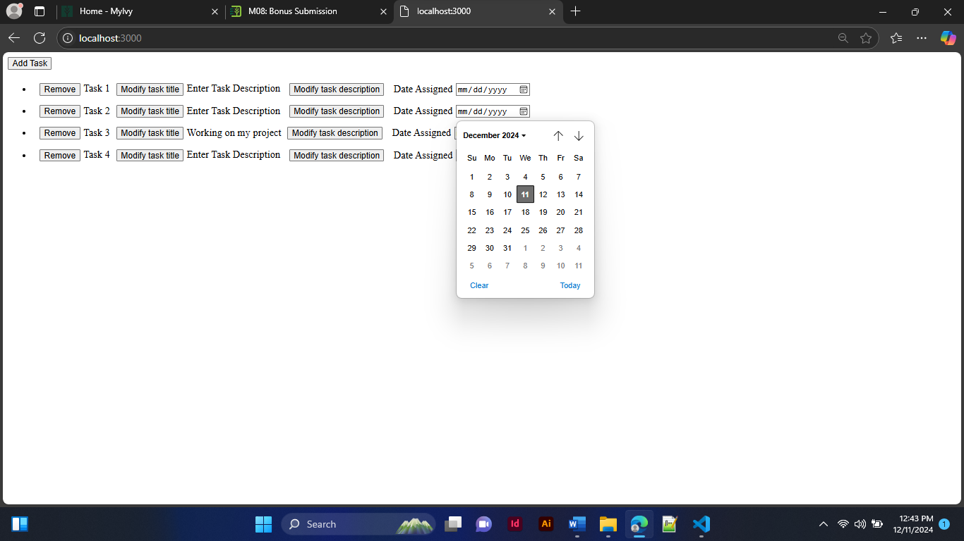  
Fig 5 – Picking a date (second element)

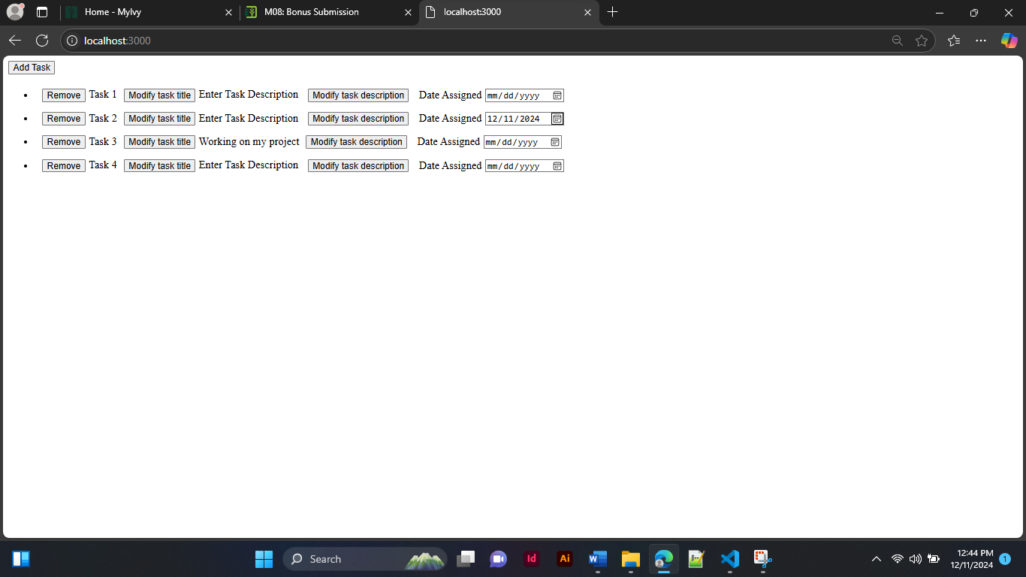  
Fig 6 – After picking a date (second element)

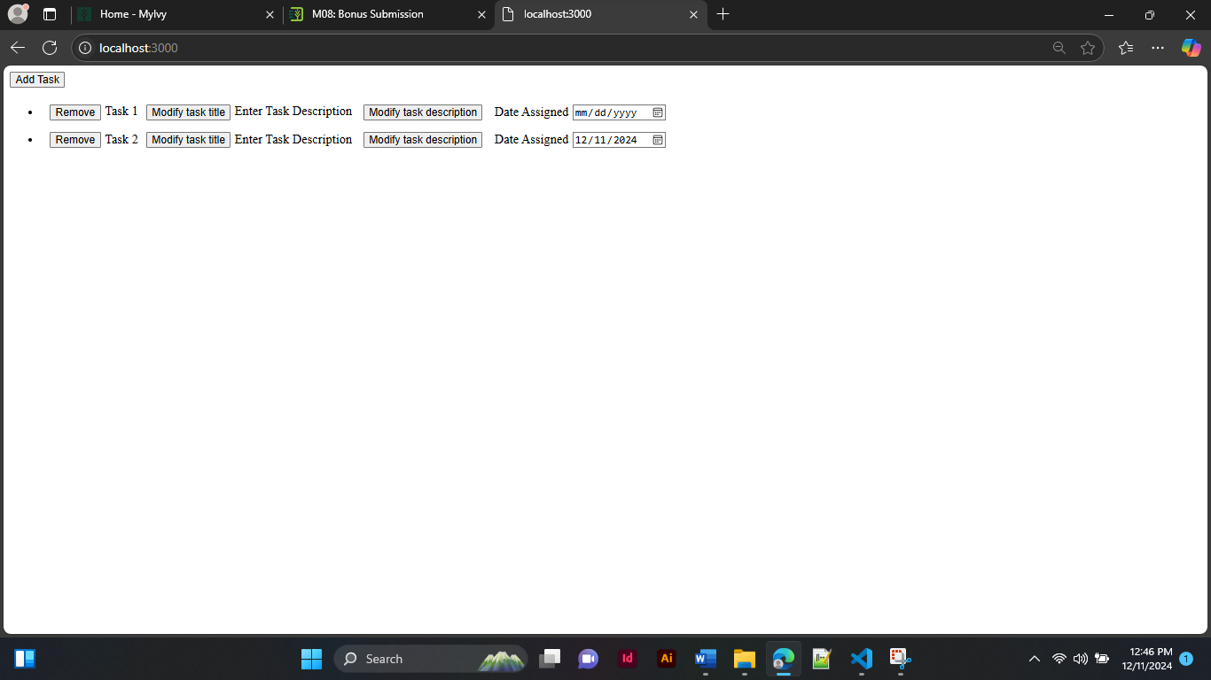  
Fig 7 – After removing 2 elements