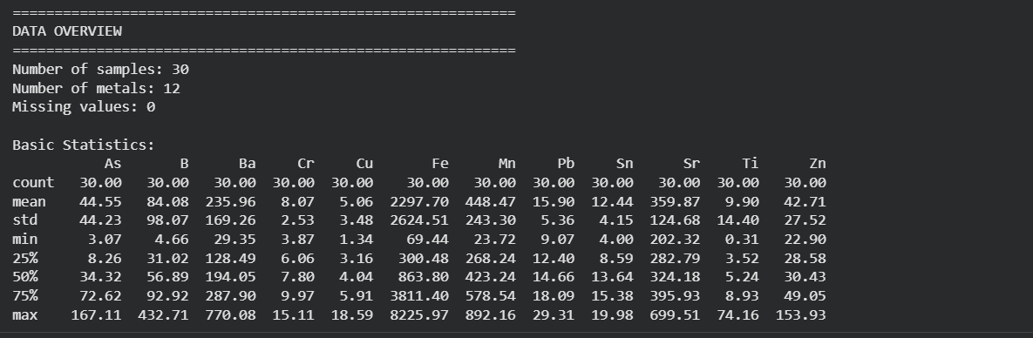
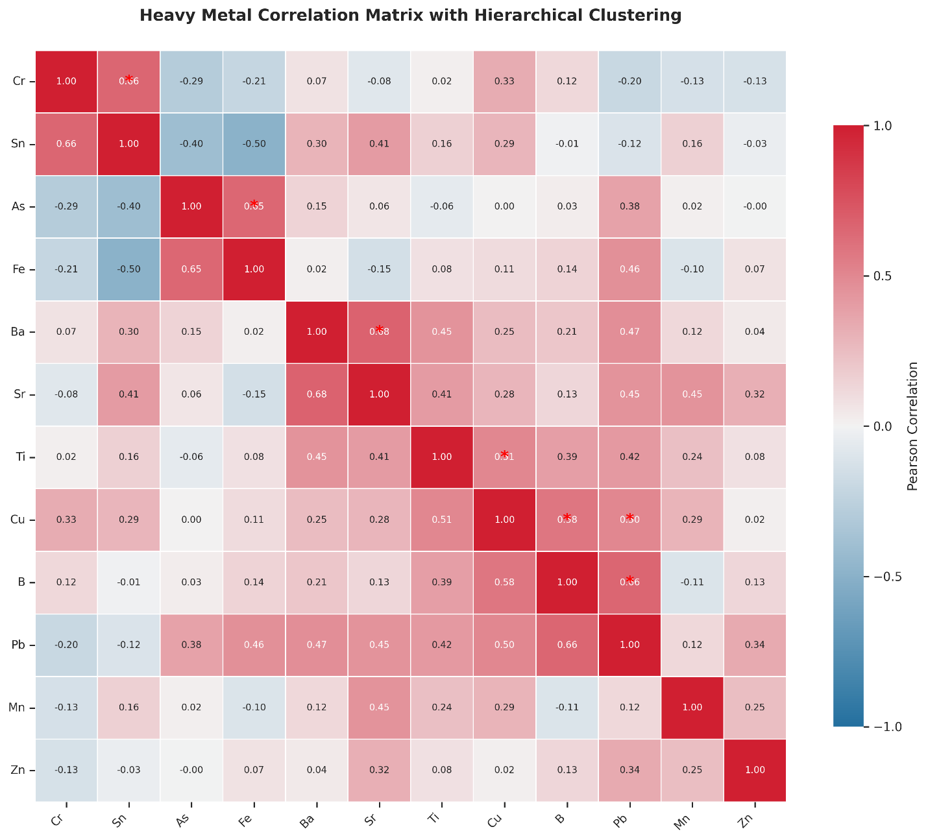
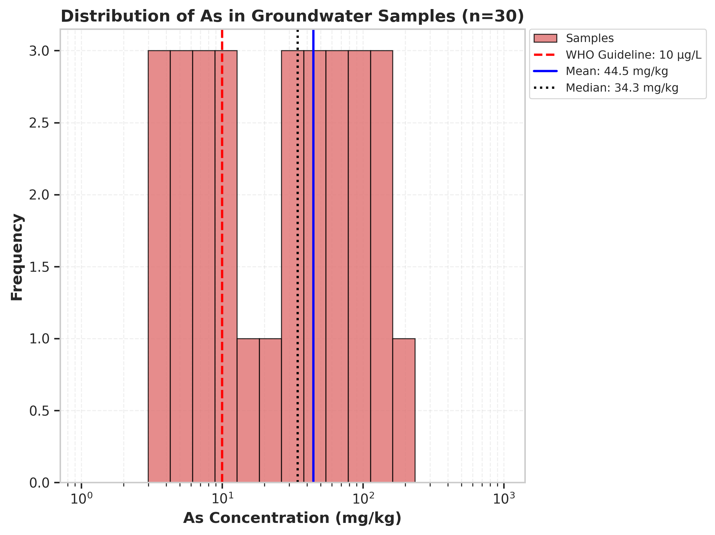

====================================================
STATISTICS FOR As (n=30)
====================================================
Parameter Value
------------------------------------------
Mean (mg/kg) 44.55
Median (mg/kg) 34.31
Standard Deviation (mg/kg) 43.49
Minimum (mg/kg) 3.07
Maximum (mg/kg) 167.11
Exceeding WHO guideline 20 / 30 (66.7%)
====================================================
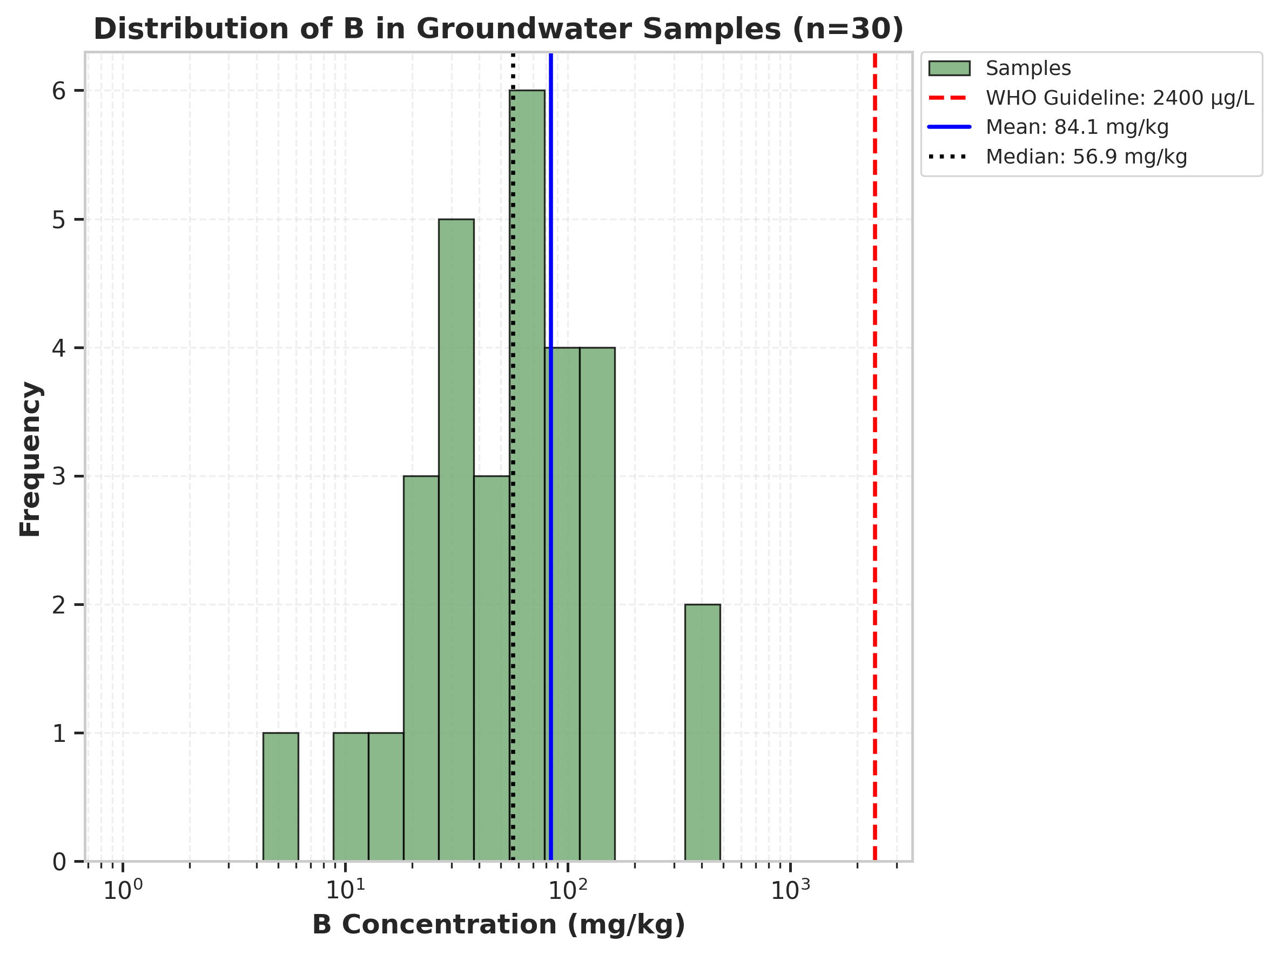

====================================================
STATISTICS FOR B (n=30)
====================================================
Parameter Value
------------------------------------------
Mean (mg/kg) 84.08
Median (mg/kg) 56.89
Standard Deviation (mg/kg) 96.42
Minimum (mg/kg) 4.66
Maximum (mg/kg) 432.71
Exceeding WHO guideline 0 / 30 (0.0%)
====================================================
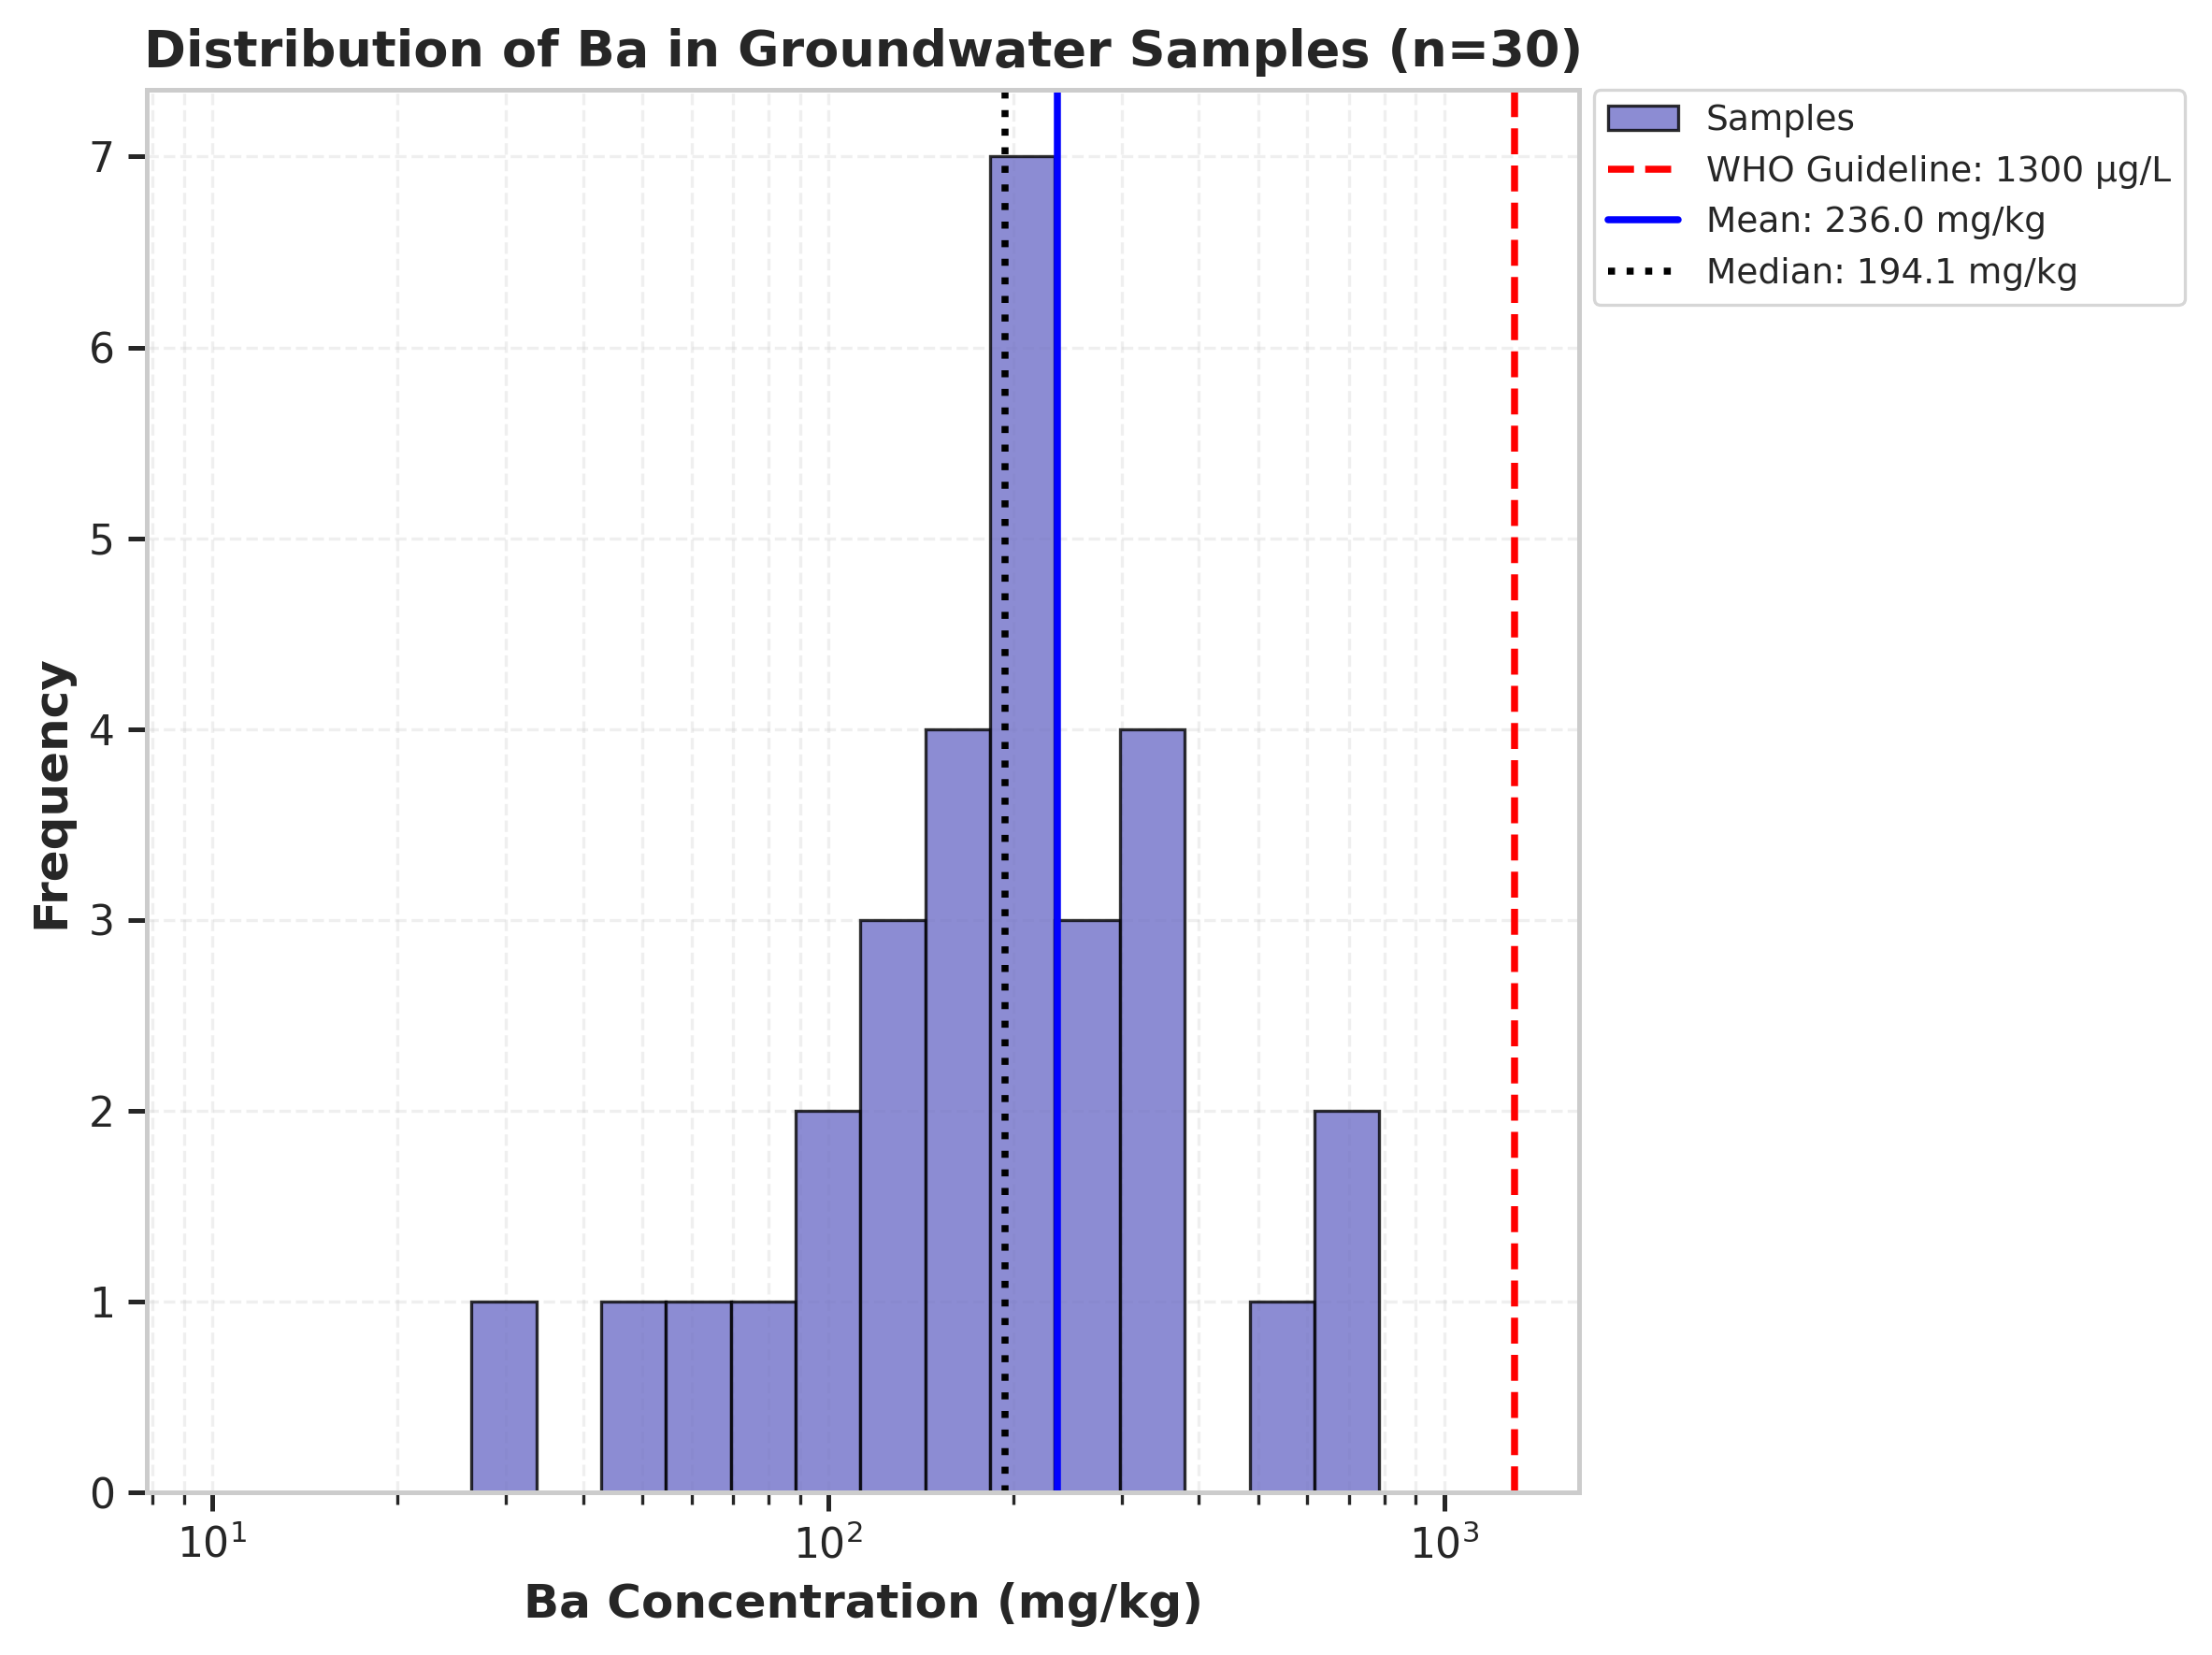

====================================================
STATISTICS FOR Ba (n=30)
====================================================
Parameter Value
------------------------------------------
Mean (mg/kg) 235.96
Median (mg/kg) 194.05
Standard Deviation (mg/kg) 166.41
Minimum (mg/kg) 29.35
Maximum (mg/kg) 770.08
Exceeding WHO guideline 0 / 30 (0.0%)
====================================================
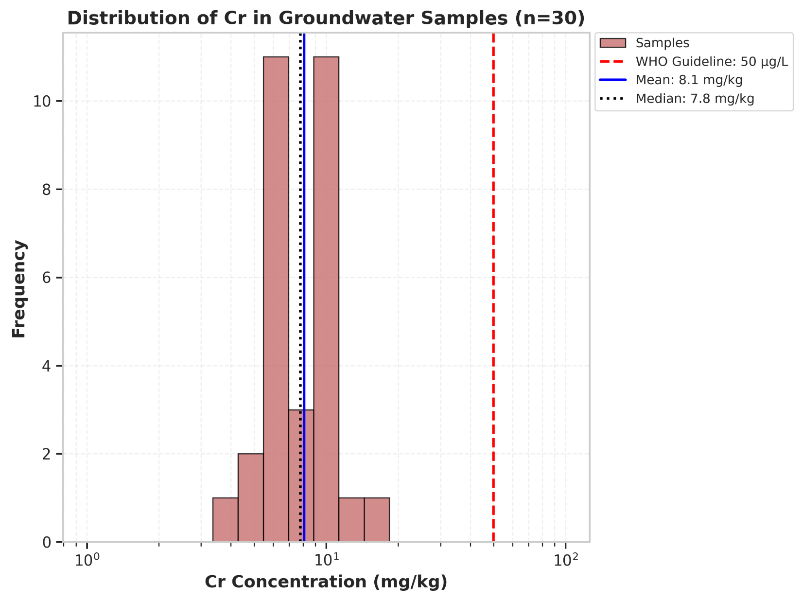

====================================================
STATISTICS FOR Cr (n=30)
====================================================
Parameter Value
------------------------------------------
Mean (mg/kg) 8.07
Median (mg/kg) 7.80
Standard Deviation (mg/kg) 2.48
Minimum (mg/kg) 3.87
Maximum (mg/kg) 15.11
Exceeding WHO guideline 0 / 30 (0.0%)
====================================================
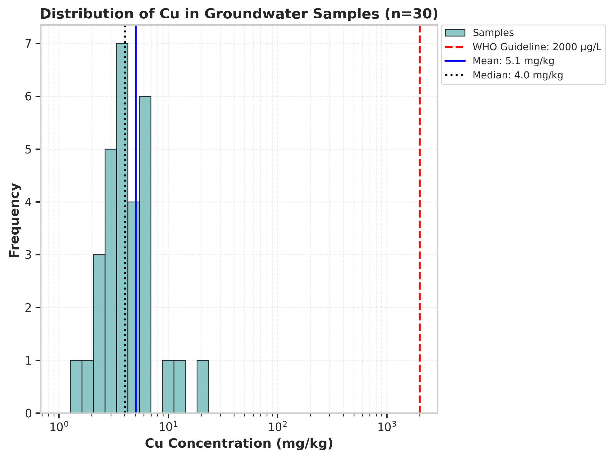

====================================================
STATISTICS FOR Cu (n=30)
====================================================
Parameter Value
------------------------------------------
Mean (mg/kg) 5.06
Median (mg/kg) 4.04
Standard Deviation (mg/kg) 3.42
Minimum (mg/kg) 1.34
Maximum (mg/kg) 18.59
Exceeding WHO guideline 0 / 30 (0.0%)
====================================================
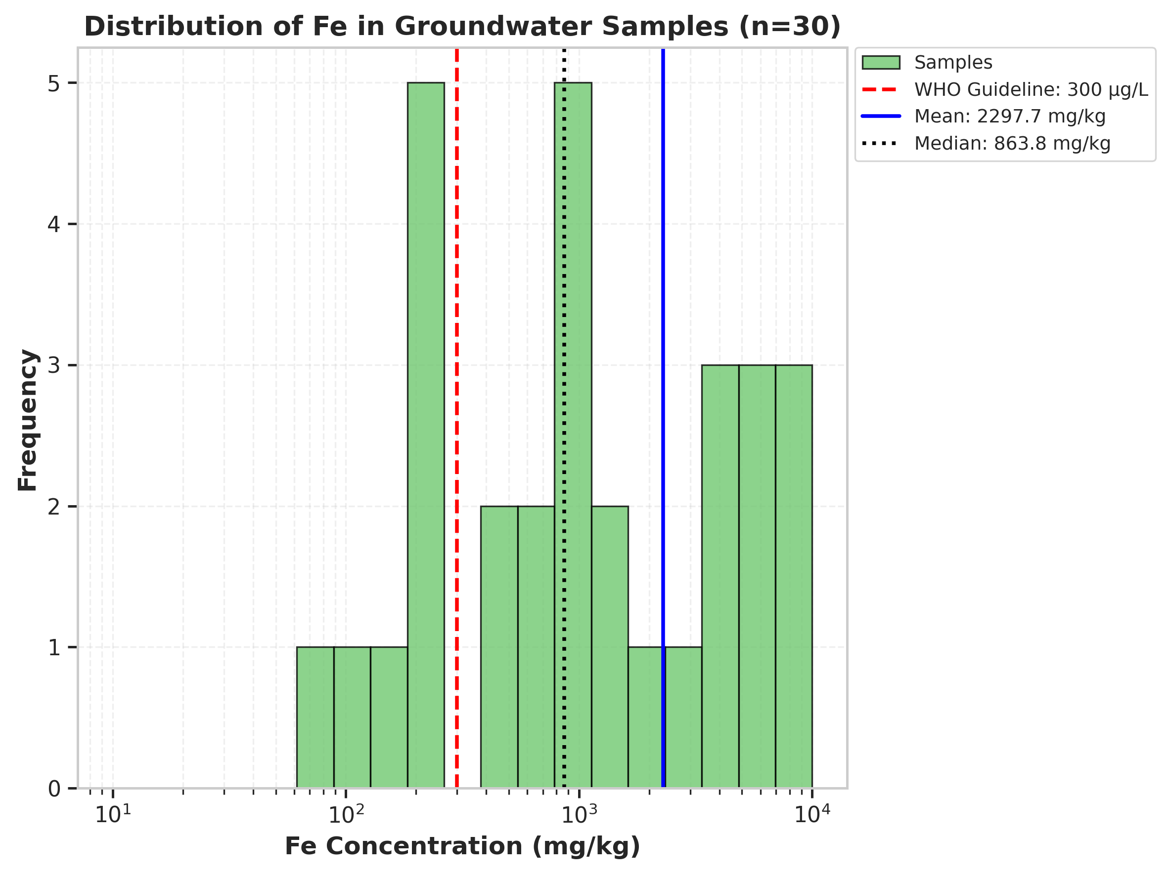

====================================================
STATISTICS FOR Fe (n=30)
====================================================
Parameter Value
------------------------------------------
Mean (mg/kg) 2297.70
Median (mg/kg) 863.80
Standard Deviation (mg/kg) 2580.39
Minimum (mg/kg) 69.44
Maximum (mg/kg) 8225.97
Exceeding WHO guideline 22 / 30 (73.3%)
====================================================
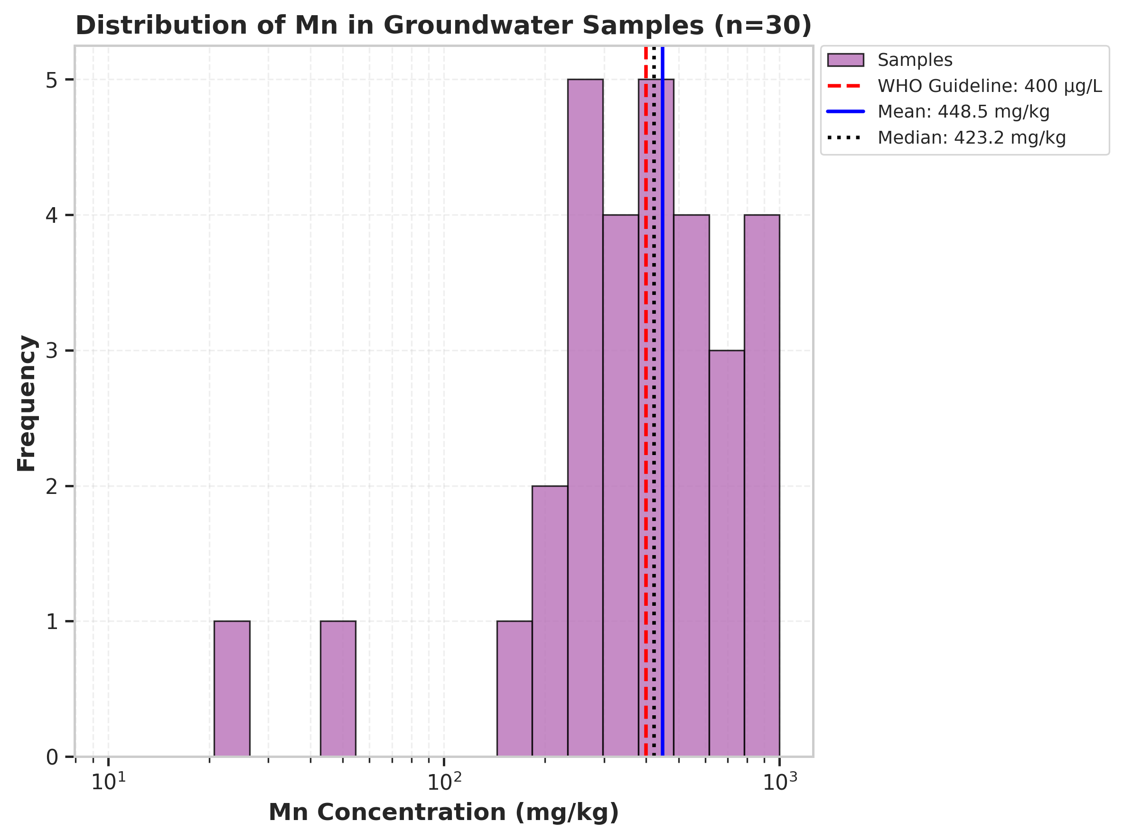

====================================================
STATISTICS FOR Mn (n=30)
====================================================
Parameter Value
------------------------------------------
Mean (mg/kg) 448.47
Median (mg/kg) 423.24
Standard Deviation (mg/kg) 239.21
Minimum (mg/kg) 23.72
Maximum (mg/kg) 892.16
Exceeding WHO guideline 16 / 30 (53.3%)
====================================================
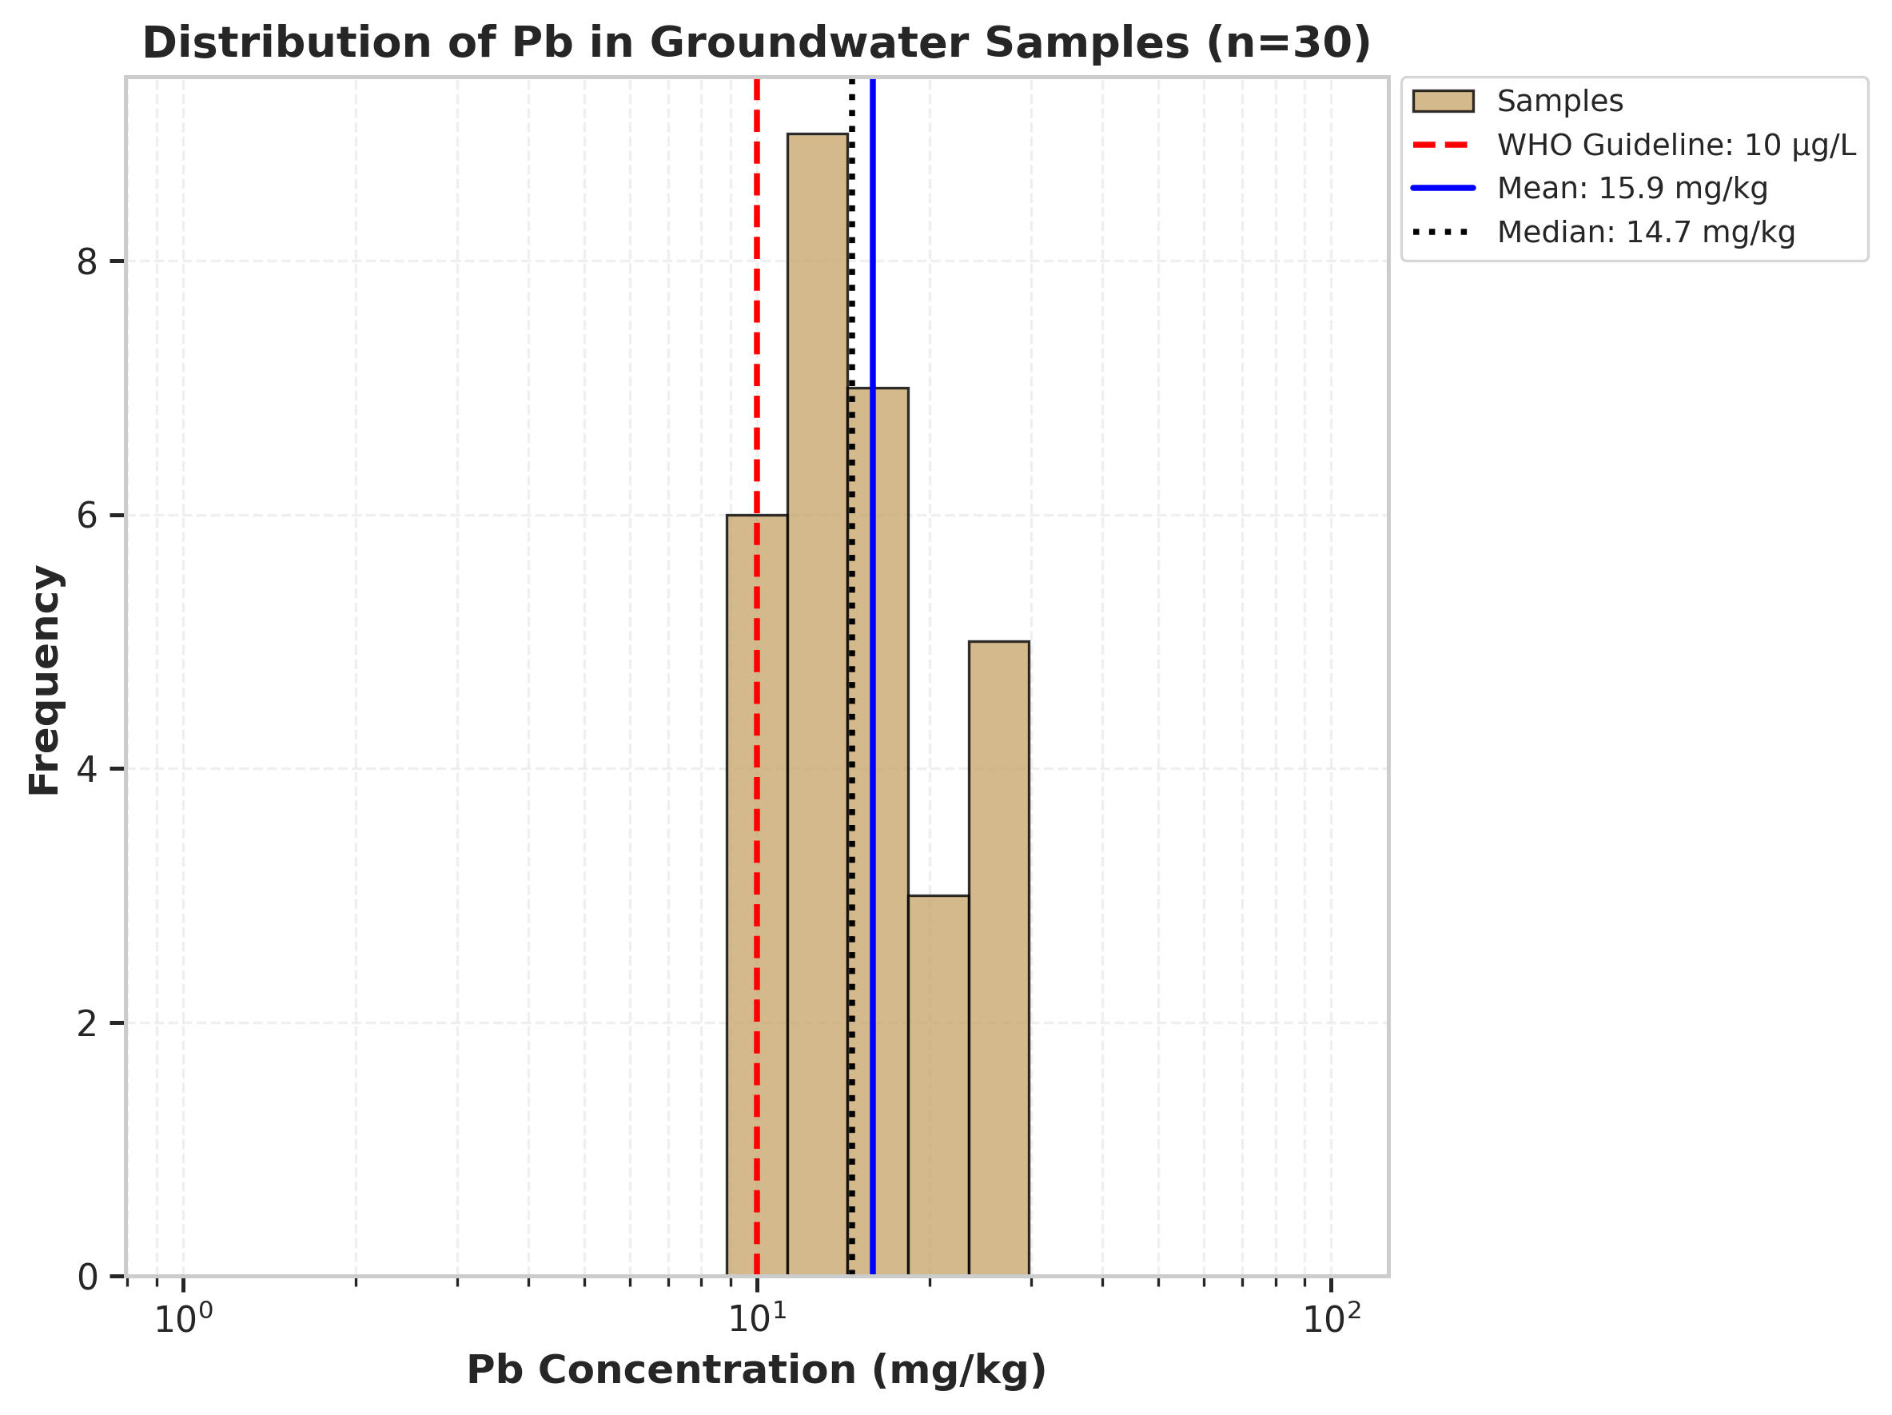

====================================================
STATISTICS FOR Pb (n=30)
====================================================
Parameter Value
------------------------------------------
Mean (mg/kg) 15.90
Median (mg/kg) 14.66
Standard Deviation (mg/kg) 5.27
Minimum (mg/kg) 9.07
Maximum (mg/kg) 29.31
Exceeding WHO guideline 26 / 30 (86.7%)
====================================================
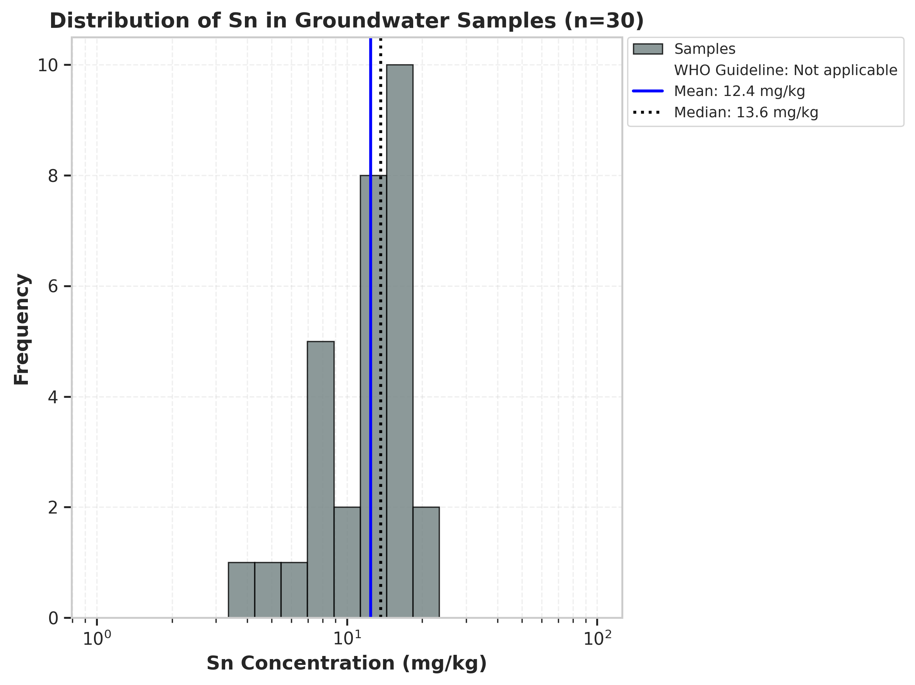

====================================================
STATISTICS FOR Sn (n=30)
====================================================
Parameter Value
------------------------------------------
Mean (mg/kg) 12.44
Median (mg/kg) 13.63
Standard Deviation (mg/kg) 4.08
Minimum (mg/kg) 4.00
Maximum (mg/kg) 19.98
WHO Guideline Not applicable
====================================================
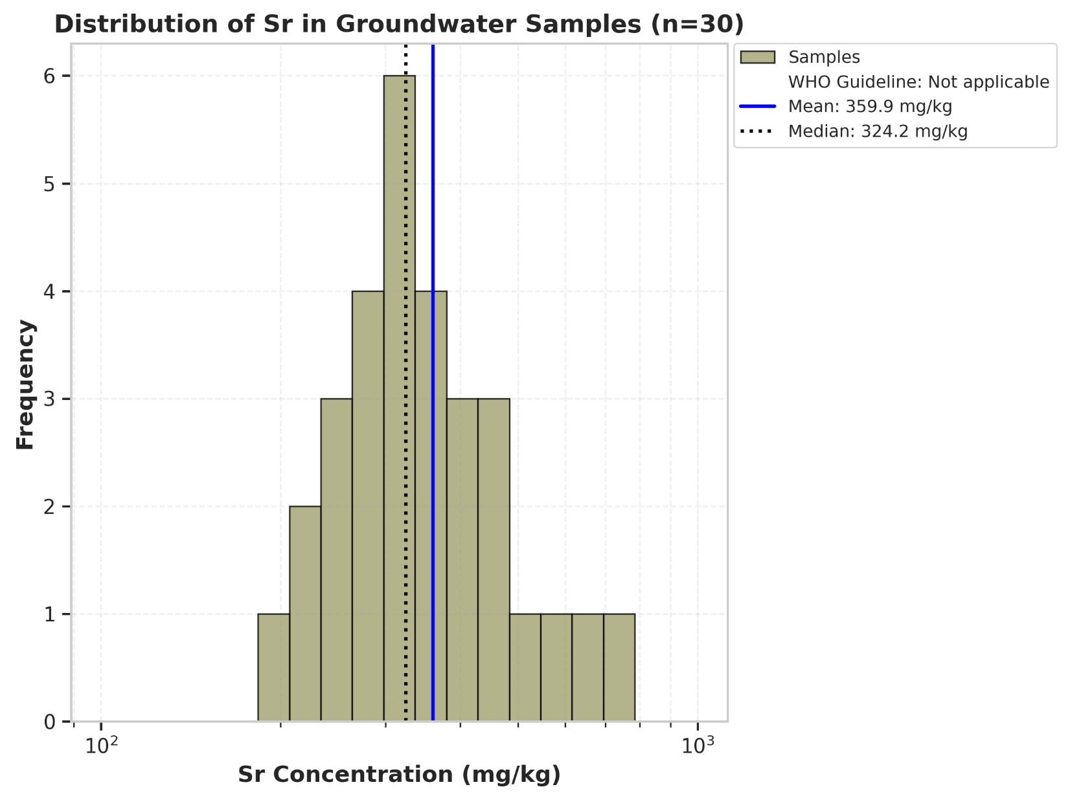

====================================================
STATISTICS FOR Sr (n=30)
====================================================
Parameter Value
------------------------------------------
Mean (mg/kg) 359.87
Median (mg/kg) 324.19
Standard Deviation (mg/kg) 122.59
Minimum (mg/kg) 202.32
Maximum (mg/kg) 699.51
WHO Guideline Not applicable
====================================================
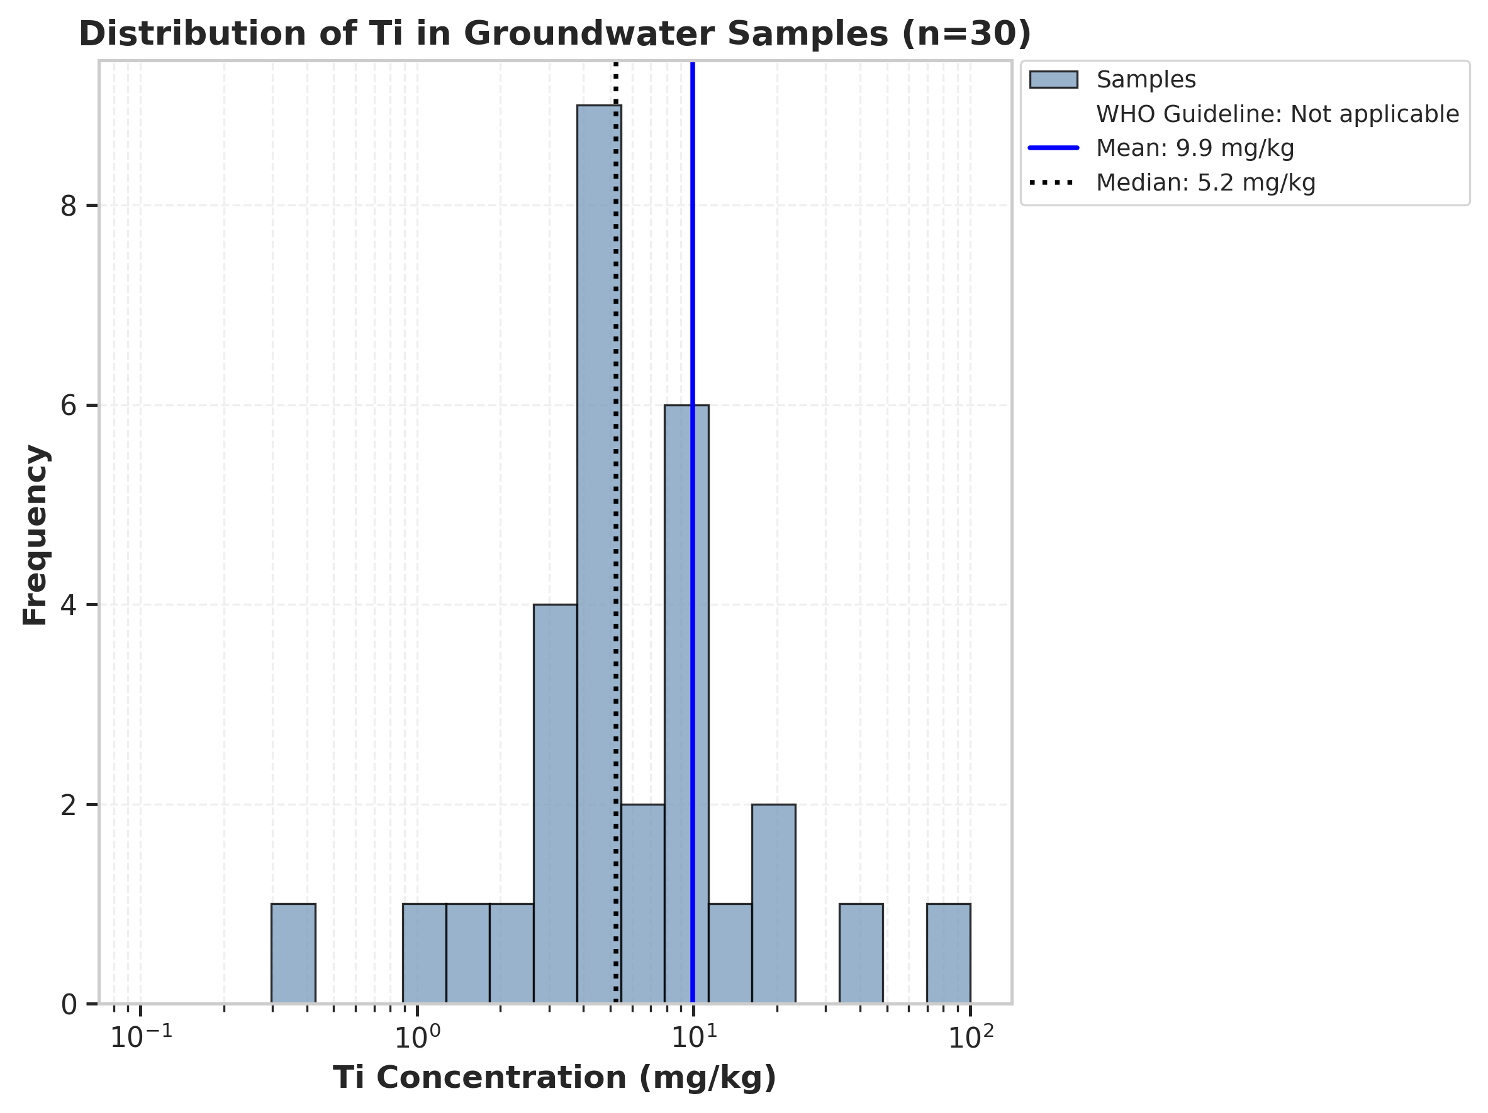

====================================================
STATISTICS FOR Ti (n=30)
====================================================
Parameter Value
------------------------------------------
Mean (mg/kg) 9.90
Median (mg/kg) 5.24
Standard Deviation (mg/kg) 14.16
Minimum (mg/kg) 0.31
Maximum (mg/kg) 74.16
WHO Guideline Not applicable
====================================================
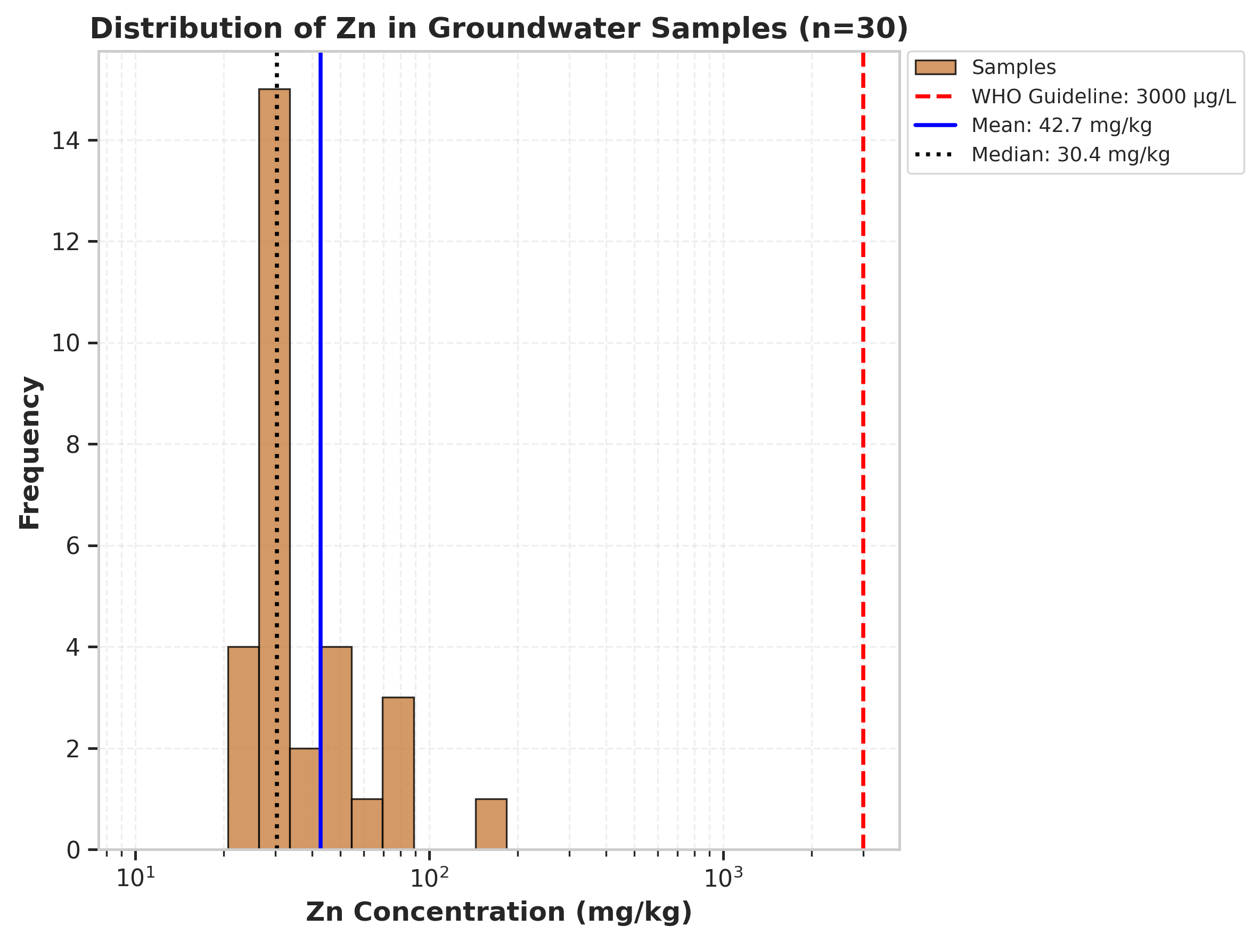

====================================================
STATISTICS FOR Zn (n=30)
====================================================
Parameter Value
------------------------------------------
Mean (mg/kg) 42.71
Median (mg/kg) 30.43
Standard Deviation (mg/kg) 27.05
Minimum (mg/kg) 22.90
Maximum (mg/kg) 153.93
Exceeding WHO guideline 0 / 30 (0.0%)
====================================================

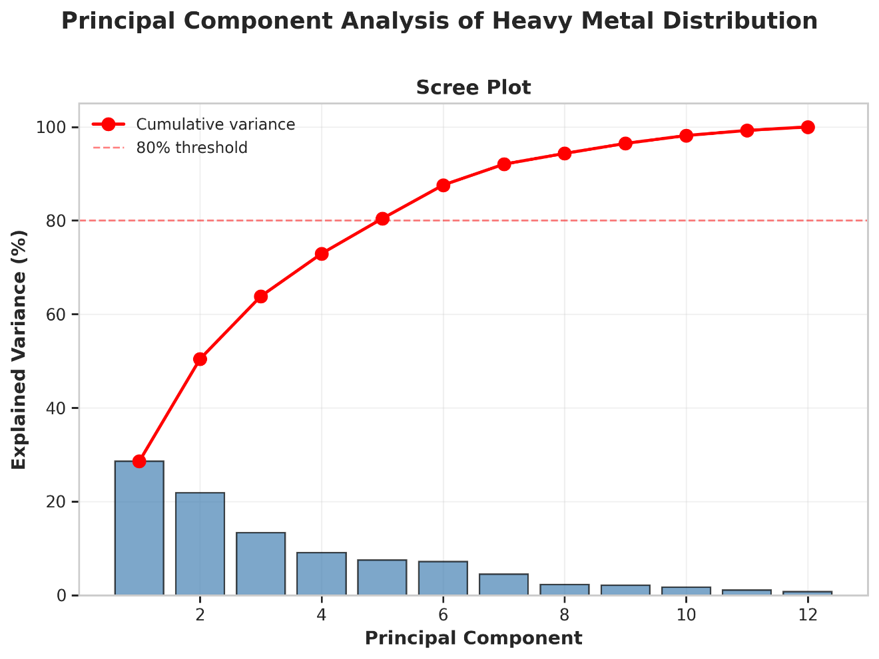
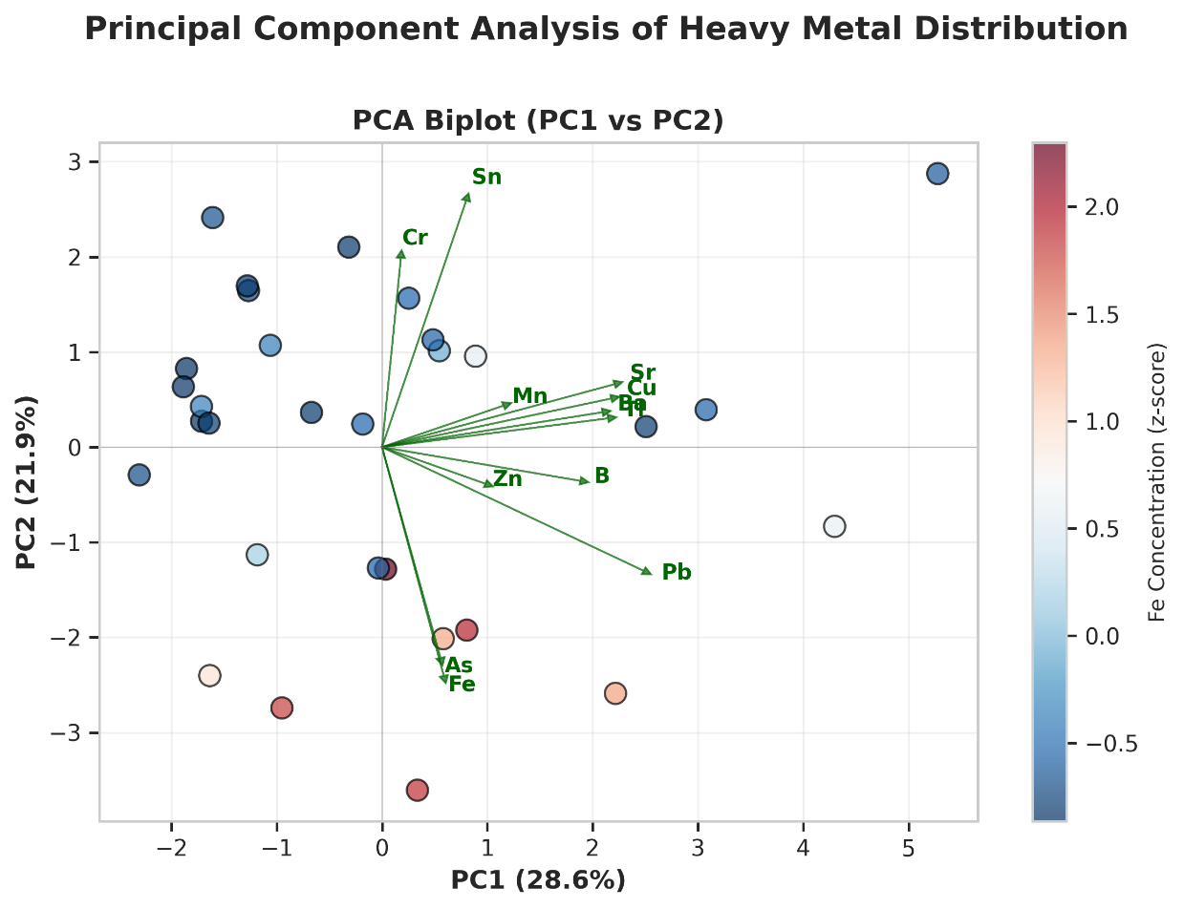

============================================================
PCA RESULTS
============================================================
PC1 variance: 28.58%
PC2 variance: 21.87%
Cumulative variance (first 3 PCs): 63.84%

Top 3 loadings for PC1:
Metal Loading
7 Pb 0.828
9 Sr 0.736
4 Cu 0.725
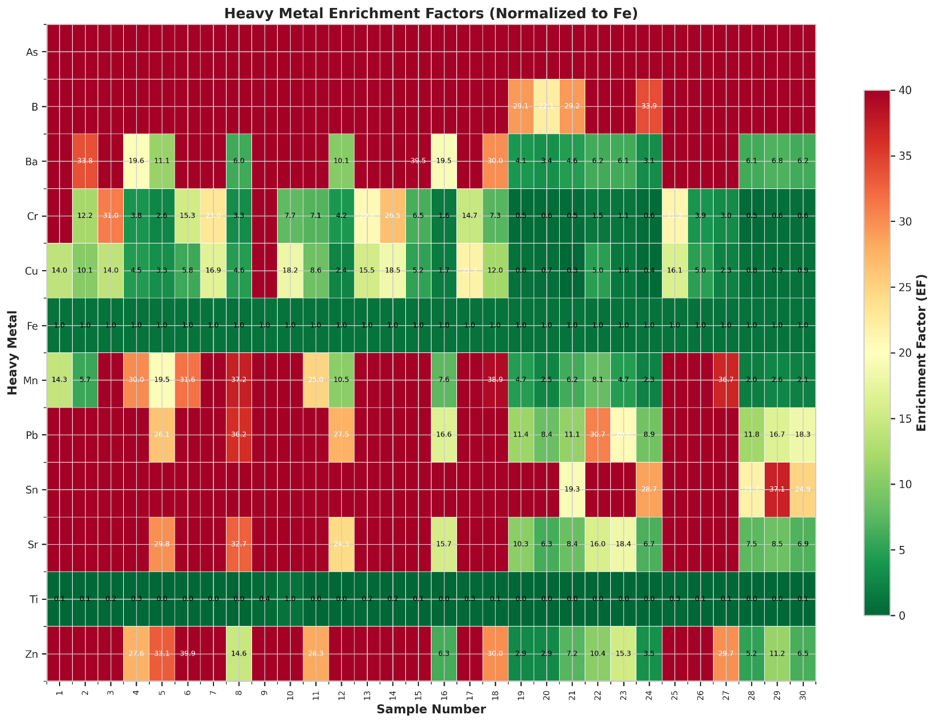

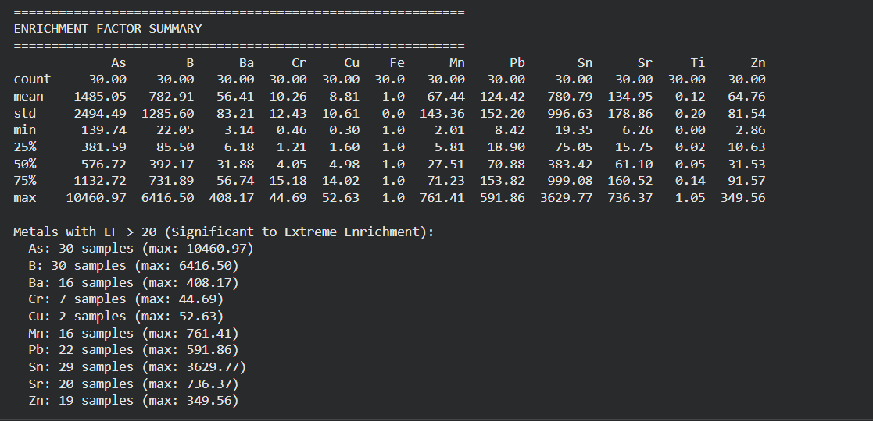
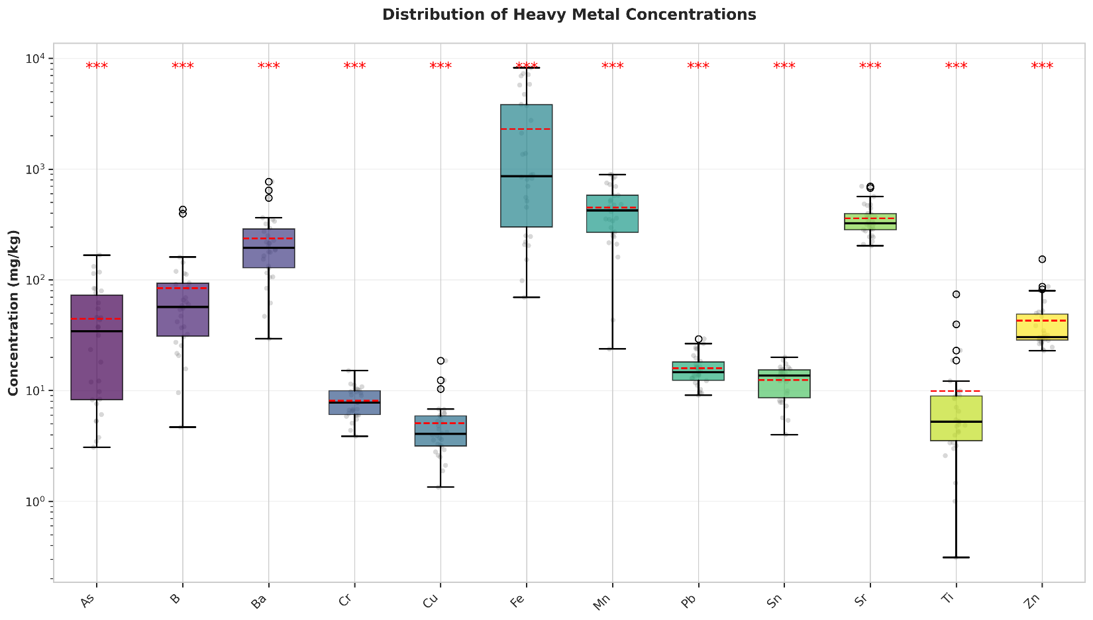
============================================================
STATISTICAL SUMMARY
============================================================

As:
Mean ± SD: 44.55 ± 44.23
Median (IQR): 34.31 (8.27 - 72.62)
CV: 99.3%

B:
Mean ± SD: 84.08 ± 98.07
Median (IQR): 56.89 (31.02 - 92.91)
CV: 116.6%

Ba:
Mean ± SD: 235.96 ± 169.26
Median (IQR): 194.05 (128.49 - 287.90)
CV: 71.7%

Cr:
Mean ± SD: 8.07 ± 2.53
Median (IQR): 7.80 (6.06 - 9.97)
CV: 31.3%

Cu:
Mean ± SD: 5.06 ± 3.48
Median (IQR): 4.04 (3.16 - 5.91)
CV: 68.8%

Fe:
Mean ± SD: 2297.70 ± 2624.51
Median (IQR): 863.80 (300.48 - 3811.40)
CV: 114.2%

Mn:
Mean ± SD: 448.47 ± 243.30
Median (IQR): 423.24 (268.24 - 578.54)
CV: 54.3%

Pb:
Mean ± SD: 15.90 ± 5.36
Median (IQR): 14.66 (12.40 - 18.09)
CV: 33.7%

Sn:
Mean ± SD: 12.44 ± 4.15
Median (IQR): 13.63 (8.59 - 15.38)
CV: 33.3%

Sr:
Mean ± SD: 359.87 ± 124.68
Median (IQR): 324.19 (282.79 - 395.93)
CV: 34.6%

Ti:
Mean ± SD: 9.90 ± 14.40
Median (IQR): 5.24 (3.52 - 8.93)
CV: 145.4%

Zn:
Mean ± SD: 42.71 ± 27.52
Median (IQR): 30.43 (28.58 - 49.05)
CV: 64.4%
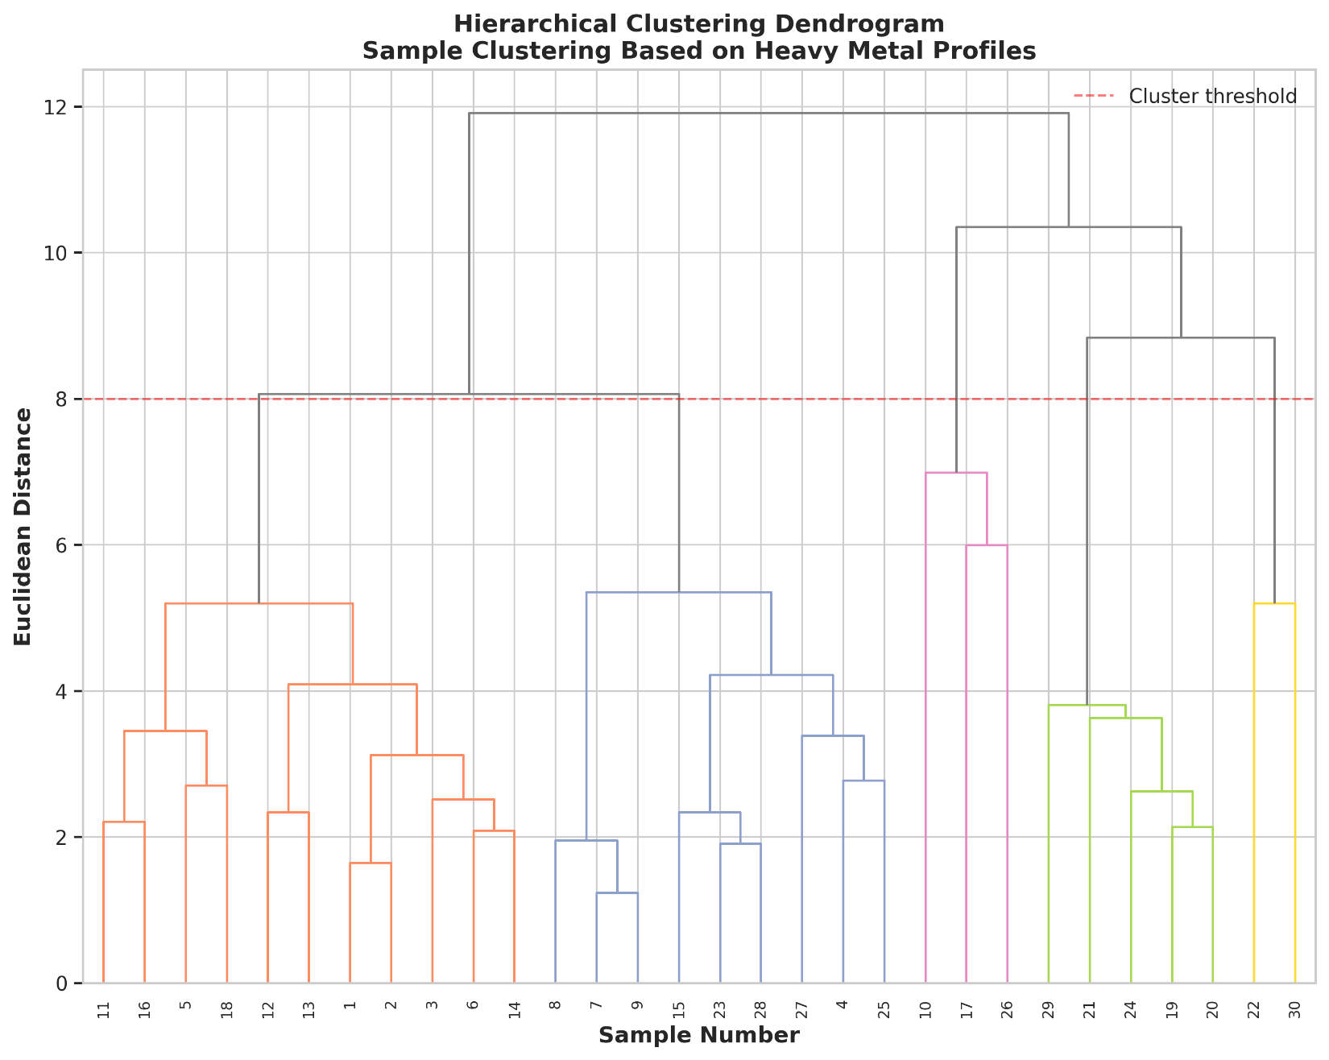
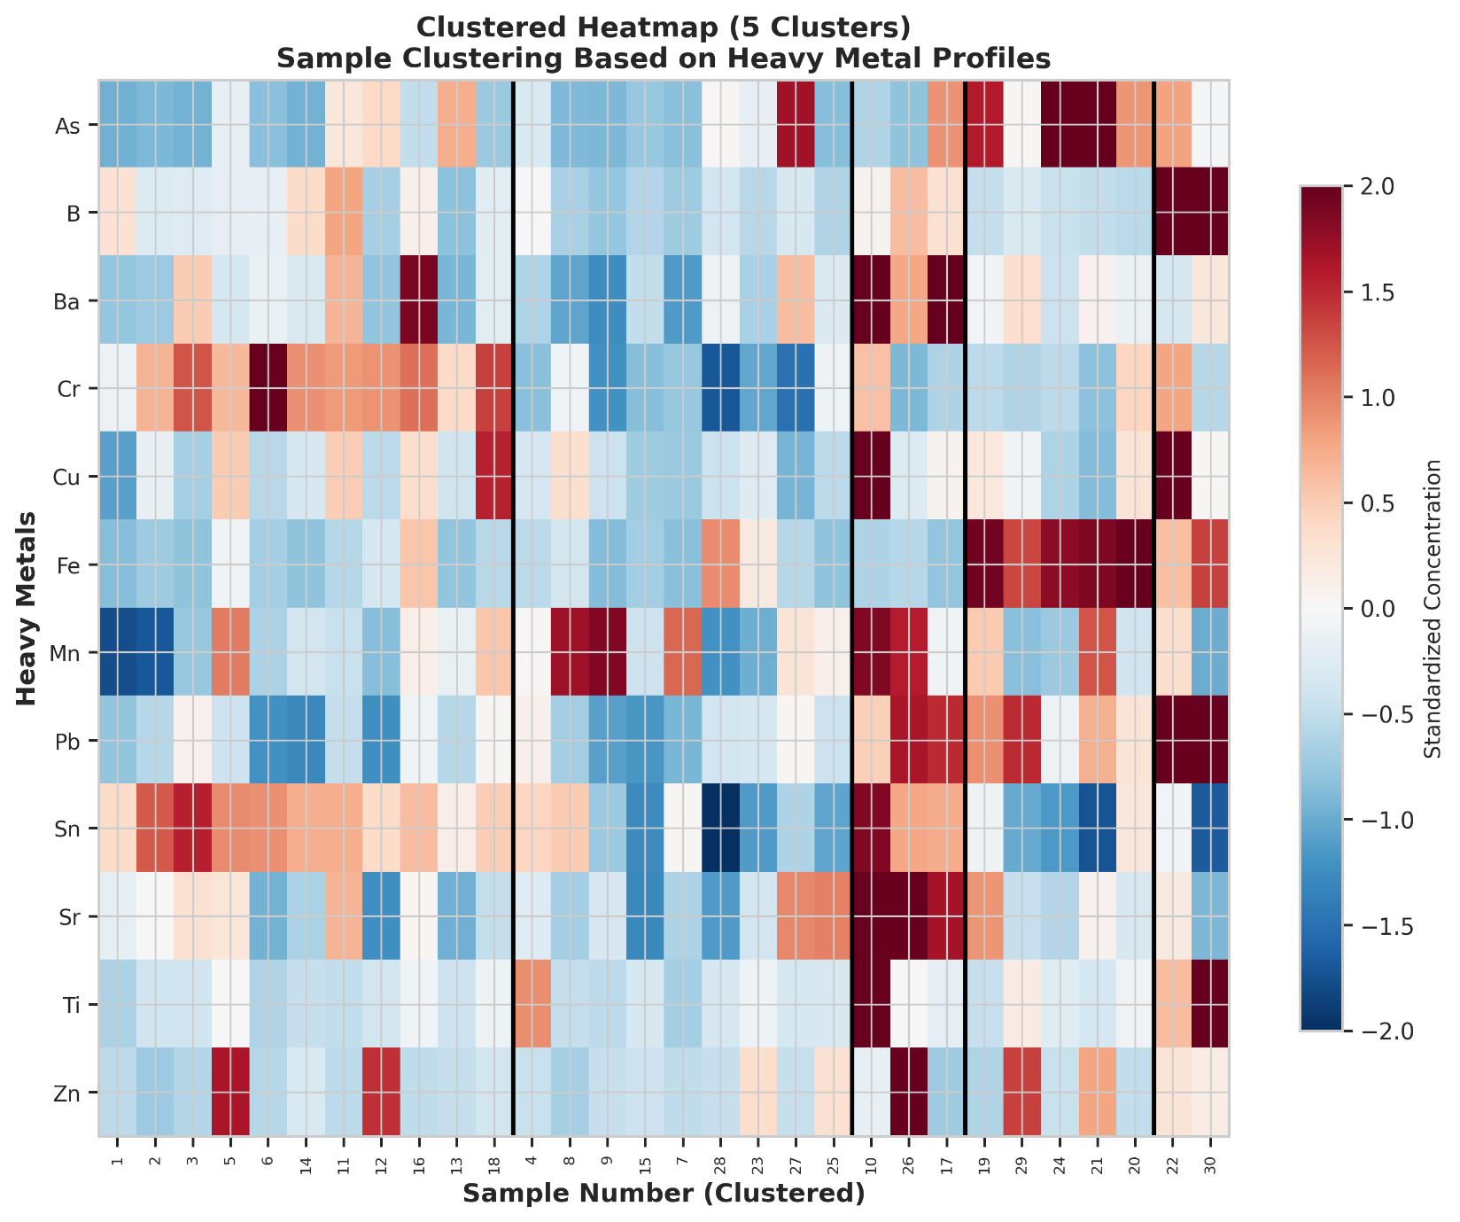

============================================================
CLUSTER ANALYSIS
============================================================
Number of clusters identified: 5
Cluster composition:
Cluster 1: 11 samples
Samples: 1, 2, 3, 5, 6...
Characterized by high: Fe(972.4), Mn(340.3), Sr(324.6)

Cluster 2: 9 samples
Samples: 4, 7, 8, 9, 15...
Characterized by high: Fe(1277.2), Mn(514.7), Sr(322.9)

Cluster 3: 3 samples
Samples: 10, 17, 26
Characterized by high: Mn(716.1), Sr(646.2), Fe(597.7)

Cluster 4: 5 samples
Samples: 19, 20, 21, 24, 29
Characterized by high: Fe(7057.7), Mn(439.1), Sr(349.8)

Cluster 5: 2 samples
Samples: 22, 30
Characterized by high: Fe(4828.9), B(414.0), Mn(367.3)
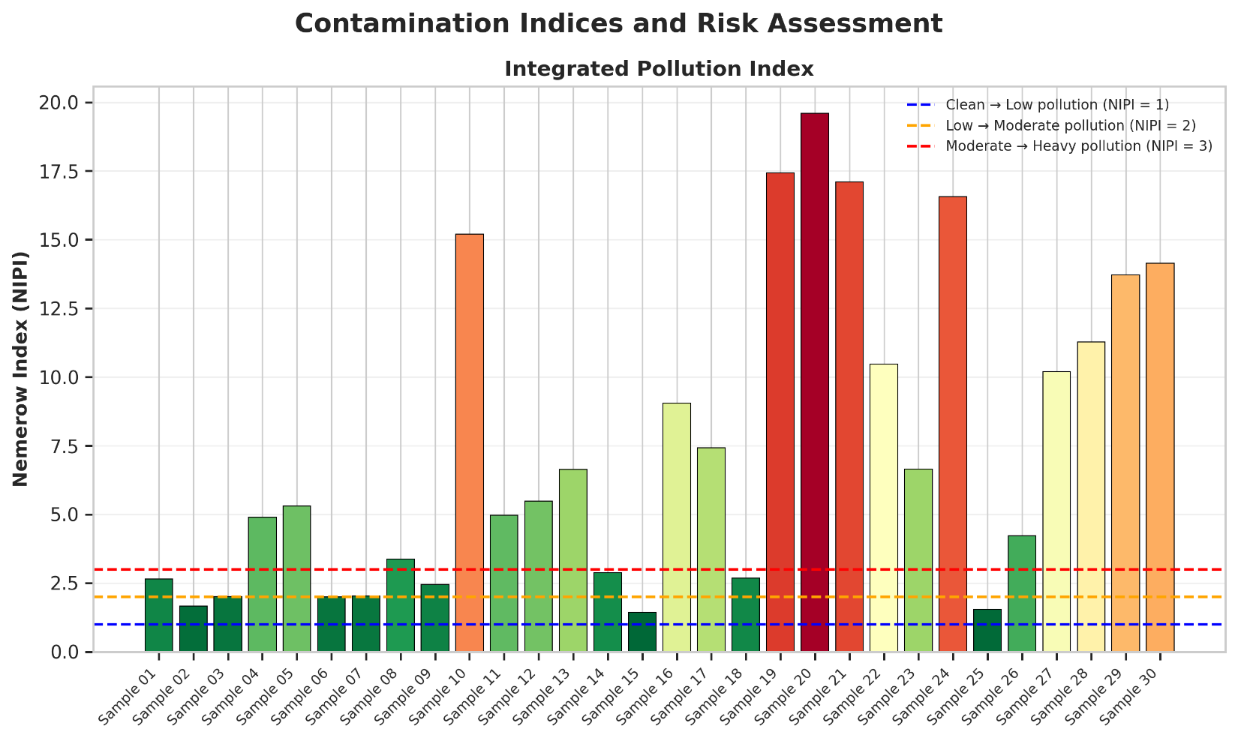
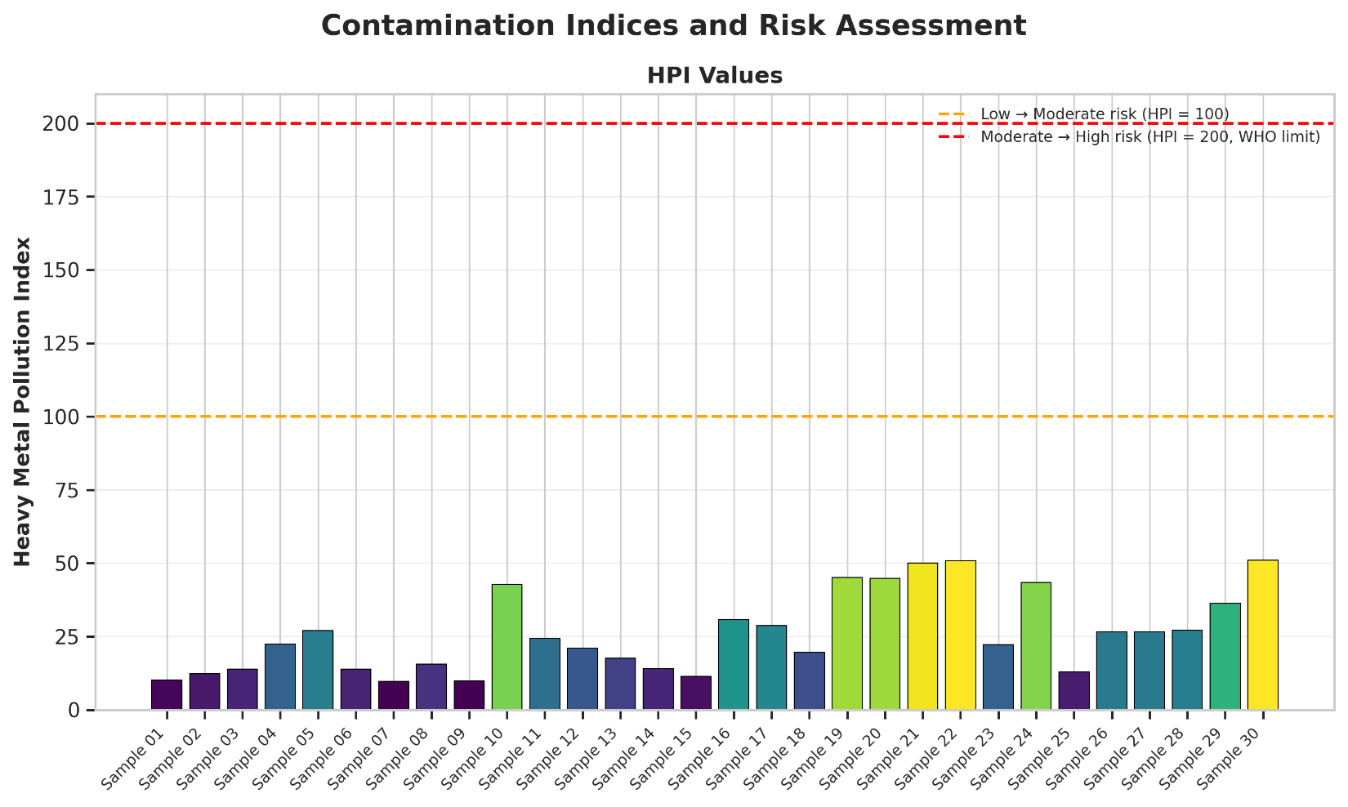
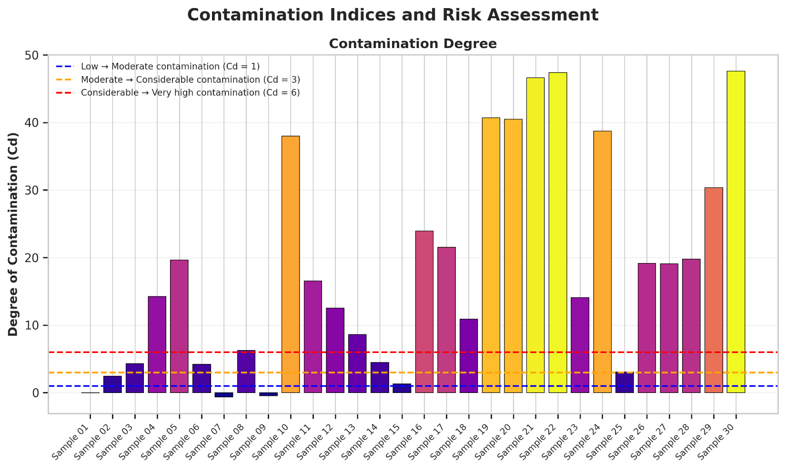
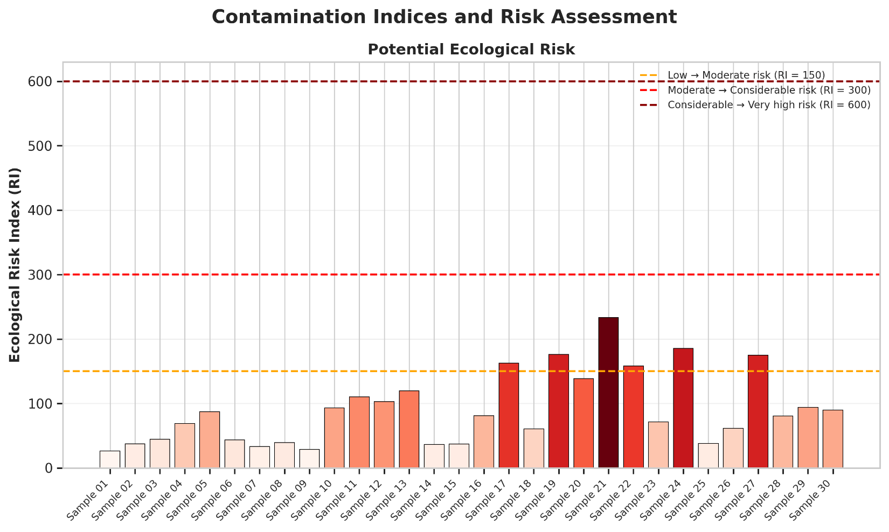

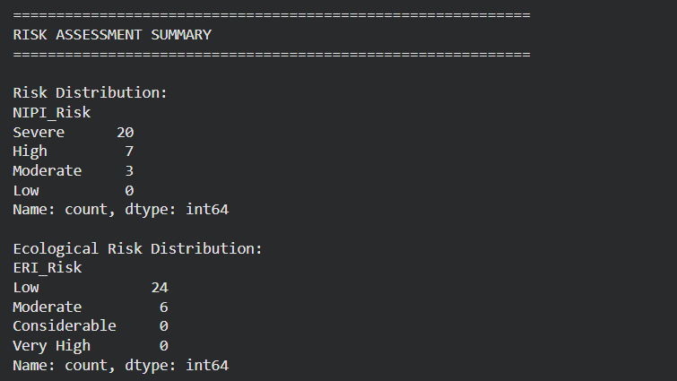
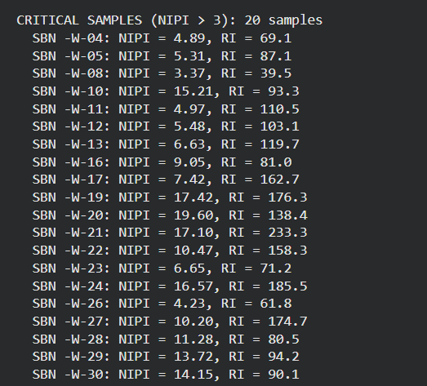
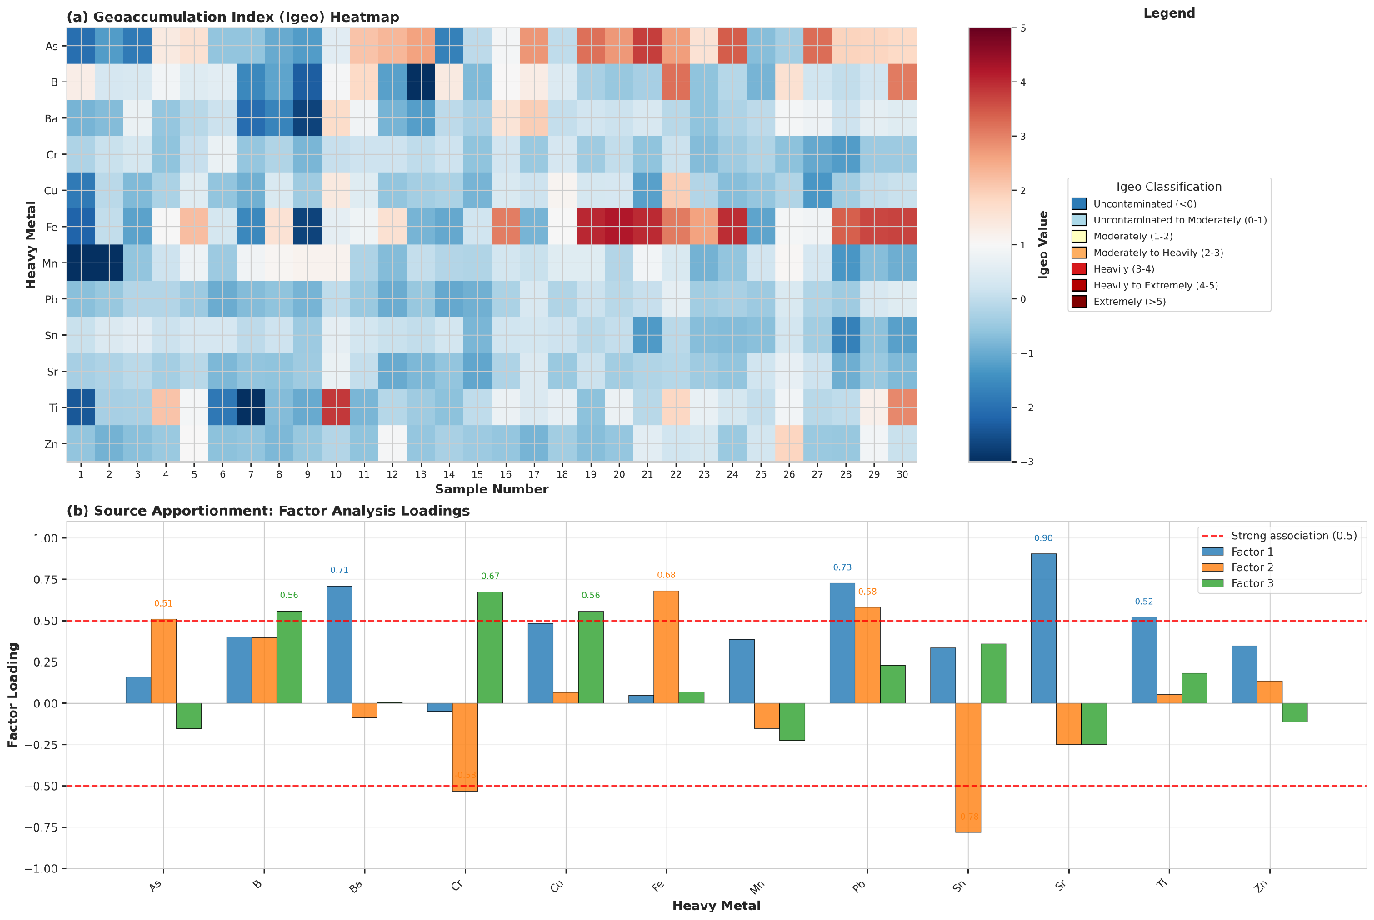
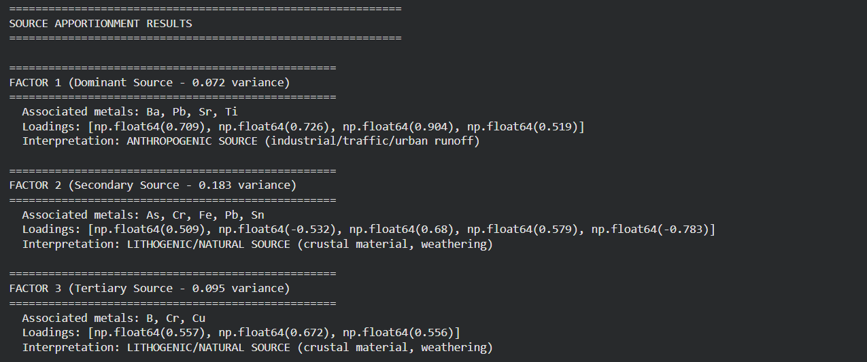
SPATIAL PATTERN ANALYSIS (Using PCA-based ordering)
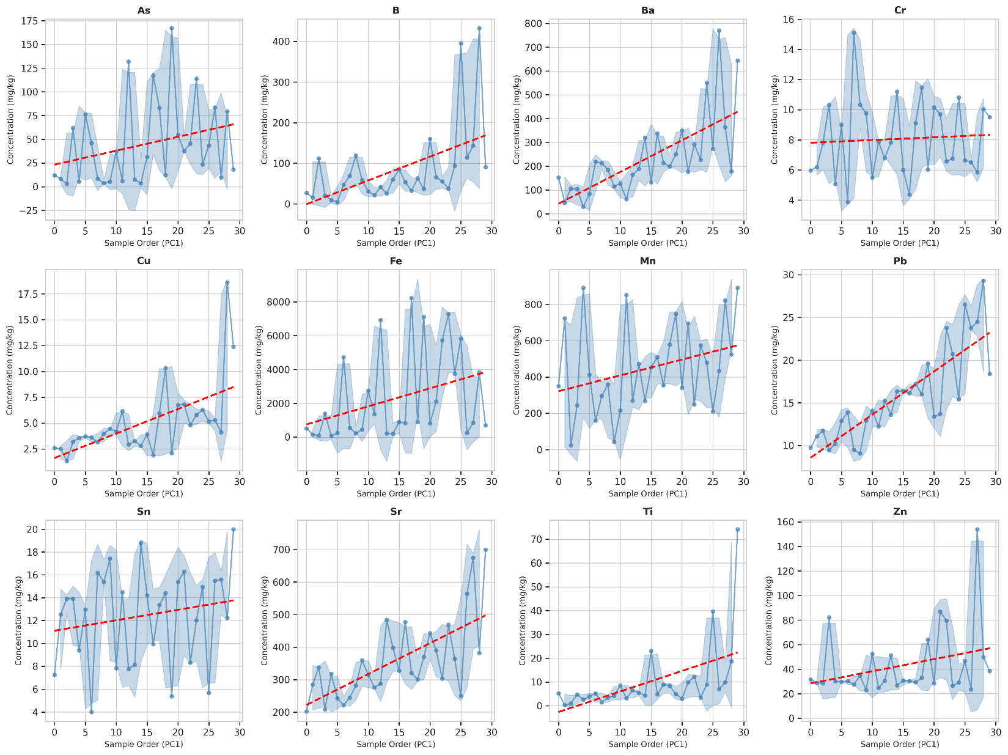
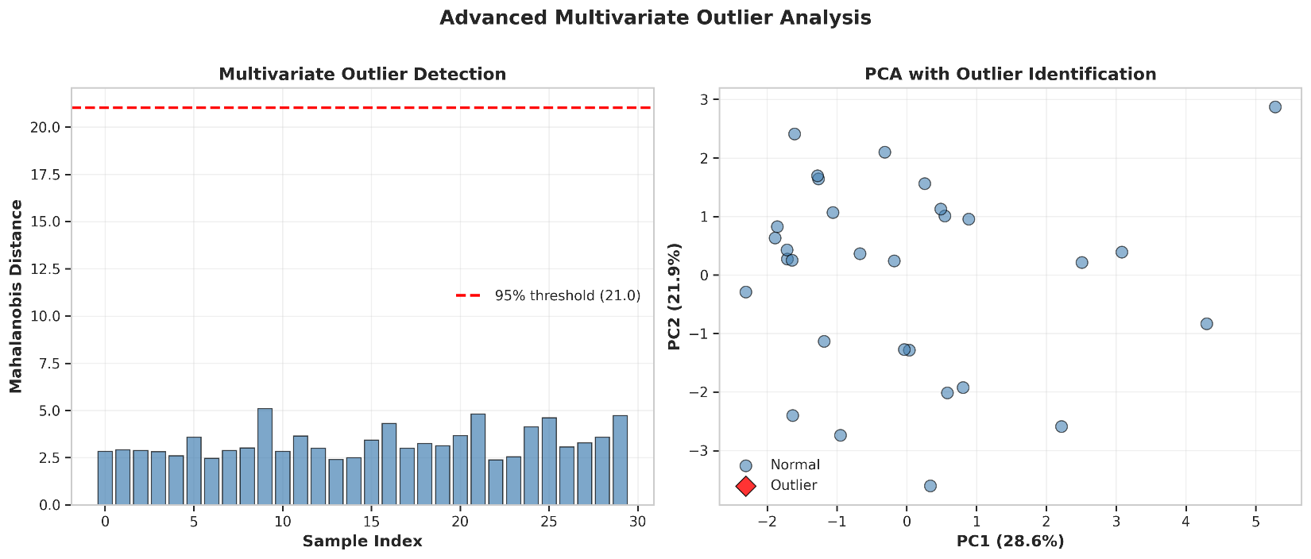

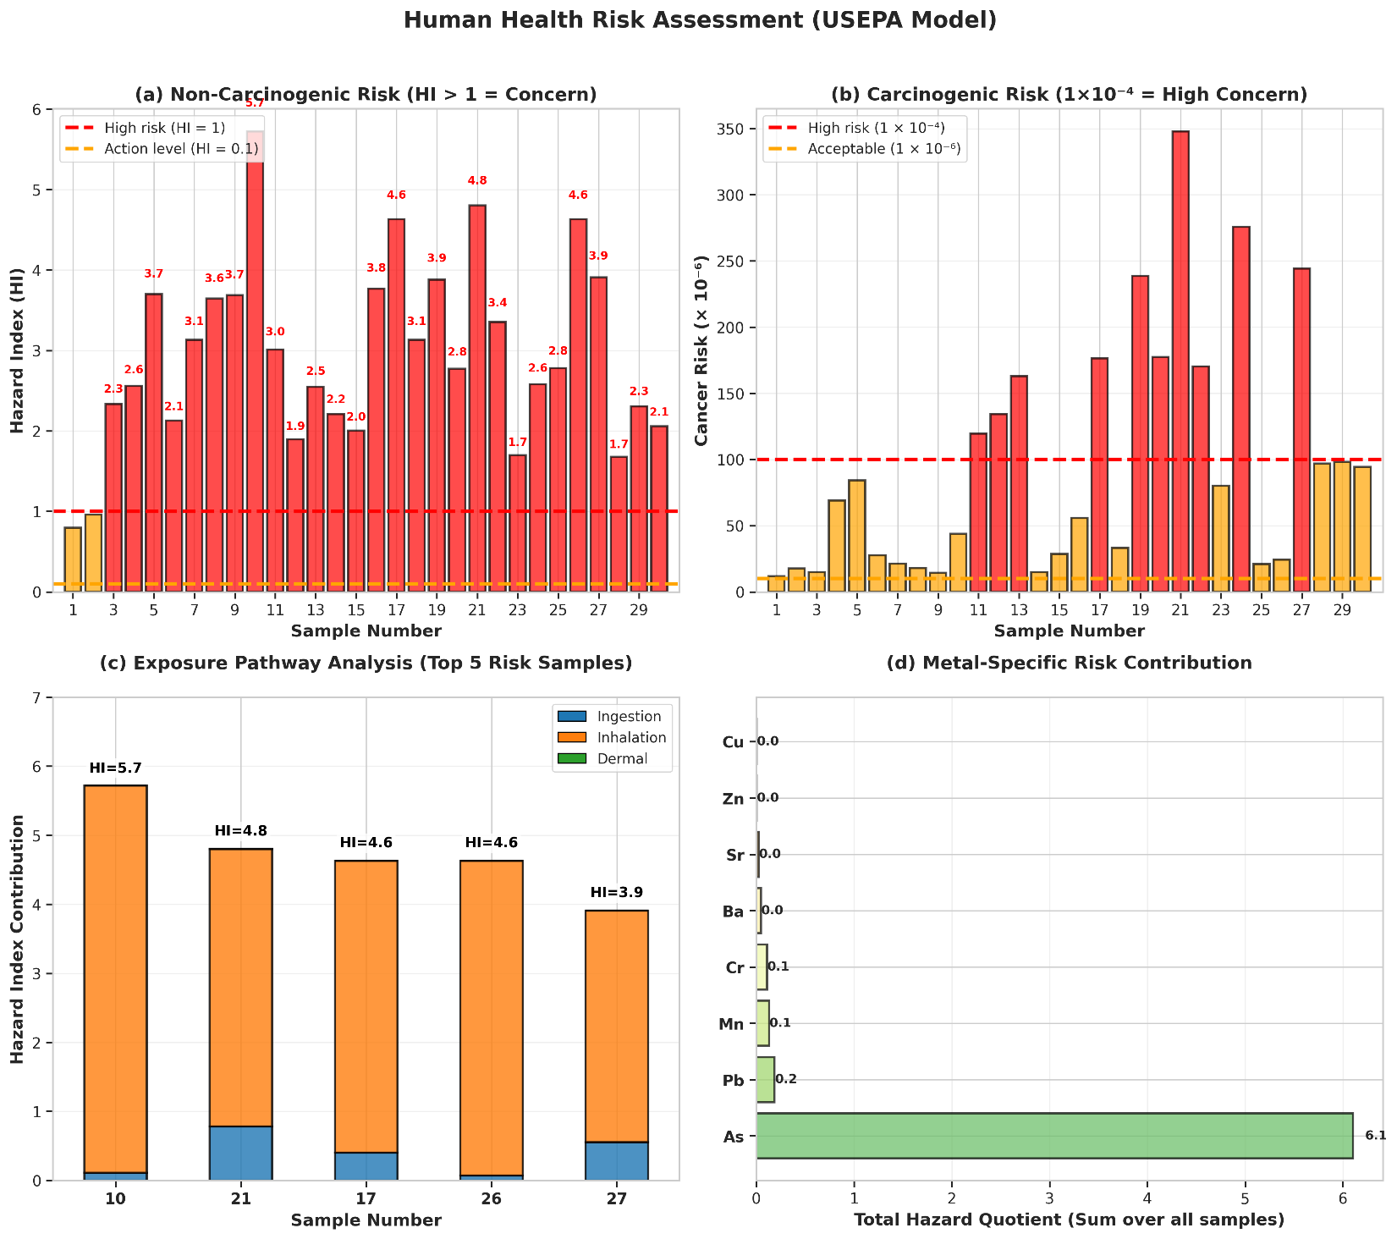
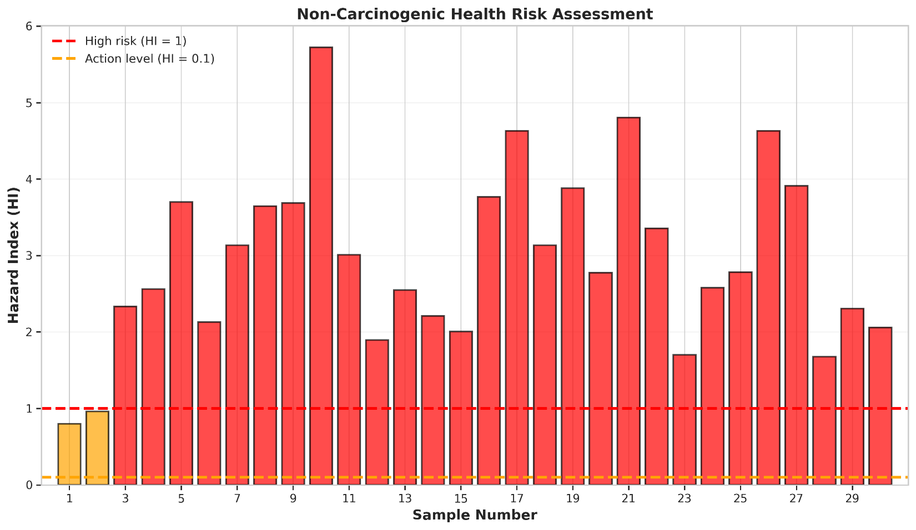
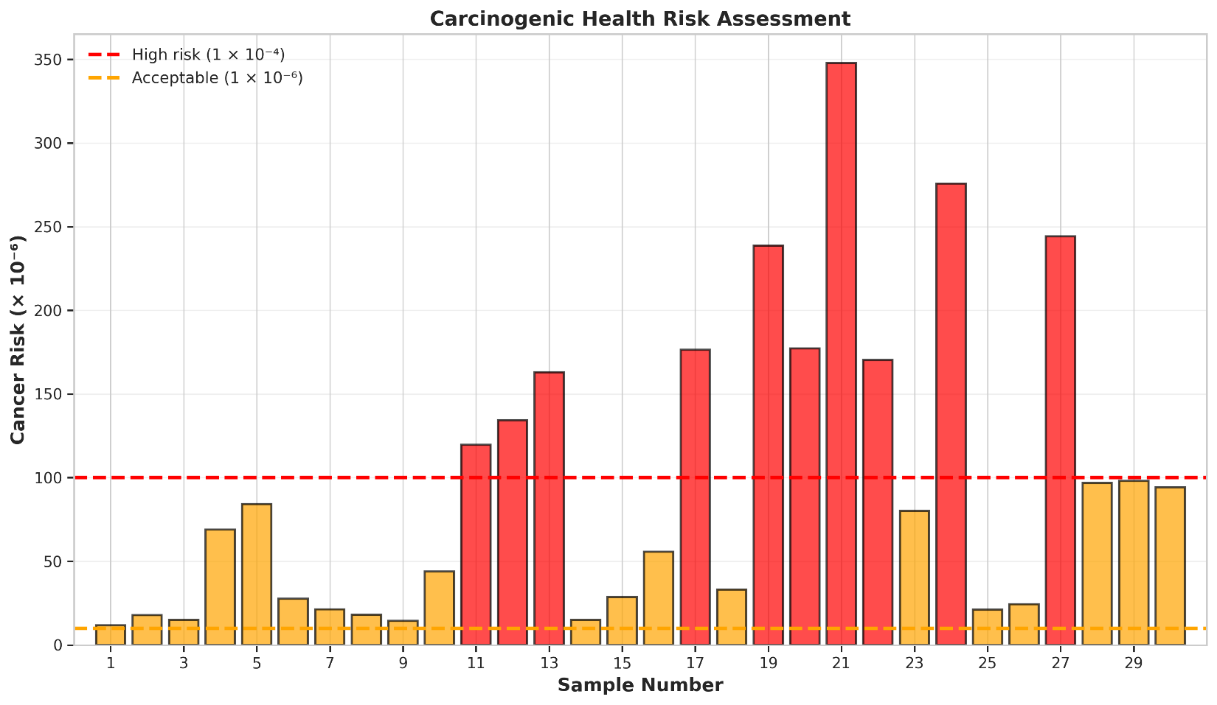
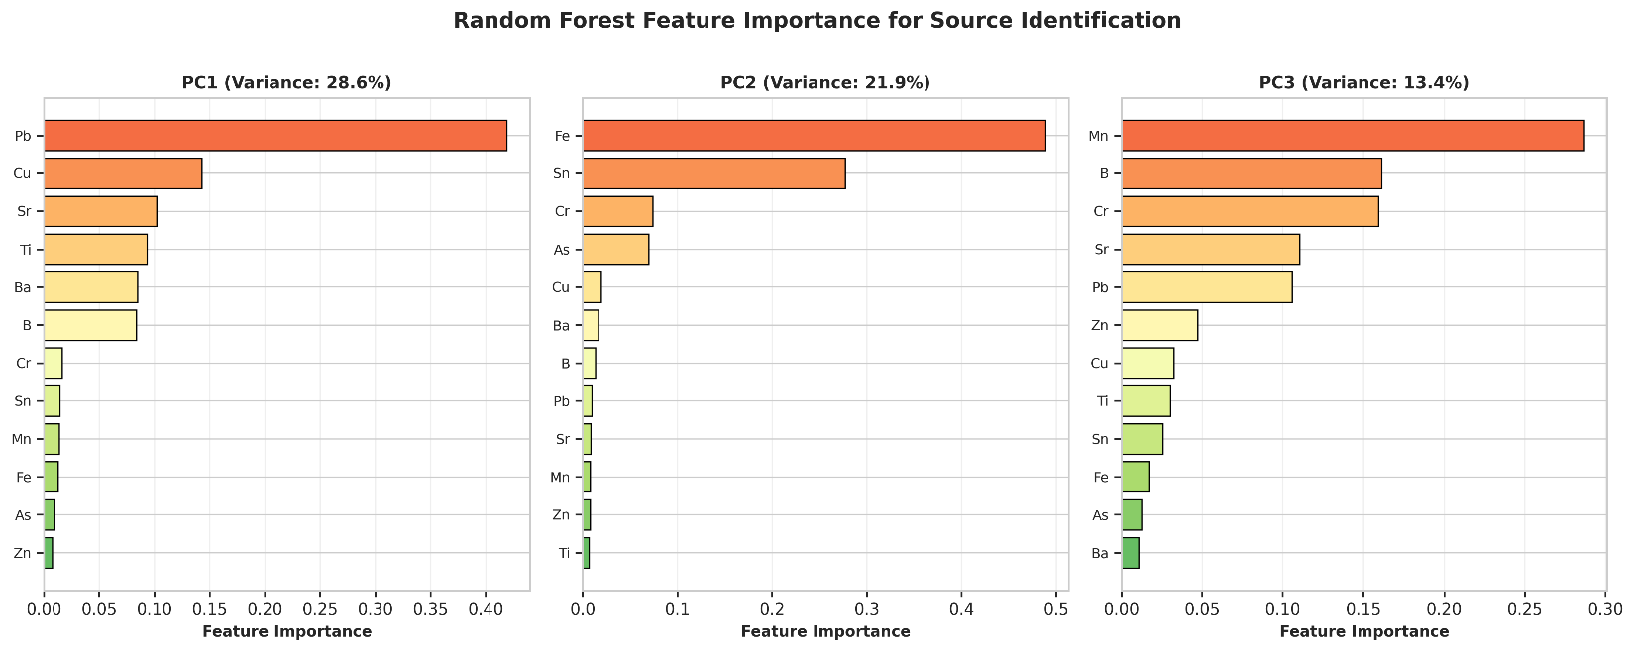
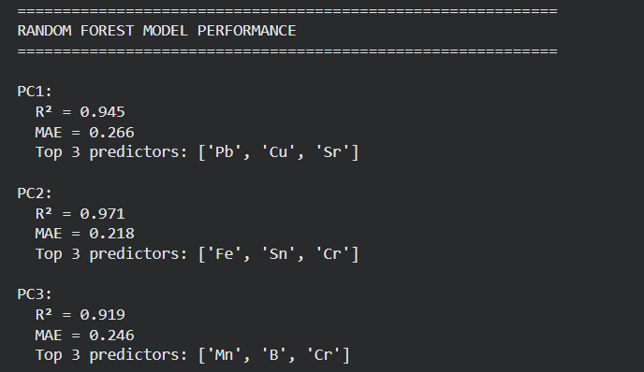
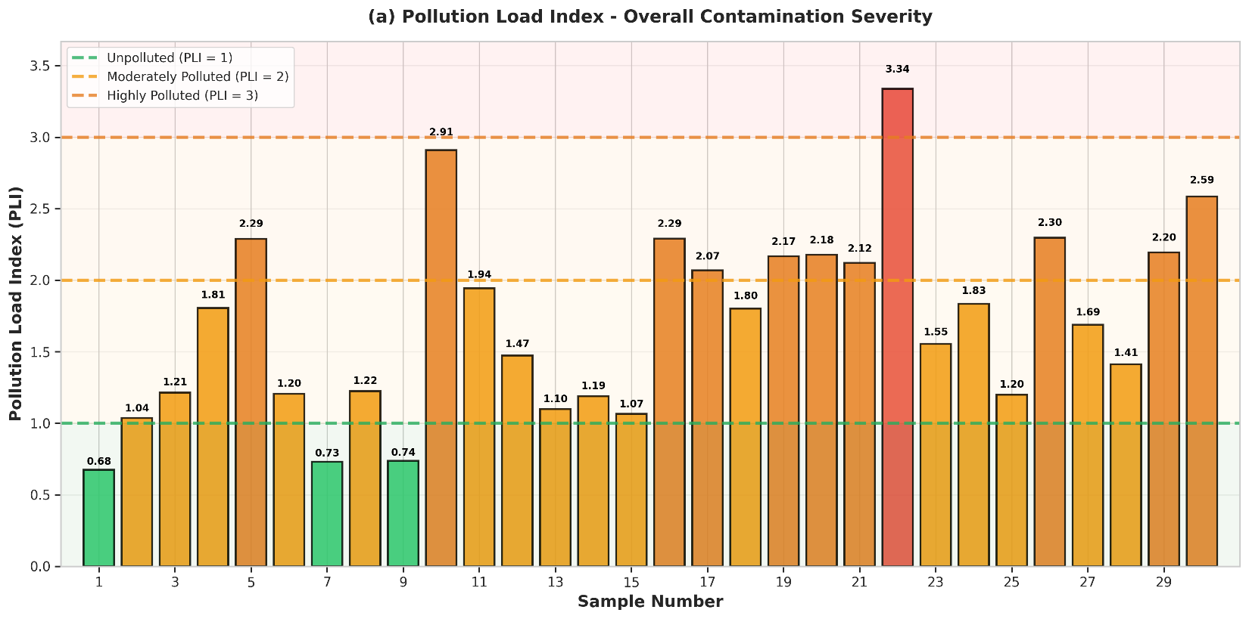
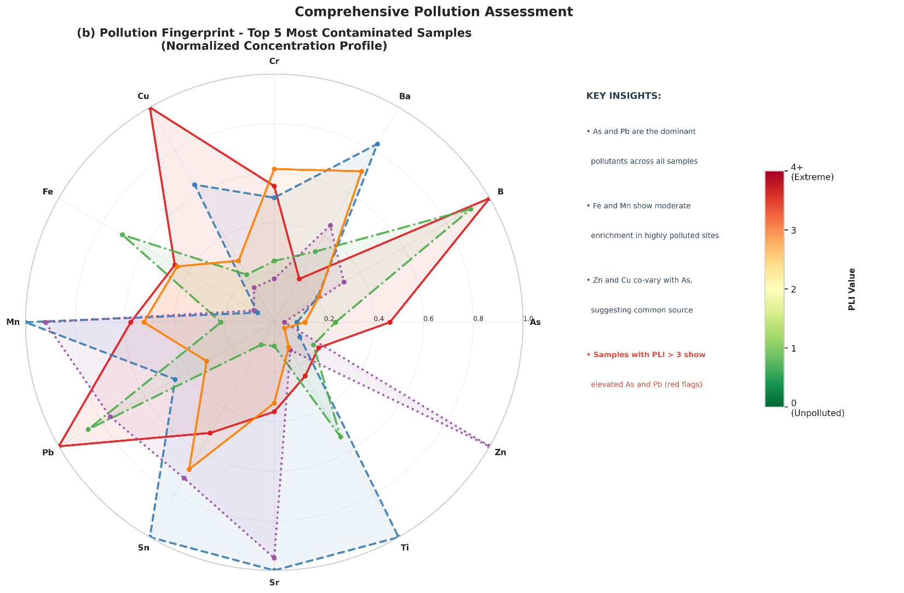
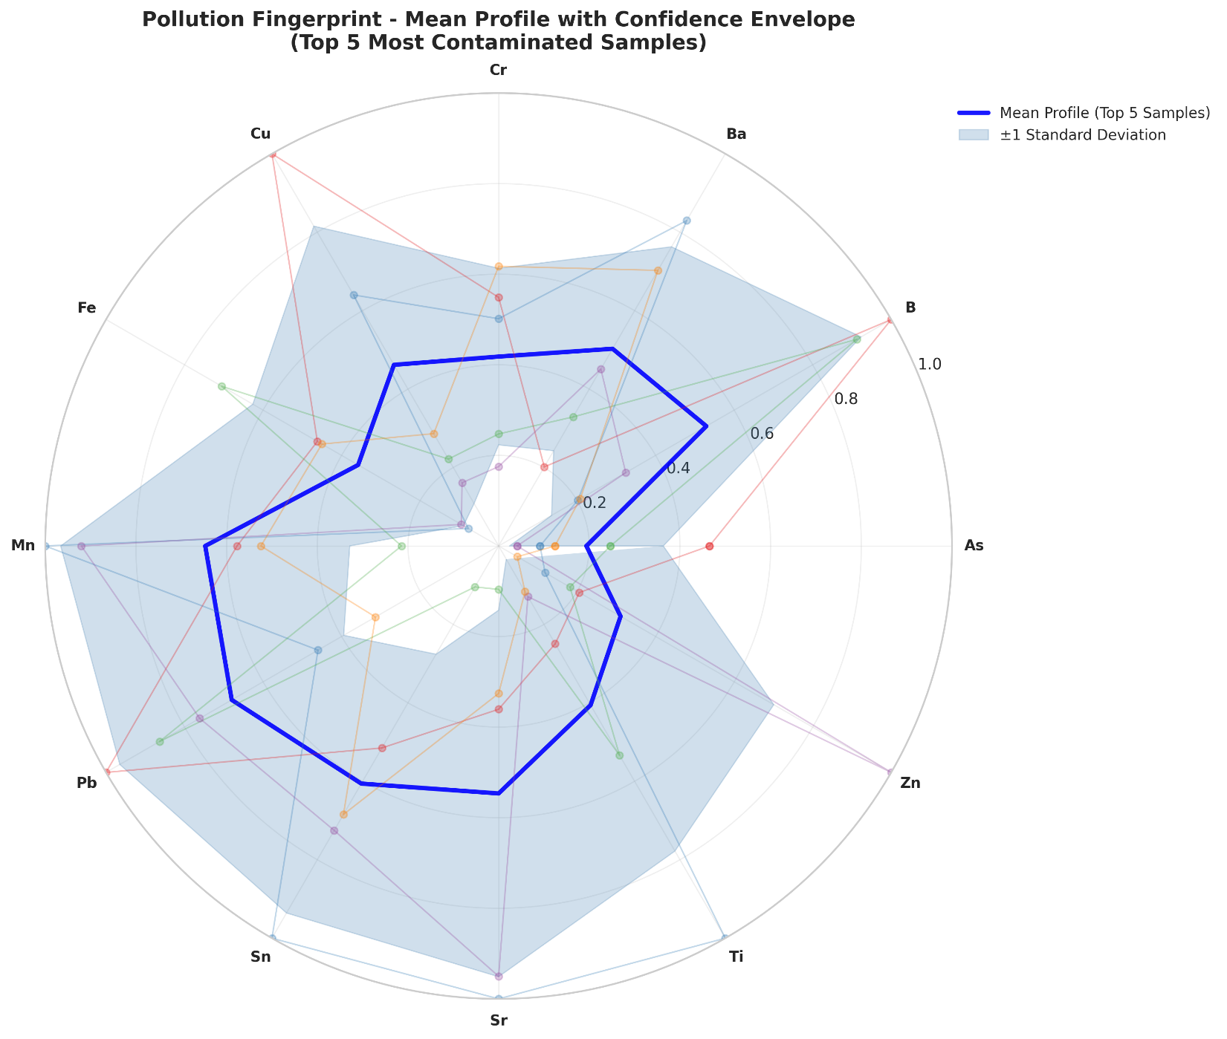
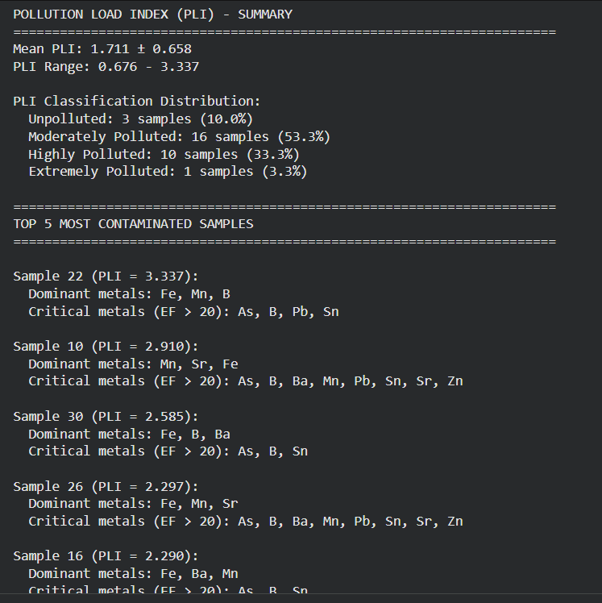
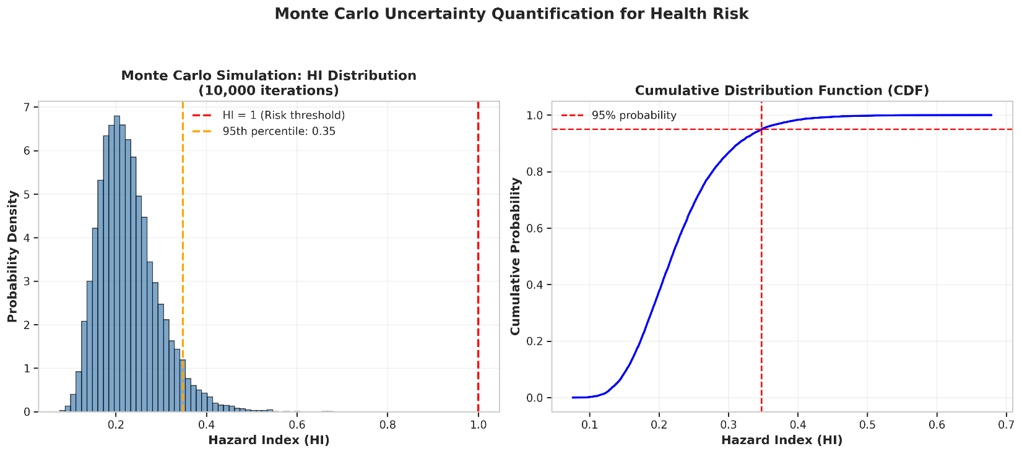
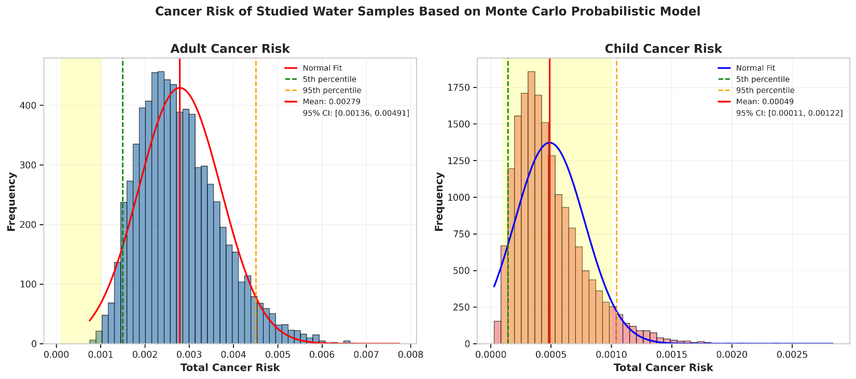

ADULT CANCER RISK:
Mean: 0.002790
Median: 0.002666
Std Dev: 0.000929
5th Percentile: 0.001500
95th Percentile: 0.004509
95% CI: [0.001357, 0.004907]
% > 1E-4: 100.0%

CHILD CANCER RISK:
Mean: 0.000489
Median: 0.000424
Std Dev: 0.000291
5th Percentile: 0.000144
95th Percentile: 0.001045
95% CI: [0.000111, 0.001218]
% > 1E-4: 98.3%

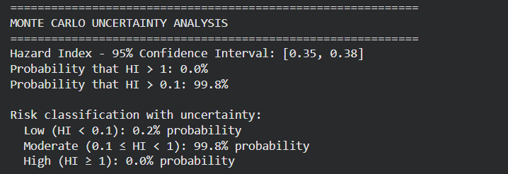
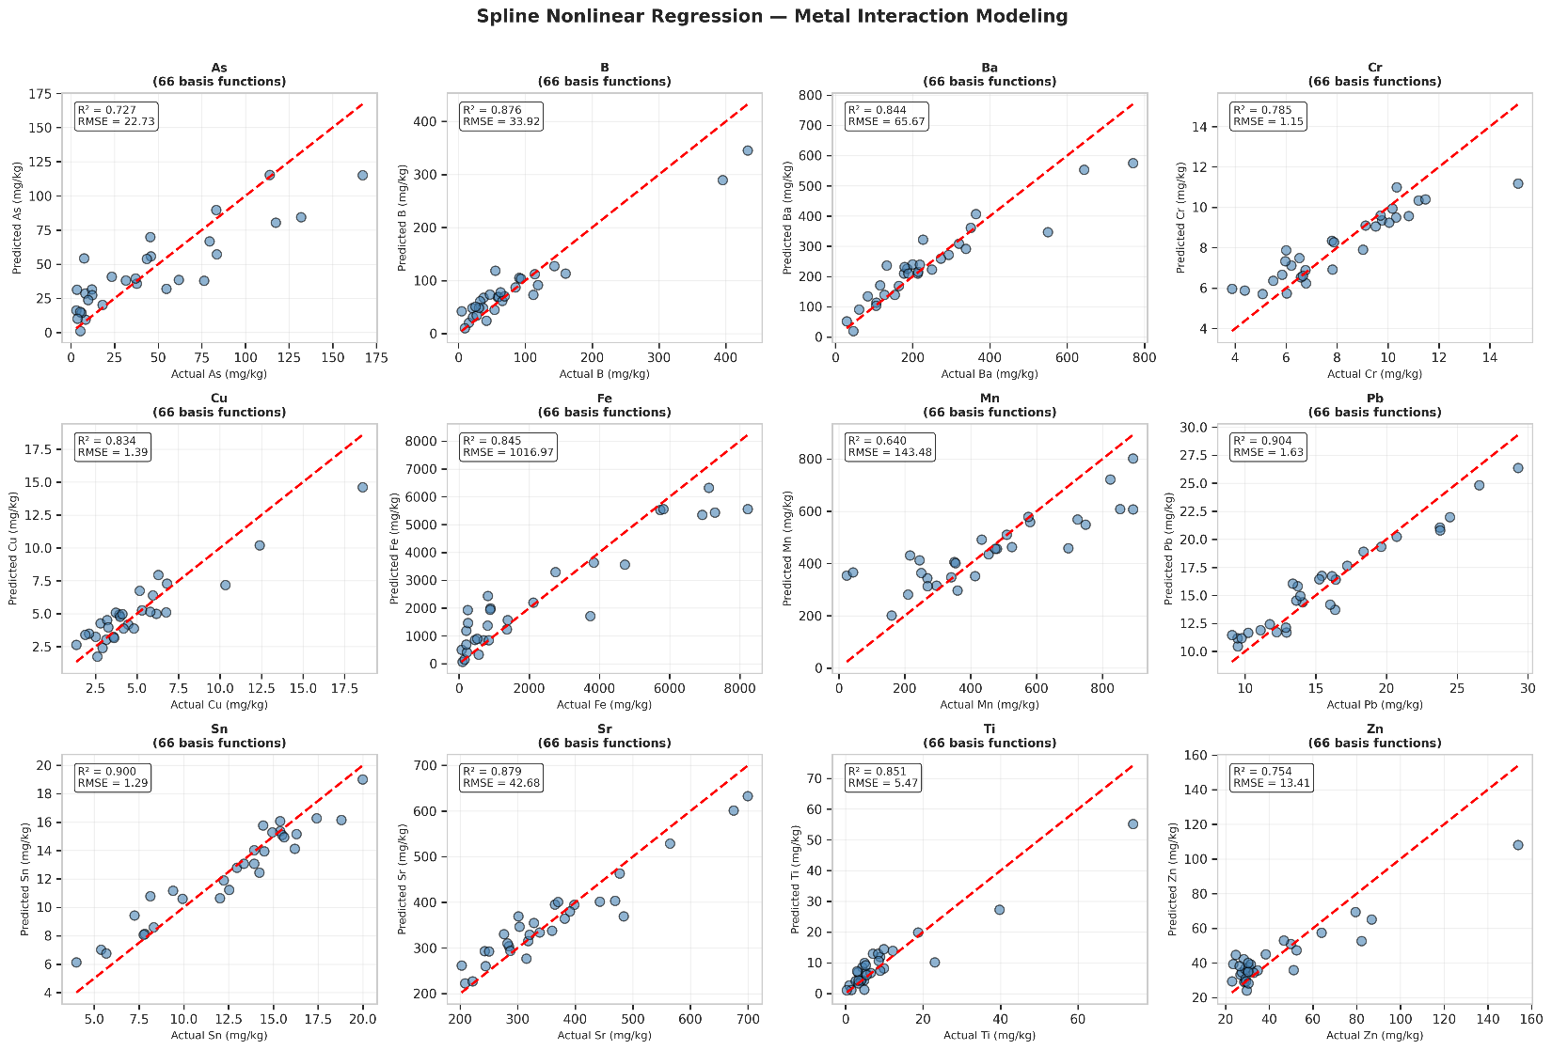
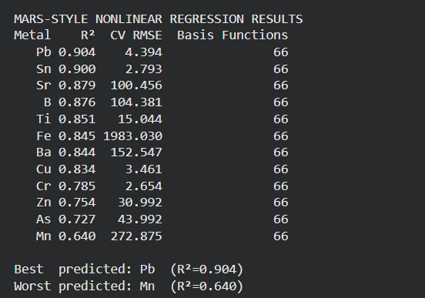
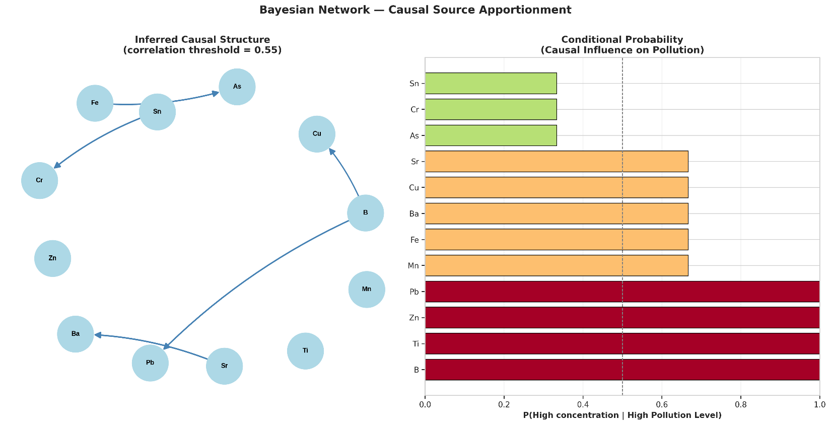
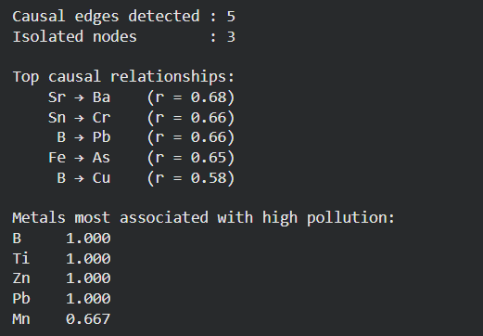
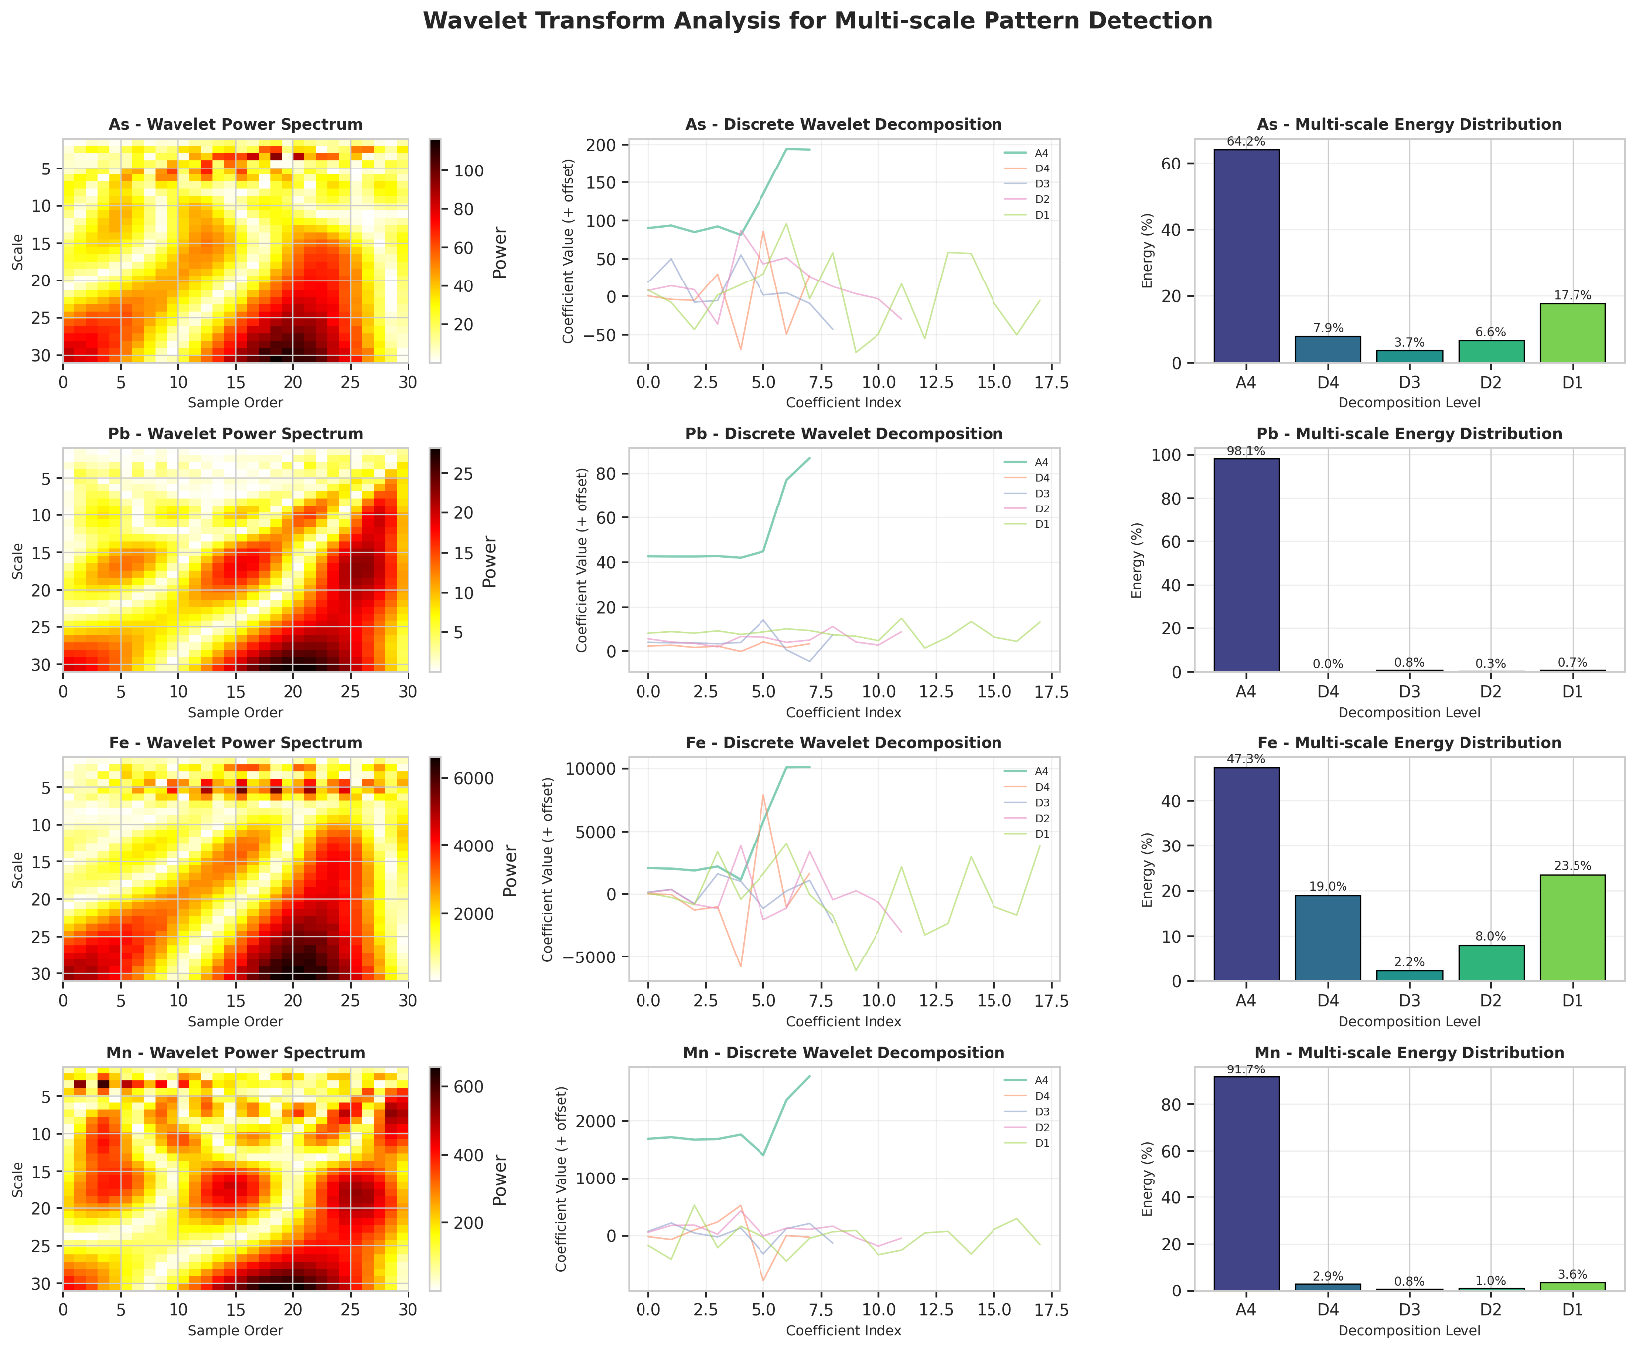
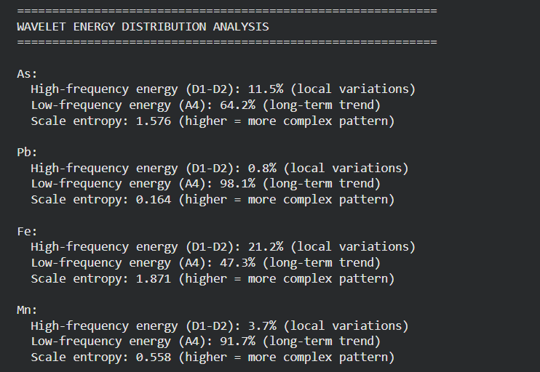
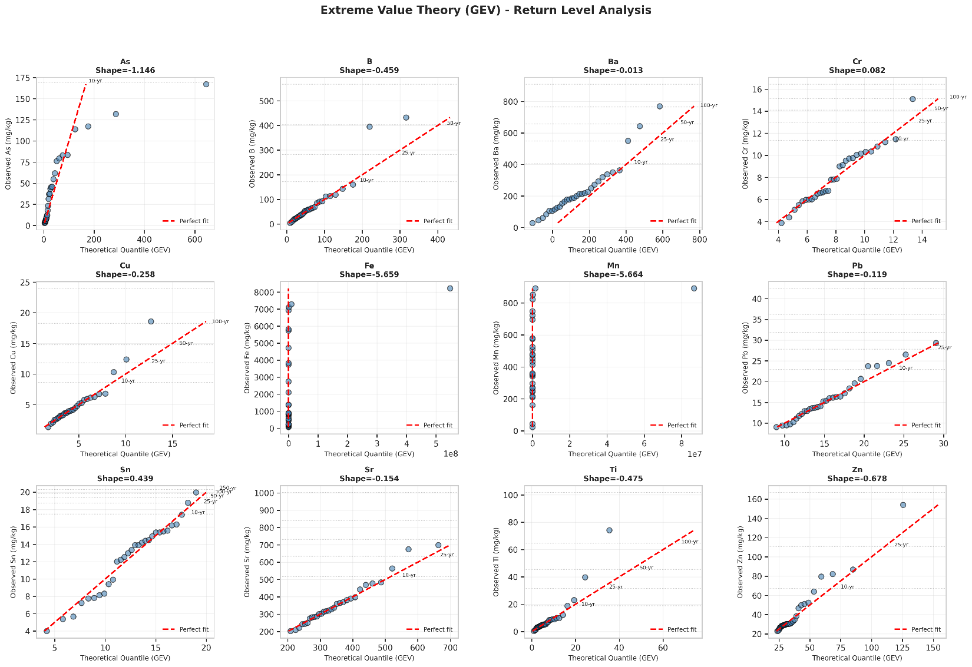
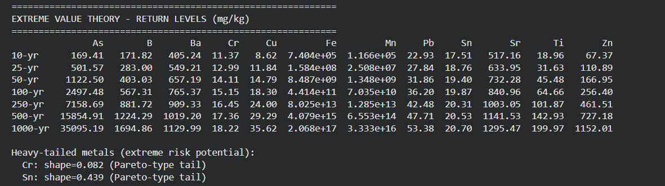
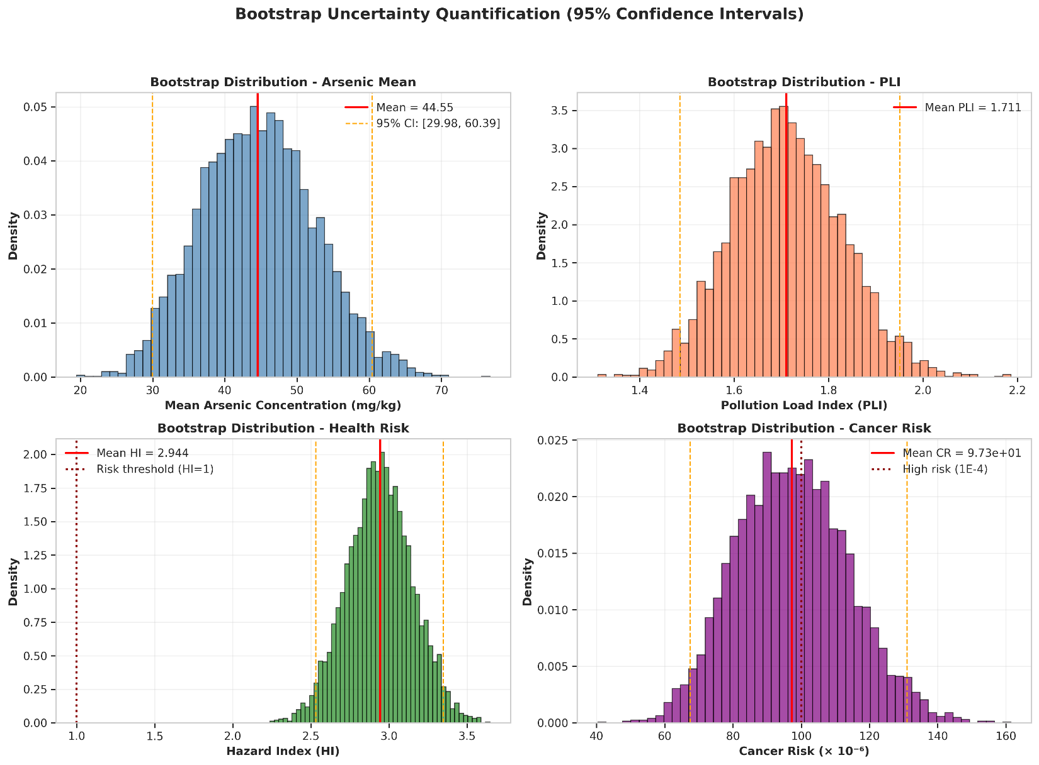
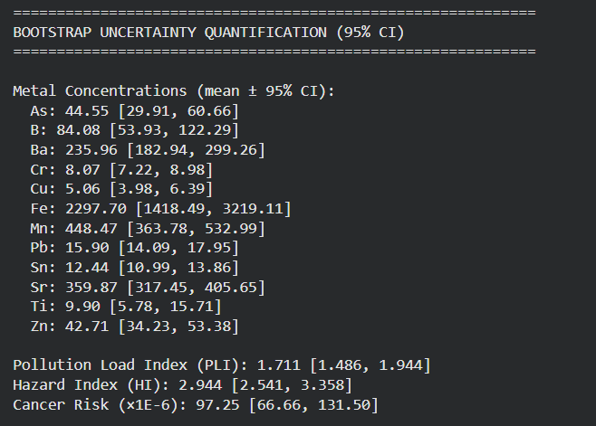
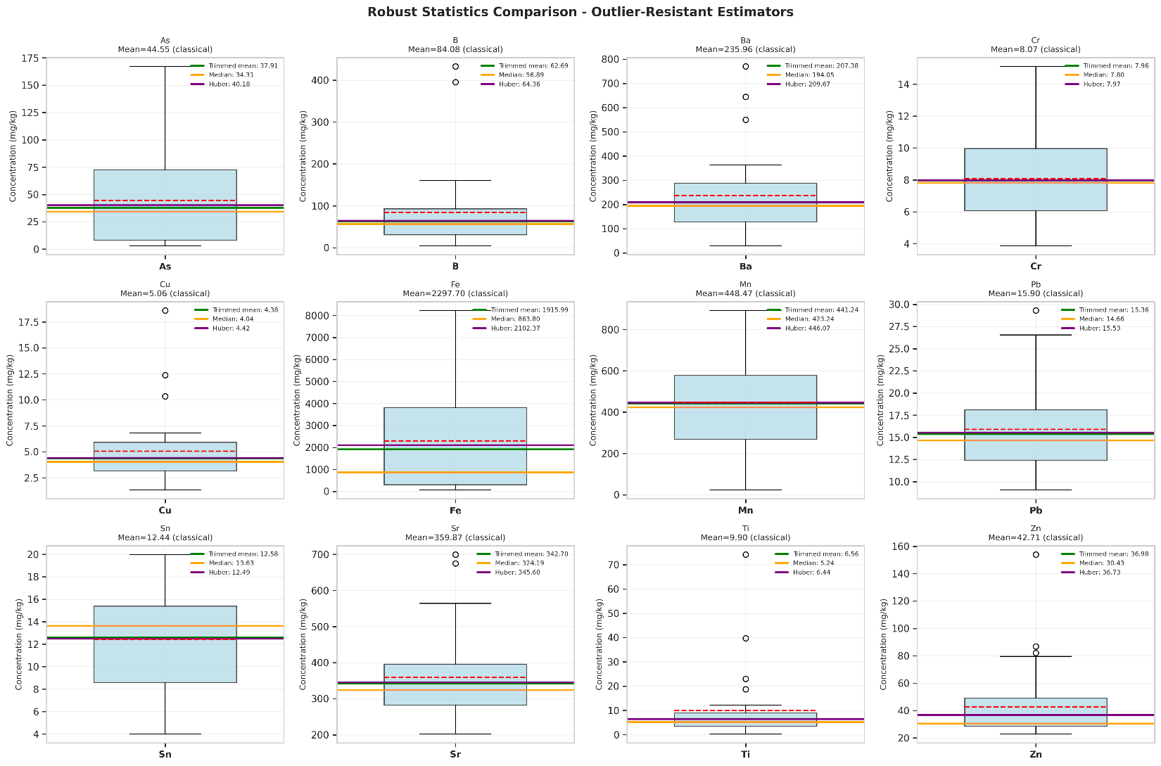
============================================================
ROBUST STATISTICS - IMPACT OF OUTLIERS
============================================================

As:
Classical mean: 44.55
Trimmed mean (10%): 37.91 (difference: +14.9%)
Huber estimator: 40.18
MAD (robust std): 40.22 vs classical std: 43.49

B:
Classical mean: 84.08
Trimmed mean (10%): 62.69 (difference: +25.4%)
Huber estimator: 64.36
MAD (robust std): 45.30 vs classical std: 96.42

Ba:
Classical mean: 235.96
Trimmed mean (10%): 207.38 (difference: +12.1%)
Huber estimator: 209.67
MAD (robust std): 116.96 vs classical std: 166.41

Cr:
Classical mean: 8.07
Trimmed mean (10%): 7.96 (difference: +1.4%)
Huber estimator: 7.97
MAD (robust std): 2.77 vs classical std: 2.48

Cu:
Classical mean: 5.06
Trimmed mean (10%): 4.38 (difference: +13.4%)
Huber estimator: 4.42
MAD (robust std): 1.86 vs classical std: 3.42

Fe:
Classical mean: 2297.70
Trimmed mean (10%): 1915.99 (difference: +16.6%)
Huber estimator: 2102.37
MAD (robust std): 976.06 vs classical std: 2580.39

Mn:
Classical mean: 448.47
Trimmed mean (10%): 441.24 (difference: +1.6%)
Huber estimator: 446.07
MAD (robust std): 231.26 vs classical std: 239.21

Pb:
Classical mean: 15.90
Trimmed mean (10%): 15.36 (difference: +3.4%)
Huber estimator: 15.53
MAD (robust std): 4.06 vs classical std: 5.27

Sn:
Classical mean: 12.44
Trimmed mean (10%): 12.58 (difference: -1.1%)
Huber estimator: 12.49
MAD (robust std): 3.34 vs classical std: 4.08

Sr:
Classical mean: 359.87
Trimmed mean (10%): 342.70 (difference: +4.8%)
Huber estimator: 345.60
MAD (robust std): 91.65 vs classical std: 122.59

Ti:
Classical mean: 9.90
Trimmed mean (10%): 6.56 (difference: +33.8%)
Huber estimator: 6.44
MAD (robust std): 3.64 vs classical std: 14.16

Zn:
Classical mean: 42.71
Trimmed mean (10%): 36.98 (difference: +13.4%)
Huber estimator: 36.73
MAD (robust std): 5.77 vs classical std: 27.05
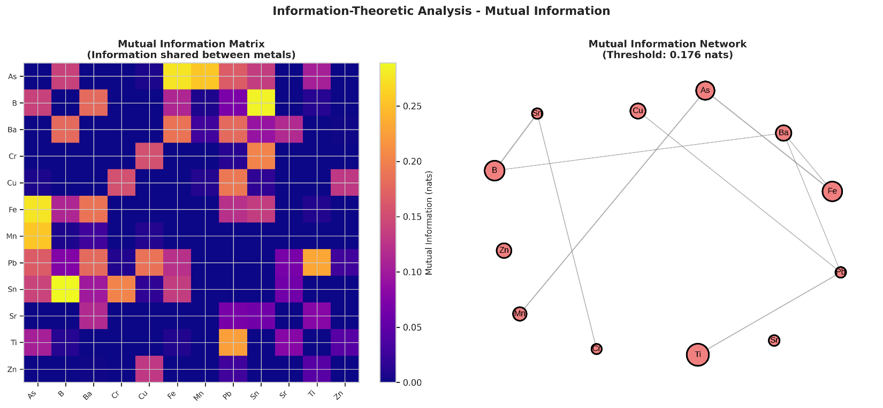
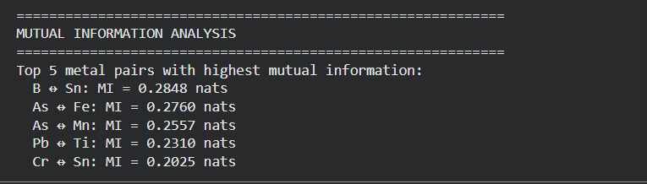

======================================================================
GLOBAL SENSITIVITY ANALYSIS (SOBOL INDICES)
======================================================================
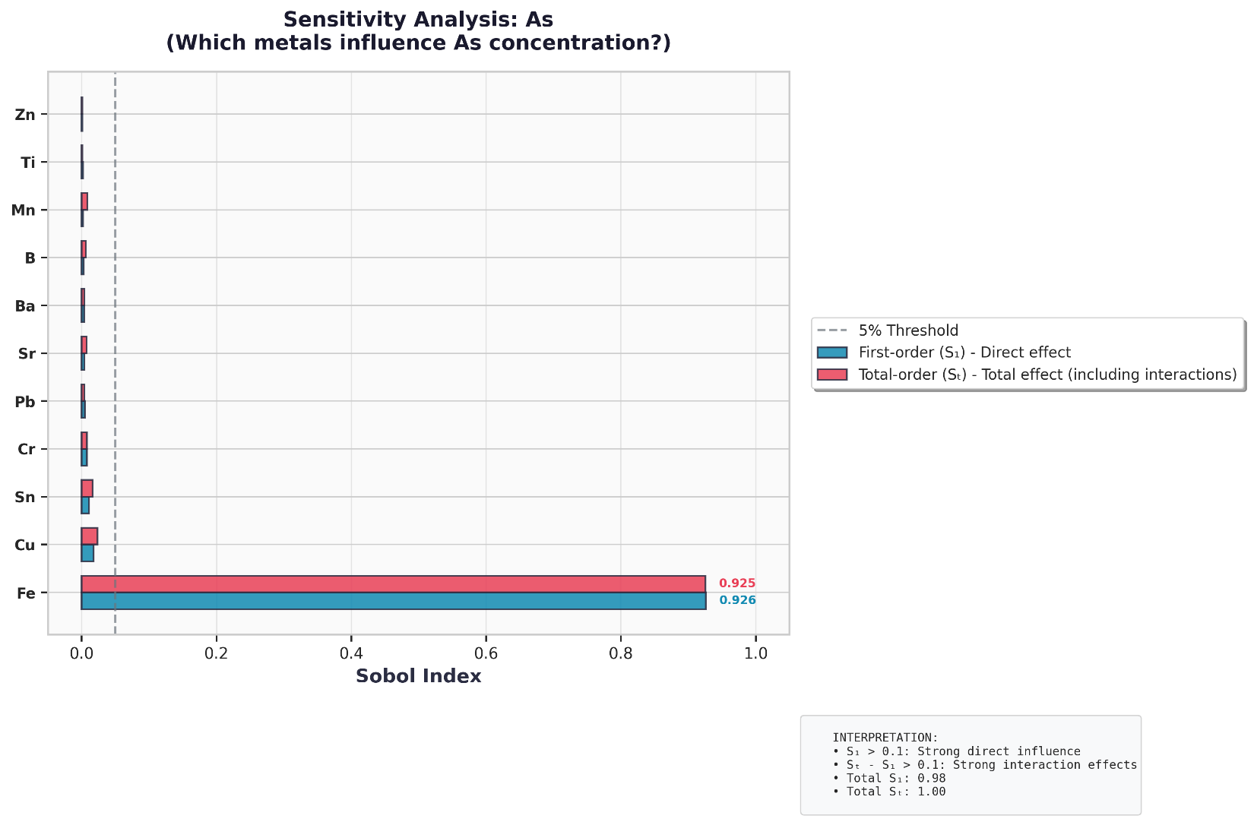
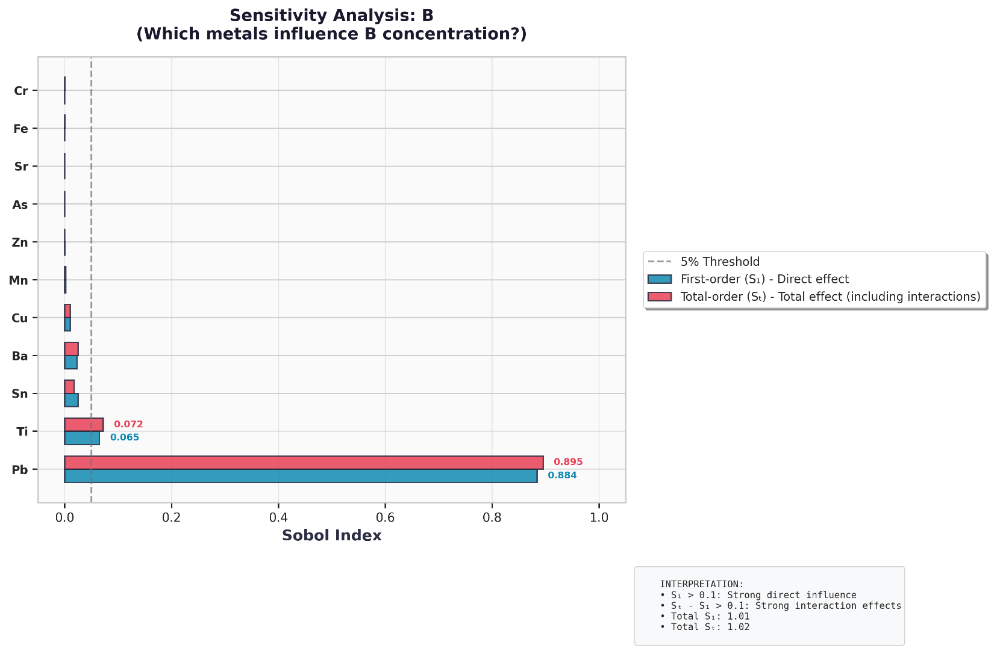
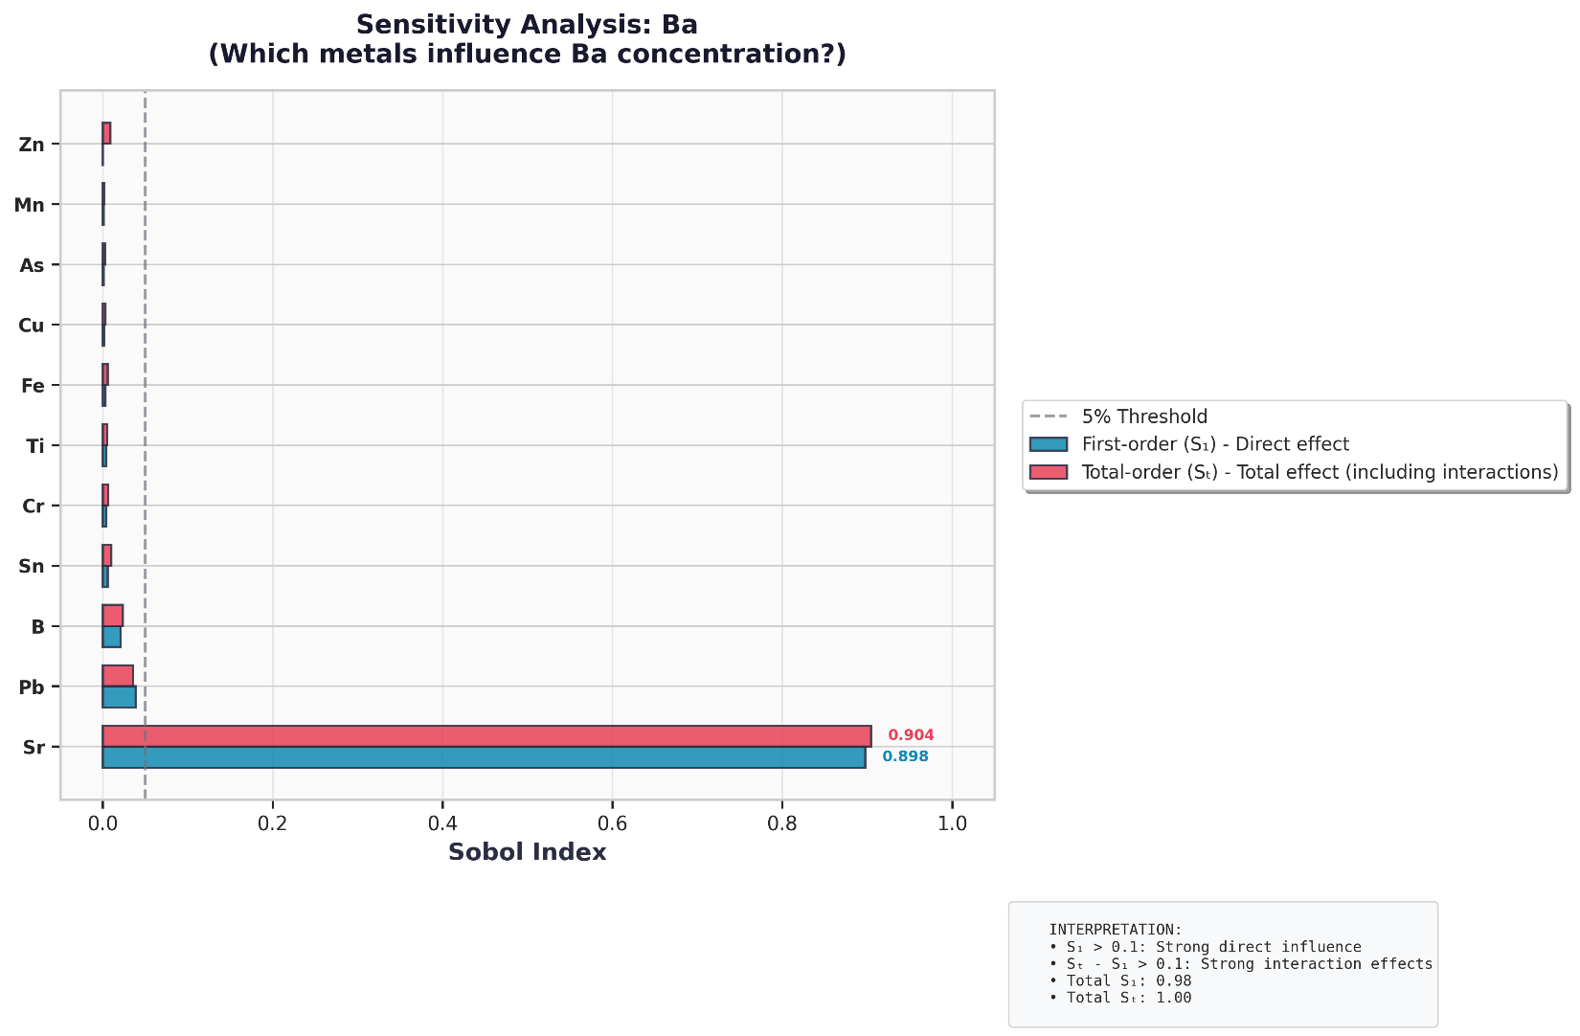
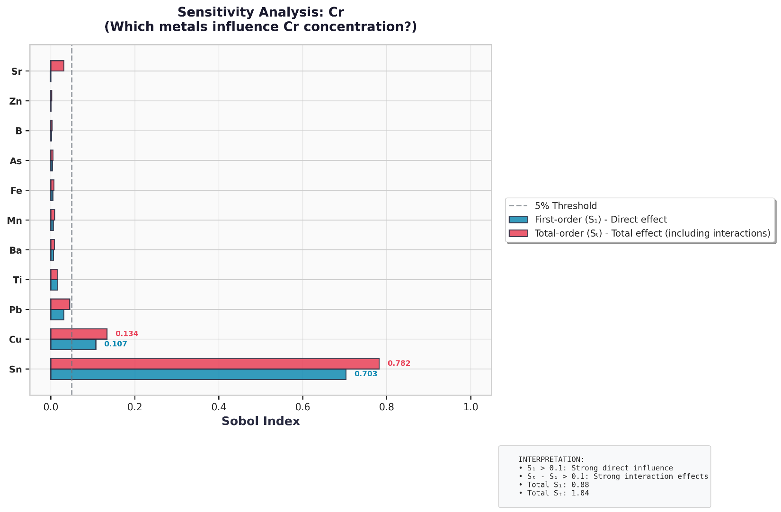
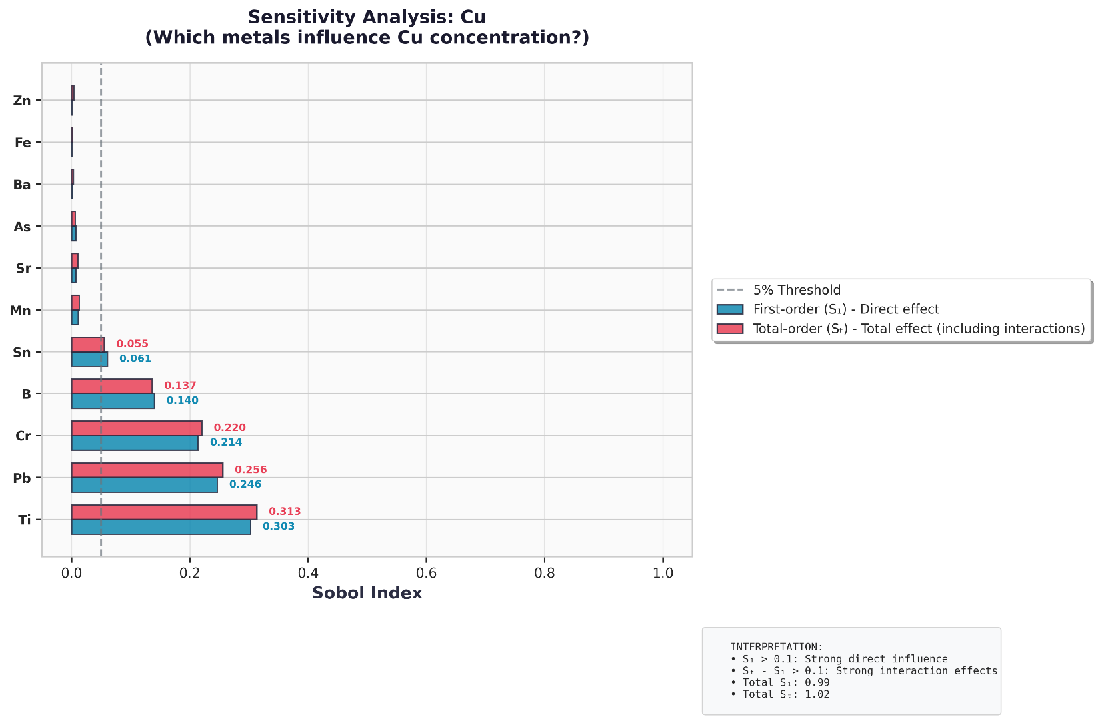
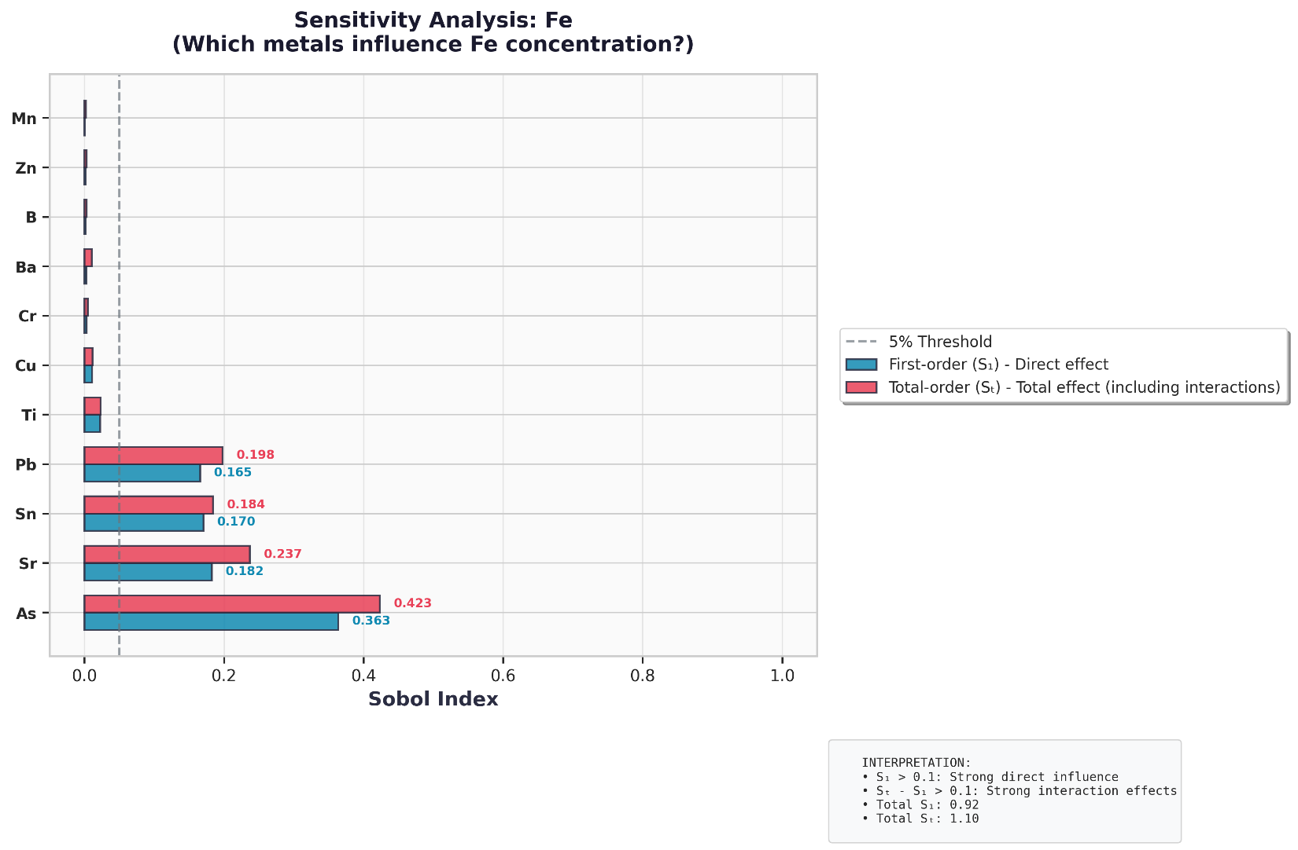
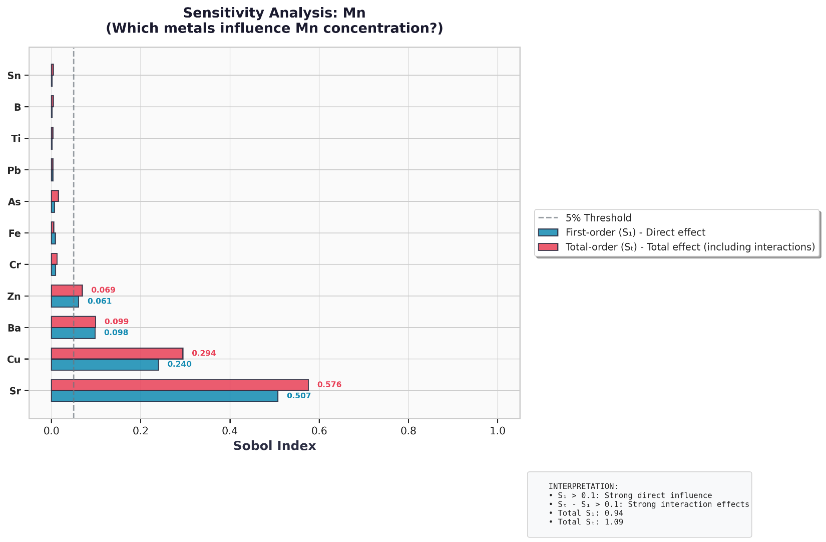
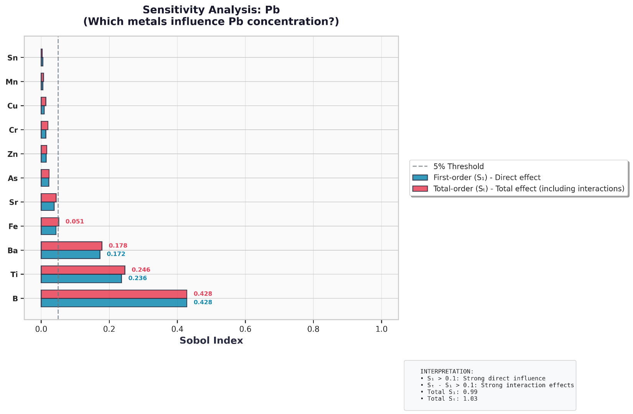
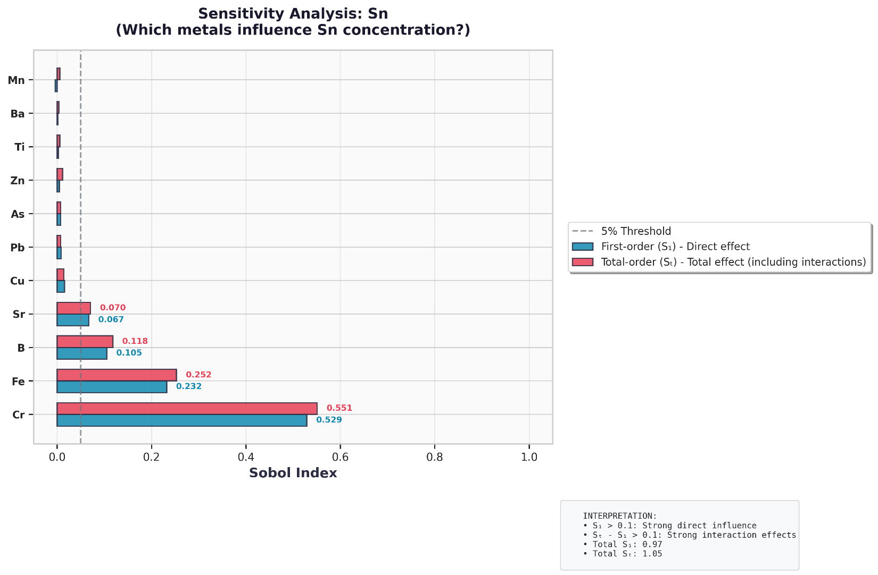
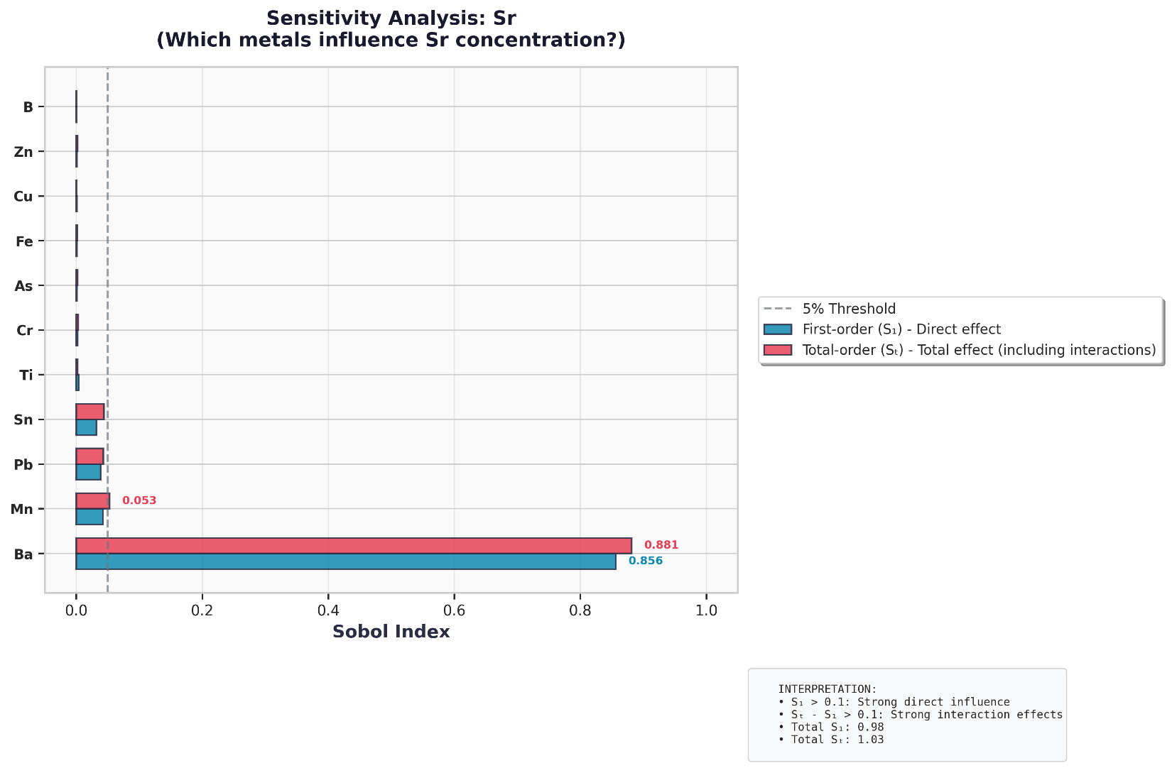
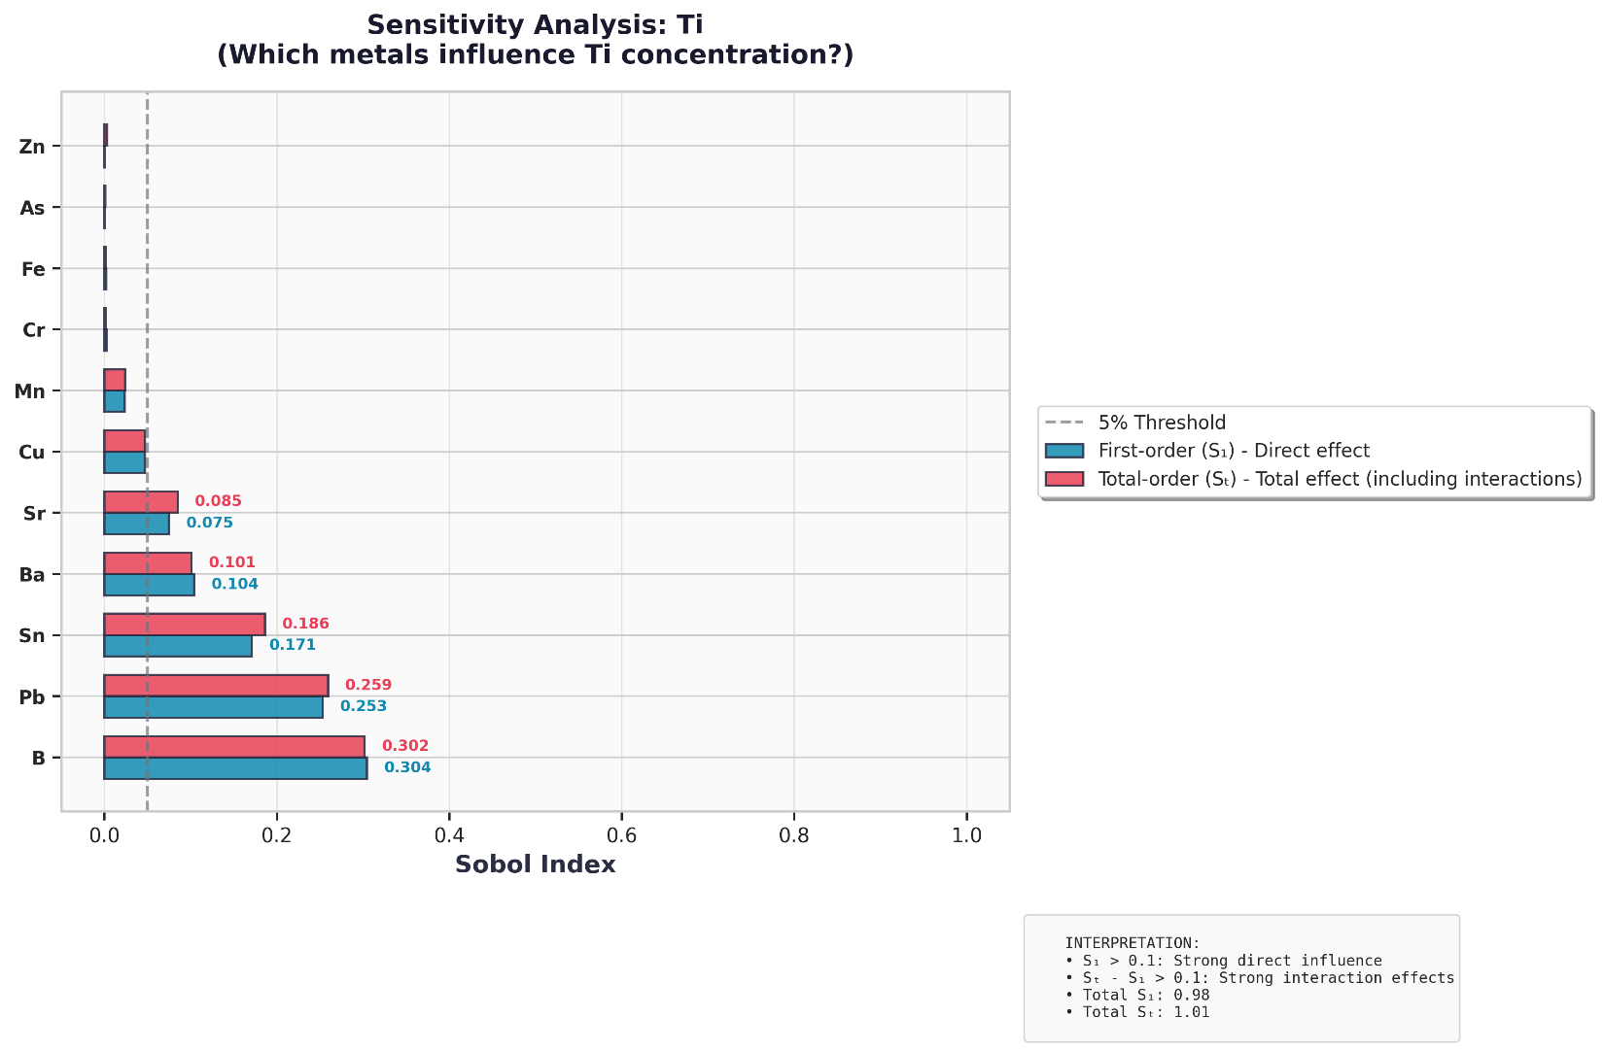
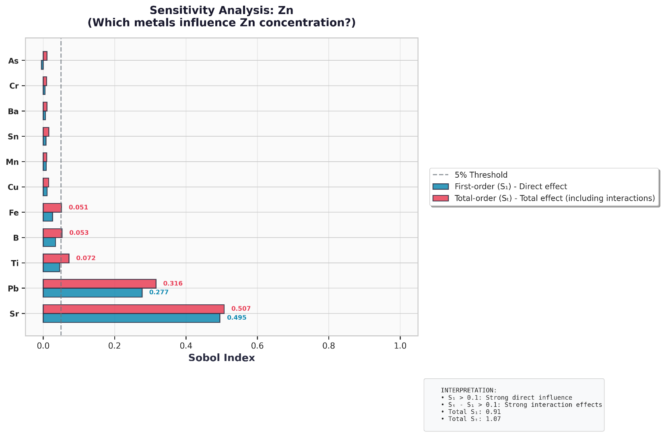
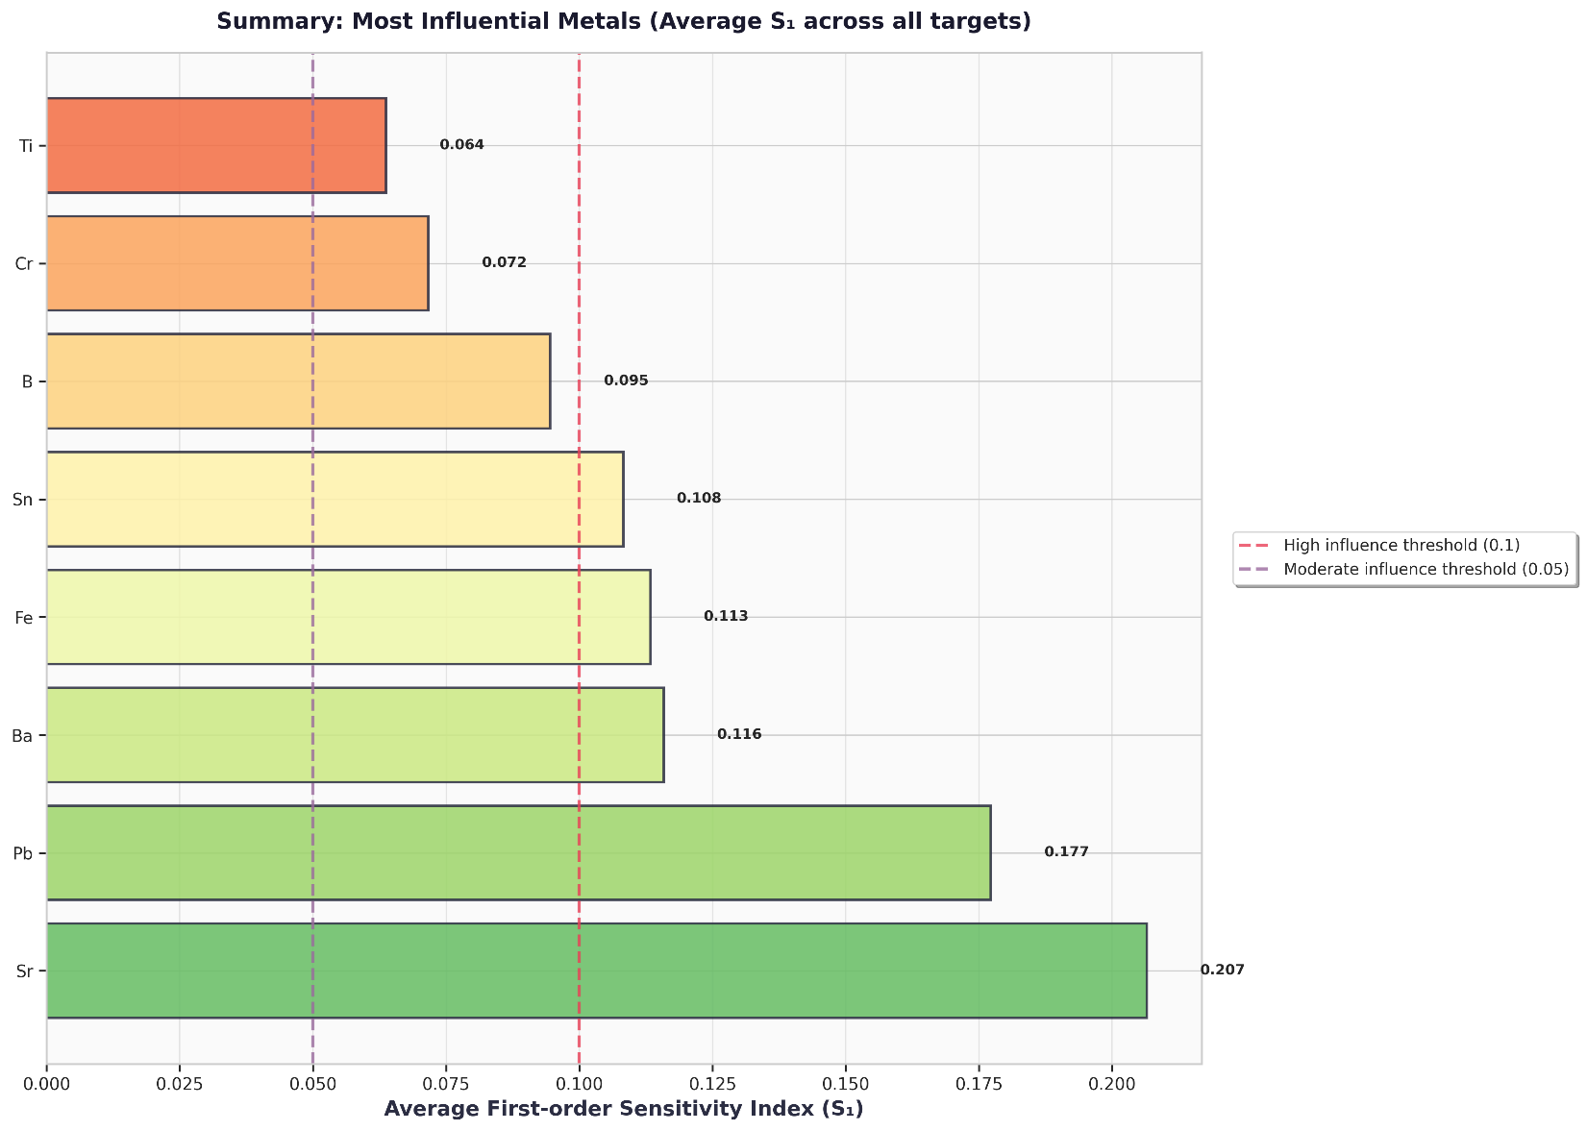

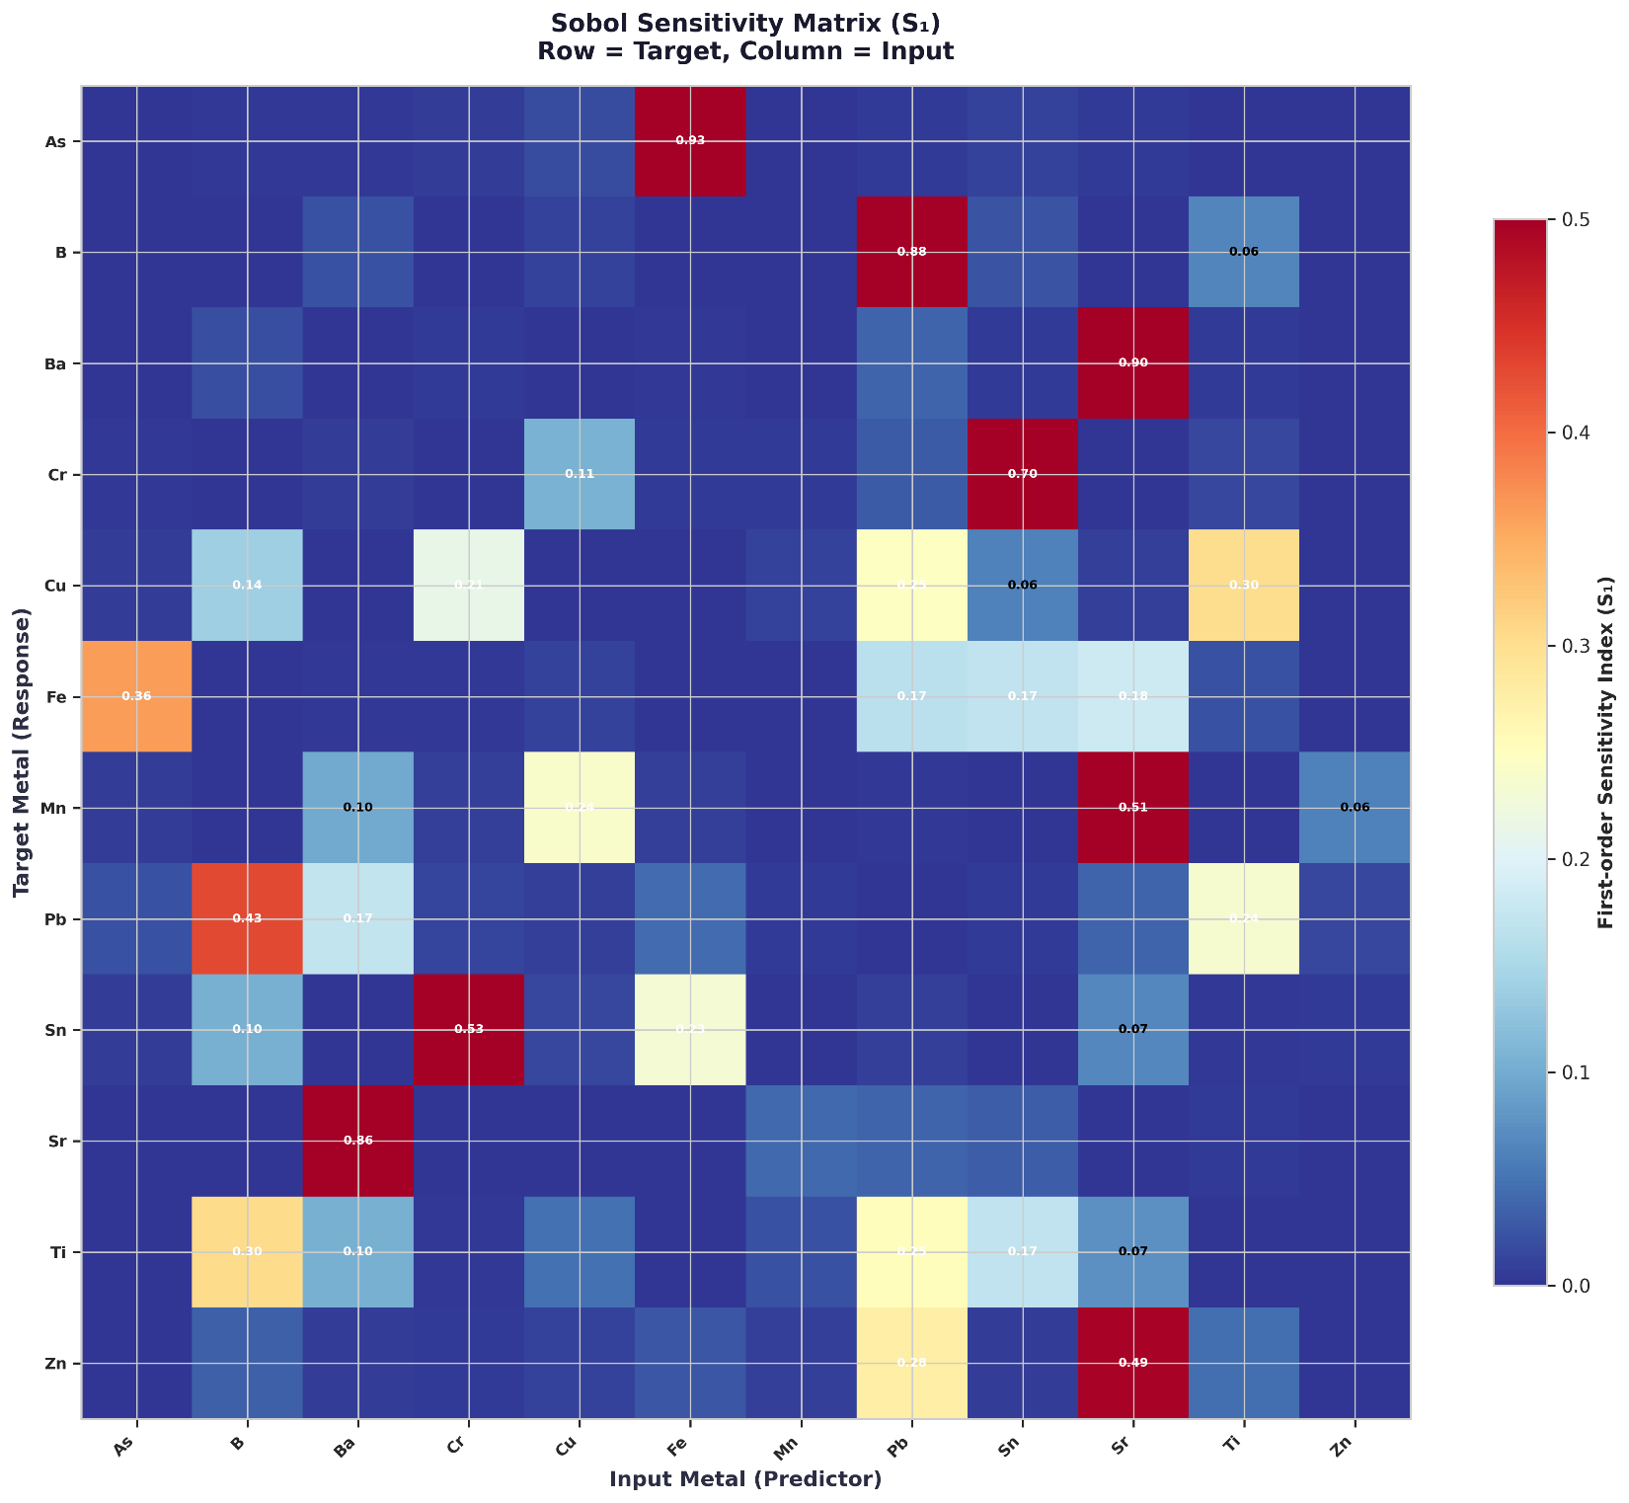

============================================================
GLOBAL SENSITIVITY ANALYSIS (SOBOL INDICES)
============================================================

As - Most influential predictors:
Cu: S1=0.926, ST=0.925

B - Most influential predictors:
Mn: S1=0.884, ST=0.895
Sr: S1=0.065, ST=0.072

Ba - Most influential predictors:
Sn: S1=0.898, ST=0.904

Cr - Most influential predictors:
Pb: S1=0.703, ST=0.782
Cr: S1=0.107, ST=0.134

Cu - Most influential predictors:
Sr: S1=0.303, ST=0.313
Mn: S1=0.246, ST=0.256
Cr: S1=0.214, ST=0.220

Fe - Most influential predictors:
As: S1=0.363, ST=0.423
Sn: S1=0.182, ST=0.237
Pb: S1=0.170, ST=0.184

Mn - Most influential predictors:
Sn: S1=0.507, ST=0.576
Cu: S1=0.240, ST=0.294
Ba: S1=0.098, ST=0.099

Pb - Most influential predictors:
B: S1=0.428, ST=0.428
Sr: S1=0.236, ST=0.246
Ba: S1=0.172, ST=0.178

Sn - Most influential predictors:
Cr: S1=0.529, ST=0.551
Fe: S1=0.232, ST=0.252
B: S1=0.105, ST=0.118

Sr - Most influential predictors:
Ba: S1=0.856, ST=0.881

Ti - Most influential predictors:
B: S1=0.304, ST=0.302
Pb: S1=0.253, ST=0.259
Sn: S1=0.171, ST=0.186

Zn - Most influential predictors:
Sr: S1=0.495, ST=0.507
Pb: S1=0.277, ST=0.316
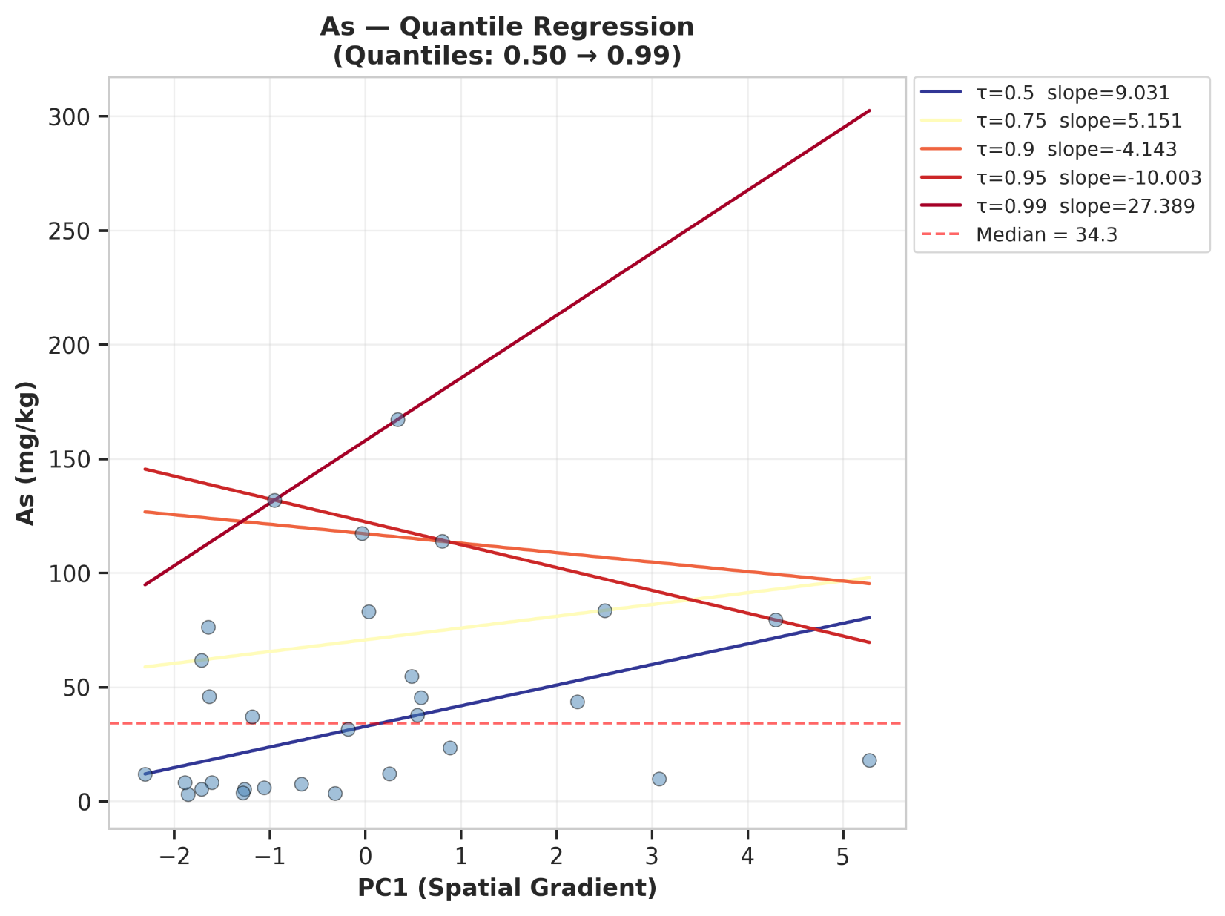
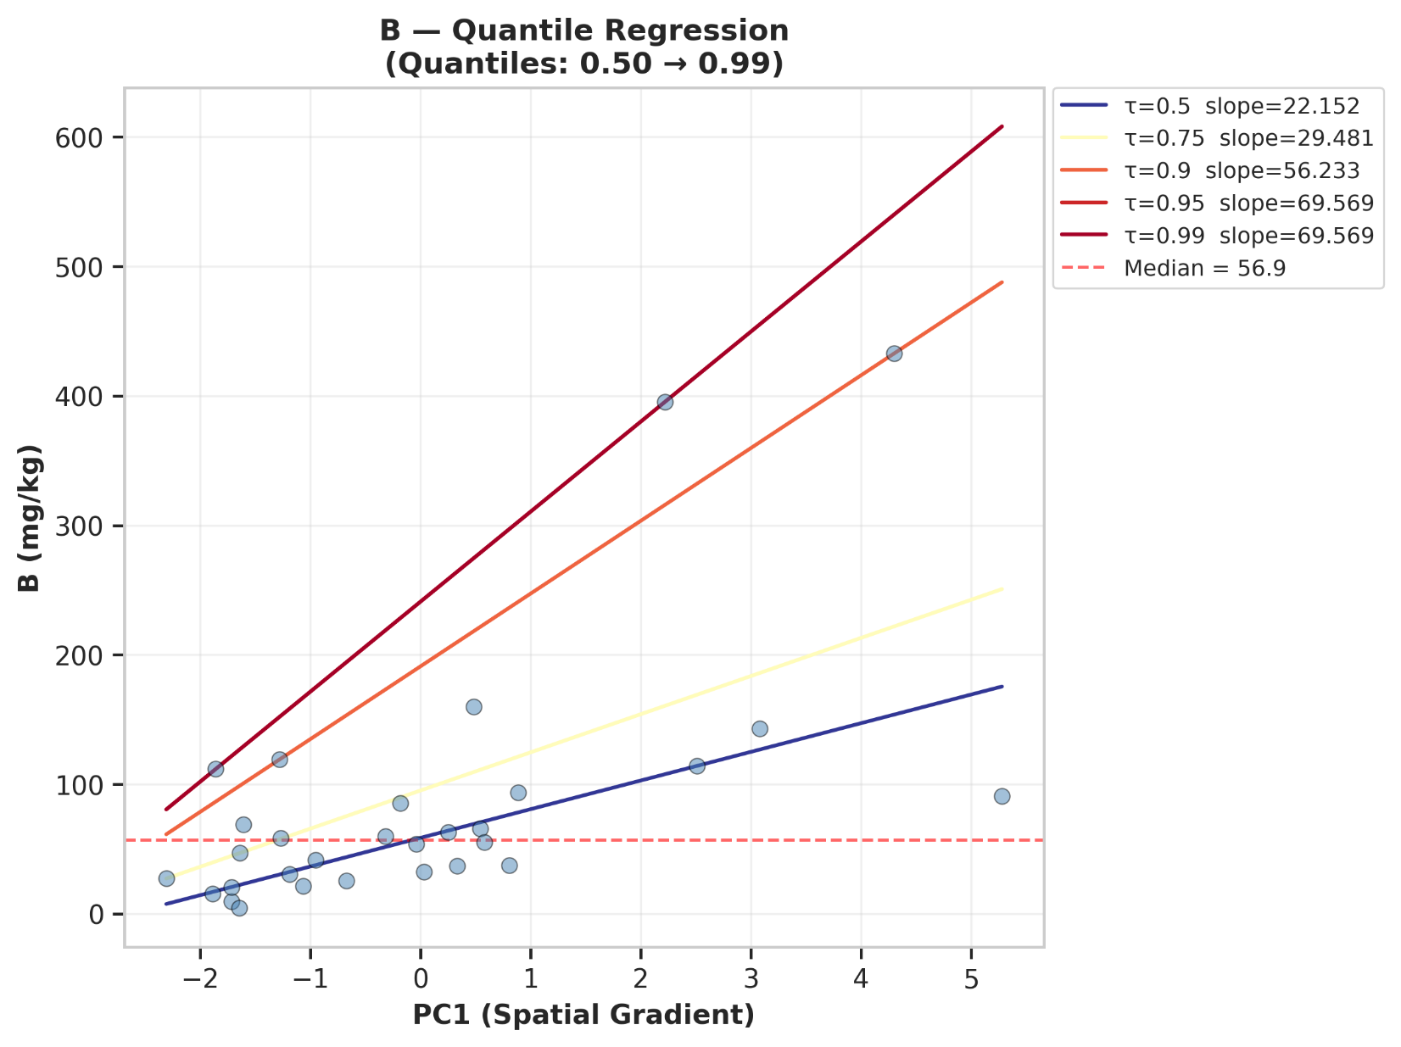
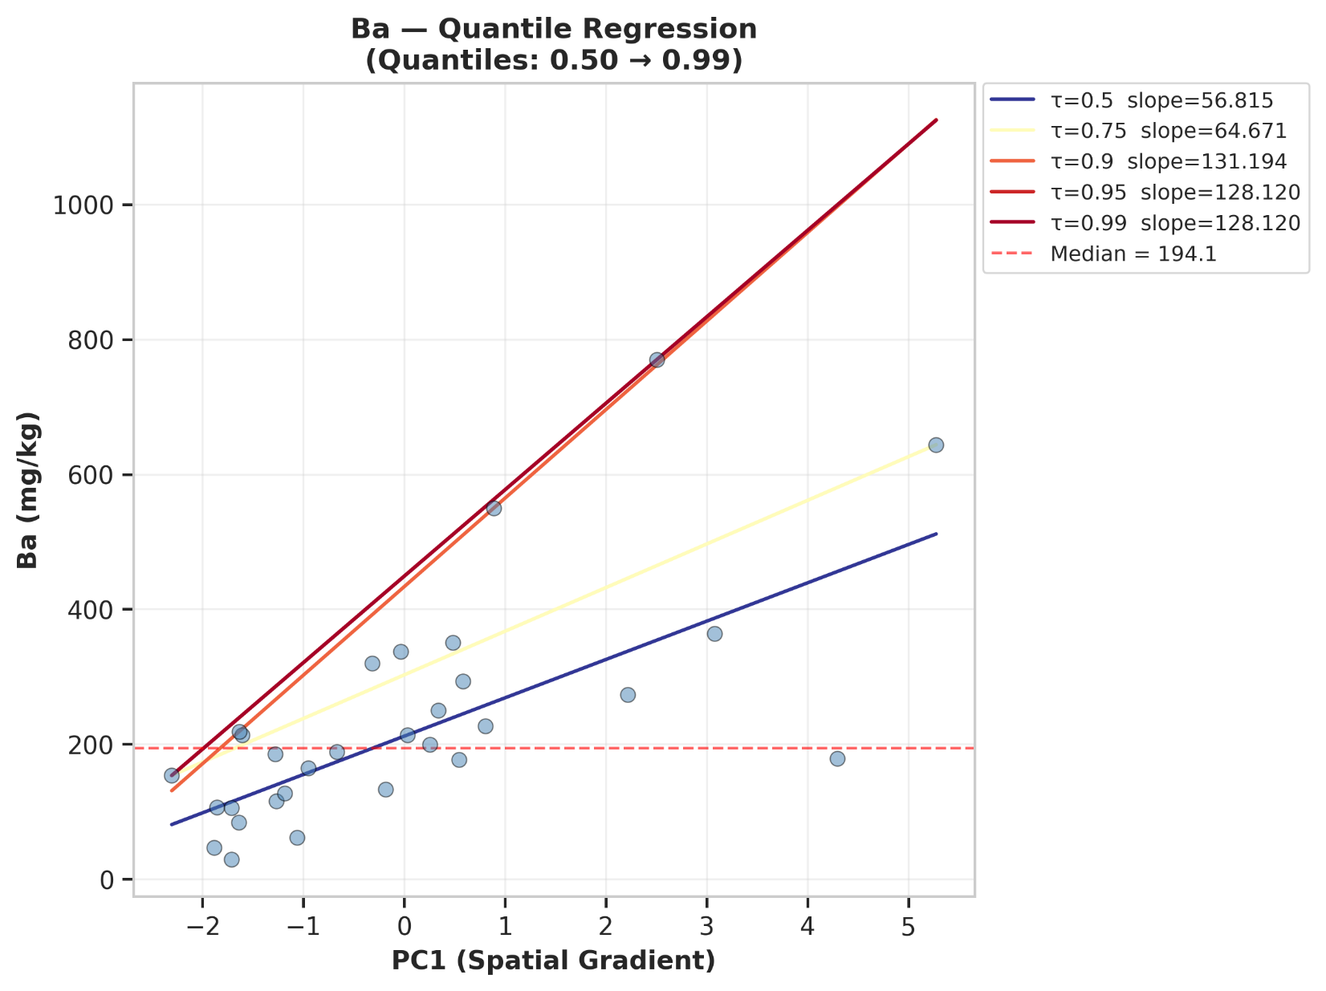
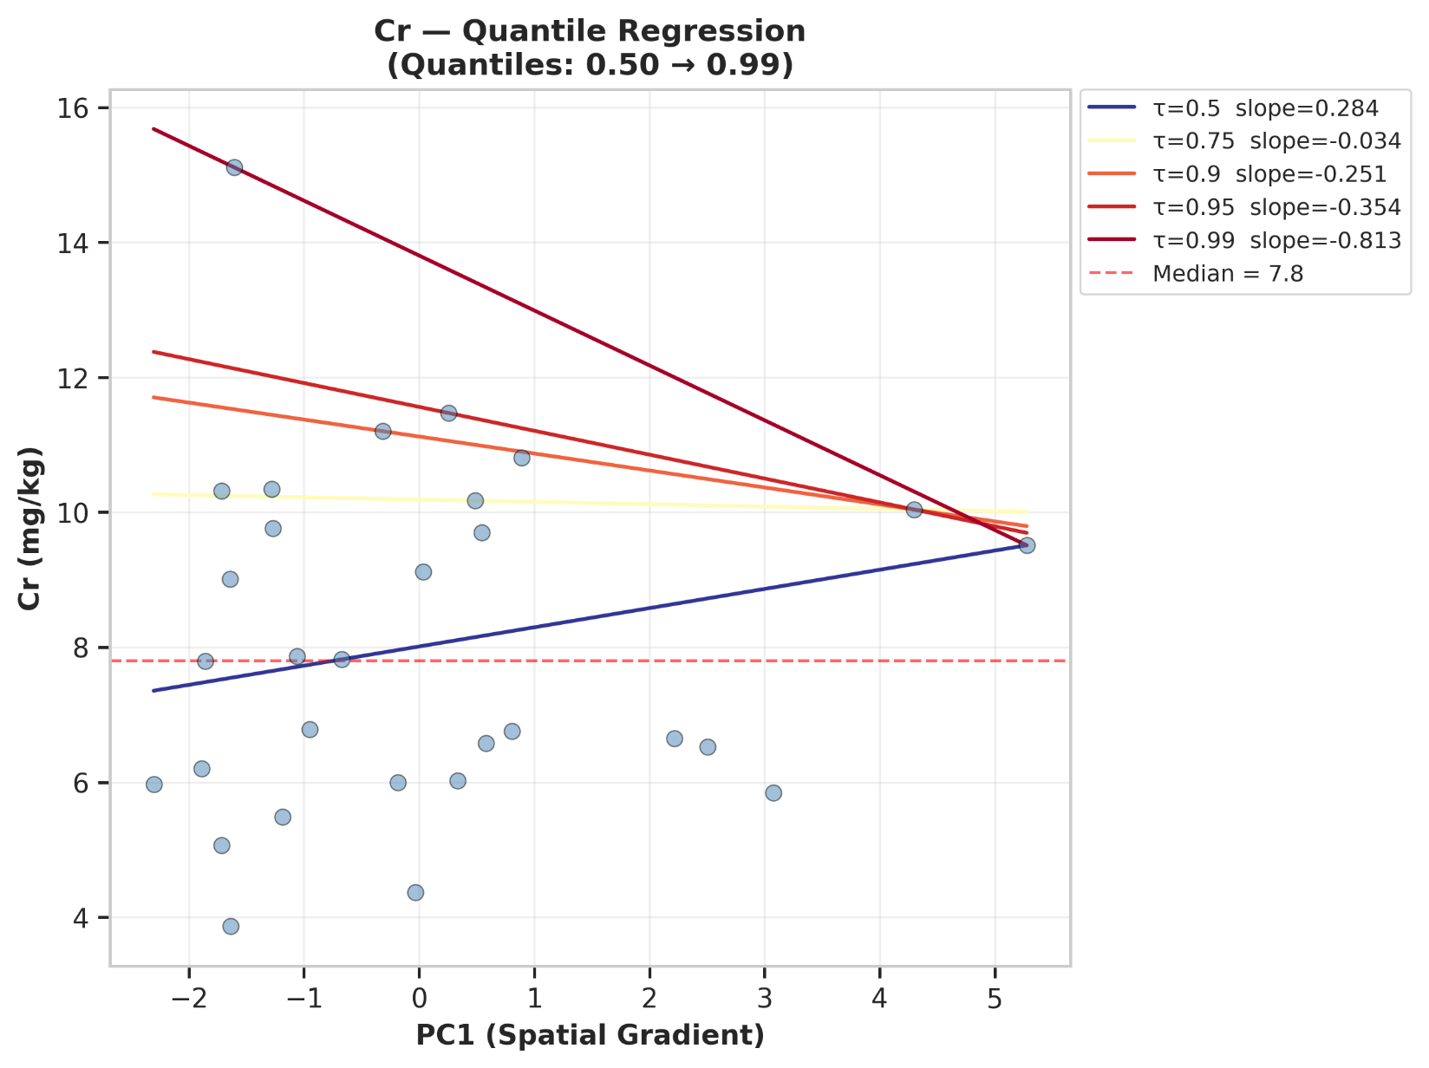
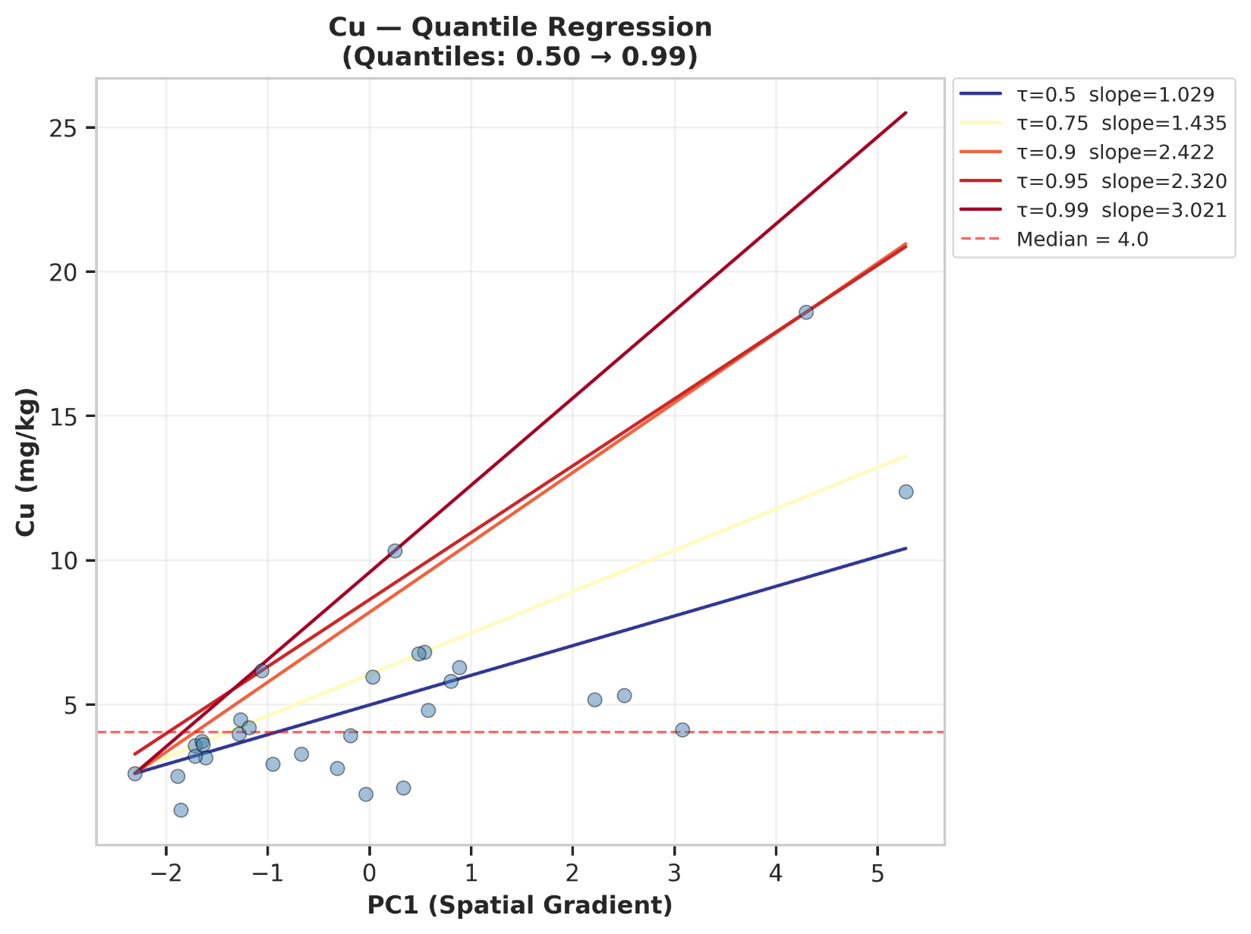
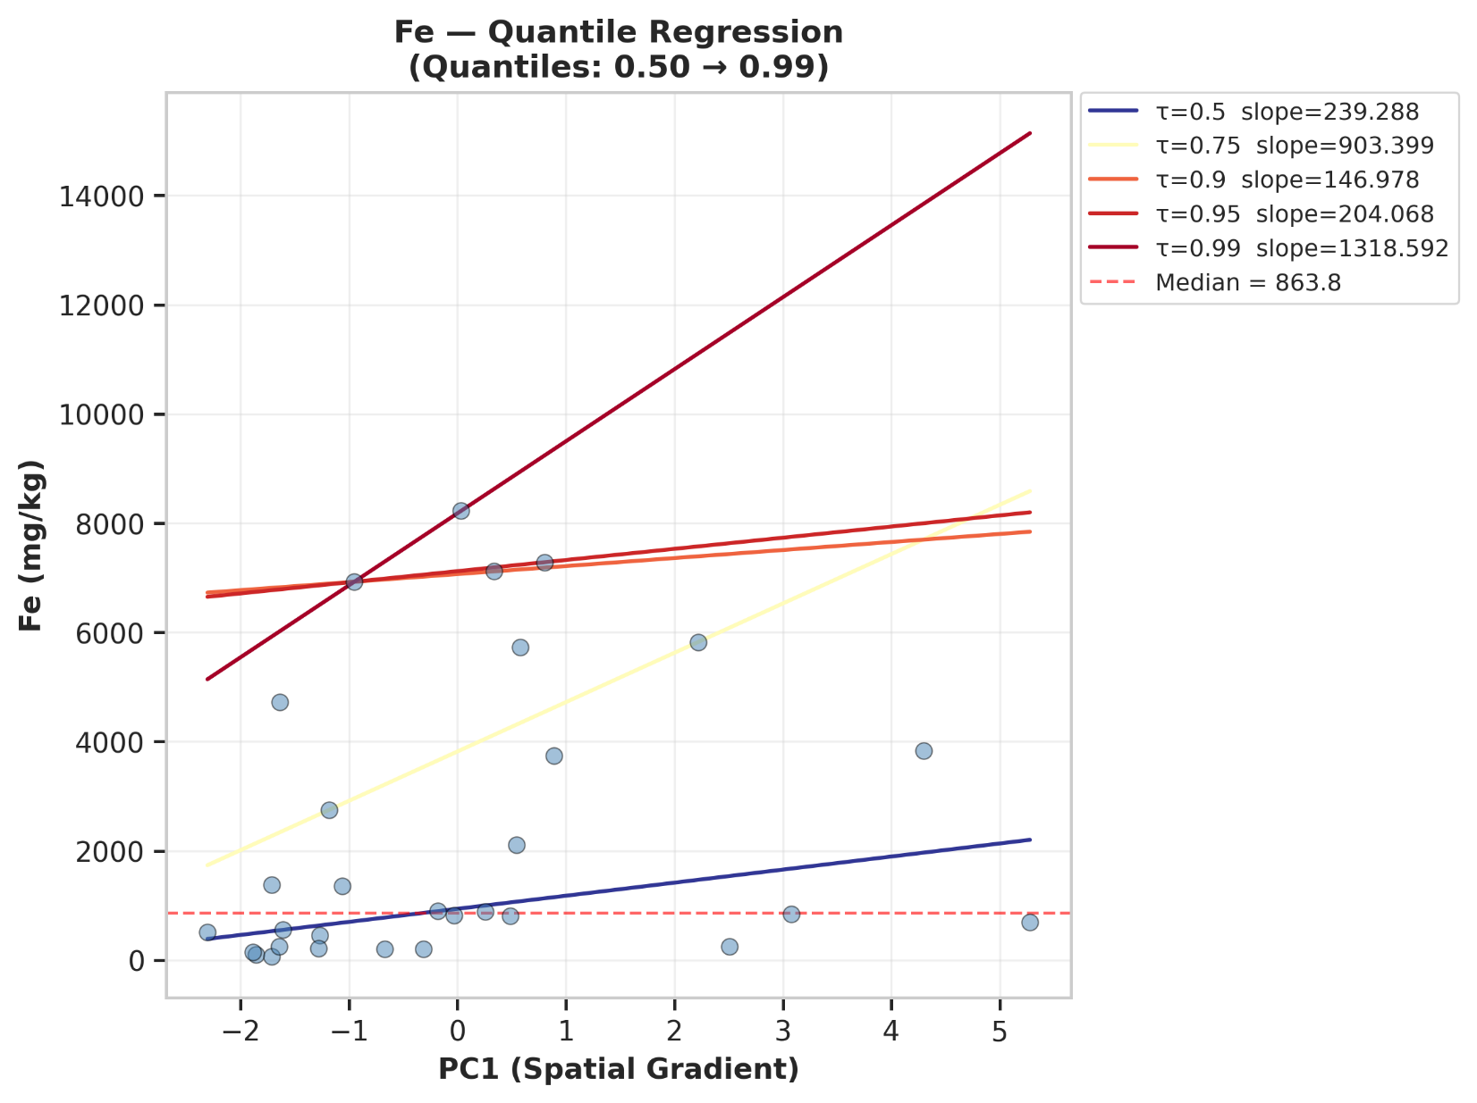
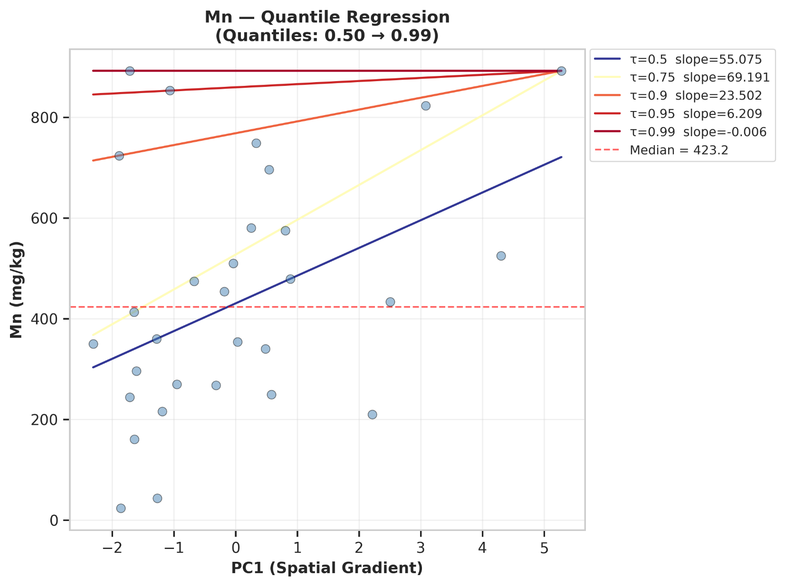
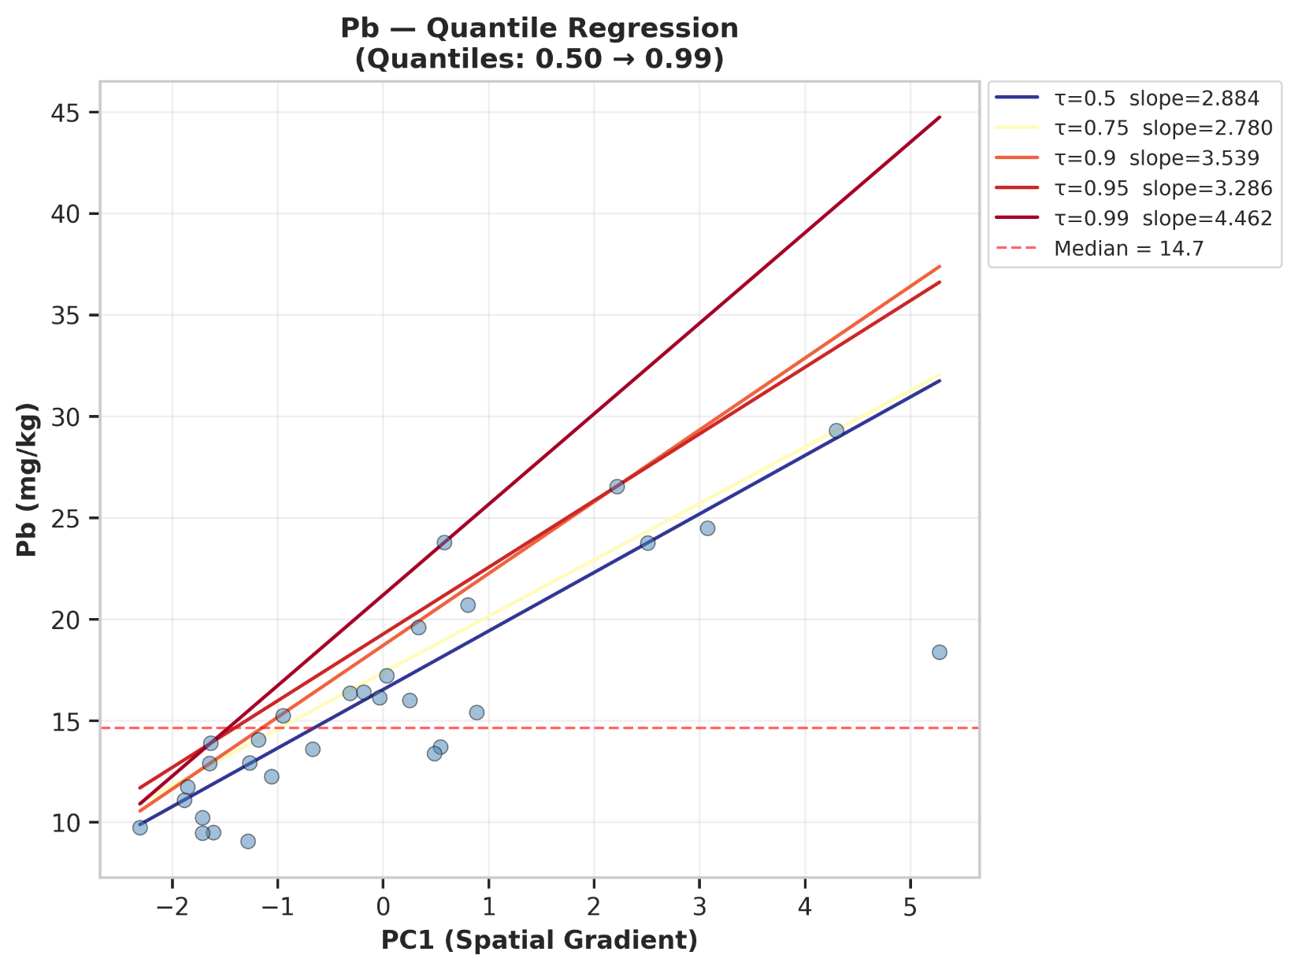
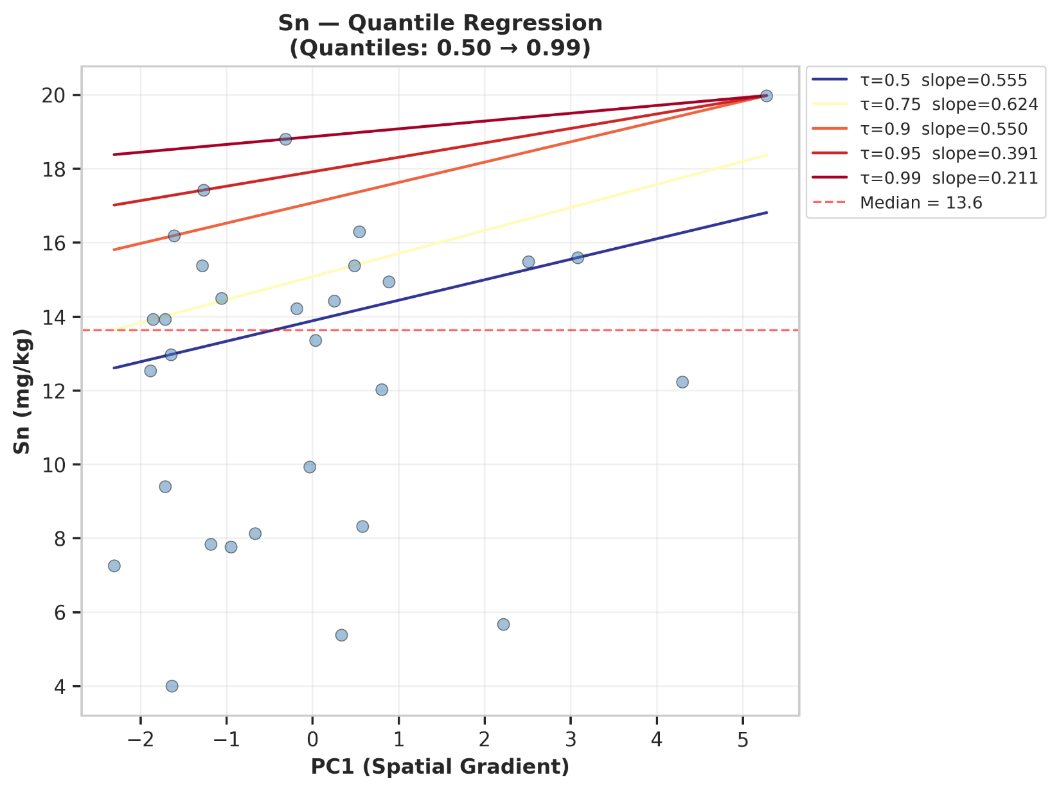
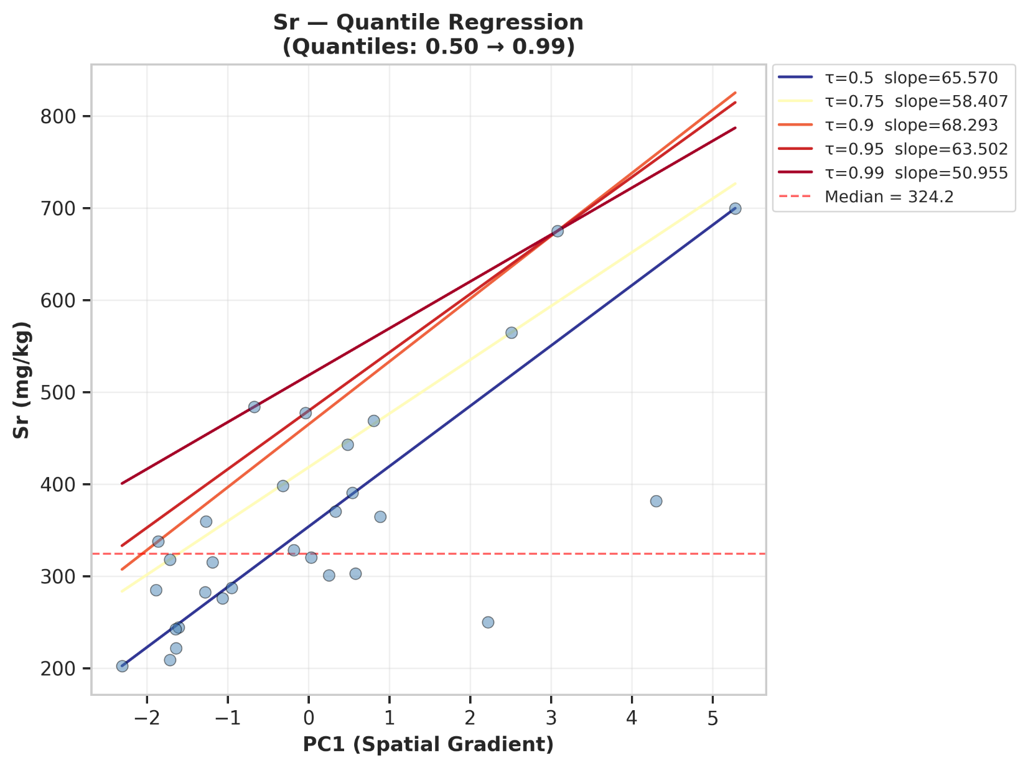
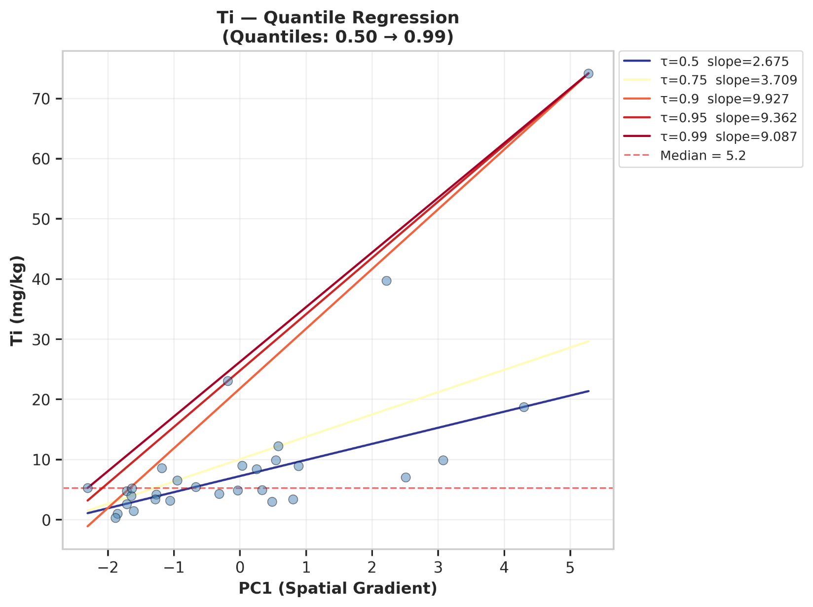
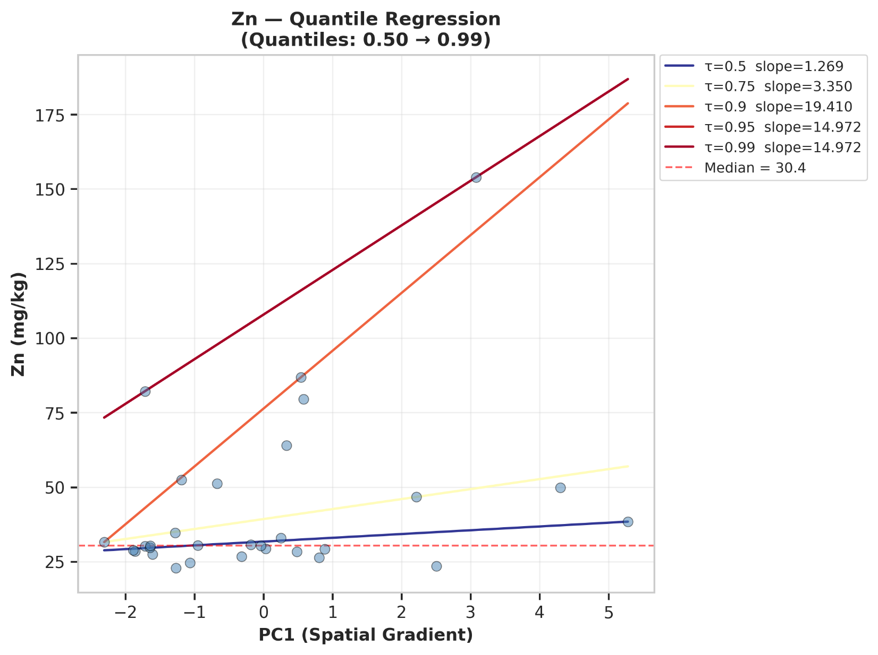

============================================================
QUANTILE REGRESSION — EXTREME VALUE TRENDS
============================================================

Metals with increasing extreme values (99th percentile slope > 0.5):
As: 99th percentile slope = 27.389
B: 99th percentile slope = 69.569
Ba: 99th percentile slope = 128.120
Cu: 99th percentile slope = 3.021
Fe: 99th percentile slope = 1318.592
Pb: 99th percentile slope = 4.462
Sr: 99th percentile slope = 50.955
Ti: 99th percentile slope = 9.087
Zn: 99th percentile slope = 14.972
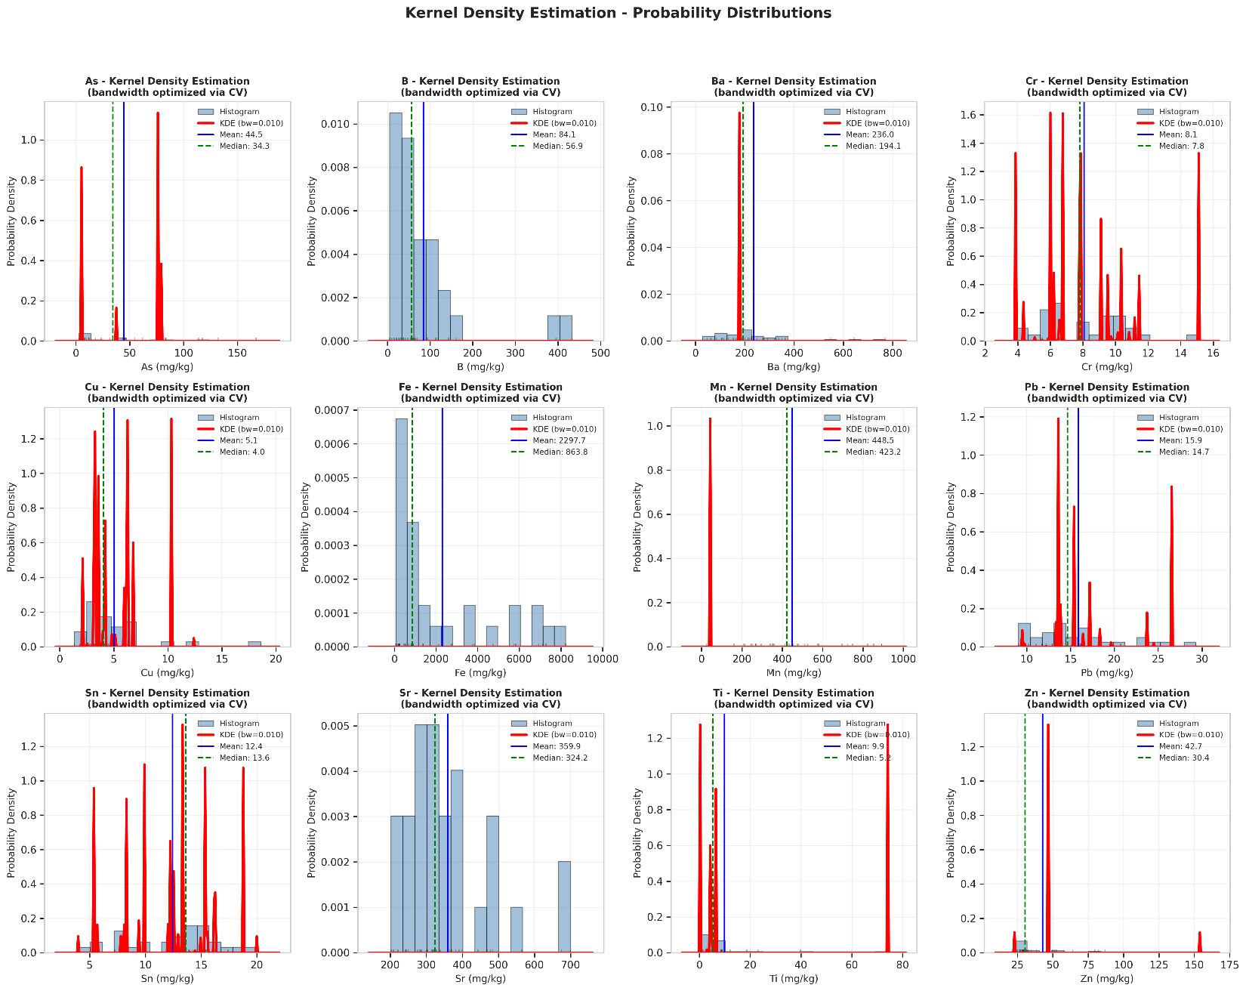

============================================================
KERNEL DENSITY ESTIMATION - OPTIMAL BANDWIDTHS
============================================================
As: bandwidth=0.0100, skewness=1.173
B: bandwidth=0.0100, skewness=2.757
Ba: bandwidth=0.0100, skewness=1.692
Cr: bandwidth=0.0100, skewness=0.607
Cu: bandwidth=0.0100, skewness=2.499
Fe: bandwidth=0.0100, skewness=1.093
Mn: bandwidth=0.0100, skewness=0.340
Pb: bandwidth=0.0100, skewness=0.916
Sn: bandwidth=0.0100, skewness=-0.374
Sr: bandwidth=0.0100, skewness=1.285
Ti: bandwidth=0.0100, skewness=3.584
Zn: bandwidth=0.0100, skewness=2.702
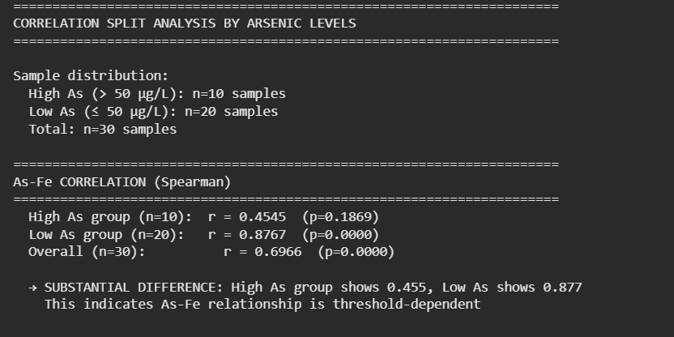
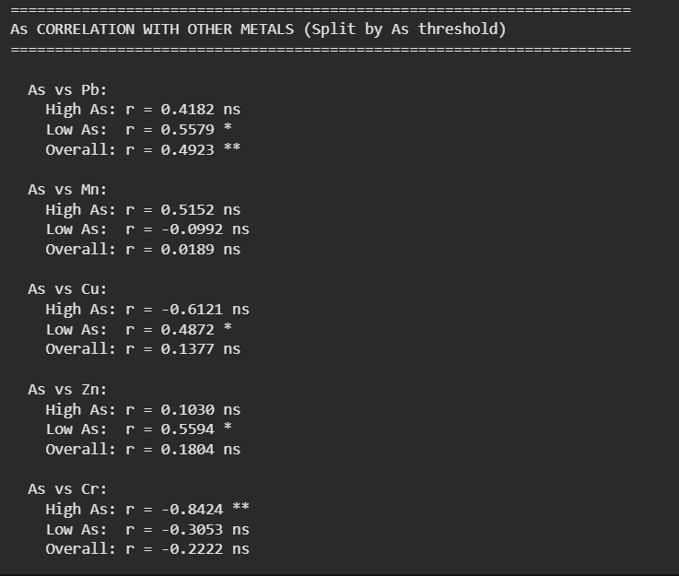
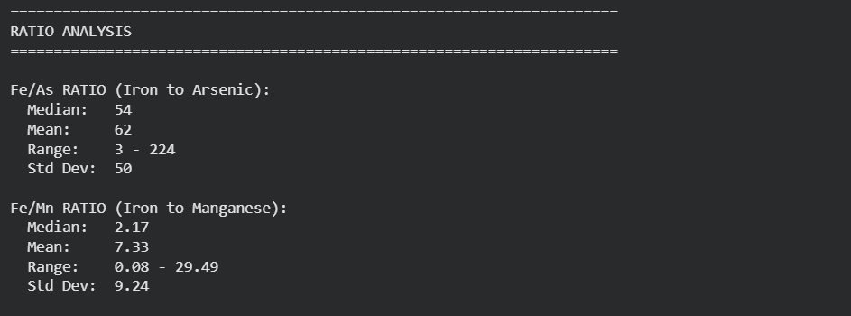
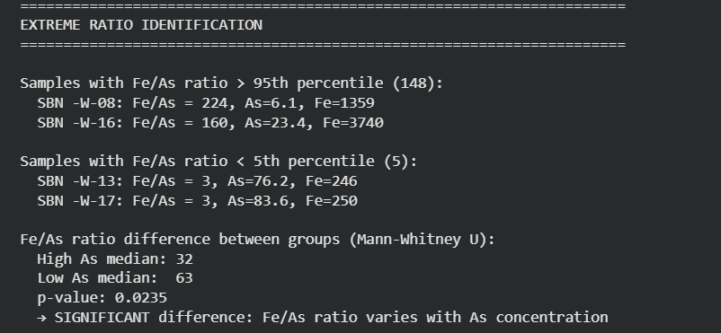
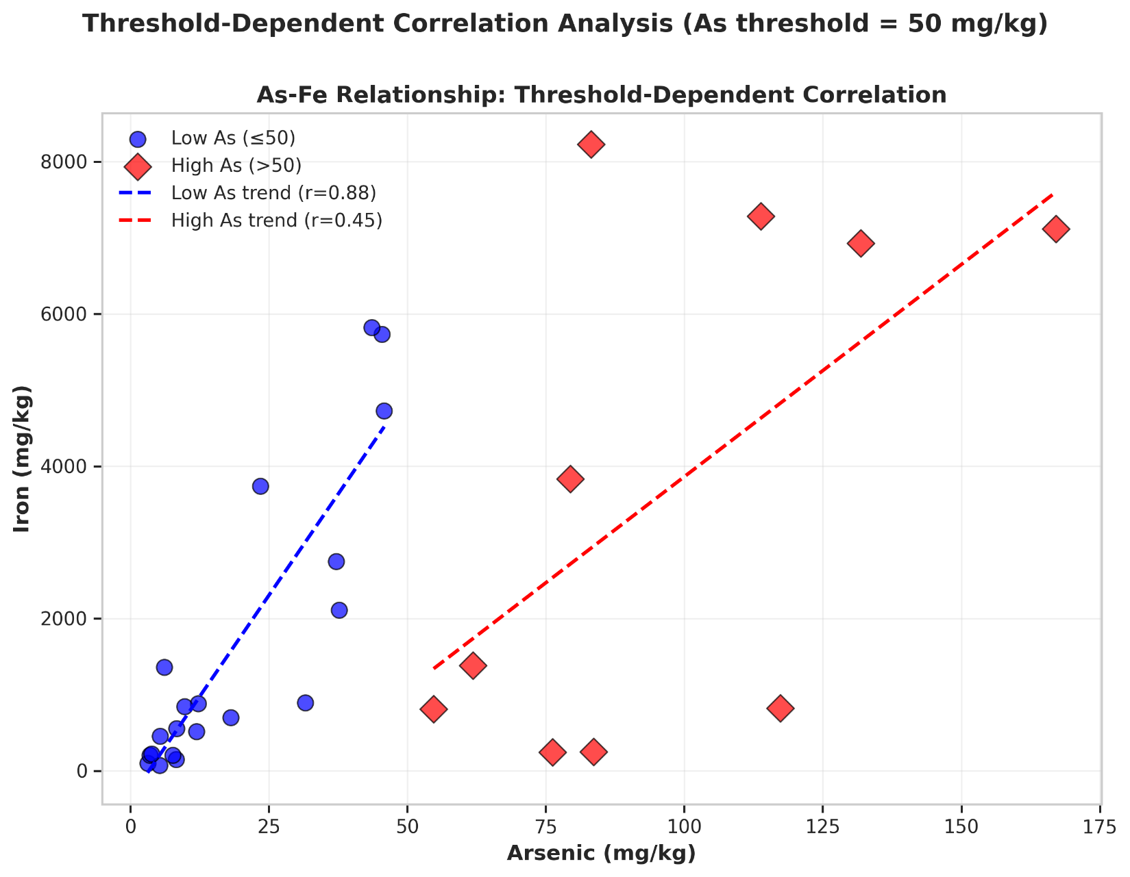
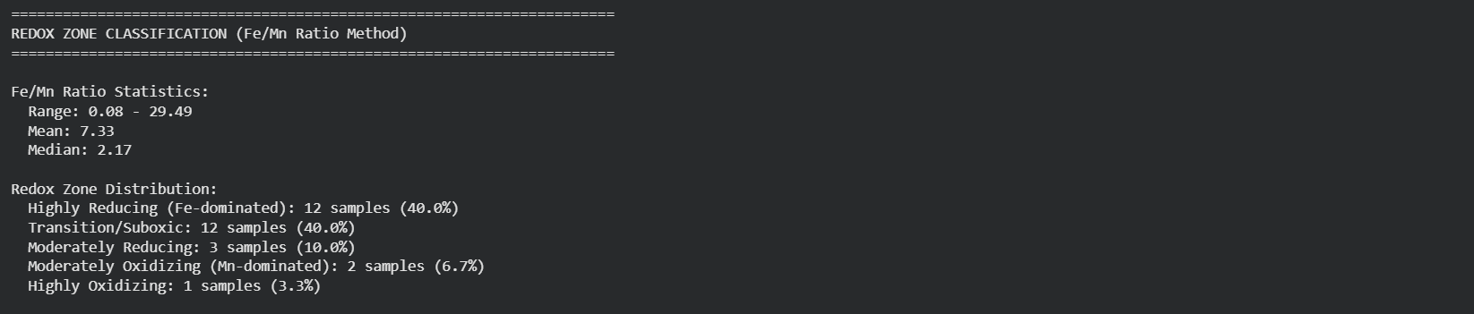
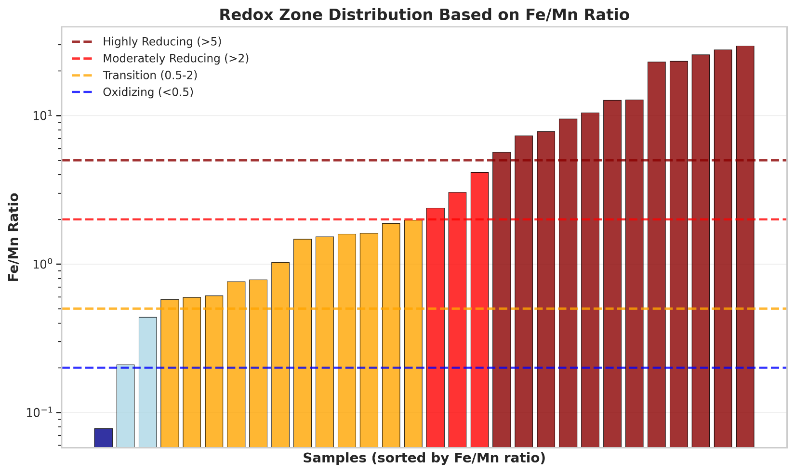
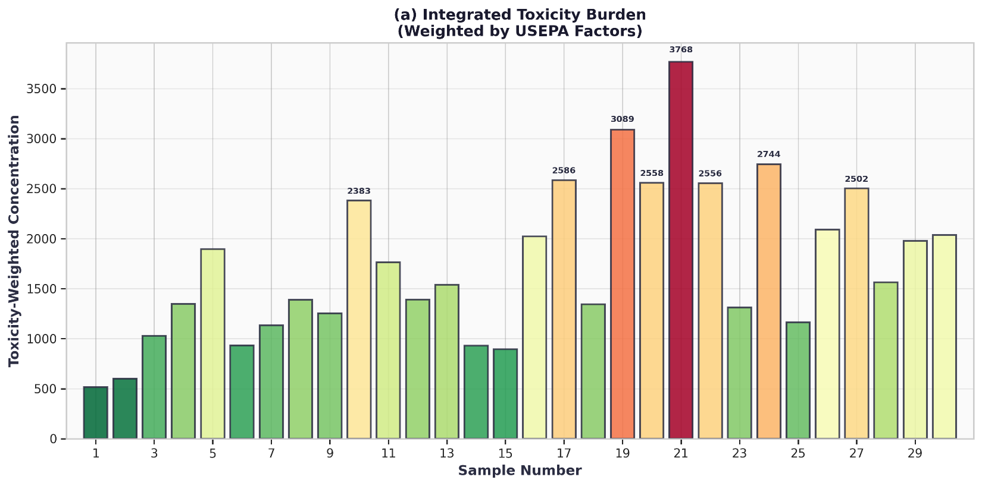
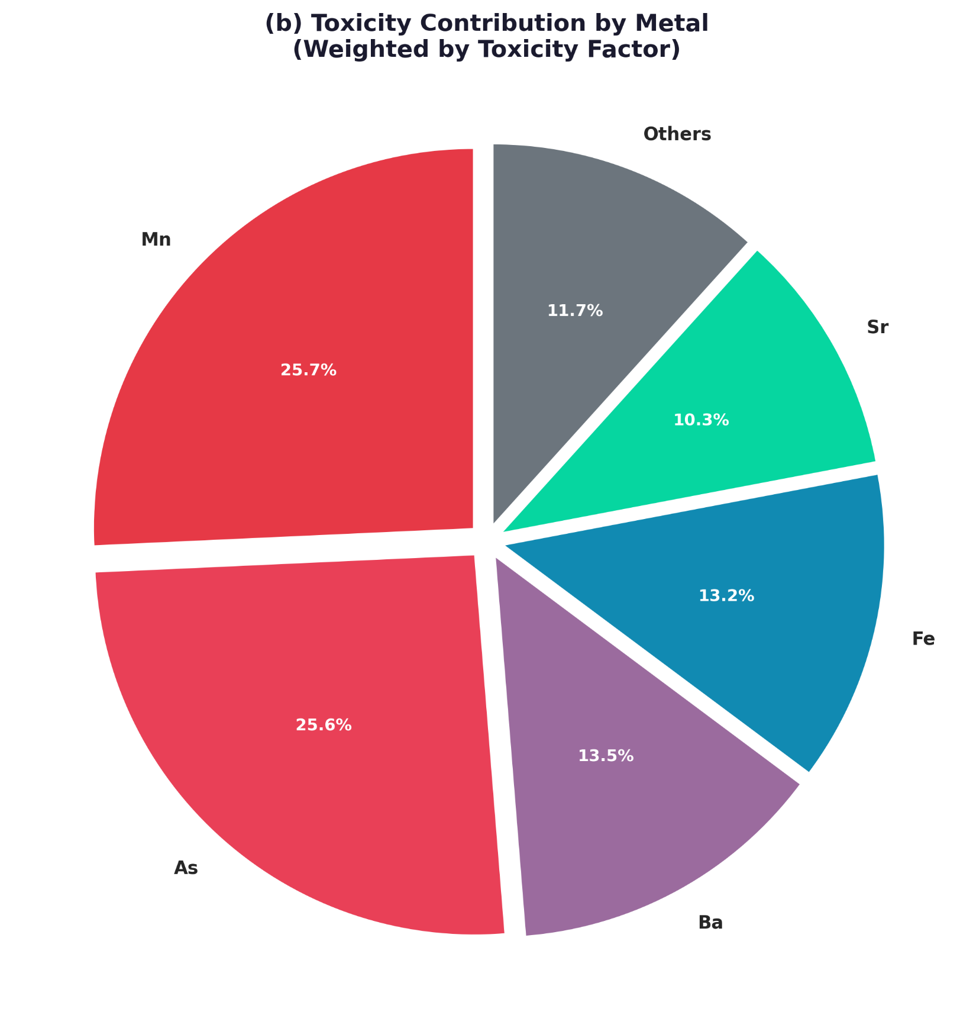
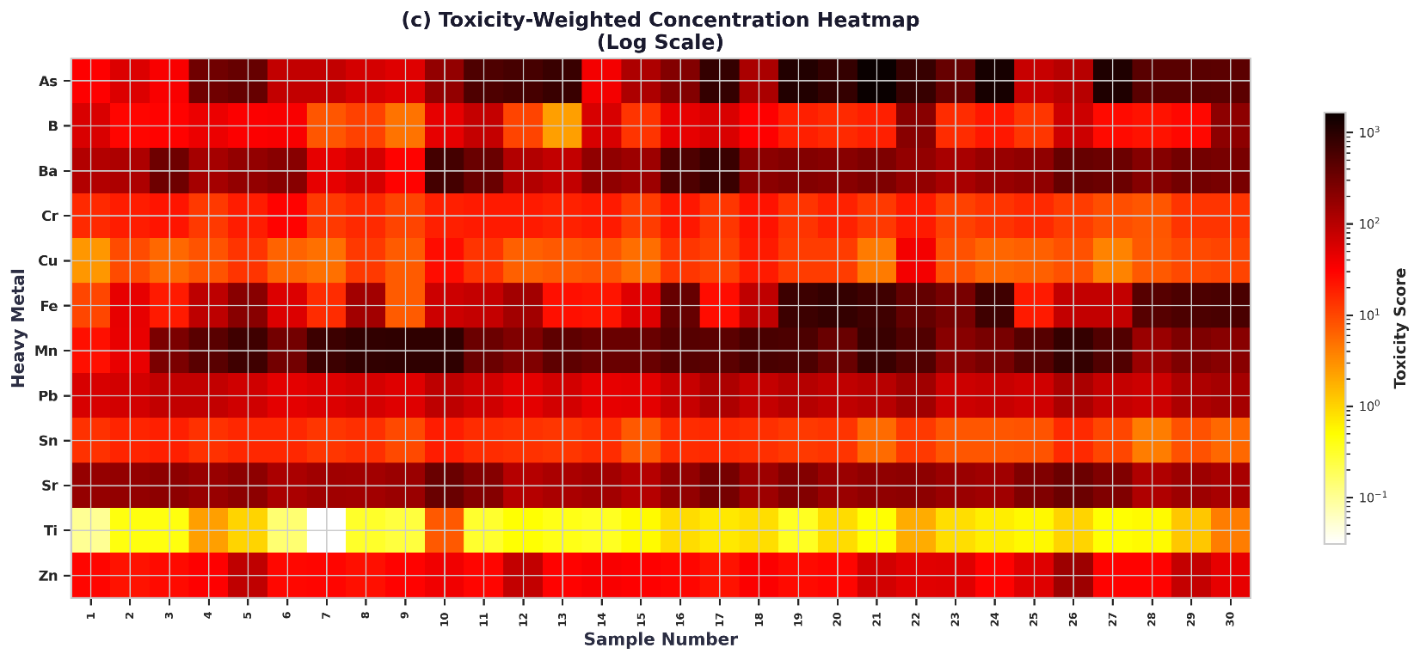
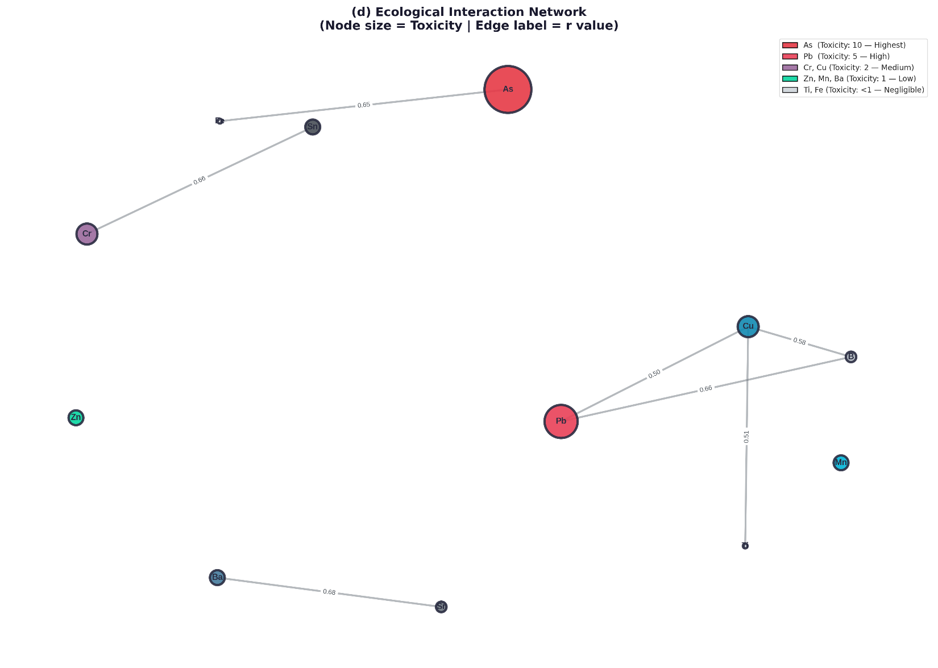
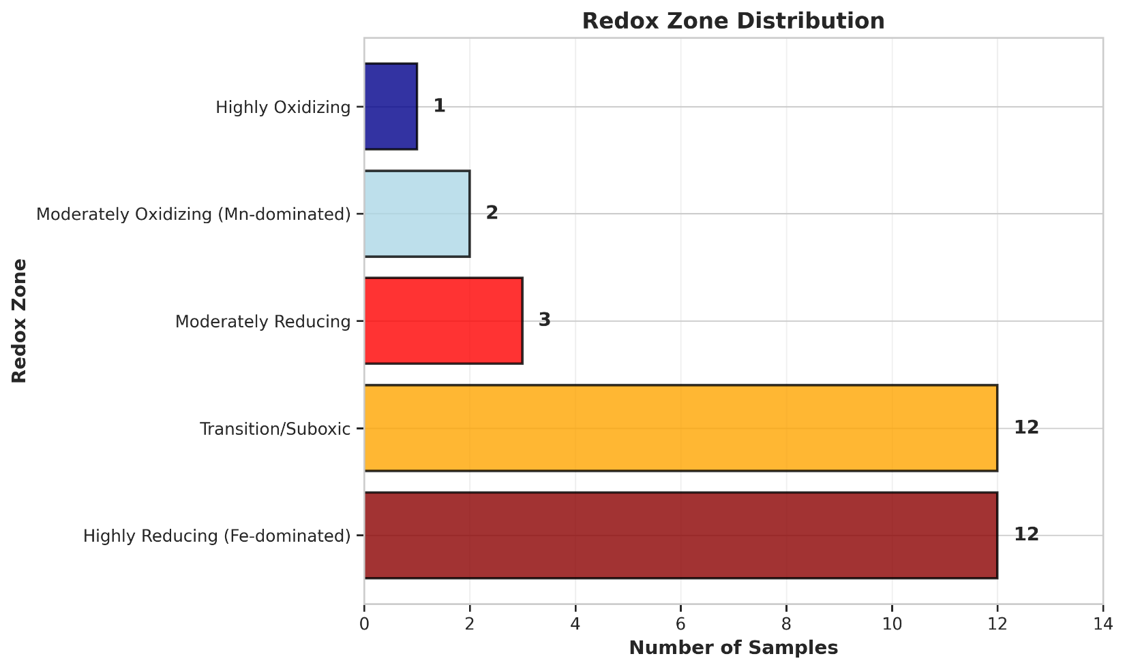
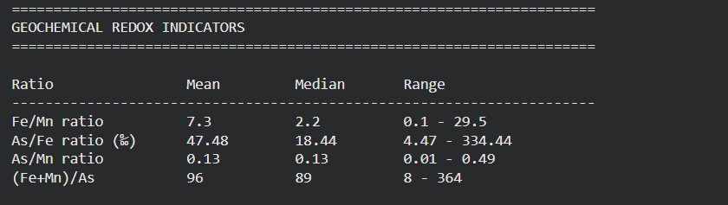
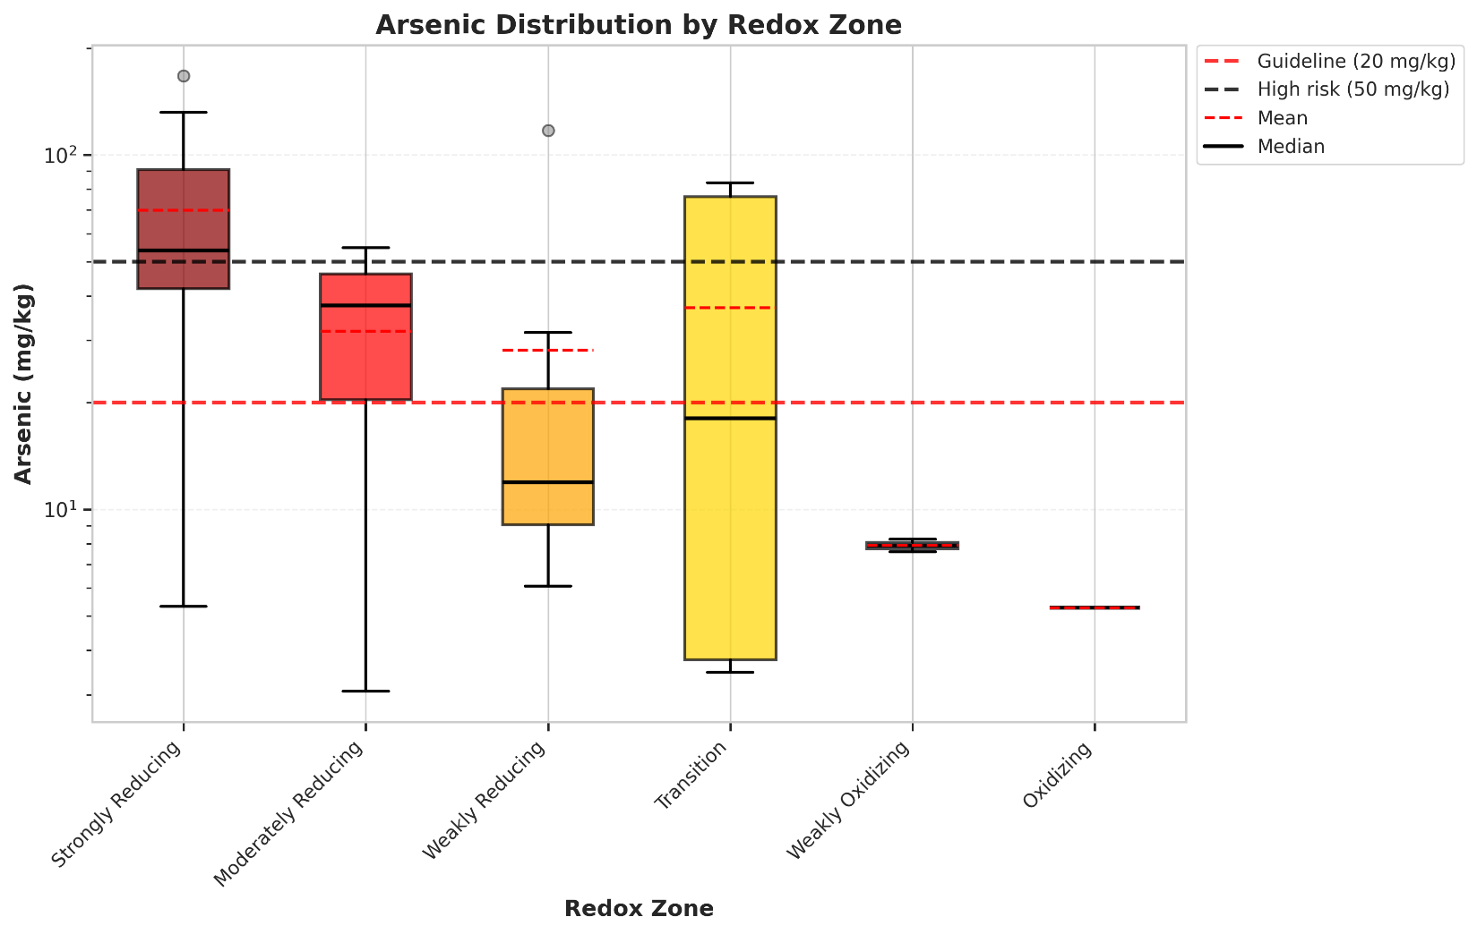

==================================================
ARSENIC DISTRIBUTION BY REDOX ZONE
==================================================

Strongly Reducing:
n = 12 samples
Mean: 69.8 mg/kg
Median: 53.8 mg/kg
Range: 5.3 - 167.1 mg/kg
Exceeds 20 mg/kg: 11 samples (91.7%)
Exceeds 50 mg/kg: 6 samples (50.0%)

Moderately Reducing:
n = 3 samples
Mean: 31.8 mg/kg
Median: 37.7 mg/kg
Range: 3.1 - 54.7 mg/kg
Exceeds 20 mg/kg: 2 samples (66.7%)
Exceeds 50 mg/kg: 1 samples (33.3%)

Weakly Reducing:
n = 7 samples
Mean: 28.2 mg/kg
Median: 11.9 mg/kg
Range: 6.1 - 117.3 mg/kg
Exceeds 20 mg/kg: 2 samples (28.6%)
Exceeds 50 mg/kg: 1 samples (14.3%)

Transition:
n = 5 samples
Mean: 37.0 mg/kg
Median: 18.1 mg/kg
Range: 3.5 - 83.6 mg/kg
Exceeds 20 mg/kg: 2 samples (40.0%)
Exceeds 50 mg/kg: 2 samples (40.0%)

Weakly Oxidizing:
n = 2 samples
Mean: 7.9 mg/kg
Median: 7.9 mg/kg
Range: 7.6 - 8.2 mg/kg

Oxidizing:
n = 1 samples
Mean: 5.3 mg/kg
Median: 5.3 mg/kg
Range: 5.3 - 5.3 mg/kg

Note: As there are 30 samples, and its quiet impossible to create a Machine Learning model. So we created 470 synthetic samples with 30 original samples. And turned the dataset from regression to Classification model…. And then Created a column named Contaminated(Yes, or No).
======================================================================
🔬 HEAVY METAL CONTAMINATION PREDICTION - ML PIPELINE
======================================================================

📊 Dataset Shape: (500, 12)
Features: 12 metals
Target distribution:
Contaminated (1): 409 samples (81.8%)
Clean (0): 91 samples (18.2%)
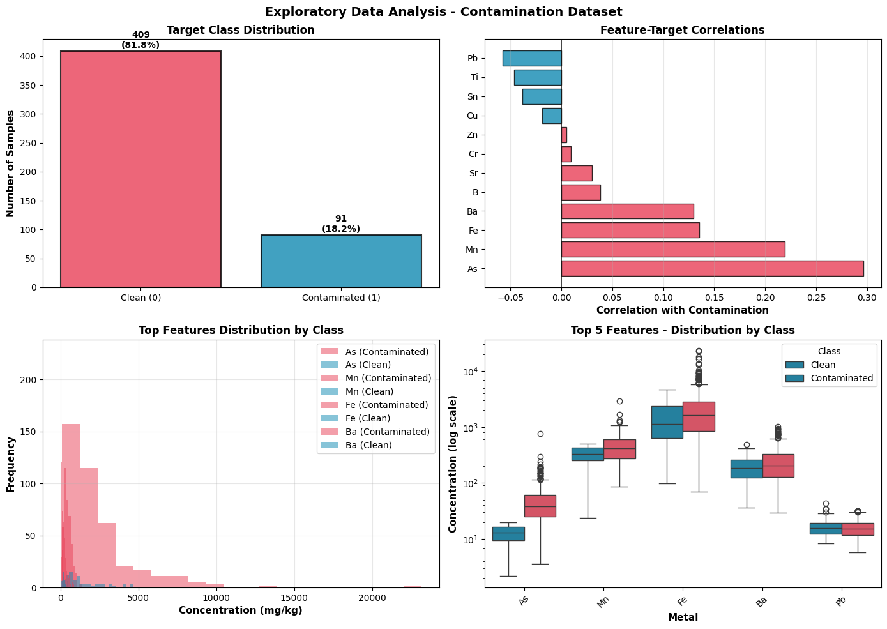

======================================================================
📊 TRAIN-TEST SPLIT
======================================================================
Training set: 375 samples
Contaminated: 307 (81.9%)
Clean: 68 (18.1%)

Test set: 125 samples
Contaminated: 102 (81.6%)
Clean: 23 (18.4%)

⚖️ Class imbalance ratio: 0.221
Applying SMOTE for class balancing...
After SMOTE: 614 samples
Contaminated: 307 (50.0%)
Clean: 307 (50.0%)

======================================================================
🤖 TRAINING MODELS (5-Fold Cross-Validation)
======================================================================

Training Logistic Regression...
✓ CV AUC: 0.9698 ± 0.0208
✓ Test AUC: 0.9761

Training Decision Tree...
✓ CV AUC: 0.9951 ± 0.0066
✓ Test AUC: 0.9853

Training Random Forest...
✓ CV AUC: 0.9999 ± 0.0002
✓ Test AUC: 1.0000

Training Gradient Boosting...
✓ CV AUC: 0.9990 ± 0.0019
✓ Test AUC: 0.9991

Training XGBoost...
✓ CV AUC: 0.9976 ± 0.0033
✓ Test AUC: 0.9996

Training LightGBM...
✓ CV AUC: 0.9996 ± 0.0007
✓ Test AUC: 1.0000

Training CatBoost...
✓ CV AUC: 0.9999 ± 0.0001
✓ Test AUC: 1.0000

Training SVM...
✓ CV AUC: 0.9955 ± 0.0043
✓ Test AUC: 0.9399

Training KNN...
✓ CV AUC: 0.9587 ± 0.0228
✓ Test AUC: 0.8393

Training Naive Bayes...
✓ CV AUC: 0.9825 ± 0.0062
✓ Test AUC: 0.9378

Training AdaBoost...
✓ CV AUC: 0.9980 ± 0.0016
✓ Test AUC: 0.9951
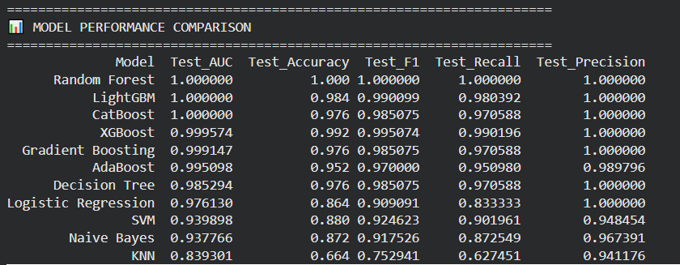
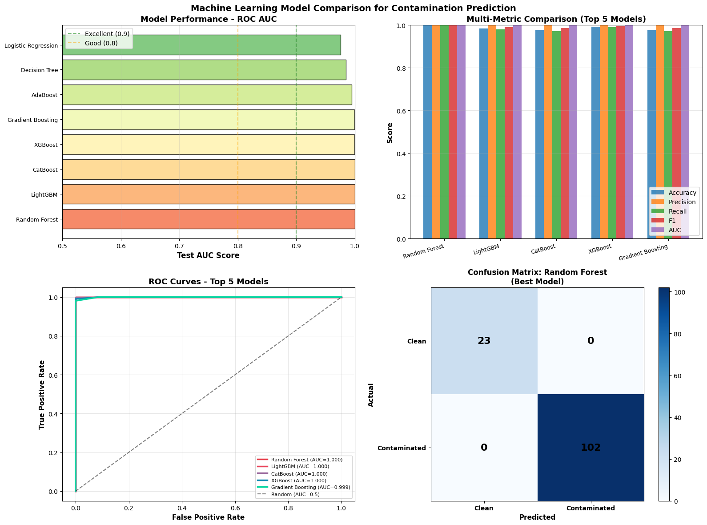
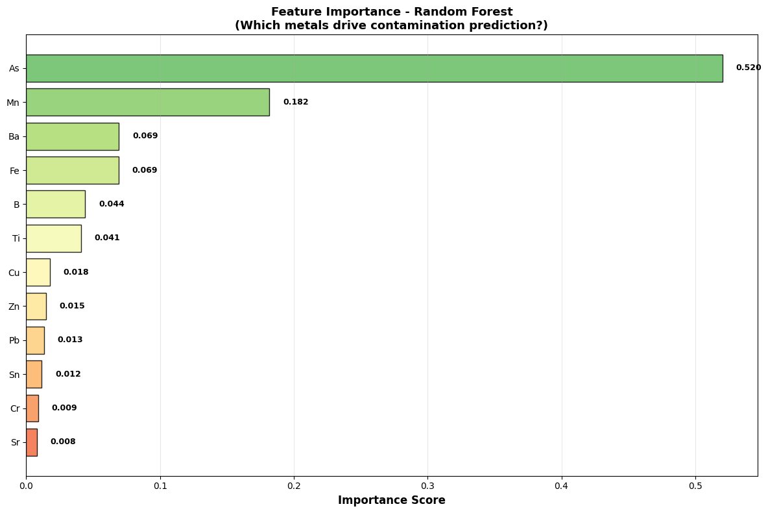

References:
Primary Guidelines & Standards
WHO (2017), Guidelines for drinking-water quality, 4th edn, World Health Organization, Geneva.
Descriptive Statistics, Outlier Analysis & Robust Statistics
He, S, Wu, J, Wang, D & He, X 2025, 'Integrating hydrogeochemical characterization and multivariate statistics to identify groundwater contamination sources and health risks in an intensive industrial region', Environmental Pollution, vol. 383, p. 126833.
Maronna, RA, Martin, RD, Yohai, VJ & Salibián-Barrera, M 2019, Robust statistics: theory and methods (with R), 2nd edn, Wiley, Hoboken, NJ.
Huber, PJ & Ronchetti, EM 2009, Robust statistics, 2nd edn, Wiley, Hoboken, NJ.
Principal Component Analysis (PCA)
Akhtar, N, Syakir Ishak, MI, Ahmad, MI, Umar, K, Md Yusuff, MS, Anees, MT, Qadir, A & Almanassra, IW 2024, 'Evaluation of toxic heavy metal concentration in aquifer system using multivariate statistical methods', Global NEST Journal, vol. 26, no. 3, pp. 1-8.
Rama Mohan, K, Vamshi Krishna, T & Sreedhar, Y 2019, 'Assessment of groundwater quality, toxicity and health risk in an industrial area using multivariate statistical methods', Environmental Systems Research, vol. 8, no. 1, p. 26.

Jolliffe, IT & Cadima, J 2016, 'Principal component analysis: a review and recent developments', Philosophical Transactions of the Royal Society A, vol. 374, no. 2065, p. 20150202.
Cluster Analysis (CA)
Bodrud-Doza, M, Islam, ARMT, Ahmed, F, Das, S, Saha, N & Safiur Rahman, M 2019, 'Characterization of groundwater quality using water evaluation indices, multivariate statistics and geostatistics in central Bangladesh', Water Science, vol. 33, no. 1, pp. 19-36.
Health Risk Assessment (Cancer Risk)
USEPA (United States Environmental Protection Agency) 2011, Exposure factors handbook, EPA/600/R-09/052F, National Center for Environmental Assessment, Washington, DC.
He, S, Wu, J, Wang, D & He, X 2025, 'Integrating hydrogeochemical characterization and multivariate statistics to identify groundwater contamination sources and health risks in an intensive industrial region', Environmental Pollution, vol. 383, p. 126833.
Li, P, Wu, J, Qian, H, Zhang, Y & Yang, N 2016, 'Hydrogeochemical characterization of groundwater in and around a wastewater irrigated forest in the southeastern edge of the Tengger Desert, Northwest China', Exposure and Health, vol. 8, no. 3, pp. 331-348.
Global Sensitivity Analysis (Sobol Indices)
Sobol, IM 2001, 'Global sensitivity indices for nonlinear mathematical models and their Monte Carlo estimates', Mathematics and Computers in Simulation, vol. 55, no. 1-3, pp. 271-280.
Cohen, M, Jakus, G & Farkas, C 2024, 'Identification of parameter importance for benzene transport in the unsaturated zone using global sensitivity analysis', Hydrology and Earth System Sciences, vol. 28, pp. 1585-1604.
Saltelli, A, Ratto, M, Andres, T, Campolongo, F, Cariboni, J, Gatelli, D, Saisana, M & Tarantola, S 2008, Global sensitivity analysis: the primer, Wiley, Chichester, UK.
Quantile Regression
Koenker, R 2005, Quantile regression, Cambridge University Press, New York.
He, Y, Wang, Y, Liu, D & Chen, X 2021, 'A runoff probability density prediction method based on B-spline quantile regression and kernel density estimation', Journal of Hydrology, vol. 598, p. 126473.
Kernel Density Estimation (KDE)
Silverman, BW 1986, Density estimation for statistics and data analysis, Chapman & Hall, London.
Das, S & Racine, JS 2016, 'Nonparametric analysis of complex nonlinear systems', McMaster University Working Paper, no. 2016-01.
Machine Learning for Contamination Prediction
Egbueri, JC 2020, 'Prediction of heavy metal contamination in groundwater using machine learning models', Chemistry Africa, vol. 3, no. 4, pp. 987-1001.
Khalil, A, Almasri, MN, McKee, M & Kaluarachchi, JJ 2005, 'Applicability of statistical learning algorithms in groundwater quality modeling', Water Resources Research, vol. 41, no. 5, p. W05010.
Chawla, NV, Bowyer, KW, Hall, LO & Kegelmeyer, WP 2002, 'SMOTE: synthetic minority over-sampling technique', Journal of Artificial Intelligence Research, vol. 16, pp. 321-357.
Breiman, L 2001, 'Random forests', Machine Learning, vol. 45, no. 1, pp. 5-32.
Chen, T & Guestrin, C 2016, 'XGBoost: a scalable tree boosting system', Proceedings of the 22nd ACM SIGKDD International Conference on Knowledge Discovery and Data Mining, San Francisco, CA, August, pp. 785-794.
General Multivariate Statistics for Groundwater
Güler, C, Thyne, GD, McCray, JE & Turner, KA 2002, 'Evaluation of graphical and multivariate statistical methods for classification of water chemistry data', Hydrogeology Journal, vol. 10, no. 4, pp. 455-474.

