This lab demonstrates access of a web site from a desktop Java app as well as from an Android app.

Let’s start with desktop Java.

1. Save the following code in a file named URLReader2.java

import java.net.*;

import java.io.*;

public class URLReader2 {

public static void main(String[] args) {

try {

URL oracle = new URL("https://www.bcit.ca/");Command

BufferedReader in = new BufferedReader(

new InputStreamReader(oracle.openStream()));

String inputLine;

while ((inputLine = in.readLine()) != null)

System.out.println(inputLine);

in.close();

} catch(Exception ex) { }

}

}

1. Assuming that you had installed Java SE on your computer. Open up command prompt, go to the folder where URLReader2.java was saved (by using cd command), and then compile and run the code by typing the following on the command prompt:

CD C:\Users\Rabby\IdeaProjects\URLReader2.java\src

Set path = C:\Program Files\Java\jdk-13.0.2\bin

javac URLReader2.java

java URLReader2

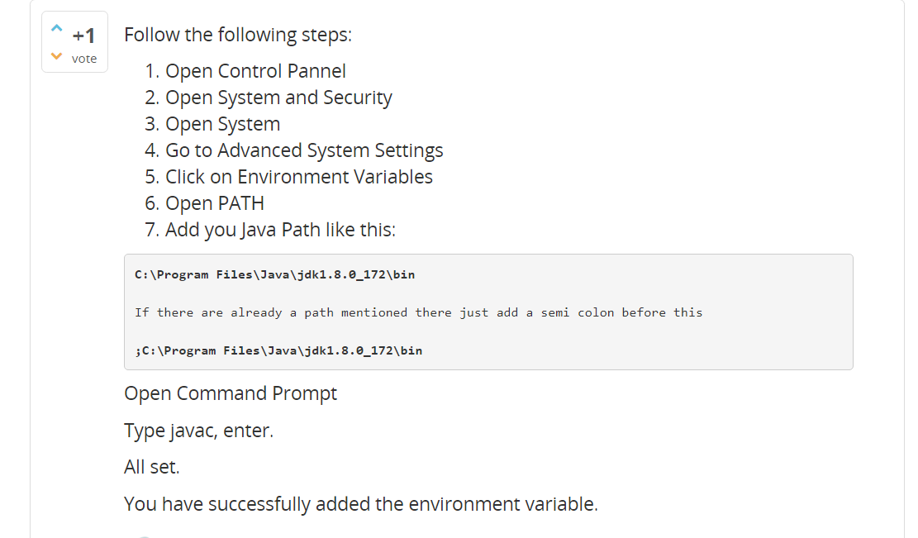

1. If you see a long web page (it is actually BCIT web site’s home page) printed on the console then you are done.

Let’s now try accessing BCIT’s home page from an Android app. Given below are the manifest file, layout file and the java file for your reference. Create an app using this reference code. When you run the app, you should see the same web page displayed on the text view of the app. Note the use of AsyncTask.

*<?***xml version="1.0" encoding="utf-8"***?>*<**manifest xmlns:android="http://schemas.android.com/apk/res/android"  
 package="com.example.http"**>  
 <**application  
 android:allowBackup="true"  
 android:icon="@mipmap/ic_launcher"  
 android:label="@string/app_name"  
 android:roundIcon="@mipmap/ic_launcher_round"  
 android:supportsRtl="true"  
 android:theme="@style/AppTheme"**>  
 <**activity android:name=".MainActivity"**>  
 <**intent-filter**>  
 <**action android:name="android.intent.action.MAIN"** />  
  
 <**category android:name="android.intent.category.LAUNCHER"** />  
 </**intent-filter**>  
 </**activity**>  
 </**application**>  
 <**uses-permission android:name="android.permission.INTERNET"** />  
</**manifest**>

<RelativeLayout xmlns:android="http://schemas.android.com/apk/res/android"

xmlns:tools="http://schemas.android.com/tools"

android:layout_width="match_parent"

android:layout_height="match_parent"

tools:context=".MainActivity" >

<TextView

android:id="@+id/textView"

android:layout_width="wrap_content"

android:layout_height="wrap_content"

android:text="" />

</RelativeLayout>

**package** com.example.http;  
**import** androidx.appcompat.app.AppCompatActivity;  
**import** android.os.AsyncTask;  
**import** android.os.Bundle;  
**import** android.util.Log;  
**import** android.widget.TextView;  
**import** java.io.BufferedReader;  
**import** java.io.IOException;  
**import** java.io.InputStream;  
**import** java.io.InputStreamReader;  
**import** java.net.HttpURLConnection;  
**import** java.net.URL;  
**public class** MainActivity **extends** AppCompatActivity {  
 TextView **textView** ;  
 @Override  
 **protected void** onCreate(Bundle savedInstanceState) {  
 **super**.onCreate(savedInstanceState);  
 setContentView(R.layout.***activity_main***);  
 **textView** = (TextView)findViewById(R.id.***textView***);  
 DownloadWebPageTask task = **new** DownloadWebPageTask();  
 task.execute(**new** String[] { **"https://www.bcit.ca"** });  
 }  
 **private class** DownloadWebPageTask **extends** AsyncTask<String, Void, String> {  
 @Override  
 **protected** String doInBackground(String... urls) {  
 String response = **""**;  
 BufferedReader br = **null**;  
 HttpURLConnection urlConnection = **null**;  
 BufferedReader reader = **null**;  
 **try** {  
 URL url = **new** URL(urls[0]);  
 urlConnection = (HttpURLConnection) url.openConnection();  
 urlConnection.setRequestMethod(**"GET"**);  
 urlConnection.connect();  
 InputStream inputStream = urlConnection.getInputStream();  
 StringBuffer buffer = **new** StringBuffer();  
 **if** (inputStream == **null**) {  
 **return null**;  
 }  
 br = **new** BufferedReader(**new** InputStreamReader(inputStream));  
 String line = **null**;  
 **while** ((line = br.readLine()) != **null**) {  
 response += line;  
 }  
 **if** (response.length() == 0) {  
 **return null**;  
 }  
 br.close();  
 } **catch** (Exception e) {  
 e.printStackTrace();  
 } **finally**{  
 **if** (urlConnection != **null**) {  
 urlConnection.disconnect();  
 }  
 **if** (reader != **null**) {  
 **try** {  
 br.close();  
 } **catch** (**final** IOException e) {  
 Log.*e*(**"PlaceholderFragment"**, **"Error closing stream"**, e);  
 }  
 }  
 }  
 **return** response;  
 }  
 @Override  
 **protected void** onPostExecute(String result) {  
 **textView**.setText(result);  
 }  
 }  
}