

Program: Computer Science and Engineering

Digital Electronics & Pulse Technique Lab

**Course Code: CSE-2366**

* **Lab Work: 05**Topic: Implementation Transistor Transistor Logic (TTL) NOT gate in tinkercad.

**Submitted by**

* Name:Md. Tanvir Hasan Rafi
* ID: 41230100716
* Section: 6A
* Date of Submission: 17.12.2024

**Submitted to**

**Nizia Nahyan**

Lecturer,

Department of CSE

* **Lab Work 05:** **Implement Transistor Transistor Logic (TTL) NOT gate in tinkercad.**
* **TTL NOT GATE:**

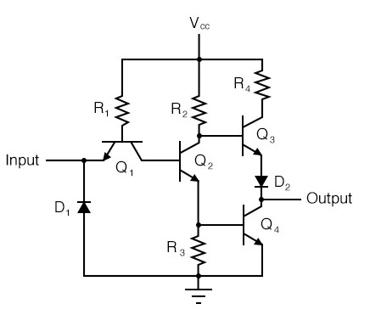

*Fig:1.1 TTL NOT Gate Diagram*

*7432*

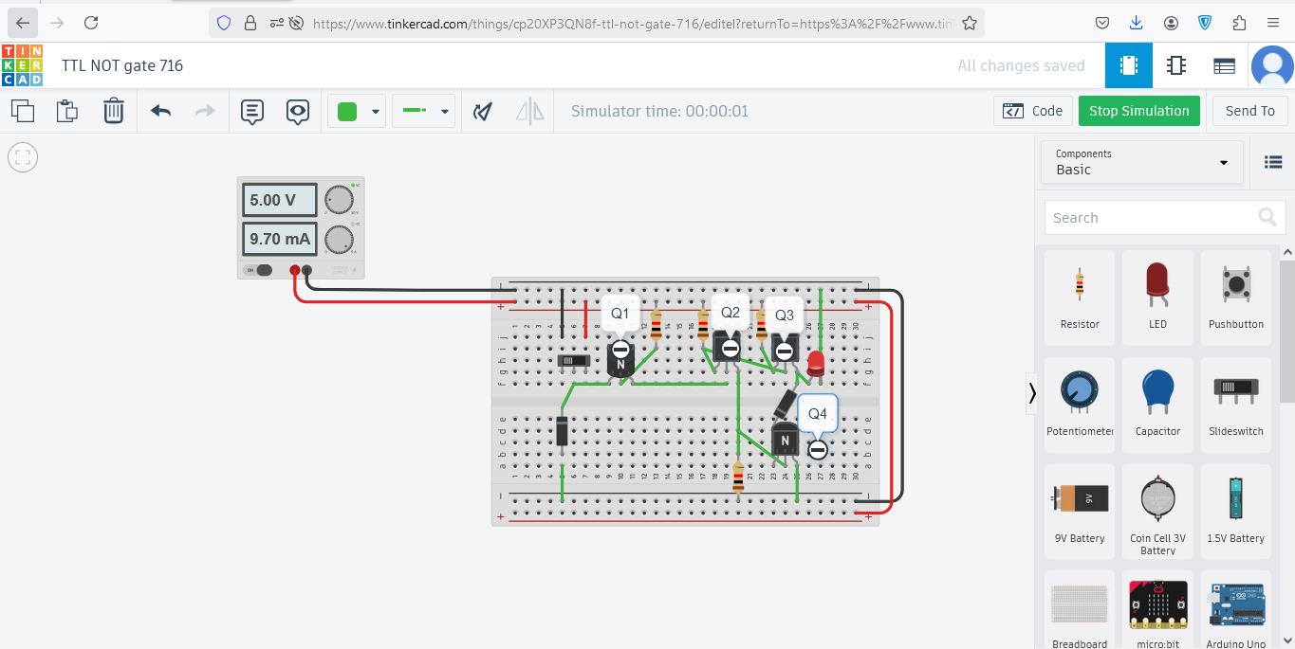

*Fig:1.2 Implementation of TTL NOT GATE*

**Circuit Link:** [**https://www.tinkercad.com/things/cp20XP3QN8f-ttl-not-gate-716**](https://www.tinkercad.com/things/cp20XP3QN8f-ttl-not-gate-716)