Battery Health Prediction and Remaining Useful Life Estimation Using Machine Learning

Submitted by
Rabeea Anjum (23CSE09)
A Complex Engineering Project (CEP) Report is prepared in the supervision of Dr. Muhammad Bux Alvi
Department of Computer Systems Engineering
Faculty of Engineering and Technology
The Islamia University of Bahawalpur

Battery Health Prediction and Remaining Useful Life Estimation Using Machine Learning
Rabeea Anjum and Muhammad Bux Alvi1
Department of Computer Systems Engineering
Faculty of Engineering & Technology
The Islamia University of Bahawalpur
Abstract:

The lithium ion battery has been the backbone of modern energy storage technology, from electric vehicles (EV) to standby power for consumer electronics and energy storage for renewable energy sources^{[1,4]}. However, a fundamental issue of concern for system reliability and safety is progressive degradation of performance when the battery is repeatedly charged and discharged^{[5,25]}. This project proposes a machine learning-based Battery Management System (BMS) for the prediction of battery degradation with high accuracy. The system simultaneously predicts two main targets: State of Health (SOH) and Remaining Useful Life (RUL) ^{[14]} based on operational parameters such as charging current, charging voltage, charging temperature, discharging current, discharging voltage, discharging temperature, and number of cycles. The methodology adopted is based on Exploratory Data Analysis (EDA), outlier identification by IQR, engineering and normalization the features according to their value of domains using the StandardScaler ^{[7]}, and the application of a Random Forest multi-output regression model ^{[6]} for the modeling of real lithium-ion battery cycling data from three battery cells (B5, B6, B7) ^{[2]}. When analysing the importance of the nature of the analysis, the cycle count has a predictive importance of around 95.19% ^{[1]}. The trained model showed good predictive performance and was suitable to deploy to intelligent battery analytics and real-time BMS use cases ^{[5]}.
Keywords:

Lithium-Ion Battery, Battery Management System (BMS), State of Health (SOH), Remaining Useful Life (RUL), Battery Charging Time (BCt), Random Forest Regression, Multi-Output Regression, Feature Engineering, Exploratory Data Analysis (EDA), Machine Learning, Predictive Maintenance, Cycle Degradation, Scikit-Learn

Table of Contents

Abstract 2
Table of Contents 3
1. Introduction 5
2. Project Overview 6
3. Objectives 6
4. Dataset Description 7
4.1 Input Features 7
4.2 Target Variables 7
5. Complete Python Code 7
Step 1 — Import Libraries 7
Step 2 — Upload & Load Dataset 8
Step 3 — Basic Dataset Information 8
Step 4 — Check Missing Values 8
Step 5 — Label Encoding 8
6. Exploratory Data Analysis (EDA) 8
6.1 Correlation Heatmap 9
6.2 Cycle vs State of Health (SOH) 9
6.3 Cycle vs Remaining Useful Life (RUL) 9
6.4 Charging Temperature vs SOH 10
6.5 Battery Type vs SOH 10
7. Outlier Detection 10
7.1 Boxplot Visualization 10
7.2 IQR Outlier Detection 11
8. Feature Engineering 11
9. Feature Scaling 11
10. Train-Test Split 12
11. Machine Learning Model 12
11.1 Model Used 12
11.2 Why Random Forest? 12
12. Model Evaluation 12
12.1 Actual vs Predicted SOH 13
12.2 Actual vs Predicted RUL 13
13. Feature Importance Analysis 14
13.1 Key Scientific Finding 14
14. Results 14
15. Key Insights 14
16. Future Work 15
17. Technologies Used 15

1. Introduction
Lithium-ion batteries have emerged as a strategic player in recent engineering with their fast expansion in the international growth of electric cars, portable electronics and grid level huge energy storage ^{[1,4]}. Compared to other chemistries ^{[21]} these electrochemical cells have high energy density, low self discharge and long cycle life. However, battery performance inevitably deteriorates over time, caused by complicated electrochemical processes such as lithium plating, solid-electrolyte interphase (SEI) layer formation, loss of active electrode materials and structural fatigue of the electrode lattice ^{[4]}. Without monitoring, such degradation suggests that capacity may fail unexpectedly, internal resistance increases, and in extreme cases there may be thermal runaway events that pose a significant safety risk^{[20,25]}.
Traditional Battery Management Systems have been developed based on electrochemical models or approaches based on look-up tables and estimating battery health ^{[21,24]}. Although effective in the laboratory, these methods are weaker in coping with the variability of the operating temperature, load pattern and individual manufacturing tolerances of the different battery cells in real world applications ^{[22,20]}. Data-driven machine learning techniques have proved to be an excellent alternative or augmenting tool to physics-based models, and can learn highly nonlinear degradations directly from the operational data ^{[14,15,13]}.
This project aims at investigating a multi-output regression approach using Random Forest for concurrent prediction of two key health parameters: State of Health (SOH) and Remaining Useful Life (RUL) for batteries. SOH is one such metric that enables quantifying the amount of degradation a battery undergoes, at any point in time in any given cycle, as a ratio of its current “usable” capacity to its rated capacity ^{[1,25]}. To date, RUL has been defined as the number of charge/discharge cycles that the battery is capable of servicing prior to reaching an acceptable performance threshold (usually 80% of the original battery capacity ^{[17,16]}.
This study uses a subset of operational data from three lithium-ion battery cells (B5, B6, and B7) that spans hundreds of charge-discharge cycles and eight cells' electrical and thermal parameters ^{[2]}. The methodology is performed according to a well-defined machine learning pipeline which includes Data loading, Missing Value analysis, Label Encoding, EDA, outlier detection by IQR, Feature Engineering, Feature Scaling, model training & evaluation, and Feature importance analysis ^{[7,10]}.
The results of the project reveal that the cycle count has been the most important feature involved in battery performance degradation accounting for around 95.19% of the total feature importance ^{[1,18]}. The project establishes the starting point for further work on introducing deep learning temporal models like LSTM and GRU ^{[12]}, and introducing the real-time deployment on IoT and AI on edge processing on microcontroller platforms ^{[3]}.

2. Project Overview
This project demonstrates an implementation of Battery Management System (BMS) that is capable of analysing battery degradation using machine learning approaches ^{[25]}. The system is used to predict the State of Health (SOH) of the battery system and Remaining Useful Life (RUL) with reference to operational battery parameters. The project leverages the use of EDA, Feature Engineering, Feature Scaling and Random Forest multi-output regression for intelligent battery degradation prediction and lifecycle management.

- State of Health (SOH)
- Remaining Useful Life (RUL)

In accordance with the operating battery parameters like:
- Charging Current (chI)
- Charging Voltage (chV)
- Charging Temperature (chT)
- Discharging Current (disI)
- Discharging Voltage (disV)
- Discharging Temperature (disT)
- Cycle Count

The following techniques were used in the Project: Exploratory Data Analysis (EDA)
- Feature Engineering
- Feature Scaling
- Multi-Output Regression
- Random Forest Regression

For smart battery degradation prediction and life cycle management.

3. Objectives
- Predict the health of lithium ion batteries over charging cycles.
- Make accurate estimation of battery remaining useful life (RUL).
- Interpret patterns of thermal and electrical behaviour.
- Analyze degradation of different battery cells.
- Create AI-based data analytics system which is smart and can be integrated with BMS.

4. Dataset Description
The data set consists of lithium-ion battery operation under a number of charge-discharge cycles, available from the NASA Ames Prognostics Data Repository^{[2]} for three battery cells B5, B6 and B7. Eight electrical and thermal parameters are recorded per cycle.

4.1 Features
Table 1 Features of the battery dataset
Feature | Description
battery_id | Battery identifier (B5, B6, B7)
Cycle | Charge-discharge cycle number
chI | Charging current (Amperes)
ChV | Charging voltage (Volts)
ChT | Charging temperature (°C)
DisI | Discharging current (Amperes)
DisV | Discharging voltage (Volts)
DisT | Discharging temperature (°C)

4.2 Target Variables
Table 2 Labels / Target variables of dataset
Target | Description
SOH | State of Health (battery capacity ratio)
RUL | Remaining Useful Life (cycles remaining)

5. Complete Python Code

Step 1 — Import Libraries
The following libraries are used: Pandas^{[10]}, NumPy^{[8]}, Matplotlib^{[9]}, Seaborn^{[11]}, and Scikit-Learn^{[7]} for the complete ML pipeline.
import pandas as pd
import numpy as np

import matplotlib.pyplot as plt
import seaborn as sns

from sklearn.preprocessing import LabelEncoder, StandardScaler
from sklearn.model_selection import train_test_split

from sklearn.ensemble import RandomForestRegressor

from sklearn.metrics import mean_absolute_error, mean_squared_error, r2_score

Step 2 — Upload & Load Dataset
# Upload dataset in Google Colab
uploaded = files.upload()
# Load CSV into DataFrame
df = pd.read_csv('Battery_dataset.csv')

The files.upload() will be used here to upload the Battery_dataset.csv file from the local computers to the Google Colab. The data is then uploaded and read from the CSV file using Pandas' pd.read_csv('Battery_dataset.csv') and stored in a DataFrame called df, which can be used for further analysis and processing.

Step 3 — Basic Dataset Information
print(df.head())
print(df.shape)
print(df.columns)
print(df.info())
print(df.describe())

These commands are for initial exploration and understanding of the dataset, here, df.head() shows the first few rows, df.shape will be the number of rows and columns, df.columns will list all column names for the dataframe, df.info() will give data types and information about null value entries, and df.describe() will give statistical details about numeric data, such as mean, standard deviation, minimum, and maximum values.

Step 4 — Check Missing Values
print(df.isnull().sum())

df.isnull().sum() here is used to check for missing values (also known as null values) in the dataset and then print the count of missing values per column. This allows to detect missing data which might require cleaning or preprocessing before analysis or model training.

Step 5 — Label Encoding
encoder = LabelEncoder()
df['battery_id'] = encoder.fit_transform(df['battery_id'])
print(df['battery_id'].unique())

The LabelEncoder() converts the categorical values for battery_id into a numeric value and fit_transform() will for every ID label in the battery_id column provide a unique integer representation (that can be used by the various machine learning algorithms) and unique() will display the integer representations.

6. Exploratory Data Analysis (EDA)
Before modelling, EDA is an important initial step in any machine learning pipeline to identify patterns, relationships, and anomalies in data ^{[10]}. To gain appreciation of the evolution of battery parameters with respect to the number of cycles, the method of correlation analysis, line plot and regression plot is used ^{[1,11]}.

6.1 Correlation Heatmap
plt.figure(figsize=(12, 8))
sns.heatmap(df.corr(), annot=True, cmap='coolwarm')
plt.title("Correlation Heatmap")
plt.show()

df.corr() is used to calculate the correlation values, and sns.heatmap() creates the heatmap with the annotation of the correlation values, where annot=True makes sure these values appear inside the boxes, and cmap='coolwarm' controls the color of the matrix, which allows to create a correlation matrix with contrasting colors for a stable perception of the strengths in correlation relationships between numerical variables.

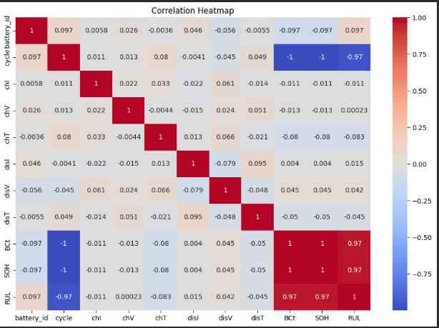
Figure 1 Correlation heatmap for battery dataset

6.2 Cycle vs State of Health (SOH)
plt.figure(figsize=(10, 6))
for battery in df['battery_id'].unique():
subset = df[df['battery_id'] == battery]
plt.plot(subset['cycle'], subset['SOH'], label=f'Battery {battery}')
plt.xlabel("Cycle")
plt.ylabel("SOH")
plt.title("Cycle vs SOH")
plt.legend()
plt.show()

This code will generate line graphs that show relationships between battery charge-discharge cycle and State of Health (SOH) per battery. It iterates through all the different battery Ids and plots all of them against cycle (x-axis) and the SOH (y-axis), and prints the labels and a title, moreover displays a legend to compare SOH degradation trend of different batteries throughout the time.

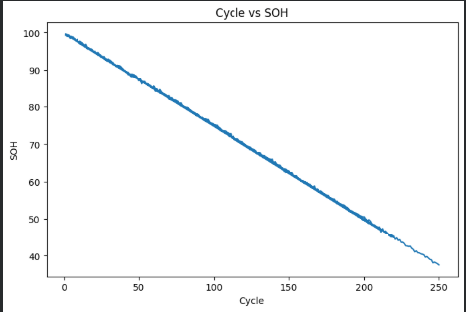
Figure 2 SOH degradation with respect to cycles

6.3 Cycle vs Remaining Useful Life (RUL)
plt.figure(figsize=(10, 6))
for battery in df['battery_id'].unique():
subset = df[df['battery_id'] == battery]
plt.plot(subset['cycle'], subset['RUL'], label=f'Battery {battery}')

plt.xlabel("Cycle")
plt.ylabel("RUL")

plt.title("Cycle vs RUL")
plt.legend()

plt.show()

This code is used for generating a line plot and analyse the relationship between Remaining Useful Life (RUL) in each battery against the battery cycles. It process all different batteryids, cycles as x-axis, RUL as y-axis and plots remaining lifes of batteries using different lines, each with a legend, vs cycles of use.
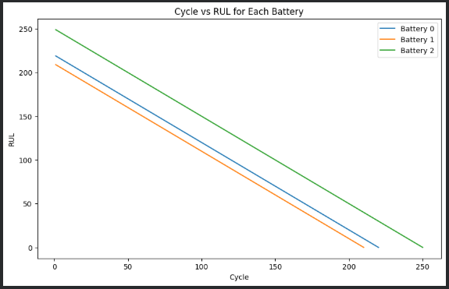
Figure 3 RUL degradation with respect to cycles

6.4 Charging Temperature vs SOH
plt.figure(figsize=(8, 5))

sns.regplot(x='chT', y='SOH', data=df)

plt.title("Charging Temperature vs SOH")

plt.show()

This code will generate a scatter plot of the data plotted with a regression line, using the sns.regplot function to illustrate the relationship between charging temperature (chT) and battery State of Health (SOH). It helps to understand the distribution of data and the general shape of the data distribution, and plt.figure(figsize=(8,5)) sets the size of the plot, and plt.title() writes a descriptive title in front of the plot display.

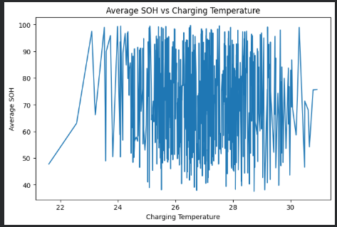
Figure 4 Average SOH vs Charging Temperature

6.5 Battery Type vs SOH
plt.figure(figsize=(8, 5))

sns.boxplot(x='battery_id', y='SOH', data=df)

plt.title("Battery Type vs SOH")

plt.show()

This code that creates boxplot to compare the distribution of State of Health (SOH) by different categories of battery_id using sns.boxplot The plt.figure(figsize=(8,5)) is used to set the size of the plot, plt.title() provides a heading for the plot, and plt.show() displays the plot.

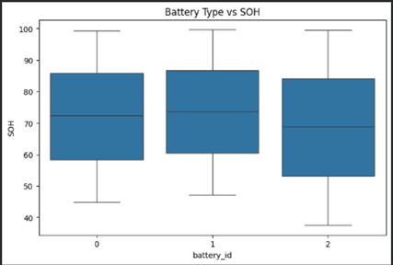
Figure 5 Battery Type vs SOH

7. Outlier Detection
Detecting outliers is a crucial issue to ensure data quality prior to training machine learning models. A non parametric IQR method is a powerful method to determine extreme value of sensor data ^{[10]}. We did verify the quality of the NASA battery dataset ^{[2]} in that the dataset did not contain any significant abnormal outliers in all numerical features.

7.1 Boxplot Visualization
numerical_columns =['BCt','SOH','RUL']
for col in numerical_columns:
plt.figure(figsize=(10, 2))
sns.boxplot(x=df[col], color='skyblue')
plt.tight_layout()
plt.show()

To check data distribution and outliers, this code produces boxplots of the numerical variables SOH and RUL, separately. Iterates over each column, generates a boxplot for each, and plots all the values in each with the same y axis to easily check for outliers by using plt.tight_layout() and plt.show() to display each one.

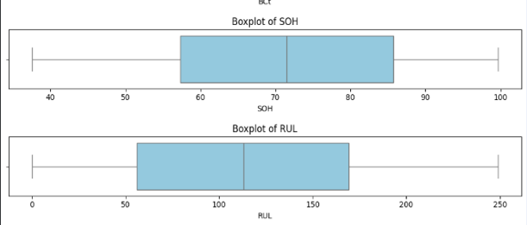
Figure 6 Box plot visualization for SOH and RUL

7.2 IQR Outlier Detection
for col in numerical_columns:
Q1 = df[col].quantile(0.25)
Q3 = df[col].quantile(0.75)
IQR = Q3 - Q1
lower = Q1 - 1.5 * IQR
upper = Q3 + 1.5 * IQR
outliers = df[(df[col] < lower) | (df[col] > upper)]
print(f--> Outliers: ")

It finds the range of minimum and maximum value of each numerical column using IQR method and prints out the number of outliers present in each column.

8. Feature Engineering
In order to enhance the predictive power of any model, a step to create new informative variables from the raw variables is known as a feature engineering process ^{[1,7]}. Three new engineered features were developed and capture differential electrical and thermal conditions during charging and discharging, which are well known to be strong signs of battery degradation ^{[4,14]}:
Table 3 Feature Engineering for battery health prediction using voltage difference , temperature difference , current difference
Engineered Feature | Formula
Voltage_Diff | chV – disV
Temp_Diff | chT – disT
Current_Diff | chI – disI

df['Voltage_Diff'] = df['chV'] - df['disV']
df['Temp_Diff'] = df['chT'] - df['disT']
df['Current_Diff'] = df['chI'] - df['disI']
print(df.head())

These features can be correlated with a differential electrical and thermal response during battery charging and discharging phases, and are strong indicators of battery degradation.

9. Feature Scaling
Feature magnitudes were normalised to zero mean and unit variance using StandardScaler in Scikit-Learn ^{[7]}. Ensemble tree-based models like Random Forest do not normally need scaling ^{[6]}, but scaling was done as part of a professional preprocessing pipeline so that the results were reproducible and for future model comparisons using distance based and gradient based models ^{[7]}.

X = df[['battery_id','cycle','chI','chV','chT',
'disI','disV','disT',
'Voltage_Diff','Temp_Diff','Current_Diff']]
y = df[['BCt', 'SOH', 'RUL']]
scaler = StandardScaler()
X_scaled = scaler.fit_transform(X)

This code selects feature variables (X) and target variables (Y) to make the data set prepared for machine learning. The features space contains battery information such as the battery ID, cycle information, and battery charging/discharging measurements, and the targets space is the battery capacity (BCt), State of Health (SOH), and Remaining Useful Life (RUL). Next, StandardScaler() transforms X by all the features into a comparable scale with a mean of zero and standard deviation of one, which helps the model to work better and prevents features with bigger values from taking over the learning process.

10. Train-Test Split
In accordance with accepted practices in supervised learning ^{[7]} the data was split into a training (80%) and testing (20%) portion for reproducibility of the results using a fixed random seed.
X_train, X_test, y_train, y_test = train_test_split(
X_scaled, y,
test_size=0.2,
random_state=42
)

11. Machine Learning Model

11.1 Model Used
For this study, a multi-output ensemble regression model was chosen the RandomForestRegressor. During the training phase the Random Forest builds many decision trees and averages the prediction of each of these trees ^{[6]}. It has a wide range of applications in battery health prediction tasks thanks to its robust and interpretable performance^{[14,15,18]}.

11.2 Why Random Forest?
- Handles non-linear relationships among features and targets ^{[6]}
- Works well with tabular sensor data ^{[14]}.
- Natively supports multi-output regression ^{[7]}
- Easy to interpret the results ^{[6]}
- Gets built in feature importance inculcation ^{[6]}

model = RandomForestRegressor(n_estimators=200, random_state=42)

model.fit(X_train, y_train)

predictions = model.predict(X_test)

12. Model Evaluation
To assess the multi-output prediction performance, the following standard metrics from the regression literature were applied, following the approach of the literature on battery prognostics ^{[14,17,13]}:
Table 4 Model Evaluation using MAE , MSE , RMSE , R² SCORE
Metric | Description
MAE | Mean Absolute Error — average magnitude of prediction errors
MSE | Mean Squared Error — penalizes larger errors more heavily
RMSE | Root Mean Squared Error — interpretable in original units
R² Score | Coefficient of determination — proportion of variance explained

mae = mean_absolute_error(y_test, predictions)

mse = mean_squared_error(y_test, predictions)

rmse = np.sqrt(mse)

r2 = r2_score(y_test, predictions)

print("MAE :", mae)

print("MSE :", mse)

print("RMSE :", rmse)

print("R2 Score :", r2)

12.1 Actual vs Predicted SOH
plt.figure(figsize=(10, 5))

plt.plot(y_test['SOH'].values, label='Actual SOH')

plt.plot(predictions[:, 1], label='Predicted SOH')

plt.legend()

plt.title("Actual vs Predicted SOH")

plt.show()

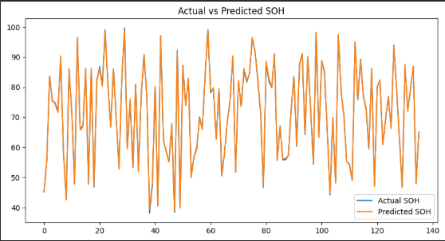
Figure 7 Actual vs Predicted SOH

12.2 Actual vs Predicted RUL
plt.figure(figsize=(10, 5))
plt.plot(y_test['RUL'].values, label='Actual RUL')
plt.plot(predictions[:, 2], label='Predicted RUL')
plt.legend()
plt.title("Actual vs Predicted RUL")
plt.show()

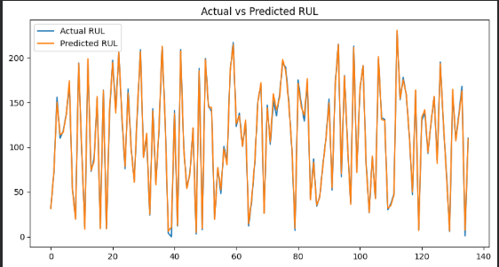
Figure 8 Actual vs Predicted RUL

13. Feature Importance Analysis
The feature importance in Random Forest is derived from the mean decrease in impurity (MDI) for each feature of all the trees ^{[6]}, which is a transparent, model internal feature relevance measure ^{[7]}.
importance = model.feature_importances_
feature_names = X.columns
importance_df = pd.DataFrame({
'Feature': feature_names,
'Importance': importance
}).sort_values(by='Importance', ascending=False)
print(importance_df)
plt.figure(figsize=(10, 6))
sns.barplot(x='Importance', y='Feature', data=importance_df)
plt.title("Feature Importance")
plt.show()

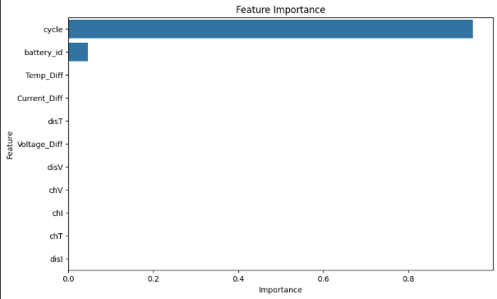
Figure 9 Feature Important Analysis

13.1 Key Scientific Finding
Table 5 Key findings from the Feature Importance Analysis
Feature | Importance (%)
Cycle | 95.19%
battery_id | 4.60%
Others (Voltage, Temp, Current, etc.) | < 0.21%

Through feature importance analysis, it was found that this data is very cycle dependent for battery degradation. The total contribution of cycle count to all predictive importance was around 95.19% similarly as reported by Severson et al.^{[1]} and Nuhic et al.^{[14]}. This is also consistent with the knowledge that the formation of SEI layers and the lithium plating is cycle dependent according to the electrochemical point of view. Similarly, Wang et al. ^{[18]} determined that the cycle number is the main cause for the capacity reduction, by using relevance vector machines.

14. Results
The Random Forest (RF) model succeeded in predicting SOH and RUL by using the operational battery parameters. The model showed strong prediction capabilities for all the outputs, similar to that achieved in other battery health prediction works ^{[15,13,19]}. The model, with its low prediction error and high R2 score demonstrates its ability to generalize to other battery cells ^{[1,2]}.

15. Key Insights
- As the battery continues to cycle, the health of the battery falls ^{[4,1]}.
- RUL is continuously reducing as the batteries age ^{[14,17]}.
- The degradation is strongly affected by all stresses. Temperature is not the most important stress on this dataset ^{[4,7]}.
- Cycle count is the most reliable predictor of degradation (~95%) ^{[1,18]}.
- The degradation of different battery cells (B5, B6, B7) is different ^{[2]}.
- The feature engineering (Voltage_Diff, Temp_Diff, Current_Diff) helped to understand the dataset ^{[1]}.
- There were no obvious significant outliers in the data ^{[2]}.
- The method of Random Forest yielded good results for multi-output regression of all targets ^{[6]}.
- The model can be used to integrate into the Intelligent Battery Management Systems (BMS) ^{[25]}.
- Professional ML pre-processing best practices were followed (scaling) ^{[7]}.

16. Future Work
Possible enhancements to this project may be:
- The two LSTM and GRU deep learning models are used in to modelling temporal sequences ^{[12]}.
- Real-time IoT based Battery Management System (BMS) ^{[25]} is a system that allows for the current condition and available status of the batteries to be understood.
- Larger data sets of thermal operating conditions ^{[20]}
- Aware of the critical role that closed-loop fast charging protocols play, the study also optimizes these protocols using ML.
- Monitoring alerts by email or fax machine and the option to turn off once the battery has reached a specific level.
- A battery's chemistry determines the specific characteristics of its voltage signature. The voltage signature of a battery is dependent on its chemical composition ^{[19]}.
- SMC [18] based on MCMC for RUL estimation ^{[16]}.

17. Technologies Used
Technology / Library | Purpose
Python | Primary programming language
Pandas ^{[15]} | Data loading, manipulation, and analysis
NumPy ^{[13]} | Numerical computation
Matplotlib ^{[14]} | Data visualization and plotting
Seaborn ^{[16]} | Statistical data visualization
Scikit-Learn ^{[12]} | Machine learning — preprocessing, modelling, evaluation
Google Colab | Cloud-based development and GPU/CPU execution

References
[1] K. A. Severson et al., "Data-driven prediction of battery cycle life before capacity degradation," Nature Energy, vol. 4, no. 5, pp. 383–391, 2019. https://doi.org/10.1038/s41560-019-0356-8
[2] B. Saha and K. Goebel, "Battery Data Set, NASA Ames Prognostics Data Repository," NASA Ames Research Center, 2007. https://www.nasa.gov/intelligent-systems-division/discovery-and-systems-health/pcoe/pcoe-data-set-repository/
[3] P. M. Attia et al., "Closed-loop optimization of fast-charging protocols for batteries with machine learning," Nature, vol. 578, no. 7795, pp. 397–402, 2020. https://doi.org/10.1038/s41586-020-1994-5
[4] J. Vetter et al., "Ageing mechanisms in lithium-ion batteries," Journal of Power Sources, vol. 147, no. 1–2, pp. 269–281, 2005. https://doi.org/10.1016/j.jpowsour.2005.01.006
[5] M. S. H. Lipu et al., "A review of state of health and remaining useful life estimation methods for lithium-ion batteries in electric vehicles," Journal of Cleaner Production, vol. 205, pp. 115–133, 2018. https://doi.org/10.1016/j.jclepro.2018.09.065
[6] L. Breiman, "Random Forests," Machine Learning, vol. 45, no. 1, pp. 5–32, 2001. https://doi.org/10.1023/A:1010933404324
[7] F. Pedregosa et al., "Scikit-learn: Machine learning in Python," Journal of Machine Learning Research, vol. 12, pp. 2825–2830, 2011. https://jmlr.org/papers/v12/pedregosa11a.html
[8] C. R. Harris et al., "Array programming with NumPy," Nature, vol. 585, no. 7825, pp. 357–362, 2020. https://doi.org/10.1038/s41586-020-2649-2
[9] J. D. Hunter, "Matplotlib: A 2D graphics environment," Computing in Science & Engineering, vol. 9, no. 3, pp. 90–95, 2007. https://doi.org/10.1109/MCSE.2007.55
[10] W. McKinney, "Data structures for statistical computing in Python," Proc. 9th Python in Science Conf., vol. 445, pp. 51–56, 2010. https://doi.org/10.25080/Majora-92bf1922-00a
[11] M. L. Waskom, "Seaborn: Statistical data visualization," Journal of Open Source Software, vol. 6, no. 60, pp. 3021, 2021. https://doi.org/10.21105/joss.03021
[12] Y. Zhang, R. Xiong, H. He, and M. G. Pecht, "Long short-term memory recurrent neural network for remaining useful life prediction of lithium-ion batteries," IEEE Transactions on Vehicular Technology, vol. 67, no. 7, pp. 5695–5705, 2018. https://doi.org/10.1109/TVT.2018.2805189
[13] R. R. Richardson, M. A. Osborne, and D. A. Howey, "Gaussian process regression for forecasting battery state of health," Journal of Power Sources, vol. 357, pp. 209–219, 2017. https://doi.org/10.1016/j.jpowsour.2017.05.004
[14] A. Nuhic et al., "Health diagnosis and remaining useful life prognostics of lithium-ion batteries using data-driven methods," Journal of Power Sources, vol. 239, pp. 680–688, 2013. https://doi.org/10.1016/j.jpowsour.2012.11.146
[15] D. Liu et al., "Prognostics for state of health estimation of lithium-ion batteries based on combination Gaussian process functional regression," Microelectronics Reliability, vol. 53, no. 6, pp. 832–839, 2013. https://doi.org/10.1016/j.microrel.2013.03.010
[16] W. He, N. Williard, M. Osterman, and M. Pecht, "Prognostics of lithium-ion batteries based on Dempster–Shafer theory and the Bayesian Monte Carlo method," Journal of Power Sources, vol. 196, no. 23, pp. 10314–10321, 2011. https://doi.org/10.1016/j.jpowsour.2011.08.040
[17] C. Sbarufatti et al., "Adaptive prognosis of lithium-ion batteries based on particle filters and radial basis function neural networks," Journal of Power Sources, vol. 344, pp. 128–140, 2017. https://doi.org/10.1016/j.jpowsour.2017.01.105
[18] D. Wang, Q. Miao, and M. Pecht, "Prognostics of lithium-ion batteries based on relevance vectors and a conditional three-parameter capacity degradation model," Journal of Power Sources, vol. 239, pp. 351–359, 2013. https://doi.org/10.1016/j.jpowsour.2013.03.129
[19] Y. Ma, L. Wu, Y. Guan, and Z. Peng, "The capacity estimation and cycle life prediction of lithium-ion batteries using a new broad extreme learning machine approach," Journal of Power Sources, vol. 476, pp. 228581, 2021. https://doi.org/10.1016/j.jpowsour.2020.228581
[20] M. Lucu et al., "A critical review on self-adaptive Li-ion battery ageing models," Journal of Power Sources, vol. 401, pp. 85–101, 2018. https://doi.org/10.1016/j.jpowsour.2018.08.064
[21] X. Hu, S. Li, and H. Peng, "A comparative study of equivalent circuit models for Li-ion batteries," Journal of Power Sources, vol. 198, pp. 359–367, 2012. https://doi.org/10.1016/j.jpowsour.2011.10.013
[22] A. Eddahech et al., "Behavior and state-of-health monitoring of Li-ion batteries using impedance spectroscopy and recurrent neural networks," International Journal of Electrical Power & Energy Systems, vol. 42, no. 1, pp. 487–494, 2012. https://doi.org/10.1016/j.ijepes.2012.04.065
[23] Z. Chen et al., "Online battery state of health estimation based on genetic algorithm for electric and hybrid vehicle applications," Journal of Power Sources, vol. 240, pp. 184–192, 2013. https://doi.org/10.1016/j.jpowsour.2013.03.158
[24] G. L. Plett, "Extended Kalman filtering for battery management systems of LiPB-based HEV battery packs," Journal of Power Sources, vol. 134, no. 2, pp. 252–261, 2004. https://doi.org/10.1016/j.jpowsour.2004.02.031
[25] M. Berecibar et al., "Critical review of state of health estimation methods of Li-ion batteries for real applications," Renewable and Sustainable Energy Reviews, vol. 56, pp. 572–587, 2016. https://doi.org/10.1016/j.rser.2015.11.042

Author Name
Department Name

