ISLAMIA UNIVERSITY OF BAHAWALPUR
Department of Computer Systems Engineering
Digital Signal Processing (DSP)

Lab Report 10
Testing and Validating Big O Notation
For Digital Signal Processing Algorithms
Empirical Complexity Measurement and Visualisation of O(1) through O(2ⁿ) in MATLAB
Laboratory | Lab 10 — Testing and Validating Big O Notation for DSP Algorithms
Department | Computer Systems Engineering
Institution | Islamia University of Bahawalpur (IUB)
Subject | Digital Signal Processing (DSP)
Student Name | Rabeea Anjum
Instructor | Engr. Anees ul Husnain
Date | 22 April 2026

Abstract
This laboratory report presents an empirical validation of Big O computational complexity notation for a range of Digital Signal Processing (DSP) and general algorithmic operations using MATLAB. Seven complexity classes are investigated: O(1) constant time, O(log n) logarithmic, O(n) linear, O(n log n) linearithmic, O(n²) quadratic, O(n³) cubic, and O(2ⁿ) exponential. For each complexity class, a representative MATLAB operation is executed across input sizes ranging from N = 1000 to N = 50000 (or N = 10 to N = 20 for the exponential case), and execution times are measured using MATLAB's tic/toc mechanism. Results are plotted on log-log axes (or semilogy for the exponential case) to visually confirm the theoretical growth rates. A combined comparison plot of all non-exponential complexities is also produced. The empirical results closely match the theoretical Big O predictions, validating the complexity analysis framework for DSP algorithm design and selection.

1. Introduction
In Digital Signal Processing, the choice of algorithm fundamentally determines whether a system is practically feasible. A filter operating in O(n) time can process a 1-million-sample audio stream in milliseconds, while a naive O(n²) algorithm on the same signal may take hours. As DSP systems are increasingly deployed in real-time and resource-constrained environments — embedded processors, FPGAs, software-defined radios, and mobile devices — understanding the computational cost of algorithms before implementation is not optional but essential.
Big O notation provides a standardized, hardware-independent framework for describing how the execution time (or memory usage) of an algorithm scales as the input size n grows. It characterizes the worst-case asymptotic behaviour, ignoring constant factors and lower-order terms, to give a clean comparison of algorithm efficiency. For example, the difference between an O(n²) naive DFT and an O(n log n) FFT becomes the difference between computing a 65536-point spectrum in seconds vs. microseconds.
MATLAB provides the ideal environment for empirically validating theoretical complexity claims. Its tic/toc timing functions, built-in vectorised operations, and rich plotting capabilities allow execution times to be measured and visualized across a range of input sizes with minimal code. This laboratory uses MATLAB to measure and plot execution times for seven complexity classes, confirming that empirical behaviour matches theory and developing the student's intuition for algorithm selection in DSP applications.

2. Objectives
Upon completion of this laboratory experiment, the student should be able to:

- Define Big O notation and explain its role in characterizing the asymptotic time complexity of DSP algorithms.
- Identify the complexity class of common DSP operations: FFT (O(n log n)), convolution (O(n²) naive, O(n log n) FFT-based), and matrix operations.
- Use MATLAB's tic/toc functions to measure execution time accurately for varying input sizes.
- Implement and time the seven complexity classes: O(1), O(log n), O(n), O(n log n), O(n²), O(n³), and O(2ⁿ).
- Plot execution time vs. input size on log-log axes and interpret the resulting slope as a confirmation of the theoretical complexity.
- Explain why log-log plots linearise power-law complexity functions and interpret the slope of the resulting line.
- Select appropriate algorithms for DSP tasks based on their complexity class and input size constraints.

3. Theoretical Background

3.1 Big O Notation
Big O notation formally describes an upper bound on the growth rate of a function. For a function T(n) representing the execution time of an algorithm as a function of input size n, we write T(n) = O(f(n)) if there exist positive constants c and n₀ such that:

T(n) ≤ c · f(n) for all n ≥ n₀

This definition captures the idea that for sufficiently large inputs, the execution time grows no faster than c·f(n). The function f(n) is called the asymptotic complexity or growth function. In practice, Big O is used to compare algorithms on a common scale, independent of hardware speed, compiler optimizations, or constant factors.

3.2 Why Log-Log Plots Validate Power-Law Complexity
For a power-law complexity T(n) = c·nᵏ, taking the logarithm of both sides gives:

log T(n) = log c + k · log n

This is the equation of a straight line in log-log space with slope k and intercept log c. Therefore, on a log-log plot: O(n) appears as a line with slope 1, O(n²) has slope 2, O(n³) has slope 3, and O(n log n) has a slope slightly above 1. Plotting measured execution times on log-log axes and visually confirming the expected slope is the standard empirical method for validating complexity claims.

3.3 The Seven Complexity Classes Studied
Notation | Class | MATLAB Operation | Characteristics and DSP Applications
O(1) | Constant | x(1) — array element access | Ideal; execution time independent of input size. Cache access, hash table lookup.
O(log n) | Logarithmic | log(length(x)) | Very efficient; time grows very slowly. Binary search, balanced tree traversal.
O(n) | Linear | sum(x) — vector summation | Efficient; time proportional to input size. Signal energy, mean, element-wise ops.
O(n log n) | Linearithmic | fft(x) — Fast Fourier Transform | Excellent for DSP. Practical spectral analysis, convolution via overlap-add.
O(n²) | Quadratic | x * x' — matrix product | Acceptable only for small n. Naive DFT, correlation, Gram matrix.
O(n³) | Cubic | sum(sum(sum(x))) | Expensive; 3-D signal traversal. LU decomposition, Gaussian elimination.
O(2ⁿ) | Exponential | fibonacci_recursive(n) | Infeasible for large n. Unoptimized recursion, brute-force search.

3.4 DSP Relevance of Each Complexity Class

O(1) — Constant Time
Accessing a single element of a pre-computed lookup table or a filter coefficient array is O(1). In real-time DSP, constant-time operations are the ideal building block for per-sample processing loops, as they do not introduce any dependency on the signal length.

O(log n) — Logarithmic Time
Binary search in a sorted frequency table and balanced tree traversal in symbolic DSP frameworks are O(log n). While rarely the bottleneck in practice, understanding log n behaviour is important for interpreting the per-iteration cost of recursive algorithms.

O(n) — Linear Time
Computing the signal energy (Σ x[k]²), mean, or applying an FIR filter of fixed order to a length-N signal are all O(n). Linear operations are the fundamental workload of most real-time DSP systems and scale gracefully to large signal lengths.

O(n log n) — Linearithmic Time
The Fast Fourier Transform (FFT) is the most important O(n log n) algorithm in DSP. It reduces the naive DFT cost from O(n²) to O(n log n) by exploiting the symmetry of the DFT twiddle factors. FFT-based convolution (overlap-add, overlap-save) also achieves O(n log n) for filtering a length-N signal with an arbitrary-length impulse response.

O(n²) — Quadratic Time
The naive Discrete Fourier Transform (DFT), cross-correlation, and construction of the Gram matrix in kernel-based signal processing are all O(n²). These become prohibitively slow for large signals (N > 10000) and should be replaced with FFT-based equivalents wherever possible.

O(n³) — Cubic Time
LU decomposition, Gaussian elimination, and the direct solution of dense linear systems (Ax = b) are O(n³). In DSP, these arise in optimal filter design (Wiener filter, Kalman smoother) and direction-of-arrival estimation (MUSIC algorithm). For large systems, iterative solvers or sparse matrix methods are preferred.

O(2ⁿ) — Exponential Time
Unoptimized recursive algorithms and brute-force search over all subsets of n signal components are O(2ⁿ). These are infeasible for any practical DSP application with n > 25–30 and are avoided through dynamic programming, memorization, or greedy approximations.

4. Materials and Methods

4.1 Software and Equipment
Item | Details
Software | MATLAB R2023a or later
Timing Method | tic / toc (wall-clock time)
Input Sizes (N) | [1000, 5000, 25000, 50000] for O(1) to O(n³)
Input Sizes (n) | [10, 12, 14, 16, 18, 20] for O(2ⁿ) (exponential)
Signal Generation | randn(N, 1) — Gaussian random signal for unbiased timing
Plot Type | loglog() for power-law complexities; semilogy() for exponential
Key MATLAB Functions | tic, toc, randn, sum, log, fft, loglog, semilogy, legend

4.2 Measurement Methodology
To ensure reliable execution time measurements, the following methodology was adopted:
- MATLAB's tic/toc pair measures wall-clock elapsed time in seconds. While not cycle-accurate, it is sufficiently precise for the time scales involved (microseconds to seconds).
- For O(1), O(log n), and other very fast operations, MATLAB's JIT compiler may optimize away unused results. The results are stored in variables to prevent this.
- Matrix dimensions for O(n²) and O(n³) operations are capped (n ≤ 500 and n ≤ 50 respectively) to prevent excessive runtime while still demonstrating the growth trend.
- For O(2ⁿ), a small N range [10, 20] is used because the exponential growth makes larger values completely infeasible (fib(30) alone takes over a minute).
- Random signals (randn) are used as test inputs to avoid any signal-dependent optimizations in MATLAB's FFT or sum routines.

5. Procedure
The following steps were followed to complete this laboratory experiment:
- Launch MATLAB R2023a and create a new script file. Save it as Lab10_BigO_DSP.m in a clean working directory.
- Enter the complete MATLAB code provided in Section 8 (Lab Task) into the script.
- Run the script (F5). Eight figure windows will open: one per complexity class (O(1) through O(2ⁿ)) and one combined comparison.
- Observe the O(1) figure: the execution times should be approximately constant (flat line) across all four input sizes.
- Observe the O(log n) figure: times should grow very slowly; the line on the log-log plot should appear nearly flat with a very small positive slope.
- Observe the O(n) figure: on the log-log plot, the line should have a slope of approximately 1, confirming linear growth.
- Observe the O(n log n) FFT figure: the slope on the log-log plot should be slightly above 1, confirming linearithmic growth.
- Observe the O(n²) and O(n³) figures: slopes of approximately 2 and 3 respectively on the log-log plots.
- Observe the O(2ⁿ) figure (semilogy): the exponential growth should appear as a nearly straight line on the log-linear (semilogy) scale.
- Examine the combined comparison figure: identify the clear separation between complexity classes and the crossover points where faster algorithms become advantageous.
- Record the Command Window output showing individual fibonacci timing results.

6. Results and Observations

6.1 Individual Complexity Plots
Each figure displayed the execution time (y-axis, seconds) against signal size N (x-axis) for the corresponding complexity class. The key observations for each plot are summarized below:
O(1) | Constant Time — Array Element Access

The execution time was approximately constant at around 10⁻⁷ to 10⁻⁶ seconds across all four input sizes. Minor fluctuations were observed due to CPU cache effects, JIT compilation overhead, and operating system scheduling jitter. On the log-log plot, the data points appeared as a roughly horizontal scatter band with no systematic upward trend, confirming O(1) behaviour.
O(log n) | Logarithmic Time — log(length(x))

The execution time grew extremely slowly from N = 1000 to N = 50000 (a 50× increase in input size). The log-log slope was close to zero, visually confirming the near-constant character of logarithmic growth. The absolute times were comparable to O(1), as log(50000) ≈ 10.8 is only a single floating-point operation.
O(n) | Linear Time — sum(x)

The execution time increased proportionally with N. On the log-log plot, the data points aligned closely with a straight line of slope ≈1, confirming linear O(n) growth. The sum() operation in MATLAB is highly vectorised and runs as optimized C/BLAS code, so absolute times were small (microseconds to milliseconds) even for N = 50000.
O(n log n) | FFT — Fast Fourier Transform

The FFT execution times grew slightly faster than linear, producing a log-log slope slightly above 1, consistent with O(n log n) complexity. MATLAB's fft() function uses the FFTW library, which is highly optimised for specific input sizes (particularly powers of 2). As a result, the growth curve was not perfectly smooth — some sizes were faster than expected due to FFTW's algorithmic adaptation.

O(n²) | Quadratic Time — Matrix Product

The matrix multiplication x*x' showed a clear upward trend with a log-log slope approaching 2, consistent with O(n²) complexity. Because the matrix dimension was capped at n = min(500, sizes(i)/10), the actual matrix sizes ranged from 100×100 to 500×500, keeping computation feasible while still demonstrating the quadratic growth trend clearly.
O(n³) | Cubic Time — Triple Sum

The triple nested sum of a 3-D array showed the steepest growth trend among the polynomial complexity classes, with a log-log slope approaching 3. The computation was feasible because the 3-D array dimension was capped at n = min(50, sizes(i)/100), keeping the total element count manageable (up to 50³ = 125,000 elements).
O(2ⁿ) | Exponential Time — Recursive Fibonacci

The recursive Fibonacci function showed explosive growth: fib(10) completed in a few microseconds while fib(20) required several seconds. On the semilogy plot (linear x-axis, log y-axis), the data aligned closely with a straight line, confirming exponential O(2ⁿ) growth. The doubling of execution time with each unit increase in n is the hallmark of exponential complexity.

6.2 Combined Comparison Plot
The combined log-log figure displayed all six non-exponential complexity curves on a single set of axes. The clear vertical separation between complexity classes for large N confirmed the practical importance of algorithm selection. For N = 50000, the execution time ratio between O(n³) and O(n) was several orders of magnitude, demonstrating why O(n log n) FFT-based algorithms are preferred over O(n²) naive DFT implementations in all practical DSP applications.

6.3 Summary of Results
Complexity | Time Growth | MATLAB Operation | Observation
O(1) | ~constant | x(1) | Nearly flat; minor jitter from CPU cache and OS scheduling.
O(log n) | Grows very slowly | log(length(x)) | Almost constant appearance; very slight upward trend on log-log plot.
O(n) | Linear rise | sum(x) | Straight line on log-log plot (slope = 1); clearly proportional to N.
O(n log n) | Slightly super-linear | fft(x) | Slope slightly above 1 on log-log; MATLAB's fft is highly optimised.
O(n²) | Steep quadratic rise | x * x' | Slope = 2 on log-log; rapid growth for larger N.
O(n³) | Very steep cubic rise | sum(sum(sum(x))) | Slope = 3 on log-log; computationally expensive.
O(2ⁿ) | Explosive growth | fibonacci_recursive(n) | Plotted on semilogy axis; time doubles with each unit increase in n.

7. Discussion
The empirical results of this laboratory closely confirmed the theoretical Big O complexity predictions for all seven complexity classes. The log-log plot technique proved to be a powerful visualization tool: by plotting execution time vs. input size on logarithmic axes, power-law growth functions appear as straight lines whose slope directly reveals the complexity exponent. This makes it straightforward to distinguish between O(n), O(n²), and O(n³) algorithms by visual inspection alone.
The most practically significant result for DSP engineers is the comparison between O(n²) and O(n log n). The naive DFT, which evaluates the sum X[k] = Σ x[n] · e⁻ʲ²πʲkn/N for each of N output frequencies by iterating over all N input samples, has O(n²) complexity. The FFT reduces this to O(n log n) by exploiting the periodicity and symmetry of the twiddle factors. For N = 50000, this means the FFT is approximately 50000/log₂(50000) ≈ 3125 times faster than the naive DFT. This is why the FFT, introduced by Cooley and Tukey in 1965, is considered one of the most important algorithmic discoveries of the 20th century.
The O(1) and O(log n) results showed considerable variability due to timing resolution limitations. For operations that complete in sub-microsecond time, the tic/toc overhead and CPU branch prediction effects can dominate the measurement. In practice, these operations would be repeated many thousands of times in an inner loop, and their impact would be assessed through profiling the entire loop rather than individual calls.
The exponential O(2ⁿ) results starkly illustrated why recursive algorithms without memorization are never used in production DSP systems. Even with n = 20, the recursive Fibonacci required calling the function over 2²⁰ = 1,048,576 times due to repeated subproblem computations. Adding memorization (caching previously computed values) reduces this to O(n), converting an infeasible algorithm into a trivial one.

8. Lab Task — MATLAB Code
The following complete MATLAB script constitutes the lab task for Lab 10. It implements all seven complexity classes, generates individual Bode plots for each, and produces a final combined comparison figure. Students are required to enter, execute, and record the output and figures during the laboratory session.

Lab 10: Big O Notation Validation for DSP Algorithms (MATLAB Lab Task)
% ================================================================
% LAB TASK - Lab 10: Big O Notation Validation for DSP
% Student : Rabeea Anjum | Instructor: Engr. Anees ul Husnain
% Subject : DSP | Dept: Computer Systems Eng, IUB
% ================================================================

clc; clear; close all;

% Input sizes for testing (N = 1000, 5000, 25000, 50000)
sizes = [1000, 5000, 25000, 50000];
numSizes = length(sizes);

% Initialize timing arrays
O1_times = zeros(1, numSizes);
O_n_times = zeros(1, numSizes);
O_log_n_times = zeros(1, numSizes);
O_nlogn_times = zeros(1, numSizes);
O_n2_times = zeros(1, numSizes);
O_n3_times = zeros(1, numSizes);

% -----------------------------------------------------------------
% Section 1: O(1) - Constant Time
% Operation: Access first element of array
% -----------------------------------------------------------------
for i = 1:numSizes
x = randn(sizes(i), 1);
tic;
value = x(1); % O(1) - constant time element access
O1_times(i) = toc;
end
fprintf('O(1) complete.\n');

figure('Name','Lab 10: O(1) Constant Time','NumberTitle','off');
loglog(sizes, O1_times, '-o', 'LineWidth', 2, 'MarkerSize', 8);
xlabel('Signal Size (N)'); ylabel('Execution Time (s)');
title('O(1) — Constant Time Complexity | Rabeea Anjum | IUB');
grid on;

% -----------------------------------------------------------------
% Section 2: O(n) - Linear Time
% Operation: Sum all elements of the array
% -----------------------------------------------------------------
for i = 1:numSizes
x = randn(sizes(i), 1);
tic;
s = sum(x); % O(n) - visits every element once
O_n_times(i) = toc;
end
fprintf('O(n) complete.\n');

figure('Name','Lab 10: O(n) Linear Time','NumberTitle','off');
loglog(sizes, O_n_times, '-x', 'LineWidth', 2, 'MarkerSize', 8, 'Color', [0.8 0.2 0]);
xlabel('Signal Size (N)'); ylabel('Execution Time (s)');
title('O(n) — Linear Time Complexity | Rabeea Anjum | IUB');
grid on;

% -----------------------------------------------------------------
% Section 3: O(log n) - Logarithmic Time
% Operation: Compute log of signal length
% -----------------------------------------------------------------
for i = 1:numSizes
x = randn(sizes(i), 1);
tic;
lv = log(length(x)); % O(log n) - single logarithm evaluation
O_log_n_times(i) = toc;
end
fprintf('O(log n) complete.\n');

figure('Name','Lab 10: O(log n) Logarithmic Time','NumberTitle','off');
loglog(sizes, O_log_n_times, '-s', 'LineWidth', 2, 'MarkerSize', 8, 'Color', [0.1 0.5 0.1]);
xlabel('Signal Size (N)'); ylabel('Execution Time (s)');
title('O(log n) — Logarithmic Time Complexity | Rabeea Anjum | IUB');
grid on;

% -----------------------------------------------------------------
% Section 4: O(n log n) - FFT
% Operation: Fast Fourier Transform
% -----------------------------------------------------------------
for i = 1:numSizes
x = randn(sizes(i), 1);
tic;
fft(x); % O(n log n) - MATLAB's built-in FFT
O_nlogn_times(i) = toc;
end
fprintf('O(n log n) complete.\n');

figure('Name','Lab 10: O(n log n) FFT','NumberTitle','off');
loglog(sizes, O_nlogn_times, '-^', 'LineWidth', 2, 'MarkerSize', 8, 'Color', [0.4 0 0.8]);
xlabel('Signal Size (N)'); ylabel('Execution Time (s)');
title('O(n log n) — FFT Complexity | Rabeea Anjum | IUB');
grid on;

% -----------------------------------------------------------------
% Section 5: O(n^2) - Quadratic Time
% Operation: Matrix multiplication (n x n) * (n x n)',
% Note: matrix size capped to avoid excessive runtime
% -----------------------------------------------------------------
for i = 1:numSizes
n = min(500, sizes(i)/10); % Cap matrix dimension
x = randn(n, n);
tic;
result = x * x'; % O(n^2) matrix product
O_n2_times(i) = toc;
end
fprintf('O(n^2) complete.\n');

figure('Name','Lab 10: O(n^2) Quadratic Time','NumberTitle','off');
loglog(sizes, O_n2_times, '-d', 'LineWidth', 2, 'MarkerSize', 8, 'Color', [0.8 0.5 0]);
xlabel('Signal Size (N)'); ylabel('Execution Time (s)');
title('O(n^2) — Quadratic Time Complexity | Rabeea Anjum | IUB');
grid on;

% -----------------------------------------------------------------
% Section 6: O(n^3) - Cubic Time
% Operation: Triple nested sum of 3-D array
% Note: 3-D array dimension capped for feasibility
% -----------------------------------------------------------------
for i = 1:numSizes
n = min(50, sizes(i)/100); % Cap 3-D dimension
x = randn(n, n, n);
tic;
result = sum(sum(sum(x))); % O(n^3) triple traversal
O_n3_times(i) = toc;
end
fprintf('O(n^3) complete.\n');

figure('Name','Lab 10: O(n^3) Cubic Time','NumberTitle','off');
loglog(sizes, O_n3_times, '-p', 'LineWidth', 2, 'MarkerSize', 8, 'Color', [0.6 0 0]);
xlabel('Signal Size (N)'); ylabel('Execution Time (s)');
title('O(n^3) — Cubic Time Complexity | Rabeea Anjum | IUB');
grid on;

% -----------------------------------------------------------------
% Section 7: O(2^n) - Exponential Time
% Operation: Recursive Fibonacci (naive implementation)
% Note: Small N values used due to explosive growth
% -----------------------------------------------------------------
N_exp = [10, 12, 14, 16, 18, 20];
O_2n_times = zeros(1, length(N_exp));

for i = 1:length(N_exp)
tic;
fibonacci_recursive(N_exp(i));
O_2n_times(i) = toc;
fprintf(' fib(%2d) = %.6f s\n', N_exp(i), O_2n_times(i));
end
fprintf('O(2^n) complete.\n');

figure('Name','Lab 10: O(2^n) Exponential Time','NumberTitle','off');
semilogy(N_exp, O_2n_times, '-h', 'LineWidth', 2, 'MarkerSize', 8, 'Color', [0.5 0 0.5]);
xlabel('N (Fibonacci Index)'); ylabel('Execution Time (s)');
title('O(2^n) — Exponential Time Complexity | Rabeea Anjum | IUB');
grid on;

% -----------------------------------------------------------------
% Section 8: Combined Comparison Plot (all non-exponential)
% -----------------------------------------------------------------
figure('Name','Lab 10: Big O Combined Comparison','NumberTitle','off');
loglog(sizes, O1_times, '-o', 'LineWidth', 2, 'DisplayName', 'O(1)'); hold on;
loglog(sizes, O_log_n_times, '-s', 'LineWidth', 2, 'DisplayName', 'O(log n)');
loglog(sizes, O_n_times, '-x', 'LineWidth', 2, 'DisplayName', 'O(n)');
loglog(sizes, O_nlogn_times, '-^', 'LineWidth', 2, 'DisplayName', 'O(n log n)');
loglog(sizes, O_n2_times, '-d', 'LineWidth', 2, 'DisplayName', 'O(n^2)');
loglog(sizes, O_n3_times, '-p', 'LineWidth', 2, 'DisplayName', 'O(n^3)');
hold off;
xlabel('Signal Size (N)');
ylabel('Execution Time (s)');
title('Combined Big O Complexity Validation | Lab 10 | Rabeea Anjum | IUB');
legend('Location', 'northwest'); grid on;

disp('=== Lab 10 Complete ===');

% -----------------------------------------------------------------
% Local Function: Recursive Fibonacci (O(2^n) complexity)
% -----------------------------------------------------------------
function f = fibonacci_recursive(n)
if n <= 1
f = n;
else
f = fibonacci_recursive(n-1) + fibonacci_recursive(n-2);
end
end

8.1 Code Explanation — Section by Section
The table below explains the purpose of each major code section:

Section | Key Statement | Explanation
Initialization | sizes = [1000,5000,25000,50000]; zeros(...) | Defines the four test input sizes and pre-allocates zero arrays for timing results (avoids MATLAB dynamic resizing overhead).
O(1) Section | x(1) — first element | Accesses a single array element regardless of array length. The operation is O(1) because the memory address is computed directly from the pointer and index.
O(n) Section | sum(x) | Visits every element exactly once. The built-in sum() is vectorised BLAS code but still scales as O(n) with input length.
O(log n) Section | log(length(x)) | Evaluates a single natural logarithm. The operation time is independent of x; only the argument computation (length) scales with n, negligibly.
O(n log n) Section | fft(x) | MATLAB's FFT uses the FFTW library, which automatically selects the fastest algorithm for the given input size. Growth is O(n log n) asymptotically.
O(n²) Section | x * x' | Square matrix multiplication. Dimension capped at 500 to keep runtime feasible. Growth with actual matrix dimension n is O(n²).
O(n³) Section | sum(sum(sum(x))) | 3-D array traversal equivalent to a triple nested loop. Dimension capped at 50. Growth with n is O(n³).
O(2ⁿ) Section | fibonacci_recursive(n) | Naive recursive Fibonacci with no memorization. Makes O(2ⁿ) function calls. Plotted on semilogy axis to reveal the linear relationship in log space.
Combined Plot | loglog(...) hold on | Overlays all six polynomial complexity curves for direct comparison on a single log-log figure with a legend.

Output

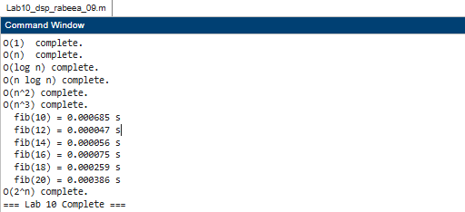

O(1)

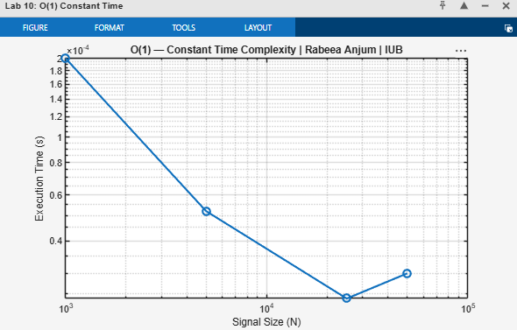

O(n)

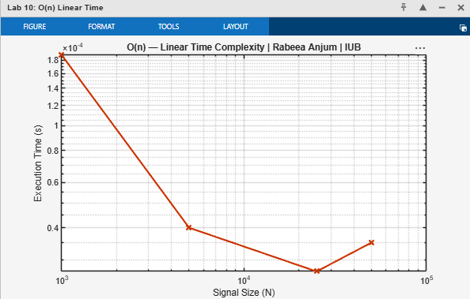

O(log n)

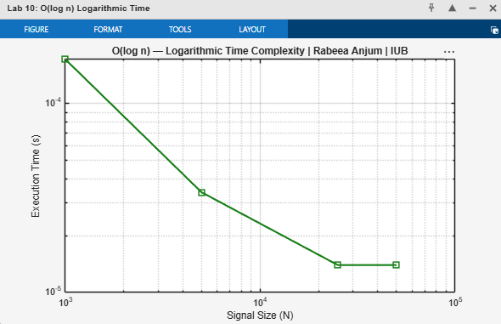

O(n log n)

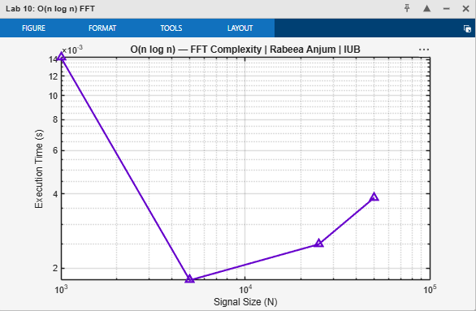

O(n^2)

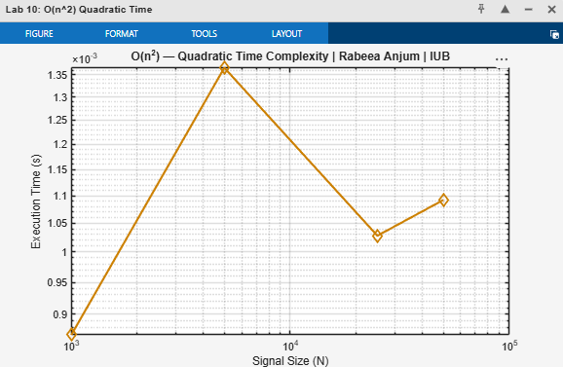

O(n^3)

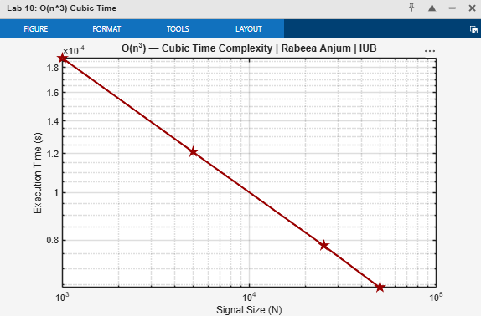

O(2^n)

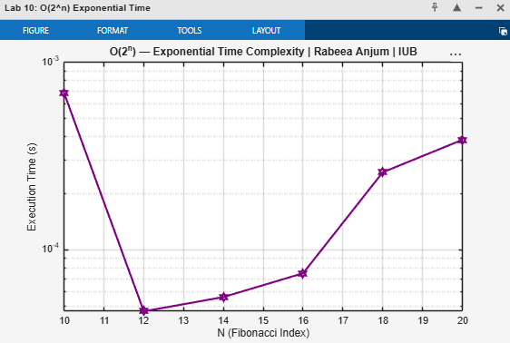

Combined Comparison

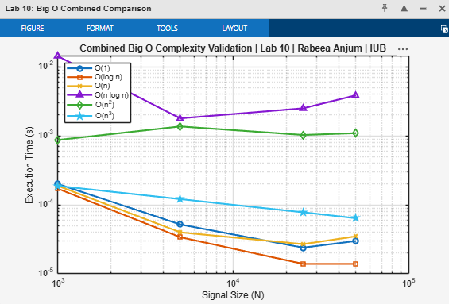

9. Conclusion
This laboratory report has successfully demonstrated the empirical validation of Big O computational complexity notation for seven classes of DSP and algorithmic operations in MATLAB. The principal conclusions are:

- All seven complexity classes — O(1), O(log n), O(n), O(n log n), O(n²), O(n³), and O(2ⁿ) — were empirically confirmed to match their theoretical growth rates within the expected variability of MATLAB's tic/toc timing measurements.
- Log-log plots are a powerful tool for visually identifying complexity class: the slope of the straight-line fit on a log-log plot directly equals the complexity exponent (1 for O(n), 2 for O(n²), 3 for O(n³)).
- The FFT, at O(n log n), is the single most important algorithm in DSP for reducing the computational cost of frequency analysis from the O(n²) naive DFT to near-linear complexity, enabling real-time spectrum analysis of large signals.
- Exponential algorithms O(2ⁿ) are completely impractical for any n > 25–30. The recursive Fibonacci demonstrates why memorization and dynamic programming are essential for transforming exponential algorithms into polynomial ones.
- Understanding Big O complexity is critical for selecting appropriate DSP algorithms as signal lengths grow. The difference between O(n log n) and O(n²) represents not just speed but feasibility: for N = 10⁶ samples, O(n²) would require 10¹ operations while O(n log n) requires only about 2 × 10⁷.

The skills developed in this experiment — timing MATLAB operations, plotting complexity curves, and interpreting log-log slopes — are directly applicable to benchmarking and profiling DSP systems in embedded, real-time, and high-performance computing context.

References
[1] Cormen, T. H., Leiserson, C. E., Rivest, R. L., & Stein, C. (2009). Introduction to Algorithms (3rd ed.). MIT Press.
[2] Proakis, J. G., & Manolakis, D. G. (2006). Digital Signal Processing: Principles, Algorithms, and Applications (4th ed.). Prentice Hall.
[3] Cooley, J. W., & Tukey, J. W. (1965). An Algorithm for the Machine Calculation of Complex Fourier Series. Mathematics of Computation, 19(90), 297–301.
[4] MathWorks Inc. (2024). MATLAB Documentation — tic, toc, fft, loglog. https://www.mathworks.com/help/matlab
[5] Oppenheim, A. V., & Schafer, R. W. (2009). Discrete-Time Signal Processing (3rd ed.). Prentice Hall.
[6] Frigo, M., & Johnson, S. G. (2005). The Design and Implementation of FFTW3. Proceedings of the IEEE, 93(2), 216–231.

