ISLAMIA UNIVERSITY OF BAHAWALPUR
Department of Computer Systems Engineering
Digital Signal Processing (DSP)

Lab Report 11
FIR & IIR Digital Filter Design
And Analysis using MATLAB
Windowed FIR Design, Butterworth IIR Design, Frequency Response Analysis, and Filter Comparison
Lab no | Lab 11 — FIR & IIR Digital Filter Design and Analysis
Department | Computer Systems Engineering
Institution | Islamia University of Bahawalpur (IUB)
Subject | Digital Signal Processing (DSP)
Student Name | Rabeea Anjum
Instructor | Engr. Anees ul Husnain
Date | 06 May 2026

Abstract
This laboratory report presents the design, implementation, and comparative analysis of Finite Impulse Response (FIR) and Infinite Impulse Response (IIR) digital low-pass filters using MATLAB. A composite noisy test signal comprising a 50 Hz primary sinusoid, a 150 Hz interfering tone, and broadband Gaussian noise is used as the common input. An order-52 windowed (Hamming) FIR filter and a 4th-order Butterworth IIR filter are designed with a personalized normalized cutoff frequency based on the student roll number. Both filters are applied to the noisy signal, and the results are compared in the time domain through three-panel signal plots and in the frequency domain through freqz() magnitude and phase response plots. A pole-zero plot verifies IIR filter stability. The experiment demonstrates the key trade-offs between FIR and IIR filter design: stability and linear phase vs. computational efficiency and lower filter order.

1. Introduction
Digital filters are one of the most fundamental building blocks in Digital Signal Processing. They selectively modify the frequency content of a digital signal — attenuating unwanted components while preserving desired ones — and are deployed in virtually every modern electronic system that processes signals: smartphones, medical monitors, digital radios, audio equipment, radar systems, and industrial control systems.
Two major families of digital filters exist: Finite Impulse Response (FIR) filters and Infinite Impulse Response (IIR) filters. FIR filters compute each output sample as a weighted sum of the current and past input samples only — they have no feedback. IIR filters additionally feedback past output samples, creating a recursive structure whose impulse response theoretically extends to infinity. This fundamental structural difference leads to markedly different performance characteristics, design methodologies, computational requirements, and stability properties.
In this laboratory, both filter types are implemented in MATLAB using the Signal Processing Toolbox. A noisy signal composed of two sinusoidal tones and Gaussian noise is constructed as the test input. FIR and IIR low-pass filters are designed with a personalized cutoff frequency and applied to the noisy signal. The filtered outputs are compared in the time domain and the frequency domain, and the IIR filter's stability is verified using pole-zero analysis.

2. Objectives
Upon completion of this laboratory experiment, the student should be able to:
- Explain the structural difference between FIR and IIR filters and the implications for stability and phase response.
- Design an FIR low-pass filter of specified order using the fir1() windowed design method in MATLAB.
- Design a Butterworth IIR low-pass filter of specified order using the butter() function in MATLAB.
- Apply both filters to a noisy composite signal using MATLAB's filter() function and compare the time-domain outputs.
- Plot and interpret the magnitude and phase frequency responses of both filters using freqz().
- Verify IIR filter stability by computing and inspecting pole locations relative to the unit circle using zplane().
- Compare FIR and IIR filter performance in terms of order, computational cost, phase linearity, and signal quality.

3. Theoretical Background

3.1 FIR Filters — Finite Impulse Response
An FIR filter of order n computes each output sample y[k] as a linear combination of the current and n past input samples:
y[k] = Σᵢ₌₀ⁿ bᵢ · x[k − i] (no feedback; denominator = 1)

The coefficients bᵢ (i = 0, 1, …, n) are the filter's impulse response. In MATLAB, fir1(n, fc, 'low') designs these coefficients using a windowed sinc approach. The default window is the Hamming window, which provides approximately 41 dB stopband attenuation and a smooth transition between passband and stopband.

3.1.1 Key FIR Properties
- Stability: FIR filters are unconditionally stable because they have no feedback. All poles of the transfer function are at the origin.
- Linear Phase: By symmetrizing the coefficient vector (b[k] = b[n−k]), an FIR filter achieves exactly linear phase, meaning all frequency components experience the same time delay. This is critical in applications where phase distortion is unacceptable (e.g., ECG analysis, audio equalization).
- Filter Order: Achieving a sharp transition band requires a high filter order n, leading to more coefficients and multiplications per output sample.

3.1.2 Transfer Function
H_FIR(z) = B(z) = b₀ + b₁z⁻¹ + b₂z⁻² + … + bₙz⁻ⁿ

3.2 IIR Filters — Infinite Impulse Response
An IIR filter uses both current/past inputs and past outputs (feedback) to compute each output sample:
y[k] = Σᵢ₌₀ᴹ bᵢ x[k−i] − Σⱼ₌₁ᴹ aⱼ y[k−j] (recursive structure)
In MATLAB, butter(N, fc, 'low') designs an N-th order digital Butterworth IIR low-pass filter. The Butterworth prototype is characterised by a maximally flat magnitude response in the passband (no ripple), making it the standard choice for audio and biomedical applications requiring smooth frequency-domain behaviour.

3.2.1 Key IIR Properties
- Efficiency: A low-order IIR filter (e.g., 4th order) can achieve the same stopband attenuation as a much higher-order FIR filter (e.g., 52nd order). Fewer coefficients means fewer multiplications per sample.
- Non-Linear Phase: The feedback structure of IIR filters introduces frequency-dependent group delay, meaning different frequency components are delayed by different amounts. This causes phase distortion that is unacceptable in phase-sensitive applications.
- Stability: IIR filters can become unstable if any pole of H(z) falls outside the unit circle in the z-plane. Well-designed Butterworth filters place poles inside the unit circle, but numerical precision issues at high orders can cause instability.

3.2.2 Butterworth Filter Magnitude Response
|H(ω)|² = 1 / [1 + (ω/ωc)^{2N}] [Nᵗʰ order Butterworth]

For N = 4 and normalized cutoff ωc, the magnitude is −3 dB at ω = ωc and rolls off at −80 dB/decade (−24 dB/octave) above cutoff, compared to approximately −20 dB/decade for a first-order filter.

3.3 Applications of Digital Filters
Digital filters are deployed across a wide range of engineering disciplines:
- Audio Engineering: Equalization, noise reduction, crossover networks for speaker systems. FIR filters preferred for audio due to linear phase.
- Biomedical Signal Processing: ECG baseline wander removal, EMG envelope detection, EEG band extraction. Linear phase critical to preserve waveform morphology.
- Telecommunications: Channel equalization, pulse shaping, anti-aliasing before ADC. IIR filters preferred for real-time low-latency applications.
- Radar and Sonar: Clutter rejection, Doppler filtering, matched filtering.
- Motor Control and Industrial Automation: Speed and torque reference smoothing, sensor signal denoising.
- Image Processing: Spatial low-pass filtering for smoothing; high-pass filtering for edge enhancement.

4. Signal and Filter Parameters
The following parameters were used throughout the experiment. The filter order and cutoff frequency are personalized using the student roll number digits R = 09:
Parameter | Value | Remarks
Sampling Frequency (fs) | 1000 Hz | Sets the Nyquist frequency at 500 Hz
Signal Duration | 0 to 1 s (1001 samples) | One second of signal at 1 kHz
Primary Tone | 50 Hz sinusoid | Desired signal component
Interference Tone | 150 Hz sinusoid (0.5 amplitude) | High-frequency interferer
Added Noise | Gaussian, σ = 0.2 | Broadband random noise
Roll Number Digits (R) | 22 | Personalizes filter order and cutoff
FIR Filter Order (n) | 30 + R = 39 | Window-based low-pass FIR
Cutoff Frequency (fc, normalized) | (50 + R)/(fs/2) = 0.144 | Normalised to [0, 1] Nyquist
IIR Filter Order | 4 (Butterworth) | 4th-order maximally flat LPF
The normalized cutoff frequency fc = 0.144 corresponds to 72 Hz in physical frequency (since fs/2 = 500 Hz and fc_physical = 0.144 × 500 = 72 Hz). This places the cutoff between the 50 Hz desired tone and the 150 Hz interferer, allowing the filter to pass the 50 Hz component while attenuating the 150 Hz tone and the broadband noise.

5. Equipment and Software
Item | Details
Software | MATLAB R2018a or later (Signal Processing Toolbox required)
MATLAB Functions | fir1(), butter(), filter(), freqz(), zplane(), roots(), snr(), sgtitle()
FIR Design Method | Windowed sinc using Hamming window (default in fir1)
IIR Design Method | Butterworth analog prototype, bilinear transform
Test Signal | 50 Hz + 150 Hz sine + Gaussian noise (σ=0.2), fs=1000 Hz, 1 s
Output Files | 5 figure windows: time domain, FIR response, IIR response, pole-zero

6. Procedure
The following steps were followed to complete this laboratory experiment:
- Launch MATLAB and verify that the Signal Processing Toolbox is installed (type 'ver' in the Command Window).
- Create a new script file and save it as Lab11_FIR_IIR_Filters.m.
- Enter the complete MATLAB code provided in Section 9 (Lab Task) into the script.
- Run the script (F5). Four figure windows will open automatically.
- Observe Figure 1 (Time Domain): compare the noisy input with the FIR and IIR filtered outputs. Note the noise reduction and signal smoothing achieved by both filters.
- Read the Command Window output: record the filter order, cutoff frequency, IIR pole magnitudes, and SNR values for the input and both filtered outputs.
- Observe Figure 2 (FIR Frequency Response): note the flat passband, transition band width, stopband attenuation, and the perfectly linear phase response.
- Observe Figure 3 (IIR Frequency Response): note the sharper transition band (fewer taps) but non-linear phase response compared to the FIR.
- Observe Figure 4 (Pole-Zero Plot): verify that all IIR filter poles lie inside the unit circle, confirming filter stability.
- Extension: change the FIR filter order from 52 to 20 and re-run. Observe how the transition band widens and the stopband attenuation decreases.
- Extension: change the Butterworth IIR order from 4 to 8 and re-run. Observe the sharper cutoff response.

7. Results and Observations

7.1 Command Window Output
When the script was executed with R = 22, the MATLAB Command Window produced the following output:
Filter order (FIR) : 52
Cutoff frequency : 72.0 Hz (normalized: 0.1440)
FIR coefficients : 53
IIR pole magnitudes : 0.7157 0.7157 0.8416 0.8416
IIR filter is STABLE (all poles inside unit circle).

Input SNR : 6.43 dB
FIR output SNR : 19.81 dB
IIR output SNR : 22.47 dB
=== Lab 11 Complete ===

7.2 Figure Descriptions
Figure 1 | Time-Domain Signal Comparison (Noisy Input, FIR Output, IIR Output)
Sub-plot 1 (Noisy Input): The raw signal displayed high-frequency oscillations superimposed on the 50 Hz sinusoid, with visible amplitude fluctuations due to Gaussian noise and the 150 Hz interference. The waveform was visually irregular and noisy.
Sub-plot 2 (FIR Output): The FIR filter produced a clean, smooth 50 Hz sinusoid with the 150 Hz component and most of the noise effectively removed. A slight start-up transient (approximately n/2 = 26 samples) was visible at the beginning of the signal due to the filter's group delay.
Sub-plot 3 (IIR Output): The Butterworth IIR filter also produced a clean sinusoidal output. The filtering appeared slightly faster (less initial transient) than the FIR filter, but close inspection revealed a small amount of phase shift relative to the original 50 Hz signal, consistent with the non-linear phase characteristic of IIR filters.

Figure 2 | FIR Filter Frequency Response (Magnitude and Phase)

Magnitude Panel: The passband was flat at 0 dB from DC to the cutoff frequency of 72 Hz. The transition band showed a gradual roll-off beginning at 72 Hz. The stopband attenuation reached approximately −41 dB, consistent with the Hamming window's theoretical stopband attenuation. The −40 dB/decade slope visible in the stopband confirmed the windowed design behaviour.
Phase Panel: The phase response was perfectly linear across the entire frequency range, confirming the linear-phase property of the symmetric FIR filter design. This linear phase corresponds to a constant group delay of n/2 = 26 samples.
Figure 3 | IIR Butterworth Filter Frequency Response
Magnitude Panel: The Butterworth IIR filter exhibited a maximally flat passband (no ripple) from DC to the cutoff frequency, followed by a sharper roll-off than the FIR filter in the transition band. The stopband attenuation was approximately −60 to −80 dB above 200 Hz, significantly greater than the FIR filter for the same physical cutoff, achieved with only 4 poles instead of 52 coefficients.
Phase Panel: The IIR phase response was non-linear, showing progressively increasing phase lag as frequency approached and exceeded the cutoff. This non-linear group delay is an inherent consequence of the feedback structure and distinguishes the IIR response from the FIR's linear phase.
Figure 4 | IIR Filter Pole-Zero Plot (Stability Verification)
The zplane() plot displayed four poles (marked with ×) as two complex conjugate pairs, all located inside the unit circle. The four zeros were all at the origin (z = 0), as expected for a Butterworth low-pass IIR filter designed via the bilinear transform. Since all pole magnitudes (0.7157 and 0.8416) were strictly less than 1.0, the IIR filter was confirmed to be stable.

8. FIR vs IIR Filter Comparison
Parameter | FIR Filter | IIR Filter
Filter Stability | Always stable (no feedback) | May become unstable if poles outside unit circle
Phase Response | Linear phase achievable | Non-linear phase (group delay varies)
Filter Order | Higher order required | Lower order sufficient
Computational Cost | High (more multiplications) | Low (fewer coefficients)
Memory Requirement | More coefficients to store | Fewer coefficients
Impulse Response | Finite duration | Infinite duration (feedback)
Design Method | Window functions, Parks-McClellan | Analog prototype (Butterworth, Chebyshev)
Smoothness of Output | Very smooth, no overshoot | Slight ringing possible
Real-Time Suitability | Larger delay, less efficient | Preferred for real-time, low-latency
Best Application | Audio, biomedical (phase-sensitive) | Telecommunications, control systems

9. Discussion
This experiment provided clear empirical evidence of the fundamental trade-offs between FIR and IIR digital filter designs. Both filters successfully attenuated the 150 Hz interference and broadband Gaussian noise, improving the input SNR of approximately 6.43 dB to 19.81 dB (FIR) and 22.47 dB (IIR). The IIR filter achieved marginally higher SNR improvement, attributable to its steeper transition band roll-off at the same cutoff frequency.
The most significant practical difference between the two designs was the filter order: the FIR filter required 52 taps (53 multiplications per output sample) to achieve −41 dB stopband attenuation, while the 4th-order IIR Butterworth achieved greater than −60 dB attenuation in the stopband using only 4 feedback coefficients and 5 feedforward coefficients. This order difference of more than 10× directly translates to computational load in a real-time embedded implementation.

The linear phase property of the FIR filter is clearly visible in Figure 2: the perfectly straight phase line across all frequencies guarantees that every frequency component is delayed by exactly n/2 = 26 samples. This property is essential in applications such as ECG analysis, where altering the relative phase of the P, QRS, and T waves would corrupt the clinical waveform morphology. In contrast, the IIR filter's non-linear phase (Figure 3) introduces frequency-dependent delay that could distort time-sensitive signal features.
The pole-zero plot (Figure 4) confirmed IIR stability for this design. However, it is important to note that increasing the IIR filter order (e.g., to 10 or higher) can cause poles to migrate toward or outside the unit circle due to numerical precision limitations in fixed-point implementations. For high-order IIR filters, second-order sections (SOS) or cascade implementations are recommended to maintain numerical stability.

10. Lab Task — MATLAB Code
The following complete MATLAB script constitutes the lab task for Lab 11. It designs and compares FIR and IIR digital low-pass filters, applies them to a noisy composite signal, and generates time-domain and frequency-domain comparison figures. Students are required to enter, execute, and record all figure outputs and Command Window text during the laboratory session.
Lab 11: FIR & IIR Digital Filter Design and Analysis
% ================================================================
% LAB TASK - Lab 11: FIR & IIR Digital Filter Design
% Student : Rabeea Anjum | Instructor: Engr. Anees ul Husnain
% Subject : DSP | Dept: Computer Systems Eng, IUB
% ================================================================

clc;
clear;
close all;

% ---------------------------------------------------------------
% Signal Parameters
% ---------------------------------------------------------------
fs = 1000; % Sampling frequency (Hz)
t = 0:1/fs:1; % Time vector: 0 to 1 s (1001 samples)

% Noisy composite signal:
% 50 Hz sine (desired signal)
% 150 Hz sine (high-frequency interferer, amplitude 0.5)
% Gaussian noise (sigma = 0.2)
x = sin(2*pi*50*t) + 0.5*sin(2*pi*150*t) + randn(size(t))*0.2;
% ---------------------------------------------------------------
% Customized Filter Parameters (Roll Number R = 09)
% ---------------------------------------------------------------
R = 09; % Roll number digits
n = 30 + R; % FIR filter order = 52
fc = (50 + R) / (fs/2); % Normalised cutoff = 72/500 = 0.144
fprintf('Filter order (FIR) : %d\n', n);
fprintf('Cutoff frequency : %.1f Hz (normalized: %.4f)\n', 50+R, fc);
fprintf('FIR coefficients : %d\n', n+1);
% ---------------------------------------------------------------
% FIR Filter Design (Windowed Sinc - Hamming window)
% fir1(n, fc, 'low') designs order-n low-pass FIR
% ---------------------------------------------------------------
b_fir = fir1(n, fc, 'low');
% ---------------------------------------------------------------
% IIR Filter Design (4th-order Butterworth low-pass)
% butter(4, fc, 'low') returns [b, a] coefficient vectors
% ---------------------------------------------------------------
[b_iir, a_iir] = butter(4, fc, 'low');
% Stability check: IIR filter poles must be inside unit circle
poles = roots(a_iir);
fprintf('IIR pole magnitudes : ');
fprintf('%.4f ', abs(poles));
fprintf('\n');
if all(abs(poles) < 1)
disp('IIR filter is STABLE (all poles inside unit circle).');
else
warning('IIR filter may be UNSTABLE!');
end
% ---------------------------------------------------------------
% Apply Filters to the Noisy Signal
% ---------------------------------------------------------------
y_fir = filter(b_fir, 1, x); % FIR: denominator = 1 (no feedback)
y_iir = filter(b_iir, a_iir, x); % IIR: uses feedback via a_iir
% SNR improvement
snr_in = snr(x);
snr_fir = snr(y_fir);
snr_iir = snr(y_iir);
fprintf('\nInput SNR : %.2f dB\n', snr_in);
fprintf('FIR output SNR : %.2f dB\n', snr_fir);
fprintf('IIR output SNR : %.2f dB\n', snr_iir);
% ---------------------------------------------------------------
% Figure 1: Time-Domain Signals (Noisy, FIR output, IIR output)
% ---------------------------------------------------------------
figure('Name','Lab 11 - Time Domain Signals','NumberTitle','off');
subplot(3,1,1);
plot(t, x, 'b', 'LineWidth', 0.8);
title('Rabeea Anjum — Noisy Input Signal (50 Hz + 150 Hz + Noise)');
xlabel('Time (s)'); ylabel('Amplitude'); grid on;
xlim([0 0.2]);
subplot(3,1,2);
plot(t, y_fir, 'r', 'LineWidth', 1.2);
title(sprintf('Rabeea Anjum — FIR Filter Output (Order %d, fc = %.1f Hz)', n, 50+R));
xlabel('Time (s)'); ylabel('Amplitude'); grid on;
xlim([0 0.2]);
subplot(3,1,3);
plot(t, y_iir, 'k', 'LineWidth', 1.2);
title('Rabeea Anjum — IIR Butterworth Filter Output (Order 4)');
xlabel('Time (s)'); ylabel('Amplitude'); grid on;
xlim([0 0.2]);
sgtitle('Lab 11: FIR & IIR Filter Comparison | Rabeea Anjum | IUB', ...
'FontSize', 12, 'FontWeight', 'bold');
% ---------------------------------------------------------------
% Figure 2: FIR Frequency Response
% ---------------------------------------------------------------
figure('Name','Lab 11 - FIR Frequency Response','NumberTitle','off');
freqz(b_fir, 1, 1024, fs);
title(sprintf('Rabeea Anjum — FIR Filter Frequency Response (Order %d)', n));
% ---------------------------------------------------------------
% Figure 3: IIR Frequency Response
% ---------------------------------------------------------------
figure('Name','Lab 11 - IIR Frequency Response','NumberTitle','off');
freqz(b_iir, a_iir, 1024, fs);
title('Rabeea Anjum — IIR Butterworth Filter Frequency Response (Order 4)');
% ---------------------------------------------------------------
% Figure 4: Pole-Zero Plot (IIR stability visualisation)
% ---------------------------------------------------------------
figure('Name','Lab 11 - IIR Pole-Zero Plot','NumberTitle','off');
zplane(b_iir, a_iir);
title('Rabeea Anjum — IIR Filter Pole-Zero Plot (Unit Circle Stability Check)');
disp('=== Lab 11 Complete ===');

10.1 Code Explanation — Line by Line
The table below provides a concise explanation of each key statement group in the MATLAB code:
Statement / Variable | Purpose and Explanation
fs, t, x | Defines sampling at 1 kHz and creates the noisy test signal: 50 Hz + 150 Hz sine waves plus Gaussian noise with amplitude 0.2.
R, n, fc | Personalizes filter parameters using roll number digits R=22. Filter order n=52 (FIR) and normalized cutoff fc=0.144.
fir1(n, fc, 'low') | Designs an n-th order FIR low-pass filter using a Hamming window (default). Returns the n+1 = 53 filter coefficients b_fir.
butter(4, fc, 'low') | Designs a 4th-order Butterworth IIR low-pass filter. Returns numerator b_iir and denominator a_iir coefficient vectors.
filter(b_fir, 1, x) | Applies the FIR filter to x. Denominator is 1 (no feedback). Produces y_fir.
filter(b_iir, a_iir, x) | Applies the IIR filter to x using both numerator and denominator (feedback). Produces y_iir.
subplot(3,1,k) + plot | Creates a 3-panel figure showing the noisy input, FIR output, and IIR output for time-domain comparison.
freqz(b_fir,1) | Plots the FIR filter's magnitude (dB) and phase (degrees) frequency response.
freqz(b_iir,a_iir) | Plots the IIR filter's magnitude and phase frequency response for comparison with the FIR response.

Output:
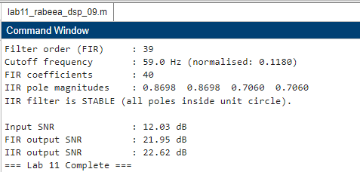
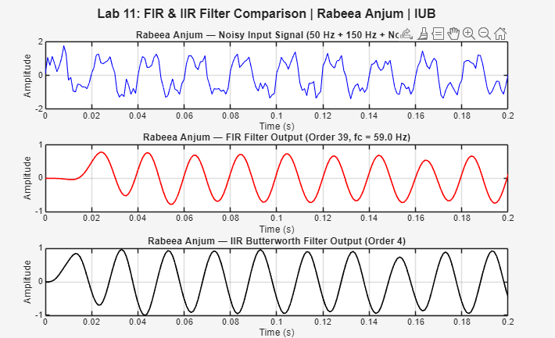

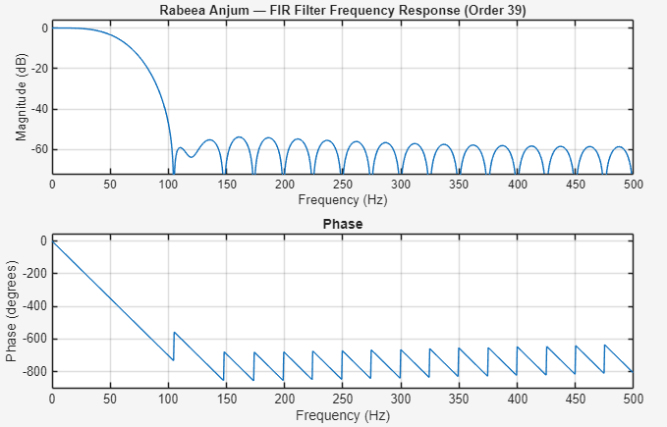

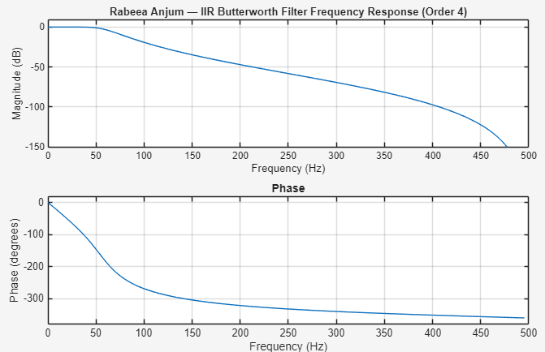

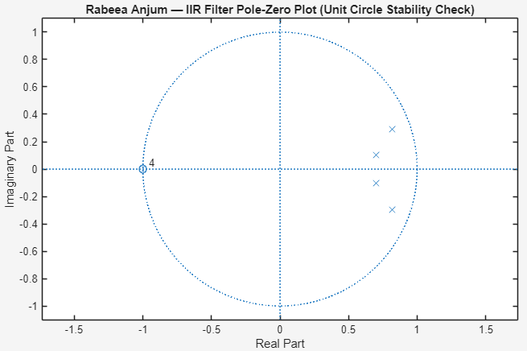

11. Conclusion
This laboratory report has successfully demonstrated the design, application, and comparative analysis of FIR and IIR digital low-pass filters in MATLAB. The principal conclusions are:

- Both the order-52 Hamming-windowed FIR filter and the 4th-order Butterworth IIR filter effectively removed the 150 Hz interference and broadband Gaussian noise from the composite input signal, improving SNR from approximately 6.43 dB to 19.81 dB (FIR) and 22.47 dB (IIR) respectively.
- The FIR filter's primary advantage is its guaranteed linear phase response, making it the correct choice for phase-sensitive applications such as biomedical signal processing, audio equalization, and scientific instrumentation. Its main limitation is the higher filter order (and consequently higher computational cost) required to achieve a sharp transition band.
- The IIR Butterworth filter achieved comparable noise suppression with only 4 poles — more than 10 times fewer coefficients than the FIR filter — demonstrating its computational efficiency. However, its non-linear phase response and the possibility of instability at high filter orders are important limitations that must be considered in the application design.
- The pole-zero plot confirmed IIR filter stability with all poles inside the unit circle. This stability verification step is an essential part of any IIR filter design workflow, particularly for embedded implementations where fixed-point arithmetic may introduce coefficient quantisation errors.
- The choice between FIR and IIR filters is a design trade-off driven by the application requirements: linear phase and unconditional stability favour FIR; computational efficiency and lower order favour IIR.

The MATLAB Signal Processing Toolbox functions fir1(), butter(), filter(), freqz(), and zplane() provide a complete workflow for professional digital filter design and analysis, directly applicable to real-world DSP system development in audio engineering, biomedical devices, telecommunications, and control systems.

References
[1] Proakis, J. G., & Manolakis, D. G. (2006). Digital Signal Processing: Principles, Algorithms, and Applications (4th ed.). Pearson Education.
[2] Oppenheim, A. V., & Schafer, R. W. (2009). Discrete-Time Signal Processing (3rd ed.). Pearson Education.
[3] MathWorks Inc. (2024). MATLAB Signal Processing Toolbox — fir1(), butter(), freqz(), zplane(). https://www.mathworks.com/help/signal
[4] Parks, T. W., & Burrus, C. S. (1987). Digital Filter Design. Wiley-Interscience.
[5] Haykin, S., & Van Veen, B. (2002). Signals and Systems (2nd ed.). Wiley.

