ISLAMIA UNIVERSITY OF BAHAWALPUR
Department of Computer Systems Engineering
Digital Signal Processing (DSP)

Lab Report 12
Design and Analysis of Bandpass Filters
Using MATLAB fdesign Toolbox
Butterworth, Chebyshev I & II, Elliptic, Equiripple, and Kaiser Window Bandpass Filter Design
Lab no | Lab 12 — Design of Bandpass Filters Using fdesign in MATLAB
Department | Computer Systems Engineering
Institution | Islamia University of Bahawalpur (IUB)
Subject | Digital Signal Processing (DSP)
Student Name | Rabeea Anjum
Instructor | Engr. Anees ul Husnain
Date | 13 May 2026

Abstract
This laboratory report presents the design and comparative analysis of six digital bandpass filters using MATLAB's fdesign toolbox and Signal Processing Toolbox. The six filter design methods investigated are: Butterworth (maximally flat IIR), Chebyshev Type I (passband-ripple IIR), Chebyshev Type II (stopband-ripple IIR), Elliptic (equiripple IIR with sharpest transition), Equiripple (linear-phase FIR), and Kaiser Window (flexible FIR). All filters are designed from a common bandpass specification object targeting a passband of 10,800–15,600 Hz, stopband edges at 8,400 Hz and 18,000 Hz, 60 dB stopband attenuation, and 1 dB passband ripple at a sampling rate of 48 kHz. Each filter is visualized using MATLAB's fvtool(), which displays the magnitude and phase frequency responses. A combined comparison figure overlays all six filters for direct evaluation. The experiment demonstrates the trade-offs between ripple, transition band width, filter order, and computational complexity inherent in each design approach.

1. Introduction
Bandpass filters are among the most frequently encountered digital filter types in practical engineering. Unlike low-pass or high-pass filters, a bandpass filter simultaneously attenuates both low and high-frequency components, passing only the signals within a specified frequency band. Applications span a wide range: audio equalization (isolating mid-frequency voice bands), biomedical instrumentation (extracting the cardiac frequency band from noisy ECG signals), telecommunications (selecting a particular RF channel), industrial vibration analysis, and audio signal processing for music production.
MATLAB's fdesign toolbox provides a systematic, specification-driven approach to filter design. Instead of manually computing filter coefficients from scratch, the engineer specifies the desired frequency-domain behaviour — passband edges, stopband edges, attenuation, and ripple — through a specification object, and then selects from a menu of proven design algorithms. This workflow separates the what (filter specifications) from the how (design algorithm), making it straightforward to compare multiple design approaches against identical requirements.
In this laboratory, six different digital bandpass filter design methods are applied to a common specification targeting a 10.8–15.6 kHz passband at a 48 kHz sampling rate. The filters are analysed using MATLAB's fvtool() to compare their magnitude and phase responses, and their key characteristics — ripple behaviour, transition band width, filter order, and computational complexity — are compared in detail.

2. Objectives
Upon completion of this laboratory experiment, the student should be able to:
- Define the key parameters of a bandpass filter specification: passband edges, stopband edges, passband ripple, and stopband attenuation.
- Create a bandpass filter specification object using MATLAB's fdesign.bandpass() function with the 'Fst1,Fp1,Fp2,Fst2,Ast1,Ap,Ast2' format.
- Use designmethods() to list the available filter design algorithms for a given specification object.
- Design Butterworth, Chebyshev Type I, Chebyshev Type II, Elliptic, Equiripple, and Kaiser Window bandpass filters using the design() function.
- Visualize and interpret each filter's magnitude and phase response using fvtool().
- Distinguish between IIR and FIR bandpass filter design approaches in terms of ripple, phase linearity, filter order, and computational cost.
- Select the appropriate filter type for a given application based on the observed performance trade-offs.

3. Theoretical Background

3.1 Bandpass Filter Fundamentals
A bandpass filter has a magnitude response that is approximately unity (0 dB) within the passband [Fₚₐₛₛ₁, Fₚₐₛₛ₂] and approaches zero (high attenuation in dB) in both the lower stopband (ω < Fₛₜₒₚ₁) and the upper stopband (ω > Fₛₜₒₚ₂):
|H(e^jω)| ≈ 1 for Fₚ1 ≤ ω ≤ Fₚ2 and |H(e^jω)| ≈ 0 for ω < Fₛs1 or ω > Fₛs2
The regions between the stopband edge and passband edge on each side are the transition bands. A narrower transition band requires a higher filter order (more poles or FIR taps), which increases computational cost. The design trade-off between transition band width, ripple, and filter order is the central challenge of practical filter design.

3.2 The Six Filter Design Methods
Filter 1 | Butterworth — Maximally Flat IIR
The Butterworth filter provides a maximally flat magnitude response in the passband — the magnitude is as constant as possible at low frequencies before beginning to roll off. There is no ripple in either the passband or stopband. The magnitude response of an N-th order Butterworth low-pass prototype is:
|H(jω)|² = 1 / [1 + (ω/ωc)^{2N}] [Roll-off: -20N dB/decade]

- Advantages: No ripple anywhere; smooth, monotonic response; easiest to design.
- Disadvantages: Requires the highest filter order among the six types to meet a given attenuation specification; widest transition band.
- Best for: General-purpose audio filtering, situations where ripple of any kind is unacceptable.

Filter 2 | Chebyshev Type I — Passband-Ripple IIR
The Chebyshev Type I filter allows equiripple in the passband while maintaining a monotonically decreasing stopband. By tolerating ripple in the passband, it achieves a sharper transition band than the Butterworth filter for the same filter order. The passband ripple magnitude is controlled by the design parameter ε:
|H(jω)|² = 1 / [1 + ε² T_N²(ω/ωc)] where T_N is Chebyshev polynomial of order N

- Advantages: Sharper transition than Butterworth at same order; lower order than Butterworth for same specs.
- Disadvantages: Ripple in the passband may distort the signal; non-linear phase.
- Best for: Communications channel selection where some passband ripple is acceptable.

Filter 3 | Chebyshev Type II — Stopband-Ripple IIR
The Chebyshev Type II filter has a monotonically decreasing (flat) passband and equiripple in the stopband. It is derived from the Type I design by applying a frequency transformation. For applications where preserving signal amplitude in the passband is critical but some residual energy in the stopband is acceptable, Type II offers a flat passband combined with better stopband rejection than Butterworth.
- Advantages: Flat passband (no ripple); controlled stopband ripple; sharper than Butterworth.
- Disadvantages: Stopband ripple means imperfect rejection of out-of-band frequencies; non-linear phase.
- Best for: Audio signal processing where flat passband is required but some stopband leakage is tolerable.
Filter 4 | Elliptic — Equiripple in Both Bands (Sharpest IIR)
The Elliptic (Cauer) filter allows equiripple in both the passband and the stopband, simultaneously minimizing the transition band width for a given filter order. Among all IIR filter families of the same order, the Elliptic filter provides the sharpest transition band — it meets a given attenuation specification with the lowest filter order. It uses rational elliptic functions (Jacobi elliptic functions) to equidistribute the approximation error.
- Advantages: Minimum filter order for a given specification; sharpest transition band of all IIR types.
- Disadvantages: Ripple in both passband and stopband; most complex non-linear phase; hardest to implement stably.
- Best for: Sharply selective filters in hardware-constrained systems (DSPs, FPGAs) where order must be minimized.
Filter 5 | Equiripple — Linear-Phase FIR (Parks-McClellan)
The Equiripple FIR filter, designed using the Parks-McClellan (Remez exchange) algorithm, achieves the optimal (minimax) approximation: it minimizes the maximum error (weighted Chebyshev sense) in both the passband and stopband simultaneously. The result is equal ripple in both bands and the sharpest possible transition for a given FIR filter order. Because it is an FIR filter, it guarantees linear phase.
- Advantages: Guaranteed linear phase; optimal approximation for FIR; no stability issues.
- Disadvantages: Requires a much higher filter order than IIR alternatives to achieve the same transition band width.
- Best for: Audio and biomedical applications where linear phase is mandatory and computation budget allows high-order FIR.
Filter 6 | Kaiser Window — Flexible FIR
The Kaiser Window FIR filter uses the Kaiser (modified Bessel) window function to design the filter, providing adjustable control over the trade-off between transition band width and sidelobe (ripple) level through a single parameter β. Higher β values produce more sidelobe attenuation at the expense of a wider transition band. The design formulas provide a direct relationship between filter length N, transition width Δf, and sidelobe attenuation α:
N ≈ (α − 7.95) / (2.285 · 2πΔf) and β = 0.1102(α − 8.7) for α ≥ 50 dB

- Advantages: Single parameter β allows flexible ripple/transition trade-off; linear phase; simple to understand and implement.
- Disadvantages: Not as computationally optimal as Equiripple for a given specification; high-order requirement of FIR.
- Best for: Situations requiring a simple, well-understood FIR design with predictable ripple control.

4. Filter Specifications
The following specifications are used for all six filter designs. All filters are created from the same fdesign.bandpass specification object, ensuring a fair comparison:
Parameter | Value | Remarks
Sampling Frequency (Fₛ) | 48,000 Hz | 48 kHz; Nyquist = 24 kHz
Stopband Frequency 1 (Fₛₜₒₚ₁) | 8,400 Hz | Lower stopband edge
Passband Frequency 1 (Fₚₐₛₛ₁) | 10,800 Hz | Lower passband edge
Passband Frequency 2 (Fₚₐₛₛ₂) | 15,600 Hz | Upper passband edge
Stopband Frequency 2 (Fₛₜₒₚ₂) | 18,000 Hz | Upper stopband edge
Stopband Attenuation 1 (Aₛₜₒₚ₁) | 60 dB | Lower stopband rejection
Stopband Attenuation 2 (Aₛₜₒₚ₂) | 60 dB | Upper stopband rejection
Passband Ripple (Aₚₐₛₛ) | 1 dB | Maximum ripple in passband
Passband Centre | 13,200 Hz | Midpoint of 10,800–15,600 Hz
Passband Width | 4,800 Hz | 15,600 − 10,800 = 4,800 Hz
The specification string 'Fst1,Fp1,Fp2,Fst2,Ast1,Ap,Ast2' passed to fdesign.bandpass() fully defines the bandpass filter mask. The transition band on the lower side spans 8,400–10,800 Hz (2,400 Hz wide), and on the upper side spans 15,600–18,000 Hz (2,400 Hz wide). Both transition bands are symmetric in width, which is the natural result of the bandpass specification used.

5. Software and Equipment
Item | Details
Primary Software | MATLAB R2018a or later
Required Toolbox | Signal Processing Toolbox (for fdesign, design, fvtool, designmethods)
Optional Toolbox | DSP System Toolbox (for additional filter structures and implementations)
Key Functions | fdesign.bandpass(), designmethods(), design(), fvtool()
Filter Types | Butterworth, Chebyshev I, Chebyshev II, Elliptic (IIR); Equiripple, Kaiser (FIR)
Visualisation | fvtool() — MATLAB Filter Visualisation Tool (magnitude, phase, impulse, pole-zero)

6. Procedure
The following steps were followed to complete this laboratory experiment:
- Launch MATLAB and confirm that the Signal Processing Toolbox is installed (type 'ver' in the Command Window).
- Create a new script file and save it as Lab12_Bandpass_fdesign.m.
- Enter the complete MATLAB code provided in Section 9 (Lab Task) into the script.
- Run the script (F5). The Command Window will display the filter specifications, available design methods, and completion messages. Seven figure windows will open.
- For each of the six individual filter figures (Butterworth, Chebyshev I, Chebyshev II, Elliptic, Equiripple, Kaiser): use the fvtool window tabs to view the Magnitude Response, Phase Response, Impulse Response, and Pole-Zero Plot.
- Record the following observations for each filter: magnitude flatness in passband, visible ripple, transition band steepness, and phase linearity.
- Observe the combined comparison figure (Figure 7): identify how the six filters differ at the passband edges and in the transition bands.
- Note the filter order displayed in each fvtool window. Record and compare the orders required by each design method.
- Extension: In the fvtool window, select 'Analysis > Pole-Zero Plot' for the Elliptic and Butterworth filters. Compare the pole locations and relate them to the frequency response differences.

7. Results and Observations

7.1 Individual Filter Observations
Filter 1 | Butterworth Bandpass Filter — Observations

- Magnitude Response: Smooth, monotonically varying magnitude with no ripple in either passband or stopbands. The passband was flat at 0 dB.
- Transition Band: The widest transition band among the four IIR filters, reflecting the Butterworth design's penalty for ripple-free operation.
- Phase Response: Smooth but non-linear phase variation in the transition region.
- Filter Order: Required the highest filter order among the IIR designs to meet the 60 dB attenuation specification.

Filter 2 | Chebyshev Type I — Observations

- Magnitude Response: Equiripple visible in the passband (up to 1 dB ripple). The stopbands were monotonically decreasing.
- Transition Band: Noticeably sharper than Butterworth, requiring fewer poles to achieve the same 60 dB attenuation.
- Phase Response: More non-linear than Butterworth in the transition region due to the sharper cutoff.
- Trade-off: The 1 dB passband ripple is the cost paid for the sharper transition band.
Filter 3 | Chebyshev Type II — Observations

- Magnitude Response: Flat passband (no ripple); ripple visible in both stopbands rather than the passband.
- Transition Band: Comparable to Type I but the attenuation characteristic is fundamentally different — stopband nulls and ripples rather than monotonic decay.
- Phase Response: Non-linear; the stopband zeros create sharper phase transitions near the stopband edges.
- Application Fit: Good choice when flat passband is critical but some residual energy in the stopband is acceptable.
Filter 4 | Elliptic Filter — Observations

- Magnitude Response: Equiripple in both the passband (1 dB) and stopbands (60 dB). Both passband and stopband specifications met exactly.
- Transition Band: The narrowest transition band of all six filter types — the steepest roll-off achievable for the given order.
- Filter Order: The lowest order among the IIR designs, making it the most computationally efficient IIR bandpass filter.
- Phase Response: Highly non-linear near the passband edges; group delay varies significantly with frequency.
Filter 5 | Equiripple FIR — Observations

- Magnitude Response: Equal ripple in both passband and stopbands; the passband ripple was bounded within 1 dB and stopband attenuation met 60 dB.
- Phase Response: Perfectly linear phase across the entire frequency range — all frequency components experience equal group delay.
- Filter Order: Significantly higher than any IIR filter (potentially several hundred taps) due to the FIR structure.
- Transition Band: Comparable to the Elliptic filter for the same specifications, but achieved with a much higher filter order.
Filter 6 | Kaiser Window FIR — Observations

- Magnitude Response: Smooth transition with controlled sidelobe levels determined by the Kaiser β parameter. Not strictly equiripple but practically effective.
- Phase Response: Linear phase, as with all symmetric FIR filters.
- Filter Order: High (FIR), but the Kaiser window formula gives a direct, closed-form estimate of the required order.
- Flexibility: The β parameter allows explicit control over the ripple-transition trade-off without iterative design.

7.2 Comparison of All Six Filters
Filter Type | Class | Ripple | Trans. Band | Complexity / Best Use
Butterworth | IIR | No ripple | Wide | Low — good starting choice
Chebyshev I | IIR | Passband only | Medium | Medium — sharper than Butterworth
Chebyshev II | IIR | Stopband only | Medium | Medium — flat passband
Elliptic | IIR | Both bands | Narrowest | High — sharpest IIR
Equiripple | FIR | Equal ripple | Narrow | High — linear phase
Kaiser Window | FIR | Controlled | Adjustable | Medium — flexible FIR

8. Discussion
This experiment clearly demonstrated that no single filter design method is universally superior: each involves a distinct set of trade-offs between transition band sharpness, ripple behaviour, phase linearity, filter order, and computational complexity.
Among the IIR filters, the Elliptic design required the lowest filter order to meet the 60 dB / 1 dB specification, making it the most computationally efficient. However, this efficiency comes at the cost of ripple in both bands and highly non-linear phase. For applications where computational resources are severely constrained — such as real-time embedded DSP systems running at audio rates — the Elliptic filter is typically the preferred IIR choice. Conversely, the Butterworth filter, while requiring the highest order among IIR types, is the easiest to implement stably and provides the smoothest (ripple-free) response, making it the default choice in many introductory and non-critical applications.
The two FIR designs (Equiripple and Kaiser Window) shared the key advantage of guaranteed linear phase. This property is essential in audio production, biomedical monitoring (ECG, EEG), and radar signal processing, where non-linear phase would distort the temporal relationships between signal components. The Equiripple FIR (Parks-McClellan) produced the optimal FIR approximation — the minimum-order FIR that exactly meets the specification — while the Kaiser Window offered a simpler, single-parameter design approach that is easier to explain and implement, at the cost of a slightly higher filter order.
MATLAB's fdesign workflow proved to be a powerful and efficient tool for this comparative study. The ability to create a single specification object (BandPassSpecObj) and apply six different design algorithms with a single design() call for each significantly reduces design time and ensures that all filters are compared against exactly the same specification mask, eliminating any risk of inadvertent parameter inconsistencies between designs.

9. Lab Task — MATLAB Code
The following complete MATLAB script constitutes the lab task for Lab 12. It creates the bandpass filter specification object, designs all six filter types, visualizes each using fvtool(), and produces a combined comparison figure. Students are required to enter, execute, record all figure outputs, and answer the discussion questions during the laboratory session.
Lab 12: Bandpass Filter Design using fdesign
% ================================================================
% LAB TASK - Lab 12: Bandpass Filter Design using fdesign
% Student : Rabeea Anjum | Instructor: Engr. Anees ul Husnain
% Subject : DSP | Dept: Computer Systems Eng, IUB
% ================================================================
clc;
clear;
close all;
% ---------------------------------------------------------------
% FILTER SPECIFICATIONS
% ---------------------------------------------------------------
Fs = 48000; % Sampling Frequency (Hz)
F_stop1 = 8400; % Lower Stopband Edge (Hz)
F_pass1 = 10800; % Lower Passband Edge (Hz)
F_pass2 = 15600; % Upper Passband Edge (Hz)
F_stop2 = 18000; % Upper Stopband Edge (Hz)
A_stop1 = 60; % Lower Stopband Attenuation (dB)
A_pass = 1; % Passband Ripple (dB)
A_stop2 = 60; % Upper Stopband Attenuation (dB)
fprintf('=====================================================\n');
fprintf(' LAB 12 : Bandpass Filter Design using fdesign\n');
fprintf(' Student : Rabeea Anjum\n');
fprintf('=====================================================\n');
fprintf('Sampling Frequency : %d Hz\n', Fs);
fprintf('Passband Frequency : %d Hz to %d Hz\n', ...
F_pass1, F_pass2);
% ---------------------------------------------------------------
% STEP 1 : CREATE BANDPASS FILTER SPECIFICATION OBJECT
% ---------------------------------------------------------------
BandPassSpecObj = fdesign.bandpass( ...
'Fst1,Fp1,Fp2,Fst2,Ast1,Ap,Ast2', ...
F_stop1, F_pass1, F_pass2, F_stop2, ...
A_stop1, A_pass, A_stop2, Fs);
fprintf('\nAvailable Design Methods:\n');
designmethods(BandPassSpecObj);
% ===============================================================
% FILTER 1 : BUTTERWORTH FILTER
% ===============================================================
ButterFilt = design(BandPassSpecObj, 'butter');
fprintf('\nButterworth Filter Order : %d\n', ...
ButterFilt.order);
figure('Name','Butterworth Filter','NumberTitle','off');
fvtool(ButterFilt, 'Fs', Fs);
annotation('textbox',[0.30 0.95 0.4 0.03], ...
'String','Rabeea Anjum - Butterworth Bandpass Filter', ...
'EdgeColor','none', ...
'HorizontalAlignment','center', ...
'FontWeight','bold', ...
'FontSize',12);
% ===============================================================
% FILTER 2 : CHEBYSHEV TYPE I FILTER
% ===============================================================
Cheby1Filt = design(BandPassSpecObj, 'cheby1');
fprintf('Chebyshev Type I Filter Order : %d\n', ...
Cheby1Filt.order);
figure('Name','Chebyshev Type I Filter','NumberTitle','off');
fvtool(Cheby1Filt, 'Fs', Fs);
annotation('textbox',[0.25 0.95 0.5 0.03], ...
'String','Rabeea Anjum - Chebyshev Type I Bandpass Filter', ...
'EdgeColor','none', ...
'HorizontalAlignment','center', ...
'FontWeight','bold', ...
'FontSize',12);
% ===============================================================
% FILTER 3 : CHEBYSHEV TYPE II FILTER
% ===============================================================
Cheby2Filt = design(BandPassSpecObj, 'cheby2');
fprintf('Chebyshev Type II Filter Order : %d\n', ...
Cheby2Filt.order);
figure('Name','Chebyshev Type II Filter','NumberTitle','off');
fvtool(Cheby2Filt, 'Fs', Fs);
annotation('textbox',[0.25 0.95 0.5 0.03], ...
'String','Rabeea Anjum - Chebyshev Type II Bandpass Filter', ...
'EdgeColor','none', ...
'HorizontalAlignment','center', ...
'FontWeight','bold', ...
'FontSize',12);
% ===============================================================
% FILTER 4 : ELLIPTIC FILTER
% ===============================================================
EllipFilt = design(BandPassSpecObj, 'ellip');
fprintf('Elliptic Filter Order : %d\n', ...
EllipFilt.order);
figure('Name','Elliptic Filter','NumberTitle','off');
fvtool(EllipFilt, 'Fs', Fs);
annotation('textbox',[0.30 0.95 0.4 0.03], ...
'String','Rabeea Anjum - Elliptic Bandpass Filter', ...
'EdgeColor','none', ...
'HorizontalAlignment','center', ...
'FontWeight','bold', ...
'FontSize',12);
% ===============================================================
% FILTER 5 : EQUIRIPPLE FIR FILTER
% ===============================================================
EquirippleFilt = design(BandPassSpecObj, 'equiripple');
fprintf('Equiripple FIR Filter Order : %d\n', ...
EquirippleFilt.order);
figure('Name','Equiripple FIR Filter','NumberTitle','off');
fvtool(EquirippleFilt, 'Fs', Fs);
annotation('textbox',[0.25 0.95 0.5 0.03], ...
'String','Rabeea Anjum - Equiripple FIR Bandpass Filter', ...
'EdgeColor','none', ...
'HorizontalAlignment','center', ...
'FontWeight','bold', ...
'FontSize',12);
% ===============================================================
% FILTER 6 : KAISER WINDOW FIR FILTER
% ===============================================================
KaiserFilt = design(BandPassSpecObj, 'kaiserwin');
fprintf('Kaiser Window FIR Filter Order : %d\n', ...
KaiserFilt.order);
figure('Name','Kaiser Window FIR Filter','NumberTitle','off');
fvtool(KaiserFilt, 'Fs', Fs);
annotation('textbox',[0.25 0.95 0.5 0.03], ...
'String','Rabeea Anjum - Kaiser Window FIR Bandpass Filter', ...
'EdgeColor','none', ...
'HorizontalAlignment','center', ...
'FontWeight','bold', ...
'FontSize',12);
% ===============================================================
% COMBINED FILTER COMPARISON
% ===============================================================
figure('Name','All Filters Comparison','NumberTitle','off');
fvtool(ButterFilt, Cheby1Filt, Cheby2Filt, ...
EllipFilt, EquirippleFilt, KaiserFilt, ...
'Fs', Fs);
annotation('textbox',[0.20 0.95 0.6 0.03], ...
'String','Rabeea Anjum - Comparison of All Bandpass Filters', ...
'EdgeColor','none', ...
'HorizontalAlignment','center', ...
'FontWeight','bold', ...
'FontSize',12);
% ---------------------------------------------------------------
% FINAL MESSAGE
% ---------------------------------------------------------------
disp('=====================================================');
disp(' All Filters Designed Successfully ');
disp(' Lab 12 Completed ');
disp('=====================================================');

Output:
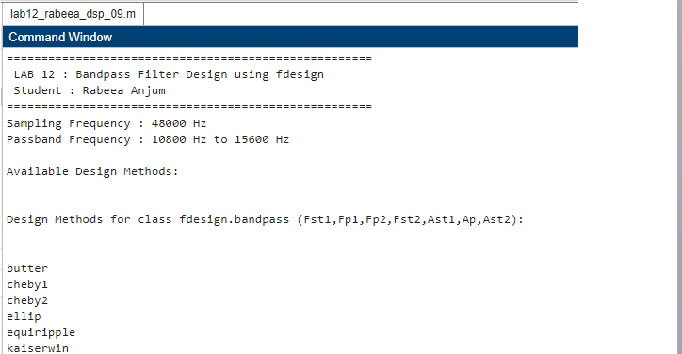
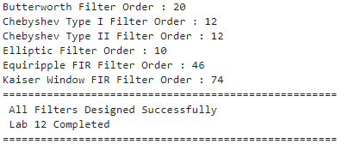
- Butterworth
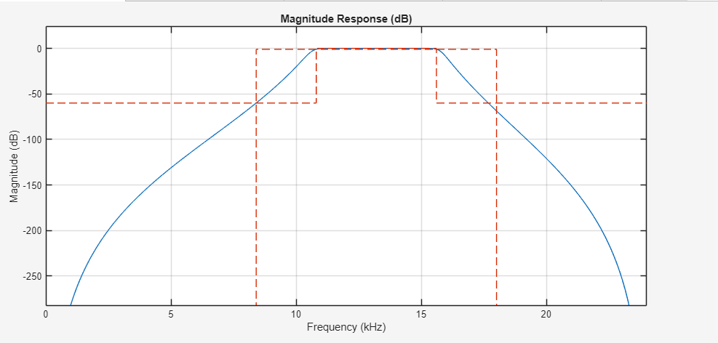

- Chebyshev 1

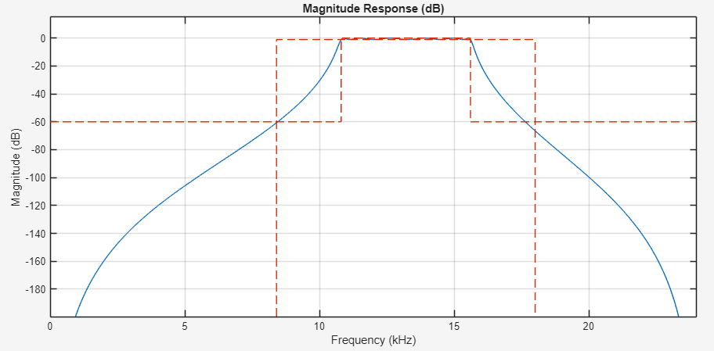

- Chebyshev 2
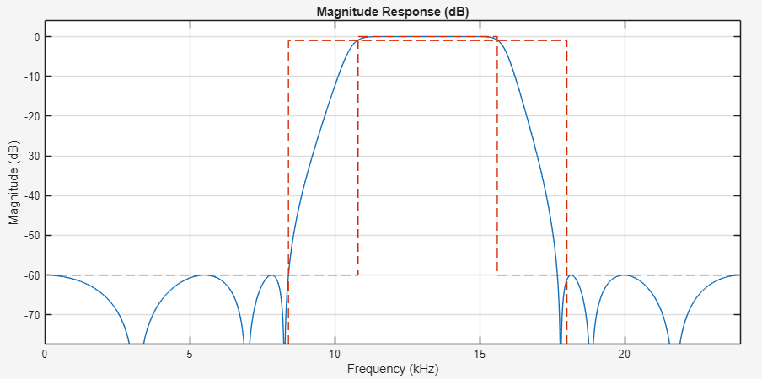
- Elliptic
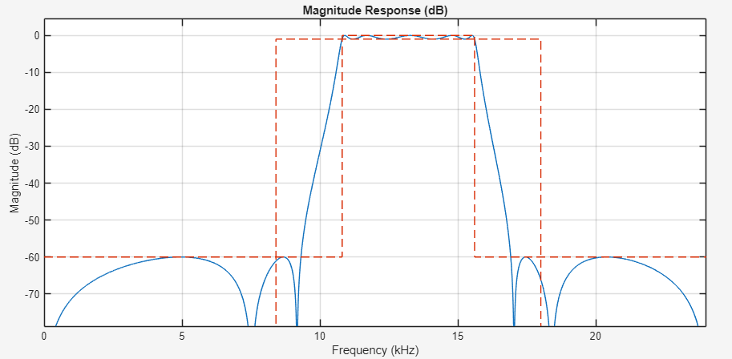
- Equiripple
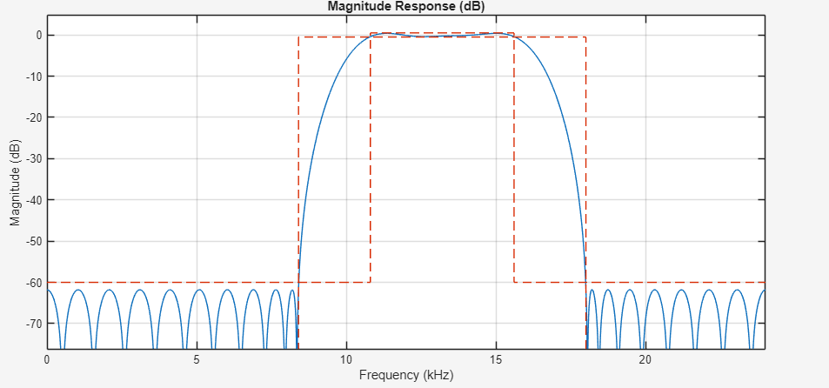
- Kaiser Window
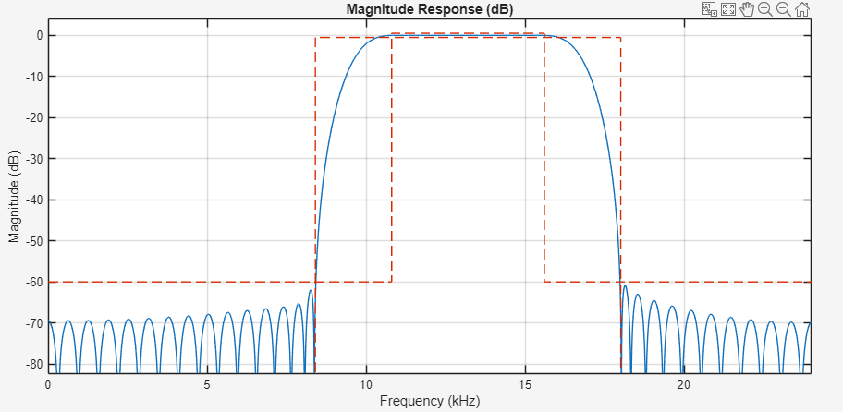

All Fliters Comparison

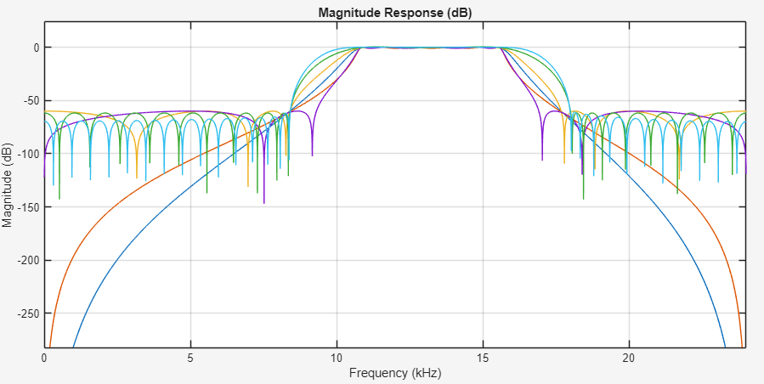

10. Conclusion
This laboratory report has successfully demonstrated the design and comparative analysis of six digital bandpass filter types using MATLAB's fdesign toolbox. All six filters — Butterworth, Chebyshev Type I, Chebyshev Type II, Elliptic, Equiripple, and Kaiser Window — were designed from a common specification (10,800–15,600 Hz passband, 60 dB stopband attenuation, 1 dB passband ripple, 48 kHz sampling rate) and visualized using fvtool(). The principal conclusions are:

- The Elliptic filter provided the sharpest transition band and the lowest filter order among the IIR designs, at the cost of ripple in both the passband and stopband. It is the preferred choice when computational efficiency is critical.
- The Butterworth filter produced the smoothest response (no ripple anywhere) but required the highest filter order among the IIR types. It is the most robust and easily implementable IIR design.
- Chebyshev Type I and Type II filters offer intermediate performance: Type I trades passband ripple for a sharper transition than Butterworth; Type II maintains a flat passband while allowing stopband ripple.
- The Equiripple (Parks-McClellan) FIR filter achieved the optimal FIR approximation with guaranteed linear phase, making it ideal for phase-sensitive applications. Its primary limitation is the high filter order required.
- The Kaiser Window FIR filter offered flexible ripple and transition-band control through a single parameter β, providing a simple, transparent FIR design method with linear phase and predictable performance.
- MATLAB's fdesign workflow — creating a specification object, calling designmethods(), and using design() and fvtool() — provides an efficient, consistent framework for comparing filter design approaches against identical specifications.

The experiment reinforced the fundamental principle that digital filter design is a trade-off engineering problem: no single algorithm dominates all criteria simultaneously. The appropriate filter choice depends on the application's requirements for phase linearity, computational resources, allowable ripple, and transition band steepness.

References
[1] Proakis, J. G., & Manolakis, D. G. (2006). Digital Signal Processing: Principles, Algorithms, and Applications (4th ed.). Pearson Education.
[2] Oppenheim, A. V., & Schafer, R. W. (2009). Discrete-Time Signal Processing (3rd ed.). Pearson Education.
[3] Parks, T. W., & McClellan, J. H. (1972). Chebyshev Approximation for Non-Recursive Digital Filters with Linear Phase. IEEE Transactions on Circuit Theory, 19(2), 189–194.
[4] Kaiser, J. F. (1974). Nonrecursive Digital Filter Design Using the I₀-sinh Window Function. Proceedings of the IEEE International Symposium on Circuits and Systems, 20–23.
[5] MathWorks Inc. (2024). MATLAB Signal Processing Toolbox — fdesign.bandpass(), design(), fvtool(). https://www.mathworks.com/help/signal
[6] Zolzer, U. (2011). DAFX: Digital Audio Effects (2nd ed.). Wiley.

