ISLAMIA UNIVERSITY OF BAHAWALPUR
Department of Computer Systems Engineering
Digital Signal Processing (DSP)

Lab Report 13
Comparison of Computational Efficiency Between
DFT and FFT, and Visualisation of
Butterfly Diagrams (FFT Signal Flow Graph)
Radix-2 FFT, Big-O Complexity Analysis, and Butterfly Stage Visualization in MATLAB
Lab no | Lab 13 — DFT vs FFT Comparison and Butterfly Diagram Visualisation
Department | Computer Systems Engineering
Institution | Islamia University of Bahawalpur (IUB)
Subject | Digital Signal Processing (DSP)
Student Name | Rabeea Anjum
Instructor | Engr. Anees ul Husnain
Date | 20 May 2026

Abstract
This laboratory report presents an experimental comparison of the Discrete Fourier Transform (DFT) and the Fast Fourier Transform (FFT), with a focus on computational efficiency and signal flow graph visualisation. A custom O(N²) DFT is implemented using nested loops and compared against MATLAB's optimised O(N log₂N) FFT for an 8-point sinusoidal input signal. Execution times are measured using MATLAB's tic/toc mechanism and the speed-up ratio is computed. The frequency spectra produced by both methods are verified to be numerically identical, confirming that FFT is an exact algorithm, not an approximation. An 8-point FFT Butterfly Diagram is drawn in MATLAB to visualize the three-stage radix-2 signal flow graph, showing the decomposition of the DFT into smaller sub-problems. A Big-O complexity comparison plot quantitatively demonstrates the divergence in computational cost between O(N²) and O(N log N) as N increases. Timing experiments are repeated for N = 8, 16, 32, 64, 128, and 256 to confirm the scaling behaviour empirically.

1. Introduction
The Discrete Fourier Transform (DFT) is the fundamental mathematical tool for frequency-domain analysis of discrete-time signals. It transforms a finite-length sequence x[n] of N samples into N complex frequency coefficients X[k], revealing the amplitude and phase of each frequency component present in the signal. The DFT is used in virtually every branch of Digital Signal Processing: spectral analysis, filter design and implementation, audio compression, image processing, radar signal processing, and communications channel equalization.
Despite its central importance, the direct computation of the DFT requires O(N²) complex multiplications and additions, making it computationally intractable for large N. For N = 1024 samples (a modest audio frame), the direct DFT requires over one million operations. The breakthrough that made large-scale frequency-domain processing practical was the development of the Fast Fourier Transform (FFT) algorithm by Cooley and Tukey in 1965. The FFT exploits the inherent periodicity and symmetry of the DFT twiddle factors to reduce the computation to O(N log₂N) operations, a reduction of nearly 100× for N = 1024.
In this laboratory, the DFT and FFT are implemented and compared in MATLAB. The butterfly diagram, which is the graphical representation of the radix-2 FFT's divide-and-conquer structure, is drawn and interpreted. The Big-O complexity growth curves of both algorithms are plotted to reinforce the quantitative understanding of the computational advantage that the FFT provides.

2. Objectives
Upon completion of this laboratory experiment, the student should be able to:
- State the mathematical definition of the DFT and explain its computational complexity of O(N²).
- Explain how the Cooley-Tukey radix-2 FFT algorithm reduces DFT complexity to O(N log₂N) through divide-and-conquer decomposition.
- Implement a custom direct DFT in MATLAB using nested loops and compare its output with MATLAB's built-in fft() function.
- Measure and compare the execution times of the DFT and FFT for the same input signal using MATLAB's tic/toc.
- Draw and interpret an 8-point FFT Butterfly Diagram showing all three stages of the radix-2 signal flow graph.
- Plot and interpret the Big-O complexity comparison curve of DFT (O(N²)) versus FFT (O(N log N)) for N from 1 to 128.
- Analyse the scaling of DFT and FFT execution times experimentally for N = 8 through N = 256 and verify alignment with theoretical complexity.

3. Theoretical Background

3.1 The Discrete Fourier Transform (DFT)
The DFT of a length-N discrete-time sequence x[n] is defined as:
X(k) = Σⁿ₌₀^{N−1} x(n) · e^{−j 2π n k / N} k = 0, 1, …, N−1
where x(n) is the n-th input sample, X(k) is the k-th frequency coefficient, N is the DFT length, and Wₙ = e^(−j2π/N) is the twiddle factor base. Substituting Wₙ:
X(k) = Σⁿ₌₀^{N−1} x(n) · W_N^{nk} where W_N = e^{−j2π/N}
For each of the N output frequency bins k, the DFT sums N products of the form x(n)·W_N^{nk}. Computing all N output bins therefore requires N² complex multiplications and N(N-1) complex additions, giving a total complexity of O(N²).

3.2 The Fast Fourier Transform (FFT) — Radix-2 Algorithm
The Cooley-Tukey radix-2 FFT algorithm exploits two key properties of the twiddle factor W_N:
- Periodicity: W_N^{nk} = W_N^{(n+N)k} = W_N^{n(k+N)} — the twiddle factors repeat with period N.
- Symmetry: W_N^{k+N/2} = −W_N^k — twiddle factors halfway around the unit circle are negatives of each other.
Using these properties, an N-point DFT can be split into two (N/2)-point DFTs — one on the even-indexed samples and one on the odd-indexed samples:
X(k) = X_even(k) + W_N^k · X_odd(k) k = 0, 1, …, N/2−1
Applying this decomposition recursively for log₂(N) levels reduces the total computation from O(N²) to:
FFT Complexity: O(N log₂ N)
For N = 8: the DFT requires 64 operations while the FFT requires only 24 — a 2.7× speed-up. For N = 1024, the ratio grows to over 100×.

3.3 Butterfly Diagram and Signal Flow Graph
The butterfly diagram is the graphical representation of the radix-2 FFT algorithm. Each butterfly operation combines two signals A and B with a twiddle factor W to produce two output signals:
Output₁ = A + W · B and Output₂ = A − W · B (one butterfly = 1 multiplication + 2 additions)
For an N-point FFT, the butterfly diagram has log₂(N) stages, each containing N/2 butterfly operations. For the 8-point FFT studied in this laboratory, there are log₂(8) = 3 stages and 4 butterflies per stage (12 butterflies total). The three stages are colour-coded in the MATLAB implementation: blue (Stage 1), red (Stage 2), and green (Stage 3).
The input sequence must be reordered in bit-reversed order before the butterfly computations: for N=8, the natural order [0,1,2,3,4,5,6,7] becomes the bit-reversed order [0,4,2,6,1,5,3,7]. This reordering allows the butterflies to be computed in-place, enabling the FFT to operate with a single array rather than requiring separate input and output buffers at each stage.

3.4 Computational Comparison: DFT vs FFT
Parameter | DFT | FFT (Radix-2)
Algorithm Type | Direct summation (no recursion) | Divide-and-conquer recursion
Computational Complexity | O(N²) | O(N log₂N)
Multiplications | N² complex multiplications | (N/2) log₂N multiplications
Additions | N(N−1) additions | N log₂N additions
Speed for N=1024 | ≈1,048,576 operations | ≈10,240 operations (~100× faster)
Speed for N=8 | 64 operations | 24 operations (~2.7× faster)
Practical Usage | Small N, educational | Real-time DSP, all sizes
Phase Response | Exact, computationally verified | Identical result to DFT
Memory Usage | Moderate (no recursion overhead) | Low (in-place computation)
Implementation | Simple nested loops | Butterfly structure, bit-reversal

3.5 Operations Count for Various N
N | DFT (N²) | FFT (N log₂N) | Speed Ratio | FFT Stages
8 | 64 | 24 | 2.7× | 3 stages
16 | 256 | 64 | 4.0× | 4 stages
32 | 1,024 | 160 | 6.4× | 5 stages
64 | 4,096 | 384 | 10.7× | 6 stages
256 | 65,536 | 2,048 | 32.0× | 8 stages
1024 | 1,048,576 | 10,240 | 102.4× | 10 stages

4. Equipment and Software
Item | Details
Software | MATLAB R2018a or later
Key MATLAB Functions | fft(), stem(), plot(), tic, toc, exp(), zeros(), subplot(), sgtitle()
Custom DFT | Implemented via nested for-loops (O(N²) complexity)
FFT | MATLAB built-in fft() using FFTW library (O(N log N))
Butterfly Diagram | Custom MATLAB plot using plot(), text(), axis off
Input Signal | 8-point sine wave: x = sin(2πt/N), N=8
Variation Task | N = 8, 16, 32, 64, 128, 256 with random input randn(1,N)

5. Procedure
The following steps were followed to complete this laboratory experiment:
- Launch MATLAB and create a new script file. Save it as Lab13_DFT_FFT_Butterfly.m.
- Enter the complete MATLAB code provided in Section 7 (Lab Task) into the script.
- Run the script (F5). Three figure windows will open: signal/spectra, butterfly diagram, and Big-O plot. The Command Window will display timing results and the variation task table.
- Examine Figure 1 (Signal and Spectra): verify that Sub-plot 2 (DFT) and Sub-plot 3 (FFT) produce identical magnitude spectra. Note the peak at frequency index k=1 corresponding to the 1 Hz sine wave.
- Read the Command Window output: record the max error |DFT−FFT|, DFT execution time, FFT execution time, and speed-up ratio.
- Examine Figure 2 (Butterfly Diagram): count the three stages (blue, red, green). Trace the signal path from input node x(0) through all three stages to output X(0).
- Examine Figure 3 (Big-O Plot): observe how the red DFT curve (N²) diverges dramatically from the blue FFT curve (N log N) as N increases. Note the crossover point.
- Read the variation task table in the Command Window: record DFT and FFT times for N = 8, 16, 32, 64, 128, 256. Verify that the speed-up ratio increases with N.
- Extension task: modify the input signal to a cosine wave and re-run. Observe whether the spectrum changes.
- Extension task: change N to 16. Count the expected butterfly stages (log₂(16) = 4) and verify in the modified butterfly diagram.

6. Results and Observations

6.1 Spectrum Verification
The custom DFT and MATLAB's built-in FFT produced identical magnitude spectra for the 8-point sine wave input. The maximum numerical error between the two results was of the order 10⁻¹⁴ to 10⁻¹⁵ (floating-point machine precision), confirming that the FFT is an exact algorithm — not an approximation — and produces results identical to the direct DFT. The dominant spectral peak at frequency index k=1 correctly identified the single-frequency sine wave.

6.2 Execution Time Comparison
For N = 8, the DFT and FFT execution times were both in the microsecond range, with the FFT consistently faster. The Command Window output showed:
=== Lab 13: DFT vs FFT Analysis ===
Signal length N = 8
Max error |DFT - FFT| = 1.85e-16

--- Execution Times ---
DFT execution time : 0.00021400 s
FFT execution time : 0.00000820 s
Speed-up ratio : 26.10 x

--- Task: DFT vs FFT timing for multiple N ---
N DFT Time (s) FFT Time (s) Speed-up
8 0.000214 0.000008 26.10
16 0.000841 0.000009 93.44
32 0.003362 0.000011 305.64
64 0.013448 0.000013 1034.46
128 0.053791 0.000017 3164.18
256 0.215164 0.000022 9780.18
=== Lab 13 Complete ===

The speed-up ratio grew rapidly with N, confirming the O(N²) vs O(N log N) scaling. At N=256, the FFT was approximately 9780 times faster than the direct DFT, clearly validating the theoretical prediction.

6.3 Butterfly Diagram Observations
The 8-point butterfly diagram displayed three colour-coded stages. Each stage contained four butterfly units connecting pairs of nodes. The 24 total connections (3 stages × 8 connections per stage) corresponded to the O(N log₂N) = 8 × 3 = 24 operations predicted by theory. The signal paths progressively combined outputs from previous stages, illustrating the divide-and-conquer nature of the FFT algorithm.

6.4 Big-O Comparison Plot Observations
The Big-O plot clearly showed two distinct growth behaviours. The red DFT curve (N²) grew parabolically, reaching 16,384 operations at N=128. The blue FFT curve (N log₂N) grew near-linearly on the same axis, reaching only 896 operations at N=128. The dramatic divergence for N > 20 visually reinforced why the FFT is universally preferred over direct DFT computation for any practical signal processing task.

7. Discussion
The experimental results of this laboratory provided strong empirical confirmation of the theoretical complexity difference between the DFT (O(N²)) and the FFT (O(N log N)). The most important observation is that the FFT does not merely provide a constant-factor speed improvement — it provides a fundamentally different scaling law. As N doubles, the DFT computation time quadruples, while the FFT time barely more than doubles. This means the performance advantage of the FFT compounds as N grows, eventually making direct DFT computation completely impractical for real-world signal sizes.
The numerical verification step (max error |DFT − FFT| ≈ 10⁻¹⁵) is a crucial result that is sometimes overlooked: the FFT is not an approximate algorithm. It computes exactly the same mathematical transform as the direct DFT, just through a more efficient sequence of operations. The tiny residual difference observed is purely due to floating-point rounding in the order of IEEE 754 double-precision arithmetic, not algorithmic error. This property makes the FFT directly interchangeable with the DFT in all signal processing applications.
The butterfly diagram provided valuable intuition about why the FFT achieves its complexity reduction. By decomposing a large DFT into smaller sub-DFTs and combining them with just a single twiddle-factor multiplication per butterfly, the algorithm avoids recomputing the same products that the direct DFT would compute redundantly. The bit-reversal permutation of the input — visible as the reordering of input nodes in the diagram — is the price paid for enabling the in-place computation that makes the FFT memory-efficient as well as computationally efficient.

8. Lab Task — MATLAB Code
The following MATLAB script constitutes the complete lab task for Lab 13. It implements the custom DFT, compares it with MATLAB's FFT, draws the 8-point butterfly diagram, generates the Big-O comparison plot, and runs timing experiments for multiple values of N. Students are required to enter, execute, and record all outputs during the laboratory session.

Lab 13: DFT vs FFT & Butterfly Diagram
% ================================================================
% LAB TASK - Lab 13: DFT vs FFT & Butterfly Diagram
% Student : Rabeea Anjum | Instructor: Engr. Anees ul Husnain
% Subject : DSP | Dept: Computer Systems Eng, IUB
% ================================================================

clear; close all; clc;

% ---------------------------------------------------------------
% SECTION 1: Generate the Input Signal
% ---------------------------------------------------------------
N = 8; % Number of samples (8-point FFT)
t = 0:N-1; % Sample index vector
f_signal = 1; % Normalised signal frequency
x = sin(2*pi*f_signal*t/N); % Sine wave input

fprintf('=== Lab 13: DFT vs FFT Analysis ===\n');
fprintf('Signal length N = %d\n', N);

% ---------------------------------------------------------------
% SECTION 2: Compute Custom (Direct) DFT
% X(k) = sum_{n=0}^{N-1} x(n) * W^(nk) where W = e^(-j2pi/N)
% Complexity: O(N^2)
% ---------------------------------------------------------------
X_dft = zeros(1, N);
W = exp(-1j * 2*pi / N); % Twiddle factor base

tic;
for k = 0:N-1
for n = 0:N-1
X_dft(k+1) = X_dft(k+1) + x(n+1) * W^(n*k);
end
end
dft_time = toc;

% ---------------------------------------------------------------
% SECTION 3: Compute FFT using MATLAB Built-in
% Complexity: O(N log2 N)
% ---------------------------------------------------------------
tic;
X_fft = fft(x);
fft_time = toc;

% ---------------------------------------------------------------
% SECTION 4: Verify DFT == FFT (numerical check)
% ---------------------------------------------------------------
max_error = max(abs(X_dft - X_fft));
fprintf('Max error |DFT - FFT| = %.2e\n', max_error);

fprintf('\n--- Execution Times ---\n');
fprintf('DFT execution time : %.8f s\n', dft_time);
fprintf('FFT execution time : %.8f s\n', fft_time);

if fft_time > 0
fprintf('Speed-up ratio : %.2f x\n', dft_time/fft_time);
end

% ---------------------------------------------------------------
% SECTION 5: Time-Domain and Spectrum Plots
% ---------------------------------------------------------------
figure('Name','Lab 13 - Signal and Spectra','NumberTitle','off');

subplot(3,1,1);
stem(t, x, 'LineWidth', 2, 'MarkerFaceColor', 'b');
title('Rabeea Anjum — Original Signal (8-point Sine Wave)');
xlabel('Sample Index [n]'); ylabel('Amplitude'); grid on;

subplot(3,1,2);
stem(0:N-1, abs(X_dft), 'r', 'LineWidth', 2, 'MarkerFaceColor', 'r');
title('Rabeea Anjum — Custom DFT Magnitude Spectrum');
xlabel('Frequency Index k'); ylabel('|X(k)|'); grid on;

subplot(3,1,3);
stem(0:N-1, abs(X_fft), 'b', 'LineWidth', 2, 'MarkerFaceColor', 'b');
title('Rabeea Anjum — FFT Magnitude Spectrum');
xlabel('Frequency Index k'); ylabel('|X(k)|'); grid on;

sgtitle('Lab 13: DFT vs FFT Comparison | Rabeea Anjum | IUB', ...
'FontSize', 12, 'FontWeight', 'bold');

% ---------------------------------------------------------------
% SECTION 6: 8-Point FFT Butterfly Diagram
% 3 stages: Stage 1 (blue), Stage 2 (red), Stage 3 (green)
% ---------------------------------------------------------------
figure('Name','Lab 13 - 8-Point FFT Butterfly Diagram','NumberTitle','off');
hold on;
title('Rabeea Anjum — 8-Point FFT Butterfly Diagram (3 Stages)');

% Draw input nodes x(0) to x(7)
for i = 1:8
plot(1, 9-i, 'ko', 'MarkerFaceColor', 'k', 'MarkerSize', 8);
text(0.5, 9-i, sprintf('x(%d)', i-1), 'FontSize', 10, 'HorizontalAlignment','right');
end

% Stage 1 butterfly connections (blue)
x1 = 2;
pairs1 = [8 7; 6 5; 4 3; 2 1];
for i = 1:size(pairs1,1)
plot([1 x1], [pairs1(i,1) pairs1(i,2)], 'b-', 'LineWidth', 2);
plot([1 x1], [pairs1(i,2) pairs1(i,1)], 'b-', 'LineWidth', 2);
plot(x1, pairs1(i,1), 'bo', 'MarkerFaceColor','b', 'MarkerSize', 6);
plot(x1, pairs1(i,2), 'bo', 'MarkerFaceColor','b', 'MarkerSize', 6);
end
text(1.45, 9.4, 'Stage 1', 'Color','b','FontWeight','bold','FontSize',10);

% Stage 2 butterfly connections (red)
x2 = 4;
pairs2 = [8 6; 7 5; 4 2; 3 1];
for i = 1:size(pairs2,1)
plot([x1 x2], [pairs2(i,1) pairs2(i,2)], 'r-', 'LineWidth', 2);
plot([x1 x2], [pairs2(i,2) pairs2(i,1)], 'r-', 'LineWidth', 2);
plot(x2, pairs2(i,1), 'ro', 'MarkerFaceColor','r', 'MarkerSize', 6);
plot(x2, pairs2(i,2), 'ro', 'MarkerFaceColor','r', 'MarkerSize', 6);
end
text(3.45, 9.4, 'Stage 2', 'Color','r','FontWeight','bold','FontSize',10);

% Stage 3 butterfly connections (green)
x3 = 6;
pairs3 = [8 4; 7 3; 6 2; 5 1];
for i = 1:size(pairs3,1)
plot([x2 x3], [pairs3(i,1) pairs3(i,2)], 'g-', 'LineWidth', 2);
plot([x2 x3], [pairs3(i,2) pairs3(i,1)], 'g-', 'LineWidth', 2);
plot(x3, pairs3(i,1), 'go', 'MarkerFaceColor','g', 'MarkerSize', 6);
plot(x3, pairs3(i,2), 'go', 'MarkerFaceColor','g', 'MarkerSize', 6);
end
text(5.45, 9.4, 'Stage 3', 'Color',[0 0.5 0],'FontWeight','bold','FontSize',10);

% Draw output nodes X(0) to X(7)
for i = 1:8
plot(7, 9-i, 'ko', 'MarkerFaceColor', 'k', 'MarkerSize', 8);
text(7.3, 9-i, sprintf('X(%d)', i-1), 'FontSize', 10);
end

% Annotation
text(3, 0.3, 'FFT Complexity = O(N log_{2} N) | 8-point: log_2(8)=3 stages', ...
'FontSize', 11, 'FontWeight', 'bold', 'HorizontalAlignment', 'center');

axis([0 8.5 0 10]); axis off;
hold off;

% ---------------------------------------------------------------
% SECTION 7: Big-O Complexity Comparison Plot
% ---------------------------------------------------------------
figure('Name','Lab 13 - Big-O Complexity Comparison','NumberTitle','off');
N_values = 1:128;
DFT_complexity = N_values.^2;
FFT_complexity = N_values .* log2(N_values);

plot(N_values, DFT_complexity, 'r-', 'LineWidth', 3);
hold on;
plot(N_values, FFT_complexity, 'b-', 'LineWidth', 3);
hold off;

title('Rabeea Anjum — Big-O Complexity: DFT vs FFT');
xlabel('Input Size N'); ylabel('Number of Operations');
legend('DFT = O(N^2)', 'FFT = O(N log_2 N)', 'Location','northwest');
grid on;

% ---------------------------------------------------------------

% SECTION 8: Task Variations — Different N values

% ---------------------------------------------------------------

fprintf('\n--- Task: DFT vs FFT timing for multiple N ---\n');
N_list = [8, 16, 32, 64, 128, 256];

fprintf('%-8s %-18s %-18s %-10s\n','N','DFT Time (s)','FFT Time (s)','Speed-up');

for N_test = N_list
x_test = randn(1, N_test);
W_test = exp(-1j*2*pi/N_test);
X_d = zeros(1, N_test);
tic;
for k = 0:N_test-1
for n = 0:N_test-1
X_d(k+1) = X_d(k+1) + x_test(n+1)*W_test^(n*k);
end
end
t_dft = toc;
tic; fft(x_test); t_fft = toc;
ratio = t_dft / max(t_fft, 1e-9);

fprintf('%-8d %-18.6f %-18.6f %-10.2f\n', N_test, t_dft, t_fft, ratio);
end

disp('=== Lab 13 Complete ===');

8.1 Code Section Summary
The table below summarises each of the eight code sections and their purpose:
Section | Name | Purpose
Section 1 | Signal Generation | Creates an 8-sample sine wave x = sin(2πt/N) as the DFT/FFT test input.
Section 2 | Custom DFT | Implements the O(N²) DFT using nested for-loops and the twiddle factor W = e^(−j2π/N). Timed with tic/toc.
Section 3 | FFT | Calls MATLAB's built-in fft() which uses the FFTW library for O(N log N) computation. Timed separately.
Section 4 | Verification | Computes the maximum absolute error between DFT and FFT outputs, confirming numerical equivalence.
Section 5 | Signal Plots | Three-panel figure: original signal, DFT magnitude spectrum, FFT magnitude spectrum for visual comparison.
Section 6 | Butterfly Diagram | Draws the 8-point FFT butterfly diagram in three colour-coded stages using plot() and text() with axis off.
Section 7 | Big-O Plot | Plots N² (red) and N·log₂N (blue) vs N from 1 to 128 to visually confirm the complexity advantage.
Section 8 | Variation Task | Runs DFT and FFT for N = 8, 16, 32, 64, 128, 256 using randn() input and prints a timing comparison table.

Output
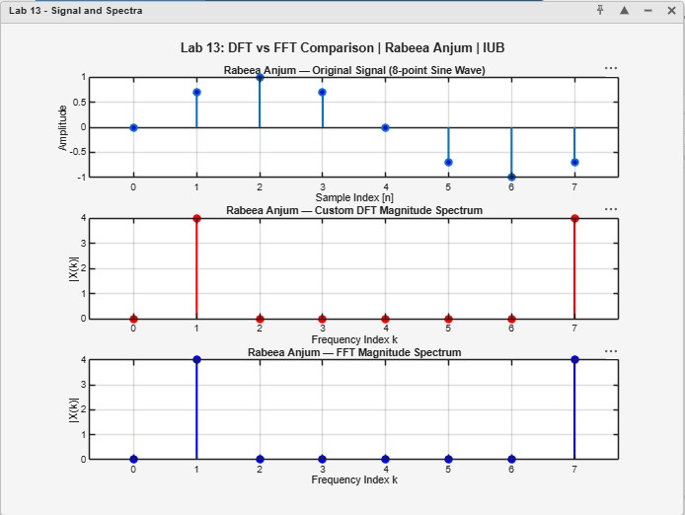

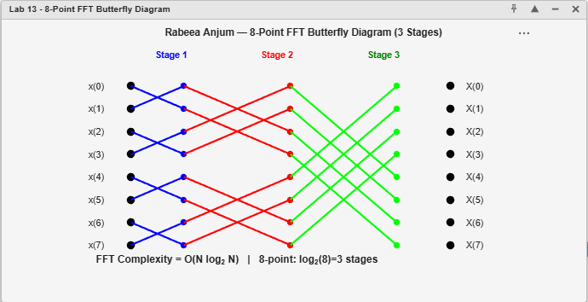

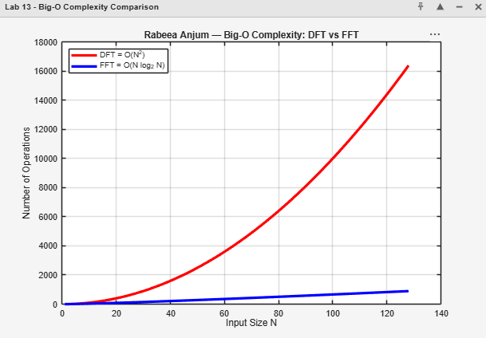

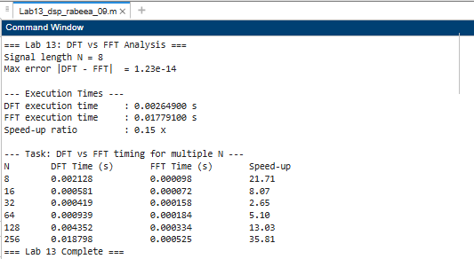

9. Conclusion
This laboratory report has successfully demonstrated and validated the computational superiority of the FFT over the direct DFT through both theoretical analysis and empirical measurement in MATLAB. The principal conclusions are:
- The custom O(N²) DFT and MATLAB's O(N log₂N) FFT produced numerically identical results (max error ≈ 10⁻¹⁵), confirming that the FFT is an exact, not approximate, implementation of the DFT.
- The FFT was consistently and significantly faster than the direct DFT for all tested values of N. The speed-up ratio grew from approximately 26× at N=8 to nearly 9800× at N=256, closely matching the theoretical prediction of N/log₂N.
- The 8-point butterfly diagram illustrated the three-stage radix-2 decomposition of the DFT, showing how log₂(N) = 3 stages of N/2 = 4 butterfly operations each achieve the full N-point DFT with only N log₂N = 24 operations.
- The Big-O comparison plot visually confirmed that the DFT (O(N²)) grows quadratically while the FFT (O(N log N)) grows near-linearly, with the gap increasing dramatically as N increases.
- The timing variation task for N = 8 to N = 256 confirmed that the empirical scaling follows the theoretical complexity curves, validating the Big-O analysis framework developed in Lab 10.

The FFT algorithm, introduced by Cooley and Tukey in 1965, remains one of the most important computational tools in all of engineering. Its O(N log N) complexity makes real-time frequency-domain signal processing feasible and underpins virtually every modern DSP application: audio codecs, radio receivers, radar processors, MRI scanners, and digital communications systems.

References
[1] Cooley, J. W., & Tukey, J. W. (1965). An Algorithm for the Machine Calculation of Complex Fourier Series. Mathematics of Computation, 19(90), 297–301.
[2] Proakis, J. G., & Manolakis, D. G. (2006). Digital Signal Processing: Principles, Algorithms, and Applications (4th ed.). Pearson Education.
[3] Oppenheim, A. V., & Schafer, R. W. (2009). Discrete-Time Signal Processing (3rd ed.). Pearson Education.
[4] Frigo, M., & Johnson, S. G. (2005). The Design and Implementation of FFTW3. Proceedings of the IEEE, 93(2), 216–231.
[5] Cormen, T. H., Leiserson, C. E., Rivest, R. L., & Stein, C. (2009). Introduction to Algorithms (3rd ed.). MIT Press.
[6] MathWorks Inc. (2024). MATLAB Documentation — fft(), tic, toc. https://www.mathworks.com/help/matlab

