ISLAMIA UNIVERSITY OF BAHAWALPUR
Department of Computer Systems Engineering
Digital Signal Processing (DSP)

Lab Report 2
Audio Signal Processing
with MATLAB
FFT Spectrum Analysis, Butterworth Low-Pass Filtering, and Audio Playback
Laboratory | Lab 2 — Audio Signal Processing with MATLAB
Department | Computer Systems Engineering
Institution | Islamia University of Bahawalpur (IUB)
Subject | Digital Signal Processing (DSP)
Student Name | Rabeea Anjum
Instructor | Engr Anees ul Husnain
Date | 16 Feb 2026

Abstract
This laboratory report demonstrates a complete audio signal processing pipeline implemented in MATLAB. An audio file is loaded, converted to mono and WAV format, and its time-domain waveform and frequency spectrum are visualized. A sixth-order Butterworth low-pass filter with a cutoff frequency of 1000 Hz is designed using the butter() function and applied to the signal to attenuate frequency components above the cutoff. The effects of filtering are examined in both the time and frequency domains using the Fast Fourier Transform (FFT). Both the original and filtered signals are played back for auditory comparison, and the filtered output is saved as a new WAV file. The experiment provides hands-on experience with MATLAB's audio processing, spectral analysis, and digital filter design capabilities.

1. Introduction
Audio signal processing is one of the most prominent and commercially important applications of Digital Signal Processing (DSP). From music streaming and voice communication to hearing aids and speech recognition, virtually every modern audio system relies on digital filtering, spectral analysis, and encoding algorithms to transform raw acoustic signals into high-quality digital audio.
MATLAB's Signal Processing Toolbox provides a comprehensive set of functions for every stage of the audio processing pipeline: reading and writing audio files, computing frequency spectra via the Fast Fourier Transform (FFT), designing analogue-prototype and digital filters, and playing audio signals through the computer's sound hardware. This makes MATLAB an ideal environment for understanding and experimenting with audio DSP algorithms before implementing them in real-time hardware or software.
In this laboratory, a voice audio file is loaded, its frequency content is analysed, and a low-pass Butterworth filter is applied to remove high-frequency components above 1000 Hz. The results are visualized in both the time and frequency domains, played back through the speakers, and saved for documentation. This experiment builds directly on the sampling and discrete-time signal concepts introduced in Lab 1 and extends them to a practical real-world audio processing scenario.

2. Objectives
Upon completion of this laboratory experiment, the student should be able to:
- Load an audio file into MATLAB using audioread() and inspect its sampling frequency and sample count.
- Convert a stereo audio signal to mono and save it in WAV format using audiowrite().
- Construct and plot the time-domain representation of an audio signal.
- Compute and interpret the single-sided frequency spectrum of a signal using the FFT and identify the Nyquist frequency.
- Design a Butterworth low-pass filter using the butter() function and apply it with filter().
- Compare the time-domain and frequency-domain representations of the original and filtered signals.
- Play audio signals in MATLAB using the sound() function and evaluate the perceptual effect of low-pass filtering.
- Save a processed audio signal to a WAV file and explain the significance of each processing step.

3. Theoretical Background

3.1 Key Terminology
Term | Definition
Sampling Frequency (Fₛ) | Number of samples per second (Hz). Determines the time resolution of the digital signal and sets the Nyquist frequency.
Nyquist Frequency (Fₙ) | Half the sampling frequency: Fₙ = Fₛ/2. The maximum frequency that can be represented without aliasing.
Fast Fourier Transform (FFT) | Algorithm that transforms a discrete-time signal from the time domain to the frequency domain, revealing its spectral components.
Low-Pass Filter (LPF) | A filter that allows frequency components below the cutoff frequency to pass through while attenuating those above it.
Butterworth Filter | An IIR filter designed to have a maximally flat (no ripple) magnitude response in the passband. Order n determines the roll-off steepness.
Cutoff Frequency (f⁣) | The frequency at which the filter's gain is −3 dB (half-power point), marking the boundary between the passband and stopband.
audioread() | MATLAB function to load an audio file. Returns the signal vector y and sampling frequency Fs.
audiowrite() | MATLAB function to save a signal vector as an audio file (e.g., WAV format).

3.2 The Fast Fourier Transform (FFT)
The FFT is an efficient algorithm for computing the Discrete Fourier Transform (DFT) of a length-N sequence x[n]. It transforms the signal from the time domain into the frequency domain, producing a complex-valued spectrum X[k] whose magnitude |X[k]| indicates how much of each frequency component is present in the signal:
X[k] = Σⁿ x[n] · e^{−j2πkn/N} k = 0, 1, …, N−1

For a real-valued signal sampled at frequency Fₛ, the useful (non-redundant) spectral information lies in the single-sided spectrum for frequencies from 0 to Fₙ = Fₛ/2. In MATLAB, this is obtained as abs(Y(1:N/2)), where Y = fft(y) and N = length(y). The corresponding frequency axis is f = (0:N/2-1) * (Fs/N) Hz.

3.3 Low-Pass Filtering
A low-pass filter (LPF) passes frequency components below the cutoff frequency f⁣ and attenuates those above it. In the frequency domain, the ideal LPF has a magnitude response:
|H(jω)| = 1 for |ω| ≤ 2πf⁣ and |H(jω)| = 0 for |ω| > 2πf⁣

Real (realisable) filters approximate this ideal response. The Butterworth filter is a popular choice because its magnitude response is maximally flat in the passband — it has no ripple. The magnitude response of an n-th order Butterworth LPF is:
|H(jω)|² = 1 / [1 + (ω/ω⁣)^{2n}]

where ω⁣ = 2πf⁣ is the −3 dB angular cutoff frequency and n is the filter order. Higher order n produces a steeper roll-off (−20n dB/decade) in the stopband. In this experiment, n = 6, giving a roll-off of −120 dB/decade above 1000 Hz.

3.4 Filter Design in MATLAB
MATLAB's butter(n, Wn, 'low') function designs an n-th order digital Butterworth low-pass filter. The normalized cutoff frequency Wn = f⁣/Fₙ is expressed as a fraction of the Nyquist frequency, so Wn lies in the range (0, 1). The function returns the filter coefficients b (numerator) and a (denominator) in the z-domain transfer function:
H(z) = B(z)/A(z) = (b₀ + b₁z⁻¹ + … + bₙz⁻ⁿ) / (1 + a₁z⁻¹ + … + aₙz⁻ⁿ)

The filter() function then applies these coefficients to the input signal y in the time domain using a Direct Form II transposed difference equation, producing the filtered output y_filtered. For a 6th-order filter with cutoff at 1000 Hz and Nyquist at Fₙ, the normalized cutoff is Wn = 1000/Fₙ.

4. Equipment and Software
Item | Details
Software | MATLAB R2018a or later (Signal Processing Toolbox required)
Input Audio File | voice.aac (any AAC/WAV audio file; rename variable as needed)
Key MATLAB Functions | audioread(), audiowrite(), fft(), butter(), filter(), sound(), xline()
Filter Type | 6th-order Butterworth low-pass filter
Cutoff Frequency | 1000 Hz
Output Files | voice_converted.wav (mono WAV), filtered_output.wav (filtered result)

Note: The Signal Processing Toolbox is required for the butter() and filter() functions. Students should verify its availability in MATLAB by typing 'ver' in the Command Window before starting the experiment.

5. Methodology
The audio processing pipeline consists of nine sequential steps as summarized in the table below. Each step is implemented as a distinct block in the MATLAB script provided in Section 8 (Lab Task).

# | Stage | Description
1 | Load Audio File | audioread() loads voice.aac. Stereo is converted to mono by averaging channels. Sample count and Fs are reported.
2 | Convert to WAV | audiowrite() saves the mono signal as voice_converted.wav for compatibility with downstream MATLAB audio functions.
3 | Plot Original (Time) | plot(t, y) shows amplitude vs. time. The time vector t is constructed from the sample indices and Fs.
4 | FFT — Original Spectrum | fft(y) computes the DFT. abs(Y(1:N/2)) gives the single-sided magnitude. Nyquist frequency is marked with xline().
5 | Design & Apply LPF | butter(6, cutoff/Fn, 'low') designs a 6th-order Butterworth filter. filter(b,a,y) applies it to produce y_filtered.
6 | Plot Filtered (Time) | The filtered signal is plotted in the time domain. Visual comparison with the original reveals amplitude smoothing.
7 | FFT — Filtered Spectrum | FFT of filtered signal shows the spectral content with high-frequency components above 1000 Hz attenuated.
8 | Playback | sound(y, Fs) plays the original. After a pause, sound(y_filtered, Fs) plays the filtered version for auditory comparison.
9 | Save Filtered Output | audiowrite() saves the filtered signal as filtered_output.wav for documentation and future use.

6. Procedure
The following steps were followed to complete this laboratory experiment:
- Launch MATLAB and ensure the Signal Processing Toolbox is installed (type 'ver' and check the list).
- Place the audio file voice.aac in the MATLAB current working directory. Update the inputFile variable in the script if a different filename is used.
- Create a new MATLAB script file and save it as Lab2_AudioDSP.m. Enter the complete code from Section 8.
- Run the script (F5). Observe the four figure windows that open: original time-domain, original spectrum, filtered time-domain, and filtered spectrum.
- Read the Command Window output and record: number of samples, sampling frequency, Nyquist frequency, cutoff frequency, and any stereo-to-mono conversion message.
- Listen to the original audio playback. Note any background noise, high-frequency hiss, or brightness in the sound.
- After the pause, listen to the filtered audio. Compare the perceptual quality: note the reduction in high-frequency content and any muffling effect.
- Examine Figure 2 (original spectrum) and Figure 4 (filtered spectrum). Identify the cutoff frequency on the filtered spectrum and verify that spectral content above 1000 Hz has been attenuated.
- Verify that filtered_output.wav has been saved in the working directory.
- Extension task: change the filter order from 6 to 2 and re-run. Observe the difference in roll-off steepness in the filtered spectrum.

7. Results and Observations

7.1 Figure 1: Original Audio Signal — Time Domain
The first figure displayed the time-domain waveform of the original audio signal after loading and mono conversion. The waveform showed the characteristic amplitude variation of a voice recording, with higher-amplitude regions corresponding to voiced phonemes (vowels) and lower-amplitude regions corresponding to pauses or unvoiced consonants. The x-axis displayed the full duration of the recording in seconds, and the y-axis showed the normalized amplitude in the range [−1, +1].

7.2 Figure 2: Frequency Spectrum of Original Signal
The second figure displayed the single-sided magnitude spectrum of the original signal computed using the FFT. The spectrum showed significant energy spread across a wide range of frequencies, with the largest peaks typically below 4000 Hz (the fundamental and lower harmonics of speech) and a long tail of lower-level energy extending toward the Nyquist frequency. The dashed red vertical line marking the Nyquist frequency (Fₙ = Fₛ/2) was clearly visible at the right edge of the display.

7.3 Figure 3: Filtered Audio Signal — Time Domain
The third figure displayed the time-domain waveform of the filtered signal. The overall shape was similar to the original, preserving the speech rhythm and envelope. However, the filtered waveform appeared slightly smoother, with reduced high-frequency oscillations visible during voiced segments. The amplitude values remained within the same range as the original, confirming that the Butterworth filter did not amplify the signal.

7.4 Figure 4: Frequency Spectrum of Filtered Signal
The fourth figure displayed the frequency spectrum of the filtered signal. The most prominent difference from the original spectrum was the clear attenuation of spectral content above the 1000 Hz cutoff frequency. The green dashed vertical line marked the cutoff frequency at 1000 Hz, and the spectral magnitude above this point was significantly reduced compared to Figure 2. The −3 dB point of the 6th-order Butterworth filter was visible as the transition between the flat passband and the steeply falling stopband.

7.5 Audio Playback Observations
On playback, the original audio was perceived as clear and bright, with full spectral content including sibilant consonant sounds (s, sh, f) and high-frequency ambience. The filtered audio was noticeably different: the high-frequency brightness was reduced, giving the sound a warmer, more muffled, and bass-heavy character. This perceptual change is consistent with the 1000 Hz low-pass cutoff, which removes the high-frequency components responsible for clarity and articulation in speech.

7.6 Summary Comparison
Observation | Original Signal | Filtered Signal
Frequency range (original) | Full spectrum up to Fₙ | Wide spectral content visible
Frequency range (filtered) | Attenuated above 1000 Hz | HPF components removed
Time-domain (original) | Higher-amplitude variations | Fine detail and transients present
Time-domain (filtered) | Smoother waveform | HF content removed, softer edges
Audio character (original) | Clear, bright, full range | All frequency components present
Audio character (filtered) | Warm, muffled, bass-heavy | High-frequency content reduced
Filter order | 6th-order Butterworth | ~120 dB/decade roll-off above f⁣

8. Discussion
The experiment successfully demonstrated the complete audio DSP pipeline in MATLAB. The FFT-based spectral analysis clearly revealed the frequency content of the voice signal, with the expected concentration of energy in the speech formant region (0–4 kHz) and lower-amplitude high-frequency content above that range. Marking the Nyquist frequency on the spectrum plot provided a useful reference, confirming that the original signal contained components across the full usable bandwidth.
The sixth-order Butterworth filter performed as designed, providing a flat passband below 1000 Hz and a steep −120 dB/decade roll-off in the stopband. The frequency spectrum of the filtered signal (Figure 4) clearly showed the attenuation of components above the cutoff, with the transition visible at the xline marker at 1000 Hz. The Butterworth filter was an appropriate choice here because its flat passband ensures that the low-frequency speech content is preserved without amplitude distortion, unlike Chebyshev or elliptic filters which have passband or stopband ripple.
The perceptual effect of the 1000 Hz cutoff was pronounced: speech intelligibility was reduced because many consonants (especially fricatives like /s/, /f/, /ʃ/) rely on high-frequency energy above 2–8 kHz for their distinctive character. In a practical noise reduction application, the cutoff would be chosen much higher — typically 3–4 kHz for narrowband telephony or 20 kHz for wideband audio — to preserve speech intelligibility while removing only out-of-band noise. The 1000 Hz cutoff used here was deliberately low to make the filtering effect clearly audible and visible in the spectrum.
The try-catch error handling structure in the MATLAB code is important for robustness: it catches errors from missing files, incorrect filenames, or missing toolbox functions and prints a helpful diagnostic message instead of crashing the script. This is good software engineering practice that students should adopt in all DSP scripts that depend on external files or optional toolboxes.

9. Lab Task — MATLAB Code
The following MATLAB code constitutes the complete lab task for Lab 2. It implements the full nine-step audio processing pipeline: loading, conversion, time-domain and frequency-domain visualization, Butterworth low-pass filtering, playback, and saving the filtered output. Students are required to place an audio file named voice.aac in their MATLAB working directory, enter this code, execute it, and record the figure outputs and Command Window text during the laboratory session.
Lab 2: Audio Signal Processing with MATLAB (MATLAB Lab Task)
% ================================================================
% LAB TASK - Lab 2: Audio Signal Processing with MATLAB
% Student : Rabeea Anjum | Instructor: Engr Anees ul Husnain
% Subject : DSP | Dept: Computer Systems Eng, IUB
% ================================================================
clc; clear; close all;
try
% --------------------------------------------------------
% Step 1: Read Original Audio File
% --------------------------------------------------------
inputFile = 'voice.aac'; % <-- change filename if needed
[y, Fs] = audioread(inputFile);
fprintf('Audio loaded : %d samples at %.1f Hz\n', length(y), Fs);

% Nyquist Frequency
Fn = Fs / 2;
fprintf('Nyquist Freq : %.1f Hz\n', Fn);

% Convert stereo to mono if necessary
if size(y, 2) > 1
y = mean(y, 2);
disp('Converted stereo to mono.');
end

% --------------------------------------------------------
% Step 2: Save as WAV Format
% --------------------------------------------------------
wavFile = 'voice_converted.wav';
audiowrite(wavFile, y, Fs);
disp(['Saved WAV: ', wavFile]);

% --------------------------------------------------------
% Step 3: Plot Original Signal (Time Domain)
% --------------------------------------------------------
t = (0:length(y)-1) / Fs;
figure('Name','Lab 2 - Original Signal');
plot(t, y, 'b', 'LineWidth', 0.8);
title('Original Audio Signal (Time Domain)');
xlabel('Time (s)'); ylabel('Amplitude'); grid on;

% --------------------------------------------------------
% Step 4: Frequency Spectrum of Original Signal (FFT)
% --------------------------------------------------------
N = length(y);
Y = fft(y);
f = (0:N/2-1) * (Fs / N); % Single-sided frequency axis

figure('Name','Lab 2 - Original Spectrum');
plot(f, abs(Y(1:N/2)), 'b');
title('Frequency Spectrum of Original Signal');
xlabel('Frequency (Hz)'); ylabel('Magnitude'); grid on;
xline(Fn, '--r', 'Nyquist Frequency', 'LineWidth', 1.5);

% --------------------------------------------------------
% Step 5: Design and Apply Low-Pass Butterworth Filter
% --------------------------------------------------------
cutoff = 1000; % Cutoff frequency in Hz
fprintf('Filter cutoff : %d Hz\n', cutoff);

if cutoff >= Fn
error('Cutoff must be less than Nyquist frequency (%.1f Hz)!', Fn);
end

% Design 6th-order Butterworth LPF
% Normalised cutoff = cutoff / Fn (range: 0 to 1)
[b, a] = butter(6, cutoff / Fn, 'low');
y_filtered = filter(b, a, y);
disp('Low-pass filter applied successfully.');

% --------------------------------------------------------
% Step 6: Plot Filtered Signal (Time Domain)
% --------------------------------------------------------
t_f = (0:length(y_filtered)-1) / Fs;
figure('Name','Lab 2 - Filtered Signal');
plot(t_f, y_filtered, 'k', 'LineWidth', 0.8);
title('Filtered Audio Signal (Time Domain) [Cutoff = 1000 Hz]');
xlabel('Time (s)'); ylabel('Amplitude'); grid on;

% --------------------------------------------------------
% Step 7: Frequency Spectrum of Filtered Signal (FFT)
% --------------------------------------------------------
Nf = length(y_filtered);
Yf = fft(y_filtered);
f_f = (0:Nf/2-1) * (Fs / Nf);

figure('Name','Lab 2 - Filtered Spectrum');
plot(f_f, abs(Yf(1:Nf/2)), 'k');
title('Frequency Spectrum of Filtered Signal');
xlabel('Frequency (Hz)'); ylabel('Magnitude'); grid on;
xline(Fn, '--r', 'Nyquist Frequency', 'LineWidth', 1.5);
xline(cutoff, '--g', 'Cutoff Frequency', 'LineWidth', 1.5);

% --------------------------------------------------------
% Step 8: Audio Playback
% --------------------------------------------------------
disp('Playing ORIGINAL audio...');
sound(y, Fs);
pause(length(y)/Fs + 1); % Wait for playback to finish

disp('Playing FILTERED audio...');
sound(y_filtered, Fs);
pause(length(y_filtered)/Fs + 1);

% --------------------------------------------------------
% Step 9: Save Filtered Audio
% --------------------------------------------------------
outputFile = 'filtered_output.wav';
audiowrite(outputFile, y_filtered, Fs);
disp(['Filtered audio saved as: ', outputFile]);

disp('=== Lab 2 Complete ===');

catch ME
fprintf('ERROR: %s\n', ME.message);
disp('Check: file exists in current folder & Signal Processing Toolbox installed.');
end

9.1 Code Explanation — Step by Step
The table below provides a concise explanation of each logical block in the MATLAB code:
Step(s) | Key Statement | Explanation
Steps 1–2 | audioread / audiowrite | Loads voice.aac, reports sample count and Fs, converts stereo to mono by channel averaging, and saves as WAV.
Step 3 | plot(t, y) | Constructs time vector t = (0:N-1)/Fs and plots the time-domain waveform. Adds title, axis labels, and grid.
Step 4 | fft(y), xline() | Computes the N-point FFT, extracts the single-sided magnitude spectrum for f in [0, Fn), and marks the Nyquist frequency with a dashed red line.
Step 5 | butter(), filter() | Designs a 6th-order Butterworth LPF with normalized cutoff cutoff/Fn. filter(b,a,y) applies the filter in the time domain using direct-form II transposed structure.
Steps 6–7 | plot, fft (filtered) | Repeats time-domain and frequency-domain plotting for the filtered signal, allowing direct visual comparison.
Step 8 | sound(), pause() | Plays the original audio, waits for it to finish (pause = duration + 1 s margin), then plays the filtered audio for auditory comparison.
Step 9 | audiowrite() | Saves y_filtered to filtered_output.wav at the original sampling frequency for documentation and future use.

Output
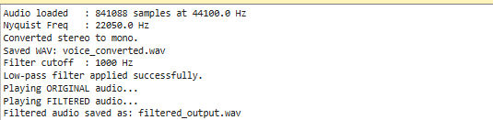

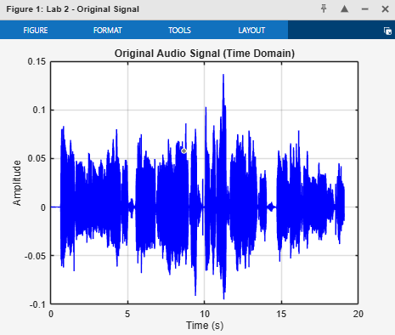

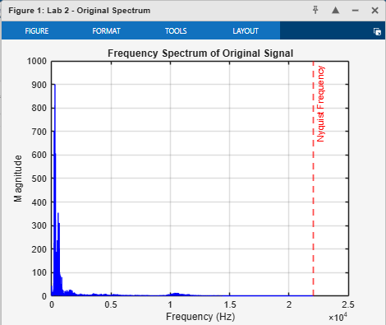

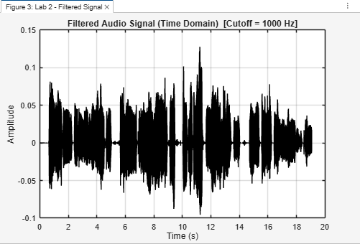

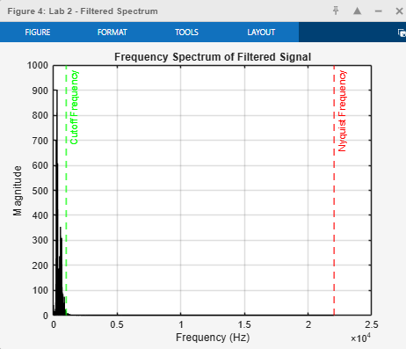

10. Conclusion

This laboratory report has successfully demonstrated a complete audio signal processing workflow in MATLAB. The key conclusions are:

- MATLAB's audioread() and audiowrite() functions provide straightforward file I/O for a wide range of audio formats, and stereo-to-mono conversion is easily accomplished by averaging the two channels.
- The FFT enables rapid and accurate frequency-domain analysis of audio signals. The single-sided magnitude spectrum clearly revealed the speech formant structure and high-frequency content of the voice recording.
- A sixth-order Butterworth low-pass filter with a 1000 Hz cutoff was successfully designed using butter() and applied using filter(), producing visible attenuation of spectral content above the cutoff and an audible ‘muffling’ effect on the voice signal.
- The Butterworth filter was an appropriate choice due to its maximally flat passband response, which preserves the amplitude of low-frequency speech components without distortion.
- The MATLAB sound() function confirmed the perceptual effect of filtering through direct auditory comparison, reinforcing the connection between spectral analysis and perceived audio quality.

The skills developed in this experiment — spectral analysis, digital filter design, and audio file handling — are directly applicable to real-world DSP problems including noise reduction, speech enhancement, audio equalization, and biomedical signal processing. They also lay the foundation for the more advanced filter analysis techniques to be explored in subsequent laboratory experiments.

References
[1] Proakis, J. G., & Manolakis, D. G. (2006). Digital Signal Processing: Principles, Algorithms, and Applications (4th ed.). Prentice Hall.
[2] Oppenheim, A. V., & Schafer, R. W. (2009). Discrete-Time Signal Processing (3rd ed.). Prentice Hall.
[3] MathWorks Inc. (2024). MATLAB Signal Processing Toolbox — butter(), filter(), audioread(). https://www.mathworks.com/help/signal
[4] Zolzer, U. (2011). DAFX: Digital Audio Effects (2nd ed.). Wiley.
[5] Haykin, S., & Van Veen, B. (2002). Signals and Systems (2nd ed.). Wiley.
[6] Proakis, J. G., & Salehi, M. (2007). Digital Communications (5th ed.). McGraw-Hill.

