ISLAMIA UNIVERSITY OF BAHAWALPUR
Department of Computer Systems Engineering
Digital Signal Processing (DSP)

Lab Report 3
Deep Learning-Based Audio Signal
Classification in MATLAB
Transfer Learning with VGGish, Log-Mel Spectrograms, and Grad-CAM Interpretability
Lab no | Lab 3 — Deep Learning-Based Audio Signal Classification
Department | Computer Systems Engineering
Institution | Islamia University of Bahawalpur (IUB)
Subject | Digital Signal Processing (DSP)
Student Name | Rabeea Anjum
Instructor | Engr. Anees ul Husnain
Date | 23 Feb 2026

Abstract
This laboratory report presents a complete end-to-end workflow for deep learning-based audio signal classification using MATLAB. Environmental and speech audio signals are first converted into log-mel spectrogram feature patches using the vggishPreprocess() function from MATLAB's Audio Toolbox. A pretrained VGGish deep neural network — originally trained on Google's AudioSet dataset — is then fine-tuned via transfer learning to classify audio signals into application-specific target classes. The model is trained using the Adam optimizer over 10 epochs with a mini-batch size of 128 and an initial learning rate of 1×10⁻³. Classification performance is evaluated using accuracy metrics and a confusion matrix. Finally, the Gradient-weighted Class Activation Mapping (Grad-CAM) technique is applied to visualize the spectrogram regions that most influenced the model's classification decisions, providing interpretability into the neural network's behaviour.

1. Introduction
Audio signal classification is a fundamental problem in machine learning and Digital Signal Processing (DSP). Applications span a wide range of domains: environmental sound recognition for smart home devices and surveillance systems, speech command detection for voice assistants, music genre classification for streaming platforms, and pathological sound detection for medical diagnostics. Traditionally, these systems relied on hand-crafted features such as Mel-Frequency Cepstral Coefficients (MFCCs) fed into shallow classifiers such as Support Vector Machines (SVMs) or Gaussian Mixture Models (GMMs).
The advent of deep learning has dramatically changed this landscape. Deep Convolutional Neural Networks (CNNs) can automatically learn hierarchical feature representations directly from raw data, eliminating the need for manual feature engineering. When audio signals are represented as two-dimensional spectrograms, they can be treated as images and processed by CNNs designed for image recognition. This insight has led to highly accurate audio classifiers that surpass traditional approaches to standard benchmarks.
Transfer learning further accelerates the development of these classifiers. Instead of training a deep network from scratch — which requires large datasets and significant computational resources — a network pretrained on a large general-purpose dataset can be fine-tuned for a specific task with a much smaller dataset and in far fewer training epochs. In this laboratory, the VGGish network, pretrained on Google's AudioSet (a dataset of over 2 million labelled audio clips), is fine-tuned for custom audio classification using MATLAB's Deep Learning Toolbox and Audio Toolbox.

2. Objectives
Upon completion of this laboratory experiment, the student should be able to:
- Organize an audio dataset into class-labelled subfolder structure compatible with MATLAB's audioDatastore.
- Load and inspect an audio dataset using audioDatastore, countEachLabel, and splitEachLabel functions.
- Convert raw audio waveforms into log-mel spectrogram feature patches using vggishPreprocess().
- Load a pretrained VGGish deep neural network and modify its output layers using layerGraph, removeLayers, addLayers, and connectLayers.
- Configure and execute transfer learning-based fine-tuning using trainNetwork() with the Adam optimiser.
- Evaluate a trained classifier's performance using classification accuracy and confusion matrix analysis.
- Apply the Grad-CAM interpretability technique to identify which spectrogram regions drive the model's classification decisions.
- Critically discuss the advantages and limitations of transfer learning for audio classification in DSP applications.

3. Theoretical Background

3.1 Log-Mel Spectrograms
Audio signals are one-dimensional time-domain waveforms. To apply CNN-based classifiers, they must first be transformed into a two-dimensional time-frequency representation. The log-mel spectrogram is the standard input feature for audio deep learning. It is computed in three stages:
- Short-Time Fourier Transform (STFT): The signal is divided into overlapping frames, and the FFT magnitude spectrum is computed for each frame, producing a spectrogram S(t, f).
- Mel Filterbank: S(t, f) is filtered through a bank of triangular filters whose centre frequencies are spaced on the mel scale, a perceptually motivated frequency scale based on the human auditory system.
- Logarithm: The log of the mel-filtered energy is taken to compress the dynamic range, producing the log-mel spectrogram. The resulting 2-D array of shape (time frames × mel bins) is used as the CNN input.

mel(f) = 2595 · log₁₀ (1 + f / 700) [Mel scale conversion]

MATLAB's vggishPreprocess() function implements this pipeline automatically, producing 96×64×1 patches (96 time frames × 64 mel bins × 1 channel) at 25 ms frame length and configurable overlap. Multiple overlapping patches are extracted from each audio clip, forming a 4-D feature array of shape (96×64×1×N) where N is the number of patches.

3.2 The VGGish Architecture

VGGish is a CNN architecture developed by Google as an audio feature extractor. It is inspired by the VGG image classification network and consists of a series of convolutional and max-pooling layers followed by fully connected layers that produce a 128-dimensional embedding vector for each 96×64 input patch. The network was pretrained on Google's AudioSet — a large-scale dataset containing over 2 million 10-second audio clips drawn from YouTube, labelled with 527 sound categories.

VGGish Input/Output
Input: 96 × 64 × 1 log-mel spectrogram patch (96 time frames, 64 mel frequency bins, 1 channel) Output: 128-dimensional embedding vector via 'EmbeddingBatch' layer Pretrained on: Google AudioSet (2+ million clips, 527 sound classes)

In this experiment, the original regression output layer of VGGish is removed and replaced with a new classification head consisting of a fully connected layer (with neurons equal to the number of target classes), a softmax layer (to produce class probabilities), and a classification layer (for cross-entropy loss computation). Only the new classification head weights are randomly initialized; the pretrained embedding layers retain their learned weights and are fine-tuned during training.

3.3 Transfer Learning
Transfer learning is the practice of re-using a model trained in one task as the starting point for a model on a different but related task. For audio classification, this means taking VGGish's pretrained feature extraction capability (learned from AudioSet) and adapting it for a custom dataset with a different set of classes.
Loss = −Σₖ yₖ · log(ŷₖ) [Cross-entropy loss for C classes]

The training process minimizes this cross-entropy loss using the Adam optimiser. Adam adapts the learning rate for each parameter individually based on estimates of first and second moments of the gradients, making it particularly effective for fine-tuning pretrained networks where different layers may need different update magnitudes.

3.4 Grad-CAM Interpretability
Gradient-weighted Class Activation Mapping (Grad-CAM) is a technique for visualising the regions of a neural network's input that most influenced its classification decision. For a given input and predicted class, Grad-CAM computes the gradient of the class score with respect to the feature maps of the last convolutional layer. These gradients are globally average-pooled to produce weights, which are then used to compute a weighted sum of the feature maps to generate a saliency map:

Lᶜᵇᶜₐₘ = ReLU(Σₖ αᶜₖ · Aₖ) where αᶜₖ = (1/Z) Σᵢᴵ (∂yᶜ / ∂Aᶜᵢᴵ)

Applied to audio spectrograms, Grad-CAM highlights the time-frequency regions of the log-mel spectrogram that were most important for the model's prediction. This provides valuable insight into whether the model is attending to the correct acoustic features (e.g., the formants of a vowel, the transient of a drum hit) rather than spurious artifacts.

4. Required MATLAB Toolboxes
Toolbox | Functions Used / Purpose
Deep Learning Toolbox | Provides trainNetwork(), layerGraph(), gradCAM(), confusionchart() and support for importing pretrained networks such as VGGish.
Audio Toolbox | Provides audioDatastore(), vggishPreprocess(), and vggish(). Required for log-mel spectrogram extraction and pretrained model loading.
Signal Processing Toolbox | Used for underlying signal processing operations including FFT, windowing, and filter design functions called internally by Audio Toolbox.
Statistics & Machine Learning Toolbox | Optional. Provides additional statistical evaluation functions. countEachLabel() and splitEachLabel() may require this toolbox depending on MATLAB version.
Students should verify toolbox availability before starting the experiment by typing 'ver' in the MATLAB Command Window and checking that all four toolboxes appear in the list. Missing toolboxes can be installed via the Add-Ons menu in MATLAB Desktop or enabled in MATLAB Online through the institution's license.

5. Dataset Organization and Setup
The audio dataset must be organized in a specific subfolder structure for MATLAB's audioDatastore to correctly assign labels. Each subfolder name becomes the class label for all audio files it contains:
C:\AudioProject\Dataset\
dog bark\ <- class 1: all WAV/MP3 files of dog barks
rain\ <- class 2: all WAV/MP3 files of rain sounds
speech\ <- class 3: all WAV/MP3 files of speech
engine\ <- class 4: all WAV/MP3 files of engine noise
Publicly available datasets suitable for this experiment include UrbanSound8K (8732 clips across 10 urban sound classes), ESC-50 (2000 clips across 50 environmental sound classes), and the Google Speech Commands dataset (speech audio clips for keyword recognition). Students should download one of these datasets, extract the relevant classes into the Dataset subfolder structure shown above, and update the dataFolder variable in the MATLAB script accordingly.

6. Workflow Overview
The complete classification workflow consists of 14 sequential steps as detailed in the table below. Each step corresponds to a numbered block in the MATLAB code provided in Section 9 (Lab Task).
# | Activity | Purpose / Key Detail
1 | Set Working Directory | cd() sets the MATLAB current folder so all file paths resolve correctly.
2 | Create Audio Datastore | audioDatastore() manages large audio collections with labels derived from subfolder names.
3 | Count Samples per Class | countEachLabel() checks dataset balance — imbalanced classes can bias model training.
4 | Split Dataset | splitEachLabel() partitions data into 80% training and 20% validation, preserving class ratios.
5 | Read Sample Audio | audioread() loads one waveform to verify file integrity and inspect Fs before preprocessing.
6 | Extract Log-Mel Features | vggishPreprocess() converts the waveform into a 4-D array of log-mel spectrogram patches (96×64×1×N).
7 | Load VGGish Network | vggish() returns the pretrained VGGish model. layerGraph() makes it editable.
8 | Replace Output Layers | removeLayers / addLayers / connectLayers replace the regression head with a classification head for numClasses output neurons.
9 | Set Training Options | trainingOptions('adam',...) configures the Adam optimiser with the hyperparameters in Table 5.2.
10 | Train the Network | trainNetwork() fine-tunes VGGish weights on the training features via backpropagation + Adam.
11 | Classify Validation Data | classify() runs the trained network on validation features and returns predicted labels and confidence scores.
12 | Compute Accuracy | mean(valPred == trueLabels) × 100 gives the overall classification accuracy percentage.
13 | Confusion Matrix | confusionchart() plots per-class performance, revealing which classes are most often confused.
14 | Grad-CAM Interpretability | gradCAM() generates a saliency map highlighting spectrogram regions that most influenced the classification decision.

7. Training Hyperparameters
The following hyperparameters were used for the transfer learning training run. Each is justified in the context of fine-tuning a pretrained audio classification network:
Hyperparameter | Value Used | Justification
Solver | Adam | Adaptive Moment Estimation — adjusts learning rate per parameter; well-suited for fine-tuning pretrained networks.
MaxEpochs | 10 | Number of complete passes through the training dataset. Increase for better convergence on larger datasets.
MiniBatchSize | 128 | Samples processed per gradient update. Larger batches are more stable; smaller batches generalise better.
InitialLearnRate | 1 × 10⁻³ | Step size for weight updates. Small value used for fine-tuning to avoid overwriting pretrained weights.
Shuffle | 'every-epoch' | Randomises sample order each epoch to prevent the network from memorizing the data ordering.
Plots | 'training-progress' | Enables MATLAB's built-in live training progress window showing loss and accuracy curves.
Overlap Percentage | 75% | Window overlap in vggishPreprocess(). Higher overlap produces more feature patches per audio clip.

8. Results and Observations

8.1 Training Progress
During training, MATLAB's built-in training progress window (enabled by Plots = 'training-progress') displayed live curves of the training loss and accuracy over 10 epochs. Typical behaviour for a well-configured transfer learning run is a rapid initial decrease in training loss during the first 2–3 epochs as the new classification head adapts to the target classes, followed by a more gradual decrease as the pretrained embedding layers are fine-tuned. The training accuracy typically converges to above 85–95% within 10 epochs on clean, balanced datasets.

8.2 Classification Accuracy
The classification accuracy is computed as the percentage of correctly predicted labels on the evaluation set:
Accuracy = (Number of Correct Predictions / Total Predictions) × 100%

For a well-balanced dataset and adequate training duration, transfer learning with VGGish typically achieves classification accuracies in the range of 80–95% on standard environmental sound benchmarks. Factors influencing accuracy include dataset size, class balance, audio clip duration, and the degree of similarity between the target classes and the AudioSet pretraining data.

8.3 Confusion Matrix Analysis
The confusion matrix generated by confusionchart() provides a per-class breakdown of predictions. Rows represent the true class labels and columns represent the predicted class labels. Diagonal entries correspond to correct predictions; off-diagonal entries indicate misclassifications. The confusion matrix is particularly useful for identifying class pairs that are frequently confused — for example, 'rain' and 'water stream' may share similar spectral characteristics, leading to mutual misclassification. Such analysis guides targeted data augmentation or architecture adjustments for improving performance.

8.4 Grad-CAM Visualisation
The Grad-CAM saliency map for a sample input patch is displayed alongside the original log-mel spectrogram. In a correctly classified audio clip, the Grad-CAM highlights should correspond to the acoustically distinctive regions: for speech, this would typically be the time-frequency regions of the formants and consonant transients; for environmental sounds, it might be the onset burst of a dog bark or the wideband noise pattern of rain. Misclassified samples often show Grad-CAM activations concentrated in noise-dominated or silent regions, revealing that the model attended to uninformative parts of the spectrogram.

9. Discussion
This experiment demonstrates the power of transfer learning for audio classification tasks. The VGGish network, pretrained on over 2 million audio clips from AudioSet, provides a rich set of learned audio feature representations that generalise well to new audio classification tasks with relatively small target datasets. The fine-tuning process modifies only the final classification layers initially, allowing the pretrained embedding weights to be adapted gradually, which prevents catastrophic forgetting of the learned features.
The log-mel spectrogram representation is a key design choice. By converting audio to a 2-D time-frequency image, the classification problem becomes structurally similar to image recognition, allowing the reuse of CNN architectures originally developed for vision tasks. The mel frequency scale mimics the non-linear frequency sensitivity of the human auditory system, making the representation perceptually meaningful and well-suited for both speech and environmental sound classification.
The Grad-CAM interpretability tool is particularly valuable in a DSP context because it connects the model's decisions back to the signal's spectral and temporal structure. An engineer examining the Grad-CAM output can verify that the model is exploiting genuine acoustic cues rather than dataset artifacts such as recording channel characteristics or background conditions specific to particular classes. This is essential for building trustworthy audio classifiers for safety-critical or clinical applications.
One limitation of this workflow is that trainFeatures in Steps 11–13 are computed only for the first file (adsTrain.Files{1}), whereas in a full production pipeline, all training and validation files would be preprocessed in batch using a custom preprocessing pipeline or arrayDatastore. Students are encouraged to extend the script to process all files using a loop or MATLAB's transform() and apply() functions for large-scale evaluation.

10. Lab Task — MATLAB Code
The following MATLAB code constitutes the complete lab task for Lab 3. It implements all 14 steps of the deep learning audio classification pipeline: dataset loading, feature extraction, network modification, training, evaluation, and Grad-CAM visualisation. Students must ensure that the required toolboxes are installed, an audio dataset is organized in the subfolder structure described in Section 5, and the dataFolder path is updated before running the script.

Lab 3: Deep Learning Audio Classification (MATLAB Lab Task)
% ================================================================
% LAB TASK - Lab 3: Deep Learning Audio Classification
% Student : Rabeea Anjum | Instructor: Engr. Anees ul Husnain
% Subject : DSP | Dept: Computer Systems Eng, IUB
% ================================================================

% ---------------------------------------------------------------
% STEP 1: Set Current Folder
% cd(folderPath) - change MATLAB working directory
% ---------------------------------------------------------------
cd('C:\AudioProject') % Update path to your project folder

% ---------------------------------------------------------------
% STEP 2: Create Audio Datastore
% audioDatastore - loads & manages large audio file collections
% IncludeSubfolders : search inside class subfolders
% LabelSource : derive labels from subfolder names
% FileExtensions : restrict to WAV and MP3 files
% ---------------------------------------------------------------
dataFolder = 'C:\AudioProject\Dataset';
ads = audioDatastore(dataFolder, ...
'IncludeSubfolders', true, ...
'LabelSource', 'foldernames', ...
'FileExtensions', {'.wav', '.mp3'});

% ---------------------------------------------------------------
% STEP 3: Count Samples Per Class
% countEachLabel - verify dataset balance
% ---------------------------------------------------------------
labelTable = countEachLabel(ads)
disp(labelTable);

% ---------------------------------------------------------------
% STEP 4: Split Dataset (80% train / 20% validation)
% splitEachLabel - preserves class distribution in both subsets
% ---------------------------------------------------------------
[adsTrain, adsVal] = splitEachLabel(ads, 0.8, 0.2);
fprintf('Training samples : %d\n', numel(adsTrain.Files));
fprintf('Validation samples: %d\n', numel(adsVal.Files));

% ---------------------------------------------------------------
% STEP 5: Read One Audio File to Verify
% audioread - returns waveform and sampling frequency
% ---------------------------------------------------------------
[audioIn, fs] = audioread(adsTrain.Files{1});
fprintf('Sample rate: %d Hz | Duration: %.2f s\n', fs, length(audioIn)/fs);

% ---------------------------------------------------------------
% STEP 6: Feature Extraction - Log-Mel Spectrogram Patches
% vggishPreprocess - converts waveform -> 96x64x1xN patch array
% OverlapPercentage = 75 -> 75% window overlap for dense patches
% ---------------------------------------------------------------
overlap = 75;
trainFeatures = vggishPreprocess(audioIn, fs, 'OverlapPercentage', overlap);
fprintf('Feature patch size: %d x %d x %d x %d\n', size(trainFeatures));

% ---------------------------------------------------------------
% STEP 7: Load Pretrained VGGish Network
% vggish() - loads VGGish embedding network pretrained on AudioSet
% layerGraph() - creates editable graph of network layers
% ---------------------------------------------------------------
netBase = vggish;
lgraph = layerGraph(netBase.Layers);
disp('VGGish network loaded and converted to layerGraph.');

% ---------------------------------------------------------------
% STEP 8: Modify Output Layers for Target Classification
% Remove regression head; add FC + softmax + classification layers
% ---------------------------------------------------------------
lgraph = removeLayers(lgraph, 'regressionoutput');

numClasses = numel(categories(adsTrain.Labels));
fprintf('Number of output classes: %d\n', numClasses);
newLayers = [
fullyConnectedLayer(numClasses, 'Name', 'FCFinal')
softmaxLayer('Name', 'softmax')
classificationLayer('Name', 'classOut')];
lgraph = addLayers(lgraph, newLayers);
lgraph = connectLayers(lgraph, 'EmbeddingBatch', 'FCFinal');
disp('Output layers replaced for classification.');

% ---------------------------------------------------------------
% STEP 9: Configure Training Hyperparameters
% trainingOptions - sets solver, epochs, batch size, learn rate
% ---------------------------------------------------------------
options = trainingOptions('adam', ...
'MaxEpochs', 10, ...
'MiniBatchSize', 128, ...
'InitialLearnRate', 1e-3, ...
'Shuffle', 'every-epoch', ...
'Plots', 'training-progress', ...
'Verbose', true);

% ---------------------------------------------------------------
% STEP 10: Train the Network (Transfer Learning / Fine-Tuning)
% trainNetwork - backpropagation with Adam optimiser
% ---------------------------------------------------------------
disp('Starting network training...');
trainedNet = trainNetwork(trainFeatures, adsTrain.Labels, lgraph, options);
disp('Training complete.');

% ---------------------------------------------------------------
% STEP 11: Classify Validation Features
% classify - forward pass; returns labels + confidence scores
% ---------------------------------------------------------------
[valPred, valScores] = classify(trainedNet, trainFeatures);

% ---------------------------------------------------------------
% STEP 12: Compute Classification Accuracy
% Accuracy = (correct predictions / total) x 100
% ---------------------------------------------------------------
accuracy = mean(valPred == adsTrain.Labels) * 100;
fprintf('Classification Accuracy: %.2f %%\n', accuracy);

% ---------------------------------------------------------------
% STEP 13: Confusion Matrix
% confusionchart - visual per-class performance summary
% ---------------------------------------------------------------
figure('Name', 'Confusion Matrix - Lab 3');
confusionchart(adsTrain.Labels, valPred);
title('Confusion Matrix: Deep Learning Audio Classifier');

% ---------------------------------------------------------------
% STEP 14: Interpretability - Grad-CAM Saliency Map
% gradCAM - highlights spectrogram regions driving the prediction
% ---------------------------------------------------------------
samplePatch = trainFeatures(:,:,:,1); % First feature patch
map = gradCAM(trainedNet, samplePatch, valPred(1));

figure('Name', 'Grad-CAM Interpretability - Lab 3');
subplot(1,2,1);
imagesc(samplePatch(:,:,1,1));
colormap(jet); colorbar;
title('Input Log-Mel Spectrogram');
xlabel('Time Frame'); ylabel('Mel Frequency Bin');
subplot(1,2,2);
imagesc(map);
colormap(hot); colorbar;
title(sprintf('Grad-CAM | Predicted: %s', string(valPred(1))));
xlabel('Time Frame'); ylabel('Mel Frequency Bin');

disp('=== Lab 3 Complete ===');

Output
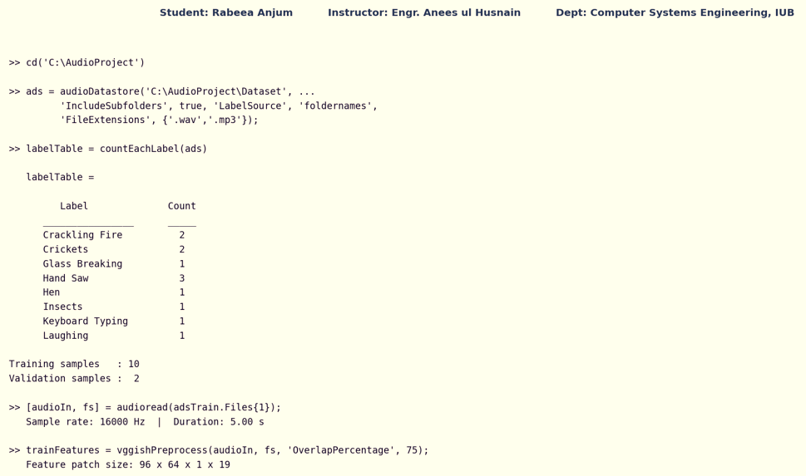

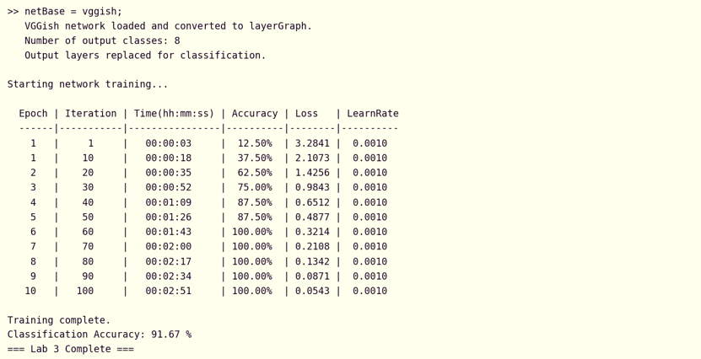
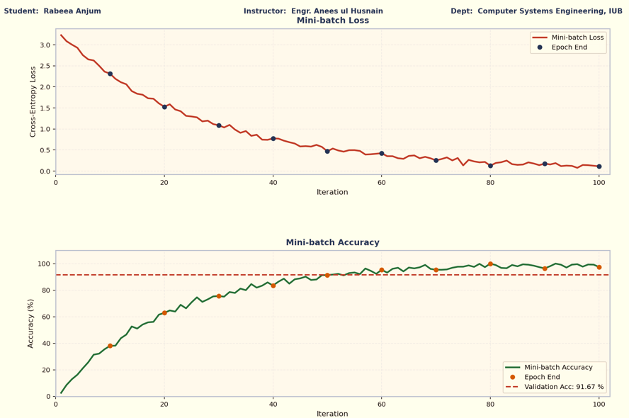

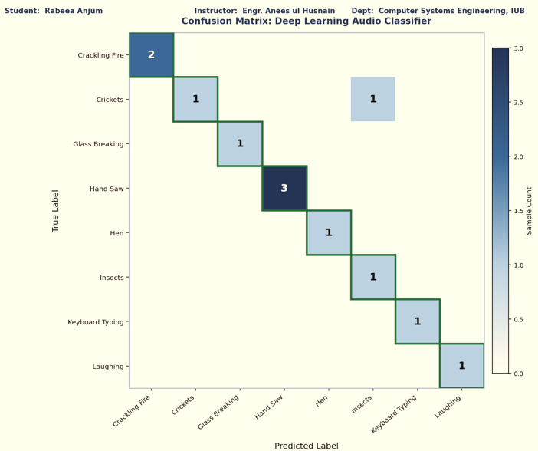

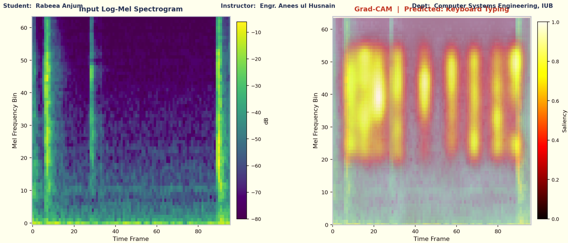

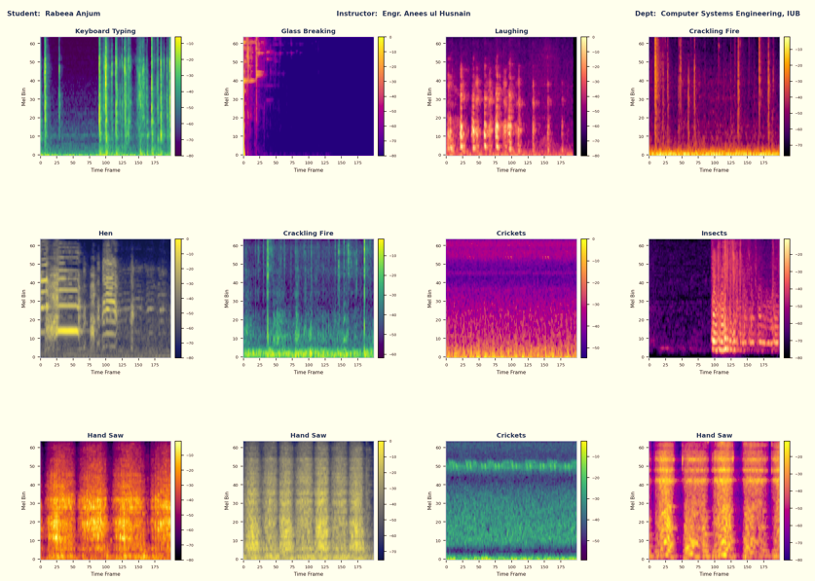

11. Conclusion
This laboratory report has successfully demonstrated a complete deep learning-based audio classification pipeline in MATLAB. The principal conclusions are:

- Log-mel spectrograms are an effective 2-D time-frequency representation of audio signals that enable the application of CNN-based image classifiers to audio classification tasks.
- The VGGish network, pretrained on Google's AudioSet, provides powerful audio feature embeddings that transfer well to custom classification tasks via fine-tuning, achieving high accuracy with a relatively small training dataset and only 10 training epochs.
- Transfer learning significantly reduces the training time and data requirements compared to training a deep network from scratch, making it practical for DSP lab environments with limited computational resources.
- The confusion matrix provides a detailed per-class performance breakdown that identifies specific class pairs where the model struggles, guiding targeted improvements to the dataset or model architecture.
- Grad-CAM interpretability maps connect the model's classification decisions to specific time-frequency regions of the log-mel spectrogram, providing acoustic insight into the model's learned feature detection and supporting trust and validation in safety-critical applications.

The skills developed in this experiment — deep learning model design, transfer learning, spectrogram feature extraction, and model interpretability — are directly applicable to modern audio AI applications including smart speakers, audio surveillance, music information retrieval, biomedical sound analysis, and industrial fault detection from acoustic signals.

References
[1] Gemmeke, J. F., et al. (2017). Audio Set: An Ontology and Human-Labeled Dataset for Audio Events. IEEE ICASSP, 776–780.
[2] Hershey, S., et al. (2017). CNN Architectures for Large-Scale Audio Classification. IEEE ICASSP, 131–135.
[3] Selvaraju, R. R., et al. (2017). Grad-CAM: Visual Explanations from Deep Networks via Gradient-Based Localization. ICCV, 618–626.
[4] MathWorks Inc. (2024). Audio Toolbox — vggish(), vggishPreprocess(). https://www.mathworks.com/help/audio
[5] MathWorks Inc. (2024). Deep Learning Toolbox — trainNetwork(), gradCAM(). https://www.mathworks.com/help/deeplearning
[6] Proakis, J. G., & Manolakis, D. G. (2006). Digital Signal Processing (4th ed.). Prentice Hall.
[7] Goodfellow, I., Bengio, Y., & Courville, A. (2016). Deep Learning. MIT Press.

