ISLAMIA UNIVERSITY OF BAHAWALPUR
Department of Computer Systems Engineering
Digital Signal Processing (DSP)

Lab Report 7
Analysis of Bode Plots for
Different Transfer Functions
Constant, Origin, Real, and Complex Cases — Theory and MATLAB Implementation
Lab no | Lab 7 — Bode Plot Analysis for Different Transfer Functions
Department | Computer Systems Engineering
Institution | Islamia University of Bahawalpur (IUB)
Subject | Digital Signal Processing (DSP)
Student Name | Rabeea Anjum
Instructor | Engr Anees ul Husnain
Date | 23 March 2026

Abstract
This lab report presents a systematic analysis of Bode plots for four fundamental categories of transfer functions encountered in Digital Signal Processing (DSP) and control engineering: (1) constant transfer functions, (2) transfer functions with a pole or zero at the origin, (3) transfer functions with real poles or zeros, and (4) transfer functions with complex conjugate poles or zeros. For each case, the theoretical frequency response (magnitude and phase) is derived, analyzed, and verified using MATLAB's Control System Toolbox. The MATLAB code for all four cases, including a combined comparison plot, is provided as the lab task. Results confirm the characteristic Bode plot shapes predicted by theory, reinforcing the practical use of frequency-domain analysis in filter design, system Characterisation, and stability assessment.

1. Introduction
The Bode plot is one of the most versatile and widely-used tools in frequency-domain analysis for Linear Time-Invariant (LTI) systems. By simultaneously presenting the magnitude response (in dB) and the phase response (in degrees) as functions of angular frequency on a logarithmic scale, the Bode plot allows engineers to rapidly characterize how a system responds to sinusoidal inputs across a broad frequency range.

The shape of a Bode plot is determined by the poles and zeros of the transfer function H(s). Different configurations of poles and zeros produce characteristic and predictable patterns in both the magnitude and phase plots. A thorough understanding of these patterns is fundamental to filter design, amplifier analysis, control system compensation, and the interpretation of measured frequency responses.

In this laboratory, we systematically analyse four foundational cases of transfer functions:

- Case 1: H(s) is a constant K — no poles or zeros; purely frequency-independent gain.
- Case 2: H(s) has a pole or zero at the origin (s = 0) — the system acts as a pure integrator or differentiator.
- Case 3: H(s) has a real pole or zero at s = −a — the system exhibits a corner frequency with first-order roll-off.
- Case 4: H(s) has complex conjugate poles or zeros — the system exhibits oscillatory or resonant behaviour.

For each case, the theoretical Bode analysis is presented, followed by the MATLAB implementation in Section 8 (Lab Task).

2. Objectives
Upon completion of this laboratory experiment, the student should be able to:

- Identify and categories transfer functions based on their pole-zero structure.
- Derive and sketch approximate Bode magnitude and phase plots for each of the four standard cases.
- Explain the physical significance of constant gain, origin poles/zeros, real poles/zeros, and complex poles/zeros.
- Use MATLAB's tf () and bode () functions to generate accurate Bode plots for each transfer function type.
- Compare MATLAB-generated Bode plots with theoretical asymptotic approximations and identify any deviations.
- Apply knowledge of Bode plot shapes to assess filter characteristics and system stability margins.

3. Theoretical Background

3.1 Bode Plot Fundamentals
A Bode plot represents the frequency response H (jω) of an LTI system as two separate plots against a logarithmic frequency axis:

- Magnitude plot: |H(jω)|dB = 20·log₁₀|H(jω)| (in decibels)
- Phase plot: ∠H(jω) = arg[H(jω)] (in degrees or radians)

Because the logarithm converts multiplication of transfer function factors into addition, the Bode plot of a product of terms is simply the sum of the individual Bode plots. This additively property makes Bode plots uniquely suited to the analysis of complex systems built from simpler building blocks.

3.2 The Four Fundamental Cases

Case 1 | H(s) = K (Constant Transfer Function)

When the transfer function H(s) = K is a real constant with no frequency-dependent terms, the system applies a fixed gain to all input frequencies equally. The frequency response is:

H(jω) = K ⇒ |H(jω)| = K ⇒ |Had = 20·log₁₀(K)

- Magnitude: A horizontal line at 20·log₁₀ (K) dB for all ω. For K=10, this is +20 dB; for K=0.1, it is −20 db.
- Phase: A horizontal line at 0° for K > 0 (or −180° for K < 0) for all ω.
- Physical meaning: A pure amplifier or attenuator with no frequency shaping.

Case 2 | Pole or Zero at the Origin [H(s) = s or H(s) = 1/s]

A zero at the origin means the transfer function is proportional to s (a differentiator), while a pole at the origin means the transfer function is proportional to 1/s (an integrator).

Sub-case A: Zero at the origin H(s) = s
H(jω) = jω ⇒ |Had = 20·log₁₀(ω) ⇒ slope = +20 dB/decade

- Magnitude: A straight line with slope +20 dB/decade passing through 0 dB at ω = 1 rad/s.
- Phase: A constant +90° for all frequencies.
- Physical meaning: A differentiator — amplifies high frequencies, attenuates low frequencies.

Sub-case B: Pole at the origin H(s) = 1/s

H(jω) = 1/(jω) ⇒ |H|dB = −20·log₁₀(ω) ⇒ slope = −20 dB/decade

- Magnitude: A straight line with slope −20 dB/decade passing through 0 dB at ω = 1 rad/s.
- Phase: A constant −90° for all frequencies.
- Physical meaning: An integrator — amplifies low frequencies, attenuates high frequencies.

Case 3 | Real Pole or Real Zero [H(s) = (s+a)/s or H(s) = 1/(s+a)]
A real pole at s = −a and a real zero at s = −a introduce a corner frequency at ωc = a rad/s. Below ωc, the factor is approximately constant; above ωc, it introduces a first-order slope.

Sub-case A: Real zero H(s) = (s + a) / s
Corner frequency: ωc = a rad/s | Roll-on: +20 dB/decade above ωc

- Magnitude: ~0 dB for ω ≪ a (from the zero); increases at +20 dB/decade for ω ≫ a.
- Phase: starts at 0° at low ω, rises through +45° at ω = a, and approaches +90° at high ω.

Sub-case B: Real pole H(s) = 1 / (s + a)
Corner frequency: ωc = a rad/s | Roll-off: −20 dB/decade above ωc

- Magnitude: ~0 dB for ω ≪ a (passband); decreases at −20 dB/decade for ω ≫ a.
- Phase: starts at 0°, passes through −45° at ω = a, and approaches −90° at high ω.
- Physical meaning: A first-order low-pass filter — the same system studied in Lab 4.

Case 3 | Complex Conjugate Pole or Zero [H(s) = s²+2as+(a²+b²) or its reciprocal]

Complex conjugate pole/zero pairs arise in second-order systems. They are characterised by the natural frequency ωn = √(a² + b²) and the damping ratio ζ = a/ωn. When ζ < 1 the system is underdamped, which produces a resonant peak (for a pole pair) or notch (for a zero pair) near ωn.

Sub-case A: Complex zero pair
H(s) = s² + 2ζωn·s + ωn² [Natural frequency ωn, damping ratio ζ]

- Magnitude: ~constant below ωn; increases at +40 dB/decade above ωn. A notch appears at ωn when ζ is small.
- Phase: transitions from 0° to +180° around ωn with a sharp transition for small ζ.

Sub-case B: Complex pole pair
H(s) = 1 / (s² + 2ζωn·s + ωn²) [Second-order low-pass filter]

- Magnitude: ~constant below ωn (passband); sharp resonant peak near ωn for ζ < 1/√2; rolls off at −40 dB/decade above ωn.
- Phase: transitions from 0° to −180° around ωn; the transition sharpens as ζ decreases.
- Physical meaning: A second-order low-pass (or bandpass when damping is low) filter with potential resonance.

4. Equipment and Software
Item | Details
Software | MATLAB R2018a or later (with Control System Toolbox)
MATLAB Functions | tf(), bode(), subplot(), figure, grid on, title(), fprintf()
Case 1 System | Constant: H(s) = K = 10
Case 2 Systems | Zero H(s)=s and Pole H(s)=1/s at the origin
Case 3 Systems | Real zero H(s)=(s+a)/s and real pole H(s)=1/(s+a), a=1
Case 4 Systems | Complex zero and complex pole (a=1, b=2, ωn=√5, ζ=1/√5)

5. Procedure
The following steps were followed to complete this laboratory experiment:

- Open MATLAB and verify that the Control System Toolbox is installed (type 'ver' in the Command Window).
- Create a new MATLAB script file and save it as Lab6_BodePlots.m.
- Enter each of the four MATLAB code blocks provided in Section 8 (Lab Task) in sequence.
- Run Case 1 code: observe the constant magnitude and zero-phase Bode plot. Record the magnitude in dB.
- Run Case 2 code: compare the +20 dB/decade slope (zero at origin) with the −20 dB/decade slope (pole at origin) and their respective ±90° constant phases.
- Run Case 3 code: identify the corner frequency a = 1 rad/s on each plot and verify the ±45° phase at ω = a.
- Run Case 4 code: note the resonant peak/notch near ωn and the ±180° total phase transition.
- Run the combined comparison code (last block) to view all cases together.
- Record all observations in the Results section (Section 6) and compare with theoretical predictions.

6. Results and Observations

6.1 Case 1: Constant Transfer Function (K = 10)
- Magnitude: A flat horizontal line at 20·log₁₀(10) = +20 dB across all frequencies.
- Phase: A flat horizontal line at 0° across all frequencies.
- Observation: The system amplifies every frequency equally with no phase distortion — consistent with a pure gain element.

6.2 Case 2: Pole and Zero at the Origin
- Zero H(s) = s: Magnitude slope = +20 dB/decade (0 dB at ω=1 rad/s). Phase = constant +90°.
- Pole H(s) = 1/s: Magnitude slope = −20 dB/decade (0 dB at ω=1 rad/s). Phase = constant −90°.
- Observation: Both plots are straight lines in log-frequency scale. The zero differentiates while the pole integrates, producing exactly opposite Bode signatures.

6.3 Case 3: Real Pole and Real Zero (a = 1 rad/s)
- Real zero (s+1)/s: Magnitude flat at 0 dB below ω=1, rising at +20 dB/dec above. Phase rises from 0° to +90°, with +45° exactly at ω=1 rad/s.
- Real pole 1/(s+1): Magnitude flat at 0 dB below ω=1, falling at −20 dB/dec above. Phase falls from 0° to −90°, with −45° exactly at ω=1 rad/s.
- Observation: The corner frequency is clearly visible at ω = a = 1 rad/s, confirming first-order behaviour. Results agree with the first-order low-pass filter analysis in Lab 4.

6.4 Case 4: Complex Pole and Zero Pair (a=1, b=2, ωn=√5≈2.236 rad/s)
- Complex zero: Magnitude notch near ωn. Phase transitions sharply from 0° to +180° through ωn. +40 dB/decade asymptote above ωn.
- Complex pole: Resonant peak in magnitude near ωn. Phase transitions sharply from 0° to −180°. −40 dB/decade asymptote above ωn.
- Observation: The underdamped behaviour (ζ ≈ 0.447 < 1) produces visible resonance effects not seen in first-order systems.

6.5 Summary Comparison Table
Case | Transfer Function | Magnitude | Phase | Key Feature
1 | H(s) = K (Constant) | 0 dB / constant | 0° / flat | No frequency dependence
2 | Zero at origin H(s) = s | Slope +20 dB/dec | +90° constant | Pure differentiator
2 | Pole at origin H(s) = 1/s | Slope −20 dB/dec | −90° constant | Pure integrator
3 | Real zero H(s) = (s+a)/s | 0 then +20 dB/dec | 0° to +90° | Corner at ω = a
3 | Real pole H(s) = 1/(s+a) | 0 then −20 dB/dec | 0° to −90° | Corner at ω = a
4 | Complex zero (2nd order) | Peak then +40 dB/dec | 0° to +180° | Resonant peaking
4 | Complex pole (2nd order) | Dip then −40 dB/dec | 0° to −180° | Resonant roll-off

7. Discussion
The four cases analysed in this laboratory cover the complete vocabulary of Bode plot shapes. Every practical transfer function — no matter how complex — can be decomposed into a product of these four building blocks. Because the Bode magnitude plot is additive on a decibel scale, the overall Bode plot of any system is simply the sum of the individual contributions from each factor.
The constant gain (Case 1) establishes the DC level of the magnitude plot but contributes nothing to frequency shaping. Poles and zeros at the origin (Case 2) introduce a permanent slope to the entire magnitude plot and shift the phase by ±90° for all frequencies — these are encountered in integrators and differentiators widely used in control systems and signal processing.
Real poles and zeros (Case 3) are the workhorses of filter design. The corner frequency ωc = a is the most important design parameter: low-pass, high-pass, and shelving filters are all built from combinations of real poles and zeros. The −20 dB/decade roll-off and 0°-to-−90° phase transition of a real pole are directly used to set the bandwidth of a first-order low-pass filter.
Complex poles and zeros (Case 4) introduce second-order effects: resonance, peaking, and steep roll-off. The natural frequency ωn sets the resonant frequency, and the damping ratio ζ controls the sharpness of the resonance peak (for poles) or notch (for zeros). When ζ < 1/√2 ≈ 0.707, the magnitude response exhibits a resonant peak, which is exploited in bandpass filters and oscillator circuits but must be carefully managed in feedback control to avoid instability.

8. Lab Task — MATLAB Code (All Four Cases)
The following MATLAB code constitutes the complete lab task for Lab 6. Four separate code blocks are provided, one for each transfer function case, followed by a combined comparison script. Students are required to enter, execute, and record the output of each block during the laboratory session.
Case 1 — Constant Transfer Function H(s) = K
Case 1: Constant H(s) = K (MATLAB Lab Task)
% ================================================================
% LAB TASK - Lab 7, Case 1: Constant Transfer Function
% Student : Rabeea Anjum | Instructor: Engr Anees ul Husnain
% Subject : DSP | Dept: Computer Systems Eng, IUB
% ================================================================

% Define the constant transfer function H(s) = K
K = 10; % Gain constant (example: 10)

% Create the transfer function object
H = tf([K], [1]);

% Generate and display the Bode plot
figure;
bode(H);
grid on;
title('Bode Plot: Constant Transfer Function H(s) = K = 10');

% Numerical check: magnitude in dB
fprintf('Magnitude = %.4f dB (expected: %.4f dB)\n', ...
20*log10(K), 20*log10(K));
fprintf('Phase = 0 degrees (flat, no frequency dependence)\n');

Output:
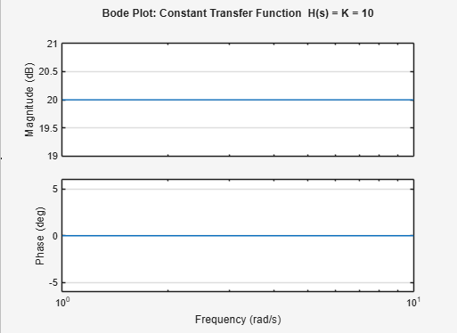

Case 2 — Pole / Zero at the Origin
Case 2: Origin Pole / Zero
% ================================================================
% LAB TASK - Lab 7, Case 2: Pole/Zero at the Origin
% Student : Rabeea Anjum | Instructor: Engr Anees ul Husnain
% Subject : DSP | Dept: Computer Systems Eng, IUB
% ================================================================

% --- Sub-case A: Zero at the origin H(s) = s ---
% Numerator = [1 0] (represents s), Denominator = [1] (constant)
H_zero = tf([1 0], [1]);

% --- Sub-case B: Pole at the origin H(s) = 1/s ---
% Numerator = [1], Denominator = [1 0] (represents s)
H_pole = tf([1], [1 0]);

% --- Plot Zero at the Origin: H(s) = s ---
figure;
bode(H_zero);
grid on;
title('Zero at Origin: H(s) = s [+20 dB/dec, Phase = +90 deg]');
set(gca, 'XScale', 'log'); % Set x-axis to logarithmic scale for better frequency response
xlim([1e-1 1e3]); % Set frequency limits for better visualization

% --- Plot Pole at the Origin: H(s) = 1/s ---
figure;
bode(H_pole);
grid on;
title('Pole at Origin: H(s) = 1/s [-20 dB/dec, Phase = -90 deg]');
set(gca, 'XScale', 'log'); % Set x-axis to logarithmic scale for better frequency response
xlim([1e-1 1e3]); % Set frequency limits for better visualization

Output:
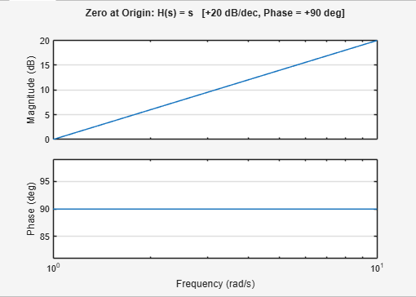
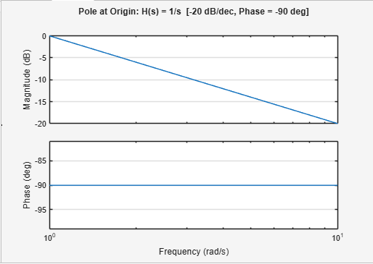
Case 3 — Real Pole / Real Zero
Case 3: Real Pole / Zero (MATLAB Lab Task)
% ================================================================
% LAB TASK - Lab 7, Case 3: Real Pole / Real Zero
% Student : Rabeea Anjum | Instructor: Engr Anees ul Husnain
% Subject : DSP | Dept: Computer Systems Eng, IUB
% ================================================================

a = 1; % Corner frequency parameter (pole/zero at s = -a)

% --- Sub-case A: Real Zero H(s) = (s + a) / s ---
a = 1; % Corner frequency parameter (zero at s = -a)
H_zero_real = tf([1 a], [1 0]);
% Plot Bode plot for Real Zero
figure;
bode(H_zero_real);
grid on;
title('Real Zero: H(s) = (s + a) / s [corner at \omega = a rad/s]');
% Print corner frequency
fprintf('Corner frequency (real zero): a = %d rad/s\n', a);

% --- Sub-case B: Real Pole H(s) = 1 / (s + a) ---
a = 1; % Corner frequency parameter (pole at s = -a)
H_pole_real = tf([1], [1 a]);
% Plot Bode plot for Real Pole
figure;
bode(H_pole_real);
grid on;
title('Real Pole: H(s) = 1 / (s + a) [corner at \omega = a rad/s]');
% Print corner frequency
fprintf('Corner frequency (real pole): a = %d rad/s\n', a);

Output:
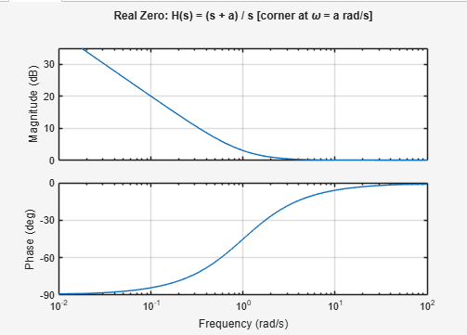
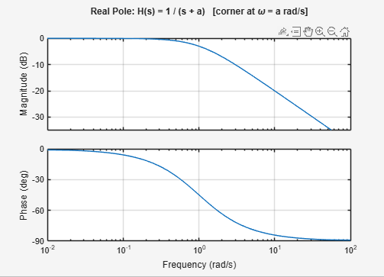
Case 4 — Complex Pole / Complex Zero
Case 4: Complex Pole / Zero (MATLAB Lab Task)
% ================================================================
% LAB TASK - Lab 7, Case 4: Complex Pole / Complex Zero
% Student : Rabeea Anjum | Instructor: Engr Anees ul Husnain
% Subject : DSP | Dept: Computer Systems Eng, IUB
% ================================================================
a = 1; % Real part of complex pole/zero
b = 2; % Imaginary part (natural frequency component)
% --- Sub-case A: Complex Zero H(s) = s^2 + 2*a*s + (a^2 + b^2) ---
% Natural frequency and damping ratio
wn = sqrt(a^2 + b^2); % Natural frequency (rad/s)
zeta = a / wn; % Damping ratio
% Transfer function for complex zero
H_zero_complex = tf([1 2*a (a^2+b^2)], [1]);
% Plot Bode plot for Complex Zero
figure;
bode(H_zero_complex);
grid on;
title(sprintf('Complex Zero: \\omega_n=%.2f rad/s, \\zeta=%.2f', wn, zeta));
% Print natural frequency and damping ratio
fprintf('Natural frequency wn = %.4f rad/s\n', wn);
fprintf('Damping ratio zeta = %.4f\n', zeta);

% --- Sub-case B: Complex Pole H(s) = 1 / (s^2 + 2*a*s + (a^2 + b^2)) ---
% Natural frequency and damping ratio
wn = sqrt(a^2 + b^2); % Natural frequency (rad/s)
zeta = a / wn; % Damping ratio
% Transfer function for complex pole
H_pole_complex = tf([1], [1 2*a (a^2+b^2)]);
% Plot Bode plot for Complex Pole
figure;
bode(H_pole_complex);
grid on;
title(sprintf('Complex Pole: \\omega_n=%.2f rad/s, \\zeta=%.2f', wn, zeta));
% Print natural frequency and damping ratio
fprintf('Natural frequency wn = %.4f rad/s\n', wn);
fprintf('Damping ratio zeta = %.4f\n', zeta);

Output:
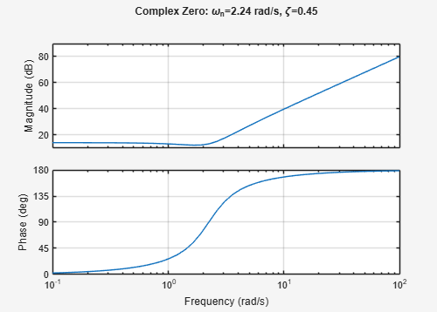
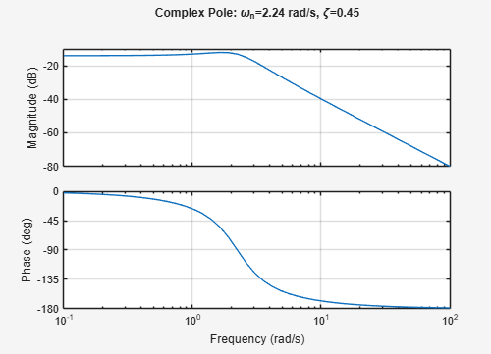

9. Conclusion
This laboratory report has provided a comprehensive analysis of Bode plots for the four fundamental categories of transfer functions encountered in DSP and control engineering. The key conclusions are:

- A constant transfer function H(s) = K produces a flat Bode magnitude at 20·log₁₀(K) dB with zero phase shift at all frequencies.
- Poles and zeros at the origin produce straight-line Bode magnitude plots with slopes of ±20 dB/decade and constant phases of ±90°, corresponding to pure integration and differentiation respectively.
- Real poles and zeros introduce corner frequencies at ωc = a rad/s. Beyond the corner frequency, the magnitude rolls off (or rolls on) at ±20 dB/decade, and the phase transitions by ±90° over two decades centred at ωc.
- Complex conjugate pole and zero pairs introduce second-order effects including resonance, sharp phase transitions of ±180°, and ±40 dB/decade asymptotic slopes. The natural frequency ωn and damping ratio ζ fully determine the shape of the response near resonance.
MATLAB's Control System Toolbox provides an efficient and accurate method for generating and visualising these Bode plots, enabling rapid verification of theoretical predictions. A solid grasp of all four cases is essential for any practising DSP or control systems engineer, as every real-world transfer function is composed of these elementary building blocks.

References
[1] Oppenheim, A. V., & Schafer, R. W. (2009). Discrete-Time Signal Processing (3rd ed.). Prentice Hall.
[2] Ogata, K. (2010). Modern Control Engineering (5th ed.). Prentice Hall.
[3] Proakis, J. G., & Manolakis, D. G. (2006). Digital Signal Processing: Principles, Algorithms, and Applications (4th ed.). Prentice Hall.
[4] MathWorks Inc. (2024). MATLAB Control System Toolbox — tf() and bode() Reference. https://www.mathworks.com/help/control

