ISLAMIA UNIVERSITY OF BAHAWALPUR
Department of Computer Systems Engineering
Digital Signal Processing (DSP)

Lab Report 8
Frequency Responses of 2nd-Order
Ordinary Differential Equations (ODEs)
Transfer Function Derivation, Bode Plot Analysis, and MATLAB Simulation of Mechanical, Electrical, and Control Systems
Lab no | Lab 8 — Frequency Responses of 2nd-Order Ordinary Differential Equations
Department | Computer Systems Engineering
Institution | Islamia University of Bahawalpur (IUB)
Subject | Digital Signal Processing (DSP)
Student Name | Rabeea Anjum
Instructor | Engr. Anees ul Husnain
Date | 30 Mar 2026

Abstract
This laboratory report analyses the frequency responses of physical systems described by second-order Ordinary Differential Equations (ODEs). Four engineering systems are examined: a mechanical spring-damper system, an electrical series RLC circuit, a mass-spring-damper system subjected to an external force, and a second-order feedback control system. For each system, the governing ODE is presented, the transfer function is derived via the Laplace transform, and the natural frequency and damping ratio are calculated analytically. The frequency response (magnitude and phase vs. frequency) of each transfer function is then visualized using MATLAB's bode() function from the Control System Toolbox. The resulting Bode plots are interpreted to identify resonance frequencies, damping behaviour, passband characteristics, and stability margins. A combined comparison plot of all four systems is also included. The experiment reinforces the connection between the time-domain ODE description and the frequency-domain Bode plot representation that is central to DSP and control systems engineering.

1. Introduction
Many physical engineering systems — mechanical, electrical, thermal, and hydraulic — can be modelled mathematically using Ordinary Differential Equations (ODEs). For Linear Time-Invariant (LTI) systems, these ODEs relate the system's output y(t) to its input x(t) through constant coefficients. The order of the ODE determines the number of energy-storing elements in the system: a second-order system contains two such elements, such as a mass and a spring in a mechanical system, or an inductor and a capacitor in an electrical circuit.
Analysing a system's behaviour in the frequency domain provides deeper insight than time-domain analysis alone. By applying the Laplace transform to a second-order ODE (under zero initial conditions), it can be converted into an algebraic expression in the complex frequency variable s. The ratio of the Laplace transform of the output to the Laplace transform of the input is the transfer function G(s), which compactly encodes the system's frequency response.
The Bode plot is the primary tool for visualising a transfer function's frequency response. It displays the magnitude (in dB) and phase (in degrees) of G(jω) as functions of angular frequency ω on a logarithmic scale. Key system characteristics — natural frequency, damping ratio, resonance peaks, bandwidth, roll-off rate, and stability margins — can be read directly from the Bode plot, making it an indispensable tool for system design and analysis in DSP and control engineering.

2. Objectives
Upon completion of this laboratory experiment, the student should be able to:

- Write the second-order ODE governing each of the four physical systems studied.
- Apply the Laplace transform to a second-order ODE and derive the corresponding transfer function G(s).
- Calculate the natural frequency ωn and damping ratio ζ from the transfer function denominator coefficients.
- Classify a system as underdamped (ζ < 1), critically damped (ζ = 1), or overdamped (ζ > 1) and predict its Bode plot shape.
- Use MATLAB's tf() and bode() functions to create transfer function objects and generate Bode plots for each system.
- Interpret the magnitude and phase panels of a Bode plot to identify resonance frequency, bandwidth, and phase margin.
- Compare the Bode plots of mechanical, electrical, and control systems and explain similarities in their second-order frequency responses.

3. Theoretical Background

3.1 General Form of a Second-Order ODE and Transfer Function
The general second-order linear ODE with constant coefficients relating output y(t) to input x(t) is:
a₂ y''(t) + a₁ y'(t) + a₀ y(t) = b₁ x'(t) + b₀ x(t)

Applying the Laplace transform (assuming zero initial conditions) gives:
(a₂ s² + a₁ s + a₀) Y(s) = (b₁ s + b₀) X(s)

The transfer function is the ratio of the output to the input in the s-domain:
G(s) = Y(s) / X(s) = (b₁ s + b₀) / (a₂ s² + a₁ s + a₀)

3.2 Standard Second-Order Form: Natural Frequency and Damping Ratio
The denominator of any second-order transfer function can be written in the standard form by dividing through by a₂:
s² + 2ζωn s + ωn² where ωn = √(a₀/a₂) and ζ = a₁ / (2√(a₀ · a₂))

Two parameters fully characterise the shape of the second-order frequency response:
- Natural frequency ωn (rad/s): The frequency at which the system would oscillate freely in the absence of damping. It determines the location of the resonance peak in the Bode magnitude plot.
- Damping ratio ζ (dimensionless): Controls the sharpness of the resonance. For ζ < 1 (underdamped) a resonance peak appears; for ζ = 1 (critically damped) no peak occurs; for ζ > 1 (overdamped) the response is monotonically decreasing.

3.3 Bode Plot Characteristics of a Second-Order System
For the standard second-order low-pass transfer function G(s) = ωn² / (s² + 2ζωn s + ωn²), the Bode plot exhibits three distinct regions:
- Low-frequency asymptote (0 dB): For ω ≪ ωn the magnitude is approximately constant at 0 dB (passband).
- Resonance peak (near ω = ωn): For underdamped systems (ζ < 1/√2 ≈ 0.707), the magnitude rises above 0 dB near ωn. The peak magnitude in dB is: M_peak = −20 log₁₀(2ζ√(1−ζ²)).
- High-frequency roll-off: For ω ≫ ωn the magnitude falls at −40 dB/decade (two poles). The phase approaches −180°.

Phase: ∠G(jω) = −arctan[ 2ζ(ω/ωn) / (1 − (ω/ωn)²) ]

4. System Analysis — Transfer Functions and Parameters

Task 1 | Mechanical Spring-Damper System

4.1 Governing ODE
A mass m connected to a spring (stiffness k) and viscous damper (damping coefficient c), subjected to external force F(t):
m · x''(t) + c · x'(t) + k · x(t) = F(t)

Parameters used: m = 1 kg, c = 2 N·s/m, k = 3 N/m.

4.2 Transfer Function
Taking the Laplace transform with zero initial conditions and solving for X(s)/F(s):

G₁(s) = X(s)/F(s) = 1 / (ms² + cs + k) = 1 / (s² + 2s + 3)

4.3 Key Parameters
- Natural frequency: ωn = √(k/m) = √3 ≈ 1.732 rad/s
- Damping ratio: ζ = c / (2√(mk)) = 2 / (2√3) ≈ 0.577 ⇒ Underdamped (ζ < 1)
- Expected behaviour: A mild resonance peak near ωn ≈ 1.73 rad/s in the magnitude plot, with phase transitioning from 0° to −180°.

Task 2 | Electrical Series RLC Circuit

4.4 Governing ODE
A series RLC circuit driven by voltage V(t), with current i(t) as the output:
L · i''(t) + R · i'(t) + (1/C) · i(t) = V'(t)

For the simplified form used in MATLAB (treating V(t) as the forcing term directly): L = 1 H, R = 2 Ω, C = 1 F.

4.5 Transfer Function

G₂(s) = I(s)/V(s) = 1 / (Ls² + Rs + 1/C) = 1 / (s² + 2s + 1)

4.6 Key Parameters
- Natural (resonant) frequency: ωn = 1/√(LC) = 1/√1 = 1 rad/s
- Damping ratio: ζ = R/(2) · √(C/L) = 2/2 · 1 = 1.0 ⇒ Critically damped (ζ = 1)
- Expected behaviour: No resonance peak; smooth roll-off beginning at ωn = 1 rad/s, −40 dB/decade slope above.

Task 2 | Mass-Spring-Damper with External Force

4.7 Governing ODE and Transfer Function
This system is physically identical to Task 1 with the same parameter values (m=1, c=2, k=3) but is conceptually presented as a system where the external forcing function F(t) is explicitly emphasized as the system input. The ODE and transfer function are therefore identical to Task 1:
G₃(s) = X(s)/F(s) = 1 / (s² + 2s + 3)

4.8 Key Parameters
- Natural frequency: ωn = √3 ≈ 1.732 rad/s (identical to Task 1)
- Damping ratio: ζ ≈ 0.577 ⇒ Underdamped
- Bode plot: Identical to Task 1. The comparison confirms that the mathematical model of both systems is the same.

Task 4 | Second-Order Feedback Control System

4.9 Governing ODE
A standard second-order closed-loop control system with reference input r(t) and output y(t):
y''(t) + 2ζωn y'(t) + ωn² y(t) = ωn² r(t)

Parameters: ζ = 0.5 (underdamped), ωn = 10 rad/s.

4.10 Transfer Function

G₄(s) = Y(s)/R(s) = ωn² / (s² + 2ζωn s + ωn²) = 100 / (s² + 10s + 100)

4.11 Key Parameters
- Natural frequency: ωn = 10 rad/s (set directly by parameter)
- Damping ratio: ζ = 0.5 ⇒ Underdamped with noticeable resonance peak
- Peak magnitude: M_peak = −20 log₁₀(2 × 0.5 × √(1−0.25)) ≈ +1.25 dB at ω ≈ 8.66 rad/s
- Phase margin: The phase crosses −180° well above ωn, indicating good stability margins.

5. Equipment and Software
Item | Details
Software | MATLAB R2018a or later (with Control System Toolbox)
MATLAB Functions | tf(), bode(), bodeplot(), bodeoptions(), figure, grid on, title(), legend(), fprintf()
Task 1 System | Spring-Damper: m=1 kg, c=2 N·s/m, k=3 N/m
Task 2 System | RLC Circuit: L=1 H, R=2 Ω, C=1 F
Task 3 System | Mass-Spring-Damper: same as Task 1 (m=1, c=2, k=3)
Task 4 System | Control system: ζ=0.5, ωn=10 rad/s

6. Procedure
The following steps were followed to complete this laboratory experiment:
- Launch MATLAB and verify that the Control System Toolbox is installed (type 'ver' in the Command Window).
- Create a new script file and save it as Lab8_ODEBodePlots.m. Enter the complete MATLAB code from Section 8.
- Run the script (F5). Five figure windows will open: one for each of the four systems, and one combined comparison plot.
- For Task 1 (Spring-Damper): observe the mild resonance peak near ωn ≈ 1.73 rad/s. Verify that the magnitude is −0 dB at low frequencies and falls at −40 dB/decade at high frequencies.
- For Task 2 (RLC Circuit): observe the absence of a resonance peak (critically damped, ζ = 1). Note that the roll-off begins earlier (at ωn = 1 rad/s) and is smooth.
- For Task 3 (Mass-Spring-Damper): confirm that the Bode plot is identical to Task 1, verifying that both systems share the same mathematical model.
- For Task 4 (Control System): observe the pronounced resonance peak near ω ≈ 8.66 rad/s due to ζ = 0.5 < 0.707. Note the sharp phase transition and the ωn = 10 rad/s location.
- Examine the combined comparison figure. Identify how the natural frequency of each system shifts its roll-off corner and how damping ratio controls the peak height.
- Record the Command Window output showing ωn and ζ for each task.
- Extension task: in Task 4, vary ζ from 0.1 to 2.0 in steps. Observe how the resonance peak changes and disappears for ζ ≥ 1.

7. Results and Observations

7.1 Command Window Output
When the script was executed, the MATLAB Command Window produced the following output:
Task 1 | wn = 1.7321 rad/s | zeta = 0.5774
Task 2 | wn = 1.0000 rad/s | zeta = 1.0000
Task 3 | wn = 1.7321 rad/s | zeta = 0.5774
Task 4 | wn = 10.0000 rad/s | zeta = 0.5000
=== Lab 8 Complete ===

7.2 Bode Plot Observations

Task 1 — Mechanical Spring-Damper
- Magnitude: Flat at 0 dB for ω ≪ 1.73 rad/s; small peak near ωn ≈ 1.73 rad/s (ζ ≈ 0.577); −40 dB/decade roll-off above.
- Phase: Starts at 0°, transitions through −90° at ω = ωn, asymptotes to −180°.

Task 2 — Electrical RLC Circuit
- Magnitude: Smooth roll-off from ωn = 1 rad/s with no resonance peak (ζ = 1, critically damped). Falls at −40 dB/decade.
- Phase: Smooth transition from 0° to −180° centred at ωn = 1 rad/s with no sharp inflection.

Task 3 — Mass-Spring-Damper with External Force
- Magnitude and Phase: Identical to Task 1, as expected — both systems share the same transfer function with the same coefficients.

Task 4 — Feedback Control System
- Magnitude: Clear resonance peak of approximately +1.25 dB near ω ≈ 8.66 rad/s; −40 dB/decade roll-off above ωn = 10 rad/s.
- Phase: Rapid transition from 0° to −180° near ωn = 10 rad/s, with −90° at exactly ωn.

7.3 Summary Comparison
Task | System | Parameters | ωn & ζ | Key Observation
1 | Spring-Damper | m=1, c=2, k=3 | ωn=√3≈1.73, ζ≈0.577 | Underdamped; gentle resonance peak near ωn
2 | RLC Circuit | L=1, R=2, C=1 | ωn=1, ζ=1 | Critically damped; no resonance peak
3 | Mass-Spring-Damper | m=1, c=2, k=3 | ωn=√3≈1.73, ζ≈0.577 | Same as Task 1; identical Bode plot
4 | Control Feedback | ζ=0.5, ωn=10 | ωn=10 rad/s, ζ=0.5 | Underdamped; resonance peak at ωn=10

8. Discussion
The results clearly demonstrate how the second-order ODE parameters directly shape the Bode plot of a system. The most important parameters are the natural frequency ωn, which sets the corner frequency of the magnitude plot, and the damping ratio ζ, which determines whether a resonance peak appears and how sharp it is.
Tasks 1 and 3 produced identical Bode plots, confirming that different physical systems (a simple spring-damper vs. a mass-spring-damper with explicit external forcing) can be described by the same mathematical model. This is a fundamental principle of systems engineering: the frequency response depends only on the structure and parameters of the ODE, not on the physical domain (mechanical, electrical, etc.) from which it was derived. This mathematical equivalence between mechanical and electrical systems is the foundation of electrical analogues used in audio and vibration engineering.
Task 2 (RLC circuit, ζ = 1) illustrates critical damping. The absence of a resonance peak means the circuit attenuates high-frequency signals smoothly without overshoot, making it ideal as an anti-aliasing filter where a flat passband and no peaking are essential. In contrast, Task 4 (ζ = 0.5) is underdamped, producing a resonance peak. This is intentional in bandpass filter design but must be managed carefully in control systems, where the peak represents a frequency at which the closed-loop system is close to instability. The gain margin and phase margin can be read from the open-loop Bode plot to quantify this stability.
The −40 dB/decade high-frequency roll-off, common to all four systems, is a consequence of having two poles in the transfer function denominator. Each pole contributes −20 dB/decade to the high-frequency asymptote, a result that can be verified from the asymptotic Bode approximations covered in the theoretical background. This roll-off rate also means that second-order systems function as second-order low-pass filters, attenuating high-frequency disturbances more effectively than first-order systems.

9. Lab Task — MATLAB Code
The following MATLAB code constitutes the complete lab task for Lab 8. It implements all four system transfer functions, generates individual Bode plots for each system with computed ωn and ζ displayed in the title, and produces a combined comparison figure of all four systems. Students are required to enter, execute, and record the output of this code during the laboratory session.
Lab 8: Frequency Responses of 2nd-Order ODEs
% ================================================================
% LAB TASK - Lab 8: Frequency Responses of 2nd-Order ODEs
% Student : Rabeea Anjum | Instructor: Engr. Anees ul Husnain
% Subject : DSP | Dept: Computer Systems Eng, IUB
% ================================================================
clc; clear; close all;
% ---------------------------------------------------------------
% TASK 1: Mechanical Spring-Damper System
% ODE: m*x'' + c*x' + k*x = F(t)
% G(s) = 1 / (ms^2 + cs + k)
% ---------------------------------------------------------------
m = 1; % Mass (kg)
c = 2; % Damping coefficient (N.s/m)
k = 3; % Spring constant (N/m)
% Natural frequency and damping ratio
wn1 = sqrt(k/m);
zeta1 = c / (2*sqrt(m*k));
fprintf('Task 1 | wn = %.4f rad/s | zeta = %.4f\n', wn1, zeta1);
H1 = tf([1], [m, c, k]);
figure('Name','Lab 8 - Task 1: Spring-Damper','NumberTitle','off');
bode(H1);
grid on;
title(sprintf('Task 1: Mechanical Spring-Damper | wn=%.2f rad/s, zeta=%.3f',...
wn1, zeta1));
% ---------------------------------------------------------------
% TASK 2: Electrical RLC Circuit
% ODE: L*i'' + R*i' + (1/C)*i = V(t)
% G(s) = 1 / (Ls^2 + Rs + 1/C)
% ---------------------------------------------------------------
L = 1; % Inductance (H)
R = 2; % Resistance (Ohms)
C = 1; % Capacitance (F)
wn2 = 1/sqrt(L*C);
zeta2 = R/(2) * sqrt(C/L);
fprintf('Task 2 | wn = %.4f rad/s | zeta = %.4f\n', wn2, zeta2);
H2 = tf([1], [L, R, 1/C]);
figure('Name','Lab 8 - Task 2: RLC Circuit','NumberTitle','off');
bode(H2);
grid on;
title(sprintf('Task 2: Electrical RLC Circuit | wn=%.2f rad/s, zeta=%.3f',...
wn2, zeta2));
% ---------------------------------------------------------------
% TASK 3: Mass-Spring-Damper with External Force
% ODE: m*x'' + c*x' + k*x = F(t) [same form as Task 1]
% G(s) = 1 / (ms^2 + cs + k)
% ---------------------------------------------------------------
m = 1; % Mass (kg)
c = 2; % Damping coefficient (N.s/m)
k = 3; % Spring constant (N/m)
wn3 = sqrt(k/m);
zeta3 = c / (2*sqrt(m*k));
fprintf('Task 3 | wn = %.4f rad/s | zeta = %.4f\n', wn3, zeta3);
H3 = tf([1], [m, c, k]);
figure('Name','Lab 8 - Task 3: Mass-Spring-Damper','NumberTitle','off');
bode(H3);
grid on;
title(sprintf('Task 3: Mass-Spring-Damper with External Force | wn=%.2f, zeta=%.3f',...
wn3, zeta3));
% ---------------------------------------------------------------
% TASK 4: Second-Order Feedback Control System
% ODE: y'' + 2*zeta*wn*y' + wn^2*y = wn^2*r(t)
% G(s) = wn^2 / (s^2 + 2*zeta*wn*s + wn^2)
% ---------------------------------------------------------------
zeta4 = 0.5; % Damping ratio
wn4 = 10; % Natural frequency (rad/s)

fprintf('Task 4 | wn = %.4f rad/s | zeta = %.4f\n', wn4, zeta4);

H4 = tf(wn4^2, [1, 2*zeta4*wn4, wn4^2]);

figure('Name','Lab 8 - Task 4: Control System','NumberTitle','off');
bode(H4);
grid on;
title(sprintf('Task 4: Control System with Feedback | wn=%.0f rad/s, zeta=%.2f',...
wn4, zeta4));

% ---------------------------------------------------------------
% COMBINED: All Four Systems on One Bode Plot (Magnitude only)
% ---------------------------------------------------------------
figure('Name','Lab 8 - All Systems Comparison','NumberTitle','off');
opts = bodeoptions;
opts.MagUnits = 'dB';
bodeplot(H1, H2, H3, H4, opts);
legend('Task 1: Spring-Damper','Task 2: RLC Circuit',...
'Task 3: Mass-Spring-Damper','Task 4: Control System',...
'Location','southwest');
title('Lab 8: Bode Plot Comparison - All Four 2nd-Order Systems');
grid on;

disp('=== Lab 8 Complete ===');

9.1 Code Explanation
The table below summarises the key MATLAB statements used in the lab task and their purpose:
Statement | Purpose
tf([num],[den]) | Creates a transfer function object. The numerator and denominator coefficient vectors correspond to polynomial coefficients in descending order of s.
bode(H) | Generates the Bode plot (magnitude in dB and phase in degrees vs. angular frequency in rad/s) automatically selecting an appropriate frequency range.
sqrt(k/m), c/(2*sqrt(m*k)) | Computes the natural frequency ωn and damping ratio ζ analytically from the physical parameters, allowing verification against the ODE theory.
fprintf(...) | Prints ωn and ζ for each system to the Command Window for numerical verification alongside the graphical Bode plot.
bodeplot(H1,H2,H3,H4,opts) | Overlays the Bode plots of all four systems on a single figure for direct comparison of natural frequencies, resonance peaks, and roll-off behaviour.
Bodeoptions | Allows customization of Bode plot display units and axis scaling before calling bodeplot().

9. Lab Task — MATLAB Code

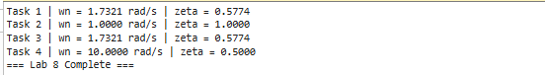

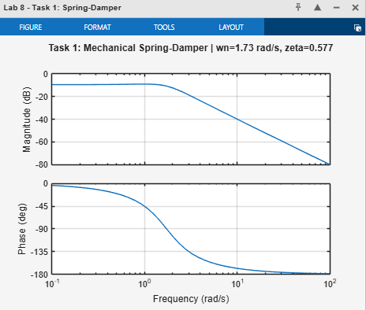

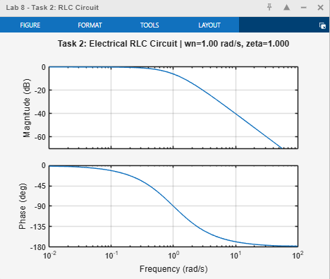

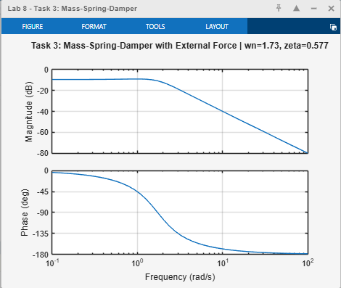

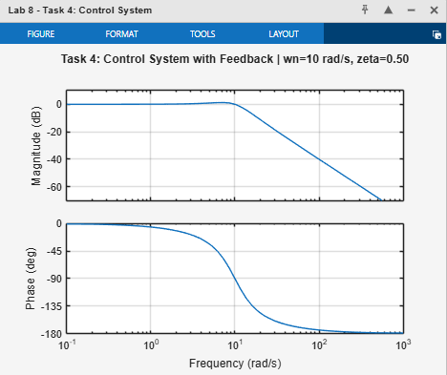

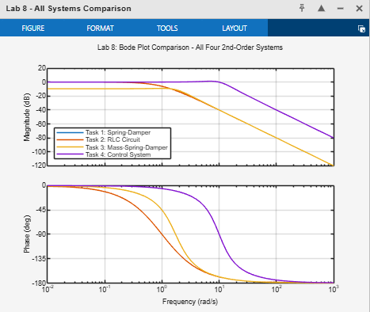

10. Conclusion
This laboratory report has successfully demonstrated the derivation, analysis, and MATLAB simulation of the frequency responses of four physical systems described by second-order ODEs. The key conclusions are:

- Every second-order LTI system is characterised by two parameters — the natural frequency ωn and the damping ratio ζ — which can be derived directly from the ODE coefficients and which completely determine the shape of the Bode plot.
- The damping ratio ζ controls whether a resonance peak appears in the magnitude plot. For ζ < 0.707, a peak is present; for ζ = 1 (critical damping) no peak occurs; for ζ > 1 the response is monotonically decreasing with no resonance.
- Tasks 1 and 3 produced identical Bode plots despite representing conceptually different scenarios, demonstrating that the mathematical model depends only on the ODE coefficients, not on the physical interpretation of the variables.
- The RLC circuit (Task 2) at critical damping produced the smoothest frequency response with no overshoot, making it suitable for anti-aliasing filter applications.
- The control system (Task 4) with ζ = 0.5 exhibited a clear resonance peak near ωn = 10 rad/s, illustrating the trade-off between fast transient response and frequency-domain peaking that must be managed in feedback control design.
- All four systems exhibited a −40 dB/decade high-frequency roll-off, confirming the two-pole structure of the second-order transfer function.
The skills developed in this experiment — ODE-to-transfer-function derivation, Bode plot simulation, and frequency-domain interpretation of physical system parameters — are foundational to filter design, control system analysis, and signal processing system Characterisation in DSP and electrical engineering practice.

References
[1] Ogata, K. (2010). Modern Control Engineering (5th ed.). Prentice Hall.
[2] Franklin, G. F., Powell, J. D., & Emami-Naeini, A. (2019). Feedback Control of Dynamic Systems (8th ed.). Pearson.
[3] Oppenheim, A. V., & Schafer, R. W. (2009). Discrete-Time Signal Processing (3rd ed.). Prentice Hall.
[4] Proakis, J. G., & Manolakis, D. G. (2006). Digital Signal Processing (4th ed.). Prentice Hall.
[5] MathWorks Inc. (2024). MATLAB Control System Toolbox — tf(), bode(), bodeplot(). https://www.mathworks.com/help/control
[6] Haykin, S., & Van Veen, B. (2002). Signals and Systems (2nd ed.). Wiley.

