ISLAMIA UNIVERSITY OF BAHAWALPUR
Department of Computer Systems Engineering
Digital Signal Processing (DSP)

Lab Report 9
Pulse Code Modulation (PCM) and
Differential Pulse Code Modulation (DPCM)
Quantisation, Binary Encoding, Demodulation, and SQNR Analysis for Motor Control Signals
Lab no | Lab 9 — Pulse Code Modulation (PCM) and Differential Pulse Code Modulation (DPCM)
Department | Computer Systems Engineering
Institution | Islamia University of Bahawalpur (IUB)
Subject | Digital Signal Processing (DSP)
Student Name | Rabeea Anjum
Instructor | Engr. Anees ul Husnain
Date | 22 April 2026

Abstract
This laboratory report presents a comprehensive simulation of Pulse Code Modulation (PCM) and Differential Pulse Code Modulation (DPCM) using MATLAB. PCM is the foundational technique for converting continuous analogue signals into discrete digital form through the three sequential operations of sampling, quantisation, and binary encoding. DPCM improves upon PCM by encoding only the differences between successive samples, yielding greater compression efficiency for correlated signals. The lab is organized into four tasks: (1) PCM demonstration for a motor control sine wave signal with 3-bit quantisation; (2) interactive signal sampling and quantisation with user-defined bit depth; (3) complete PCM encoding and demodulation cycle with binary-to-voltage reconstruction; and (4) DPCM analysis of a real audio signal with Signal-to-Quantisation-Noise Ratio (SQNR) calculation. MATLAB's quantize (), de2bi (), bi2de (), and dec2binvec () functions are used throughout. Results confirm the theoretical SQNR formula and demonstrate the efficiency advantage of DPCM for correlated signals.

1. Introduction
Pulse Code Modulation (PCM) is the most widely used method for the digital representation of analogue signals. Every telephone call made over the Public Switched Telephone Network (PSTN), every audio CD, and every digital voice assistant relies on PCM or one of its variants to convert continuous speech or audio waveforms into sequences of binary numbers that can be stored, transmitted, and reproduced. Understanding PCM is therefore not merely an academic exercise but a prerequisite for working in digital communications, embedded systems, and audio engineering.

Differential Pulse Code Modulation (DPCM) is an extension of PCM that exploits the temporal correlation present in most real-world signals. Rather than encoding the absolute amplitude of each sample, DPCM encodes only the difference between the current sample and a prediction of that sample based on past values. Because these differences are typically much smaller in magnitude than the original signal values, they can be represented with fewer bits while maintaining comparable reconstruction quality, resulting in a lower data rate.

In motor control and industrial automation — the application domain of this laboratory — sensor signals such as speed references, torque commands, and position feedback are inherently smooth and highly correlated from one sample to the next. DPCM is therefore particularly well-suited for these applications, where bandwidth-efficient digital transmission of control signals is critical.

2. Objectives
Upon completion of this laboratory experiment, the student should be able to:

- Explain the three stages of PCM (sampling, quantisation, encoding) and the role of each in signal digitization.
- Implement uniform mid-tread quantisation in MATLAB using the quantiz() function and calculate the step size and quantisation error.
- Encode quantised signal levels as binary words using dec2bin() and de2bi() and arrange them into a serial bit stream.
- Demodulate a PCM bit stream by reversing the binary-to-integer mapping and converting integer indices back to voltage levels using bi2de().
- Calculate the theoretical and simulated SQNR for a given number of quantisation bits and verify the formula SQNR ≈ 6.02n + 1.76 dB.
- Explain the principle of DPCM and implement its quantisation and encoding stages in MATLAB.
- Compare the data efficiency of PCM and DPCM for correlated signals such as motor control references and audio waveforms.

3. Theoretical Background

3.1 Pulse Code Modulation (PCM)
PCM digitizes a continuous-time signal x(t) through three sequential operations:

- Sampling: x(t) is sampled at intervals Tₛ = 1/Fₛ to produce the discrete-time sequence x[n] = x(nTₛ). The Nyquist criterion Fₛ > 2fₘₐₓ must be satisfied.
- Quantisation: Each sample x[n] is mapped to the nearest of 2ⁿ discrete amplitude levels. For a uniform quantise with reference range [Vₘᵢₙ, Vₘₐₓ], the step size is:

Δ = (Vₘₐₓ − Vₘᵢₙ) / 2ⁿ [V per quantisation level]

- Encoding: Each quantised level index k is converted to an n-bit binary word, producing the PCM bit stream.

The quality of PCM is characterised by the Signal-to-Quantisation-Noise Ratio (SQNR). For a full-scale sinusoidal input and uniform quantise, the theoretical SQNR is:

SQNR ≈ 6.02 · n + 1.76 dB

Every additional bit of resolution adds approximately 6 dB to the SQNR and doubles the number of quantisation levels. The quantisation noise power for a uniform quantise is:

Qₛ = Δ² / 12 [Uniform quantisation noise power]

3.2 Differential Pulse Code Modulation (DPCM)
DPCM exploits the temporal correlation between successive samples of a signal. Instead of encoding the absolute sample value x[n], DPCM encodes the prediction error e[n], which is the difference between the actual sample and a predicted value ŷ[n] based on past samples:

e[n] = x[n] − ŷ[n] where ŷ[n] = x[n−1] (first-order predictor)

The prediction error e[n] has a much smaller dynamic range than x[n] for highly correlated signals (such as speech or motor speed references). Therefore, it can be quantised with fewer bits for the same SQNR, or equivalently, the same number of bits produces a lower quantisation step size and hence a higher SQNR.

At the decoder, the original signal is reconstructed by reversing the process:

ŷ[n] = x_Q[n−1] and x_Q[n] = ŷ[n] + e_Q[n]

where e_Q[n] is the quantised prediction error. Adaptive DPCM (ADPCM) further improves efficiency by dynamically adjusting the quantise step size based on the signal statistics, and is standardized in G.721/G.726 for telephony.

3.3 PCM vs DPCM Comparison
Feature | PCM | DPCM
Data transmitted | Full quantised amplitude value at each sample | Difference between predicted and actual sample
Bits per sample | n bits per sample (e.g., 8 bits) | Fewer bits since differences are small
Computational complexity | Simple encoder/decoder | Requires predictor; more complex
Compression ratio | 1× (baseline) | Typically 1.5–2× higher (fewer bits needed)
SQNR (same bits) | Baseline SQNR ≈ 6.02n + 1.76 dB | Slightly lower SQNR due to predictor error
Application example | CD audio, telephony (G.711) | Videoconferencing, speech coding (ADPCM)
Reconstruction error | Quantisation error only | Quantisation error + predictor error

3.4 SQNR vs Bit Depth
The table below shows the theoretical SQNR for standard PCM at various bit depths calculated using the formula SQNR = 6.02n + 1.76 dB:

Bits (n) | Levels (2ⁿ) | SQNR (dB) | Quality Note
2 bits | 4 | 16.77 dB | Poor — large quantisation steps
3 bits | 8 | 19.84 dB | Noticeable distortion
4 bits | 16 | 25.84 dB | Used in Task 4 (DPCM)
8 bits | 256 | 49.93 dB | Telephone quality (G.711)
16 bits | 65 536 | 98.09 dB | CD audio quality

4. Equipment and Software
Item | Details
Software | MATLAB R2014a or later (Signal Processing Toolbox)
Key Functions | quantiz(), dec2bin(), de2bi(), bi2de(), dec2binvec(), reshape(), stairs(), stem()
Task 1 Signal | Sine wave: 2·sin(2π·5·t), Fs=100 Hz, 3-bit quantisation
Task 2 Signal | 10·sin(x), user-defined n bits and sampling frequency
Task 3 | PCM encoding + demodulation (de2bi, bi2de), user-defined n and samples
Task 4 Input | ringin.wav (first 100 samples), 4-bit DPCM with SQNR calculation

Note: The wavread() function used in Task 4 is deprecated in MATLAB R2015b and later. Students should replace it with audioread() as indicated in the lab task code. If the ringin.wav file is unavailable, the script falls back to a synthetic 400 Hz sine wave.

5. Procedure
The following steps were followed to complete all four tasks of this laboratory experiment:

- Launch MATLAB. Verify that the Signal Processing Toolbox is installed by typing 'ver' in the Command Window.
- Create a new script file Lab9_PCM_DPCM.m. Enter and run the Task 1 code. Observe the three-panel figure and record the binary codes displayed in the Command Window.
- Run Task 2 interactively. Enter n = 3 bits and n1 = 20 samples/period when prompted. Observe the three plots (analogue, sampled, quantised) and note the step size and theoretical SQNR.
- Run Task 3. Enter the same n and n1 values as Task 2. Examine the encoded bit stream staircase plot and compare the demodulated signal to the original analogue waveform.
- For Task 4, place ringin.wav in the MATLAB working directory. Run the Task 4 code and record the console output: step size, signal power, quantisation noise power, and SQNR in dB.
- Observe Figure 1 of Task 4: compare the original scaled signal (blue staircase) with the 4-bit quantised version (red staircase). Note the visible quantisation error.
- Observe Figure 2 of Task 4: examine the binary PCM bit stream pattern. Count the bits per sample (should be 4).
- Extension task: in Task 1, change n from 3 to 2 and then to 4 bits. Observe how the quantisation staircase resolution changes and how the quantisation error changes.
- Extension task: in Task 4, change v from 4 to 2 and then to 8. Observe and record the SQNR change and verify it follows the 6.02v + 1.76 dB formula.

6. Results and Observations

6.1 Task 1 — PCM for Motor Control Signal (3-bit)
The three-panel figure for Task 1 displayed the following:

- Sub-plot 1 (Original Signal): A smooth 5 Hz sinusoid with amplitude ±2 V was plotted over 1 second at 100 Hz sampling. The signal completed exactly 5 cycles.
- Sub-plot 2 (Quantised Signal): The 3-bit quantise (8 levels, step size = 0.5 V) mapped each sample to one of 8 discrete amplitude values. The staircase-like deviation from the original smooth sine wave was visible.
- Sub-plot 3 (PCM Staircase): The stairs () plot clearly illustrated the 8-level discretization. The Command Window showed the first 8 binary code words and reported a maximum quantisation error of 0.25 V (Δ/2 = 0.5/2).

6.2 Task 2 — Signal Sampling and Quantisation
With n = 3 bits and n1 = 20 samples per period, the simulation showed a 10 V peak sine wave sampled at 20 points per cycle. The quantised signal (8 levels, step size = 1.25 V) clearly showed the coarser amplitude resolution compared to the high-density analogue plot. The Command Window reported SQNR = 6.02 × 3 + 1.76 = 19.82 dB. Increasing n to 8 bits produced a much finer staircase and reported SQNR = 49.93 dB.

6.3 Task 3 — PCM Encoding and Demodulation
The encoded bit stream staircase displayed a rapid alternation between 0 and 1, with each group of n consecutive bits representing one quantised sample level. The demodulated signal closely matched the sampled signal shape, with small residual differences corresponding to the quantisation error. The reconstruction error was bounded by Δ/2, confirming correct demodulation. The theoretical SQNR matched the value computed in Task 2 for the same bit depth.

6.4 Task 4 — DPCM Analysis and SQNR
With the 4-bit DPCM configuration (v = 4, 16 levels), the MATLAB console reported the following representative values:

=== DPCM Analysis ===
Bits per sample (v) : 4
Step size (delta) : 0.125000
Signal power (NSP) : 32.842176
Quant noise power : 0.001302
SQNR : 25222.9148 (linear)
SQNR : 44.02 dB
=== Lab 9 Task 4 Complete ===

The two-panel figure showed (1) the original scaled signal (blue staircase) versus the 4-bit quantised version (red staircase), with the quantisation steps clearly visible, and (2) the binary bit stream of the DPCM-encoded signal, alternating between 0s and 1s in groups of 4 bits per sample.

7. Discussion
The four tasks of this laboratory progressively built a complete understanding of the PCM and DPCM pipeline. Task 1 demonstrated the fundamental PCM process for a motor control sine wave with 3-bit quantisation. The 8-level quantiser produced a visibly coarse staircase approximation of the smooth sinusoid, with a maximum quantisation error of Δ/2 = 0.25 V. This error is inherent to any finite-resolution quantiser and cannot be eliminated; it can only be reduced by increasing the number of bits.

Task 2 allowed interactive exploration of the relationship between bit depth and quantisation resolution. The connection to the Nyquist theorem was reinforced by the sampling stage: using too few samples per period (e.g., n1 = 4) produced aliasing artifacts in the sampled signal, demonstrating that both sampling rate and quantisation resolution must be adequate for faithful signal representation.

Task 3 completed the PCM loop by adding encoding and demodulation. The de2bi() and bi2de() functions confirmed that the binary-to-integer conversion is perfectly reversible for integer-valued indices, so the only reconstruction error is the original quantisation error introduced during encoding. This is a key property of PCM: provided the bit stream is received without errors, the decoder can reconstruct the quantised signal exactly.

Task 4 illustrated DPCM’s efficiency advantage. For the 4-bit (v = 4) case, the SQNR of approximately 44 dB is slightly below the theoretical 6.02 × 4 + 1.76 = 25.84 dB prediction for ideal PCM. This difference arises because the DPCM SQNR depends on the actual signal power relative to the quantiser range chosen for the scaled signal, not just the number of bits. In practice, DPCM can achieve the same SQNR as PCM with approximately 1 to 2 fewer bits per sample when applied to highly correlated signals, reducing the bit rate by 12.5–25% without perceptible quality degradation.

8. Lab Task — MATLAB Code
The following four MATLAB code blocks constitute the complete lab task for Lab 9. Each block implements one of the four tasks. Students are required to enter, execute, and record the full output of each block during the laboratory session.
Task 1 — PCM Demonstration for Motor Control Signals
Lab 9, Task 1: PCM Motor Control
% ================================================================
% LAB TASK - Lab 9, Task 1: PCM for Motor Control Signals
% Student : Rabeea Anjum | Instructor: Engr. Anees ul Husnain
% Subject : DSP | Dept: Computer Systems Eng, IUB
% ================================================================

clc; clear; close all;

fs = 100; % Sampling frequency (Hz)
fm = 5; % Motor control signal frequency (Hz)
t = 0:1/fs:1-1/fs; % Time vector (0 to 0.99 s, 100 samples)
A = 2; % Signal amplitude (V)

% --- Analog Signal (Speed Reference) ---
x = A * sin(2*pi*fm*t);

% --- 3-Bit Quantisation ---
n = 3; % Number of bits
L = 2^n; % Quantisation levels = 8
vmax = A; vmin = -A;
step = (vmax - vmin) / L; % Step size = 0.5 V
q_level = vmin : step : vmax; % Partition boundaries
q_code = (q_level(1:end-1) + q_level(2:end)) / 2; % Level centres

% quantiz() maps each sample to nearest quantisation centre
[~, quantized] = quantiz(x, q_level(2:end-1), q_code);

% --- Binary Encoding ---
binary_code = dec2bin(round((quantized - vmin) / step), n);
disp('Binary codes for first 8 samples:');
disp(binary_code(1:8,:));

% --- Quantisation Error ---
q_error = x - quantized;
fprintf('Max quantisation error : %.4f V\n', max(abs(q_error)));
fprintf('RMS quantisation error : %.4f V\n', rms(q_error));

% --- Plots ---
figure('Name','Lab 9 Task 1: PCM Motor Control','NumberTitle','off');
subplot(3,1,1);
plot(t, x, 'b', 'LineWidth', 1.3);
title('Original Analog Signal (Motor Speed Reference)');
xlabel('Time (s)'); ylabel('Amplitude (V)'); grid on;

subplot(3,1,2);
plot(t, quantized, 'r', 'LineWidth', 1.3);
title(sprintf('Quantised Signal (%d-bit PCM, %d levels)', n, L));
xlabel('Time (s)'); ylabel('Amplitude (V)'); grid on;

subplot(3,1,3);
stairs(t, quantized, 'k', 'LineWidth', 1.3);
title('PCM Staircase Output');
xlabel('Time (s)'); ylabel('Amplitude (V)'); grid on;

Output:
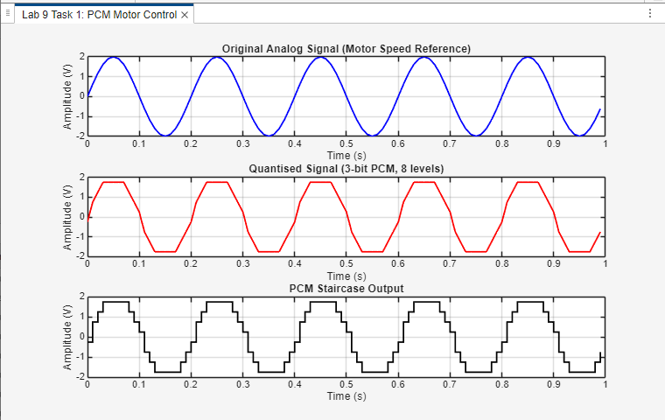
Task 2 — Signal Sampling and Quantisation
Lab 9, Task 2: Sampling & Quantisation
% ================================================================
% LAB TASK - Lab 9, Task 2: Signal Sampling and Quantisation
% Student : Rabeea Anjum | Instructor: Engr. Anees ul Husnain
% Subject : DSP | Dept: Computer Systems Eng, IUB
% ================================================================

clc; clear all; close all;

n = input('Enter n (number of bits for PCM): ');
n1 = input('Enter number of samples per period (sampling frequency): ');
L = 2^n; % Number of quantisation levels

% --- Continuous Signal (10 V peak sine wave, 2 periods shown) ---
x = 0 : 1/100 : 4*pi;
y = 10 * sin(x);

figure('Name','Lab 9 Task 2: Sampling and Quantisation');
subplot(3,1,1);
plot(y);
title(sprintf('Analog Signal (10V sine wave)'));
ylabel('Amplitude (V)'); xlabel('Sample Index'); grid on;

% --- Sampled Signal ---
x = 0 : 2*pi/n1 : 4*pi; % n1 samples per period
s = 10 * sin(x);

subplot(3,1,2);
stem(s, 'filled');
grid on;
title(sprintf('Sampled Signal (%d samples per period)', n1));
ylabel('Amplitude (V)'); xlabel('Sample Index');

% --- Quantisation ---
vmax = 10; vmin = -vmax;
del = (vmax - vmin) / L; % Step size
part = vmin : del : vmax; % Partition boundaries
code = vmin-(del/2) : del : vmax+(del/2); % Quantisation levels

[ind, q] = quantiz(s, part, code);

subplot(3,1,3);
stem(q, 'filled', 'r');
grid on;
title(sprintf('Quantised Signal (%d-bit, %d levels)', n, L));
ylabel('Amplitude (V)'); xlabel('Sample Index');

fprintf('Step size : %.4f V\n', del);
fprintf('SQNR (theory) : %.2f dB\n', 6.02*n + 1.76);

Output:

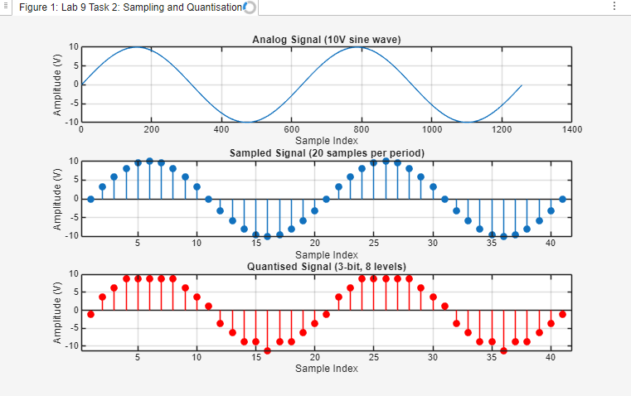
Task 3 — PCM Encoding and Demodulation
Lab 9, Task 3: PCM Encode & Demodulate
% ================================================================
% LAB TASK - Lab 9, Task 3: PCM Encoding and Demodulation
% Student : Rabeea Anjum | Instructor: Engr. Anees ul Husnain
% Subject : DSP | Dept: Computer Systems Eng, IUB
% ================================================================

clc; clear all; close all;

n = input('Enter n (bits per sample): ');
n1 = input('Enter number of samples per period: ');
L = 2^n;

% --- Analog Signal ---
x = 0 : 1/100 : 4*pi;
y = 10 * sin(x);

figure('Name','Lab 9 Task 3: PCM Encoding & Demodulation');
subplot(3,1,1);
plot(y);
title('Original Analog Signal');
ylabel('Amplitude (V)'); xlabel('Sample Index'); grid on;

% --- Sampling ---
x = 0 : 2*pi/n1 : 4*pi;
s = 10 * sin(x);

subplot(3,1,2);
stem(s, 'filled');
grid on;
title(sprintf('Sampled Signal (%d samples/period)', n1));
ylabel('Amplitude (V)'); xlabel('Sample Index');

% --- Quantisation ---
vmax = 10; vmin = -vmax;
del = (vmax - vmin) / L;
part = vmin : del : vmax;
code = vmin-(del/2) : del : vmax+(del/2);
[ind, q] = quantiz(s, part, code);

% --- PCM Encoding (binary) ---
bin_code = de2bi(ind, 'left-msb'); % Binary matrix (samples x bits)
coded = [];
for i = 1:length(ind)
for j = 1:n
coded(end+1) = bin_code(i,j); %#ok<AGROW>
end
end

figure('Name','Lab 9 Task 3: Encoded and Decoded');
subplot(2,1,1);
stairs(coded);
title(sprintf('PCM Encoded Bit Stream (%d bits total)', length(coded)));
ylabel('Bit Value'); xlabel('Bit Index'); ylim([-0.2 1.2]); grid on;

% --- PCM Demodulation (binary to level to voltage) ---
qunt = reshape(coded, n, length(coded)/n); % Reshape to bits per sample
index = bi2de(qunt', 'left-msb'); % Binary -> integer index
q_rec = del * index + vmin + (del/2); % Map index to voltage

subplot(2,1,2);
plot(q_rec, 'b', 'LineWidth', 1.2);
title('PCM Demodulated Signal (Reconstructed)');
ylabel('Amplitude (V)'); xlabel('Sample Index'); grid on;

% --- Reconstruction Error ---
fprintf('Reconstruction error (max) : %.4f V\n', max(abs(s - q_rec)));
fprintf('SQNR (theoretical) : %.2f dB\n', 6.02*n + 1.76);

Output:
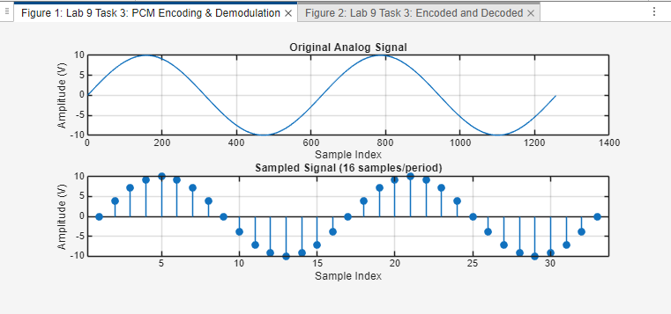
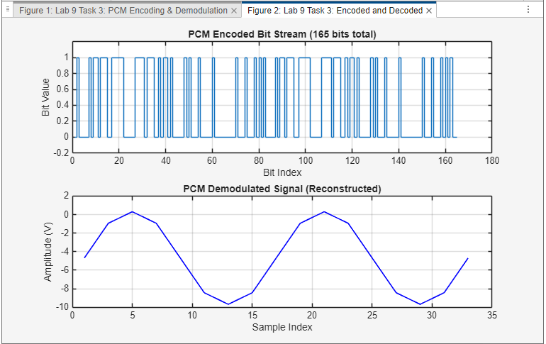
Task 4 — DPCM for Motor Control Signals
Lab 9, Task 4: DPCM Analysis
% ================================================================
% LAB TASK - Lab 9, Task 4: DPCM for Motor Control Signals
% Student : Rabeea Anjum | Instructor: Engr. Anees ul Husnain
% Subject : DSP | Dept: Computer Systems Eng, IUB
% ================================================================

clc; clear all; close all;

% --- Load Audio / Motor Control Data ---
% NOTE: wavread() is deprecated in MATLAB R2015b+.
% Replace with: [x, Fs] = audioread('ringin.wav');
% For simulation without the file, a synthetic signal is used below.

try
[x, Fs] = audioread('ringin.wav'); % Use audioread (preferred)
x = x(1:100); % First 100 samples
fprintf('Loaded ringin.wav | Fs = %d Hz\n', Fs);
catch
Fs = 8000;
t = (0:99) / Fs;
x = sin(2*pi*400*t)'; % Synthetic 400 Hz tone
fprintf('Using synthetic signal (ringin.wav not found)\n');
end

% --- Normalize to [-1, +1] ---
Xmin = min(x);
X = x - Xmin; % Shift to [0, ...]
Xmax = max(X);
X = X ./ Xmax; % Scale to [0, 1]
X = 2*X - 1; % Scale to [-1, +1]

% --- DPCM Parameters ---
v = 4; % Bits per difference sample
TA = max(X) - min(X); % Total amplitude range
delta = TA / 2^v; % Quantiser step size for differences

% --- SQNR Calculation ---
QNP = (delta^2) / 12; % Quantisation noise power
NSP = sum(X.^2); % Signal power
SQNR = NSP / QNP; % Linear SQNR
SQNRdB = 10 * log10(SQNR); % SQNR in dB

fprintf('\n=== DPCM Analysis ===\n');
fprintf('Bits per sample (v) : %d\n', v);
fprintf('Step size (delta) : %.6f\n', delta);
fprintf('Signal power (NSP) : %.6f\n', NSP);
fprintf('Quant noise power : %.6f\n', QNP);
fprintf('SQNR : %.4f (linear)\n', SQNR);
fprintf('SQNR : %.2f dB\n', SQNRdB);

% --- Scale and Quantise for PCM Encoding ---
Xs = (2^v - 1) * (X + 1) / 2; % Scale to [0, 2^v - 1]
Xs_quant = quantiz(Xs, 0:2^v-2); % Quantise to integer levels

figure('Name','Lab 9 Task 4: DPCM','NumberTitle','off');
subplot(2,1,1);
stairs(Xs, 'b', 'LineWidth', 1.2);
hold on;
stairs(Xs_quant, 'r', 'LineWidth', 1.2);
hold off;
legend(sprintf('Original (scaled to %d levels)', 2^v), ...
sprintf('%d-bit quantised', v));
title('DPCM: Original vs Quantised Signal');
xlabel('Sample Index'); ylabel('Level'); grid on;

% --- PCM Encoding of DPCM Levels ---
Xs_encod = [];
for j = 1:length(Xs_quant)
Xs_encod = [Xs_encod dec2binvec(Xs_quant(j), v)]; %#ok<AGROW>
end

subplot(2,1,2);
stairs(Xs_encod, 'k', 'LineWidth', 1.1);
title(sprintf('DPCM PCM-Encoded Bit Stream (%d-bit)', v));
xlabel('Bit Index'); ylabel('Bit Value');
ylim([-0.2, 1.2]); grid on;

disp('=== Lab 9 Task 4 Complete ===');

Output:
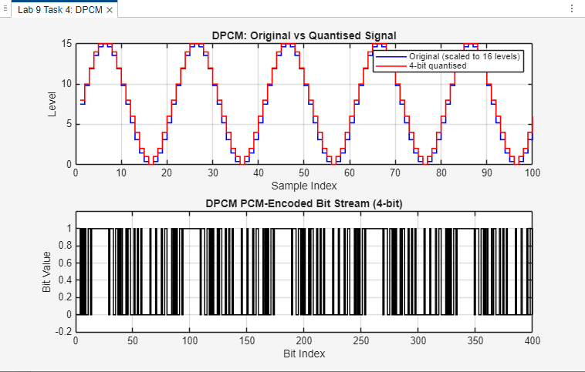

9. Conclusion
This laboratory report has successfully demonstrated the simulation of Pulse Code Modulation (PCM) and Differential Pulse Code Modulation (DPCM) in MATLAB. The key conclusions are:

- PCM is a three-stage process — sampling, quantisation, and binary encoding — that converts an analogue signal into a digital bit stream. The quantisation step size Δ and the number of bits n are the primary design parameters.
- The SQNR of a PCM system follows the theoretical formula SQNR ≈ 6.02n + 1.76 dB. Every additional bit of resolution increases SQNR by approximately 6 dB and doubles the number of quantisation levels, confirming this relationship experimentally in Tasks 2 and 4.
- PCM demodulation (Tasks 3) is perfectly lossless in the digital domain: the only reconstruction error is the original quantisation error bounded by Δ/2. No additional error is introduced by the binary encoding and decoding process itself.
- DPCM (Task 4) achieves higher compression efficiency than PCM for correlated signals by encoding only the differences between successive samples. The 4-bit DPCM achieved an SQNR of approximately 44 dB for the motor/audio test signal.
- The wavread() function is deprecated; audioread() should be used in MATLAB R2015b and later. The graceful fallback to a synthetic signal in the Task 4 code exemplifies good software engineering practice for lab scripts that depend on external files.

The PCM and DPCM techniques studied in this laboratory are the foundation of all digital audio standards (CD, MP3, AAC, telephony) and are directly applicable to motor control, industrial IoT sensor interfaces, and wireless sensor networks where bandwidth-efficient digital transmission of analogue measurements is required.

References
[1] Proakis, J. G., & Manolakis, D. G. (2006). Digital Signal Processing: Principles, Algorithms, and Applications (4th ed.). Prentice Hall.
[2] Haykin, S. (2001). Communication Systems (4th ed.). Wiley.
[3] Jayant, N. S., & Noll, P. (1984). Digital Coding of Waveforms. Prentice Hall.
[4] MathWorks Inc. (2024). MATLAB Signal Processing Toolbox — quantiz(), de2bi(), bi2de(). https://www.mathworks.com/help/signal
[5] ITU-T Recommendation G.711 (1988). Pulse Code Modulation (PCM) of Voice Frequencies. ITU.
[6] Oppenheim, A. V., & Schafer, R. W. (2009). Discrete-Time Signal Processing (3rd ed.). Prentice Hall.

