OpenEndedLab – 1

Student-Name: RABEEA Anjum | Roll-no : 23-CSE-09
Lab Instructor Signature _____________ | Date_________________________________

Intelligent Dual Traffic Light Control System Using Arduino

Abstract
This project presents the design and implementation of an Intelligent Dual Traffic Light Control System using an Arduino Uno in Tinkercad. The system improves a basic traffic light setup by integrating smart features such as vehicle detection using an ultrasonic sensor and automatic day/night operation using an LDR (Light Dependent Resistor). The traffic lights dynamically adjust their timing according to traffic density and ambient light conditions. During daytime, the traffic lights operate with longer green durations, while at night the timing becomes shorter due to reduced traffic flow. The ultrasonic sensor detects the presence of vehicles and provides priority to lanes with traffic. This project demonstrates how embedded systems and sensors can be used to create an adaptive and efficient traffic management system.

1. Introduction
Traffic congestion has become a major issue in modern cities due to the increasing number of vehicles. Conventional traffic light systems operate on fixed timing sequences and cannot respond to real-time traffic conditions. Intelligent traffic management systems are therefore required to improve traffic flow, reduce waiting time, and enhance road safety.
This project develops a smart dual traffic light system using Arduino Uno. The project incorporates two enhancements:
- Ambient light detection using an LDR sensor for day/night operation.
- Vehicle detection using an ultrasonic sensor for traffic-based signal control.
The system was designed and simulated in Tinkercad using LEDs, sensors, and Arduino programming.

2. Objectives
The main objectives of this project are:
- To design a dual traffic light system using Arduino Uno.
- To simulate intelligent traffic management using sensors.
- To implement day/night traffic control using an LDR sensor.
- To detect vehicle presence using an ultrasonic sensor.
- To improve traffic efficiency by dynamically adjusting traffic signals.

3. Components Used

Component | Quantity | Purpose
Arduino Uno | 1 | Main controller
Red LEDs | 2 | Stop signal
Yellow LEDs | 2 | Warning signal
Green LEDs | 2 | Go signal
Ultrasonic Sensor (HC-SR04) | 1 | Vehicle detection
LDR Sensor | 1 | Day/Night detection
220Ω Resistors | 6 | LED current limiting
10kΩ Resistor | 1 | LDR circuit
Breadboard | 1 | Circuit connections
Jumper Wires | Multiple | Electrical connections

4. Circuit Connections

4.1 LED Connections

Lane 1 Traffic Lights
- Red LED → Pin 2
- Yellow LED → Pin 3
- Green LED → Pin 4

Lane 2 Traffic Lights
- Red LED → Pin 5
- Yellow LED → Pin 6
- Green LED → Pin 7
Each LED is connected in series with a 220Ω resistor to prevent excessive current.

4.2 LDR Sensor Connection
The LDR sensor is used to detect ambient light intensity.
- One terminal of LDR → 5V
- Other terminal of LDR → A0 and 10kΩ resistor
- Other side of resistor → GND
This forms a voltage divider circuit.

4.3 Ultrasonic Sensor Connection

HC-SR04 Sensor
- VCC → 5V
- GND → GND
- TRIG → Pin 9
- ECHO → Pin 10
The ultrasonic sensor measures the distance between vehicles and the sensor to determine traffic presence.

5. Working Principle
The intelligent traffic light system operates based on two conditions:

5.1 Day and Night Detection
The LDR sensor continuously measures ambient light intensity.
- During daytime:
  - Higher light intensity detected.
  - Green lights remain ON longer.
- During nighttime:
  - Lower light intensity detected.
  - Traffic signal timing becomes shorter.
This simulates reduced traffic flow at night.

5.2 Vehicle Detection Using Ultrasonic Sensor
The HC-SR04 ultrasonic sensor detects vehicles approaching the traffic lane.
- If a vehicle is detected within a predefined distance:
  - The green light duration increases.
  - Traffic flow becomes smoother.
- If no vehicle is detected:
  - The signal changes normally.
This reduces unnecessary waiting time and improves efficiency.

6. Arduino Program

#define trigPin 9
#define echoPin 10
int ldrPin = A0;
int red1 = 2;
int yellow1 = 3;
int green1 = 4;
int red2 = 5;
int yellow2 = 6;
int green2 = 7;
long duration;
int distance;
int lightValue;
void setup() {
pinMode(red1, OUTPUT);
pinMode(yellow1, OUTPUT);
pinMode(green1, OUTPUT);
pinMode(red2, OUTPUT);
pinMode(yellow2, OUTPUT);
pinMode(green2, OUTPUT);
pinMode(trigPin, OUTPUT);
pinMode(echoPin, INPUT);
Serial.begin(9600);
}
void loop() {
lightValue = analogRead(ldrPin);
digitalWrite(trigPin, LOW);
delayMicroseconds(2);
digitalWrite(trigPin, HIGH);
delayMicroseconds(10);
digitalWrite(trigPin, LOW);
duration = pulseIn(echoPin, HIGH);
distance = duration * 0.034 / 2;
Serial.print("Distance: ");
Serial.println(distance);
// Day Mode
if(lightValue > 500)
{
trafficSystem(5000);
}
// Night Mode
else
{
trafficSystem(3000);
}
// Vehicle Detection
if(distance < 20)
{
digitalWrite(green1, HIGH);
digitalWrite(red2, HIGH);
delay(5000);
}
}
void trafficSystem(int delayTime)
{
// Lane 1 Green
digitalWrite(green1, HIGH);
digitalWrite(red1, LOW);
digitalWrite(red2, HIGH);
digitalWrite(green2, LOW);
delay(delayTime);
// Yellow Transition
digitalWrite(green1, LOW);
digitalWrite(yellow1, HIGH);
delay(2000);
digitalWrite(yellow1, LOW);
digitalWrite(red1, HIGH);
// Lane 2 Green
digitalWrite(red2, LOW);
digitalWrite(green2, HIGH);
delay(delayTime);
// Yellow Transition
digitalWrite(green2, LOW);
digitalWrite(yellow2, HIGH
delay(2000);
digitalWrite(yellow2, LOW);
digitalWrite(red2, HIGH);
}

Output:

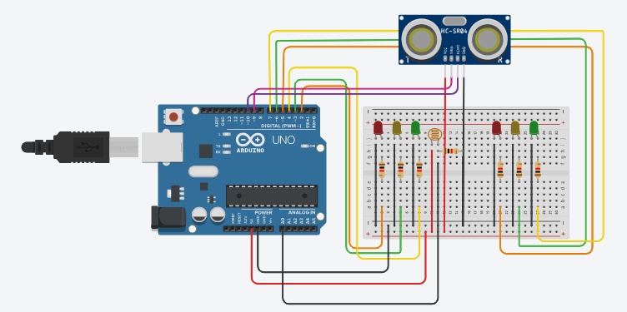
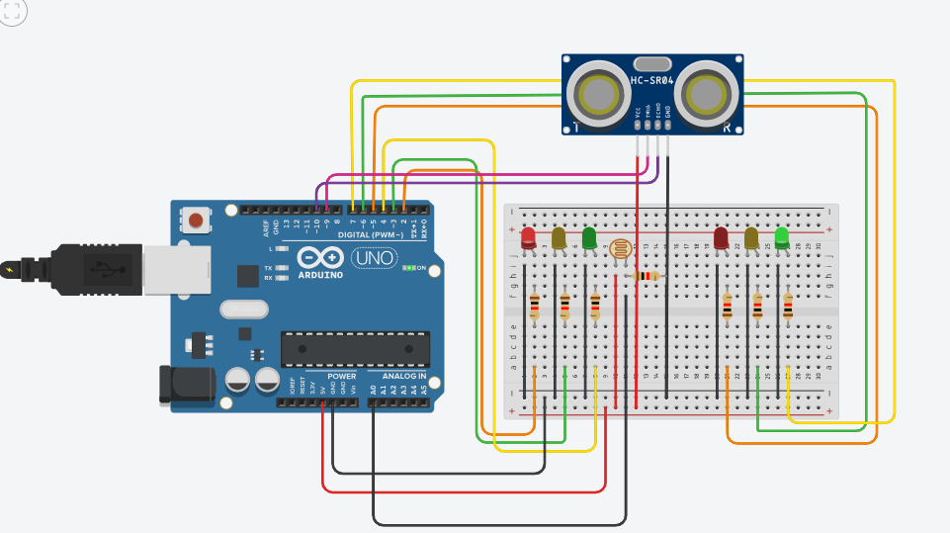

7. Advantages of the System
- Reduces traffic congestion.
- Minimizes unnecessary waiting time.
- Provides adaptive traffic management.
- Saves energy during nighttime operation.
- Demonstrates real-world intelligent transportation concepts.
- Easy to implement using low-cost components.

8. Applications
- Smart city traffic systems
- Highway intersections
- Parking management systems
- Automated road safety systems
- Educational Arduino and IoT projects

9. Limitations
- Only suitable for small-scale simulation.
- Uses a single ultrasonic sensor.
- Cannot detect exact vehicle count.
- Weather conditions may affect sensor performance.

10. Future Improvements
The system can be further enhanced by adding:
- Multiple ultrasonic sensors for accurate traffic density analysis.
- Emergency vehicle priority system.
- Pedestrian crossing buttons.
- IoT-based remote monitoring.
- GSM/Wi-Fi connectivity for smart city integration.
- LCD display for countdown timers.

11. Conclusion
The Intelligent Dual Traffic Light Control System successfully demonstrates how sensors and microcontrollers can be used to improve conventional traffic management systems. By integrating an LDR sensor and ultrasonic sensor, the traffic signals become adaptive to environmental and traffic conditions. The project effectively simulates real-world intelligent traffic control systems and provides a strong foundation for advanced smart transportation applications. The implementation in Tinkercad makes the project cost-effective, educational, and easy to understand for students and beginners in embedded systems and Arduino programming.

