OpenEndedLab – 2

Student-Name: RABEEA Anjum | Roll-no : 23-CSE-09
Lab Instructor Signature _____________ | Date_________________________________

Smart Water Level Monitoring and Alert System Using Arduino

Abstract
This project presents the design and implementation of a Smart Water Level Monitoring and Alert System using Arduino Uno in Tinkercad. The system continuously monitors the water level in a tank using a sensor simulated by a potentiometer. An LCD displays the current water level and system status in real time. Three LEDs indicate low, medium, and full water levels, while a buzzer provides an alert when the water level becomes critically low. The system offers a simple and cost-effective solution for water monitoring and demonstrates the application of embedded systems in real-world automation and resource management.

1. Introduction
Water is one of the most important resources for daily life and industrial applications. Efficient monitoring of water levels is essential to prevent water shortages, tank overflow, and wastage. Traditional methods of checking water levels manually are inefficient and time-consuming.
This project develops a Smart Water Level Monitoring System using Arduino Uno. The system uses sensors and visual indicators to provide real-time information about the water level inside a tank. The implementation demonstrates how embedded systems can automate monitoring tasks and improve resource management.

2. Objectives
The main objectives of this project are:
- To design a water level monitoring system using Arduino Uno.
- To display water level information on an LCD screen.
- To indicate water level conditions using LEDs.
- To provide an audible alert when water level becomes critically low.
- To simulate a real-world water monitoring system using Tinkercad.

3. Components Used
Component | Quantity | Purpose
Arduino Uno | 1 | Main controller
LCD 16×2 | 1 | Display water level and system status
Potentiometer | 1 | Simulates water level sensor input
Red LED | 1 | Indicates low water level
Yellow LED | 1 | Indicates medium water level
Green LED | 1 | Indicates full water level
Buzzer | 1 | Provides low water level alarm
220Ω Resistors | 3 | Limit current through LEDs
Breadboard | 1 | Circuit assembly and prototyping
Jumper Wires | Multiple | Electrical connections between components

4. Circuit Connections

4.1 LCD Connections
LCD Pin | Arduino Pin
RS | 12
E | 11
D4 | 5
D5 | 4
D6 | 3
D7 | 2

Additional Connections:

VSS → GND

VDD → 5V

VO → Potentiometer (contrast adjustment)
4.2 Water Level Sensor Connection
The potentiometer is used to simulate varying water levels.
- One terminal → 5V
- Other terminal → GND
- Middle terminal (wiper) → A0
4.3 LED Connections
Low Water Indicator
- Red LED → Pin 9
Medium Water Indicator
- Yellow LED → Pin 10
Full Water Indicator
- Green LED → Pin 13
Each LED is connected through a 220Ω resistor.
4.4 Buzzer Connection
- Positive Terminal → Pin 8
- Negative Terminal → GND
The buzzer activates when the water level is critically low.

5. Working Principle
The system continuously reads the analog value from the water level sensor (potentiometer).
Based on the measured value, the water level is classified into three categories:
  - Low Water Level
When: Water Level < 400
Actions:
- Red LED turns ON.
- Buzzer activates.
- LCD displays "LOW WATER".
This warns the user that the tank requires refilling.
  - Medium Water Level
When: 400 ≤ Water Level < 700
Actions:
- Yellow LED turns ON.
- Buzzer remains OFF.
- LCD displays "MEDIUM LEVEL".
This indicates a moderate amount of water in the tank.
  - Full Water Level
When: Water Level ≥ 700
Actions:
- Green LED turns ON.
- Buzzer remains OFF.
- LCD displays "TANK FULL".
This indicates sufficient water availability.

6. Arduino Program

#include <LiquidCrystal.h>

LiquidCrystal lcd(12, 11, 5, 4, 3, 2);

int sensorPin = A0;

int redLED = 9;
int yellowLED = 10;
int greenLED = 13;

int buzzer = 8;

int waterLevel = 0;

void setup()
{
pinMode(redLED, OUTPUT);
pinMode(yellowLED, OUTPUT);
pinMode(greenLED, OUTPUT);
pinMode(buzzer, OUTPUT);

Serial.begin(9600);

lcd.begin(16, 2);

lcd.print("Water Monitor");
delay(2000);

lcd.clear();
}

void loop()
{
waterLevel = analogRead(sensorPin);

Serial.print("Water Level: ");
Serial.println(waterLevel);

lcd.setCursor(0, 0);
lcd.print("Level: ");
lcd.print(waterLevel);
lcd.print(" ");

if (waterLevel < 400)
{
digitalWrite(redLED, HIGH);
digitalWrite(yellowLED, LOW);
digitalWrite(greenLED, LOW);

tone(buzzer, 1000);

lcd.setCursor(0, 1);
lcd.print("LOW WATER ");
}
else if (waterLevel >= 400 && waterLevel < 700)
{
digitalWrite(redLED, LOW);
digitalWrite(yellowLED, HIGH);
digitalWrite(greenLED, LOW);

noTone(buzzer);

lcd.setCursor(0, 1);
lcd.print("MEDIUM LEVEL ");
}
else
{
digitalWrite(redLED, LOW);
digitalWrite(yellowLED, LOW);
digitalWrite(greenLED, HIGH);

noTone(buzzer);

lcd.setCursor(0, 1);
lcd.print("TANK FULL ");
}
delay(1000);
}
7. Output
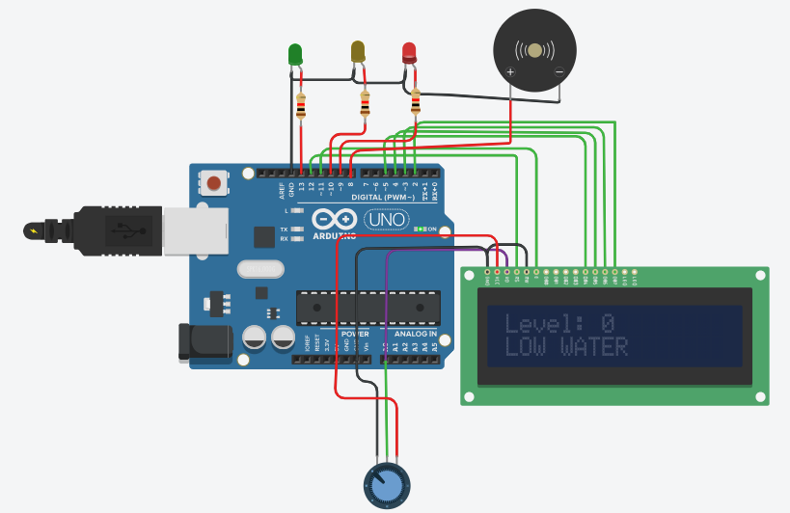
8. Advantages of the System
- Provides real-time water level monitoring.
- Prevents water shortages.
- Easy to implement and maintain.
- Cost-effective solution.
- Suitable for educational and practical applications.
- Provides visual and audible alerts.
9. Applications
- Residential water tanks
- Industrial storage tanks
- Agricultural irrigation systems
- Smart home automation
- Water management systems
- Educational Arduino projects
10. Limitations
- Potentiometer is only a simulated water sensor.
- Cannot measure actual water volume directly.
- No remote monitoring capability.
- Suitable only for small-scale demonstrations.
11. Future Improvements
The system can be enhanced by adding:
- Real water level sensors.
- Automatic water pump control.
- IoT monitoring using ESP32.
- Mobile application integration.
- SMS or email notifications.
- Cloud-based data logging.
- Ultrasonic water level measurement.
- Solar-powered operation.
12. Conclusion
The Smart Water Level Monitoring and Alert System successfully demonstrates the use of Arduino and sensors for automated monitoring applications. The LCD, LEDs, and buzzer provide real-time feedback about water availability, helping users manage water resources efficiently. The project serves as a practical example of embedded system design and can be extended into a fully automated IoT-based water management solution.

1

