Week: 01 The Human-Machine Interaction Loop

Theoretical Core: UI vs. UX (The Anatomy of a Product)

- UI (User Interface): The surface—colors, fonts, LERP animations, and layout (The 2 x 8 grid you sketched).
- UX (User Experience): The submerged part—logic, speed, ease of finding a scholarship, and the emotional feeling of the app.
A beautiful UI (high-end graphics) cannot save a poor UX (confusing navigation).
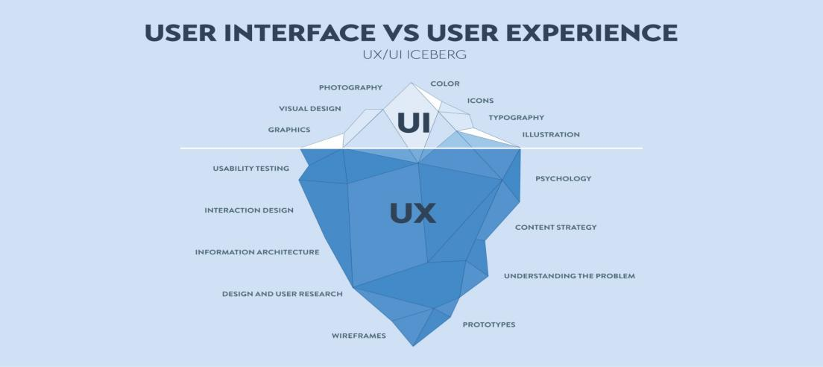

Human & Machine Interaction
Real-Life Example:
- When using the Instagram app:
  - Swiping = natural gesture (human behavior)
  - Double tap = like → reduces effort
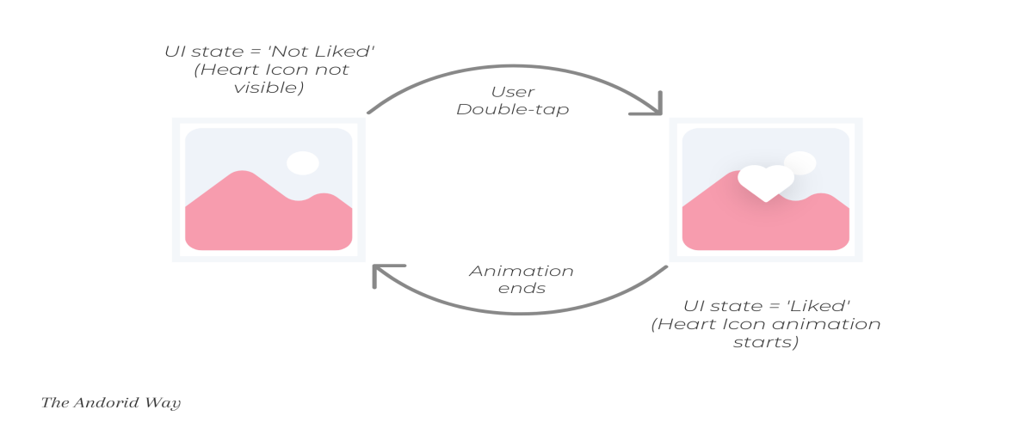

This shows that modern interfaces are designed based on human psychology rather than machine logic.

Human Memory

Types of Memory
Type | Duration | Example
Sensory Memory | milliseconds | seeing a notification
Short-Term Memory | ~15–30 sec | remembering OTP
Long-Term Memory | years | password you always use

According to HCI principles, interfaces should not overload short-term memory, as users can only hold limited information at a time.
Example
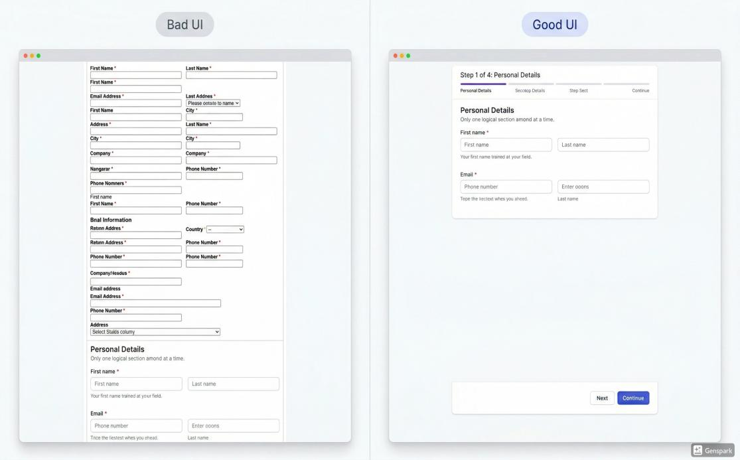
Bad Design (on the left )
a very long single-page form with no hints or helper text, overcrowded fields, poor spacing, inconsistent alignments.
Good Design (on the right )
a clean Google Forms-style step-by-step input flow, clear progress indicator, one section at a time, generous whitespace, strong visual hierarchy, concise helper text, intuitive labels, friendly modern colors,

Difference Between UI and UX
Although often used together, UI and UX represent different aspects of design.

Comparison Table
UI (User Interface) | UX (User Experience)
Focuses on visual design | Focuses on overall experience
Includes buttons, colors | Includes usability and flow
How it looks | How it feels

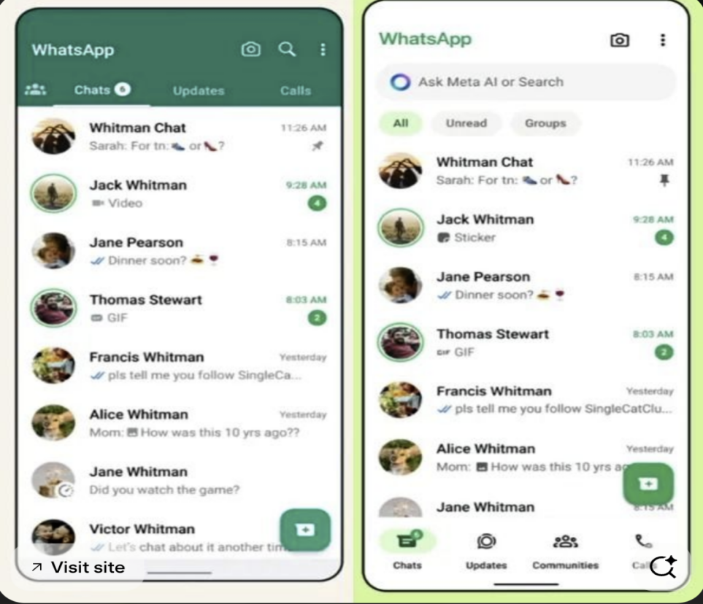

Example Analysis
- WhatsApp:
  - Simple interface
  - Easy navigation
→ Leads to smooth and efficient user experience
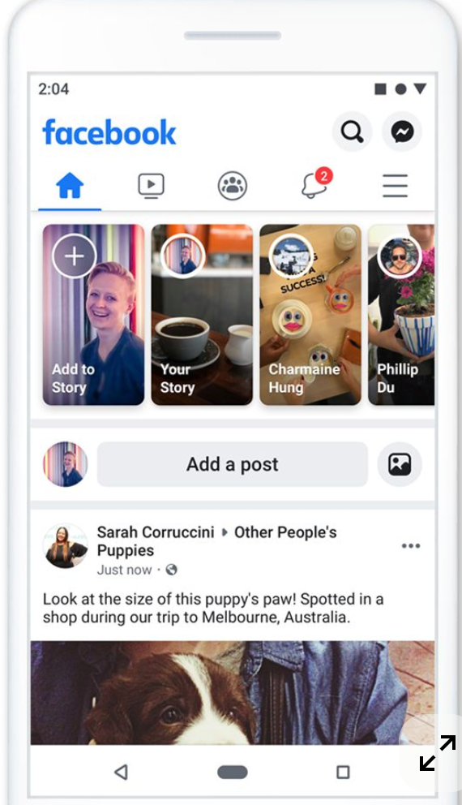
- Facebook:
  - More complex layout
  - Multiple features and distractions
→ Can sometimes reduce usability
A visually appealing interface (UI) does not guarantee a good experience (UX), but a good user experience always depends on a well-designed interface.

Mini Case Study: Login Interface Analysis

Good Design Features
- Autofill options reduce effort
- Clear “Forgot Password” option
- Simple and minimal input fields

Bad Design Features
- Too many fields create confusion
- Lack of error messages
- Poor visibility of important actions

Analysis
A well-designed login system reduces cognitive effort and helps users complete tasks quickly and efficiently.

Week 2: Communication, Memory & Cognitive Design in HCI

Types of Communication Modes
- Command Line Interface (CLI)
Users type commands (e.g., terminal)
- Graphical User Interface (GUI)
Users interact with visual elements like buttons and icons
- Touch-Based Interaction
Gestures like tapping, swiping (used in smartphones)
- Voice Interaction
Commands using speech (e.g., virtual assistants)
Real-Life Example
Applications like WhatsApp use:
- Touch (tap, swipe)
- Visual feedback (ticks, notifications)
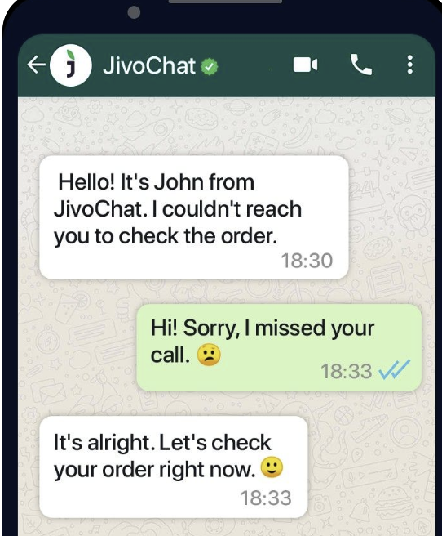
The double blue tick feature indicates that a message has been read by the recipient.

Feedback Principle (Core HCI Concept)
- Provides instant feedback to the sender
- Shows message status:

Visibility of System Status
The system should always keep users informed about what is happening.

Recognition Over Recall
Users don’t need to remember what each tick means.

Cognitive Load Theory
- Information is minimal and clear
Insight:
Modern systems combine multiple communication modes to improve usability and accessibility.

Short-Term Memory (STM)
Short-term memory plays a critical role in user interface design.

Key Characteristics
- Duration: 15–30 seconds
- Capacity: Limited (5–9 items approx.)

Design Implications
Interfaces should:
- Avoid too much information at once
- Break content into smaller parts
- Use visual cues and reminders

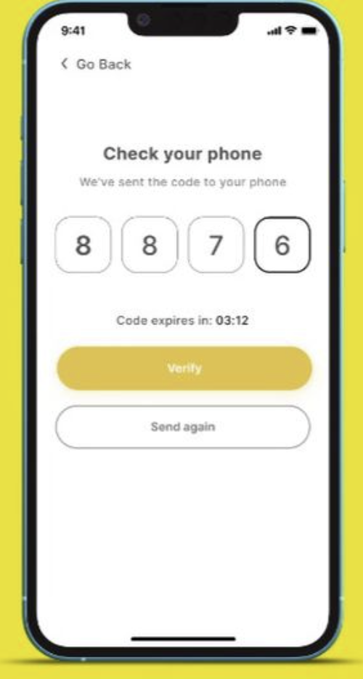

Example
OTP verification screens:
- Show code input boxes
- Often auto-fill → reduces memory load
UI Comparison: Daraz vs Amazon

Visual Layout & Design

🟠 Daraz
- Bright colors (orange theme)
- Heavy use of banners and promotions
- Feels crowded and visually busy

Amazon
- Simple color scheme (white, black, blue)
- Clean layout with structured sections
- More minimal and organized

HCI Insight:
Amazon follows minimalism, while Daraz increases cognitive load with excessive visuals.

Why Chunking is Important
- Reduces cognitive load
- Improves readability
- Helps users process information faster
Instead of showing everything at once, good design organizes content into sections.

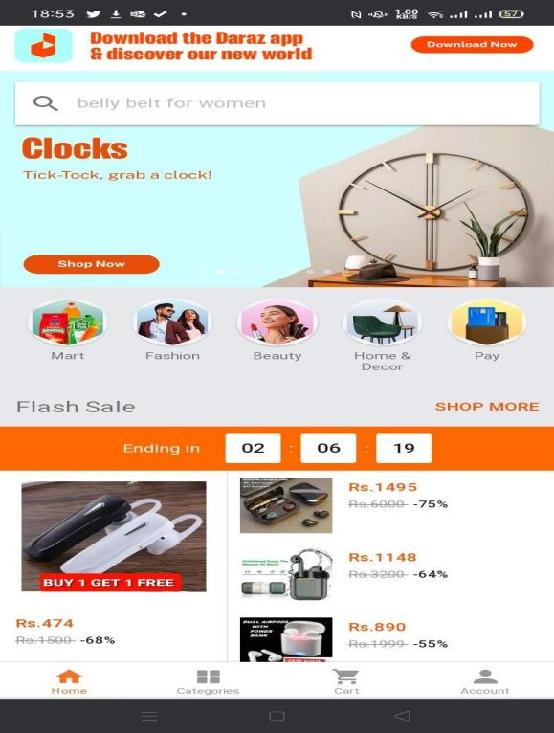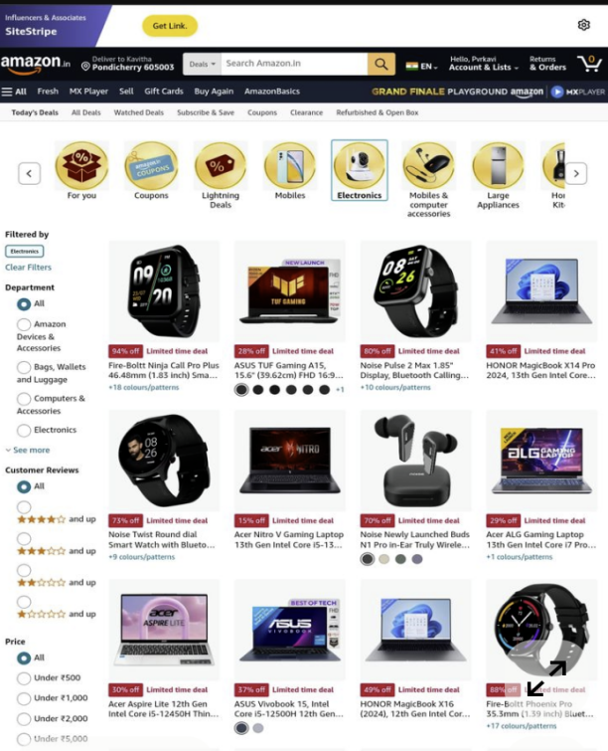

Chunking in Daraz | Chunking in Amazon
Issues  - Homepage shows:  - Flash sales  - Ads  - Categories  - Recommendation All mixed together  - Weak separation between sections  - Promotions interrupt browsing flow | Strengths  - Clear grouping:  - Categories (Electronics, Fashion, etc.)  - “Today’s Deals” section  - “Recommended for You”  - Each section is visually separated  - Consistent layout across pages
HCI Analysis  - Poor chunking leads to:  - Higher cognitive load  - Difficulty in scanning content  - Slower decision-making  Users must mentally organize information themselves | HCI Analysis  - Strong chunking:  - Reduces cognitive effort  - Improves navigation  - Helps users quickly find information  The system does the organization for the user

Memory Retention in HCI
Retention refers to how well users remember information over time.

Improving Retention in UI
- Use repetition (frequent actions)
- Use visuals (icons, colors)
- Provide feedback (confirmation messages)

Example
- Save icons help users remember function
- Notifications reinforce actions
 | Save | Saving files in software
️ | Delete | Removing files or messages
 | Search | Searching content
⚙️ | Settings | Opening system/app settings
✏️ | Edit | Editing content
 | Folder/File | Organizing files
❤️ | Like/Favorite | Social media engagement
 | Lock/Security | Privacy or secure content
☰ | Menu (Hamburger) | Navigation menu
➕ | Add/New | Creating new item
❌ | Close/Cancel | Closing windows

HCI Principles Behind These Symbols

Recognition Over Recall
Users recognize icons instantly instead of remembering commands.
Example:
 immediately means search (no need to read text)

Consistency
Platforms like Apple, Google, and Microsoft use similar icons.
This ensures:
- Users don’t need to relearn interfaces

Cognitive Load Reduction
Icons:
- Save space
- Reduce reading effort
- Speed up interaction

Week 3: Bridging the Human-Computer Gap

Human Goals and System Feedback in Everyday Interfaces

Case Study 01: Mobile Payment Confirmation (Google Pay vs. JazzCash)
When users send money or pay bills, small design details determine whether they trust the system feedback.
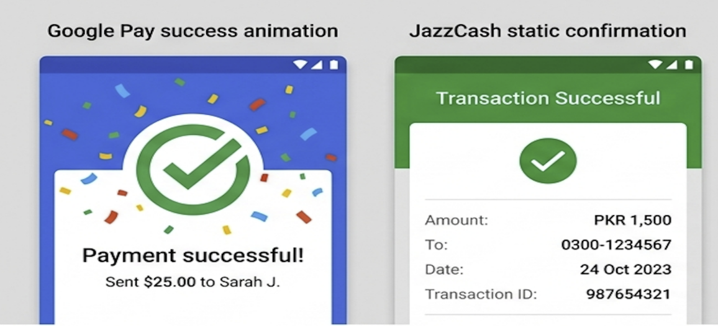
Stage | Google Pay | JazzCash | HCI Insight
1. Goal | “Send ₹500 to Aman instantly” | “Send Rs.500 to Ali” | Both have clear user goals – fast, confirmed payment.
2. Plan | Big, obvious "Send Money" button | Hidden inside menu tree → “Send Money → To Mobile → JazzCash” | Poor discoverability increases execution gulf.
3. Specify | Amount + name + confirm button visible upfront | Must go through multiple confirmation screens | Google Pay supports mental model: one-step confirm.
4. Execute | “Tap to pay” – smooth animation | Button delay; unclear if pressed | Lack of motion feedback adds execution anxiety.
5. Perceive | Check icon + “Payment successful” popup | No checkmark, only SMS after delay | Visual feedback builds trust.
6. Interpret | User immediately knows it’s done | User unsure: “Did it even send?” | Google Pay minimizes evaluation gulf.
7. Evaluate | App history instantly updated | Must open "My Payments" tab manually | Visibility ensures cognitive closure.
HCI Insight:
Google Pay translates Norman’s Goal → Execution → Feedback Loop more directly — shortening the Gulf of Execution and Gulf of Evaluation. JazzCash can improve by adding real-time visual feedback and consistent confirmation symbols.

Case Study 02: Wi-Fi Toggle (System Controls — iOS vs. Android)

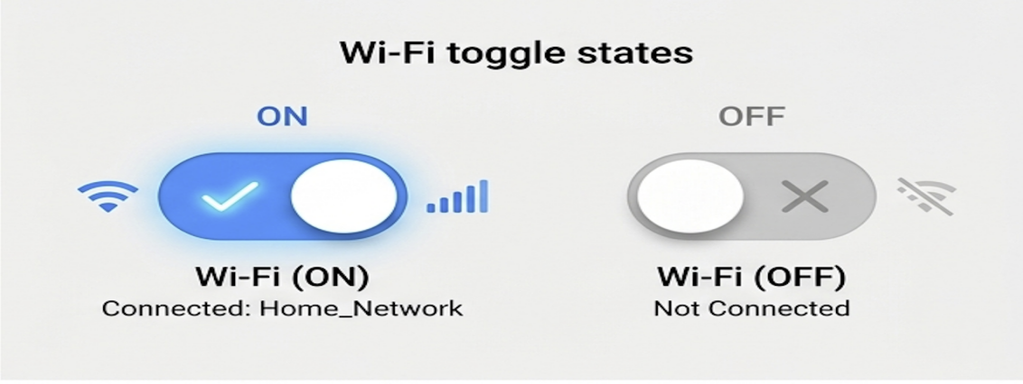
Norman Stage | iOS Control Center | Android Quick Settings
Goal | Turn on Wi-Fi | Turn on Wi-Fi
Plan | Swipe down and tap Wi-Fi icon | Swipe down → search Wi-Fi
Execution | One-tap toggle | Tap → may open sub-menu depending on version
Feedback | Icon turns blue + stays on top row | Icon lights up or opens detailed menu
Interpret | Color + icon change confirms "Wi-Fi ON" | Icons inconsistent across devices
Evaluation | User quickly checks connection icon on top bar | Unclear connection state on some skins
Insight:
Apple's micro-interactions are predictable, consistent, and visible, aligning tightly with Norman’s Visibility of System Status principle. Android UIs could be improved by enforcing icon standardization across device brands (reducing Gulf of Evaluation).

Micro Analysis: When Systems Fail Feedback Loops]

Case: Spotify “Offline Mode” Confusion
- Goal: Stream music on the go
- Problem: “Offline Mode” lacks clear feedforward or feedback
- Execution Gulf: Icon doesn’t change; user keeps refreshing tracks
- Evaluation Gulf: No clear reason why playback fails
Improvement Concept:
Add animated banners or contextual hints (“You’re offline. Downloaded songs available → ✨”) using color-coded states to align user understanding with system condition.
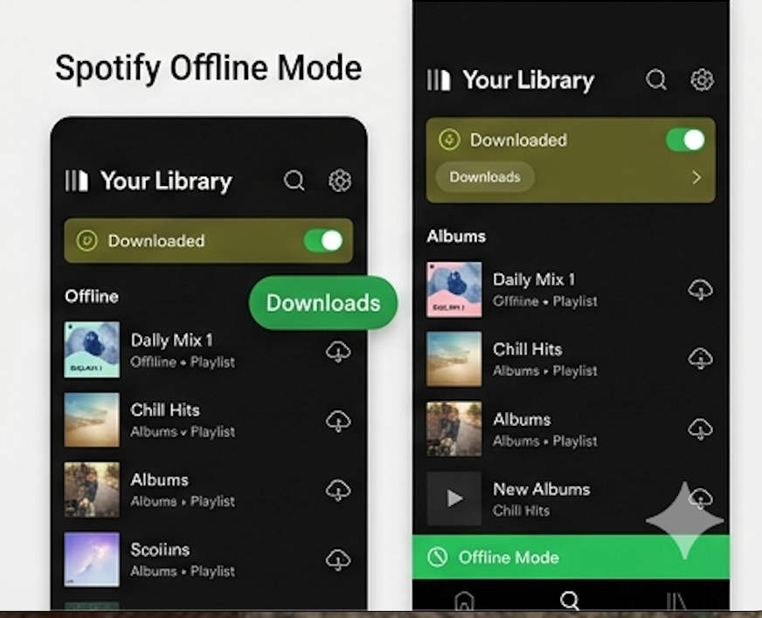

Summary Reflection
Principle | Key Takeaway from Case Studies
Gulf of Execution | Occurs when users cannot easily find or perform actions (JazzCash, Android).
Gulf of Evaluation | Occurs when feedback is unclear or delayed (Spotify, WhatsApp).
Cognitive Load | Reduced through structure, chunking, and visibility (Splitwise, Google Pay).
Recognition over Recall | Consistent icons, clear labels, context states simplify interaction (iOS Wi-Fi, Splitwise).
Emotional Design Insight | Frictionless feedback builds trust, not just efficiency.

