**Program1**

**Aim:-**

Write a program that prompts the uses to Enter his first name and Last name then dispalys a messege as “Greetings!!! First name Last name”.

a=input("Enter your First Name:");

b=input("Enter your Last Name:");

print("Greetin!!!",a,b)

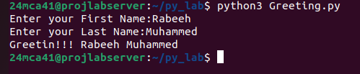

**Program2**

Aim:-

Write a program to demonstrate different number data types in python?

x,y,z=2,3.3,3+2j

print("integer:",x)

print("Float:",y)

print("Complex Number:",z)

print("type of X=",type(x))

print("type of y=",type(y))

print("type of z=",type(z))

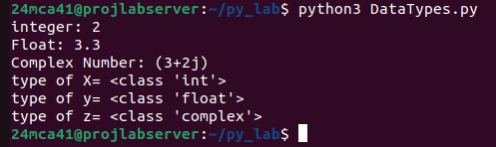

**program3**

Aim:-

Write a program to calculate the area of a circle by reading inputs from the user

Radius=float(input("Enter the Radius of Circle:"))

print("Area=",3.14*Radius*Radius)

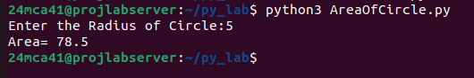

**Program4**

Aim:-

Write a program to calculate the salary of an employee given his basic pay (to be   
entered by the user) . HRA = 10 percent of the basic pay, TA = 5 percent of the   
basic pay

basic_pay=float(input("Enter Your Basic Pay:"))

HRA=0.10*basic_pay

TA=0.05*basic_pay

print("Total Salary=",basic_pay+HRA+TA)

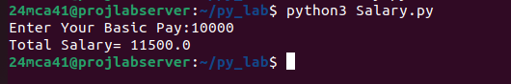

**Program5**

Aim:-

Write a Python program to perform arithmetic operations on two integer   
numbers.

x=int(input("Enter First Number:"))

y=int(input("Enter Second Number:"))

print(f"Sum={x}+{y}={x+y}")

print(f"Difference={x}-{y}={x-y}")

print(f"Division={x}/{y}={x/y}")

print(f"Multiplication={x}*{y}={x*y}")

print(f"Reminder={x}%{y}={x%y}")

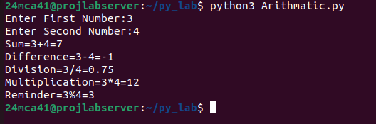

**Program6**

Aim:-

Write a Python program to get a string which is n (non-negative integer) copies   
of a given string.

str=input("Enter a String:")

n=int(input("Enterthe amound of copies"))

if n<=0:

print("Invalid Input")

else:

print(str*n)

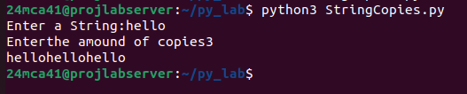

**Program7**

Aim:-

Program to accept an integer n and compute n+nn+nnn. [Hint : n = 5, then

compute 5 + 55 + 555]

n=input("Enter the Number:")

print(n,"+",n*2,"+",n*3)

sum=(int(n)+int(n*2)+int(n*3))

print("Sum=",sum)

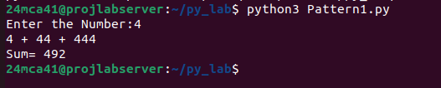

**Program8**

Aim:-

Find biggest of 3 numbers entered.

Num1=int(input("Enter the First Number:"))

Num2=int(input("Enter the Second Number:"))

Num3=int(input("Enter the Third Number:"))

if Num1>Num2 and Num1>Num2 :

print(Num1,"is Greatest")

elif Num2>Num1 and Num2>Num3 :

print(Num2,"is Greatest")

else:

print(Num3,"is Greatest")

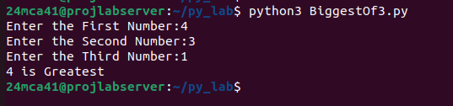

**Program9**

Aim:-

Program to determine whether a year is a leap year or not.

Year=int(input("Enter the Year:"))

if Year % 400==0 or Year%100==0 or Year%4==0 :

print(Year,"is a Leap Year")

else :

print(Year,"is not a Leap Year")

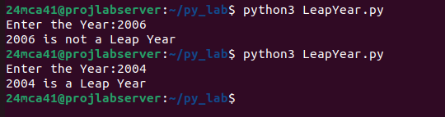

program10

Aim:-

Write a Python program to determine the rate of entry-ticket in a trade fair

|  |  |
| --- | --- |
| AGE | RATE |
| <10 | 7 |
| >=10 AND <10 | 10 |
| >=60 | 5 |

based on age as follows:

age=int(input("Enter the age:"))

if age>=60 :

print("Ticket Prize= 5")

elif age<60 and age>=10 :

print("Ticket Prize=10")

else :

print("Ticket Prize=7")

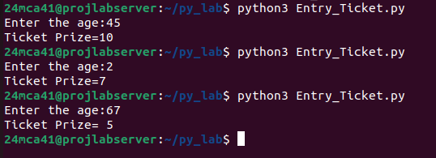

Program 11

Aim:-

Write a Python program to solve a quadratic equation

import math  
print("Quaderatic equation ax^2 + bx + c")  
a = float(input())  
b = float(input())  
c = float(input())  
descr = (b*b) - (4*a*c)  
if(descr == 0):  
 print("Only one root value")  
 ans = -b / (2 * a)  
 print("x : ", ans)  
elif descr > 0:  
 sqrtValue = math.sqrt(descr)  
 ansOne = (-b + sqrtValue) / (2 * a)  
 ansTwo = (-b - sqrtValue) / (2 * a)  
 print("X1 = ", ansOne)  
 print("X2 = ", ansTwo)  
else:  
 print("Complex root")  
 sqrtValue = math.sqrt(abs(descr)) / (2 * a)

print(-b/(2*a), "+i", sqrtValue)  
 print(-b/(2*a), "-i", sqrtValue)

