Bahria University,
Karachi Campus


LAB EXPERIMENT NO.
9
LIST OF TASKS
TASK NO | OBJECTIVE
1. | You are a real estate agent working in a competitive market.
2. | You are an HR manager at a tech company tasked with developing a salary prediction model to assist in determining appropriate compensation for new hires and promotions.

Submitted On:
28th November 2025
(Date: DD/MM/YY)
Task No. 1: You are an HR manager at a tech company tasked with developing a salary prediction model to assist in determining appropriate compensation for new hires and promotions. Your company values transparency and fairness in salary negotiations, and they believe that a data- driven approach will help achieve these goals. You have been provided with a dataset containing information on employees' years of experience and their corresponding salaries. Write a python program on the given dataset and implement linear regression model to check best fit line and perform following task:
Output:
import numpy as np
import pandas as pd
import matplotlib.pyplot as plt
df = pd.read_csv("Real estate.csv")
df.head()
df.isnull().sum()
X = df.drop('Y house price of unit area', axis = 'columns')
y = df['Y house price of unit area']
from sklearn.preprocessing import StandardScaler
scaler = StandardScaler()
X = scaler.fit_transform(X)
from sklearn.model_selection import train_test_split
X_train, X_test, y_train, y_test, = train_test_split(X, y, test_size=0.33, random_state=42)
from sklearn.linear_model import LinearRegression
model = LinearRegression()
model.fit(X_train, y_train)
predict = model.predict(X_test)
plt.scatter(predict, y_test)
from sklearn import metrics

print("\n--- Model Evaluation ---")
print("MAE:", metrics.mean_absolute_error(y_test, predict))
print("MSE:", metrics.mean_squared_error(y_test, predict))

rmse = np.sqrt(metrics.mean_squared_error(y_test, predict))
print("RMSE:", rmse)

print("\n--- Visualisation ---")
plt.scatter(y_test, predict)
plt.plot(y_test, y_test, linewidth=2)

plt.xlabel("Actual Price")
plt.ylabel("Predicted Price")
plt.title("Best Fit Line (Actual vs Predicted)")
plt.show()

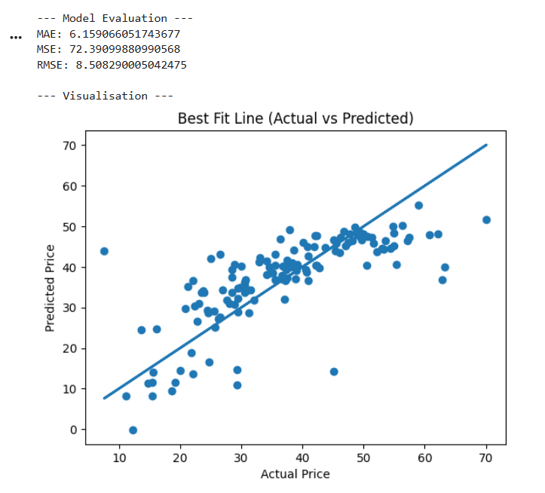

Task No. 2: You are an HR manager at a tech company tasked with developing a salary prediction model to assist in determining appropriate compensation for new hires and promotions. Your company values transparency and fairness in salary negotiations, and they believe that a data- driven approach will help achieve these goals. You have been provided with a dataset containing information on employees' years of experience and their corresponding salaries. Write a python program on the given dataset and implement linear regression model to check best fit line and perform following task:
Output:
import numpy as np
import pandas as pd
import matplotlib.pyplot as plt

df = pd.read_csv("salary_Data.csv")
print(df.head())
print(df.info())
print(df.describe())
print(df.isnull().sum())

X = df[['YearsExperience']]
y = df['Salary']

from sklearn.model_selection import train_test_split
X_train, X_test, y_train, y_test = train_test_split(X, y, test_size=0.33, random_state=42)

from sklearn.linear_model import LinearRegression
model = LinearRegression()
model.fit(X_train, y_train)

predict = model.predict(X_test)

exp = np.array([[7.5]])
predicted_salary = model.predict(exp)
print("\nPredicted Salary for 7.5 years experience:", predicted_salary[0])

from sklearn import metrics

print("\n--- Model Evaluation ---")
print("MAE:", metrics.mean_absolute_error(y_test, predict))
print("MSE:", metrics.mean_squared_error(y_test, predict))

rmse = np.sqrt(metrics.mean_squared_error(y_test, predict))
print("RMSE:", rmse)

print("\n--- Visualisation ---")
plt.scatter(X_test, y_test, color='blue', label='Actual Salary')
plt.plot(X_test, predict, color='red', linewidth=2, label='Best Fit Line')

plt.xlabel("Years of Experience")
plt.ylabel("Salary")
plt.title("Best Fit Line (Experience vs Salary)")
plt.legend()
plt.show()
