RABIA SHAFIQUE-09030003
ASSIGNMENT 3

Question 1.

- Size of full data cube for nominal attributes:

n1=work class 8
n2=Education 16
n3= Marital status has 7
n4= Occupation has 14
n5= Relationship has 6
n6= Race has 5
n7= Sex has 2
n8= native country has 41
n9=Income has 2
Hence size of the full cube is
(8+1)*(16+1)*(7+1)*(14+1)*(6+1)*(5+1)*(2+1)*(41 +1) *(2+1) =291483360
Cardinality of 1 attribute +1 as for calculating all cuboids.

- I1 age, i2 final weight,i3 education #, i4 capital gain, i5 capital loss,i6 hours per week
Aggregate functions with meaningful results are given in table:-

Attributes | Average | Minimum | Maximum | Count | Mode | Median
Age: | 53.014 | 17 | 90 |  | 69 | 53
Final weight: | 196528.765 | 12285.0 | 1484705.0 |  | 51201.0
Education#: |  | 1 | 16 | 16 | 15
Capital gain: | 6782.9832 | 0.0 | 99999.0 |  | 0 | 3471.0
Capital loss: | 1889.11956 | 0.0 | 4356.0 |  | 1735.0
Hours per week: | 48.4575 | 1 | 99 |  | 15 | 47.5

Count aggregate function tells about no. of distinct values of any attribute.
Checking ignore_missing box doesn’t effect on result as it will ignore missing values, whereas unchecking ignore_missing by using Rapid miner Aggregate function it will not count and showing missing ? value for such attributes that having missing values.
d)
No, Aggregation Operator doesn’t generate full data cube.
Explanation: Full data cube consist of Apex +all intermediate D’s+ Base Cuboids , It only gives all or apex level or we can generate base by giving certain conditions but at once doesn’t generate full data cube.
e)
Firstly I applied aggregation operator and apply aggregation function count on aggregation attribute n2 and n4 (Education and occupation). And given this value n[2+4] in group by attributes.
Then add Example Filter operator for giving conditions.

For i) > 5 it generates following results where adults are>5 having same education and Occupation.
Some of records are displaying.

 | Education | Occupation | Count(n2) | Count(n4)
1 | Bachelors | Adm-clerical | 679.0 | 506.0
2 | Bachelors | Exec-managerial | 1369.0 | 1369.0
3 | Bachelors | Handlers-cleaners | 50.0 | 50.0
4 | Bachelors | Prof-specialty | 1495.0 | 1495.0
5 | Bachelors | Other-service | 181.0 | 181.0
14 | HS-grad | Adm-clerical | 1898.0 | 1365.0
21 | HS-grad | Transport-moving | 825.0 | 825.0
107 | 7th-8th | Machine-op-inspct | 93.0 | 93.0
108 | 7th-8th | Protective-serv | 9.0 | 9.0
109 | 7th-8th | Priv-house-serv | 8.0 | 8.0
110 | Doctorate | Exec-managerial | 55.0 | 55.0
111 | Doctorate | Prof-specialty | 321.0 | 321.0
112 | Doctorate | Sales | 8.0 | 8.0
116 | Prof-school | Sales | 18.0 | 18.0
117 | Prof-school | Craft-repair | 7.0 | 7.0
118 | Prof-school | Tech-support | 7.0 | 7.0
119 | 5th-6th | Adm-clerical | 36.0 | 6.0
124 | 5th-6th | Transport-moving | 28.0 | 28.0
125 | 5th-6th | Farming-fishing | 36.0 | 36.0
126 | 5th-6th | Machine-op-inspct | 56.0 | 56.0
127 | 5th-6th | Priv-house-serv | 14.0 | 14.0
128 | 10th | Adm-clerical | 140.0 | 38.0
131 | 10th | Prof-specialty | 9.0 | 9.0
132 | 10th | Other-service | 194.0 | 194.0
147 | 1st-4th | Priv-house-serv | 11.0 | 11.0
148 | Preschool | Other-service | 15.0 | 15.0
150 | Preschool | Machine-op-inspct | 11.0 | 11.0
159 | 12th | Farming-fishing | 16.0 | 16.0
160 | 12th | Machine-op-inspct | 35.0 | 35.0
161 | 12th | Protective-serv | 6.0 | 6.0

For ii) > 50
1 | Bachelors | Adm-clerical | 679.0 | 506.0
2 | Bachelors | Exec-managerial | 1369.0 | 1369.0
3 | Bachelors | Prof-specialty | 1495.0 | 1495.0
9 | Bachelors | Machine-op-inspct | 69.0 | 69.0
10 | Bachelors | Tech-support | 230.0 | 230.0
25 | 11th | Handlers-cleaners | 123.0 | 123.0
30 | 11th | Machine-op-inspct | 99.0 | 99.0
31 | Masters | Adm-clerical | 116.0 | 68.0
32 | Masters | Exec-managerial | 501.0 | 501.0
33 | Masters | Prof-specialty | 844.0 | 844.0
34 | Masters | Sales | 134.0 | 134.0
35 | 9th | Other-service | 101.0 | 101.0
36 | 9th | Craft-repair | 96.0 | 96.0
37 | 9th | Machine-op-inspct | 76.0 | 76.0
38 | Some-college | Adm-clerical | 1797.0 | 1281.0
39 | Some-college | Exec-managerial | 879.0 | 879.0
40 | Some-college | Handlers-cleaners | 267.0 | 267.0
41 | Some-college | Prof-specialty | 430.0 | 430.0
42 | Some-college | Other-service | 781.0 | 781.0
43 | Some-college | Sales | 1009.0 | 1009.0
44 | Some-college | Craft-repair | 868.0 | 868.0
45 | Some-college | Transport-moving | 283.0 | 283.0
46 | Some-college | Farming-fishing | 174.0 | 174.0
47 | Some-college | Machine-op-inspct | 310.0 | 310.0
63 | Assoc-voc | Farming-fishing | 52.0 | 52.0
64 | Assoc-voc | Machine-op-inspct | 63.0 | 63.0
65 | Assoc-voc | Tech-support | 126.0 | 126.0
66 | 7th-8th | Other-service | 98.0 | 98.0
67 | 7th-8th | Craft-repair | 116.0 | 116.0
68 | 7th-8th | Transport-moving | 60.0 | 60.0
69 | 7th-8th | Farming-fishing | 70.0 | 70.0
70 | 7th-8th | Machine-op-inspct | 93.0 | 93.0
71 | Doctorate | Exec-managerial | 55.0 | 55.0
72 | Doctorate | Prof-specialty | 321.0 | 321.0
73 | Prof-school | Exec-managerial | 52.0 | 52.0
74 | Prof-school | Prof-specialty | 452.0 | 452.0
75 | 5th-6th | Other-service | 64.0 | 64.0
76 | 5th-6th | Machine-op-inspct | 56.0 | 56.0
77 | 10th | Handlers-cleaners | 71.0 | 71.0
78 | 10th | Other-service | 194.0 | 194.0
82 | 10th | Machine-op-inspct | 101.0 | 101.0
83 | 12th | Other-service | 85.0 | 85.0
84 | 12th | Craft-repair | 58.0 | 58.0

f.
Group by income, education and country and average of age, hours per week and count number of adults

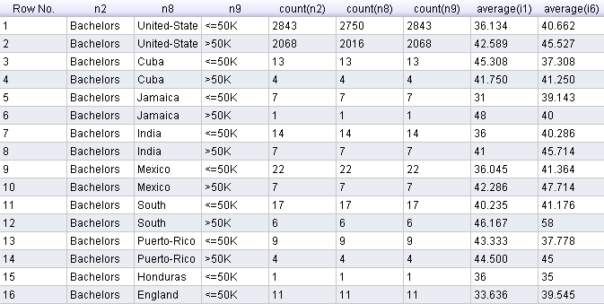
…………………..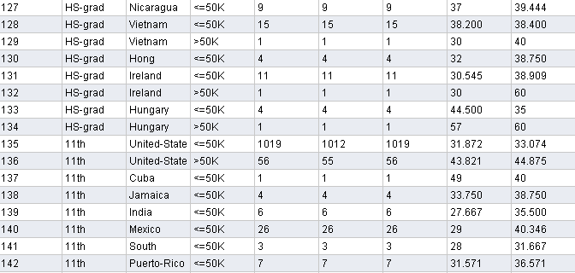
………………
Comments:
- It grouping and counting records of particular education, country and income and count showing the number of adults belonging to same country and having same income or education.
- Showing average age and avg. hours per week of related group.
- Generally number of adults should be same but as there are some missing values while taking count of country that’s why adults counting is differing in some records.

g)
Comments:
- Here data is grouped by sex and country, Adults belongs to same group are together, average i1 and average i6 shows average age and hourse per week respectively. Count showing the number of adults belongs to corresponding group.
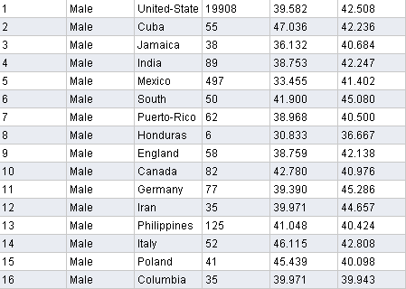
………………………
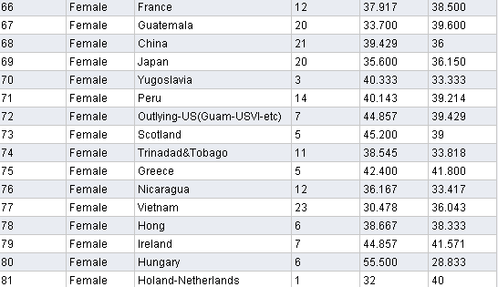

h.)

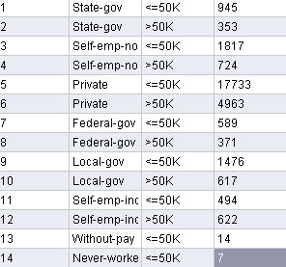

Comments: Adults are grouped having same income and workclass and count showing the number of adults of same group.

