Outlier Detection/Anomaly Detection Survey
Name: Rabia Shafique___E-mail/Roll#/M#: 09030003_________________
Question 1. What is meant by Anomalies/Outliers in general?
Anomilies: The value that occurs very rare, like age=125yrs.
Outliers: Any value that is true and significantly different from rest of values of data.
Question 2. How can u differentiate between Outlier and Noise?

Question 3 What are the reasons for outliers?

Question 4. Do we always want to remove outliers or they can be useful in some cases? Give an example.

Question 2. How would you map anomalies from a general to a specific definition focusing onto a particular domain? Map to any domain of your interest (e.g. Health, fraud, Image, industry etc. ).

Question 3. Whenever an AD problem (domain- specific) presented to you, what steps would you follow to resolve the problem?

Question 4. How important is the domain knowledge in Anomaly detection practical problems?
{ Give rank # from least(1) to most (10)}

Question 5. What steps would you follow to analyze the domain data on the basis of domain knowledge?

Question 6. What would be the selection/rejection criterion for the available Algorithms to solve an AD problem in your domain of interest?

Question 7. What would you do if an Algorithm with desired output is not available for your domain?
Consider Computer Intrusion detection or Outbreak Detection in the city in which data is online and may be coming in streaming fashion. Or u can take any example of your choice.

Question 8. By learning all the algorithms in a traditional way, can you expect from yourself as a learner to efficiently select some of them for a given problem.( NO/YES )
Question 9. What is the reason for above answer?

Question 10. What problems/difficulties would a learner face while mapping general concepts of AD and selection of desired algorithm to a domain specific problem?

Question 11. What methodology should be adopted to enhance the understanding for AD related practical problems? (Any suggestion with reasoning)

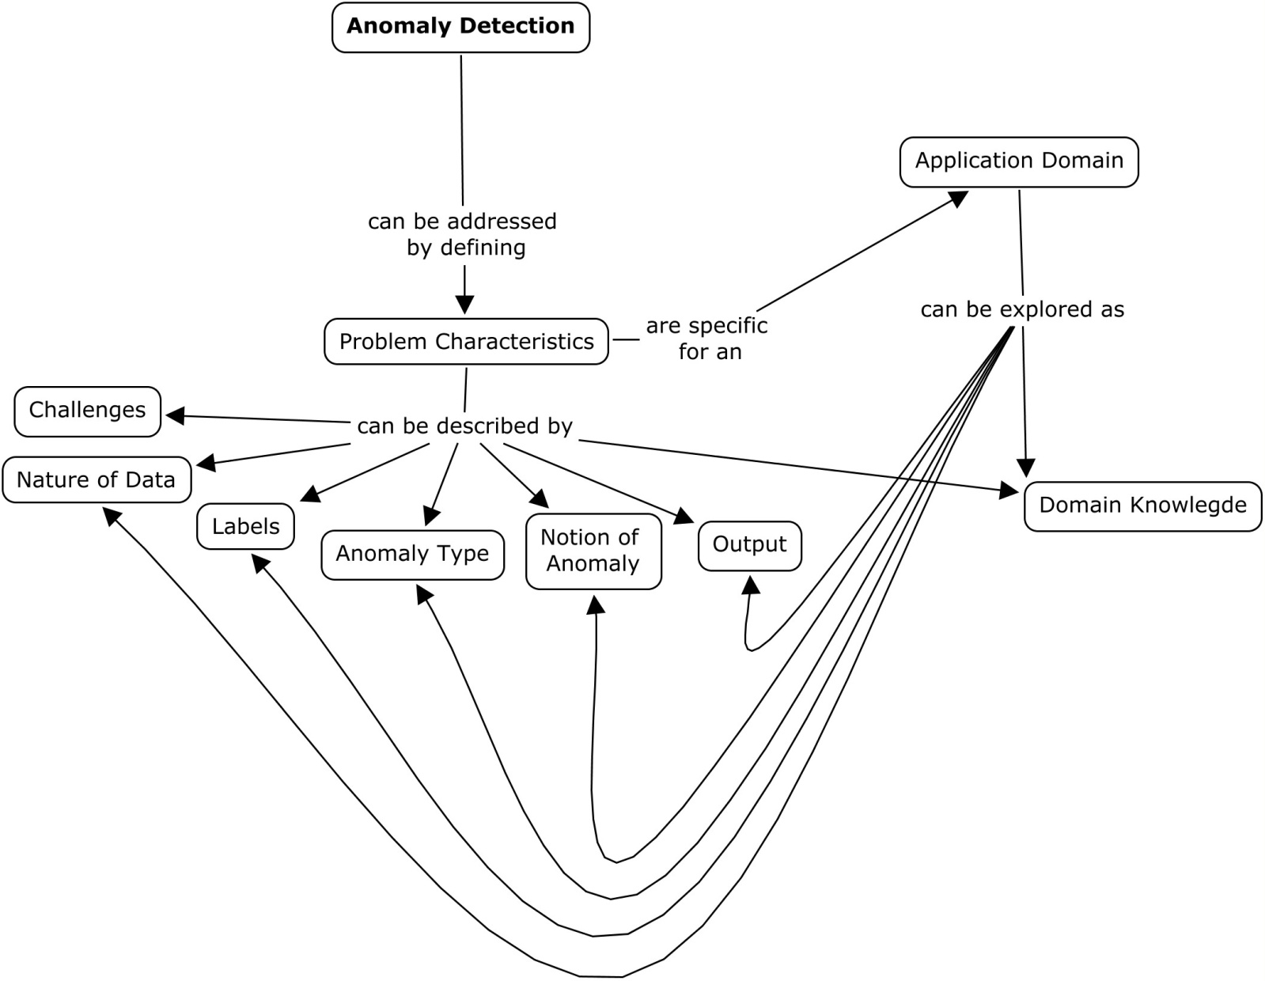
Question 12. Point out if anything is missing in the above concept map for AD.

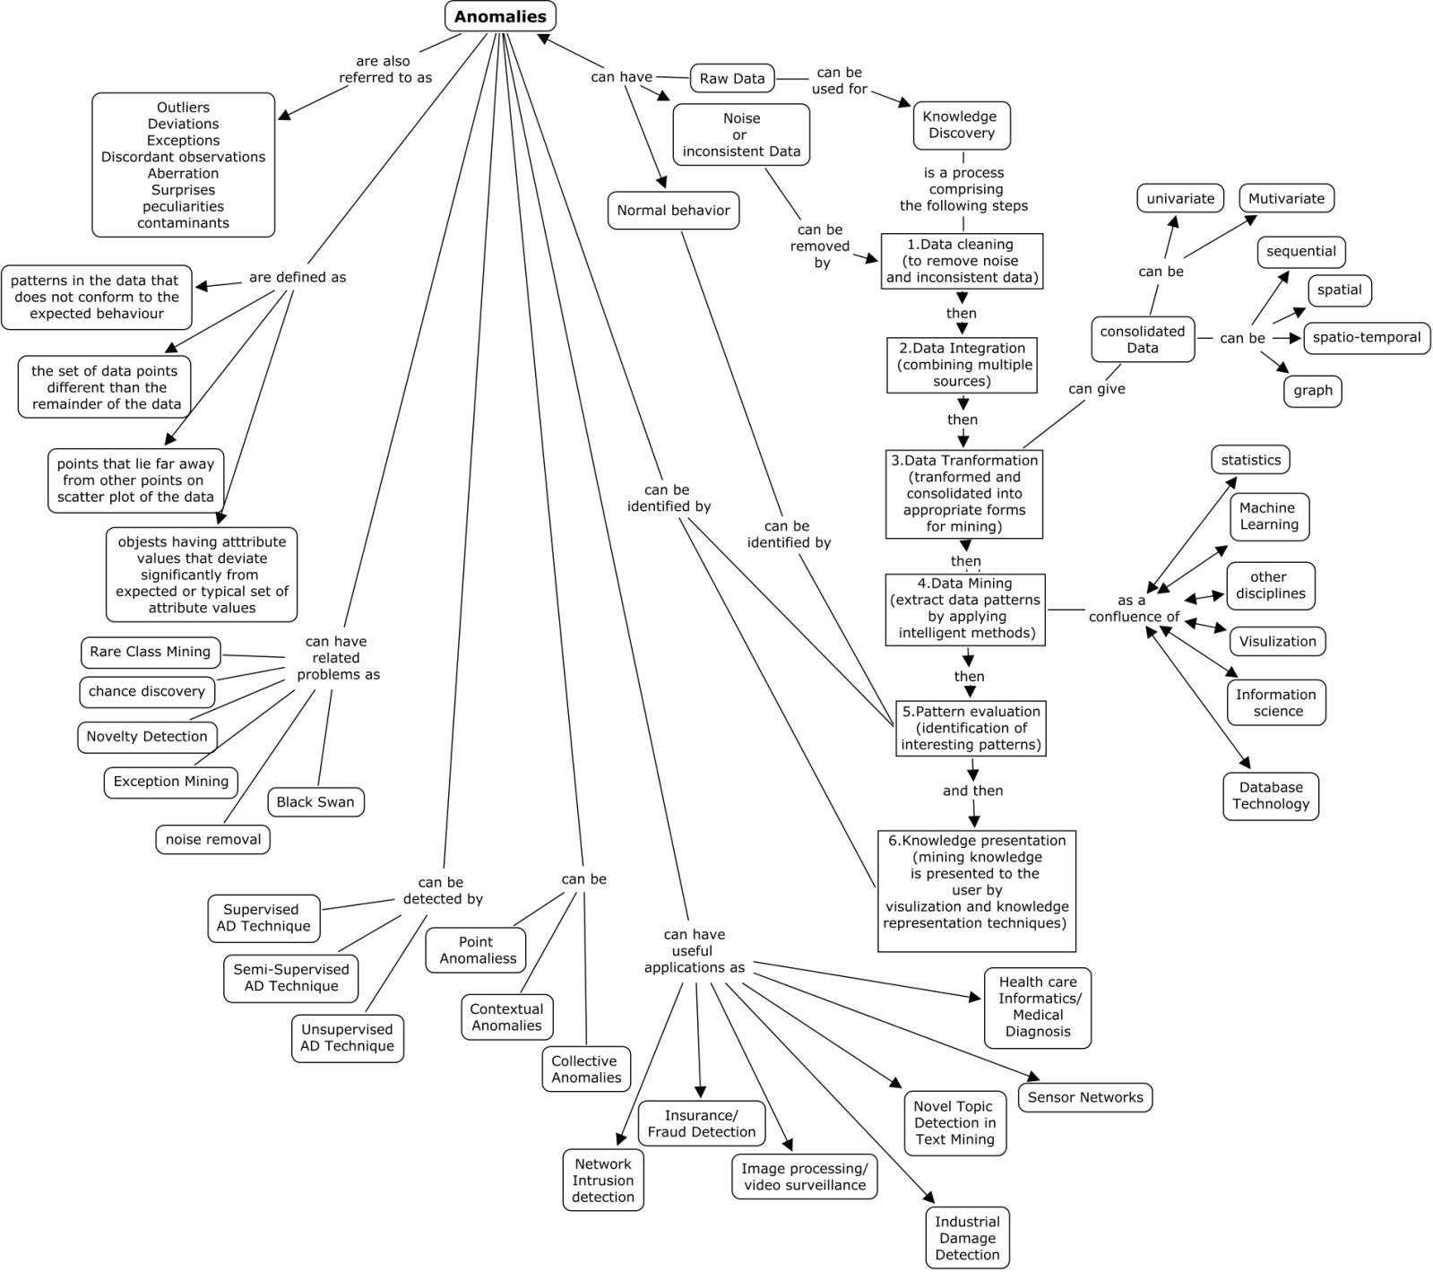

Question 13. Do u think the above knowledge is enough for solving any new emerging AD problem? Please give reason for your answer.

