
Shaukat Khanum Memorial Hospital
Final Report
Rabia Shafique (09030003) & Mehar un Nisa (09030008)
05/21/2010

Table of Contents

1 Data Analysis 2
1.1 MRNO 3
1.2 REGISTRATION_DATE 3
1.3 DOB 3
1.4 FIRST_VISIT_DATE 3
1.5 AGE_AT_PRESENTATION 3
1.6 SEX 3
1.7 TEHSIL 3
1.8 DISTRICT 3
1.9 PROVINCE 4
1.10 COUNTRY 4
1.11 MARITAL_STATUS 4
1.12 OCCUPATION 4
1.13 RELATION 4
1.14 FAMILY_HISTORY_ICD 4
1.15 FAMILY_HISTORY_ICD_DESC 4
1.16 ADDICTION 4
1.17 PREVIOUS_TREATMENT 5
1.18 VALID_BASIS_OF_DIAGNOSIS 5
1.19 DIAGNOSIS_AT_SKM 5
1.20 DEFINITIVE_DIAGNOSIS_INSTITUTE 5
1.21 ICDO_3_DATE 5
1.22 ORGAN 5
1.23 SUBSITE 5
1.24 MORPHOLOGY 5
1.25 GRADE 6
1.26 LATERALITY 6
1.27 TUMOR_SIZE 6
1.28 REGIONAL_LYMPH_NODE_EXAMINED 6
1.29 REGIONAL_LYMPH_NODE_POSITIVE 6
1.30 SURGICAL_MARGINS 6
1.31 CLINICAL_STAGE 7
1.32 COMMENTS_CLNICAL 7
1.33 PATHOLOGICAL_STAGE 7
1.34 COMMENTS_PATHOLOGICAL 7
1.35 SEER_SUMMARY_STAGE 7
1.36 FIRST_TREATMENT_DATE 7
1.37 FIRST_TREATMENT_ICD 7
1.38 FIRST_TREATMENT_ICD_DESC 7
1.39 DATE_OF_DEATH 8
1.40 A_DEATH_CAUSE 8
1.41 CLASS_OF_CASE 8
2 Data Statistics 9
2.1 Basic Statistics 9
2.1.1 Comments 10
2.2 Correlation Matrix 10
2.2.1 Comments on Results 13
2.3 Covariance Matrix 14
2.3.1 Comments 15
3 Frequent item set Mining 16
3.1 Need for mining frequent item sets 16
3.1.1 Minimum Support: .005 16
3.1.2 Min Support: 1.0 23
4 Cluster Analysis 31
4.1 Overall Analysis 31
4.2 Detail Analysis 32
4.2.1 Cluster 1 32
4.2.2 Cluster 2 33
4.2.3 Cluster 3 34
4.2.4 Cluster 4 35
4.2.5 Cluster 5 36
5 References 39
6 Appendix A 40
7 Appendix B 46

Data Analysis
The following data analysis of the dataset is for the year 2004-2008. This analysis includes the values of different attributes and the amount of missing values for each attribute.

MRNO
MRNO stands for Medical Record Number. It’s an integer value and is unique for every patient. Every patient must have one MRNO. There are no missing values for this attribute in the data.

REGISTRATION_DATE
It’s a date on which a patient is registered with SKM. There are no missing values for this attribute in the data. This attribute has a nominal value.

DOB
It’s a date on which a patient is born. There are no missing values for this attribute in the data. This attribute has a nominal value.

FIRST_VISIT_DATE
It’s a date on which a patient has first visited to SKM. There are no missing values for this attribute in the data. This attribute has a nominal value.

AGE_AT_PRESENTATION
This attribute shows the age of the patient. There are no missing values for this attribute in the data. This attribute has a nominal value.

SEX
This attribute shows the gender of the patient. There are no missing values for this attribute in the data. This attribute has a nominal value.

TEHSIL
This attribute shows the Tehsil from which the patient belongs to. There are 675 missing values for this attribute in the data. This attribute has a nominal value.

DISTRICT
This attribute shows the District from which the patient belongs to. There are 675 missing values for this attribute in the data. This attribute has a nominal value.

PROVINCE
This attribute shows the Province from which the patient belongs to. There are 675 missing values for this attribute in the data. This attribute has a nominal value.

COUNTRY
This attribute shows the Country from which the patient belongs to. There are no missing values for this attribute in the data. This attribute has a nominal value.

MARITAL_STATUS
This attribute shows the Marital status of a patient. There are no missing values for this attribute in the data. This attribute has a nominal value.

OCCUPATION
This attribute shows the occupation of a patient. There are 223 missing values for this attribute in the data. This attribute has a nominal value.

RELATION
This attribute shows those relations of a patient who have diagnosed cancer in them. There are 53749 missing values for this attribute in the data which means that these patients didn’t have anyone in family with cancer. This attribute has a nominal value.

FAMILY_HISTORY_ICD
This attribute shows the ICD(International code for disease) of those relations of a patient who have diagnosed cancer in them. There are 53700 missing values for this attribute in the data. This attribute has a real value.

FAMILY_HISTORY_ICD_DESC
This attribute shows the description of the ICD(International code for disease) of those relations of a patient who have diagnosed cancer in them. There are 53700 missing values for this attribute in the data. This attribute has a Nominal value.

ADDICTION
This attribute shows those addictive substances to which a patient is addicted to. There are 16 missing values for this attribute in the data. This attribute has a nominal value.

PREVIOUS_TREATMENT
This attribute shows the previous treatments that a patient has taken. There are 194 missing values for this attribute in the data. This attribute has a nominal value.

VALID_BASIS_OF_DIAGNOSIS
This attribute shows the procedure through which cancer was diagnosed in the patient. There are 29584 missing values for this attribute in the data. This attribute has a nominal value.

DIAGNOSIS_AT_SKM
This attribute shows that whether cancer of a particular patient was diagnosed in SKM. There are 1495 missing values for this attribute in the data. This attribute has a nominal value.

DEFINITIVE_DIAGNOSIS_INSTITUTE
This attribute shows that the institute in which a cancer was diagnosed in the patient. There are 35840 missing values for this attribute in the data. This attribute has a nominal value.

ICDO_3_DATE
This attribute shows the date for the ICDO-3 of a patient. There are 149 missing values for this attribute in the data. This attribute has a nominal value.

ORGAN
This attribute shows the organ in which a patient has cancer. There are no missing values for this attribute in the data. This attribute has a nominal value.

SUBSITE
This attribute shows a little detail about the organ in which a patient has cancer. There are no missing values for this attribute in the data. This attribute has a nominal value.

MORPHOLOGY
The morphology of a cancer refers to the histological classification of the cancer tissue (histopathological type) and a description of the course of development that a tumour is likely to take: benign or malig0t (behaviour). The designation is based on a microscopic diagnosis of morphology by the pathologist (Esteban, Whelan, Laudico & Parkin 1995).[1]

This attribute shows the morphology of the cancer and there are 4 missing values for this attribute. This attribute has a nominal value.

GRADE
The grade is a system used to classify cancer cells in terms of how abnormal they look under a microscope and how quickly the tumor is likely to grow and spread.[2]

This attribute shows the grade of the cancer of a particular patient. There are 28607 missing values for this attribute. This attribute has a nominal value.

LATERALITY
This attribute shows on which side of the organ a patient has cancer. There are 2321 missing values for this attribute. This attribute has a nominal value.

TUMOR_SIZE
This attribute shows the tumor size of the cancer of a particular patient. There are 21276 missing values for this attribute. This attribute has an integer value.

REGIONAL_LYMPH_NODE_EXAMINED
A regional lymph node is a lymph node that drains lymph from the region around a tumour.

This attribute shows the number of lymph nodes examined in a particular patient. There are 21671 missing values for this attribute. This attribute has an integer value.

REGIONAL_LYMPH_NODE_POSITIVE

The total number of regional lymph nodes examined by a pathologist and reported as containing tumour.

This attribute shows the number of Regional lymph nodes positive in a particular patient. There are 21681 missing values for this attribute. This attribute has an integer value.

SURGICAL_MARGINS
Surgical margin in a surgery reports define the visible margin or free edge of "normal" tissue seen by the surgeon with the naked eye. Surgical margin as read in a pathology report define the histological measurement of normal or unaffected tissue surrounding the visible tumour under a microscope on a glass mounted histology section. A "narrow" surgical margin implies that the tumour exists very close to the surgical margin, and a "wide" surgical margin implies the tumour exists far from the cut edge or the surgical margin.

There are 22498 missing values for this attribute. This attribute has integer values.

CLINICAL_STAGE
Cancer stage refers to the extent or severity of the cancer, based on factors such as the location of the primary tumor, tumor size, number of tumors, and lymph node involvement (spread of cancer into lymph nodes).

There are 16107 missing values for this attribute and has nominal values.

COMMENTS_CLNICAL
This attribute shows the comments on the value of the previous attribute. There are 50764 missing values for this attribute and takes nominal values only.

PATHOLOGICAL_STAGE
Pathology is the study and diagnosis of disease through examination of organs, tissues, bodily fluids, and whole bodies (autopsies). Pathology also encompasses the related scientific study of disease processes, called general pathology.[3]

This attribute has 56053 missing values and takes nominal data only.

COMMENTS_PATHOLOGICAL
This attribute shows the comments on the value of the previous attribute. There are 56476 missing values for this attribute and takes nominal values only.

SEER_SUMMARY_STAGE
This attribute shows the comments on the value of the stage attribute. There are no missing values for this attribute and takes nominal values only.

FIRST_TREATMENT_DATE
This attribute shows the date for the first treatment of a particular patient. There are 9576 missing values for this attribute and takes nominal values only.

FIRST_TREATMENT_ICD
This attribute shows the ICD of a patient on date for his/her first treatment. There are 9546 missing values for this attribute and takes nominal values only.

FIRST_TREATMENT_ICD_DESC
This attribute shows the ICD description of the previous attribute. There are 9546 missing values for this attribute and takes nominal values only.

DATE_OF_DEATH
This attribute shows the date on which a particular patient died. There are 55531 missing values for this attribute and takes nominal values only.

A_DEATH_CAUSE
This attribute shows the cause of death of a particular patient. There are 55561 missing values for this attribute and takes nominal values only.

CLASS_OF_CASE
This attribute shows the class of cancer for a particular patient. There are 19650 missing values for this attribute and takes nominal values only.

Data Statistics
This section shows the results of different statistics applied on the dataset. The results are shown in the tabular form and are commented also.

Basic Statistics

Following is the analysis of data with respect to the value type, min, max, mean, standard deviation and mode of each attribute.

Attribute | Value Type | Min | Max | Mean | Standard Deviation | Mode
MRNO | Integer |  |  | 57015.78 | 10991.03
Registration_Date | Nominal |  |  |  |  | 19 09 2005 03:04:00
DOB | Nominal |  |  |  |  | 01-Jan-1960
First_Visit_Date | Nominal |  |  |  |  | 16-Jun-2008
Age_At_Presentation | Nominal |  |  |  |  | 50 Years
Sex | Nominal |  |  |  |  | Female
Tehsil | Nominal |  |  |  |  | Lahore
District | Nominal |  |  |  |  | Lahore
Province | Nominal |  |  |  |  | Punjab
Country | Nominal |  |  |  |  | Pakistan
Mrital_Status | Nominal |  |  |  |  | Married
Occupation | Nominal |  |  |  |  | HouseWife
Relation | Nominal |  |  |  |  | Mother
Family_History_ICD | Numerical | 15 | 239 | 175.591 | 17.48
Family_History_ICD_Desc | Nominal |  |  |  |  | neoplasm of breast (female), unspecified site
Addiction | Nominal |  |  |  |  | No
Previous_Treatment | Nominal
Valid_Basis_of_Diagnosis | Nominal |  |  |  |  | Pathology
Diagnosis_At_SKM | Nominal |  |  |  |  | Yes
Definitive_Diagnosis_Institute | Nominal |  |  |  |  | Unknown
ICDO_3_Date | Nominal |  |  |  |  | 15-Jun-2006
Organ | Nominal |  |  |  |  | Breast
Subsite | Nominal |  |  |  |  | Breast, NOS
Morphology | Nominal |  |  |  |  | Infiltrating Duct Carcinoma
Grade | Nominal |  |  |  |  | III
Laterality | Nominal |  |  |  |  | No
Tumor_Size | Numerical | 0 | 999 | 531.12 | 475.36
Regional_Lymph_Node_Examined | Numerical | 0 | 99 | 33.52 | 42.22
Regional_Lymph_Node_Positive | Numerical | 0 | 99 | 67.17 | 44.51
Surgical_Margins | Nominal | 0 | 6 | 3.46 | 2.57
Clinical_Stage | Nominal |  |  |  |  | Stage IV Any T Any N M1
Comments_Clinical | Nominal |  |  |  |  | Unstageable
Pathological_Stage | Nominal |  |  |  |  | Stage IIA T2 N0 M0
Comments_Pathological | Nominal |  |  |  |  | T2N2aMx
Seer_Summary_Stage | Nominal |  |  |  |  | Local
First_Treatment_Date | Nominal |  |  |  |  | 24-Dec-2008
First_Treatment_ICD | Nominal |  |  |  |  | V58.0
First_Treatment_ICD_Decs | Nominal |  |  |  |  | Radiotharapy
Date_Of_Death | Nominal |  |  |  |  | 01 01 2010 11:30:00
A_Death_Cause | Nominal |  |  |  |  | cardiopulmonary arrest
Class_Of_Death | Nominal |  |  |  |  | Class 1

Comments

- Mostly patients diagnosed at 50 years old and belong to city Lahore.
- Female cancer patients are more than males and cancer organ is breast.
- Mostly diagnosis at Shaukat Khanam hospital.
- Mostly basis of Diagnosis is pathological.
- Min size for tumour is 0 and it goes at maximum 999.
- Mostly class of death cases are of class1.

Correlation Matrix

Following are the results of correlation of each attribute. Since it is lot of data and it is difficult to show the correlation in the form of matrix, we have shown the correlation as follows.

First Attribute | Second Attribute | Correlation
REGISTRATION_DATE | DOB | 0.68
REGISTRATION_DATE | FIRST_VISIT_DATE | 1.00
REGISTRATION_DATE | AGE_AT_PRESENTATION | 0.04
REGISTRATION_DATE | TEHSIL | 0.06
REGISTRATION_DATE | DISTRICT | 0.04
REGISTRATION_DATE | COUNTRY | 0.04
REGISTRATION_DATE | MARITAL_STATUS | 0.03
REGISTRATION_DATE | OCCUPATION | 0.14
REGISTRATION_DATE | RELATION | 0.04
REGISTRATION_DATE | FAMILY_HISTORY_ICD | 0.07
REGISTRATION_DATE | DIAGNOSIS_AT_SKM | 0.09
REGISTRATION_DATE | DEFINITIVE_DIAGNOSIS_INSTITUTE | 0.51
REGISTRATION_DATE | ICDO_3_DATE | 0.92
REGISTRATION_DATE | SUBSITE | 0.02
REGISTRATION_DATE | MORPHOLOGY | 0.07
REGISTRATION_DATE | LATERALITY | 0.01
REGISTRATION_DATE | TUMOR_SIZE | 0.02
REGISTRATION_DATE | REGIONAL_LYMPH_NODE_POSITIVE | 0.02
REGISTRATION_DATE | CLINICAL_STAGE | 0.04
REGISTRATION_DATE | COMMENTS_CLNICAL | 0.55
REGISTRATION_DATE | PATHOLOGICAL_STAGE | 0.13
REGISTRATION_DATE | COMMENTS_PATHOLOGICAL | 0.67
REGISTRATION_DATE | SEER_SUMMARY_STAGE | 0.24
REGISTRATION_DATE | FIRST_TREATMENT_DATE | 0.93
REGISTRATION_DATE | FIRST_TREATMENT_ICD | 0.34
REGISTRATION_DATE | FIRST_TREATMENT_ICD_DESC | 0.34
REGISTRATION_DATE | DATE_OF_DEATH | 0.99
REGISTRATION_DATE | A_DEATH_CAUSE | 0.67
REGISTRATION_DATE | CLASS_OF_CASE | 0.05
DOB | FIRST_VISIT_DATE | 0.68
DOB | AGE_AT_PRESENTATION | 0.04
DOB | TEHSIL | 0.03
DOB | DISTRICT | 0.02
DOB | COUNTRY | 0.04
DOB | MARITAL_STATUS | 0.07
DOB | OCCUPATION | 0.10
DOB | RELATION | 0.06
DOB | FAMILY_HISTORY_ICD | 0.05
DOB | FAMILY_HISTORY_ICD_DESC | 0.06
DOB | DIAGNOSIS_AT_SKM | 0.06
DOB | DEFINITIVE_DIAGNOSIS_INSTITUTE | 0.35
DOB | ICDO_3_DATE | 0.63
DOB | SUBSITE | 0.01
DOB | MORPHOLOGY | 0.08
DOB | TUMOR_SIZE | 0.04
DOB | REGIONAL_LYMPH_NODE_POSITIVE | 0.02
DOB | CLINICAL_STAGE | 0.03
DOB | COMMENTS_CLNICAL | 0.27
DOB | PATHOLOGICAL_STAGE | 0.08
DOB | COMMENTS_PATHOLOGICAL | 0.10
DOB | SEER_SUMMARY_STAGE | 0.17
DOB | FIRST_TREATMENT_DATE | 0.64
DOB | FIRST_TREATMENT_ICD | 0.22
DOB | DATE_OF_DEATH | 0.74
DOB | A_DEATH_CAUSE | 0.43
DOB | CLASS_OF_CASE | 0.03
FIRST_VISIT_DATE | AGE_AT_PRESENTATION | 0.04
FIRST_VISIT_DATE | TEHSIL | 0.06
FIRST_VISIT_DATE | COUNTRY | 0.04
FIRST_VISIT_DATE | MARITAL_STATUS | 0.03
FIRST_VISIT_DATE | OCCUPATION | 0.14
FIRST_VISIT_DATE | RELATION | 0.03
FIRST_VISIT_DATE | FAMILY_HISTORY_ICD | 0.07
FIRST_VISIT_DATE | DIAGNOSIS_AT_SKM | 0.09
FIRST_VISIT_DATE | DEFINITIVE_DIAGNOSIS_INSTITUTE | 0.51
FIRST_VISIT_DATE | ICDO_3_DATE | 0.93
FIRST_VISIT_DATE | SUBSITE | 0.02
FIRST_VISIT_DATE | MORPHOLOGY | 0.07
FIRST_VISIT_DATE | COMMENTS_CLNICAL | 0.53
FIRST_VISIT_DATE | PATHOLOGICAL_STAGE | 0.14
FIRST_VISIT_DATE | COMMENTS_PATHOLOGICAL | 0.66
FIRST_VISIT_DATE | SEER_SUMMARY_STAGE | 0.24
FIRST_VISIT_DATE | FIRST_TREATMENT_DATE | 0.93
FIRST_VISIT_DATE | DATE_OF_DEATH | 0.99
FIRST_VISIT_DATE | A_DEATH_CAUSE | 0.65
TEHSIL | DISTRICT | 0.70
DEFINITIVE_DIAGNOSIS_INSTITUTE | COMMENTS_PATHOLOGICAL | 0.27
DEFINITIVE_DIAGNOSIS_INSTITUTE | FIRST_TREATMENT_DATE | 0.52
DEFINITIVE_DIAGNOSIS_INSTITUTE | FIRST_TREATMENT_ICD | 0.18
DEFINITIVE_DIAGNOSIS_INSTITUTE | DATE_OF_DEATH | 0.59
DEFINITIVE_DIAGNOSIS_INSTITUTE | A_DEATH_CAUSE | 0.47
ICDO_3_DATE | COMMENTS_CLNICAL | 0.37
ICDO_3_DATE | COMMENTS_PATHOLOGICAL | 0.49
ICDO_3_DATE | SEER_SUMMARY_STAGE | 0.25
ICDO_3_DATE | FIRST_TREATMENT_DATE | 0.88
ICDO_3_DATE | FIRST_TREATMENT_ICD | 0.30
ICDO_3_DATE | DATE_OF_DEATH | 0.92
ICDO_3_DATE | A_DEATH_CAUSE | 0.61
MORPHOLOGY | PATHOLOGICAL_STAGE | 0.23
GRADE | REGIONAL_LYMPH_NODE_POSITIVE | 0.15
GRADE | SURGICAL_MARGINS | 0.12
TUMOR_SIZE | REGIONAL_LYMPH_NODE_EXAMINED | 0.22
TUMOR_SIZE | REGIONAL_LYMPH_NODE_POSITIVE | 0.48
TUMOR_SIZE | SURGICAL_MARGINS | 0.50
REGIONAL_LYMPH_NODE_EXAMINED | CLASS_OF_CASE | 0.04
REGIONAL_LYMPH_NODE_POSITIVE | SURGICAL_MARGINS | 0.73
REGIONAL_LYMPH_NODE_POSITIVE | PATHOLOGICAL_STAGE | 0.27
REGIONAL_LYMPH_NODE_POSITIVE | FIRST_TREATMENT_ICD | 0.05
SURGICAL_MARGINS | PATHOLOGICAL_STAGE | 0.22
COMMENTS_CLNICAL | COMMENTS_PATHOLOGICAL | 0.71
COMMENTS_CLNICAL | SEER_SUMMARY_STAGE | 0.10
COMMENTS_CLNICAL | FIRST_TREATMENT_DATE | 0.52
COMMENTS_CLNICAL | FIRST_TREATMENT_ICD | 0.18
COMMENTS_CLNICAL | DATE_OF_DEATH | 0.51
COMMENTS_CLNICAL | A_DEATH_CAUSE | 0.38
COMMENTS_CLNICAL | CLASS_OF_CASE | 0.06
PATHOLOGICAL_STAGE | COMMENTS_PATHOLOGICAL | 0.08
PATHOLOGICAL_STAGE | DATE_OF_DEATH | 0.22
COMMENTS_PATHOLOGICAL | FIRST_TREATMENT_DATE | 0.44
COMMENTS_PATHOLOGICAL | DATE_OF_DEATH | 0.61
COMMENTS_PATHOLOGICAL | A_DEATH_CAUSE | 0.47
SEER_SUMMARY_STAGE | FIRST_TREATMENT_DATE | 0.28
SEER_SUMMARY_STAGE | DATE_OF_DEATH | 0.24
SEER_SUMMARY_STAGE | A_DEATH_CAUSE | 0.22
FIRST_TREATMENT_DATE | FIRST_TREATMENT_ICD_DESC | 0.31
FIRST_TREATMENT_DATE | DATE_OF_DEATH | 0.93
FIRST_TREATMENT_DATE | A_DEATH_CAUSE | 0.61
FIRST_TREATMENT_ICD | FIRST_TREATMENT_ICD_DESC | 1.00
FIRST_TREATMENT_ICD | DATE_OF_DEATH | 0.41
DATE_OF_DEATH | A_DEATH_CAUSE | 0.64

Comments on Results

- Registration date and date-of-death, First treatment date, death-cause are strongly dependent and correlated attributes.
- ICDO, seer summary stage, occupation, pathological stage, family history ICD, Morphology, country and district with Registration date are positively correlated whereas surgical margins, province and lymph-node are negatively correlated or independent of registration date.
- Date of death and first treatment date strongly correlated with date of birth of patients.
- Date of death depends upon first visit date.
- Sex strongly correlated with Seer summary stage and first treatment date.
- First treatment date and date of death are dependent strongly.
- Tehsil and District are strongly correlated.
- ICDO 3 Date and Date of death are strongly correlated.
- Grade dependent on REGIONAL_LYMPH_NODE_POSITIVE and surgical margins.
- Marital status correlated with lymph node examined, morphology, grade, laterality, tumour size, lymph node positive and surgical margins.
- Tumour size and surgical margins are strongly correlated.
- Comments clinical and comments pathological are strongly correlated.
- Regional lymph node positive and surgical margins are strongly correlated.
- Addiction is positively correlated with surgical margins, lymph node positive, basis of diagnose, pathological stage, grade, subsite, tumour size, clinical stage and seer summary stage.
- Occupation is positively correlated with ICD-date, regional lymph node positive, first treatment date, date of death, tumour size, surgical margins, pathological stage, addiction, first treatment ICD, subsite, morphology, death cause, grade and class of case.

Covariance Matrix

Since it is lot of data and it is difficult to show the covariance in the form of matrix, we have shown the covariance as follows. There were a lot of attributes that having zero covariance (non-linear relationship between them or they were independent), we have removed them. This following table is showing only those attributes that have either positive or negative covariance.

First Attribute | Second Attribute | Covariance
REGISTRATION_DATE | DOB | 10689453.48
REGISTRATION_DATE | AGE_AT_PRESENTATION | 4633.30
REGISTRATION_DATE | SEX | -78.70
REGISTRATION_DATE | COUNTRY | 26.39
REGISTRATION_DATE | MARITAL_STATUS | 82.40
REGISTRATION_DATE | SUBSITE | 4003.95
REGISTRATION_DATE | SEER_SUMMARY_STAGE | 2642.15
DOB | AGE_AT_PRESENTATION | 3126.08
DOB | SEX | -27.81
DOB | COUNTRY | 18.72
DOB | MARITAL_STATUS | 119.03
DOB | SUBSITE | 1360.43
DOB | SEER_SUMMARY_STAGE | 1305.09
AGE_AT_PRESENTATION | SEX | -1.50
AGE_AT_PRESENTATION | COUNTRY | -0.01
AGE_AT_PRESENTATION | MARITAL_STATUS | 1.95
AGE_AT_PRESENTATION | SUBSITE | -5.04
AGE_AT_PRESENTATION | SEER_SUMMARY_STAGE | -2.69
SEX | MARITAL_STATUS | 0.01
SEX | SUBSITE | -2.83
SEX | SEER_SUMMARY_STAGE | 0.11
COUNTRY | SUBSITE | 0.20
COUNTRY | SEER_SUMMARY_STAGE | 0.01
MARITAL_STATUS | SUBSITE | 0.07
MARITAL_STATUS | SEER_SUMMARY_STAGE | -0.04
SUBSITE | SEER_SUMMARY_STAGE | -3.33

Comments

- Registration date and date of birth of patient is strongly related and values of both dates varied together in same direction from their means.
- Registration date have negative covariance or relationship with sex.
- Date of Birth and age at presentation have positive covariance and have strong relationship.
- Registration date have positive covariance with Age at presentation, country, marital status, subsite and seer summary stage.
- Age at presentation have positively related with marital status.
- But negative covariance with sex, country, and subsite and seer summary stage, indicates that higher than average values of one age at presentation tend to be paired with lower than average values of the other attributes.
- Sex has positive covariance with marital status and seer summary stage but negative covariance with subsite.
- Country is positively related with subsite and seer summary stage.
- Marital status is negatively related with subsite and seer summary stage but positively related with subsite and subsite.
- Subsite has negative covariance with seer summary stage.

Frequent item set Mining

Need for mining frequent item sets
Frequent sets play an essential role in many Data Mining tasks that try to find interesting patterns from databases, such as association rules, correlations, sequences, clusters and many more of which the mining of association rules, is one of the most popular problems. The identification of sets of items, objects products, symptoms, characteristics, and so forth that often occur together in the given database of year 2004-2008 is given here.

FP-Growth:

Minimum Support: .005
With this min support we got following result where no. of occurances are > 307.
No. of sets: 165, Total Max size: 4

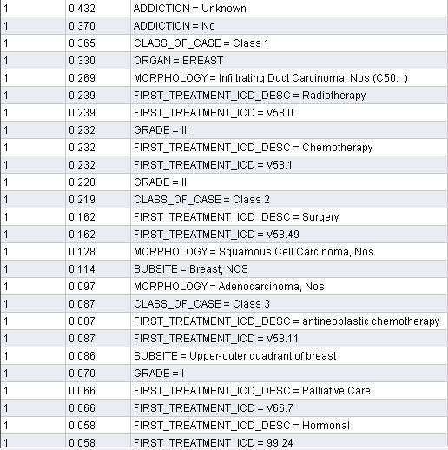

Comments of itemset size 2
- 26352 patients addiction is unknown whereas 22725 patients have no addiction.
- 16521.98 patient’s MORPHOLOGY=infilitrating Duct Carcinoma,Nos
- 14,679 patient’s first treatment ICD Desc is Radiotherapy.
- 14,679 patient’s first treatment ICD is V58.
- 14,249 patient’s Grade is III.
- 14,249 patient’s First treatment ICD Description is Chemotherapy.
- 13,512 Patient’s GRADE=II
- 13,451 patient’s class of case is Class 2.
- 9950 patient’s first treatment ICD Description is Surgery.
- 7862 patient’s MORPHOLOGY=squamous Cell Carcinoma
- 7,002 patient’s subsite is Breast.
- 5,957 patient’s MORPHOLOGY=Adenocarcinoma.
- 5343 patient’s class of case is Class3.
- 5343 patient’s first treatment ICD Description is “antineoplastic chemotherapy”
- 4054 patient’s first treatment ICD Desc is “Palliative Care”.

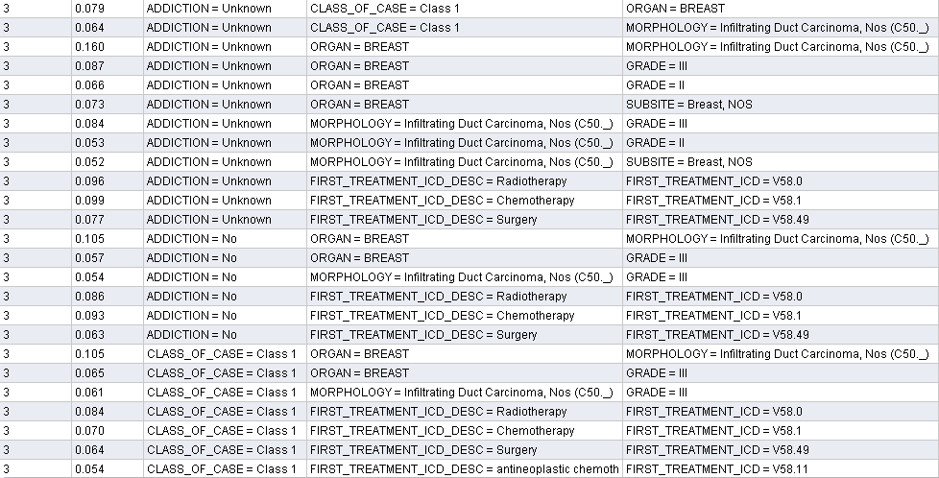

Comments of itemset size 3

- 9336 patient’s class of case is one & addiction cause is not given.
- 12,161 patient’s diagnose cancer in Organ “Breast” & no addiction cause available for them.
- 9,827 patient’s addiction is unknown having Marphology= Inflitrating Duct Carcinoma.
- 4,852 patient’s addiction is unknown, class of case is “Class 1” and organ= “BREAST”
- 5,159 patient’s addiction is unknown, Marphology=” infilitrating Duct Carcinoma,Nos” and GRADE=III
- 3,255 patient’s addiction is unknown, Marphology=” infilitrating Duct Carcinoma,Nos” and GRADE=II.
- 3,194 patient’s addiction is unknown, Marphology=” infilitrating Duct Carcinoma,Nos” and subsite=Breast.
- 5,856 patient’s addiction is unknown, First Treatment ICD Description is “Radiotherapy” and first treatment ICD is V58.0
- 6,080 patient’s addiction is unknown, First Treatment ICD Description is “Chemotherapy” and first treatment ICD is V58.1
- 4,729 patient’s addiction is unknown, First Treatment ICD Description is “Surgery” and first treatment ICD is V58.49
- 5,282 patient’s having no addiction, First Treatment ICD Description is “Radiotherapy” and first treatment ICD is V58.0
- 5,712 diagnosed patient’s having no addiction, First treatment ICD Description is “chemotherapy” and first treatment ICD is V58.1
- 3,869 patient’s having no addiction, First Treatment ICD Description is “Surgery” and first treatment ICD is V58.49
- 3,746 patient’s class of case=class1, Marphology=” infilitrating Duct Carcinoma,Nos” and GRADE=III
- 5,159 patient’s class of case = class1, First Treatment ICD Description is “Radiotherapy” and first treatment ICD is V58.0
- 4,300 patient’s class of case = class1,First Treatment ICD Description is “Chemotherapy” and first treatment ICD is V58.1
- 3,930 patient’s class of case = class1,First Treatment ICD Description is “Surgery” and first treatment ICD is V58.49
- 3,316 patient’s class of case = class1, First Treatment ICD Description is antineoplastic chemotherapy and first treatment ICD is V58.11

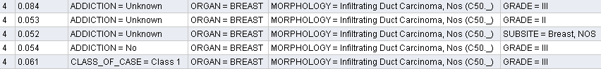

Comments of itemset size 4
- 3930 patient’s addiction is unknown, class of case=class1, organ=BREAST, and Marphology=” infilitrating Duct Carcinoma,Nos”
- 5,159 patient’s addiction is unknown,organ=BREAST, Marphology=” infilitrating Duct Carcinoma,Nos” and GRADE=III
- 3,255 patient’s addiction is unknown,organ=BREAST, and Marphology=” infilitrating Duct Carcinoma,Nos” and GRADE=II
- 3,194 patient’s addiction is unknown,organ=BREAST, and Marphology=” infilitrating Duct Carcinoma,Nos” and SUBSITE=Breast
- 3,3166 patients have no addiction, organ=BREAST, Marphology=” infilitrating Duct Carcinoma,Nos” and GRADE=III
- 3,747 patients Class of case= class 1, Organ=Breast, Marphology=” infilitrating Duct Carcinoma,Nos” and GRADE=III
- 3,747 patients Organ=Breast, Marphology=” infilitrating Duct Carcinoma,Nos” ,First treatment ICD DESC= Radiotherapy and First Treatment ICD is V58.0
- 3,562 patient’s Organ=Breast, Marphology=” infilitrating Duct Carcinoma,Nos” ,First treatment ICD DESC= Chemotherapy and First Treatment ICD is V58.1
- 4,053 patient’s Organ=Breast, Organ=Breast, First treatment ICD DESC= Surgery and First Treatment ICD is V58.49

Association Rules
The purpose of the analysis is to find associations between the attributes of diagnosed patients, i.e., to derive association rules that identify the attributes and co-occurrences of different attributes of patients that appear with the greatest (co-)frequencies

Min Confidence: 0.8 or 80%
Min Support: 0.5 %
Best association rules where confidence 100%. For example If X then (likely) Y where X and Y can be single values items, words, etc., or conjunctions of values, items, words, etc.

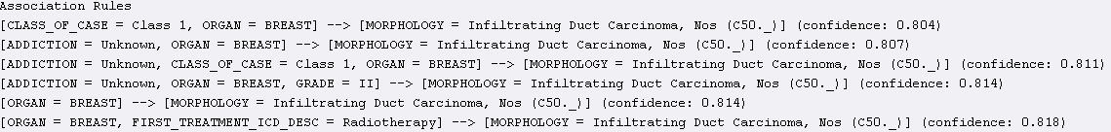
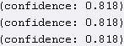

Comments
- 81% confidence if patient’s diagnose cancer in Organ Breast and First treatment ICD Desc is radiotherapy then Morphology is infiltrating duct carcinoma.
- 82% confidence if patient’s diagnosed cancer organ breast, first treatment ICD Desc Radiotherapy then Marophology is infiltrating duct carcinoma First treatment ICD=V58.0
- 83% confidence if patient organ is breast, first treatment ICD Desc is surgery then Morphology is infiltrating duct carcinoma and first treatment ICD is V58.49.
- 84% confidence if patient diagnosed cancer in organ Breast and First treatment ICD Description is Chemotheropy then morphology is infiltrating duct carcinoma and First treatment ICD=V58.1

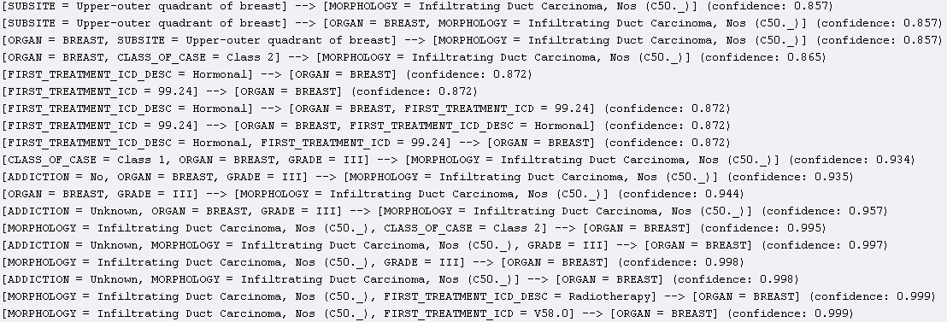

Comments:
- 87% confidence if First treatment ICD=99.24 then organ is breast and first treatment ICD Desc=hormonal.
- 93% confidence if class of case is class1, organ=breast, grade=III then morphology is Infiltrating duct carcinoma.
- 99% confidence if morphology=infiltrating duct, first treatment ICD=V58.0 then Organ is breast.
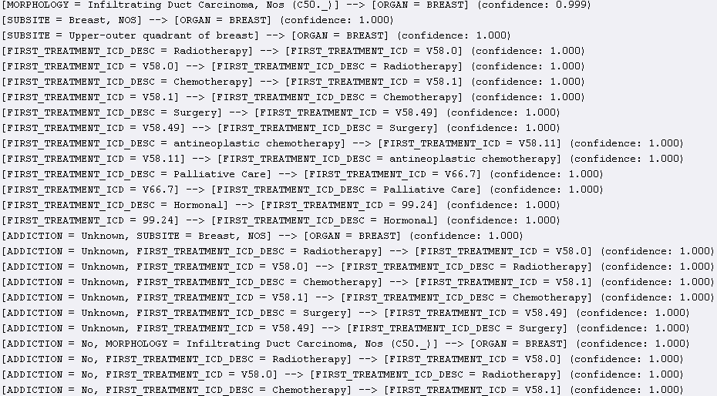

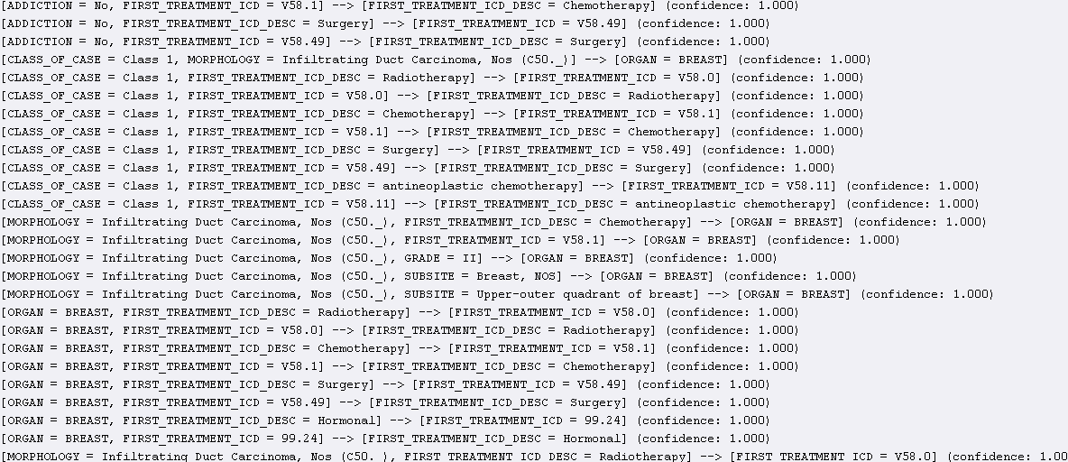

Comments:
- These are best association rules as here confidence is 100% and minimum support is 0.5%.
- Left hand side of rules showing if part and right hand side showing then part means the occurances of attributes with relation of left part of rule.

Minimum Support: 1.0
With this min support we got following result where no. of occurrences are in range 1000- 50000.

No. of sets: 145
Total Max size: 5

- Support value showing the percentage of item in complete dataset records. And size showing combination of item either occurring alone or with combination of others as at most 5 item size would show results of occurrences of 5 items together.

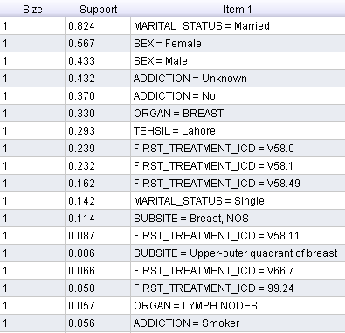

Comments of itemset size 1
- 51000 diagnosed patients out of 62000 are married.
- 8662 patients material status is single.
- 35000 diagnosed patients are female and 26000 are male.
- 20,000 patients effected organ is breast.
- 18000 diagnosed patients belong to tehsil Lahore.
- 3416 patients got cancer due to addiction of smoking.
- 14600 diagnosed patients assigned First_treatment_icd=V58.0
- 14250 patients assigned First_treatment_icd=V58.1
- 1000 patients assigned First_treatment_icd=V58.49
- 5344 patients assigned First_treatment_icd=V58.11
- 4053 patients assigned First_treatment_icd=V66.7
- 3477 patients effected organ is LYMPH NODES.

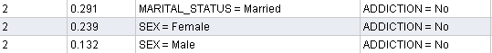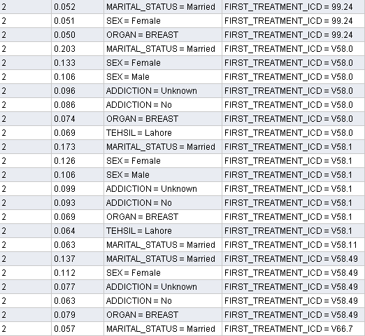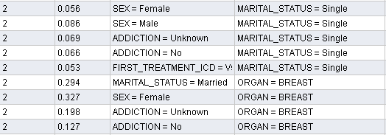

Comments of itemset size 2
- 17751 patients having material status married diagnosed cancer without any addiction.
- 14580 female and 8052 male patients diagnosed cancer without any addiction.
- 3132 female patients have first treatment ICD= 99.24
- 3194 married patients have first treatment ICD= 99.24
- 12,383 married patients have first treatment ICD=V58.0
- 7,686 female patients have first treatment ICD=V58.1
- 6,466 male patients have first treatment ICD= V58.1
- 6,832 female patients have first treatment ICD=V58.49
- 5,426 patients diagnosed cancer without any addiction and assigned first treatment ICD=V58.0
- 3,842 patients diagnosed cancer without any addiction and assigned first treatment ICD=V58.49
- 3,477 married patients assigned first treatment ICD=V66.7
- 3,416 female diagnosed patients are single.
- 5,246 male diagnosed patients are single.
- 200086 female patients diagnosed cancer in organ Breast.

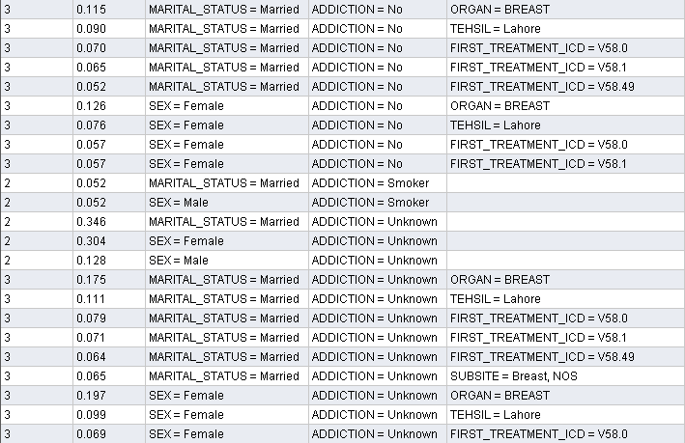

Comments of itemset size 3
- 3172 married patients diagnosed cancer due to addiction of smoking.
- 3172 male diagnosed cancer due to addiction of smoking.
- 4299 married patients got cancer without having any addiction and assigned first treatment ICD=V58.0
- 3194 married patients got cancer without having any addiction and assigned first treatment ICD=V58.49
- 3477 female patients have no addiction and assigned first treatment ICD=V58.1 or ICD=V58.0
- 4697 female married patients diagnosed cancer in upper-outer quadrant of breast.

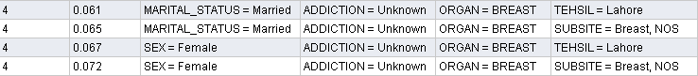

Comment of itemset size 4
- 4392 female patients diagnosed cancer in organ breast and subsite=breast, NOS without any addiction.

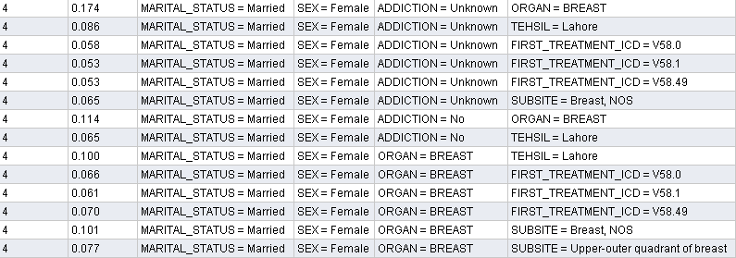
- 4,729 patients are female married, diagnosed cancer in organ Breast in subsite Upper-outer Quadrant of breast
- 6,142 female married patients diagnosed cancer in Breast belongs to Lahore.

Comment of itemset size 5
- 3,685 female married patients diagnosed organ breast belong to tehsil lahore and addiction cause is unknown.

Association Rules

Min. Support 0.95 Minimum confidence 0.9

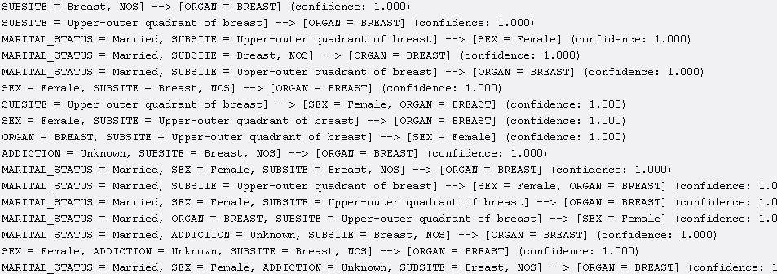
Comments:
- These are best association rules as here minimum confidence is 90% and minimum support is 95%.
- Left hand side of rules showing if part and right hand side showing then part means the occurances of attributes with relation of left part of rule.

Minimum Support 0.95
Min. Confidence 0.8

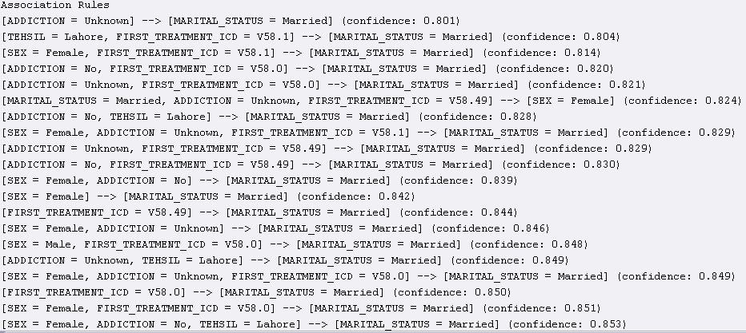

Comments:
- These are best association rules as here minimum confidence is 80% and minimum support is 95%.
- Left hand side of rules showing if part and right hand side showing then part means the occurances of attributes with relation of left part of rule.

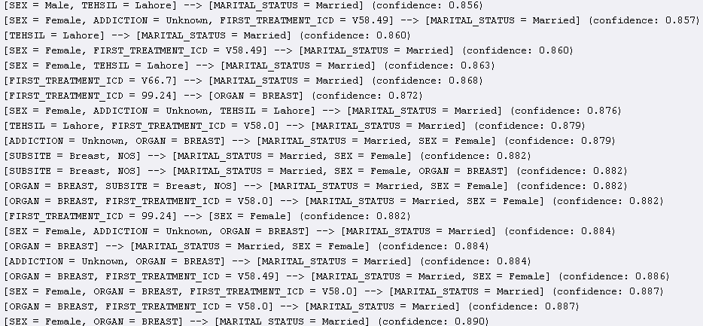

Comments:

- The above rules association is 85% to 89%.
- Left hand side of rules showing if part and right hand side showing then part means the occurances of attributes with relation of left part of rule.

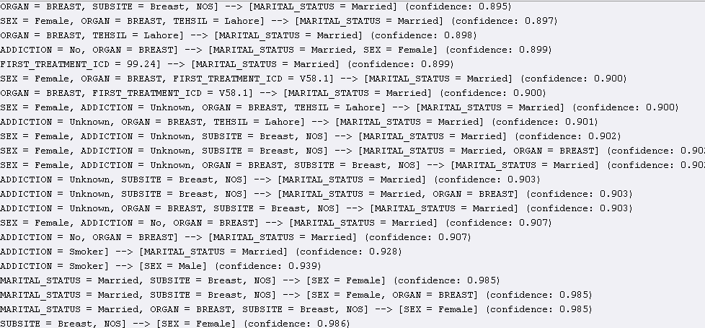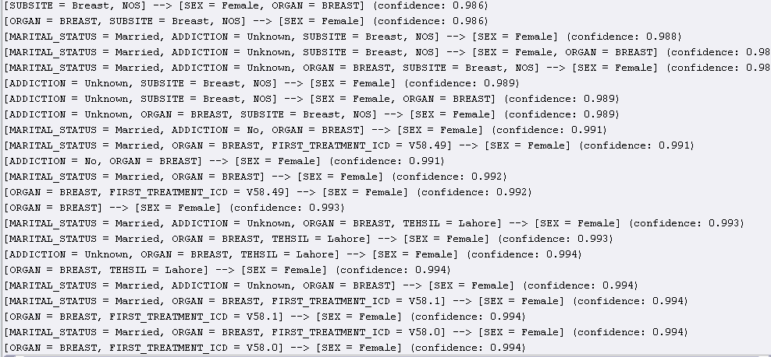

Comments:

- The above rules association is 89% to 99%.
- Left hand side of rules showing if part and right hand side showing then part means the occurances of attributes with relation of left part of rule.

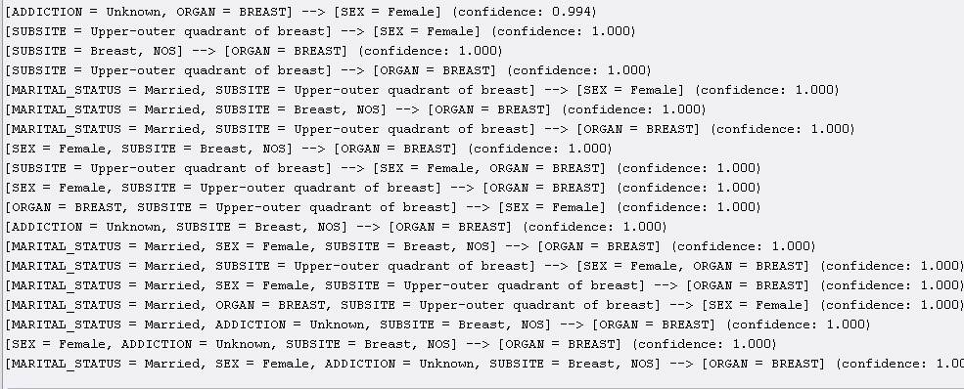

Comments:

- The above rules association is 100% these are best association rules with min support 95% and min confidence 80% .
- Left hand side of rules showing if part and right hand side showing then part means the occurances of attributes with relation of left part of rule.

Cluster Analysis
To see the trends, similarities and dissimilarities between difference instances we divided the whole data into five clusters. There were 61426 instances in the complete dataset. After making cluster, the dataset is divided as follows:

Cluster Id | Instances | Percentage
1 | 17495 | 28%
2 | 10640 | 17%
3 | 4539 | 7%
4 | 12677 | 21%
5 | 16075 | 26%

Overall Analysis

The following table gives the analysis of each cluster. This table is showing the centroid or most occurring value for each attribute of the cluster.

Attribute | Cluster 0 | Cluster 1 | Cluster 2 | Cluster 3 | Cluster 4
Age_At_Presentation | 46.0775 | 46.341 | 40.2575 | 46.5432 | 47.5204
Sex | Female | Female | Female | Male | Male
District | Lahore | Lahore | Lahore | Lahore | Lahore
Province | Punjab | Punjab | Punjab | Punjab | Punjab
Country | Pakistan | Pakistan | Pakistan | Pakistan | Pakistan
Mrital_Status | Married | Married | Married | Married | Married
Occupation | Housewife | Housewife | Unknown | Other | Other
Relation | Missing | Missing | Missing | Missing | Missing
Addiction | Unknown | Unknown | Unknown | No | No
Previous_Treatment | No | Surgery | Surgery | No | No
Valid_Basis_of_Diagnosis | Missing | Missing | Pathology | Missing | Pathology
Diagnosis_At_SKM | Yes | No | Yes | No | Yes
Organ | Breast | Breast | Lymph nodes | Lymph Node | Breast
Grade | III | III | Missing | Missing | Missing
Laterality | Right | Left | No | No | No
Tumor_Size | 241.1591 | 527.1914 | 879.8874 | 765.3826 | 550.3291
First_Treatment_ICD | V58.1 (Chemotherapy) | V58.49 (Surgery) | V58.1 (Chemotherapy) | V58.0 (Radiotherapy) | V58.49 (Surgery)
Class_Of_Death | Class 1 | Missing | Missing | Class 2 | Class 1

Detail Analysis

In this section we will analyse each cluster by defining the most commonly occurring values for each attribute.

Cluster 1

- Age:The mean age of patients of this cluster is 46.47
- Gender: 5% of people of this cluster are male and 94% are female.
- District: 40% people of this cluster belong to Lahore and 6% from Gujranwala, 5% from Faisalabad and 4% from Sialkot, and 2% from Gujrat, 2% from Sargodha,1% from Islamabad, 2% from Multan, 1% from Rawalpindi and 2% from Peshawar.
- Province: 85% patients from Punjab, 9% are from N.W.F.P, 1% from Sindh and 1% from Federal Capital.
- Country: 90% (17418) are from Pakistan. Only 77 patients are from Afghanistan that is very low quantity.
- Marital Status: 86% are married,8% are single and 4% are widow.
- Occupation: 58% patients are housewife,19% are Others and 10% occupation is unknown and 2% are teachers.
- Relation: 80% of people didn’t have any one in family who ever had cancer. Only 4% people had cancer in their mother and 4% had in their sister.
- Addiction: 60% of patient’s addiction is unknown and 34% patients’ are not addicted to anything.
- Previous Treatment: 71% didn’t have any previous treatment while only 20% are previously treated by surgery, 3% patient’s treatment is unknown, 2% by Chemo and 1% by Hormonal.
- Valid basis of diagnosis: 41% of patients’ cancer was diagnosed due to “Pathology”, 4% due to consultant and data about 51% of patients is missing for this attribute.
- Diagnoses at SKM: The cancer of 80% patients of this cluster was diagnosed at SKM.
- ORGAN:73% of patients got cancer diagnosed in “Breast”, 1% in “BONES_JOINTS_AND_ARTICULAR_CARTILAGE_OF_LIMBS”, 1% in “CONNECTIVE_SUBCUTANEOUS_AND_OTHER_SOFT_TISSUES”, 1% in “CERVIX_UTERI”, 1% in “Lymph node”, 1% in “BRONCHUS_AND_LUNG”, 3% in “Ovary” and 1% in “HEMATOPOIETIC_AND_RETICULOENDOTHELIAL_SYSTEMS”
- GRADE: 43% patients have cancer of grade III and 26% have cancer of grade II and 26% patient’s grade is missing.
- Laterality: 49% of data has “Right” value for this attribute, 31% has “left” and 13% has “No”.
- Tumor Size: The value of centroid for this attribute is 188.549 +/-344.702.
- First Treatment ICD: 35% patients have ICD V58.1 (Chemotherapy), 20% have V58.0 (Radiotherapy), 13% have V58.49 (Surgery), 11% have 99.24(Hormonal), 8% have V58.11 and 6% patients’ data was missing.
- Class of Case: 54% of patients belong to Class 1, 9% belongs to Class 2 and 33% patients’ data was missing for this attribute.

Cluster 2

- Age:The mean age of patients of this cluster is 46.63
- Gender: 11% of people of this cluster are male and 88% are female.
- District: 33% people of this cluster belong to Lahore and 5% from Gujranwala, 4% from Faisalabad and 4% from Sialkot, and 2% from Gujrat, 2% from Sargodha, 2% from Multan, 2% from Islamabad, 3% from Rawalpindi and 3% from Peshawar.
- Province: 78% patients from Punjab, 12% are from N.W.F.P, 2% from Sindh , 1% from Baloshistan and 2% from Federal Capital.
- Country: 90% (10573) are from Pakistan. Only 59 patients are from Afghanistan and 2 from kenya.
- Marital Status: 87% are married,7% are single and 3% are widow.
- Occupation: 52% patients are housewife,16% are Others,17% occupation is unknown, 2% teacher and 1% student.
- Relation: 80% of people didn’t have any one in family who ever had cancer. Only 4% people had cancer in their mother and 4% had in their sister.
- Addiction: 66% of patient’s addiction is unknown, 21% patients’ are not addicted to anything and 1% is smokers.
- Previous Treatment: 17% didn’t have any previous treatment while only 64% are previously treated by surgery, 3% patient’s treatment is unknown, 7% by Chemo, 2% by Hormonal and 4% by radiation.
- Valid basis of diagnosis: 34% of patients’ cancer was diagnosed due to “Pathology”, 15% due to consultant and data about 48% of patients is missing for this attribute.
- Diagnoses at SKM: The cancer of 16% patients of this cluster was diagnosed at SKM.
- ORGAN:61% of patients got cancer diagnosed in “Breast”, 1% in “HEMATOPOIETIC_AND_RETICULOENDOTHELIAL_SYSTEMS ”, 1% in “ PROSTATE_GLAND”, 1% in “THYROID GLAND”, 1% in “Bladder”, 2% in “CERVEX UTERI”, 1% in “ CONNECTIVE_SUBCUTANEOUS_AND_OTHER_SOFT_TISSUES”, 1% in “Brain”, 1% in “ BONES_JOINTS_AND_ARTICULAR_CARTILAGE_OF_LIMBS”,1% in “Colon”, 1% in “Rectum”, 1% in “Corpus Uteri” and 5% in “Ovary”
- GRADE: 26% patients have cancer of grade III and 27% have cancer of grade II,5% have of grade I and 39% patient’s grade is missing.
- Laterality: 22% of data has “Right” value for this attribute, 48% has “left” and 18% has “No”.
- Tumor Size: The value of centroid for this attribute is 583.08.
- First Treatment ICD: 7% patients have ICD V58.1 (Chemotherapy), 18% have V58.0 (Radiotherapy), 32% have V58.49 (Surgery), 9% have 99.24(Hormonal), 4% have V58.11 (antineoplastic_chemotherapy), 2% have V66.7 (Palliative_Care) and 24% patients’ data was missing.
- Class of Case: 3% of patients belong to Class 1, 26% belongs to Class 2, 20% belongs to Class 3 and 49% patients’ data was missing for this attribute.

Cluster 3

- Age:The mean age of patients of this cluster is 36.45
- Gender:77% of people of this cluster are male and 22% are female.
- District: 5% people of this cluster belong to Lahore and 3% from Gujranwala, 2% from Faisalabad and 2% from Sialkot, and 1% from Gujrat, 2% from Sargodha, 1% from Multan, 1% from Islamabad, 5% from Swat, 3% from Rawalpindi, 4% from Mardan, 2% from Noshera and 19% from Peshawar.
- Province: 35% patients from Punjab, 51% are from N.W.F.P, 2% from Sindh, 2% from Baloshistan, 2% from FATA and 1% from Federal Capital.
- Country: 98% are from Pakistan. Only 1% are from Afghanistan.
- Marital Status: 64% are married and 35% are single.
- Occupation: 7% patients are housewife, 21% are Others, 28% occupation is unknown, 6% labourer, 2% farmer, 2% retired, 1% teacher, 1% businessman, 1% shopkeeper and 10% student.
- Relation: 93% of people didn’t have any one in family who ever had cancer. Only 1% people had cancer in their brothers.
- Addiction: 60% of patient’s addiction is unknown, 17% patients’ are not addicted to anything, 6% are addicted to Naswar, 2% are Ex.Smoker, 2% are chronic-Smoker and 5% is smokers.
- Previous Treatment: 71% didn’t have any previous treatment while only 16% are previously treated by surgery, 4% patient’s treatment is unknown, 5% by Chemo and 2% by radiation.
- Valid basis of diagnosis: 48% of patients’ cancer was diagnosed due to “Pathology”, 8% due to consultant and data about 41% of patients is missing for this attribute.
- Diagnoses at SKM: The cancer of 58% patients of this cluster was diagnosed at SKM.
- ORGAN:31% of patients got cancer diagnosed in “Lymph node”,2% in “ ESOPHAGUS”, 1% in “ PROSTATE_GLAND”, 1% in “THYROID GLAND”, 1% in “Bladder”, 1% in “CERVEX UTERI”, 2% in “ CONNECTIVE_SUBCUTANEOUS_AND_OTHER_SOFT_TISSUES”, 2% in “Stomach”, 1% in “ BONES_JOINTS_AND_ARTICULAR_CARTILAGE_OF_LIMBS”,1% in “Colon”, 3% in “Brain”, 1% in “Corpus Uteri”, 3% in “Rectum”, 1% in “Bronchus and Lungs” and 1% in “Colon”
- GRADE: 6% patients have cancer of grade III and 9% have cancer of grade II,5% have of grade I, 1% have of grade IV and 76% patient’s grade is missing.
- Laterality: 6% of data has “Right” value for this attribute, 6% has “left” and 80% has “No”.
- Tumor Size: The value of centroid for this attribute is 909.74.
- First Treatment ICD: 71% patients have ICD V58.1 (Chemotherapy), 8% have V58.0 (Radiotherapy), 5% have V58.11 (antineoplastic_chemotherapy), 2% have V66.7(Palliative_Care) and 10% patients’ data was missing.
- Class of Case: 33% of patients belong to Class 1, 17% belongs to Class 2, 7% belongs to Class 3 and 40% patients’ data was missing for this attribute.

Cluster 4

- Age:The mean age of patients of this cluster is 46.5
- Gender:71% of people of this cluster are male and 28% are female.
- District: 29% people of this cluster belong to Lahore and 4% from Gujranwala, 3% from Faisalabad and 3% from Sialkot, and 2% from Gujrat, 2% from Sargodha, 1% from Multan, 1% from Islamabad, 5% from Swat, 3% from Rawalpindi, 1% from Mardan and 2% from Peshawar.
- Province: 74% patients from Punjab, 14% are from N.W.F.P, 3% from Sindh, 2% from Baloshistan, 1% from FATA and 1% from Federal Capital.
- Country: 98% are from Pakistan. Only 1% are from Afghanistan.
- Marital Status: 81% are married, 16% are single and 1% are widow.
- Occupation: 11% patients are housewife, 41% are Others, 9% occupation is unknown, 5% labourer, 1% driver, 2% farmer, 4% retired, 1% teacher, 2% businessman, 1% shopkeeper and 4% student.
- Relation: 91% of people didn’t have any one in family who ever had cancer. Only 1% people had cancer in their brothers, 1% in father and 1% in mother.
- Addiction: 25% of patient’s addiction is unknown, 40% patients’ are not addicted to anything, 5% are addicted to Naswar, 3% are Ex.Smoker, 3% are chronic-Smoker, 3% is bettle leaf and 10% is smokers.
- Previous Treatment: 65% didn’t have any previous treatment while only 23% are previously treated by surgery, 1% by Hormonal, 2% patient’s treatment is unknown, 4% by Chemo and 2% by radiation.
- Valid basis of diagnosis: 26% of patients’ cancer was diagnosed due to “Pathology”, 15% due to consultant and data about 55% of patients is missing for this attribute.
- Diagnoses at SKM: The cancer of 14% patients of this cluster was diagnosed at SKM.
- ORGAN:8% of patients got cancer diagnosed in “Lymph node”,2% in “Breast”, 2% in “ Tongue”, 14% in “ HEMATOPOIETIC_AND_RETICULOENDOTHELIAL_SYSTEMS”, 5% in “ PROSTATE_GLAND”, 1% in “THYROID GLAND”, 3% in “Bladder”, 1% in “CERVEX UTERI”, 2% in “ CONNECTIVE_SUBCUTANEOUS_AND_OTHER_SOFT_TISSUES”, 2% in “Stomach”, 3% in “ BONES_JOINTS_AND_ARTICULAR_CARTILAGE_OF_LIMBS”,1% in “Colon”, 3% in “Esophagus”, 4% in “Brain”, 1% in “Corpus Uteri”, 5% in “Rectum”, 3% in “Bronchus and Lungs”, 5% in “Larynx”
- GRADE: 13% patients have cancer of grade III and 19% have cancer of grade II, 11% have of grade I, 1% have of grade IV and 53% patient’s grade is missing.
- Laterality: 9% of data has “Right” value for this attribute, 7% has “left” and 77% has “No”.
- Tumor Size: The value of centroid for this attribute is 760.8
- First Treatment ICD: 13% patients have ICD V58.1 (Chemotherapy), 52% have V58.0 (Radiotherapy), 9% have V58.11 (antineoplastic_chemotherapy), 1% have 99.24(Hormonal), 9% have V66.7(Palliative_Care) and 12% patients’ data was missing.
- Class of Case: 8% of patients belong to Class 1, 58% belongs to Class 2, 12% belongs to Class 3 and 20% patients’ data was missing for this attribute.

Cluster 5

- Age:The mean age of patients of this cluster is 47.87
- Gender:73% of people of this cluster are male and 26% are female.
- District: 35% people of this cluster belong to Lahore and 6% from Gujranwala, 5% from Faisalabad and 3% from Sialkot, and 2% from Gujrat, 2% from Sargodha, 2% from Multan, 1% from Islamabad, 5% from Swat, 1% from Rawalpindi, 1% from Mardan and 2% from Peshawar.
- Province: 81% patients from Punjab, 11% are from N.W.F.P, 1% from Sindh, 1% from Baloshistan, 0% from FATA and 1% from Federal Capital.
- Country: 98% are from Pakistan. Only 1% are from Afghanistan.
- Marital Status: 80% are married, 17% are single and 1% are widow.
- Occupation: 11% patients are housewife, 41% are Others, 9% occupation is unknown, 4% labourer, 1% driver, 2% farmer, 5% retired, 1% teacher, 3% businessman, 1% shopkeeper and 4% student.
- Relation: 90% of people didn’t have any one in family who ever had cancer. Only 1% people had cancer in their brothers, 1% in father, 1% in sister and 1% in mother.
- Addiction: 18% of patient’s addiction is unknown, 47% patients’ are not addicted to anything, 3% are addicted to Naswar, 5% are Ex.Smoker, 4% are chronic-Smoker, 2% is bettle leaf and 9% is smokers.
- Previous Treatment: 76% didn’t have any previous treatment while only 14% are previously treated by surgery, 1% by Hormonal, 3% patient’s treatment is unknown, 2% by Chemo and 1% by radiation.
- Valid basis of diagnosis: 45% of patients’ cancer was diagnosed due to “Pathology”, 9% due to consultant and data about 40% of patients is missing for this attribute.
- Diagnoses at SKM: The cancer of 86% patients of this cluster was diagnosed at SKM.
- ORGAN:4% of patients got cancer diagnosed in “Lymph node”,13% in “ LIVER_AND_INTRAHEPATIC_BILE_DUCTS”, 3% in “Breast”, 4% in “ Tongue”, 4% in “ HEMATOPOIETIC_AND_RETICULOENDOTHELIAL_SYSTEMS”, 3% in “ PROSTATE_GLAND”, 1% in “THYROID GLAND”, 3% in “Bladder”, 1% in “CERVEX UTERI”, 2% in “ CONNECTIVE_SUBCUTANEOUS_AND_OTHER_SOFT_TISSUES”, 3% in “Stomach”, 2% in “ BONES_JOINTS_AND_ARTICULAR_CARTILAGE_OF_LIMBS”,3% in “Colon”, 2% in “Esophagus”, 2% in “Brain”, 1% in “Corpus Uteri”, 4% in “Rectum”, 5% in “Bronchus and Lungs”, 2% in “Larynx”
- GRADE: 11% patients have cancer of grade III and 18% have cancer of grade II, 8% have of grade I, 1% have of grade IV and 59% patient’s grade is missing.
- Laterality: 9% of data has “Right” value for this attribute, 10% has “left” and 72% has “No”.
- Tumor Size: The value of centroid for this attribute is 571.89
- First Treatment ICD: 13% patients have ICD V58.1 (Chemotherapy), 13% have V58.0 (Radiotherapy), 24% have V58.39(Surgery),11% have V58.11 (antineoplastic_chemotherapy), 1% have 99.24(Hormonal), 12% have V66.7(Palliative_Care) and 23% patients’ data was missing.
- Class of Case: 61% of patients belong to Class 1, 5% belongs to Class 2, 4% belongs to Class 3, 2% belongs to Class 0 and 25% patients’ data was missing for this attribute.

References

http://meteor.aihw.gov.au/content/index.phtml/itemId/269647/
http://www.cancer.gov/cancertopics/factsheet/Detection/tumor-grade
http://en.wikipedia.org/wiki/Pathology/
http://meteor.aihw.gov.au/content/index.phtml/itemId/289198/
http://en.wikipedia.org/wiki/Surgical_margin/

Appendix A

The following histograms shows the important facts about each attribute of the dataset.

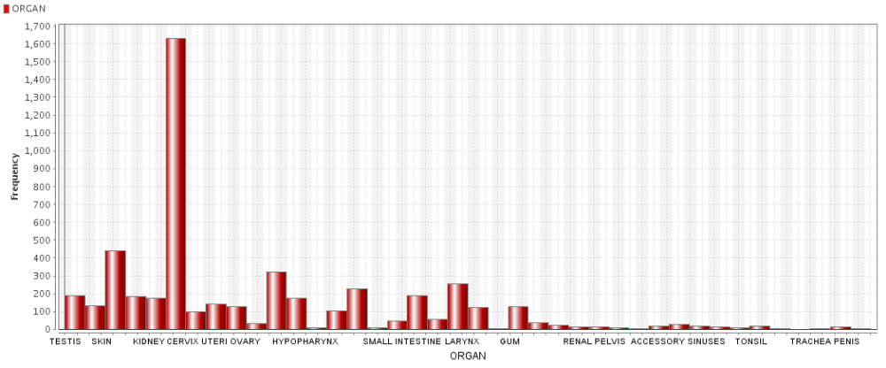
The above graphs shows that the most common cancer diagnosed is the organ “Cervix”.

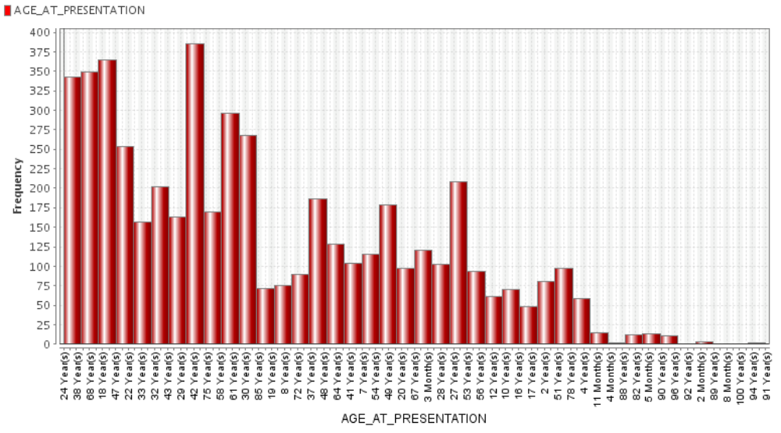

Mostly cancer is diagnosed in people having age 42 years.

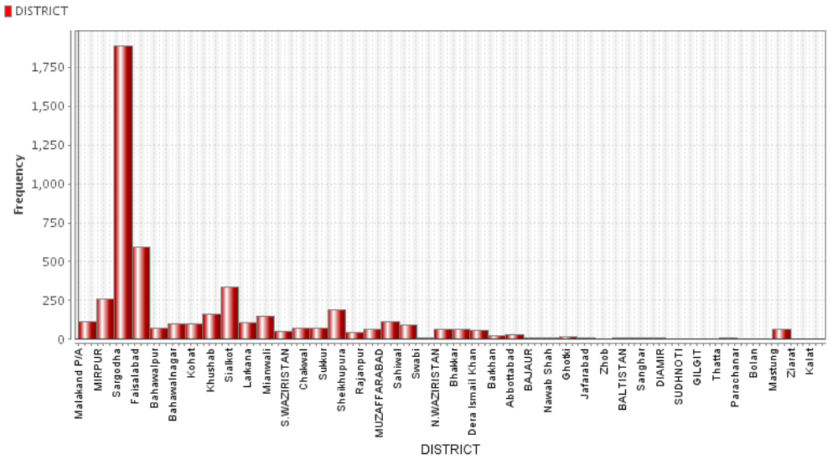

The people of Lahore are mostly affected by Cancer by given statistics.

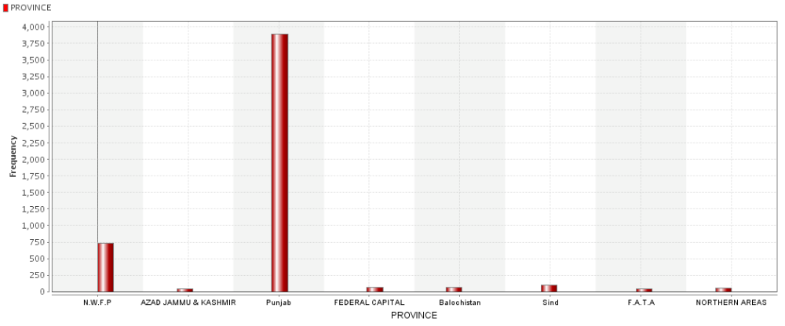

Province of Punjab has the most number of cancer patients.

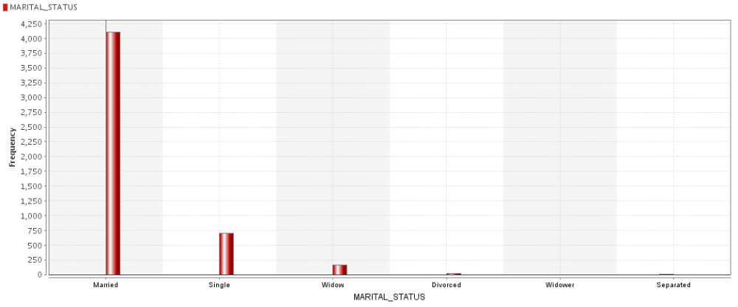

The above histogram displays that Marriad people are the frequent patient of cancer.

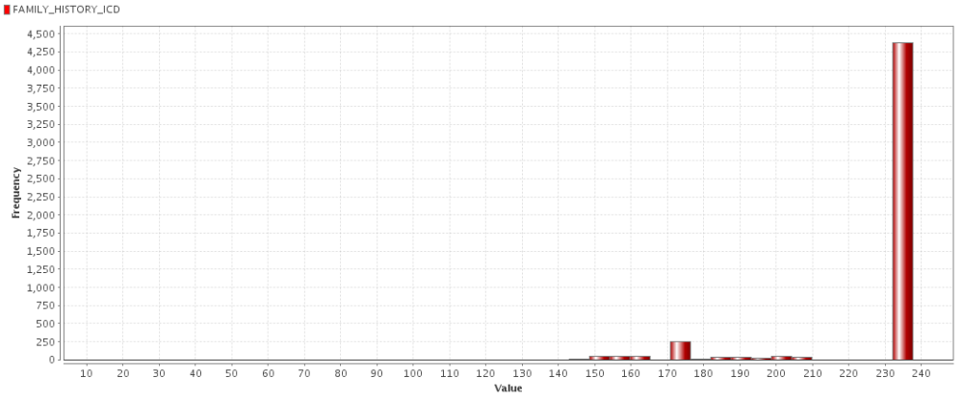
Usually the people who have ralatives having ICD 230-240 are mostly affected by the cancer

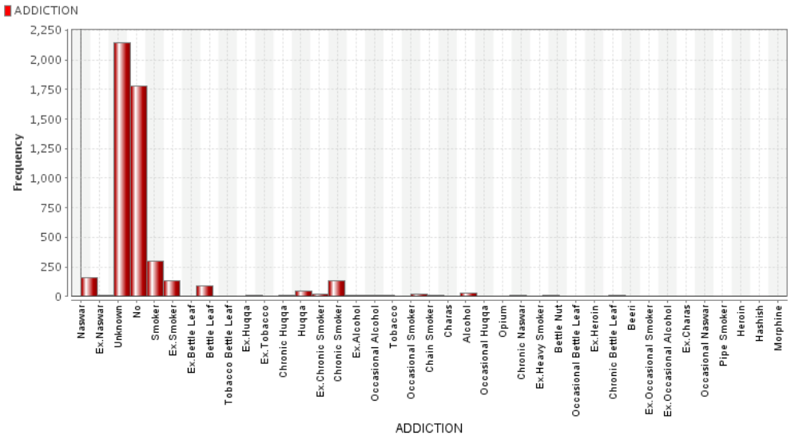
Mostly the cancer patients donot have any Addiction.

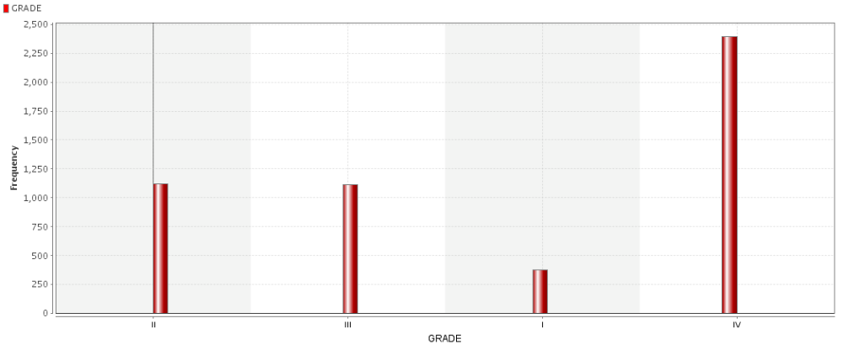
The most common cancer diagnosed is of grade IV.
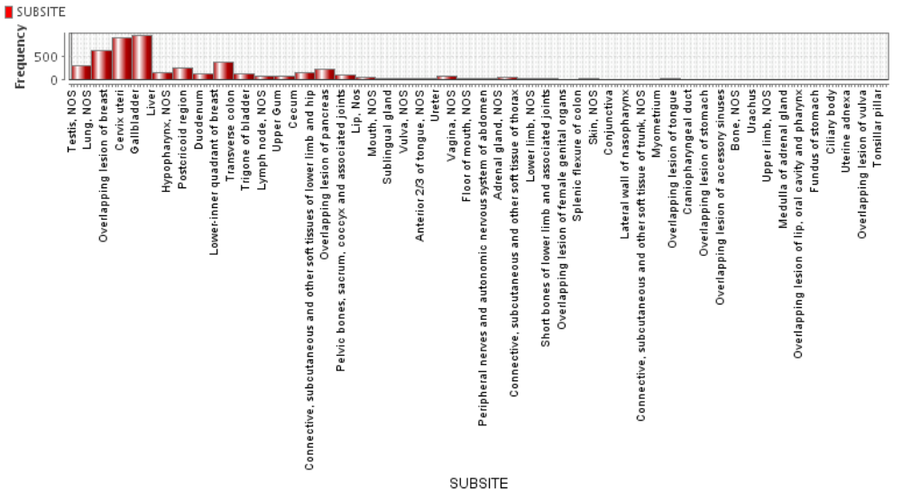

Mostly cancer is detected in Cervix uteri and Gallblader.

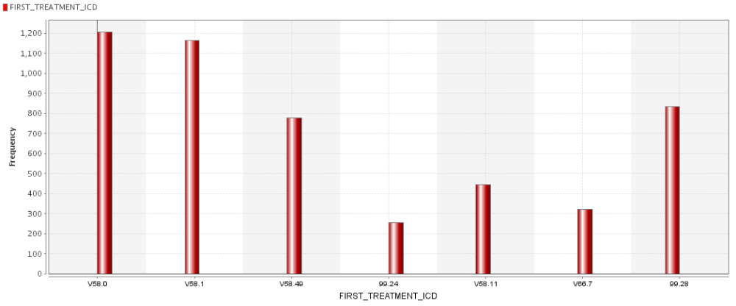
The most common ICD detected is V58.0
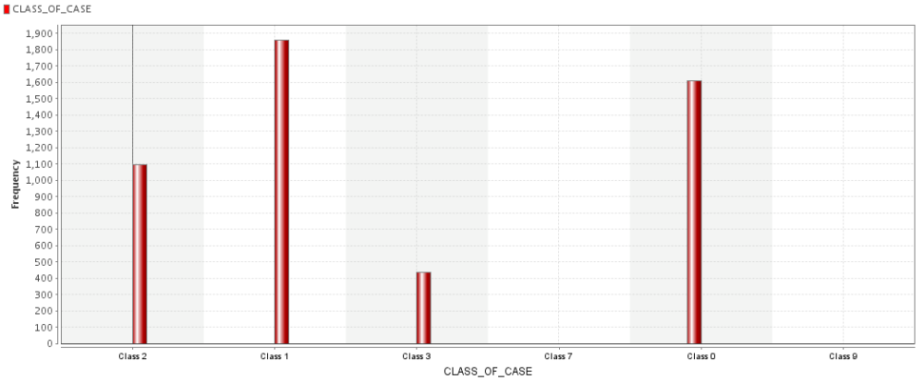
Mostly the people have cancer of Class1.

The most common type of cancer detected is Breast Cancer.

Appendix B
Scatter Plots for visualization of data

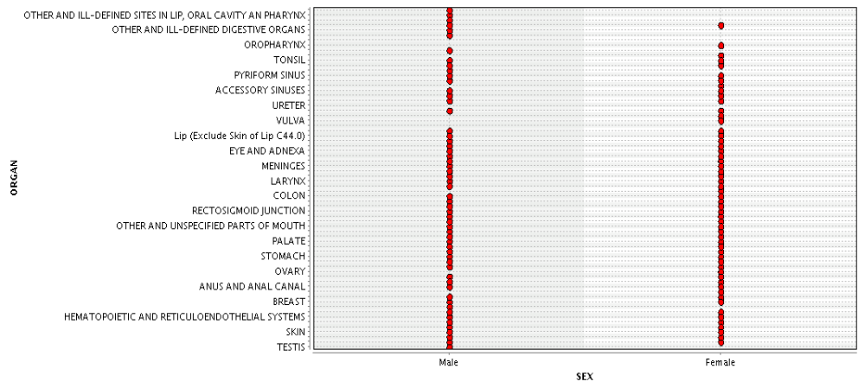

This graph shows that females don’t have any cancer diagnosed for the “ill-defined digestive organs” and “ill-defined sites in lip, oral cavity an pharynx” and mostly diagnose in these organs; breast, ovary and anal canal.
And males don’t have cancer diagnosed in vulva, or pharynx and ovary. Whereas mostly diagnosed at Testis and colon.
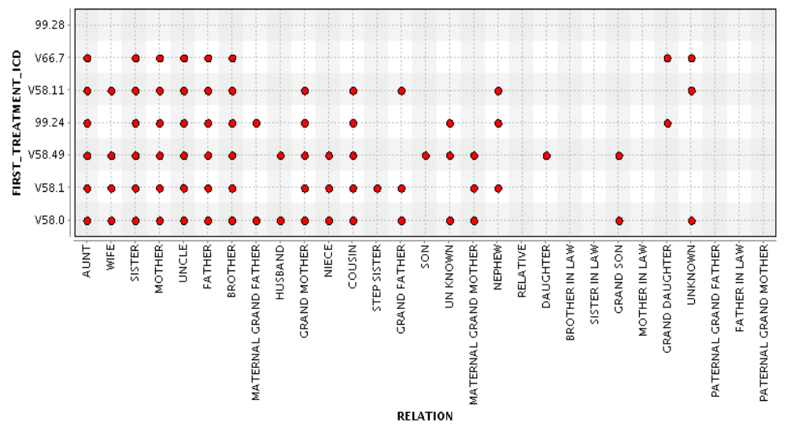

This graph shows the ICD numbers that are assigned according to specific relations.
The symbol * showing the presence of ICD allot due to relation showing in that row. Blank cells showing no ICD against that relation .

Relation | FIRST-TREATMENT-ICD
 | V58.0 | V58.1 | V58.49 | 99.24 | V58.11 | V66.7 | 99.28
Aunt | * | * | * | * | * | *
Wife | * | * | * |  | *
Sister | * | * | * | * | * | *
Mother | * | * | * | * | * | *
Uncle | * | * | * | * | * | *
Father | * | * | * | * | * | *
Brother | * | * | * | * | * | *
Maternal Grand father | * |  |  | *
Husband | * |  | *
Grand Mother | * | * | * | * | *
Niece | * | * | *
Cousin | * | * | * | * | *
Step sister |  | *
Grand Father | * | *
Son |  |  | *
Maternal Grand Father | * | * | *
Nephew |  | * |  | * | *
Daughter |  |  | *
Brother in Law
Sister in Law
Grand Son | * |  | *
Mother in law
Grand Daughter |  |  |  | * |  | *
Paternal Grand Father
Father-in-law
Paternal Grand Mother

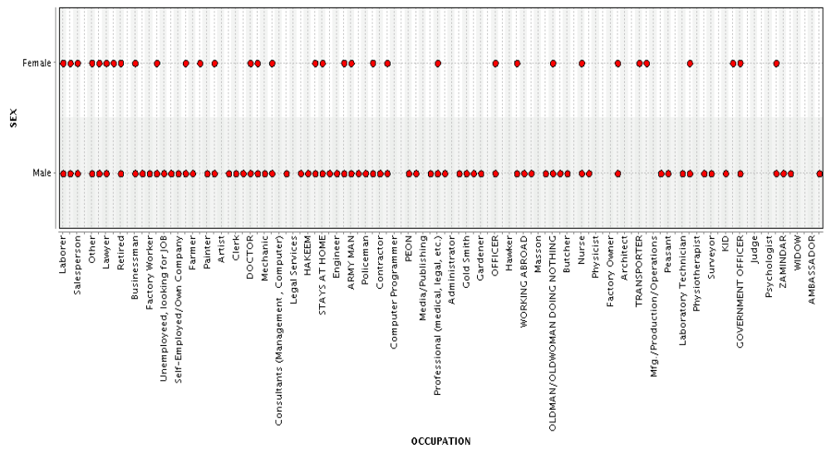

There is more span for males as they adopt different occupation whereas females work in limited fields that’s why more variations for males than females.
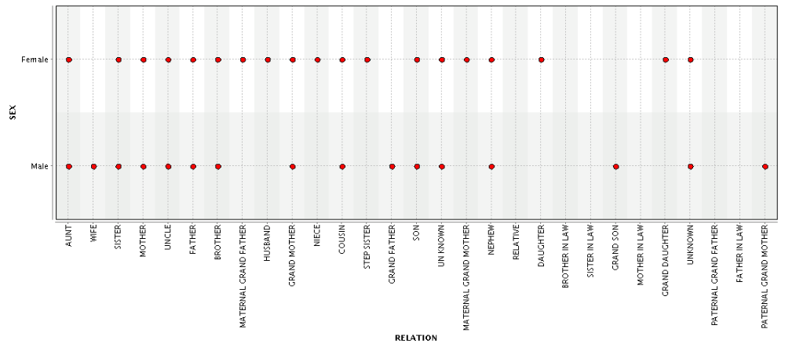

There is no cancer diagnosed for males if the relations are marital grand father, niece, step sister, daughter, sister and brother in law, mother in law, grand father and father-in-law.
Similarly there is no cancer diagnose for females if relations are grand father, mother in law, sister in law, grand son, mother-in-law and father-in-law.

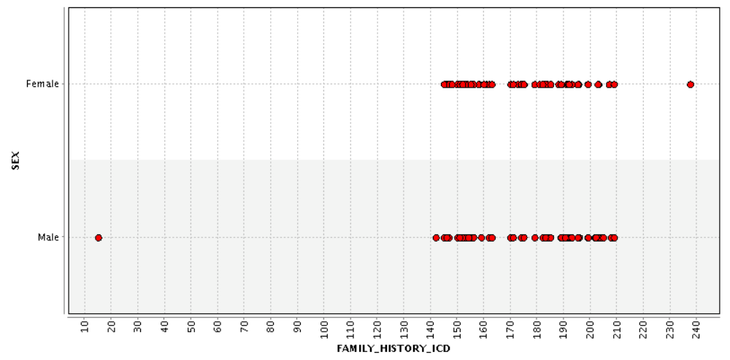
In males cancer is diagnosed due to family relation ICD mostly in the range of 140 – 210 and also at ICD 10.And for females its mostly in the range 145-208.9 and also at 237.5.

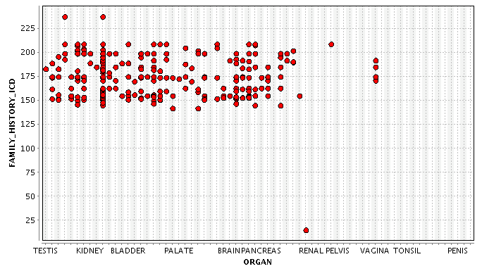

The above graph showing if Family History ICD is 15 then Effected Organ is Renal Pelvis, and from range 140-220 Testis,Kidney,Bladder,Palate,Brainpancreas and Vagina tonsil organ would effect.

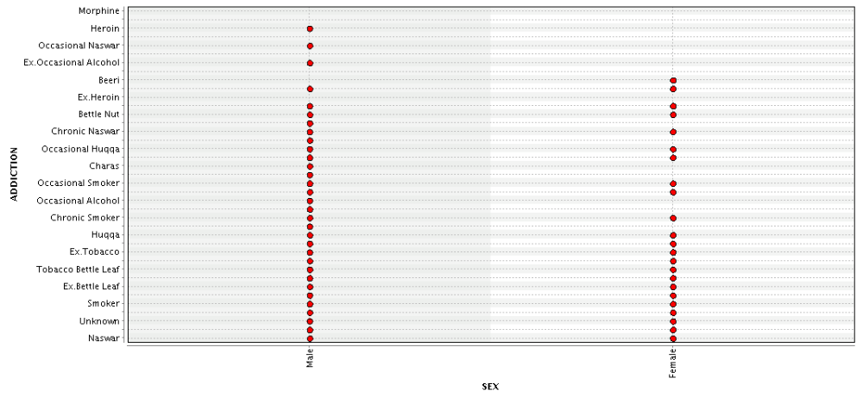
The above graph showing different addictions for both males and females. Males are more addicted while females are less addicted to addictive substances.
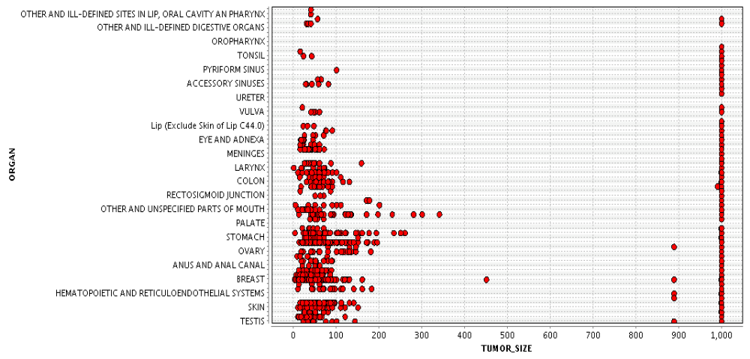

The above graph shoes that mostly all the tumors are of size 1000 when they are diagnosed but for testis,skin,breast,anal,ovary,stomach,colon,larynx and Vulva, tumor of other sizes are also diagnosed.

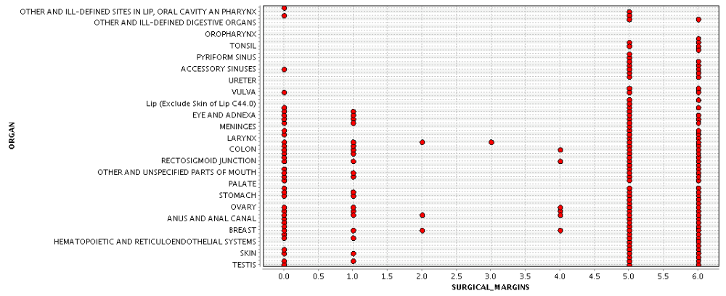

The above graph shows the sugical margin for each organ. Commonly for all organs except Orophynx and Uterer have Surgical margins of 5 and 6, which means that these cancers effect their surronded regions as well.
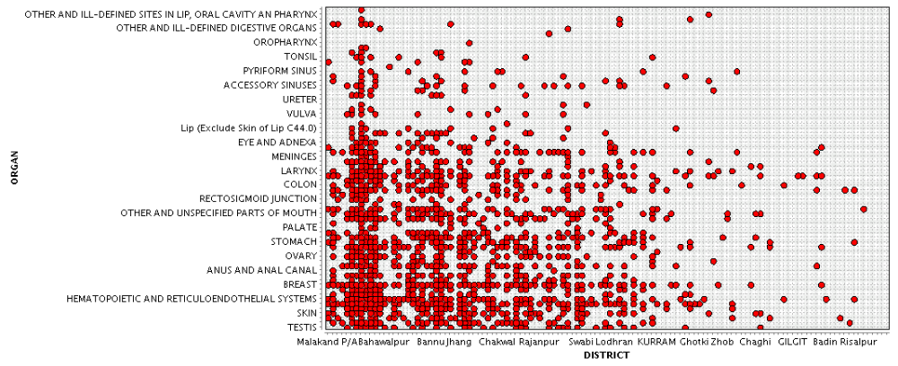
The above graph shows that almost all kind of cancers are diagnosed for the districts like Malakand and Bahawalpur. This might be due to the environment of these districts. While for Gilgit the only cancer detected are “Colon” and “Hematopoetic and Reticuloendothelial System”.

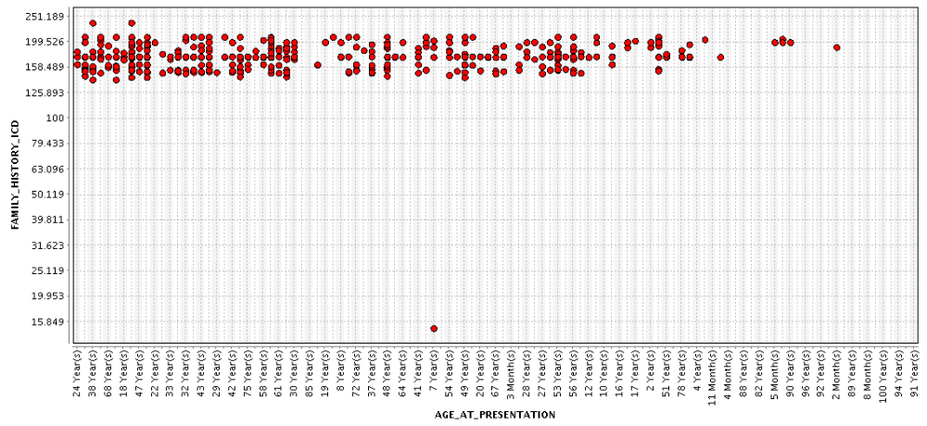

The above graph shows that if the Family_History_ICD is 15.849 then the only age in which cancer was diagnosed is 7 Years while almost in every age and Family_History_ICD of 158.409 to 199.526, the cancer is diagnosed.

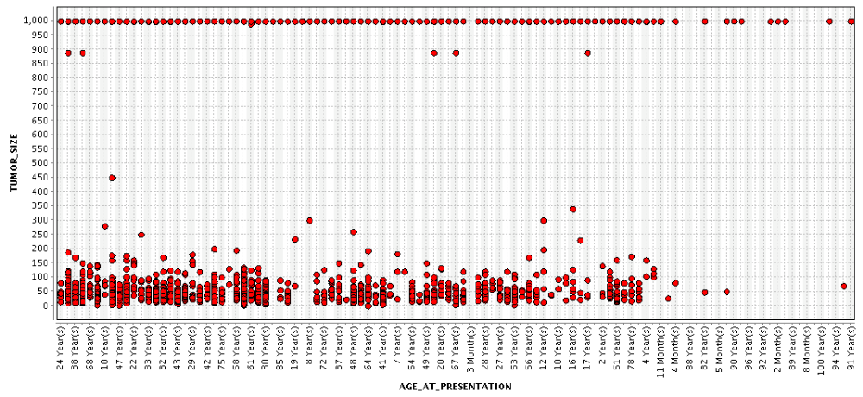

This graph shows the different tumour sizes for different ages. As we can see that 1000 Tumour size is diagnosed in almost all ages.

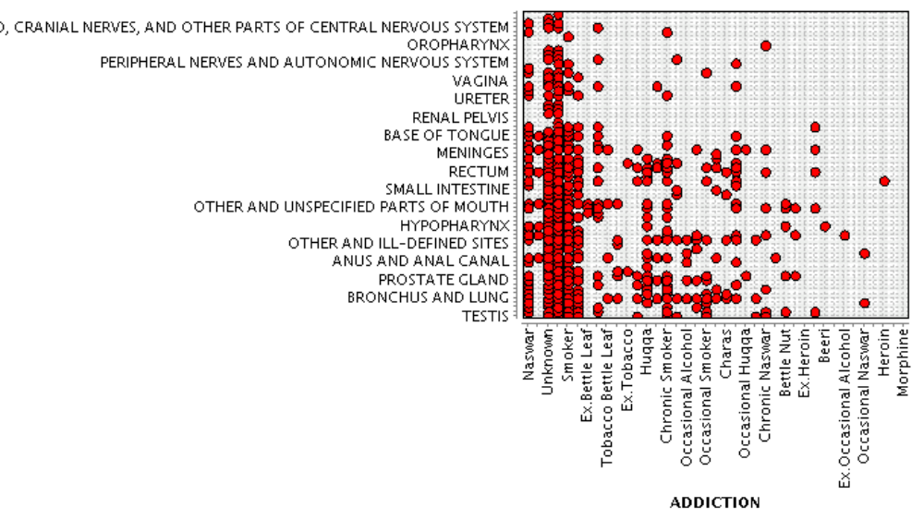

This graph shows the effects of addicted materials on different organs some important are showing below:-

Addictive Materials | Organs
Naswar | Testis,Skin,Prostrate grand, Anus and anul canal,unspecified parts of mouth,Rectum,Meninges, base of tounge, pyriform sinus and ill-defined sites in lip, oral cavity an pharynx
Smoking | Testis, Prostrate grand, Anus and anul, Meninges, base of tounge,hypopharynx,small intestine.rectum, peripheral nerves , autonomic nervous system and other parts of nervous system
Tobacco battle leaf | Bronchus and lung, Anus and anal canal, unspecified parts of mouth and Meninges
Huqqa | Bronchus and lung, unspecified parts of mouth, Anus and anal canal, hypopharynx and Rectum
Beer | Hypopharynx
Herion | Rectum

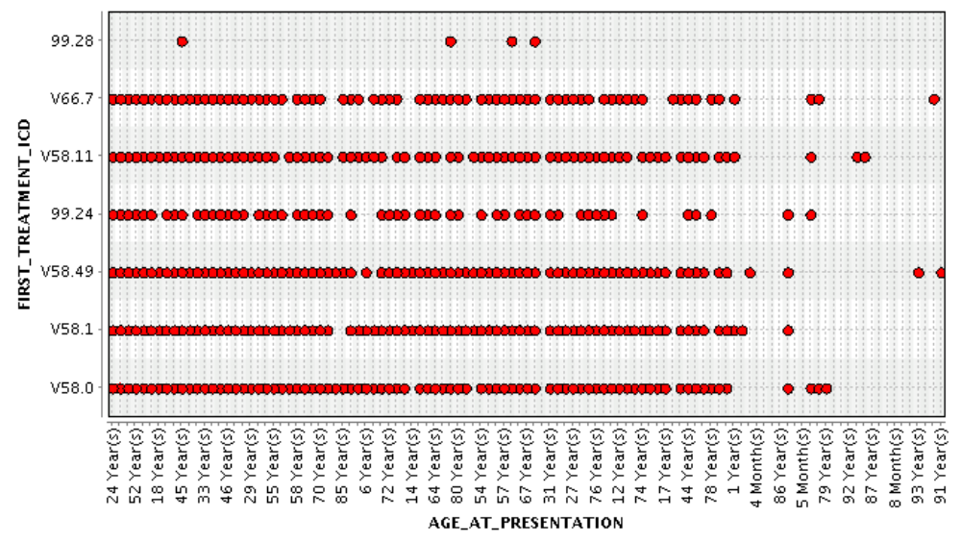

This graph shows the ICD(International code for disease) allocation among different ages.

Like for;
- 24,52,18,33,46,29,55,58,70 years old persons ICDs are v58.0,v 58.1,v58.49,v58.11,v66.7
- 85 year old patients don’t have v58.0,v58.49,v58.11,v66.7
- 45,57,67 years old patients normally have ICD 99.28 with others too.
- 91,92 years old have V58.11 ICD.
- 5-8 Months patients have V58.0

