The George Washington University
School of Engineering and Applied Science
Department of Computer Science
CSCi 243 – Data Mining – Spring 2007

Homework Assignment #2 Solution

Instructor: A. Bellaachia

Problem 1: (20 points)
For the following vectors x and y, calculate the indicated similarity or distance measures:

- x =(1,1,1,1), y=(2,2,2,2) cosine, correlation, Euclidian

Ans: cos(x, y) = 1, corr(x, y) = 0/0 (undefined), Euclidean(x, y) = 2

- x =(0,1,0,1), y=(1,0,1,0) cosine, correlation, Euclidian, Jaccard

Ans: cos(x, y) = 0, corr(x, y) = −3, Euclidean(x, y) = 2, Jaccard(x, y) = 0

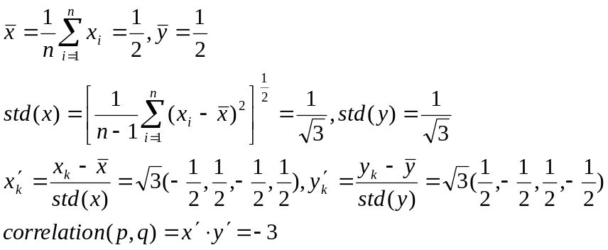
- x =(1,-1,0,1), y=(1,0,-1,0) cosine, correlation, Euclidian

Ans: corr(x, y)=0

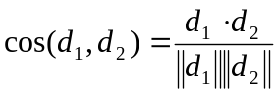, 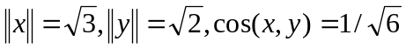

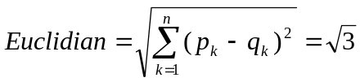,

- x =(1,1,0,1,0,1), y=(1,1,1,0,0,1) cosine, correlation, Jaccard
Ans: cos(x, y) = 0.75, corr(x, y) = 1.25, Jaccard(x, y) = 0.6

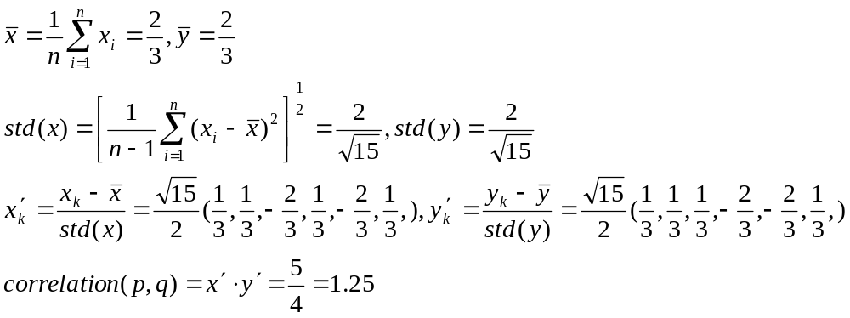

- x =(2,-1,0,2,0,-3), y=(-1,1,-1,0,0,-1) cosine, correlation

Ans: cos(x, y) = 0, corr(x, y) = 0

Problem 2: (20 points)
An educational psychologist wants to use association analysis to analyze test results. The test consists of 100 questions with four possible answers each.

- How would you convert this data into a form suitable for association analysis?

Ans:
Association rule analysis works with binary attributes, so you have to convert original data into binary form as follows:

Q1 = A | Q1 = B | Q1 = C | Q1 = D | .. | Q100 = A | Q100 = B | Q100 = C | Q100 = D
1 | 0 | 0 | 0 | ... | 1 | 0 | 0 | 0
0 | 0 | 1 | 0 | ... | 0 | 1 | 0 | 0

- In particular, what type of attributes would you have and how many of them are there?
Ans:
400 asymmetric binary attributes.

Problem 3: (20 points)
Suppose that the data for analysis includes the attribute age. The age values for the data tuples are (in increasing order):13, 15, 16, 16, 19, 20, 20, 21, 22, 22, 25, 25, 25, 25, 30, 33, 33, 35, 35, 35, 35, 36, 40, 45, 46, 52, 70.

- Use smoothing by bin means to smooth the above data, using a bin depth of 3. Illustrate your steps. Comment on the effect of this technique for the given data.
Ans:

Step 1: Sort the data (this step is not required here as the data is already sorted.)
Step 2: Partition the data into equidepth bins of depth 3
Bin 1: 13, 15, 16 Bin 2: 16,19,20 Bin 3: 20, 21, 22
Bin 4: 22, 25, 25 Bin 5: 25,25,30 Bin 6: 33, 33, 35
Bin 7: 35, 35, 35 Bin 8: 36, 40, 45 Bin 9: 46, 52, 70
Step 3: calculate the arithmetic mean of each bin
Step 4: Replace each of the values in each bin by the arithmetic mean calculated for the bin.

Bin 1: 44/3, 44/3, 44/3 Bin 2: 55/3, 55/3, 55/3 Bin 3: 21, 21, 21
Bin 4: 24, 24, 24 Bin 5: 80/3, 80/3, 80/3 Bin 6: 101/3, 101/3, 101/3
Bin 7: 35, 35, 35 Bin 8: 121/3, 121/3, 121/3 Bin 9: 56, 56, 56

- How might you determine outliers in the data?

Ans:
Outliers in the data may be detected by clustering, where similar values are organized into groups, or “clusters”. Values that fall outside of the set of groups may be considered outliers. Alternatively, a combination of computer and human inspection can be used where a predetermined data distribution is implemented to allow the computer to identify possible outliers. These possible outliers can then be verified by human inspection with much less effort than would be required to verify the entire data set.

- What other methods are there for data smoothing?
Ans:
Other methods that can be used for data smoothing include alternate forms of binning such as smoothing by bin medians or smoothing by bin boundaries, etc.

Problem 4: (20 points)
Here, we further explore the cosine and correlation measures.
(a) What is the range of values that are possible for the cosine measure?

Ans:
[−1, 1]. Many times the data has only positive entries and in that case
the range is [0, 1].

(b) If two objects have a cosine measure of 1, are they identical? Explain.
Ans:
Not necessarily. All we know is that the values of their attributes differ
by a constant factor.

(c) What is the relationship of the cosine measure to correlation, if any? (Hint: Look at statistical measures such as mean and standard deviation in cases where cosine and correlation are the same and different.)
Ans:

1. Cosine similarity:
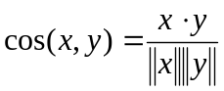
2. Correlation:
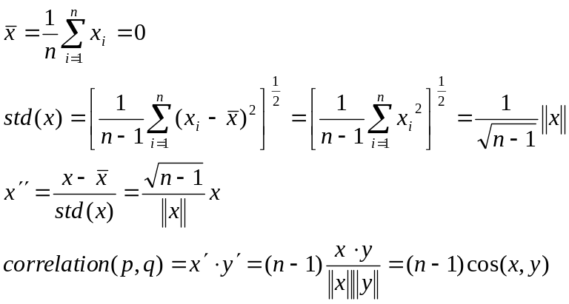

Problem 4: (20 points)

Consider the data set shown in the following table.

Customer ID | Transaction ID | Items Bought
1 | T1 | {a, d, e}
1 | T2 | {a, b, c, e}
2 | T3 | {a, b, d, e}
2 | T4 | {a, c, d, e}
3 | T5 | {b, c, e}
3 | T6 | {b, d, e}
4 | T7 | {c, d}
4 | T8 | {a, b, c}
5 | T9 | {a, d, e}
5 | T10 | {a, b, e}

- Compute the support for itemsets {e}, {b, d}, and {b, d, e} by treating each transaction ID as a market basket.
Ans:
s({e}) = 8/10 = 0.8
s({b, d}) = 2/10 = 0.2
s({b, d, e}) = 2/10 = 0.2

- Use the results in part (a) to compute the confidence for the association rules
{b, d} −→ {e} and {e} −→ {b, d}.
Is confidence a symmetric measure?
Ans:
c(bd → e) = 0.2/ 0.2 = 100%
c(e → bd) = 0.2/0.8 = 25%

- Repeat part (a) by treating each customer ID as a market basket. Each item should be treated as a binary variable (1 if an item appears in at least one transaction bought by the customer, and 0 otherwise.)
Ans:

s({e}) = 4/5 = 0.8
s({b, d}) = 5/5 = 1
s({b, d, e}) = 4/5 = 0.8

- Use the results in part (c) to compute the confidence for the association rules
{b, d} −→ {e} and {e} −→ {b, d}.
Ans:

c(bd −→ e) = 0.8/1 = 80%
c(e −→ bd) = 0.8/0.8 = 100%

