NHS Project
File Version : NHSPRoject_Draft_V1.0
DRAFT DOCUMENT FOR NHS PROJECT

I. Project Cover sheet – Following are the personnels working on NHS project.
Louise
Rabia

II. Organizational history, mission, vision and structure – CGI develops digitized products for nearly all walks of life. It is developing real-time finance products, medical products and many more. CGI creating mobile app, desktop applications and web applications.

III. Background and analysis of the problem to be addressed –
This project is for National Health Service board. It takes patient information and save that in database. Displays information in user friendly way. Application user can update patient information. Currently, they are facing problems with patients registered with them. This project will be user friendly, that will make their task easier to save/alter and view all patients list.

IV. Proposed goal, objectives, target population and implementation plan –
Overall goal is to have user friendly application that will be used by any NHS staff to perform registration process.

Currently, only few features for sprint will be added. New features or functionality will be added in application as new requirement comes in.

Following are the tools used for this project:
Agile methodology is adopted for development of NHS application
Trello is used for tracking of all tasks, user stories, task deadlines, mentions current Sprint.
Trello helps in finding status of each task under tabs like, In Progress, Ready to Verify and Done.
For each Sprint, sprint backlog is created.
CGI will share trello board with NHS, so that they are well aware of status of project.

Developemnt Environment:

Following are the tools and frameworks used for developing environment:
Integrated Development Environment for back-end Coding is Intellij.
Spring MVC framework and Hibernate as object relational mapping will be used for back-end development.

Technology used for front end development is JSP.

Definition of testing strategies and associated tech:

TDD will be followed as testing code strategy.
DBUnit will be used for testing database coding.
For testing back-end coding, Framework Mockito will be used.

Define technologies used for containers and document (PostgeSQL, PGAdmin3, Tomcat)
Database management system is PostgreSQL whereas database created on PostgreSQL is ‘nhsdatabase’ with same user name and role.
For development, PGAdmin3 will be used as client for PostgreSQL server.
The container used for deployment of application, Tomcat will be used.

Definition of version control strategy and associated tech:
Github is used as version control system. Git feature available with intellij will be used. Alternatively, git command on terminal can be used.
NHS Project Repository can be cloned from following address:
https://github.com/Rabia2017/nhs.git

Define dependency management strategy and technology to use (Gradle):
Gradle can be used for project dependencies to be resolved.

Create MVP wireframes

Wireframe for Displaying all patients:

Wire-frame for entry of new patient in system:

Wire-frame for Alteration existed patient in system:

Database schema diagram

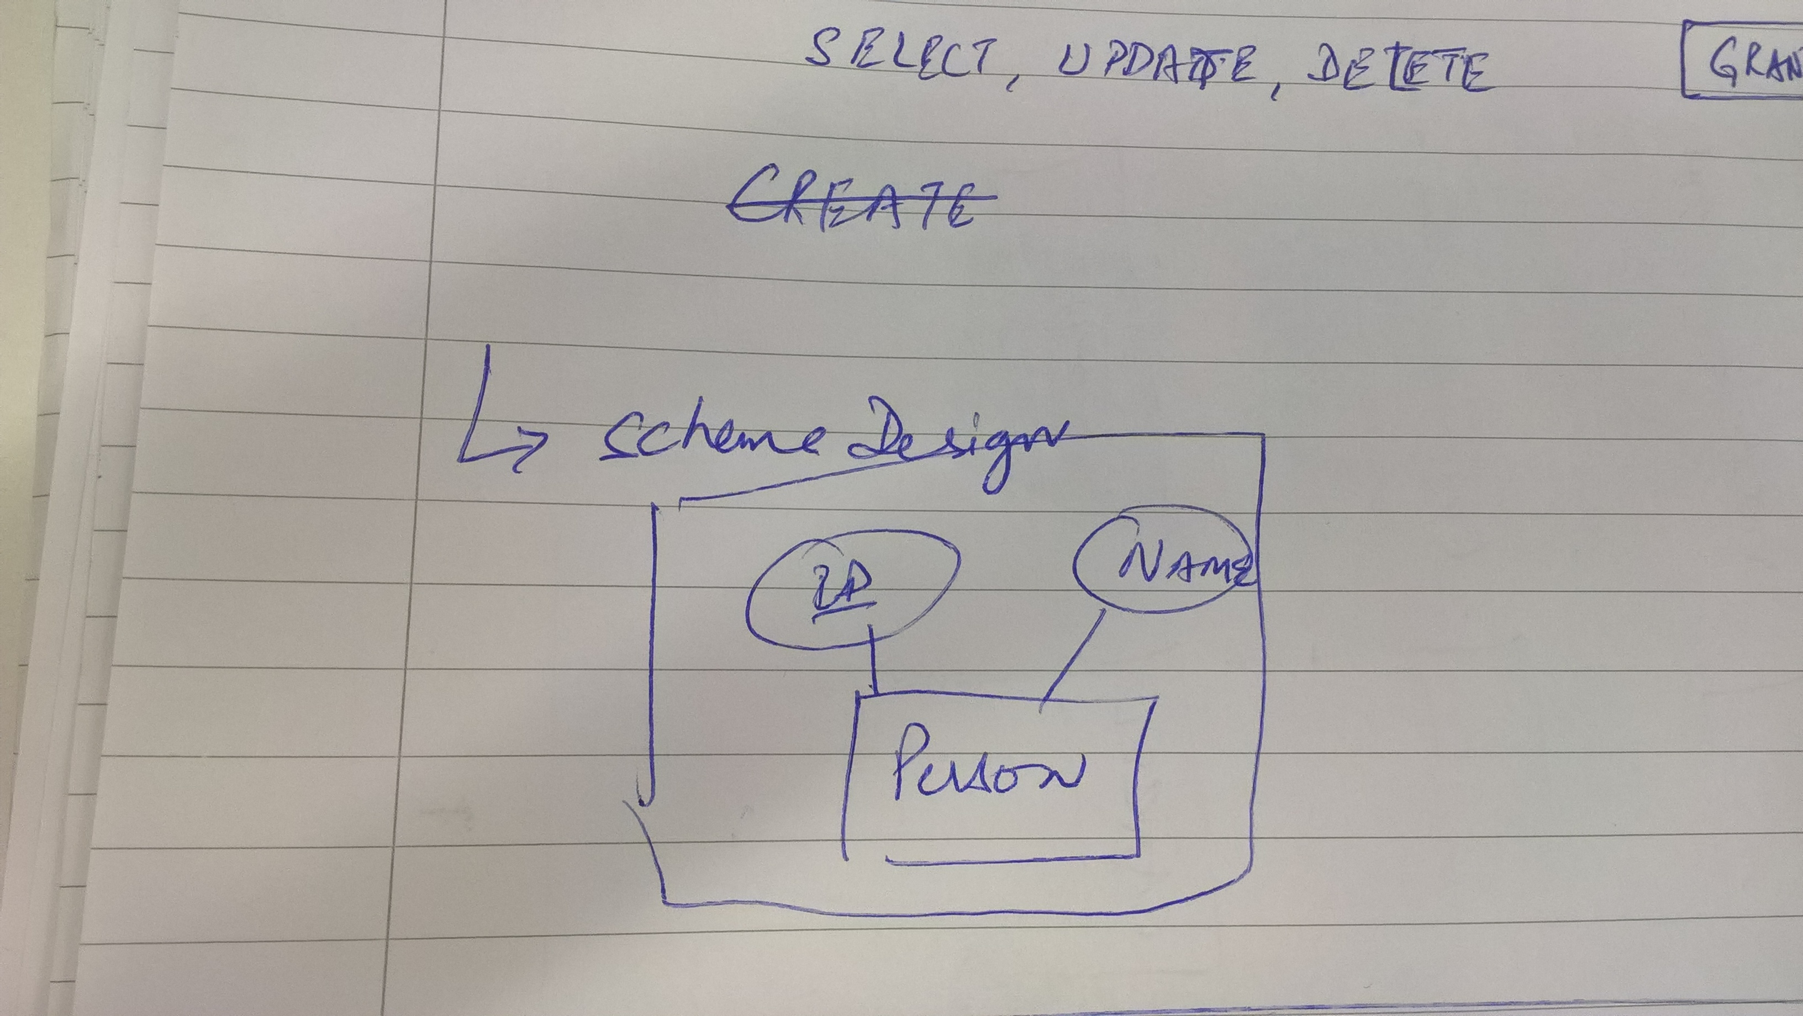

Create architecture diagram
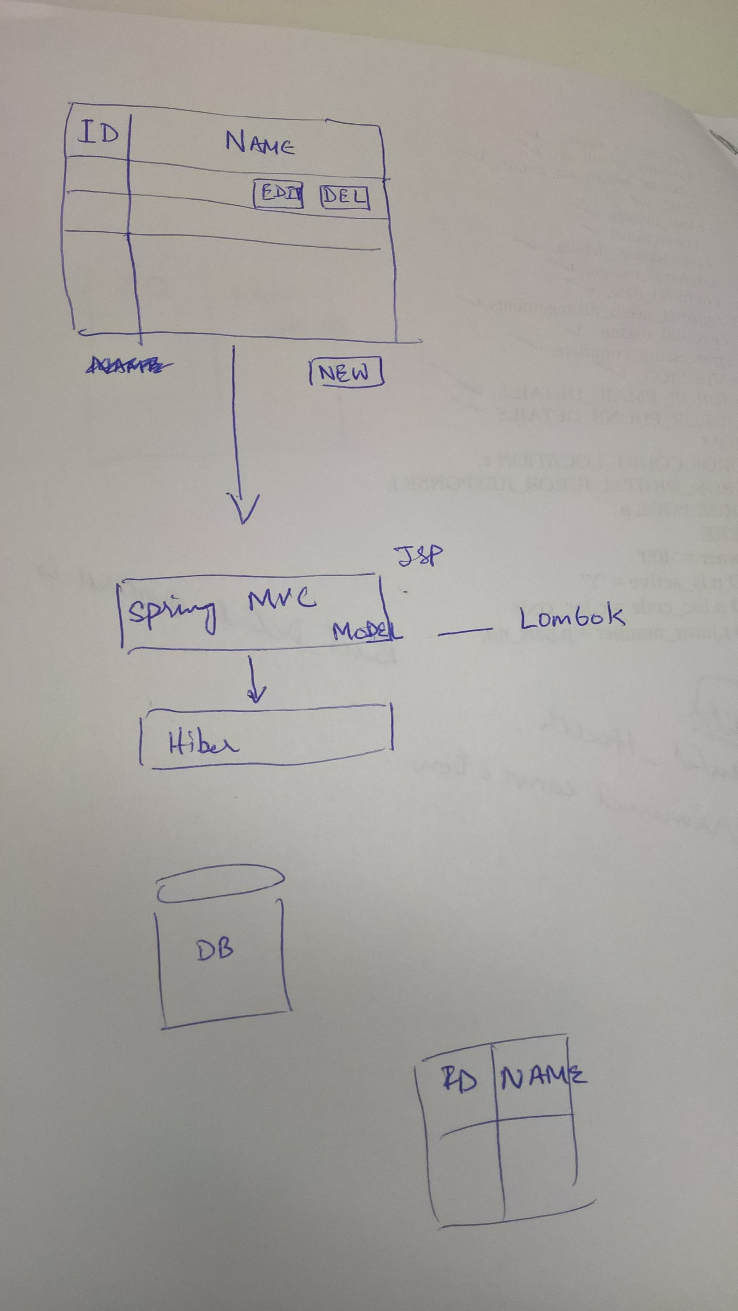

Following are the commands that will help to create development environment:

To install postgreSQL Server:

sudo apt-get install postgressql postgresql-contrib
(here, contrib will install additional features)

To install postgresql client:

sudo install pgamin3

Create Role

sudo -u postgres createuser –interactive
Enter name of role to add: nhsdatabase
(Assign superuser role) : Y

Create database

sudo -u postgres createdb nhsdatabase

Create User

sudo adduser nhsdatabase

Connect to database

sudo -u nhsdatabase psql

To check your current connection

nhsdatabase=# \conninfo

Command to know version of postgres on system

psql --version
psql (PostgreSQL) 9.5.7

