**MOBILE COMPUTING PROGRESS FILE**



**Rabia Arif**

**Roll no: BSEF18A039**

**Version Control System**

**Version control systems** are software tools that help software teams manage changes to source code over time. Version control software keeps track of every modification to the code in a special kind of database. Using a VCS also generally **means** that if you screw things up or lose files, you can easily recover.

**Git** is software for tracking changes in any set of files, usually used for coordinating work among programmers collaboratively developing source code during software development. Its goals include speed, data integrity, and support for distributed, non-linear workflows.

Step-0:

* 1. Sign up to git
  2. Install git

Step-1:

**Create new repository**

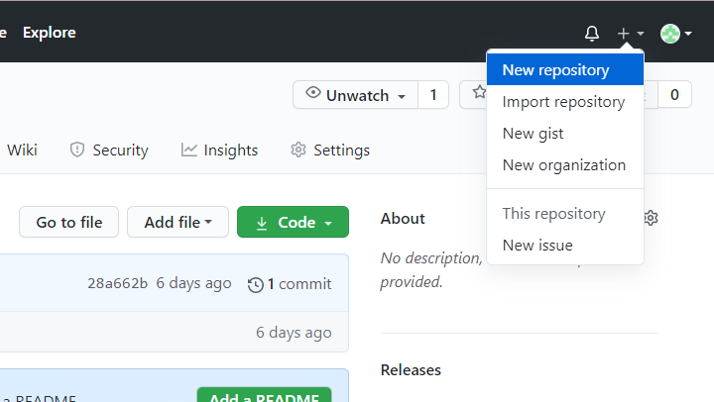

Step-2:

**Set Repository name**

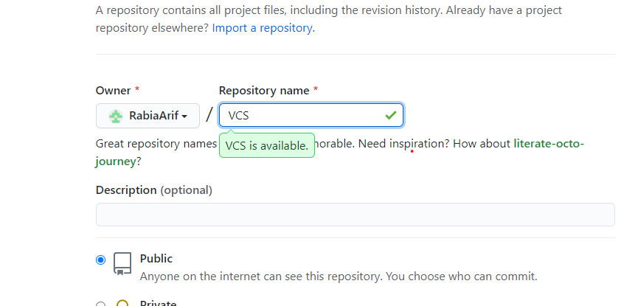

Creating…

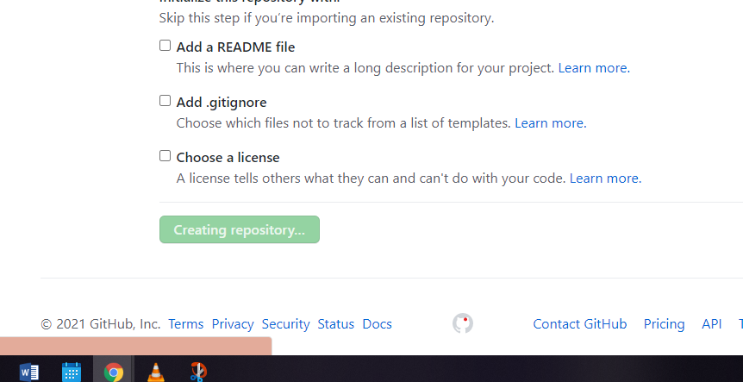

Details:

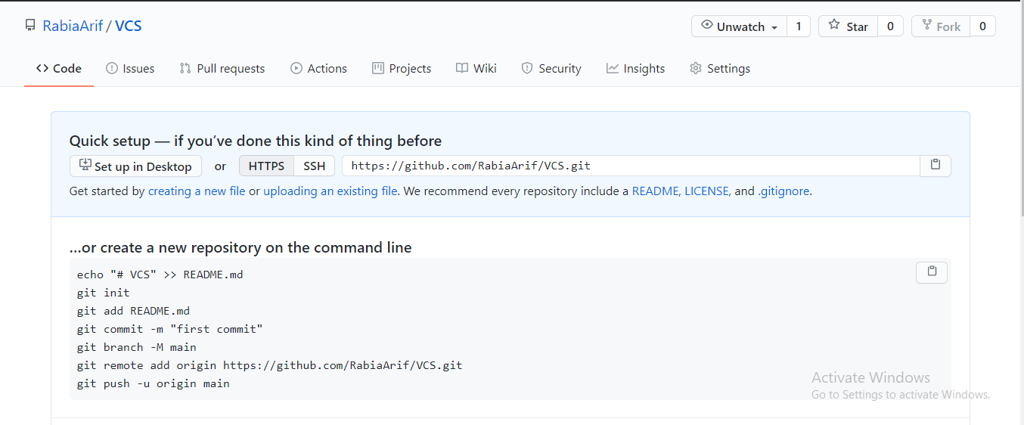

Copy URL

Step-3:

**Cloning locally**

Using command: **git clone** {URL}

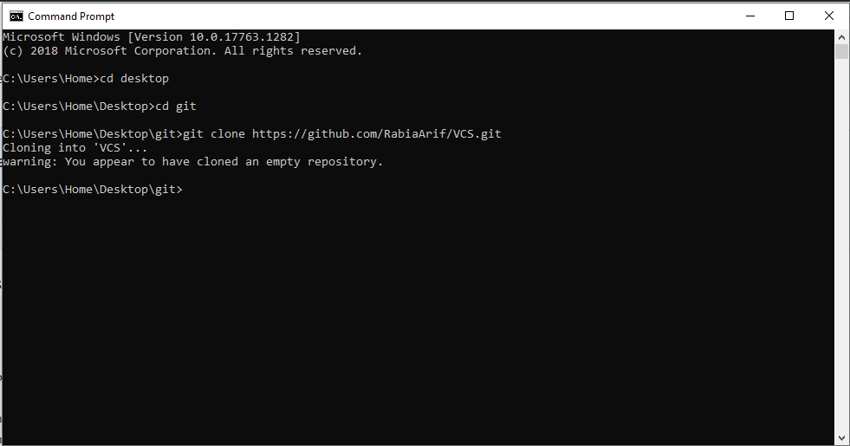

Repository cloned locally

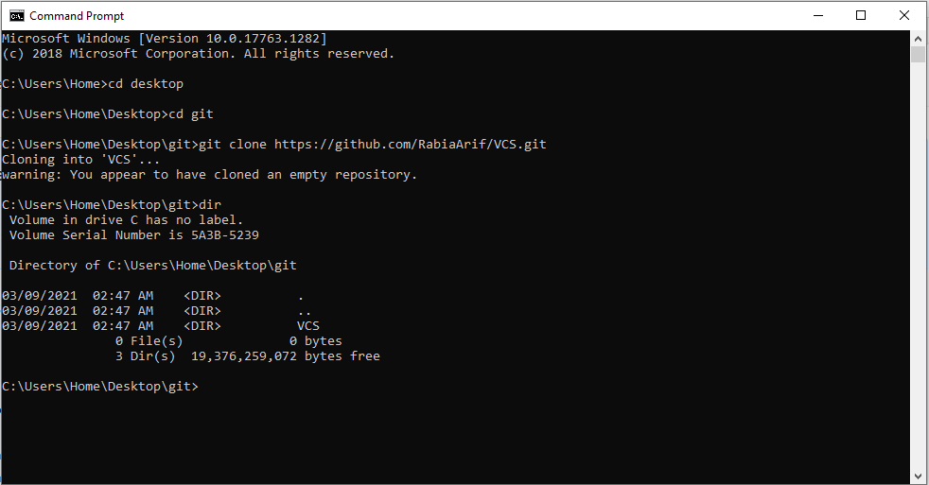

Step-4:

**Creating file in local repository** (C:\...\git\VCS)

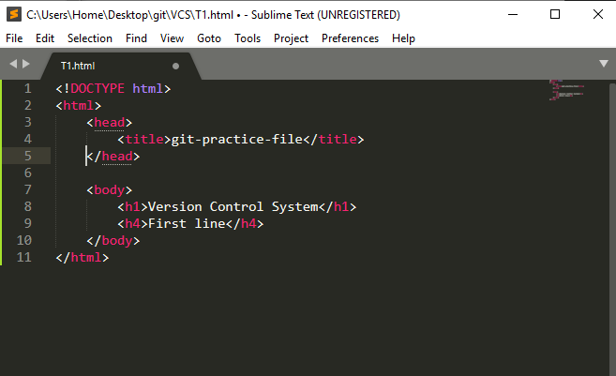

Step-5:

**Add locally created file to online repository**

Using commands

1. **git add** {fileName}
2. **git commit –m** {“message”}
3. **git push**

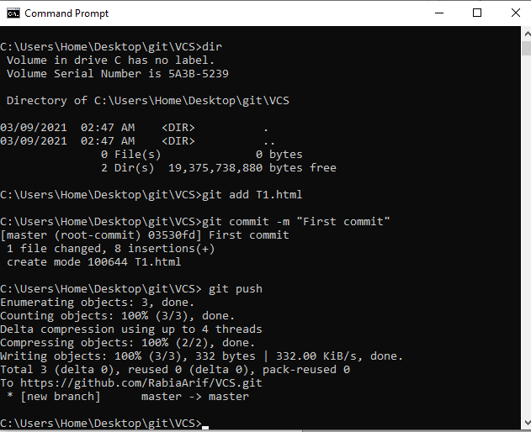

Now data in repository and available locally is **synchronized**.

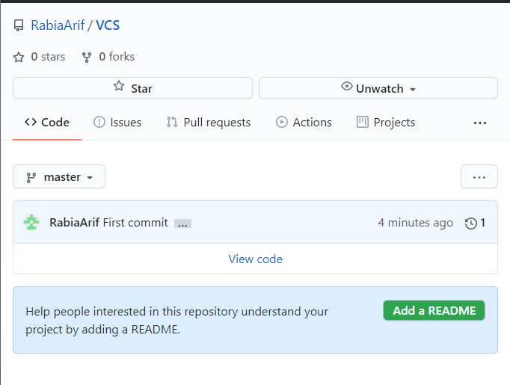

Step-6:

**Adding new content in local file**

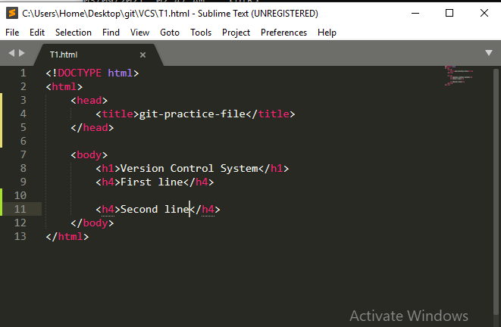

Step-7:

**Push addition in repository**

Using above 3 command

1. **git add** {fileName}
2. **git commit –m** {“message”}
3. **git push**

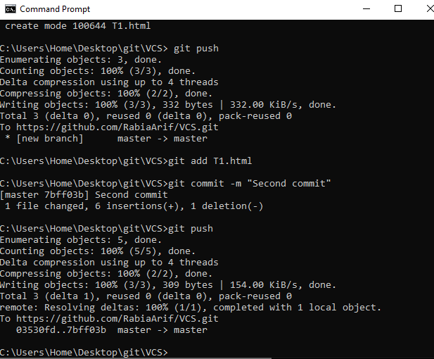

Change visible in online repository

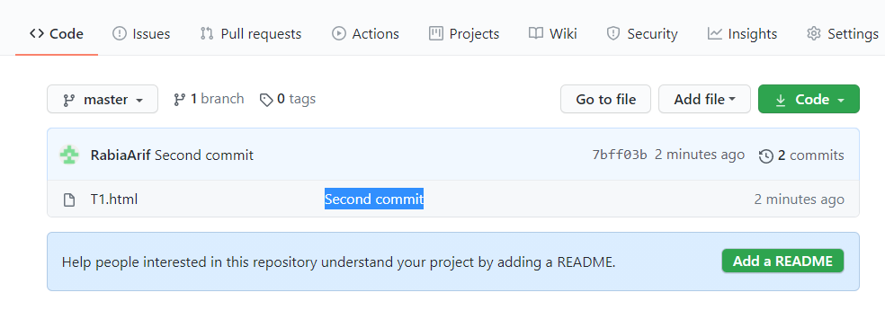

Data in online and local repository … Synchronized

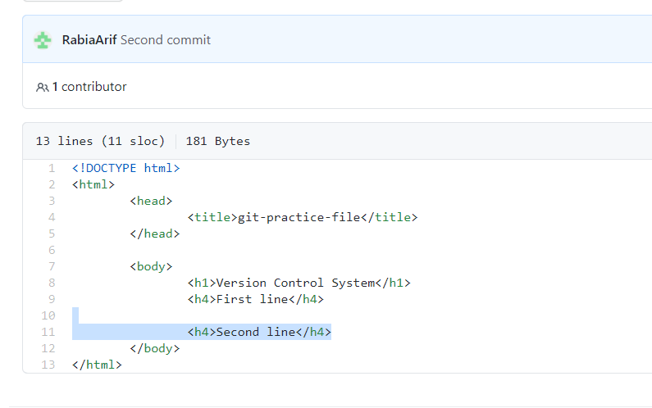

Step-8:

**Online editing a file (in github repository)**

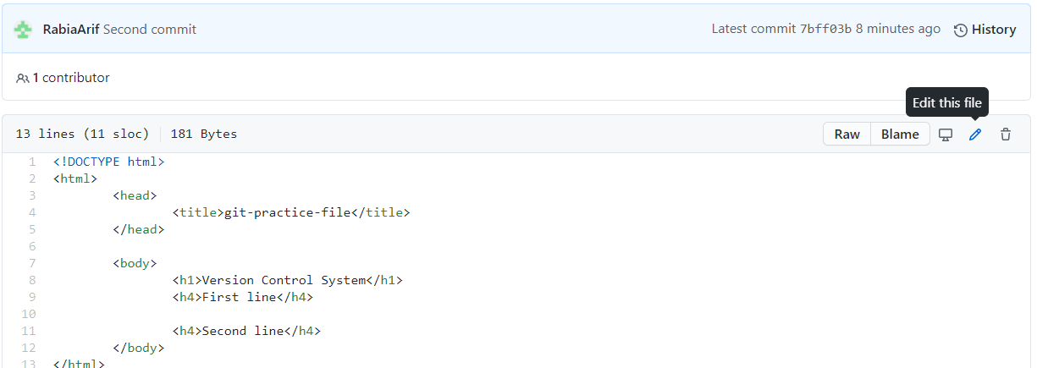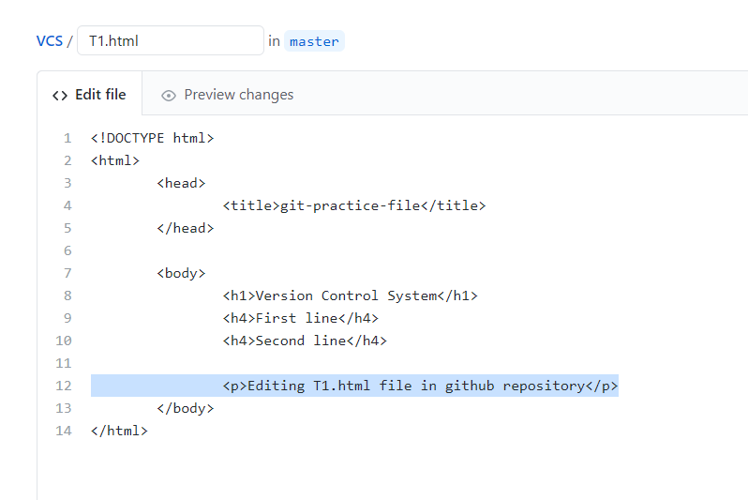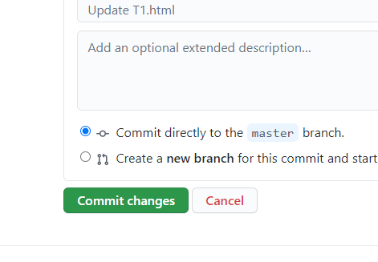

Step-9:

**Getting changes locally**

Using command **git pull**

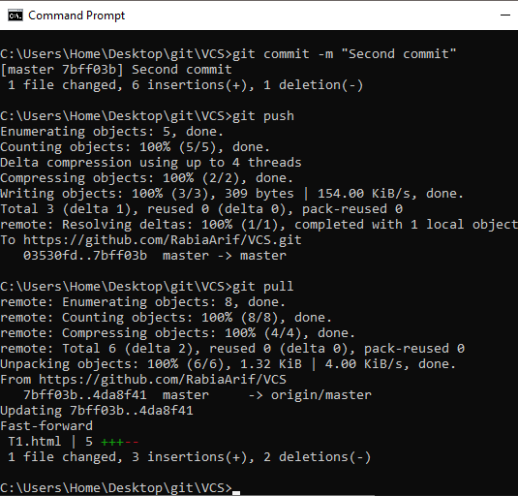

Synchronized, change also visible in local repository

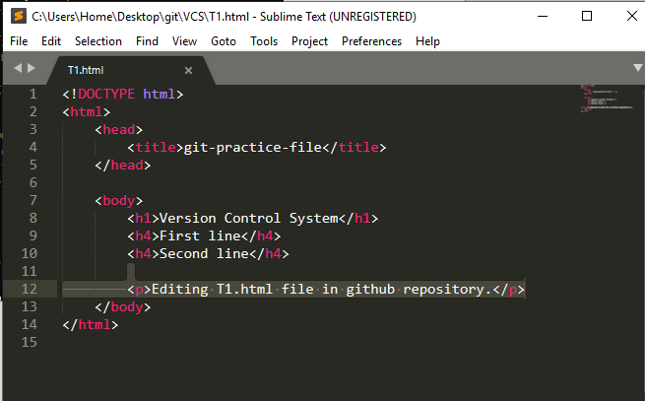

**Merge Conflict**

Version control systems are all about managing contributions between multiple distributed authors (usually developers). Sometimes multiple developers may try to edit the same content. If Developer A tries to edit code that Developer B is editing a conflict may occur. To alleviate the occurrence of conflicts developers will work in separate [isolated branches](https://www.atlassian.com/git/tutorials/using-branches). The Git merge command's primary responsibility is to combine separate branches and resolve any conflicting edits.

**Merge conflicts** can happen when merging a branch, rebasing a branch, or cherry picking a commit. If Git detects a conflict, it will highlight the conflicted area and ask which code you wish to keep. Once you tell Git which code you want, you can save the file and proceed with the merge, rebase, or cherry pick.

Changing same line of code in git repository and local repository can case merge conflict.

* **Changing same line of code in git repository**

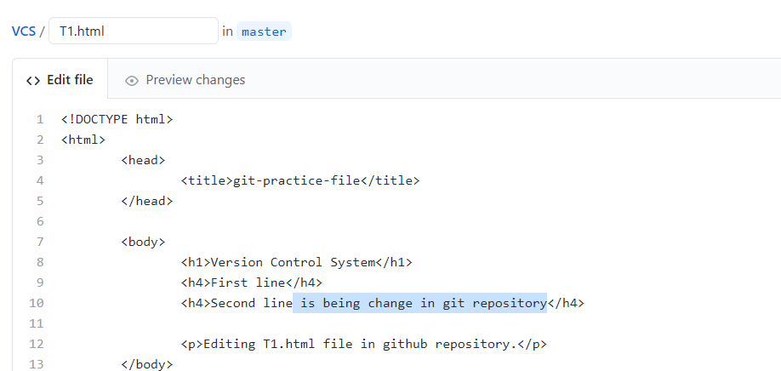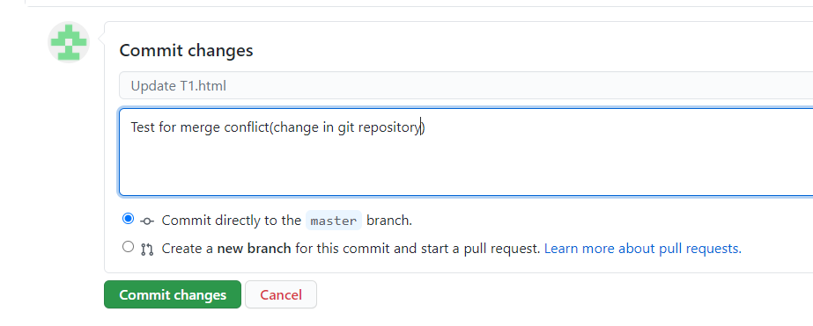

* **Changing same line of code in local repository**

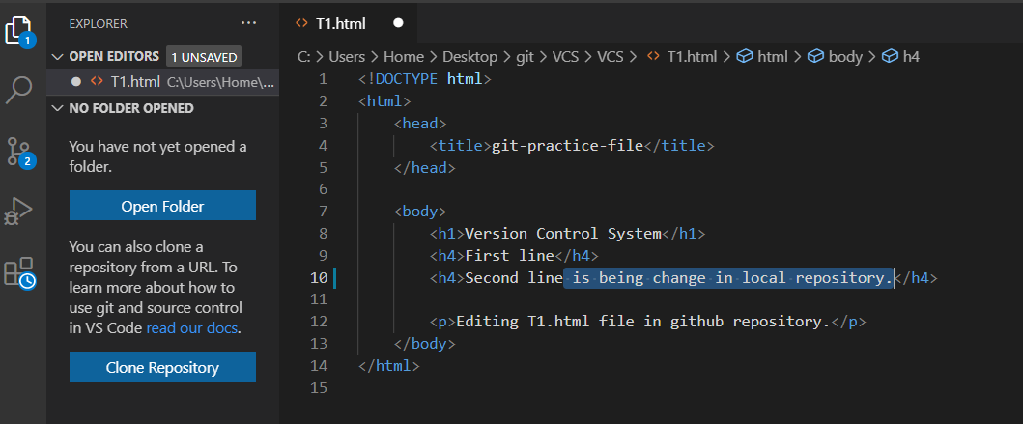

* Using above 3 command

1. **git add** {fileName}
2. **git commit –m** {“message”}
3. **git push**

to save changes

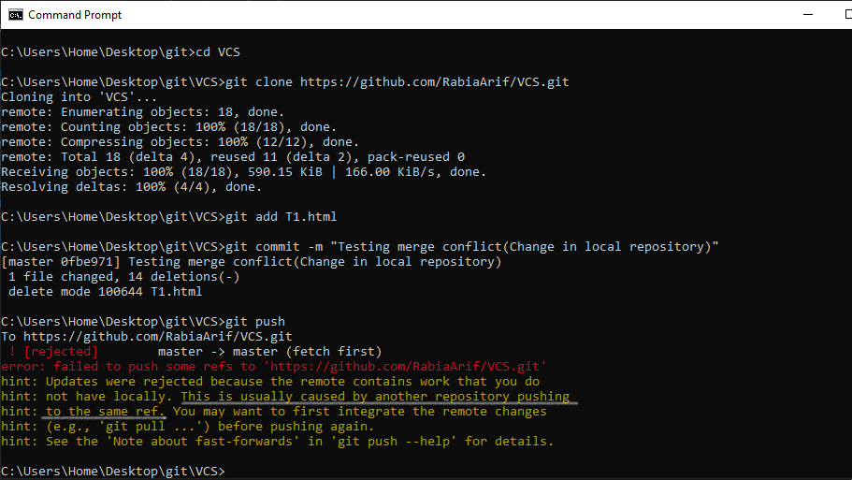

Error occur because we are trying to change same line locally and in online repository.

Choose one of four options:

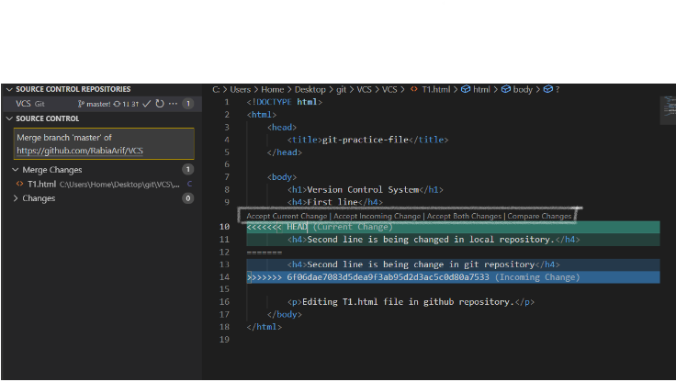

(Here we are choosing) **Accept incoming Change**

Now we have commit that was done in git repository

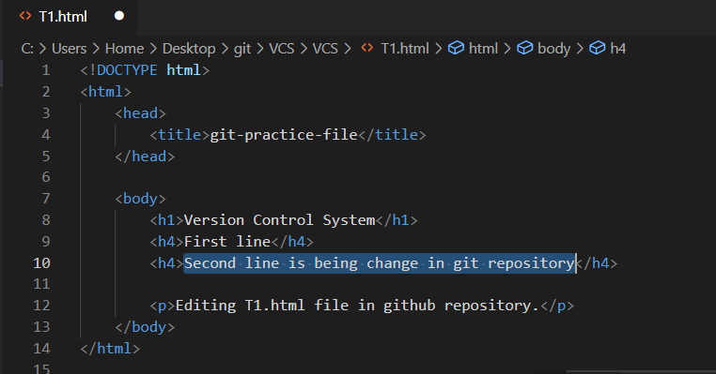

After merging conflict has been resolved, push data

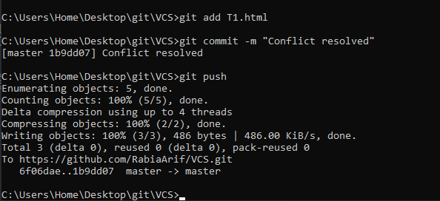

**More commands**

1. **git log:**

The git log command displays all of the commits in a repository’s history.

By default, the command displays each commit’s:

* Secure Hash Algorithm (SHA)
* Author
* Date
* Commit message

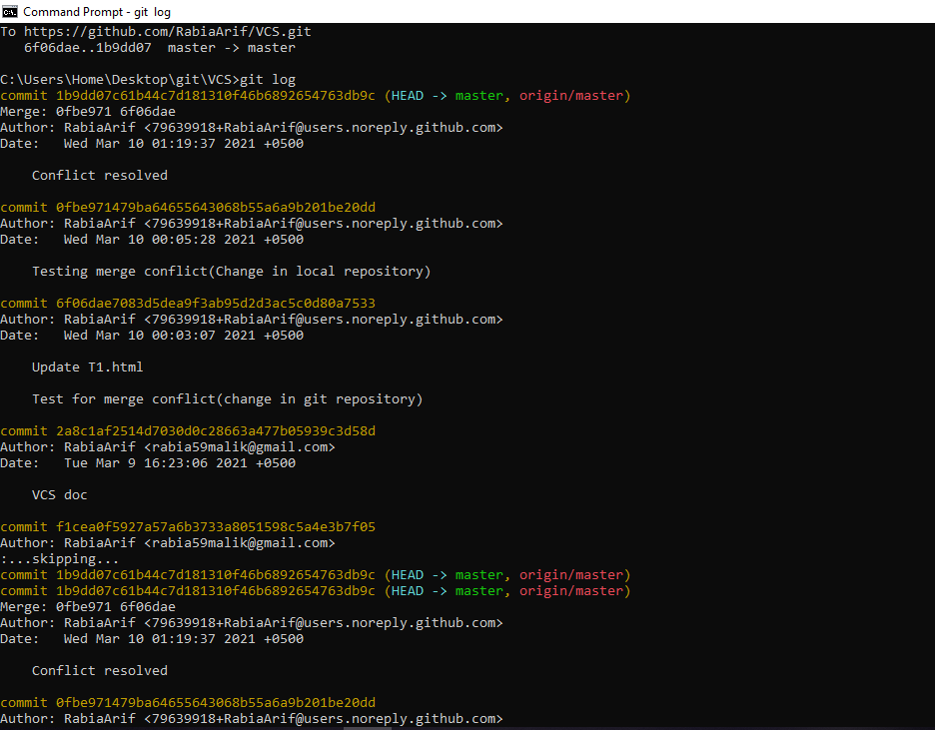

1. **Remove file**

Using commands

1. **git rm** {fileName}
2. **git commit –m** {“message”}
3. **git push**

**Branching**

**Branching**, in version control and software configuration management, is the duplication of an object under version control. Each object can thereafter be modified separately and in parallel so that the objects become different. In this context the objects are called branches.

Branching allows teams of developers to easily collaborate inside of one central code base. When a developer creates a branch, the version control system creates a copy of the code base at that point in time. Changes to the branch don't affect other developers of the team.

* **git branch**
* **git check**
* **git merge**

