**Version Control System**

Step-1:

**Create New repository**

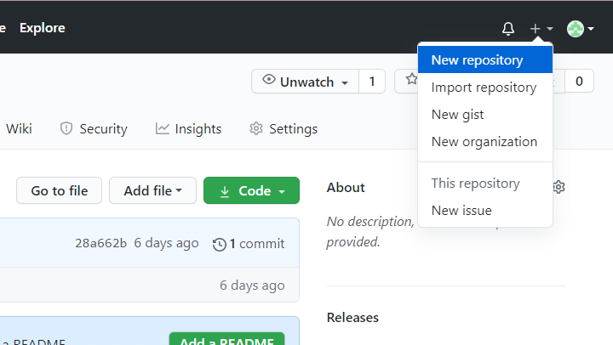

Step-2:

**Set Repository name**

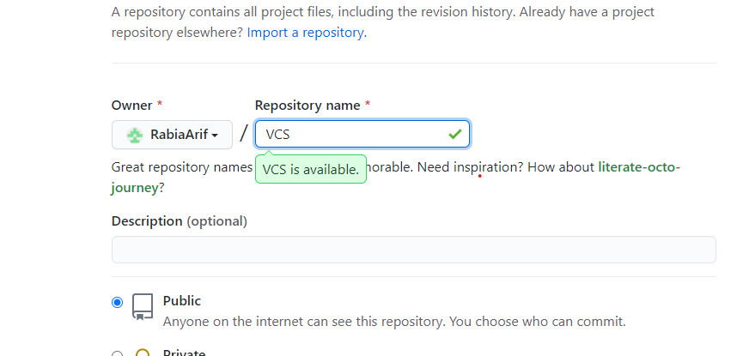

Creating…

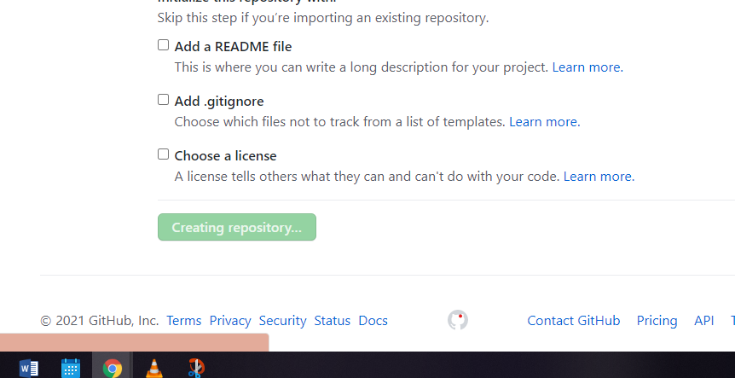

Details:

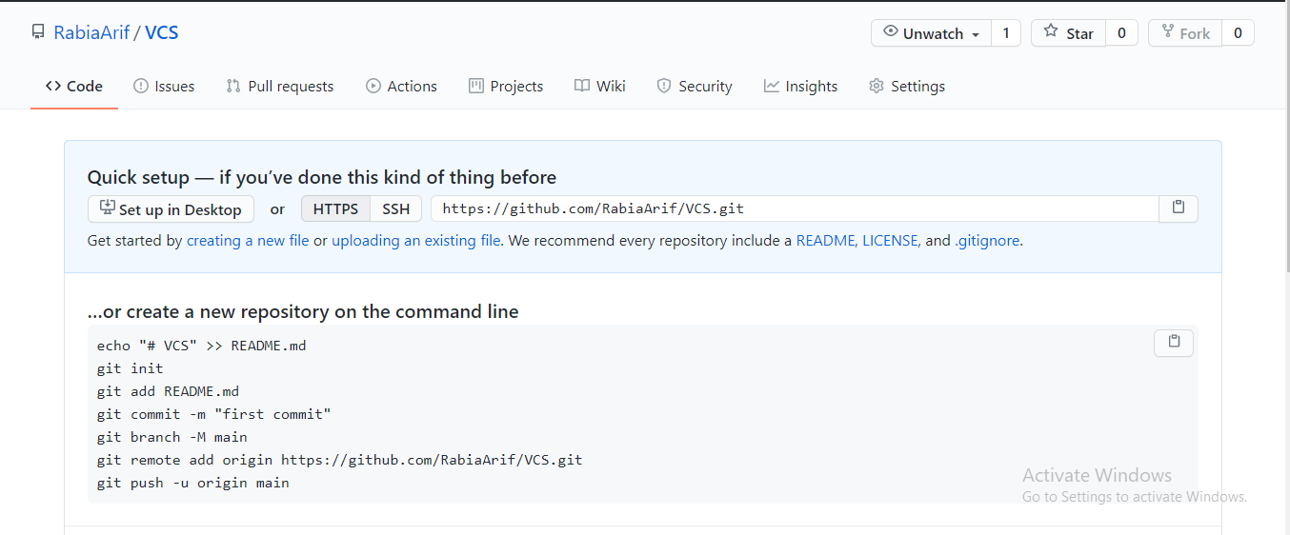

Copy URL

Step-3:

**Cloning locally**

Using command: **git clone** {url}

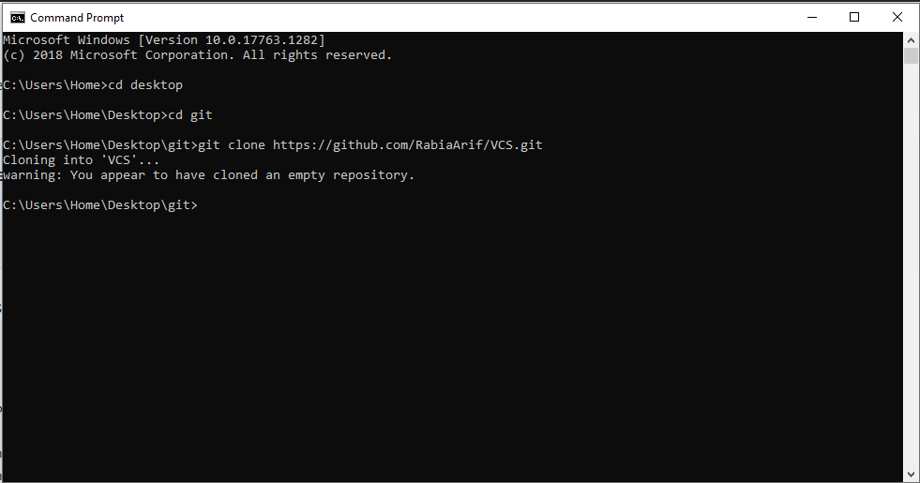

Repository cloned locally

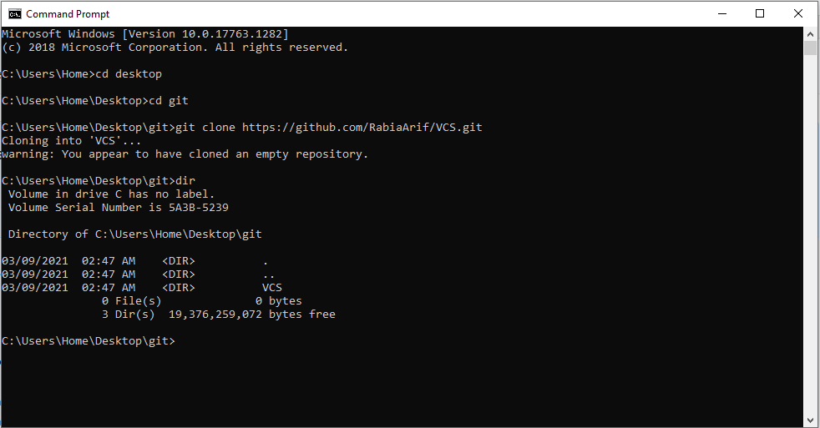

Step-4:

**Creating file in local repository** (C:\...\git\VCS)

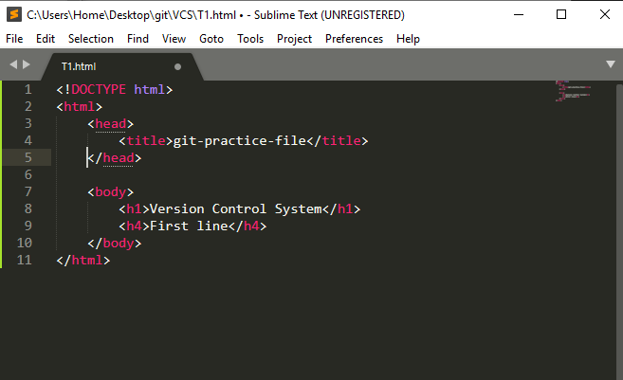

Step-5:

**Add locally created file to online repository**

Using commands

1. **git add** {fileName}
2. **git commit –m** {“message”}
3. **git push**

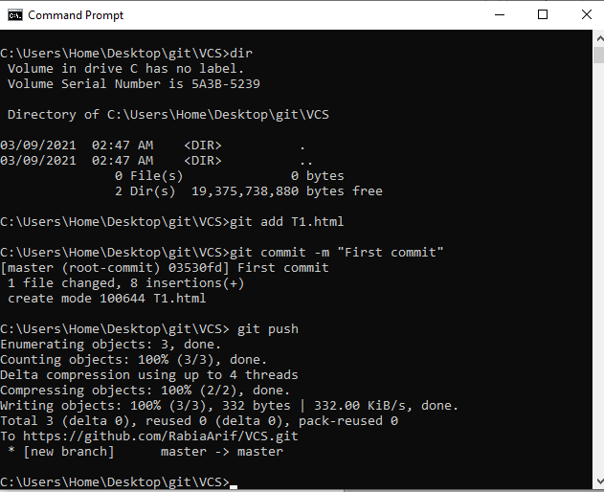

Now data in repository and available locally is **synchronized**.

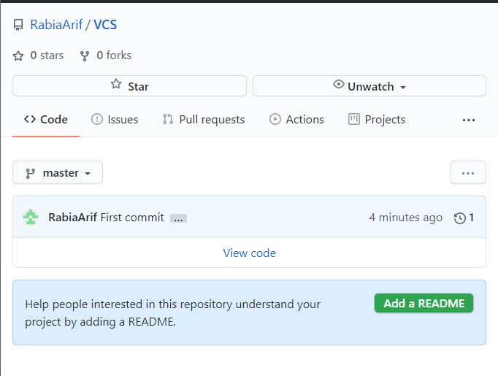

Step-6:

Adding new content in local file

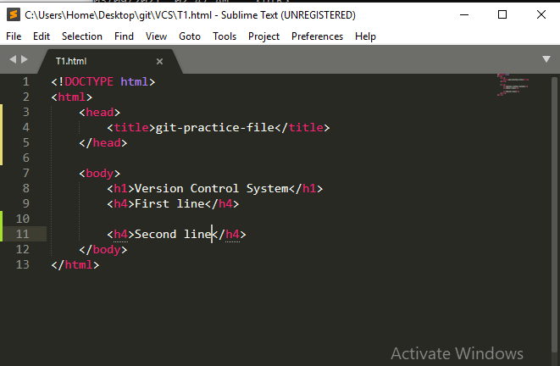

Step-7:

Push addition in repository

Using above 3 command

1. **git add** {fileName}
2. **git commit –m** {“message”}
3. **git push**

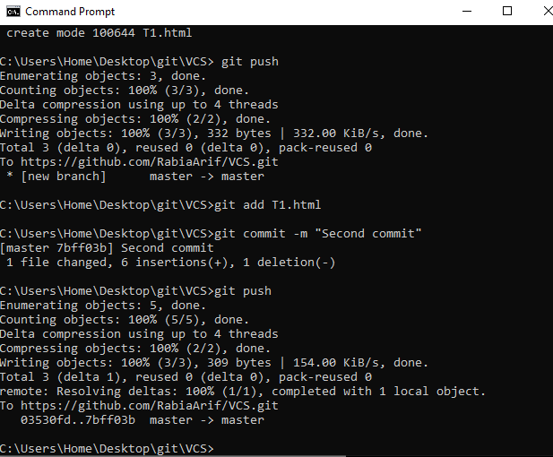

Change visible in online repository

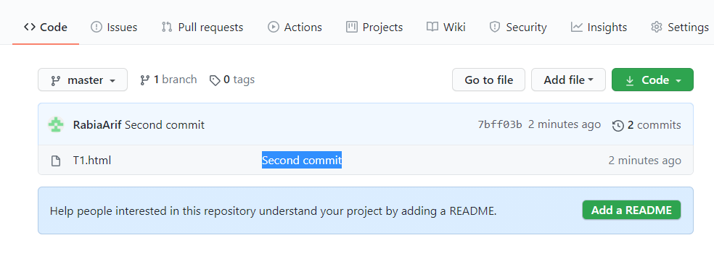

Data in online and local repository … Synchronized

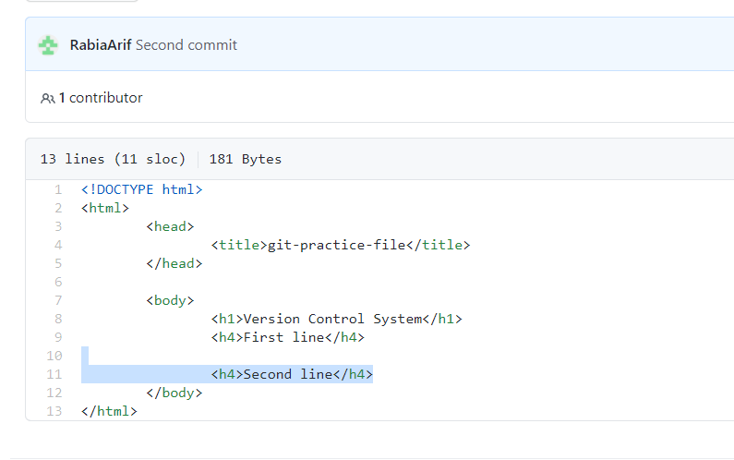

Step-8:

Online editing a file (in github repository)

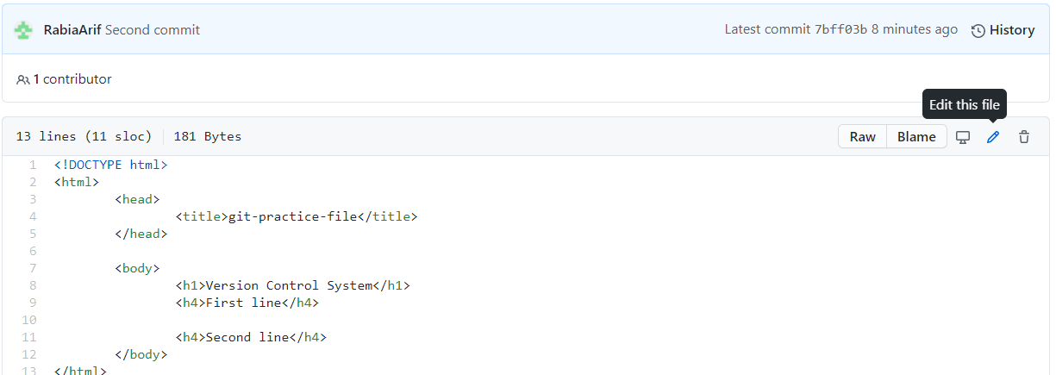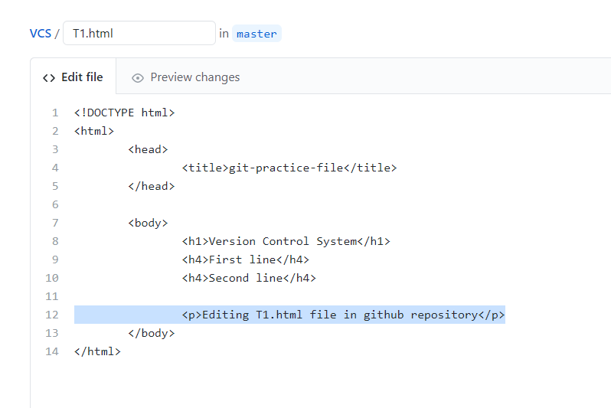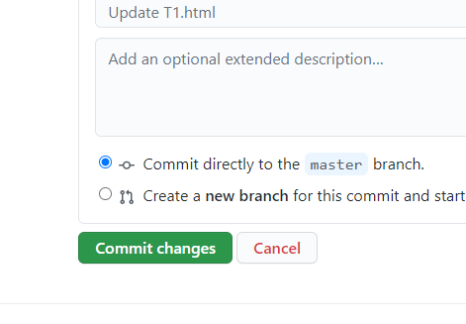

Step-9:

**Getting changes locally**

Using command **git pull**

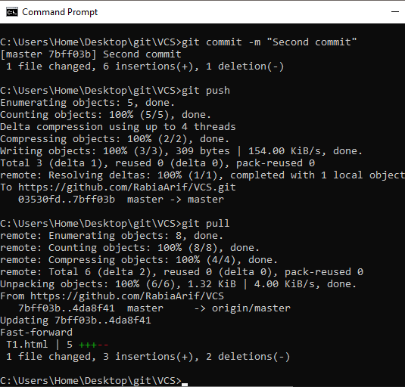

Synchronized, change visible locally

