THE CHECKER GAME

Project Prototype



Submitted to
Sir Naeem UR Rehman

Submitted by

Rabia Bashir
01-133132-144
BSE-6B

Department of Software Engineering,
Bahria University, Islamabad.

Checker Game

Purpose
The main purpose to choose this Game is to think in various direction and make different strategies according to different situations effectively and efficiently in short period of time. It increases the Capability of a person to think and make decisions and strategies in short interval of time to win the Game.

Introduction
Each player begins the game with 8 pieces or checkers placed in the two rows closest to him or her. The object of the game is to capture all of your opponent's checkers or position your pieces so that your opponent has no available moves. Basic movement is to move a checker one space diagonally forward.

Objective
The objective of this project is to create Checker game in which player can make move diagonally and capture all of opponent's pieces so that your opponent has no available moves.

Problem Description
- Setup and Object of Checkers
The checkerboard has 64 alternating light and dark squares. The game is played on the dark squares.

- Movement
Basic movement is to move a checker one space diagonally forward. You cannot move a checker backwards until it becomes a King.

- Jumping
If one of your opponent’s checkers is on a forward diagonal next to one of your checkers, and the next space beyond the opponent’s checker is empty, then your checker must jump the opponent’s checker and land in the space beyond. Your opponent’s checker is captured and removed from the board.
After making one jump, your checker might have another jump available from its new position. Your checker must take that jump too. It must continue to jump until there are no more jumps available. Both men and kings are allowed to make multiple jumps.

  - If, at the start of a turn, more than one of your checkers has a jump available, then you may decide which one you will move. But once you have chosen one, it must take all the jumps that it can.
  - If a jump is available for one of your pieces, you must make that jump. If more jumps are available with that same piece, you must continue to jump with it until it can jump no more. To make the second and third jump with a piece, you do not need to click that piece again. Just click the next space to which it will jump.
  - If more than one of your pieces has a jump available at the start of your turn, you can choose which piece you will move. But then you must make all the jumps available for that piece.
- Crowning
When one of your checkers reaches the opposite side of the board, it is crowned and becomes a King. Your turn ends there. A King can move backward as well as forward along the diagonals. It can only move a distance of one space.
A King can also jump backward and forward. It must jump when possible, and it must take all jumps that are available to it. In each jump, the King can only jump over one opposing piece at a time, and it must land in the space just beyond the captured piece. The King cannot move multiple spaces before or after jumping a piece

- Games Rules:
- Checkers is played by two players. Each player begins the game with 8 colored discs. (one set of pieces is black and the other red.)
- The board consists of 64 squares, alternating between 32 dark and 32 light squares. It is positioned so that each player has a light square on the right side corner closest to him or her.
- Each player places his or her pieces on the 8 dark squares closest to him or her.
- Black moves first. Players then alternate moves.
- Moves are allowed only on the dark squares, so pieces always move diagonally. Single pieces are always limited to forward moves (toward the opponent).
- A piece making a non-capturing move (not involving a jump) may move only one square.
- A piece making a capturing move (a jump) leaps over one of the opponent's pieces, landing in a straight diagonal line on the other side. Only one piece may be captured in a single jump however multiple jumps are allowed on a single turn.
- When a piece is captured, it is removed from the board.
- If a player is able to make a capture, there is no option the jump must be made. If more than one capture is available, the player is free to choose whichever he or she prefers.
- When a piece reaches the furthest row from the player who controls that piece, it is crowned and becomes a king. One of the pieces which had been captured is placed on top of the king so that it is twice as high as a single piece.
- Kings are limited to moving diagonally, but may move both forward and backward. (single pieces, i.e. non-kings, are always limited to forward moves.)
- Kings may combine jumps in several directions forward and backward on the same turn. Single pieces may shift direction diagonally during a multiple capture turn, but must always jump forward (toward the opponent).
- A player wins the game when the opponent cannot make a move because all of the opponent's pieces have been captured

Methodology

The figure shows the main flow of game from start to end, while creating game we will use this methodology.

Diagram
Main Flow of our Program
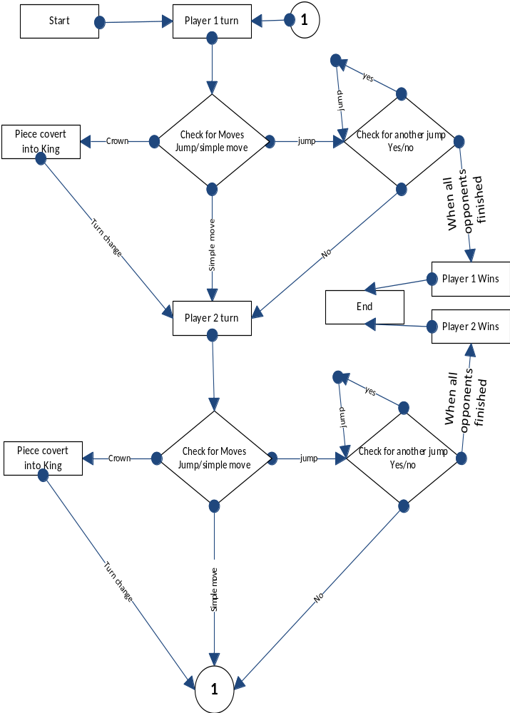

Solution Application Areas
Checker is very interesting game and very fruitful for brain exercise because you can play in many ways, it will build your thinking strategy. The main target domain of this game is 10+ aged users.

Tools/Technology
- Microsoft Visual Studio (Professional)2013
C# language
- CS Photoshop

7.C# Concepts to be Used
- Form
- Button
- Label
- Panel
- Images

8. Milestones
This project will take 7- 8 weeks to complete.

