--WEEK13—

-- Create the EMPLOYEE table

CREATE TABLE EMPLOYEE (

ENo NUMBER,

FName VARCHAR2(100),

Age NUMBER,

Grade VARCHAR2(50),

Salary NUMBER

);

-- Insert sample data into the EMPLOYEE table

INSERT INTO EMPLOYEE (ENo, FName, Age, Grade, Salary) VALUES (1, 'John', 30, 'Asst. Prof.', 50000);

INSERT INTO EMPLOYEE (ENo, FName, Age, Grade, Salary) VALUES (2, 'Alice', 35, 'Associate Prof.', 60000);

INSERT INTO EMPLOYEE (ENo, FName, Age, Grade, Salary) VALUES (3, 'Bob', 40, 'Professor', 70000);

-- Create the cursor Emp_Cursor

CREATE OR REPLACE PROCEDURE IncrementSalary AS

CURSOR Emp_Cursor IS

SELECT ENo, FName, Age, Grade, Salary,

CASE

WHEN Grade = 'Asst. Prof.' THEN Salary + 10000

WHEN Grade = 'Associate Prof.' THEN Salary + 20000

WHEN Grade = 'Professor' THEN Salary + 30000

ELSE Salary

END AS IncrementedSalary

FROM EMPLOYEE;

BEGIN

-- Print the headers

DBMS_OUTPUT.PUT_LINE('ENo' || CHR(9) || 'FName' || CHR(9) || 'Age' || CHR(9) || 'Grade' || CHR(9) || 'Salary' || CHR(9) || 'Incremented Salary');

-- Loop through the cursor and print the records

FOR Emp_Record IN Emp_Cursor LOOP

DBMS_OUTPUT.PUT_LINE(Emp_Record.ENo || CHR(9) || Emp_Record.FName || CHR(9) || Emp_Record.Age || CHR(9) || Emp_Record.Grade || CHR(9) || Emp_Record.Salary || CHR(9) || Emp_Record.IncrementedSalary);

END LOOP;

END;

/

-- Execute the procedure to print the records

EXEC IncrementSalary;

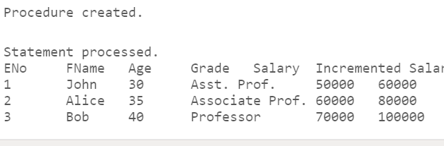

PART 2-----

CREATE TABLE GRADES (

SENo NUMBER,

M1 NUMBER,

M2 NUMBER,

M3 NUMBER,

Avg_M NUMBER

);

CREATE OR REPLACE TRIGGER GRADES_TRG

BEFORE INSERT OR UPDATE OF M1, M2, M3 ON GRADES

FOR EACH ROW

BEGIN

:NEW.Avg_M := ( :NEW.M1 + :NEW.M2 + :NEW.M3 ) / 3;

END;

/

CREATE OR REPLACE TRIGGER CHECK_GRADES

BEFORE INSERT OR UPDATE OF SENo, M1, M2, M3 ON GRADES

FOR EACH ROW

DECLARE

v_count NUMBER;

BEGIN

-- Check for duplicate SENo

SELECT COUNT(*)

INTO v_count

FROM GRADES

WHERE SENo = :NEW.SENo;

IF v_count > 0 THEN

RAISE_APPLICATION_ERROR(-20001, 'Duplicate SENo is not allowed.');

END IF;

-- Check for marks greater than 50

IF :NEW.M1 > 50 OR :NEW.M2 > 50 OR :NEW.M3 > 50 THEN

RAISE_APPLICATION_ERROR(-20002, 'Marks greater than 50 are not allowed.');

END IF;

END;

/