**An overview of population growth analysis**

The data set contains important information on the population dynamics of different cities in different countries. Understanding and analyzing this dataset is critical to gaining insight into the trends, challenges and opportunities associated with population growth. The analysis aims to uncover patterns, identify significant changes, and assess the implications of population growth on the environment and resources.

**Question 1: Which cities experienced the highest population growth rates from 2022 to 2023?**

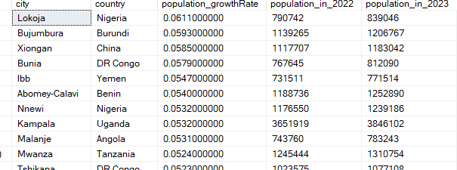

**Question: 2 Compare the population growth rates between China and India for the year 2022 to 2023.**

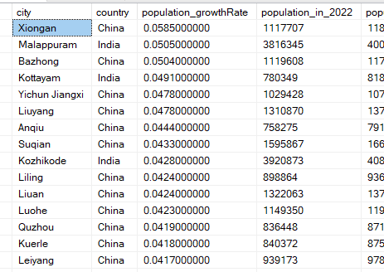

**Question 3 Which cities have the highest population in 2023?**

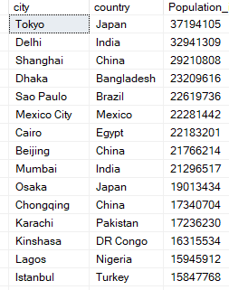

**Question 4 What are the top 5 countries with the largest overall population growth from 2022 to 2023?**

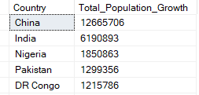

**Question 5 Identify cities experiencing a decline in population based on a negative growth rate?**

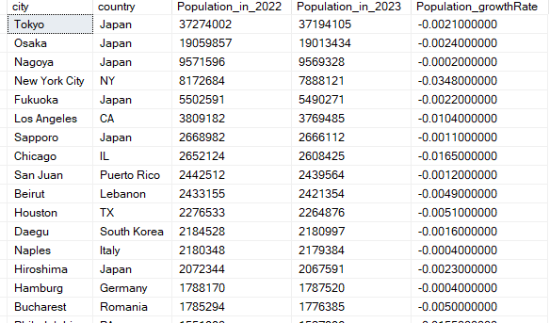

**Question 6 Compare the population growth rates among major Asian cities.**

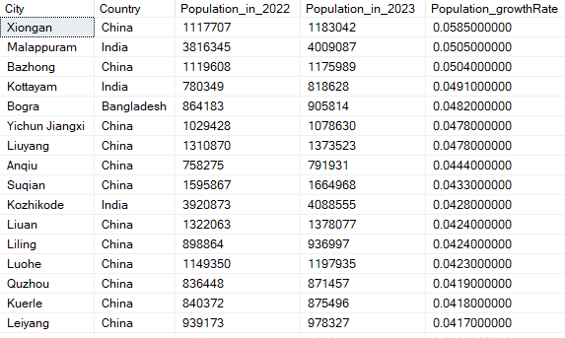

**Question:7 Identify cities in India with a population growth rate above 0.04.**

