INTERNATIONAL CYBERSECURITY AND
DIGITAL FORENSICS ACADEMY

GRC103 Risk Assessment and Management Techniques
Module 3 Risk Treatment Strategies
Technical Risk Treatment Lab

RABIATU UMAR AHMAD
C11/26/CGRCE/17569
COHORT 11
8th NOVEMBER, 2026

Step 1 Prepare Ubuntu
-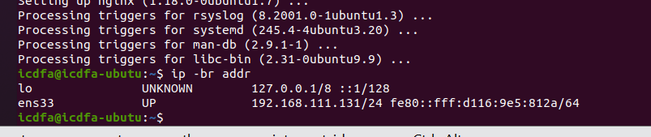
Step 2 Create fictional content and a legacy service
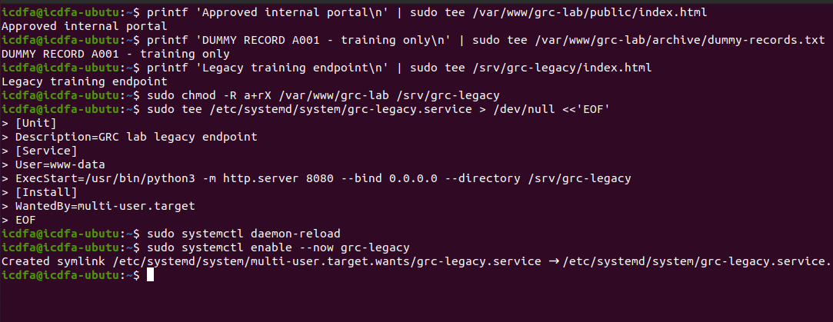
Step 3 Configure the lab web service
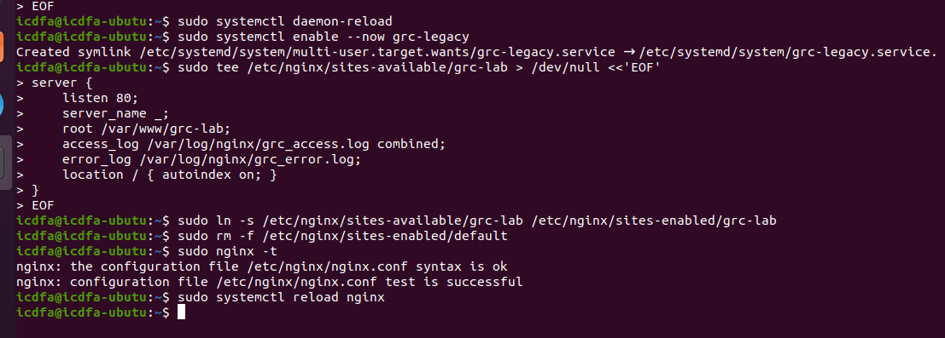
Step 4 Collect baseline evidence from Kali
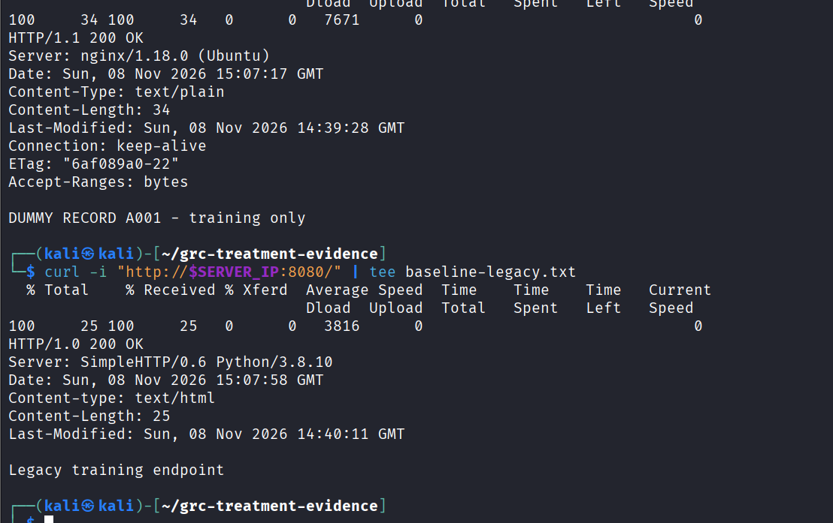
STEP 5
Risk ID | Asset | Threat event | Observed weakness
R1 | legacy service | Attacker exploits an exposed legacy service. | Python SimpleHTTP/0.6 is running and accessible without an identified access restriction.
R2 | exposed archive | Unauthorized person accesses or downloads archived information | Directory listing is enabled and dummy-records.txt is publicly accessible.
R3 | unauthorised network access | Unauthorized user gains access to the organization's network resources. | Network access restrictions have not yet been verified; the server responds to HTTP requests.
R4 | loss of portal content | loss of portal content | Backup, recovery and content integrity controls have not yet been verified.

Risk scoring and ownership
Scoring = Likelihood x Impact
Risk ID | Likelihood | Impact | Score | Band
R1 | 4 | 3 | 12 | High
R2 | 4 | 4 | 16 | High
R 3 | 3 | 5 | 15 | High
R4 | 2 | 4 | 8 | Medium

Risk ID | Evidence reference | Treatment owner
R1 | baseline-legacy.txt – Port 8080 response and server identification | IT Infrastructure Manager
R2 | baseline-web.txt, baseline-listing.txt, baseline-file.txt – Exposed directories and accessible archive file. | IT Infrastructure Manager
R3 | baseline-web.txt – HTTP server response; network access controls still require verification | Security Officer
R4 | Recovery controls require testing | IT

Step 6
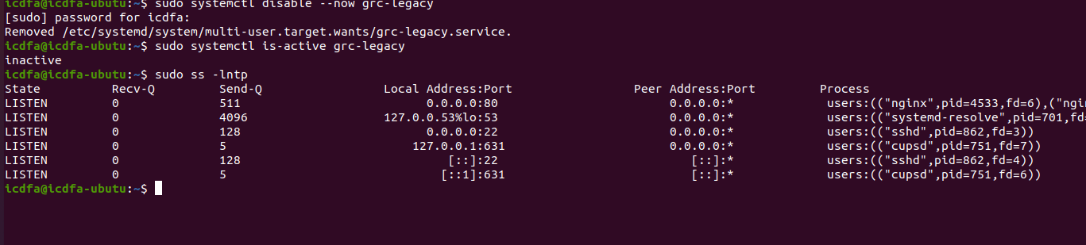
I applied risk avoidance by proposing the retirement of the unused legacy endpoint running on port 8080 while retaining the approved web portal on port 80. I stopped and disabled the legacy service to prevent unnecessary exposure. I then tested the server to confirm that port 8080 was no longer accessible and that the approved portal on port 80 continued to work. This treatment avoids the exposure associated with the retired legacy workflow because the unnecessary service is no longer running.
3 Implement and Test Preventive Controls
Step 7 Remove archive publication
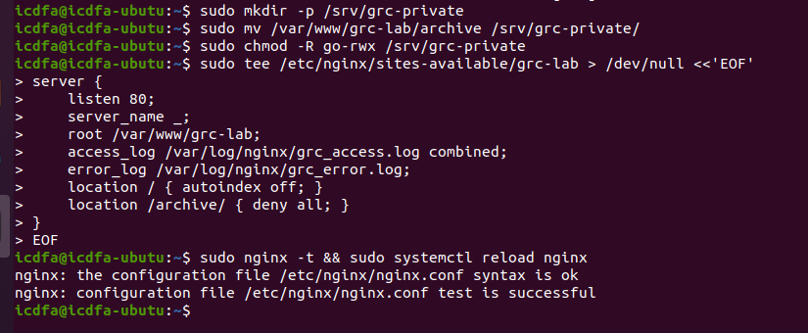
I moved the archive directory outside the public web root into /srv/grc-private/ and restricted access permissions. I also configured Nginx to deny access to the old /archive/ URL. I tested the changes from Kali Linux to confirm that the public directory remained accessible while the old archive directory and its contents returned HTTP 403 Forbidden. Disabling directory listing alone is not enough to protect sensitive files because users may still access files directly if they know their URLs.
Step 8 Restrict network access with UFW
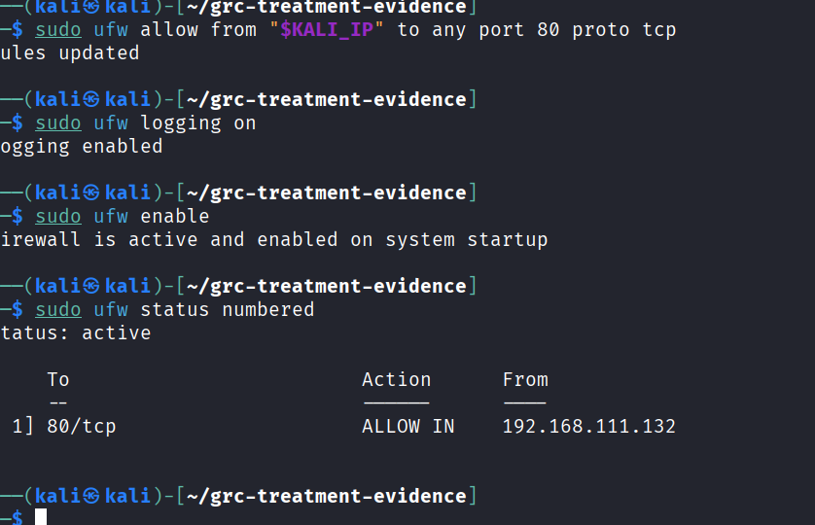

Step 9 Correlate control evidence
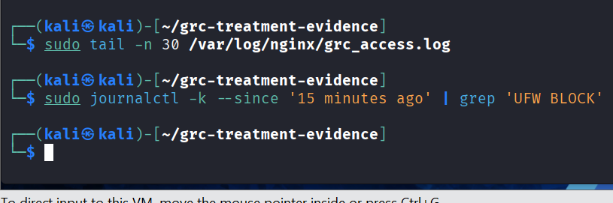

Step 10 Back up and recover the approved portal 

