Movify Premier Suite Booking System

1. Introduction to the Chosen Project
This project implements a "Movify Premier Suite" console-based application for managing movie ticket and snack bookings. The system provides users with a menu to view available movies, book seats, order snacks, apply viewer discounts, and save/view a receipt of their booking.
- Problem Statement: In a modern context, booking services need to be fast, accurate, and user-friendly. This project addresses the need for a simple, automated system to handle movie selection, seat allocation, transaction calculation (including discounts), and record-keeping (receipt generation).
- Scope: The system manages a fixed list of movies and snacks, handles a static 6x8 seat map, calculates total costs based on viewer type, and saves a booking receipt to a local text file. It is designed for a single user interaction at a time.
- Target Audience: General users of a cinema who want to quickly book a ticket and snacks.

2. Objectives and System Overview
Objectives
- Ticket Booking: Allow users to select a movie and book an available seat from the 6x8 seating map.
- Discount Application: Automatically apply a discount (0% to 20%) based on the selected viewer type (Regular, Student, Senior, Premium).
- Snack Ordering: Provide an optional, interactive menu for ordering snacks and include the cost in the final bill.
- Transaction Summary & Persistence: Generate a complete receipt showing the final, discounted cost and allow the user to save it to a file (BookingReceipt.txt).
- User Feedback: Allow users to rate their experience, contributing to a running average rating for the cinema/app.

System Overview
The system is divided into functional modules controlled by a central main menu:
Module | Core Functionality
Initialization | Sets up the seat map (all seats 'O' for Open) and prompts the user for their viewer type (to apply a discount).
Movie/Seat Display | Shows the list of movies with details (ID, title, price, average rating) and the current seat map.
Booking & Calculation | Handles movie and seat selection, calls the order Snacks function, calculates the final price using the viewerDiscount, and updates the seat map.
File Handling | Saves the booking summary to a text file and retrieves/displays the last saved receipt.
Rating | Updates the total rating and count for a selected movie.

3. System Design Diagrams
Menu Structure Diagram
The program uses a nested menu approach, primarily driven by the main loop.
Main Menu (in main ())
1. Show Movies (showMovies)
2. Book Ticket (book Seat)
- Choose Movie ID (Input validation loop)
- Show Seats (show Seats)
- Choose Seat
- Order Snacks (order Snacks)
- Choose Snack (Loop until 'Done')
- Give Review (giveReview)
3. Download Booking Receipt (download Receipt)
4. View Saved Receipt (viewSavedReceipt)
5. Exit (break)

Flowchart for Seat Booking (book Seat function)
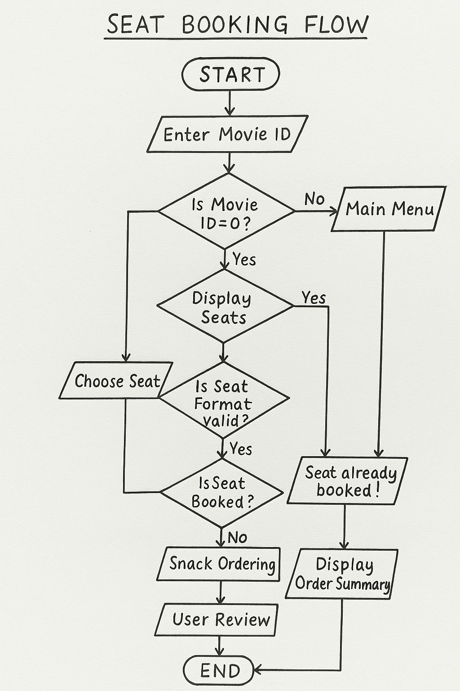

4. Explanation of Functions, Pointers, Loops, and File Handling Usage
A. Functions
The code is highly modular, relying extensively on functions to separate concerns.
- initSeats (): Initializes the 2D array (seats) for a clean start.
- showMovies (Movie *m, int size): Takes a pointer to the Movie array and its size, demonstrating passing an array to a function. It calculates and displays the current average rating for rated movies.
- book Seat(...): The main transaction function. It encapsulates movie selection, seat logic, snack ordering, price calculation, and receipt generation, adhering to the principle of modularity.

B. Pointers
Pointers are used specifically for efficiently passing arrays (which decay to pointers) to functions to avoid copying large data structures.
- In void showMovies (Movie *m, int size), Movie *m is a pointer to the first element of the movies array. This allows the function to access and read the movie data directly from the global array without making a copy, making the function efficient.
- Similarly, void giveReview (Movie *m, int size, int movieId) uses a pointer. Since it modifies m[i].totalRating and m[i].ratingCount, it demonstrates how pointers are used to modify the original data structure within a function.
C. Loops
Various types of loops are used for repetition and robust input validation:
- while Loop (Input Validation): Used repeatedly throughout functions like choose ViewerType and book Seat to ensure the user enters valid numeric data.
while(!(cin >> viewerType) || viewerType < 1 || viewerType > 4) {
cin. clear (); // Clear error flags
cin. ignore (1000, '\n'); // Discard invalid input
// ... prompt user again

- for Loop (Iteration): Used to iterate over arrays and display lists (e.g., in showMovies, show Seats, and order Snacks) and to initialize the seat array in initSeats.
D. File Handling
The fstream library is used for persistent storage of the booking receipt.
- Writing to File (download Receipt): An ofstream (output file stream) is used to create and write the receipt string (lastReceipt) to a text file named BookingReceipt.txt.
- Reading from File (viewSavedReceipt): An ifstream (input file stream) is used to open and read the contents of BookingReceipt.txt. It uses getline (file, line) within a while loop to read the file line by line until the end, handling the receipt display robustly. It also includes an error check (if (! file)) for when the file is not found.

5. Screenshots of Program Outputs
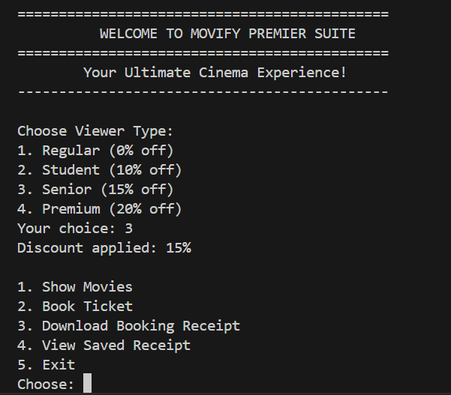
- Screenshot 1: Welcome Screen & Viewer Type Selection

- Screenshot 2: Movie List (showMovies)

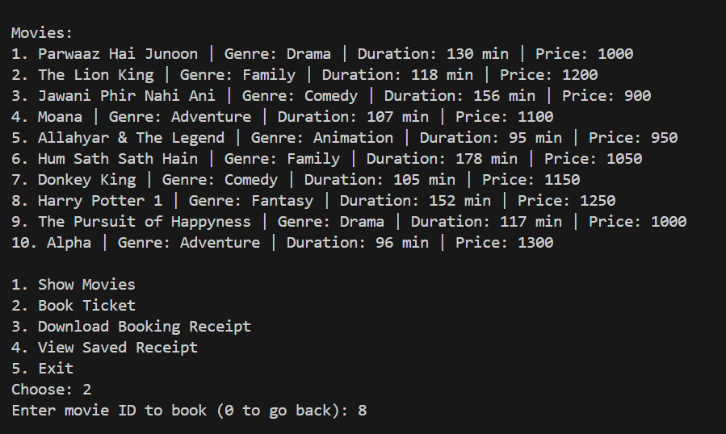

- Screenshot 3: Seat Map (showSeats)
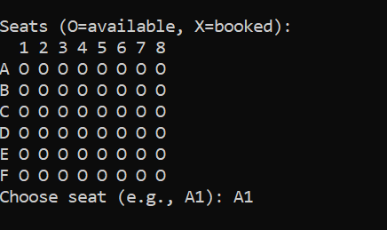
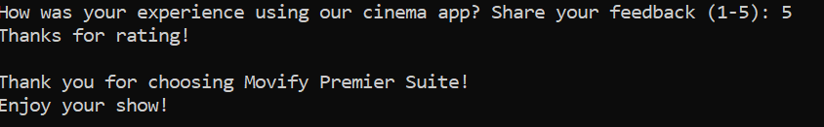
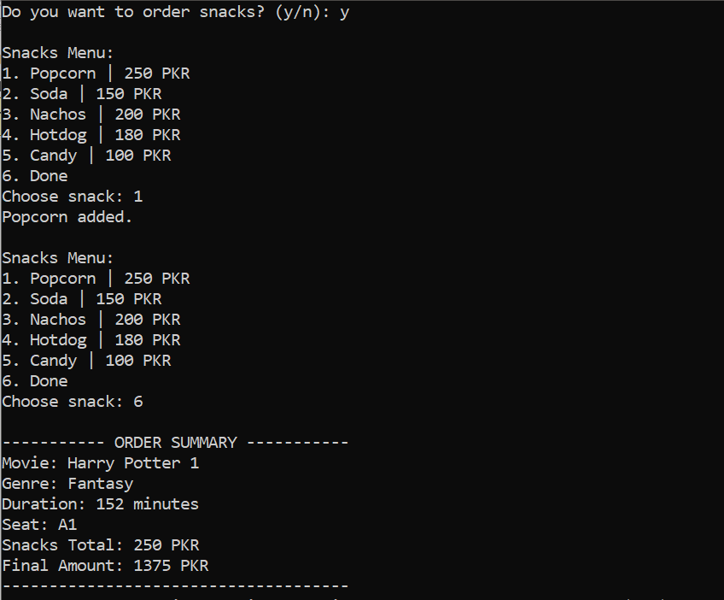
- Screenshot 4: Final Order Summary

6. Description of Challenges and How They Were Resolved
Challenge 1: Robust Input Validation
- Description: When dealing with console input (cin), users often enter non-numeric characters when a number is expected, causing the program to enter an infinite loop or behave unexpectedly.
- Resolution: I implemented a robust input validation loop for all critical numerical inputs (Movie ID, Viewer Type, Rating). This uses a while loop with cin. clear () to reset the error flags and cin. ignore (1000, '\n') to discard the invalid non-numeric characters from the input buffer. This forces the user to re-enter valid data.
Challenge 2: Persistent Storage of Booking Summary
- Description: The booking receipt was only displayed to the screen, meaning the data was lost when the program closed. The requirement was to save the receipt for later viewing.
- Resolution: I used C++ File Handling (fstream). The final receipt is stored in a global string variable (lastReceipt). The download Receipt () function uses an ofstream to write this string to BookingReceipt.txt, and the viewSavedReceipt () function uses an ifstream to read it back, achieving data persistence.

Future Improvements
- Dynamic Seat Allocation: Implement a system to handle multiple screenings/shows simultaneously, where each show has its own dedicated seat map.
- Admin Functions: Add an admin login to allow staff to update movie details or view sales reports.

