Secure VPC Web Server with Private Amazon S3 Access

AWS CLOUD PRACTICE PROJECT

Cloud Administration Hands-On Project Report

Prepared by: Rabih Hamdan
Project Type: AWS Cloud Practitioner
Platform: Amazon Web Services (AWS)
Date: August 2026

Project Report

Abstract
This project documents the design and implementation of a small AWS environment created to practice the core skills expected from an entry-level cloud administrator. The environment combines networking, compute, security, storage, and identity services in a single working architecture.
A custom Amazon Virtual Private Cloud (VPC) was created with the CIDR block 10.0.0.0/16. A public subnet using 10.0.1.0/24 hosts an Amazon EC2 Linux instance running the Nginx web server. Internet connectivity is provided through an Internet Gateway and a public route table. The EC2 Security Group allows HTTP traffic from the internet while administrative SSH access is restricted to the administrator's public IP address.
The project also demonstrates AWS identity and access management. Instead of storing access keys on the server, an IAM role is attached to the EC2 instance. A least-privilege policy permits the instance to retrieve a test object from a private Amazon S3 bucket. This validates the use of temporary role credentials and demonstrates why cloud workloads should avoid hard-coded long-term credentials.
The completed environment provides practical experience with Amazon VPC, EC2, S3, IAM, Security Groups, routing, Linux administration, Nginx, AWS CLI, troubleshooting, and the principle of least privilege.

Table of Contents
Abstract 2
Chapter 1 Introduction and Background 4
A. Overview 4
B. AWS Services Practiced 4
C. Learning Outcomes 4
Chapter 2 Problem Statement and Project Objectives 5
A. Problem Statement 5
B. Project Objectives 5
C. Scope 5
Chapter 3 Proposed Solution 6
A. Traffic Flow 6
B. Architecture Diagram 6
Chapter 4 Design Specification 7
A. Network Design 7
B. Security Group Design 7
C. Compute Design 7
D. Storage and IAM Design 7
Chapter 5 Methodology and Implementation 8
A. VPC and Subnet Creation 8
B. Internet Gateway and Routing 8
C. EC2 and Nginx 9
D. Secure SSH Administration 10
E. IAM Role and Private S3 Access 11
Chapter 6 Security and Cost Considerations 13
A. Security Controls 13
B. Cost Awareness 13
C. Cleanup Plan 13
Chapter 7 Testing and Verification 14
A. Troubleshooting Findings 14
Chapter 8 Conclusions and Future Work 15
A. Conclusion 15
B. Future Work 15
Appendix A AWS CLI Commands 16
Appendix B Screenshot Checklist 16

Chapter 1
Introduction and Background
Cloud administrators are responsible for provisioning, securing, monitoring, and maintaining cloud resources. Understanding individual AWS services is important, but practical administration also requires understanding how those services interact. This project was therefore designed as a compact hands-on environment that connects several foundational AWS concepts in one deployment.

A. Overview
The project deploys a Linux web server inside a custom AWS network. The server is publicly reachable over HTTP, while SSH administration is intentionally limited. The EC2 instance also receives permission to access a private S3 object through an IAM role. The project is small enough to build and troubleshoot manually while still representing patterns used in larger AWS environments.

B. AWS Services Practiced
- Amazon VPC — isolated network and CIDR planning.
- Subnet — allocation of a smaller address range from the VPC.
- Internet Gateway — internet connectivity for the public subnet.
- Route Table — routing 0.0.0.0/0 toward the Internet Gateway.
- Amazon EC2 — Linux compute instance hosting Nginx.
- Security Groups — stateful instance-level traffic filtering.
- AWS IAM — role and least-privilege permissions for the EC2 workload.
- Amazon S3 — private object storage used to validate controlled server access.
- AWS CLI — verification of the instance identity and S3 permissions.

C. Learning Outcomes
- Plan VPC and subnet CIDR ranges.
- Understand the difference between routing and access control.
- Publish a basic web service without exposing SSH to the entire internet.
- Use an EC2 IAM role instead of long-term access keys.
- Apply and test least-privilege permissions.
- Troubleshoot failed SSH connectivity and distinguish browser-based EC2 Instance Connect from direct SSH.
- Verify cloud configuration from both the AWS Console and the Linux command line.

Chapter 2
Problem Statement and Project Objectives

A. Problem Statement
A new cloud administrator needs more than theoretical knowledge of services. A common challenge is understanding how networking, security, compute, and IAM combine to make a workload both reachable and protected. Misconfigurations such as opening SSH to 0.0.0.0/0 or storing AWS access keys directly on a server may make a lab work, but they do not represent good security practice.

B. Project Objectives
- Create a non-default VPC using 10.0.0.0/16.
- Create a public subnet using 10.0.1.0/24.
- Provide internet access through an Internet Gateway and public route.
- Launch an Amazon Linux EC2 instance in the public subnet.
- Install and run Nginx as a public website.
- Permit HTTP from the internet while restricting SSH to the administrator's public IP /32.
- Create a private S3 bucket containing a test object.
- Attach an IAM role to EC2 with only the S3 permissions required by the project.
- Demonstrate that permitted S3 operations succeed while an unpermitted account-wide bucket listing fails.

C. Scope
The project focuses on foundational AWS administration. It does not yet implement high availability, load balancing, Auto Scaling, a private application subnet, NAT Gateway, database services, Route 53, HTTPS, infrastructure as code, or centralized monitoring. These are identified as future enhancements.

Chapter 3
Proposed Solution
The proposed solution uses a custom VPC containing one public subnet and one EC2 web server. The public subnet is associated with a route table that forwards internet-bound traffic to an Internet Gateway. The EC2 Security Group exposes only the services required for the lab.

A. Traffic Flow
- Web user → Internet → Internet Gateway → Public Route Table → Public Subnet → Security Group → EC2/Nginx on TCP port 80.
- Administrator → Internet → Internet Gateway → EC2 on TCP port 22, permitted only from the administrator's current public IPv4 address.
- EC2 → IAM role temporary credentials → AWS API → private S3 bucket → permitted object retrieval.

B. Architecture Diagram
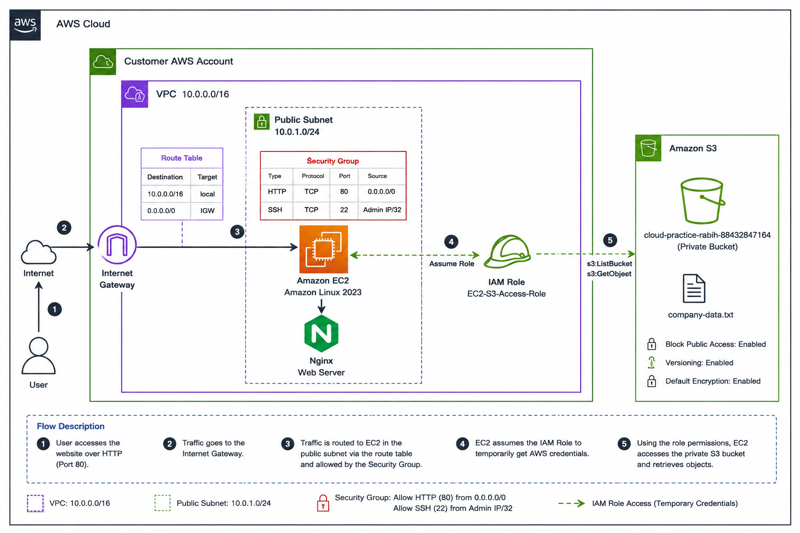
Figure 3-1. AWS project architecture diagram
The architecture diagram should show the AWS Cloud boundary, the VPC 10.0.0.0/16, public subnet 10.0.1.0/24, Internet Gateway, public route table, EC2 instance with Nginx, Security Group rules, IAM role, and private S3 bucket.

Chapter 4
Design Specification

A. Network Design
Component | Configuration | Purpose
VPC | 10.0.0.0/16 | Private AWS network boundary
Public Subnet | 10.0.1.0/24 | Hosts the internet-facing EC2 instance
Internet Gateway | Attached to VPC | Provides a path between the VPC and internet
Public Route | 0.0.0.0/0 → Internet Gateway | Routes non-local IPv4 traffic to the internet
Local Route | 10.0.0.0/16 → local | Enables routing inside the VPC

B. Security Group Design
Type | Protocol/Port | Source | Reason
HTTP | TCP/80 | 0.0.0.0/0 | Public website access
SSH | TCP/22 | Administrator public IP/32 | Restricted server administration
During troubleshooting, SSH was temporarily opened to 0.0.0.0/0 to confirm that the network path was functional. After successful testing, the rule was returned to the administrator's public IP /32. The final restricted rule is the configuration that should be documented as the secure state.

C. Compute Design
- Amazon EC2 Linux instance named cloud-web-server.
- Nginx installed and used as the web service.
- Public IPv4 connectivity used for the lab.
- SSH key pair used for direct administrative access.

D. Storage and IAM Design
The S3 bucket remains private. A small object, company-data.txt, is used as a test object. Its purpose is to prove that the EC2 workload can retrieve a specific private object through IAM permissions; the value of the exercise is the access pattern rather than the text file itself.
The EC2 instance assumes the IAM role CloudPracticeEC2Role. The role provides temporary AWS credentials to the workload, avoiding the need to place an access key and secret key on the server.

Chapter 5
Methodology and Implementation

A. VPC and Subnet Creation
A custom VPC named cloud-practice-vpc was created with the IPv4 CIDR 10.0.0.0/16. A public subnet was then created from this address space using 10.0.1.0/24. This subnet consumes 256 addresses from the VPC's 65,536-address IPv4 range, although AWS reserves five addresses in each subnet.
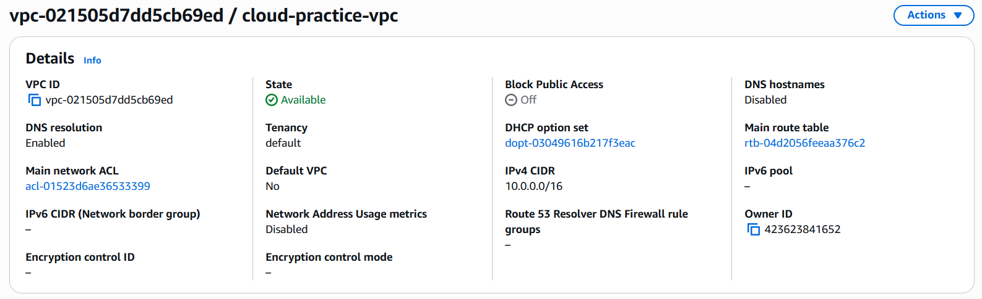
Figure 5-1. VPC details showing 10.0.0.0/16
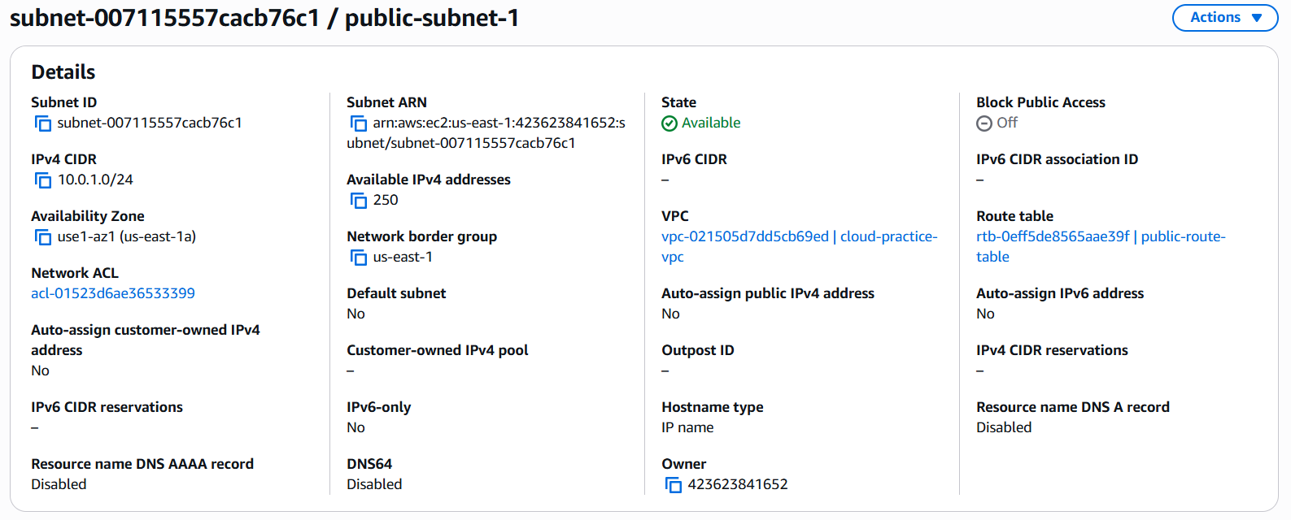
Figure 5-2. Public subnet details showing 10.0.1.0/24

B. Internet Gateway and Routing
An Internet Gateway was created and attached to the custom VPC. The public route table contains the VPC local route and a default IPv4 route, 0.0.0.0/0, pointing to the Internet Gateway. The route table is associated with the public subnet.
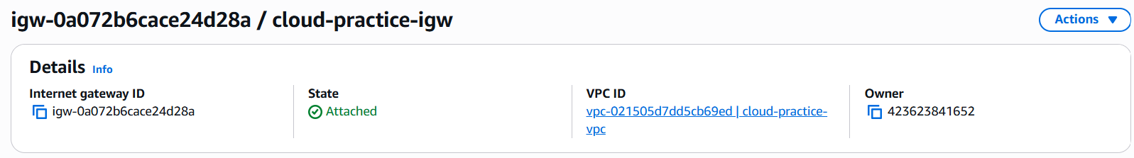
Figure 5-3. Internet Gateway attached to cloud-practice-vpc
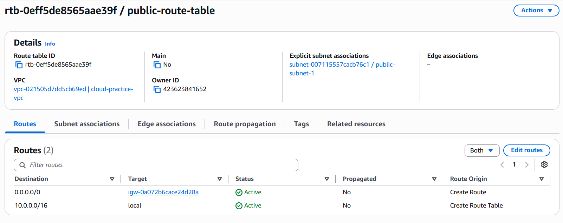
Figure 5-4. Public route table with 0.0.0.0/0 route

C. EC2 and Nginx
An Amazon Linux EC2 instance was launched in the public subnet. After SSH connectivity was verified, Nginx was installed and started. HTTP port 80 was opened to 0.0.0.0/0 so that the web page could be reached from a normal browser.
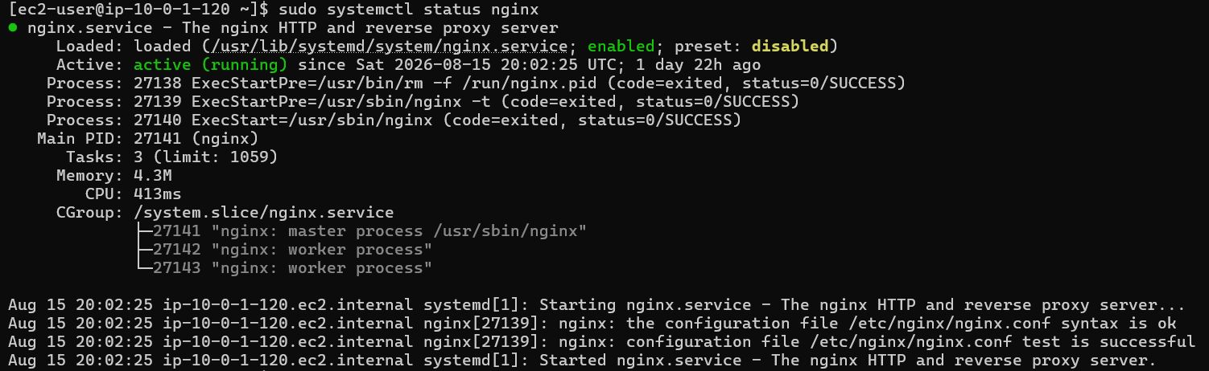
Figure 5-5. EC2 instance details and running state
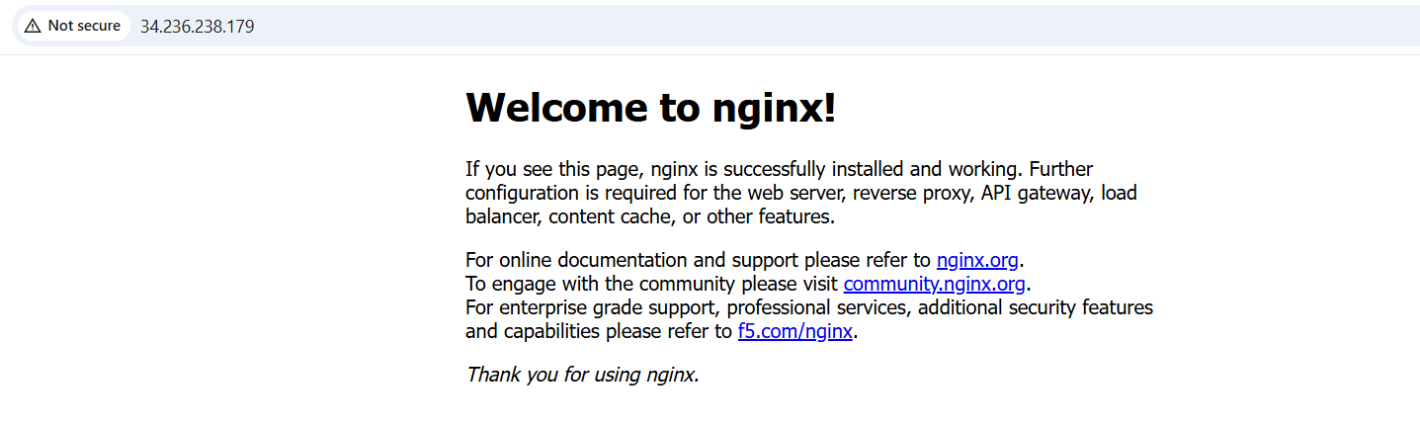
Figure 5-6. Nginx website reachable through the EC2 public IP

D. Secure SSH Administration
Browser-based EC2 Instance Connect initially failed when SSH was restricted to the administrator's IP because the browser-based connection originates from AWS EC2 Instance Connect infrastructure rather than directly from the administrator's workstation. Direct SSH from the local machine was therefore used with the private key. Once the Security Group source matched the workstation's public IP, direct SSH succeeded.
ssh -i "C:\path\to\cloud-practice-key.pem" ec2-user@<EC2-PUBLIC-IP>
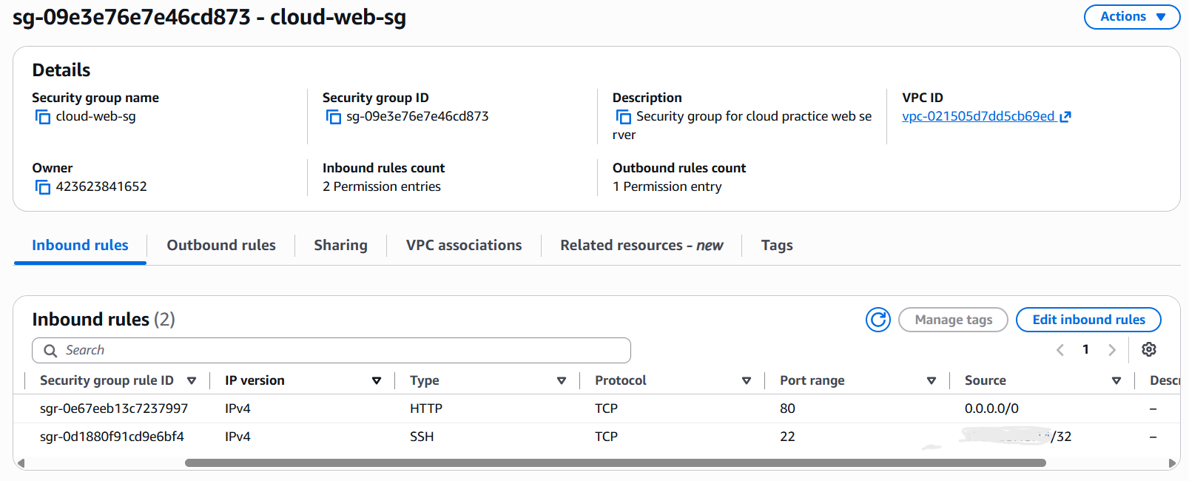
Figure 5-7. Final Security Group: HTTP from 0.0.0.0/0 and SSH from administrator IP/32

E. IAM Role and Private S3 Access
An IAM role named CloudPracticeEC2Role was created for the EC2 service and attached to the running instance. The role was configured with limited S3 permissions for the project bucket rather than broad administrator permissions.
The instance identity was verified with AWS STS. The returned ARN showed an assumed-role session associated with CloudPracticeEC2Role and the EC2 instance.
aws sts get-caller-identity
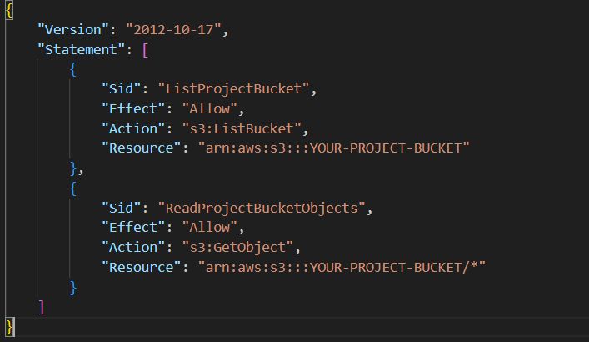
Figure 5-8. IAM role attached to EC2
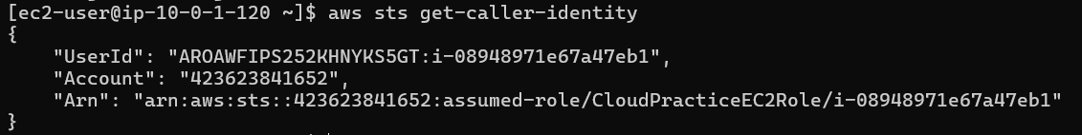
Figure 5-9. aws sts get-caller-identity showing assumed-role/CloudPracticeEC2Role
A deliberate permission test was performed with aws s3 ls. The command attempts to list all S3 buckets in the account and requires s3:ListAllMyBuckets. The role did not have that permission, so AWS returned AccessDenied. This was expected and demonstrated that the role was not over-permissioned.
aws s3 ls
Figure 5-10. Expected AccessDenied for account-wide S3 bucket listing
The permitted operation was then tested against the project bucket. The object could be downloaded when a destination path was provided. The correct AWS CLI syntax is:
aws s3 cp s3://<PROJECT-BUCKET>/company-data.txt .
Figure 5-11. Successful download of company-data.txt from private S3

Chapter 6
Security and Cost Considerations

A. Security Controls
- SSH is not left open to 0.0.0.0/0; it is restricted to the administrator's public IP.
- HTTP is intentionally public because the EC2 instance is acting as a public web server.
- The S3 bucket is private and is not made public merely to allow the EC2 instance to read an object.
- EC2 uses an IAM role and temporary credentials rather than hard-coded access keys.
- The IAM policy follows least privilege by granting only the S3 actions required for the test.
- The failed aws s3 ls operation is retained as evidence that broader S3 account permissions were not granted.

B. Cost Awareness
The lab uses a small number of resources, but AWS charges depend on the account's current Free Tier plan, credits, region, instance type, public IPv4 usage, and service configuration. Resources should therefore be monitored in AWS Billing and removed after documentation is complete. A cloud administrator should never assume that a resource is free simply because it is used for a learning project.

C. Cleanup Plan
- Terminate the EC2 instance when screenshots and testing are complete.
- Delete unnecessary S3 objects and the project bucket when no longer needed.
- Detach and delete project IAM policies/roles if they will not be reused.
- Delete the custom Security Group after the EC2 instance is removed.
- Delete the public subnet, route table associations/resources, detach and delete the Internet Gateway, then delete the VPC.
- Review Billing and Cost Management after cleanup.

Chapter 7
Testing and Verification
Testing was performed throughout the build rather than only after deployment. Both successful and intentionally denied operations were used to verify that the environment behaved according to the design.
Test | Expected Result | Observed Result | Status
VPC creation | VPC available with 10.0.0.0/16 | VPC created successfully | PASS
Public subnet | Subnet belongs to project VPC | 10.0.1.0/24 subnet created | PASS
HTTP website | Nginx page reachable from internet | Website reachable | PASS
SSH with broad rule | Connectivity works | Connection worked | PASS / troubleshooting only
SSH restricted to admin IP | Direct workstation SSH succeeds | Direct SSH succeeded | PASS
STS identity | EC2 reports assumed IAM role | CloudPracticeEC2Role returned | PASS
aws s3 ls | Denied without ListAllMyBuckets | AccessDenied returned | PASS
S3 GetObject | company-data.txt can be retrieved | Object downloaded | PASS

A. Troubleshooting Findings
The most important troubleshooting lesson involved SSH. Opening TCP/22 to 0.0.0.0/0 proved that the EC2 instance, route table, Internet Gateway, and SSH service were reachable, but this was not an acceptable final security state. Restricting the rule to the workstation's public IP and using direct SSH provided both connectivity and stronger access control.
A second useful test involved S3. The AccessDenied response from aws s3 ls was not a project failure. It showed that the EC2 role lacked s3:ListAllMyBuckets, while the separate object-level operation remained available. Understanding expected authorization failures is an important cloud administration skill.

Chapter 8
Conclusions and Future Work

A. Conclusion
This project successfully combined foundational AWS networking, compute, storage, and identity concepts into one working environment. A custom VPC and subnet were created, internet routing was configured, a Linux EC2 instance hosted an Nginx website, and Security Group rules separated public web access from restricted administration.
The project also demonstrated a secure AWS workload identity pattern. The EC2 instance accessed a private S3 object through an IAM role instead of a stored access key. Least-privilege behavior was validated by allowing the required object access while denying the unrelated account-wide S3 bucket listing operation.
For an entry-level cloud administrator portfolio, the strongest evidence from this project is not the size of the architecture but the ability to explain why each component exists, troubleshoot connectivity, validate permissions, and return temporary troubleshooting changes to a secure final configuration.

B. Future Work
- Add a second Availability Zone and a second EC2 instance.
- Introduce an Application Load Balancer and Auto Scaling Group.
- Move application servers to private subnets and use a controlled administration method such as AWS Systems Manager Session Manager.
- Enable HTTPS with an Application Load Balancer, AWS Certificate Manager, and Route 53.
- Add CloudWatch metrics, logs, alarms, and dashboards.
- Enable VPC Flow Logs for network visibility.
- Use an S3 Gateway VPC Endpoint so private workloads can reach S3 without using the public internet path.
- Rebuild the entire environment using Terraform or AWS CloudFormation.
- Add AWS Budgets / cost alerts and document operational monitoring.

Appendix A
AWS CLI Commands
Verify EC2 role identity: aws sts get-caller-identity
Test account-wide bucket listing (expected denial): aws s3 ls
Download permitted object: aws s3 cp s3://<PROJECT-BUCKET>/company-data.txt .
Display downloaded file: cat company-data.txt
Check Nginx service: sudo systemctl status nginx

Appendix B
Screenshot Checklist
- VPC details — name, state, 10.0.0.0/16.
- Subnet details — 10.0.1.0/24 and VPC association.
- Internet Gateway — attached state.
- Route table — local route and 0.0.0.0/0 → IGW.
- EC2 instance — running state, subnet, Security Group.
- Security Group — final HTTP and SSH inbound rules.
- Nginx website in browser.
- S3 bucket — private settings and company-data.txt.
- IAM role — CloudPracticeEC2Role and attached policy.
- EC2 terminal — aws sts get-caller-identity.
- EC2 terminal — expected AccessDenied from aws s3 ls.
- EC2 terminal — successful aws s3 cp / cat company-data.txt.
- AWS architecture diagram.

