**ARTIFICIAL INTELLIGENCE (CS-219)**

**PROJECT REPORT**



**PROJECT TITLE**

RAINFALL PREDICTION

**GROUP MEMBERS**

RABIL MAKNOJIA (18K-1183)

**TABLE OF CONTENTS**

1. **Abstract** 3
2. **Introduction** 3
3. **Methodology** 3-4
4. **Data and Results** 5-8
5. **Conclusion** 8
6. **Reference** 8

**ABSTRACT**

Rainfall prediction is important as heavy rainfall can lead to many disasters. The prediction helps people to take preventive measures and moreover the prediction should be accurate. There are two types of prediction short term rainfall prediction and long term rainfall. Prediction mostly short term prediction can gives us the accurate result. The main challenge is to build a model for long term rainfall prediction. Heavy precipitation prediction could be a major drawback for earth science department because it is closely associated with the economy and lifetime of human. It’s a cause for natural disasters like flood and drought that square measure encountered by individuals across the world each year. Accuracy of rainfall statement has nice importance for countries like India whose economy is basically dependent on agriculture. The dynamic nature of atmosphere, applied mathematics techniques fail to provide sensible accuracy for precipitation statement. The prediction of precipitation using machine learning techniques may use regression. Intention of this project is to offer non-experts easy access to the techniques, approaches utilized in the sector of precipitation prediction and provide a comparative study among the various machine learning techniques.

**INTRODUCTION**

Rainfall forecasting is very important because heavy and irregular rainfall can have many impacts like destruction of crops and farms, damage of property so a better forecasting model is essential for an early warning that can minimize risks to life and property and also managing the agricultural farms in better way. This prediction mainly helps farmers and also water resources can be utilized efficiently. Rainfall prediction is a challenging task and the results should be accurate. There are many hardware devices for predicting rainfall by using the weather conditions like temperature, humidity, pressure. These traditional methods cannot work in an efficient way so by using machine learning techniques we can produce accurate results. We can just do it by having the historical data analysis of rainfall and can predict the rainfall for future seasons. We can apply many techniques like classification, regression, Autoregressive integrated moving average (ARIMA), long short-term memory (LSTM) and according to the requirements and also we can calculate the error between the actual and prediction and also the accuracy. Different techniques produce different accuracies so it is important to choose the right algorithm and model it according to the requirements.

**METHODOLOGY**

The predictive model is used to prediction of the precipitation. The first step is converting data in to the correct format to conduct experiments then make a good analysis of data and observe variation in the patterns of rainfall. We predict the rainfall by separating the dataset into training set and testing set. We apply different deep learning approaches (ARIMA, LSTM, etc.) and statistical techniques and compare and draw analysis over various approaches used with the help of numerous approaches we attempt to minimize the error. As the dataset is very large, feature reduction is done so that it improves the accuracy, reduces the computation time and also storage. Principal Component Analysis (PCA) is a technique of extracting necessary variables from a huge set of variables. It extracts low dimensional set with a motive to capture the maximum amount of information. With few variables, visualization becomes more significant. The parameters considered for the evaluation of the performance and the efficiency of the proposed rainfall prediction model are Root Mean 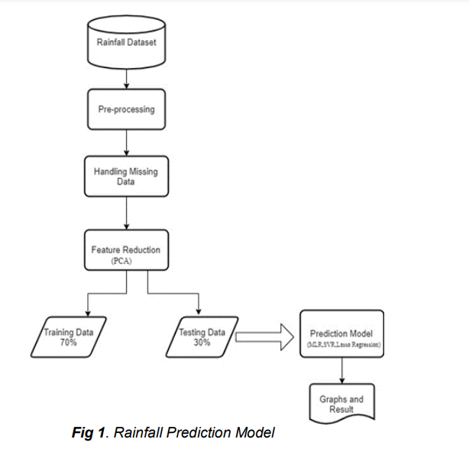Square Error (RMSE).

**DATA**

Dataset was obtained from Kaggle. The dataset contains 121-year rainfall data of Pakistan which have which consist of 1400 records of rainfall in Pakistan.

**RESULTS**

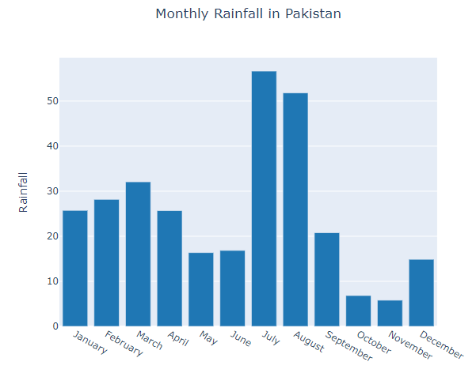

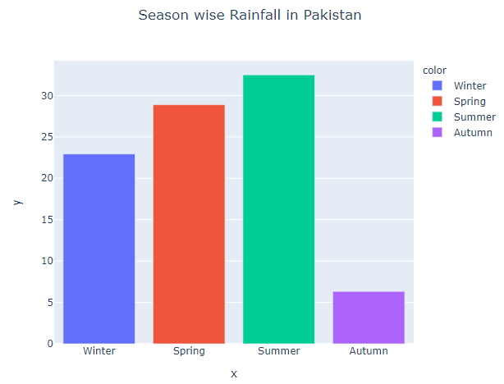

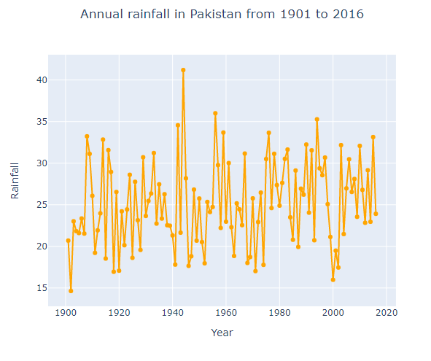

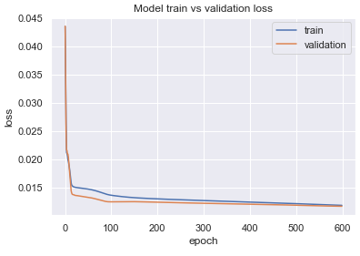Train and Validation Learning Curves Showing a Good fit because the plot of validation loss decreases and has a small gap with the training loss.

The parameters considered for the evaluation of the performance and the efficiency of the proposed rainfall prediction model are Root Mean Square Error (RMSE)

|  |  |
| --- | --- |
| **MODEL** | **RESULT (RMSE)** |
| Autoregressive integrated moving average (ARIMA) | 16.64 |
| Long short-term memory (LSTM) | 16.37 |

**ARIMA Model**

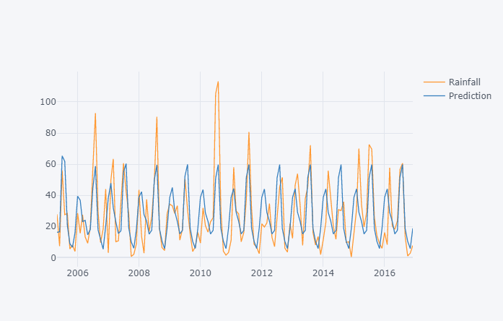

**LSTM Model**

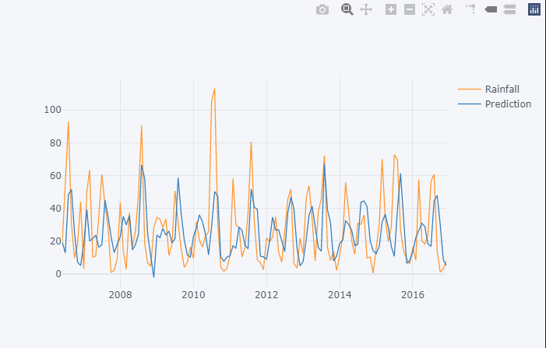

**CONCLUSION**

**SUMMARY**

This paper reports a detailed survey on rainfall predictions using different rainfall prediction methods extensively used over last years. By using artificial neural network for rainfall prediction we got significant results. The forecasting techniques that use ARIMA and LSTM are suitable to predict rainfall than other forecasting techniques such as statistical and numerical methods. However some limitations is clearly noticed in all the methods of rainfall prediction discussed below.

**LIMITATION**

1. The data sample is limited to monthly statistics only and does not provide the daily output predictions.
2. The climatic change and the global warming effect may impact the accuracy of the expected output

**REFERENCE**

1. <http://www.ijstr.org/final-print/jan2020/Prediction-Of-Rainfall-Using-Machine-Learning-Techniques.pdf>
2. http://docs.neu.edu.tr/library/6689487225.pdf