**.Net History**

Microsoft started development of the .NET Framework in the late 1990s, originally under the name of Next Generation Windows Services (NGWS). By late 2000 the first beta versions of .NET 1.0 were released.

The C# programming language was developed with the .NET Framework by Anders Hejlsberg, Scott Wiltamuth, and Peter Golde and was first available in July 2000.

These are the versions of C# and .Net framework:

* C# 1.0; released with .NET 1.0 and VS2002 (January 2002).Contained the first version CLR and base class libraries
* C# 1.2 ; released with .NET 1.1 and VS2003 (April 2003). First version to call Dispose on IEnumerators which implemented IDisposable.Included updates to ASP.NET and ADO.NET. Introduced side-by-side execution, which enables apps on a single computer to run against multiple versions of the CLR.
* C# 2.0; released with .NET 2.0 and VS2005 (November 2005). Major new features: **generics**, **nullable types**
* C# 3.0; released with .NET 3.5 and VS2008 (November 2007). Major new features: **lambda expressions**(=>),LINQ , implicit typing (**var**), query expressions
* C# 4.0; released with .NET 4 and VS2010 (April 2010). Major new features: **Dynamic language run-time**, parallel computing, named arguments and **optional parameters**
* C# 5.0; released with .NET 4.5 and VS2012( August 2012).Major new features: **asynchronous file operations** and improved on parallel computing.
* 4.5.1 Preview with Visual Studio 2013 Preview. Includes performance and debugging improvements, support for automatic binding redirection, and expanded support for Windows Store apps.

**Overview of the .NET Framework**

The .NET Framework is a technology that supports building and running the next generation of applications and XML Web services. The .NET Framework is designed to fulfill the following objectives:

* Provide a runtime environment that simplifies software deployment and reduces the chances of version conflicts.
* Enable the safe execution of code.
* Use industry standards for all communication to enable integration with non-.NET code.
* Provide a consistent developer experience across all types of applications in a way that is language- and platform-independent.
* Provide a runtime environment that minimizes or eliminates the performance problems of scripted or interpreted languages.

**Terminoly:**.NET enabled Microsoft's marketing people to emphasise the "Network"-ing aspect of its technologies, and was also a reaction to the marketing blitz by Sun Microsystems in the late 1990s whose theme was "The network is the computer". The term "Dot-Com" was synonymous with the Internet that time, and "Dot-NET" was a play on that term.

**.Net architecture**

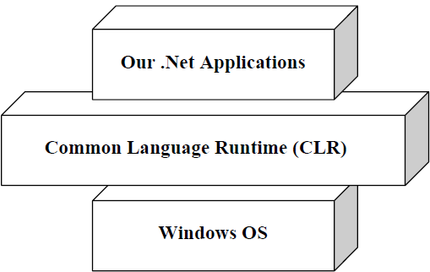

**Common Language Runtime(CLR)**

It is the heart of the .NET framework. it is the responsibility of the runtime to take care of the code execution of the program. Programms don’t directly communicate with the OS but go through the CLR.

Following are the responsibilities of CLR:

• **Garbage Collection: -** CLR automatically manages memory thus eliminating memory leaks. When objects are not referred, GC automatically releases those memories thus providing efficient memory management.

• **Code Access Security**: - CAS grants rights to program depending on the security configuration of the machine. Example the program has rights to edit or create a new file but the security configuration of machine does not allow the program to delete a file. CAS will take care that the code runs under the environment of machines security configuration.

• **Code Verification**: - This ensures proper code execution and type safety while the code runs. It prevents the source code to perform illegal operation such as accessing invalid memory locations etc.

**Managed Code**

Managed code runs inside the environment of CLR i.e. .NET runtime. In short, all IL are managed code. However, if you are using some third party software example VB6 or VC++ component they are unmanaged code, as .NET runtime (CLR) does not have control over the source code execution of these languages.

**MSIL(Microsoft Intermediate Language) or CIL(Common Intermediate Language) or IL(Intermediate Language)**

All .NET source code is converted to an intermediate code known as MSIL which is interpreted by the CLR. MSIL is OS and hardware independent code. This MSIL is converted to binary executable code(native code) at the point where the software is installed.

**Just-In-Time(JIT) compiler**

It compiles the IL code to native executable code(.exe or .dll) that is designed for specific machine and OS.

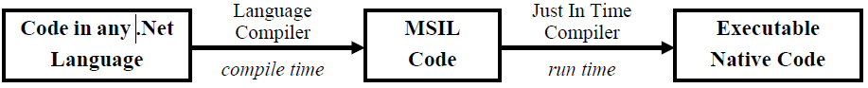

**The Framework Class Library(FCL)**

The .Net Framework class library (FCL) provides the core functionality of .Net Framework architecture. The .Net Framework Class Library (FCL) includes a huge collection of reusable classes, interfaces, and value types that ease and optimize the development process and provide access to system functionality.

This library is categorized into different modules and can access to Windows application, Web development, Network programming ,IO etc.

**Common Type System(CTS)**

CTS define how types are declared, used and managed in the CLR, and is also an important part of the runtime's support for cross-language integration. The common type system performs the following functions:

* Establishes a framework that helps enable cross-language integration, type safety, and high-performance code execution.
* Provides an object-oriented model that supports the complete implementation of many programming languages.
* Defines rules that languages must follow, which helps ensure that objects written in different languages can interact with each other.
* Provides a library that contains the primitive data types (such as Boolean, Byte, Char, Int32, and UInt64) used in application development.

This makes it possible for the 2 languages to communicate with each other by passing/receiving parameters to and from each other. A type is a representation of data(such as int).

All types in the .NET Framework are either **value types** or **reference types.**

**Common Language Specification**

CLS is a set of basic language features that .Net Languages needed to develop Applications and Services.

It is a subset of the CTS. The CLS establishes the minimum set of rules to promote language interoperability.

When there is a situation to communicate Objects written in different .Net Complaint languages , those objects must expose the features that are common to all the languages . Common Language Specification (CLS) ensures complete interoperability among applications, regardless of the language used to create the application.

Microsoft has defined CLS, which are nothing but guidelines, that language should follow so that it can communicate with other .NET languages in a seamless manner.

**The Visual Studio .Net IDE**

Which is the successor of Visual Studio 6. It eases the development process of the .Net applications(VC#.Net,VB.Net and more). The key features of VS.Net

* Keyword and syntax highlighting.
* Intellisense(auto complete), which helps by automatically completing the syntax as you type a dot(.) with objects, enumerations and namespaces and when you use “new ” keyword.
* Project and solution management with solution explorer that helps to manage application consisting multiple files.
* Help building user interface with simple drag and drop support.
* Properties tab that you to set different properties for multiple windows and controls.
* Standard debugger that allows you to debug your program using putting break points for observing run-time behavior.
* Hot compiler that checks the syntax of code as type it and error notification.
* Compiling and building applications.
* Program Execution with or without the debugger.
* Deploying .Net application over the internet or to disk.

**Projects and Solutions**

A project is a combination of executable and library files that make an application or module. A project information is usually placed in a file with the extention ‘.csproj’ where ‘cs’ represents C-Sharp. Similaryly, VB.Net projects are stored as ‘vbproj’. Several different kinds of projects such as Console applications, Windows applications, ASP.Net Web applications, Class Libraries and more.

A solution is a placeholder for different logically related projects that make some application. For example, a solution may consist of an ASP.Net Web application project and a Windows Form project.

**Toolbox, Properties and Class View tabs**

The toolbox contains a number of common controls for windows, web and data applications like the text box etc.

The properties Tab allows you to set the properties on controls and forms without getting into code.

The Class View Tab shows all the classes that project contains along with the methods and fields in in tree hierarchy.

**Advantages**

Supports fully managed code.

Fully integrated IDE available.

WPF and WCF are the new way of buildign UI's and Communicating between processes and systems.

Linux and Mac support through 3rd parties (Mono).

Many languages available, both dynamic (IronPython and IronRuby) and static (C#, VB.NET, C++), both object oriented (C#, VB.NET, C++) and functional (F#).

Interoperability: Now developers of different languages can work easily together on the same project.

**Disadvantages**

- Multi platform support isn't available from MS and isn't available straight after installing Visual Studio  
- Managed code can be slower than native code

**2.Windows Development using .NET**

**Structured programming**

Structured programming is a logical programming method that is considered a precursor to object-oriented programming (OOP). Structured programming facilitates program understanding and modification and has a top-down design approach, where a system is divided into compositional subsystems(developers map out the overall program structure into separate subsections.).

Structured programming (sometimes known as *modular programming*) is a subset of procedural programming that enforces a logical structure on the program being written to make it more efficient and easier to understand and modify. such as Ada and Pascal are designed with features that encourage or enforce a logical program structure.

A defined function or set of similar functions is coded in a separate module or sub-module, which means that code can be loaded into memory more efficiently and that modules can be reused in other programs.

Program flow follows a simple hierarchical model. These are sequence, selection, and repetition:

* "Sequence" refers to an ordered execution of statements.
* In "selection" one of a number of statements is executed depending on the state of the program. Keyword such if..then.. else.. endif, switch, or case.
* In "repetition" a statement is executed until the program reaches a certain state. Keywords such as while, for

**Object Oriented Programming**

Real-world entities of problem represent as an object. Objects are instances of classes. It is a technique to think real world in terms of objects. Object maps the software model to real world concept. These objects have responsibilities and provide services to application or other objects.

The four primary concepts of object-oriented programming are encapsulation, abstraction, inheritance, and polymorphism.

**Class**

Classes are special kinds of templates from which we can create objects.A class describes all the attributes of objects, as well as the methods that implement the behavior of member objects. It is a comprehensive data type, which represents a blue print of objects. Each object contains data and methods to manipulate and access that data.

**Object**

An object can be considered a "thing" that can perform a set of related activities.

**Encapsulation:** the wrapping up of data and function into a single unit(class) is called **encapsulation.**

Data is not accessible to the outside world and functions which are wrapped in the class can access it. Function provide interface between the object’s data and the program. This insulation of data from direct access by program is called data hiding.

**Abstraction:**refers for representing essential features without including the background details of explanations.

**Inheritance**: is the process by which objects of one class acquire properties of objects of another class

**Polymorphism:**means one name ,multiple forms

**C#**

C# is an **object-oriented language** and fully supports the object-oriented programming concepts of inheritance, polymorphism, encapsulation, and abstraction.

It is similar to c++ and Java. C# code is made up of a **series of statements**, each of which is terminated with a **semicolon.**

C# is a **block-structured language**, meaning that all statements are part of a block of code. These blocks which are delimited with curly brackets(**{}**), may contain any number of statements, or none at all.

C# code is **case-sensitive.**

C# is a general-purpose, object-oriented, type-safe programming language

`There were two ways of commenting C# code. (//, /*….*/ and special comment ///).

used for writing applications of any type.

#region and #endregion keywords, which defines the start and end of a region of code that can be expanded and collapsed.

# is actually preprocessor directive

Using keyword allow to access the all classes of “System” namespace

**Simple Types**

Int, long, byte, float, char, bool, string

**Variable and Function declaration**

**<accessibility_level><type><variable_name>;**

Example

int a=2;

string myString;

**<accessibilityLevel><returnType><functionName>(paramType paramName, . . . . . . )**

{

Logic here

}

Example

public int Sum(int a, int b)

{

Return a+b;

}

**Naming Conventions**

Generally two naming conventions in .Net Framework

**PascalCase and camelCase**

**Private viables(fields of class)name are generally in camelCase**

age, firstName

**Methods and public varibles name are generally inPascalCase**

Above example. We can call function **Sum()**

**Escape sequence**(\)

String myString=”\”myInteger\” is “; if you myString=””myInteger” is “ then compiler error

\’ single quotation mark

\n new line

\t horizontal tab

\\ backslash

“C:\\MyDocument\\MyFile.doc”

@“C:\MyDocument\MyFile.doc”

**String formatting**

MessageBox.Show(string.Format(“{0} {1}.”, myString, myInteger));

String is actually template into which you insert the contents of variables. Each set of curly brackets in the string is a placeholder. The integers start at 0 and are incremented by 1 and numbers of varibales are separated by comma. Each placeholder is replaced by the corresponding value for each variable. In above example,{0} is replaced by value of myString and {1} is replaced by value of myInteger

**Namespace**

Way of providing containers for application code. We can define sub namespace within parent namespace.

namespace CosMos

{

Code here

}

**Assignment operators**

var1 +=var2; var1 is assigned value that is the sum of var1 and var2. Similarly for other operators(-,*,/,%)

**Flow Control**

Controlling program flow(order of execution of lines of C# code)

**Branching**:execute code conditionally, depending on the outcome of an evaluation.

**Looping:** repeatedly executing the same statements.

**Boolean Logic:**bool types are used to store the result of a comparison.

|  |  |
| --- | --- |
| var1=! var2 | var1 is assigned value true if var2 is false(Logical NOT). |
| var1=var2&&var3 | var1 is assigned value true if var2 and var3 are both true. |
| var1=var2||var3 | var1 is assigned value true if either var2 or var3 are true. |

**Branching**

* The ternary operator
* The **if** statement
* The **switch** statement

**Ternary operator**

<test> ? <resultIfTrue> : <resultIfFlase>

Eg.string str=(myInteger<10) ? “Less than 10” : “Greater than or equal to 10”;

**Interrupting Loops**

* **breake:** Causes the loop to end immediately.
* **continue:**Cauesed the current loop cycle to end immediately(execution continues with the next loop cycle)
* **return:** Jumps out of the loop and its containinfuction.
* **goto:** allows jumping out of a loop to a labeled position(generally not used)

**Type Conversion**

|  |  |
| --- | --- |
| Convert.ToInt32(val) | val converted to int |
| Convert.ToDecimal(val) | val converted to decimal |
| Convert.ToString(val) | val converted to string |

**Declaring Arrays**

<baseType>[ ] <name>;

Eg.int[] myIntArray;

string[ ] friendNames={“Ram ”,”Hari”,”Sita”}

**Foreach loops**

foreach(<baseType><name> in <array>)

{

// can use <name> for each element

}

Eg.

string[ ] friendNames={“Hari”,”Ram”,”Sita”} ;

foreach(stringfriendName in friendNames)

{

MessageBox.Show(friendName);

}

**String Manipulation**

Eg. stringmyString=”A string”;

char[ ] myChars=myString.ToCharArray();

string convertToLower=myString.ToLower();

int length=myString.Length;

string myString==”This is dotnet lab”;

char[ ] separator={‘’};

string[ ] myWords=myString.Split(separator);

string takeSubString = myString.Substring(0,10);

**String Interpolation**

int x = 4;

Console.Write ($"A square has {x} sides");

S**tring.Format**

we provide a composite format string followed by each of the embedded variables.

Eg. string composite = “Your username:{0} and password:{1} ";

string s = string.Format (composite, “user123”, “pass123");

**Reference and Value parameters**

**Value parameter**

In this you have passed a value into a variable used by the function.

Void ShowDouble(intval)

**Reference Parameter**

Void ShowDouble(ref intval):unassigned variable is illegal

Void ShowDouble(out intval): unassigned variable is legal

**Overloading functions**

Same function name with different signature that means same function name but different in paramete type or number of parameters

//overloaded functions

int sum;

decimal dsum;

public void Add(inta,intb)

{

         sum = a+b;

}

public void Add(decimala,decimalb)  
{  
           dsum = a+b;  
 }

**Complex Variable Types**

* **Enumerations:**Variable types that have a user-defined discrete set of possible values that can be used in a human-readable way

An enum is a special "class" that represents a group of constants (unchangeable/read-only variables).

To create an enum, use the enum keyword (instead of class or interface), and separate the enum items with a comma:

* **Structures:**Composite variable types made up of a user-defined set of other variable types
* Arrays: Types that hold multiple variables of one type, allowing index access to the individual values.

**Defining Enumerations**

enum typeName

{

value1,

value2,

value3

}

typeName varName=typeName.value;

eg.

enum Orientation

{

north=1,

south=2,

east=3,

west=4

}

Orientation myDirection=Orientation.north;

**Defining Structs**

struct<typeName>

{

<memberDeclarations> this contain <accessibility><type><name>

}

Eg.

struct route

{

public orientation direction;

public double distance;

}

**Classes and Objects**

**Classes and structs have members that represent their data and behavior. Those members include:**

**Fields**

Fields are instances of objects that are considered part of a class, normally holding class data. For example, a calendar class may have a field that contains the current date.

public class CalendarDate

{

publicintmonth;

}

**Properties**

A property can provide protection for a class field to keep it from being changed without the object's knowledge.

**publicclass**Person

{

//classic way of defining a property

**private string** _FirstName;

**public string** FirstName

{

**get**{**return**_FirstName;}

**set**{_FirstName = value;}

}

//simple/compact way of defining a property with get/set operations //internally/implicitly maintains a private variable

**publicstring**LastName { **get**; **set**; }

**Methods**

Are used to give access to functionality of object .Methods define the actions that a class can perform. Method can take parameters that provide input data, and can return output data through parameters. Methods can also return a value directly, without using a parameter.

**Events**

Events are a way of providing notifications about occurrences, such as button clicks or the successful completion of a method, to other objects. Events are defined and triggered using delegates.

**Constructors**

A constructor has the same name as the class .Class have internally default constructor and we can also define constructor.

public class Student

{

//Constructor without parameter:

public Student() { }

public Student(int ID) { }

}

// object instantiation  
   StudentobjStudent = newStudent();

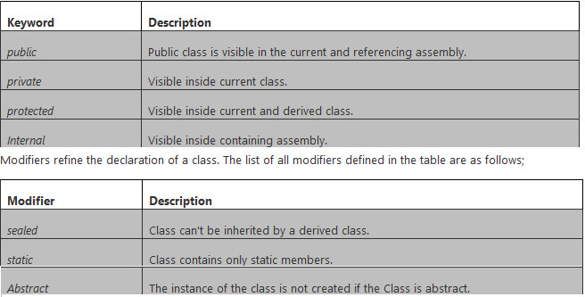

By default, classes inherit from the System.Object type.

**Methods type**

**static:** accessible through class name. not the object instance.

**virtual:**Method may be overridden in derived class.

**abstract:**Method must be overridden in non-abstract derived class(permitted only on abstract class).

**override:** Method overrides a base class method.

**Partial classes**

Many developers need access to the same class, then having the class in multiple files can be beneficial. The partial keywords allow a class to span multiple source files.

There are some rules for defining a partial class as in the following;

* A partial type must have the same accessibility.
* Each partial type is preceded with the "partial" keyword.
* If the partial type is sealed or abstract then the entire class will be sealed and abstract.

Eg.

public partial class partialclassDemo  
{

}

**Static classes**  
A static class is declared using the "static" keyword. If the class is declared as static then the compiler never creates an instance of the class. All the member fields, properties and functions must be declared as static and they are accessed by the class name directly not by a class instance object.

public static class staticDemo  
{  
        //static fields  
        public static int a=10,b=15,sum;

        //static method  
       public static void Add()  
        {  
            sum =a+b;  
        }  
}

//function calling directly  
            staticDemo.Add();

**Abstract Classes**  
C# allows both classes and functions to be declared abstract using the **abstract** keyword. We can't create an instance of an abstract class. An abstract member has a signature but no function body and they must be overridden in any non-abstract derived class.//abstract class  
    public abstract class Employess  
    {  
        //abstract method with no implementation  
        public abstract void displayData();  
    }

    //derived class  
    public class test :Employess  
    {  
        //abstract class method implementation  
        public override voiddisplayData()  
        {  
            Console.WriteLine("Abstract class method");  
        }  
    }  
**Sealed Classes**  
Sealed classes cannot be inherited. You can create an instance of a sealed class. A sealed class is used to prevent further refinement through inheritance.

sealed class SealedClass  
{  
        void myfunv();  
}

 public class test :SealedClass//wrong. will give compilation error  
{  
}

**OOPs another property**

**Inheritance**

**publicclass**Person

{

//classic way of defining a property

**privatestring**_FirstName;

**publicstring**FirstName

{

**get**{**return**_FirstName;}

**set**{_FirstName = value;}

}

//simple/compact way of defining a property with get/set operations //internally/implicitly maintains a private variable

**publicstring**LastName { **get**; **set**; }

**publicclass**Employee : Person //"Employee" class, now contains all properties of "Person" class

{

**publicint**EmployeeID { **get**; **set**; }

//the "FirstName" and "LastName" properties in "Person" classare automatically carried into this class.

}

Employee objEmployee = **new**Employee();

objEmployee.EmployeeID = 100;

objEmployee.FirstName = "Ram";

objEmployee.LastName = "Shreshtha";

**Multiple Inheritance**

Multiple inheritance in .NET framework cannot be implemented with classes, It can only be implemented with interfaces.

**Interface**  
An interface is a set of related functions that must be implemented in a derived class. Members of an interface are implicitly public and abstract. Interfaces are similar to abstract classes. First, both types must be inherited; second, you cannot create an instance of either.

It is used to achieve multiple inheritance which can't be achieved by class. An interface is a completely "abstract class", which can only contain abstract methods and properties

Using interface-based design concepts provides loose coupling, component-based programming, easier maintainability, makes your code base more scalable and makes code reuse much more accessible because the implementation is separated from the interface. Interfaces add a plug and play like architecture into your applications.

Although there are several differences as in the following;

* An Abstract class can contain some implementations but an interface can't.
* An Interface can only inherit other interfaces but abstract classes can inherit from other classes and interfaces.
* An Abstract class can contain constructors and destructors but an interface can't.
* An Abstract class contains fields but interfaces don't.

interfaceIControl

{

void Paint();

}

interfaceISurface

{

void Paint();

}

classSampleClass :IControl, ISurface

{

// BothISurface.Paint and IControl.Paint call this method.

publicvoid Paint()

{

}

}

**Polymorphism**  
Polymorphism is the ability to treat the various objects in the same manner. It is one of the significant benefits of inheritance. We can decide the correct call at runtime based on the derived type of the base reference. This is called late binding.

public abstract class Employee  
    {  
        public virtual void LeaderName()  
        {  
        }  
    }

    public class hrDepart :Employee  
    {  
        public override void LeaderName()  
        {  
            Console.WriteLine("Mr. jone");   
        }  
    }  
    public class itDepart : Employee  
    {  
        public override void LeaderName()  
        {  
            Console.WriteLine("Mr. Tom");  
        }  
    }

hrDepart obj1 = new hrDepart();  
itDepart obj2 = new itDepart();

 obj1.LeaderName();  
 obj2.LeaderName();  
**Windows Form**

We can create a userinterface by dragging and dropping controls from a toolbox to your form

Common controls

Controls for displaying information to the user, such as the **Label** and **LinkLabel** controls.

Controls for triggering events, such as the **Button** control.

Controls tha allow you to have the user of you application enter text, such as the **TextBox** control.

Controls that allow you to inform the user of the current state of the application and allow the user to change that state, such as **RadioButton** and **CheckButton** controls.

Controls that allow you to display lists of information, such as the **ListBox** and **ListView** controls.

Controls that allow you to group other controls together, such as the **Groupbox.**

**Menu** control.

**Properties**

All controls have a number of properties that are used to manipulate the behavior of the control.

|  |  |
| --- | --- |
| Name | Description |
| Enabled | Set to true usually means that control can receive input form user. |
| Name | The name of the control. This name can be used to reference the control in code |
| Text | This holds the text that is associated with this control. |
| Visible | Specifies whether or not the control is visible at runtime |
|  |  |

**Events**

Events generated by Windwos Form controls.These events are usually associated with the actions of the user. Example when user clicks or presses a button, that button generates an event.

**Click:**Occurs when control is clicked. Sometime, this event will also occur when user press the Enter key.

**KeyPress:** Occurs when a key is pressed while control has focus.

**MouseMove:** Occurs continually as the mouse travels over the control.This event will also occur when a user presses the Enter key.

**What is an Exception**

An exception is an error condition or unexpected behavior encountered by an executing program during runtime.

**What is Exception Handling**

Exception handling is an in built mechanism in .NET framework to detect and handle run time errors.

Exceptions are handled in C# using the 'try/catch/finally' statements.

Finally block is executed in every time.

Exceptions can be explicitly generated by a program by using the **throw** keyword.

try  
{  
// this code may cause an exception. If it does cause an exception, the execution will not continue.   
// Instead,it will jump to the 'catch' block.  
}  
catch (Exception ex)  
{  
// I get executed when an exception occurs in the try block. Write the error handling code here.

thrownewException("Customise error message");  
}

finally

{

//Release resources.For example to close any streams or files that were opened in the try block.

}

**Delegate**

A delegate is a type that enables you to store references to functions. Delegates are declared much like functions, but with no function body and using the delegate keyword. The delegate declaration specifies a function signature consisting of a return type and the parameter list.

**Eg.**

delegate double MyDelegate(double param1, double param2);

static double Add(double param1, double param2)

{

return param1 + param2;

}

static double Subtract(double param1, double param2)

{

return param1 - param2;

}

MyDelegate md;

if(input==”M”)

md=new MyDelegate(Add);

else

md=new MyDelegate(Subtract);

double d= MyDelegate(3,4)

**Event and Event handling**

Events are certain actions that happen during execution of program that the application wishes to be notified about, so it can respond. Event can be mouse click or keystroke.An event is message which is said to be fired or triggered when the respective action occurs. Delegate is used in Event and Event handling. A method which is used to handle a particular event is called an **“event handler”.** Events are defined using the event keyword.

public delegate void MessagedHandler(string messageText);

public event MessageHandlermessageArrived;

if (messageArrived!=null)

{

messageArrived(“Hello friend”);

}

2.Adding new class,Display, stored in Display.cs

public class Display

{

public void DisplayMessage(string message)

{ MessageBox.Show(“MessageArrived:”+message);

}

4. Display objDisplay=new Display();

**Class Library Project**

A project that contains only classes(but no entry point) is called class library. Class Library projects compile into .dl assemblies and you can gain access to their contents by adding references to them from other projects.

**How to add Class Library Project**

Click on Add new project and select the Class Library.

## What is HTML

## HTML is a language for describing web pages.

* HTML stands for **H**yper **T**ext **M**arkup **L**anguage
* HTML is a **markup** language
* A markup language is a set of markup **tags**
* The tags **describe** document content
* HTML documents contain HTML **tags** and plain **text**
* HTML documents are also called **web pages**

<!DOCTYPE html>  
<html>  
<body>  
<h1>My First Heading</h1>  
<p>My first paragraph.</p>  
</body>  
</html>

* The DOCTYPE declaration defines the document type
* The text between <html> and </html> describes the web page
* The text between <body> and </body> is the visible page content
* The text between <h1> and </h1> is displayed as a heading
* The text between <p> and </p> is displayed as a paragraph

## JavaScript is a Scripting Language

A scripting language is a lightweight programming language.JavaScript is programming code that can be inserted into HTML pages.To insert a JavaScript into an HTML page, use the <script> tag.

The <script> and </script> tells where the JavaScript starts and ends.

Scripts can be in the <body> or in the <head> section of HTML, and/or in both.

<!DOCTYPE html>  
<html>

<head>  
<script>  
function myFunction()  
{  
document.getElementById("demo").innerHTML="My First JavaScript Function";  
}  
</script>  
</head>

<body>

<h1>My Web Page</h1>

<p id="demo">A Paragraph</p>

<button type="button" onclick="myFunction()">Try it</button>

</body>  
</html>

**Scripts can also be placed in external files.External JavaScript files have the file extension .js.**

<!DOCTYPE html>  
<html>  
<body>  
<script src="myScript.js"></script>  
</body>  
</html>

**ASP**

Active Server Pages (ASP), also known as Classic ASP or ASP Classic, was Microsoft's first server-side script engine for dynamically generated web pages.The use of ASP pages with Internet Information Services (IIS).

Web pages with the .asp file extension use ASP

**VBScript**

The interpreter replaces all the code in between the <% and %> tags. In the example below Response.WriteNow() dynamically replaced by the current time of the server.

<html>

<head>

<title>The current time</title>

</head>

<body>

The server's current time:<br />

<%

Response.WriteNow()

%>

</body>

</html>

**ASP.NET**

ASP.NET is a server-side Web application framework designed for Web development to produce dynamic Web pages. It was developed by Microsoft to allow programmers to build dynamic web sites, web applications and web services.

ASP.NET is a unified Web development model that includes the services necessary for you to build enterprise-class Web applications with a minimum of coding. ASP.NET is part of the .NET Framework, and when coding ASP.NET applications you have access to classes in the .NET Framework.

**ASP.NET Page Life-Cycle Events**

**PreInit**

Raised after the start stage is complete and before the initialization stage begins.

Use this event for the following:

• Check the IsPostBack property to determine whether this is the first time the page is being processed. The IsCallback and IsCrossPagePostBack properties have also been set at this time.

• Create or re-create dynamic controls.

• Set a master page and Theme dynamically.

• Set initialization.

If the request is a postback, the values of the controls have not yet been restored from view state. If you set a control property at this stage, its value might be overwritten in the next event.

**Init**

Raised after all controls have been initialized and any skin settings have been applied. The Init event of individual controls occurs before the Init event of the page. Use this event to read or initialize control properties.

**PreLoad.**

Raised after the page loads view state for itself and all controls, and after it processes postback data that is included with the Request instance.

**Load**

The Page object calls the OnLoad method on the Page object, and then recursively does the same for each child control until the page and all controls are loaded. The Load event of individual controls occurs after the Load event of the page.

Use the OnLoad event method to set properties in controls and to establish database connections.

**PreRender**

Raised after the Page object has created all controls that are required in order to render the page, including child controls of composite controls. The Page object raises the PreRender event on the Page object, and then recursively does the same for each child control. The PreRender event of individual controls occurs after the PreRender event of the page.

Use the event to make final changes to the contents of the page or its controls before the rendering stage begins.

**Render**

It’s now time to send the output to the browser. If you would like to make some changes to the final HTML which is going out to the browser, you can enter your HTML logic here.

This is not an event; instead, at this stage of processing, the Page object calls this method on each control. All ASP.NET Web server controls have a Render method that writes out the control's markup to send to the browser.

If you create a custom control, you typically override this method to output the control's markup. However, if your custom control incorporates only standard ASP.NET Web server controls and no custom markup, you do not need to override the Render method.

**Unload**

Raised for each control and then for the page. Page object is unloaded from the memory.

In controls, use this event to do final cleanup for specific controls, such as closing control-specific database connections.

For the page itself, use this event to do final cleanup work, such as closing open files and database connections, or finishing up logging or other request-specific tasks.

**ASP.NET - Server Controls**

Types of server controls:

* HTML Server Controls - Traditional HTML tags
* Web Server Controls - New ASP.NET tags
* Validation Server Controls

**ASP.NET - HTML Server Controls**

HTML server controls are HTML tags understood by the server.

HTML elements in ASP.NET files are, by default, treated as text. To make these elements programmable, add a runat="server" attribute to the HTML element. This attribute indicates that the element should be treated as a server control. The id attribute is added to identify the server control. The id reference can be used to manipulate the server control at run time.

Note: All HTML server controls must be within a <form> tag with the runat="server" attribute. The runat="server" attribute indicates that the form should be processed on the server. It also indicates that the enclosed controls can be accessed by server scripts.

<html>  
<body>  
<form runat="server">  
<a **id="link1"runat="server"**>Visit cosmos!</a>  
</form>  
</body>  
</html>

**ASP.NET - Web Server Controls**

Web server controls are special ASP.NET tags understood by the server.

Web server controls are also created on the server and they require a runat="server" attribute to work.

The syntax for creating a Web server control is:

<asp:control_name id="control_id" runat="server" />

Example

<asp:Button ID="Button1" runat="server" Text="Submit" onclick="Button1_Click" />

**ASP.NET - Validation Server Controls**

* Validation Server Controls - For input validation

Validation server controls are used to validate user-input. If the user-input does not pass validation, it will display an error message to the user.

Each validation control performs a specific type of validation (like validating against a specific value or a range of values).

By default, page validation is performed when a Button, ImageButton, or LinkButton control is clicked. You can prevent validation when a button control is clicked by setting the CausesValidation property to false.

The syntax for creating a Validation server control is:

<asp:control_name id="control_id" runat="server" />

Example

<asp:TextBox ID="TextBox1" runat="server" ></asp:TextBox>

<asp:RequiredFieldValidator ID="RequiredFieldValidator1" runat="server" ErrorMessage="invalid" ControlToValidate="TextBox1" Text="*"></asp:RequiredFieldValidator>

**Introduction to ADO.NET**

ADO.NET is an object-oriented set of libraries that allows you to interact with data sources. Commonly, the data source is a database, but it could also be a text file, an Excel spreadsheet, or an XML file

**Data Providers**

ADO.NET allows us to interact with different types of data sources and different types of databases. Since different data sources expose different protocols, we need a way to communicate with the right data source using the right protocol .

ADO.NET provides a relatively common way to interact with data sources, but comes in different sets of libraries for each way you can talk to a data source. These libraries are called Data Providers and are usually named for the protocol or data source type they allow you to interact with.

###### Table 1. ADO.NET Data Providers are class libraries that allow a common way to interact with specific data sources or protocols. The library APIs have prefixes that indicate which provider they support.

|  |  |  |
| --- | --- | --- |
| **Provider Name** | **API prefix** | **Data Source Description** |
| ODBC Data Provider | Odbc | Data Sources with an ODBC interface. Normally older data bases. |
| OleDb Data Provider | OleDb | Data Sources that expose an OleDb interface, i.e. Access or Excel. |
| Oracle Data Provider | Oracle | For Oracle Databases. |
| SQL Data Provider | Sql | For interacting with Microsoft SQL Server. |
|  |  |  |

### ADO.NET Objects

##### **The SqlConnection Object**

The SqlConnection object creates a link (or connection) to a specified data source. This object must contain the necessary information to discover the specified data source and to log in to it properly using a defined username and password combination and other parameters.

SqlConnection conn = new SqlConnection("Data Source=server_name;Initial Catalog=database_name;Integrated Security=True");

##### **The SqlCommand Object**

The SqlCommand object uses the Connection object to execute SQL queries. These queries can be in the form of inline text, stored procedures, or direct table access. If the SQL query uses a SELECT clause, the result set it returns is usually stored in either a DataSet or a DataReader object. The Command object provides a number of **Execute** methods that you can use to perform various types of SQL queries.

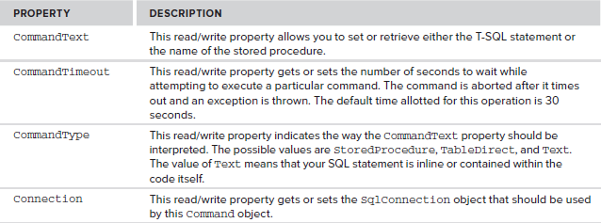

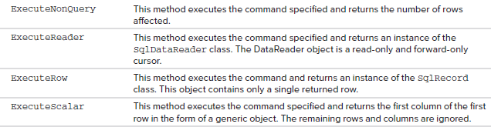

##### **The SqlDataReader Object**

The SqlDataReader object is a simple forward-only and read-only cursor. It requires a live connection with the data source and provides a very efficient way of looping and consuming all or part of the result set. This object cannot be directly instantiated. Instead, you must call the ExecuteReader method of the Command object to obtain a valid DataReader object. When using a DataReader object, be sure to close the connection when you are done using the data reader. If not, then the connection stays alive.

**Example:**

protected void Page_Load(object sender, EventArgs e)

{

if (!Page.IsPostBack)

{

SqlDataReaderMyReader;

SqlConnectionMyConnection = new SqlConnection(ConfigurationManager.ConnectionStrings["ConnString"].ConnectionString);

SqlCommandMyCommand = new SqlCommand();

MyCommand.CommandText = "SELECT * FROM Student";

MyCommand.CommandType = CommandType.Text;

MyCommand.Connection = MyConnection;

MyCommand.Connection.Open();

MyReader = MyCommand.ExecuteReader(CommandBehavior.CloseConnection);

gvCustomers.DataSource = MyReader;

gvCustomers.DataBind();

MyCommand.Dispose();

MyConnection.Dispose();

}

}

##### **The SqlDataAdapter Object**

The SqlDataAdapter is a special class whose purpose is to bridge the gap between the disconnected DataTable objects and the physical data source. The SqlDataAdapter provides a two-way data transfer mechanism. It is capable of executing a SELECT statement on a data source and transferring the result set into a DataTable object. It is also capable of executing the standard INSERT, UPDATE, and DELETE statements and extracting the input data from a DataTable object.

The commonly used properties offered by the SqlDataAdapter class.

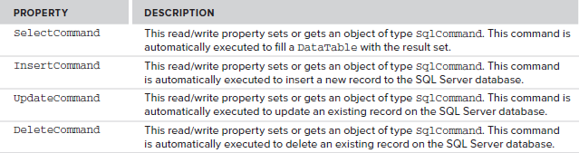

The SqlDataAdapter class also provides a method called Fill(). Calling the Fill() method automatically executes the command provided by the SelectCommand property, receives the result set, and copies it to a DataTable object.

**DataSet**

DataSet objects are in-memory representations of data. They contain multiple Datatable objects. **The DataSet is specifically designed to help manage data in memory** and to support disconnected operations on data

**DataTable**

The DataTable object represents a logical table in memory. It contains rows(DataRow), columns(DataColumn), primary keys, constraints, and relations with other DataTable objects.

**Example:**

protected void Page_Load(object sender, EventArgs e)

{

if (!Page.IsPostBack)

{

DataSetMyDataSet = new DataSet();

SqlConnectionMyConnection = new SqlConnection(ConfigurationManager.ConnectionStrings["ConnString"].ConnectionString);

SqlCommandMyCommand = new SqlCommand();

MyCommand.CommandText = "SELECT TOP 5 * FROM CUSTOMERS";

MyCommand.CommandType = CommandType.Text;

MyCommand.Connection = MyConnection;

SqlDataAdapterMyAdapter = new SqlDataAdapter();

MyAdapter.SelectCommand = MyCommand;

MyAdapter.Fill(MyDataSet);

gvCustomers.DataSource = MyDataSet.Tables[0];

gvCustomers.DataBind();

MyAdapter.Dispose();

MyCommand.Dispose();

MyConnection.Dispose();

}

}

**SqlParameter**

To add parameter/s in queriesusingSqlParameter class and providing it thenecessary information, such as parameter name, value, type, size, direction, and so on.

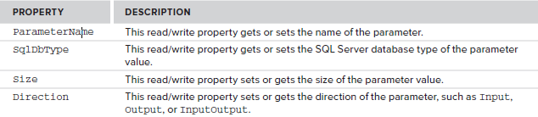

SqlCommandMyCommand = new SqlCommand();

SqlParameterIDParam= new SqlParameter();

IDParam.ParameterName = “@ID”;

IDParam.SqlDbType = SqlDbType.Int32;

IDParam.Direction = ParameterDirection.Input;

IDParam.Value = “2”;

MyCommand.Parameters.Add(IDParam);

### State Management

### Client-Based State Management Options

### View State

View state is the method that the ASP.NET page framework uses to preserve page and control values between round trips

View state is used automatically by the ASP.NET page framework to persist information that must be preserved between postbacks.

ViewState["UserId"]=1

int userId=(int)ViewState["LanguageId"]

**Cookies**

ASP.NET includes two intrinsic cookie collections. The collection accessed through the [Cookies](http://msdn.microsoft.com/en-us/library/system.web.httprequest.cookies%28v=vs.100%29.aspx) collection of [HttpRequest](http://msdn.microsoft.com/en-us/library/system.web.httprequest%28v=vs.100%29.aspx) contains cookies transmitted by the client to the server in the Cookie header. The collection accessed through the Cookies collection of [HttpResponse](http://msdn.microsoft.com/en-us/library/system.web.httpresponse%28v=vs.100%29.aspx) contains new cookies created on the server and transmitted to the client in the Set-Cookie header.

After you add a cookie by using the HttpResponse.Cookies collection, the cookie is immediately available in the [HttpRequest.Cookies](http://msdn.microsoft.com/en-us/library/system.web.httprequest.cookies%28v=vs.100%29.aspx) collection, even if the response has not been sent to the client.

HttpCookie objcook = newHttpCookie("username", txtUserName.Text);

objcook.Expires = DateTime.Now.AddDays(7);

Response.Cookies.Add(objcook);

string username= Request.Cookies["username"].Value

### Query Strings

A query string is information that is appended to the end of a page URL

http://www.cosmos.com/editstudent.aspx?id=100

int id= Convert.ToInt32(Request.QueryString["id"])

**Server-Based State Management Options**

ASP.NET session state enables you to store and retrieve values for a user as the user navigates ASP.NET pages in a Web application. HTTP is a stateless protocol. This means that a Web server treats each HTTP request for a page as an independent request.

Session["USerName"] = txtUserName.Text;

string userName= Session["USerName"].ToString();

**File I/O and Stream**

Can manage the files on the local file system by using the frameworks System.IO namespace.

Can read from and write different data formats to memory and the local system by using various **Stream classes** within the framework.

Can use the .Net framework to communicate with other commputers across the Internet using common protocols like HTTP and FTP.

**The DriveInfo Class**

To create a DriveInfo object and display local drive information on a web page

DriveInfo drive=new DriveInfo(@“C:\”)

drive.Name, drive.DriveType.ToString(), drive.DriveFormat; drive.TotalFreeSpace.ToString(), drive.TotalSize.toString()

**The Directory and DirectoryInfo Classes**

To work with the file system directories.

The **Directory** class exposes static methods and can use to create, move and delete directories.

Example: Directory.CreateDirectory(“C:\\Dotnet”), Directory.Exists(“C:\\Dotnet”), Directory.Delete(“C:\\Dotnet”).

The **DirectoryInfo** represents a specific directory and you can perform many of the same actions as the Directory class on specific directory. It enumerates child directories and files. We can use GetDirectories() method of the DirectoryInfo class

DirectoryInfo directory=new DirectoryInfo(path), DirectoryInfo[] directories=directory.GetDirectories();

**File and FileInfo**

**File:** a static utility class that exposes many static methods for moving, copying and deleting files.

Methods:Copy(), Create(), Delete(), Open(), Move()

**FileInfo:** Represents a physical file on disk, and has methods to manipulate this file.

FileInfo aFile=new FileInfo(@”C:\test.txt”)

aFile.Exists, aFile.Name, aFile.FullName, aFile.Extension, aFile.CreationTime

**FileStream**

Represents a file that can be written to or read from, or both. This file can be written to and read from.

FileStream aFile=new FileStream(filename, FileMode.Member);

FileStreamaFile=new FileStream(filename, FileMode.Member, FileAccess.Member);

**Example 1.**

System.IO.FileStream fs = new System.IO.FileStream(

Server.MapPath("TextFile.txt"),System.IO.FileMode.Open);

byte[] data = new byte[fs.Length];

fs.Read(data, 0, (int)fs.Length);

fs.Close();

this.lblResult.Text= ASCIIEncoding.Default.GetString(data);

**Example 2.**

System.IO.FileStreamfs = new System.IO.FileStream(Server.MapPath("TextFile.txt"),

System.IO.FileMode.Append, System.IO.FileAccess.Write,System.IO.FileShare.Read, 8, System.IO.FileOptions.None);

byte[] data = System.Text.Encoding.ASCII.GetBytes("This is an additional string");

fs.Write(data, 0, data.Length);

fs.Flush();

fs.Close();

this.lblResult.Text = ASCIIEncoding.Default.GetString(data);

**StreamWriter:** Writes character data to a stream and can be created by using a FileStream as base

**Example**

StreamWriter sw = new StreamWriter(File.Open(MapPath("TextFile.txt"),FileMode.Open));

sw.Write("This is a string");

sw.Close();

**StreamReader:** Reads character data from a stream and can be created by using a FileStream as base

**Example**

StreamReader sr = new StreamReader(File.Open(MapPath("TextFile.txt"),FileMode.Open));

string tmp = sr.ReadToEnd();

sr.Close();

**Introduction to XML**

* XML stands for EXtensible Markup Language
* XML is designed to transport and store data.
* XML tags are not predefined. You can define your own tags

**The Difference between XML and HTML**

XML was designed to transport and store data, with focus on what data is

HTML was designed to display data, with focus on how data looks

Example

<bookstore>  
  <book category="COOKING">  
    <title lang="en">Everyday Italian</title>  
    <author>Giada De Laurentiis</author>  
    <year>2005</year>  
    <price>30.00</price>  
  </book>  
  <book category="CHILDREN">  
    <title lang="en">Harry Potter</title>  
    <author>J K. Rowling</author>  
    <year>2005</year>  
    <price>29.99</price>  
  </book>  
</bookstore>

**Well Formed XML Documents**

A "Well Formed" XML document has correct XML syntax.

The syntax rules were described in the previous chapters:

* XML documents must have a root element
* XML elements must have a closing tag
* XML tags are case sensitive
* XML elements must be properly nested
* XML attribute values must be quoted

**Namespace:** System.Xml

**Classes:**  XmlDocument, XmlElement, XmlNode

XmlDocument objDoc = new XmlDocument();

objDoc.Load(HttpContext.Current.Server.MapPath("~/students.xml"));

**Creating XML from programming(dynamic) of Student information**

XmlDocument xmlDoc = newXmlDocument();

XmlElement xmlRoot = xmlDoc.CreateElement("students");

xmlDoc.AppendChild(xmlRoot);

XmlElement xmlStudent = xmlDoc.CreateElement("student");

xmlRoot.AppendChild(xmlStudent);

XmlElement xmlName = xmlDoc.CreateElement("Name");

xmlName.InnerText = "Ram Shreshtha";

xmlStudent.AppendChild(xmlName);

XmlElement xmlDOB = xmlDoc.CreateElement("DOB");

xmlDOB.SetAttribute("date", "yyyyMMDD");

xmlDOB.InnerText = "20010214";

xmlStudent.AppendChild(xmlDOB);

xmlDoc.Save("~/students.xml");

**Web Service**

A **web service** is a method of communication between different applications. Or a software system designed to support interoperable machine-to-machine interaction over a network. Using web services we can exchange virtually any data over internet.

The basic Web services platform is XML + HTTP.

XML provides a language which can be used between different platforms and programming languages and still express complex messages and functions.

**Web services platform elements:**

* SOAP (Simple Object Access Protocol)
* UDDI (Universal Description, Discovery and Integration)
* WSDL (Web Services Description Language)

**What is SOAP**

SOAP is an XML-based protocol to let applications exchange information over HTTP. SOAP is a protocol for accessing a Web Service.

**What is WSDL**

WSDL is an XML-based language for locating and describing Web services.

**What is UDDI**

UDDI is a directory service where companies can register and search for Web services.

UDDI:

is a directory for storing information about web services

is a directory of web service interfaces described by WSDL

communicates via SOAP.

is built into the Microsoft .NET platform­.

**Namespace:** System.Web.Services

Class: WebService

Web Service file extension is **.asmx**

The only difference from a normal application is that this function is defined as a "WebMethod".

Use "WebMethod()" to convert the functions in your application into web services:

Example

public class WebService : System.Web.Services.WebService

{

[WebMethod]

publicstring HelloWorld()

{

return"Hello World";

}

}

**Return from web service**

<?xml version="1.0" encoding="utf-8"?>

<string>Hello World</string>

**GDI+(**Graphics Device Interface**)**

GDI+ is a technology that developers generally associate with Windows Forms applications because they use it to draw anything on the screen from custom controls to diagrams.

We can also use GDI+ in ASP.NET Web applications whenever you want to serve up dynamic images. You can use GDI+ to create dynamic banners, photo albums, graphs, diagrams, and more.

GDI+ is the .NET Framework wrapper assembly for Microsoft's GDI (Graphics Device Interface) technology. In simple terms, you use GDI+ to draw on a drawing surface such as a Window, Control (technically just a window), or Bitmap, among others. Drawing with GDI+ is rather straightforward. You just need a *Graphics* object that links you to a drawing surface.

GDI+ resides in System.Drawing.dll assembly. namespaces are System.Drawing, System.Drawing.Imaging etc.

**The Graphics Class**

GDI+ uses a *Graphics* object as the main means to draw on a surface. The Graphics object has methods including DrawLine() or DrawArc() to draw line-based graphics, and FillEllipse() and FillPath() to fill areas with color.

Once you have the Graphics reference, you can call any of this class's members to draw various objects. Here are some of Graphics class's methods:

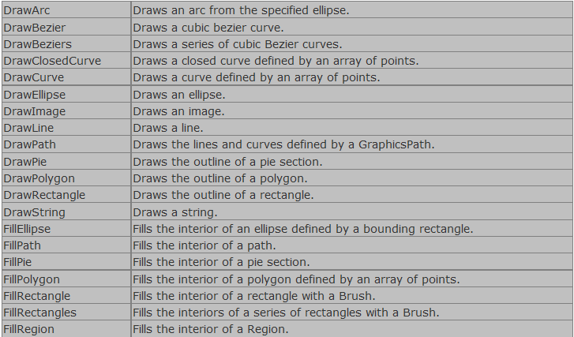

**Graphics Objects**

After creating a Graphics object, you can use it draw lines, fill shapes, draw text and so on. The major objects are:

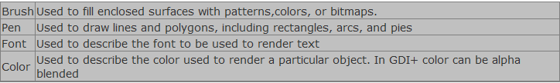

**The Pen Class**

A pen draws a line of specified width and style. You always use Pen constructor to create a pen. The constructor initializes a new instance of the Pen class. You can initialize it with a color or brush.

Initializes a new instance of the Pen class with the specified color.

public Pen(Color);

Initializes a new instance of the Pen class with the specified Brush.

public Pen(Brush);

Initializes a new instance of the Pen class with the specified Brush and width.

public Pen(Brush, float);

Initializes a new instance of the Pen class with the specified Color and Width.

public Pen(Color, float);

Here is one example:

Pen pn = new Pen(Color.Blue ); or Pen pn = new Pen( Color.Blue, 100 );

Some of its most commonly used properties are:

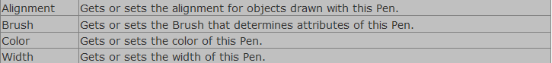

**The Color Structure**

A Color structure represents an ARGB color. Here are ARGB properties of it:

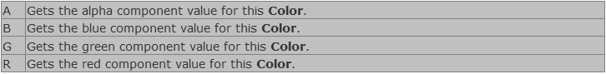

**The Font Class**

The Font class defines a particular format for text such as font type, size, and style attributes. You use font constructor to create a font.

Initializes a new instance of the Font class with the specified attributes.

public Font(string, float);

Initializes a new instance of the Font class from the specified existing Font and FontStyle.

public Font(Font, FontStyle);

Where FontStyle is an enumeration and here are its members:

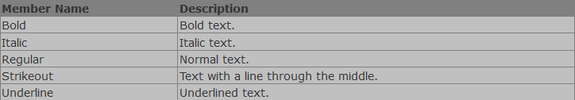

Here is one example:

Graphics g ;

Font font = new Font("Times New Roman", 26);

Some of its most commonly used properties are:

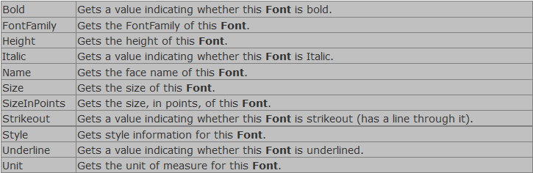

**The Brush Class**

The Brush class is an abstract base class and cannot be instantiated. We always use its derived classes to instantiate a brush object, such as SolidBrush, TextureBrush, RectangleGradientBrush, and LinearGradientBrush.

Here is one example:

LinearGradientBrush lBrush = new LinearGradientBrush(rect, Color.Red, Color.Yellow, LinearGradientMode.BackwardDiagonal);

OR

Brush brsh = new SolidBrush(Color.Red), 40, 40, 140, 140);

The SolidBrush class defines a brush made up of a single color. Brushes are used to fill graphics shapes such as rectangles, ellipses, pies, polygons, and paths.

The TextureBrush encapsulates a Brush that uses an fills the interior of a shape with an image.

The LinearGradiantBrush encapsulates both two-color gradients and custom multi-color gradients.

**The Rectangle Structure**

public Rectangle(Point, Size); or public Rectangle(int, int, int, int);

The Rectangle structure is used to draw a rectangle on WinForms. Besides its constructor, the Rectangle structure has following members:

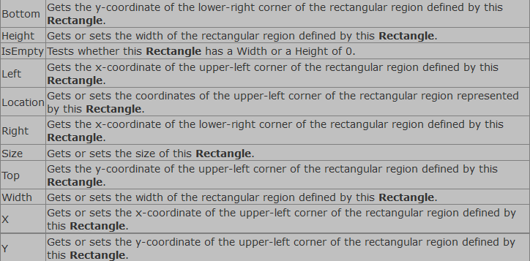

Its constructor initializes a new instance of the Rectangle class. Here is the definition:

public Rectangle(Point, Size); or public Rectangle(int, int, int, int);

**The Point Structure**

This structure is similar to the POINT structure in C++. It represents an ordered pair of x and y coordinates that define a point in a two-dimensional plane. The member x represents the x coordinates and y represents the y coordinates of the plane.

Here is how to instantiate a point structure:

Point pt1 = new Point( 30, 30);

Point pt2 = new Point( 110, 100);

**Some sample Examples:**

protected void Page_Load(object sender, EventArgs e)

**{**

Bitmap bm = new Bitmap(300, 150);

Graphics g = Graphics.FromImage(bm);

g.Clear(Color.White);

//g.DrawLine(Pens.Red, 10, 10, 150, 150);

//g.FillRectangle(new SolidBrush(Color.Red), 10, 10, 150, 100);

g.DrawString("Binod Thapa", new Font(FontFamily.GenericSerif,34,FontStyle.Bold), Brushes.Green, 10, 40);

// Now, we only need to send it // to the client.This save image in memory

Response.ContentType = "image/jpeg";

bm.Save(Response.OutputStream, ImageFormat.Jpeg);

Response.End();

//bm.Save(Server.MapPath("~/uploads/") + "sss.jpeg",ImageFormat.Jpeg);//save in directory

// Cleanup

g.Dispose();

oCanvas.Dispose();

**}**

**Reflection**

Reflection is able to find out details of an object, method, and create objects and invoke methods at runtime. The **System.Reflection** namespace contains classes and interfaces that provide a managed view of loaded types, methods, and fields, with the ability to dynamically create and invoke types. Programmer can use **typeof** operator to get the object's type of the current instance.

Public class MyClass2

{

int answer;

public MyClass2()

{

answer = 0;

}

public int AddNumb(intnumb1, intnumb2)

{

answer = numb1 + numb2;

return answer;

}

}

Type type1 = typeof(MyClass2);

**Windows Service Applications**

Microsoft Windows services enable us to create long-running executable applications that run in their own Windows sessions. These services can be automatically started when the computer boots, can be paused and restarted, and do not show any user interface.

We can then use the **Services Control Manager** to start, stop, pause, resume, and configure your service.

Using Microsoft Visual Studio or the Microsoft .NET Framework SDK, We can easily create services by creating an application that is installed as a service. This type of application is called a Windows service. With framework features, you can create services, install them, and start, stop, and otherwise control their behavior.

**Threading**

A thread is a sequence of instructions executed within the context of a process. MultiThreading is achieved when a program uses multiple execution threads allowing each thread to share the CPU concurrently depending on the priority assigned to these threads. This helps in the optimum usage of System Resources.

**Namespace: System.Threading**

Thread.Sleep(60000);//in mimiseconds

using System;

usingSystem.Threading;

public class ThreadTest

{

// This method that will be called when the thread is started

public void test()

{

//code here for logic

}

}

Using thread

ThreadTestobj = new ThreadTest ();

Thread oThread = new Thread(new ThreadStart(obj.test));

//to start thread

oThread.Start();

// Spin for a while waiting for the started thread to become

// alive:

while (!oThread.IsAlive);

// Put the Main thread to sleep for 1 millisecond to allow oThread

// to do some work:

Thread.Sleep(1);

// Request that oThread be stopped

oThread.Abort();