**UML Class Diagram:**

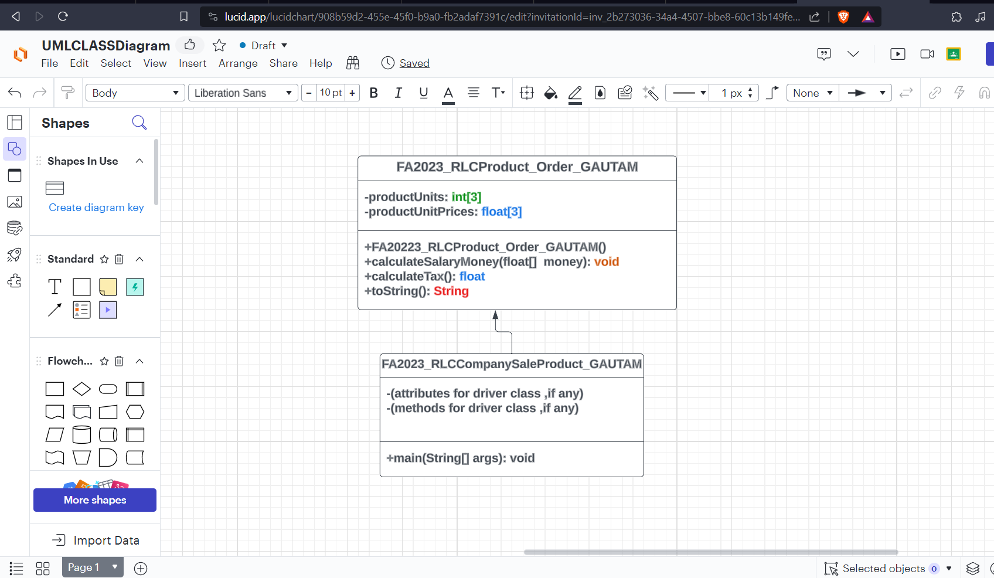

**PseudoCode for DataType Class:FA2023_RLCProduct_Order_GAUTAM**

**CLASS FA2023_RLCProduct_Order_GAUTAM**

**PRIVATE productUnits: int[3]**

**PRIVATE productUnitPrices: float[3]**

**PUBLIC METHOD FA2023_RLCProduct_Order_GAUTAM()**

**// Initialize productUnits and productUnitPrices arrays**

**PUBLIC METHOD calculateSaleMoney(float[] money)**

**// Calculate sale money for each size and store in money array**

**money[0] = productUnitPrices[0] * productUnits[0]**

**money[1] = productUnitPrices[1] * productUnits[1]**

**money[2] = productUnitPrices[2] * productUnits[2]**

**PUBLIC METHOD calculateTax(): float**

**// Calculate sale tax**

**RETURN (calculateSaleMoney() * 0.0825)**

**PUBLIC METHOD toString(): String**

**// Format and return receipt as a string**

**DECLARE subtotal: float**

**DECLARE tax: float**

**DECLARE total: float**

**subtotal = SUM(productUnitPrices[0] * productUnits[0], productUnitPrices[1] * productUnits[1], productUnitPrices[2] * productUnits[2])**

**tax = calculateTax()**

**total = subtotal + tax**

**RETURN "SIZE PRICE UNITS MONEY\n" +**

**"Product Small: " + productUnitPrices[0] + " " + productUnits[0] + " " + (productUnitPrices[0] * productUnits[0]) + "\n" +**

**"Product Medium: " + productUnitPrices[1] + " " + productUnits[1] + " " + (productUnitPrices[1] * productUnits[1]) + "\n" +**

**"Product Large: " + productUnitPrices[2] + " " + productUnits[2] + " " + (productUnitPrices[2] * productUnits[2]) + "\n" +**

**"Subtotal: " + subtotal + "\n" +**

**"Sale Tax: " + tax + "\n" +**

**"Total: " + total**

**Pseudo Code for Driver Class:FA2023_RLCCompanySaleProduct_GAUTAM**

**CLASS FA2023_RLCCompanySaleProduct_GAUTAM**

**PUBLIC STATIC METHOD main(String[] args)**

**// Declare and initialize necessary variables and arrays**

**DECLARE productOrder: FA2023_RLCProduct_Order_GAUTAM**

**DECLARE input: Scanner**

**// Display the sale menu and read user input**

**DISPLAY "SALE RLC PRODUCT MENU – GAUTAM"**

**DISPLAY "----------------------------------------"**

**DISPLAY "E. Exit"**

**DISPLAY "S. Size SMALL ($124.29/per unit)"**

**DISPLAY "M. Size MEDIUM ($236.59/per unit)"**

**DISPLAY "L. Size LARGE ($348.79/per unit)"**

**DISPLAY "P. Print The Receipt"**

**DISPLAY "Type S, M, L to select the size, P to print the receipt or E to End the program: "**

**READ userChoice**

**// Process user input**

**WHILE userChoice is not 'E'**

**SWITCH userChoice**

**CASE 'S':**

**// Read and update the number of small units in productOrder**

**// Display the menu again**

**CASE 'M':**

**// Read and update the number of medium units in productOrder**

**// Display the menu again**

**CASE 'L':**

**// Read and update the number of large units in productOrder**

**// Display the menu again**

**CASE 'P':**

**// Calculate sale details using productOrder**

**// Display the receipt**

**// Display the menu again**

**DEFAULT:**

**// Display an error message for invalid input**

**READ userChoice**

**// Exit the program**

**DISPLAY "The program is terminating..."**

**<<<<<<<<<<<<<<<<<<OUTPUT SCREENSHOTS>>>>>>>>>>>>>>>>>>>>>>>>>>>>**

