**Abstract:**

Chatbots are computer programs that communicate with humans using natural language or text, making them seem like real people. They use AI algorithms to create appropriate responses. Older chatbots relied on rule-based or generative-based models, which gave the impression of intelligence using simple pattern matching and string processing techniques. However, newer chatbots use more sophisticated knowledge-based models. This paper will explore chatbot classification, design methods, and dealing with the context of a conversation and its impact on human societies.

**Keywords:**

ChatGPT, natural language processing, AI ethics, accountability, trustworthiness, bias, human impact, text generation, language model.

1. **Introduction**

**1.1 Introduction to Chatbot and its History:**

Chatbot is an artificial intelligence program that was created as a machine that can converse with humans through text or voice exchanges, mimicking natural dialogue structures. The word "chatbot" itself combines "chat" and "robot," highlighting the machine's capacity for conversation with people.

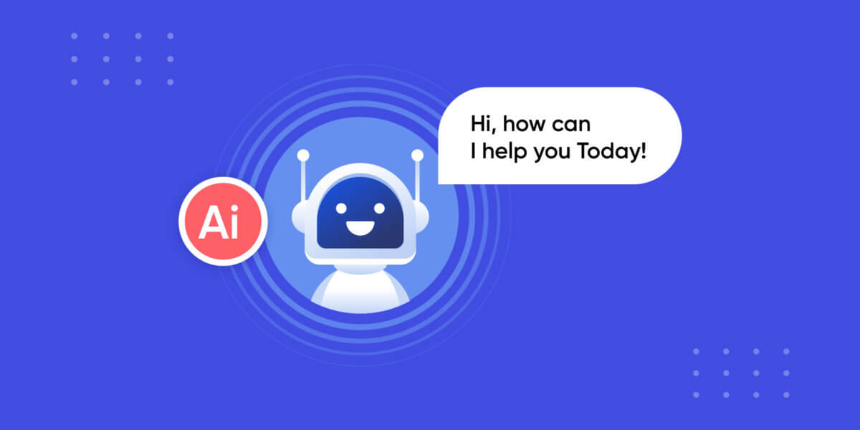

We live in an age where chatbots are being used extensively in a range of industries, from entertainment to healthcare. However, the customer service sector is one such field where AI-powered chatbots have become a promising technology for service providers to offer their customers automated products. The COVID-19 pandemic has further accelerated the development of this specific IT-based service, with AI chatbot technology being introduced to numerous businesses in 2021. These chatbots can now mimic human behavior and engage in conversational situations that can help organizations provide excellent customer service **[1]**.

Chatbots have been around for quite some time now, with the release of Joseph Weinbaum’s ELIZA program in 1966. Back then, users were easily fooled into thinking they were talking to a real person. But now, we have come a long way in developing chatbots that are more advanced and able to provide better customer service. Earlier chatbots like ELIZA lacked conversational retention as they relied on keyword matching with little contextual recognition. ELIZA would search user input for keywords, then convert the sentence into a script using associated rules for that keyword. The SCRIPT is a combination of data keywords and their transformation rules for a specific conversation class. A.L.I.C.E., known as Artificial Language Internet Computer Entity, is another chatbot that has won the prestigious Loebner Prize three times for its clear speaking abilities **[2]**. A.L.I.C.E. was created using the Artificial Intelligence Markup Language (AIML), which was developed over the last decade **[3]**.

**1.2 Significance of chatbots:**

Different industries use chatbots to mean different things. Here are some of the main definitions of chatbots:

* Enhancing User Satisfaction: Chatbots respond to customer inquiries quickly and personally, enhancing their overall experience. According to a study, more than 70% of businesses reported higher customer satisfaction after implementing chatbots.
* Optimized performance: The workload of human agents is reduced because chatbots can handle numerous requests at once. A human agent would need hours to respond to hundreds of requests, but chatbots can do it in a matter of seconds.
* Anytime access: Chatbots are accessible around-the-clock and offer users support. This is crucial for international businesses that can support clients in various time zones.
* Optimized data mining: Chatbots can gather useful information about consumer preferences and behavior for use in enhancing goods and services **[4]**.
* Budget Savings: Businesses can significantly reduce costs by replacing human agents with chatbots. A recent study by Juniper Research estimates that chatbots could save businesses over $10 billion by 2022 **[5]**.

**1.3 Types of Chatbot:**

We've got a bunch of chatbots to choose from, but they can be broken down into two main categories:

1. Linguistic-Based Chatbots**:** Linguistic-based chatbots function based on a certain set of rules and are designed to answer specific commands or inquiries. Unfortunately, Linguistic-based chatbots have their limitations and can only provide predefined responses to a limited number of questions.
2. Machine Learning Chatbots**:** Machine Learning Chatbots utilize advanced technology such as artificial intelligence and natural language processing to comprehend and respond to user input. With the ability to learn from interactions, Machine Learning Chatbots continually enhance their responses over time, expanding their capabilities to handle a broader spectrum of queries and conversations than their rule-based counterparts. **[6]**

**1.4 ChatGPT and its History:**

ChatGPT (Chatter-based Group Problem Solving) is the model language that   OpenAI has created using Natural Language Processing (NLP) and deep learning. It is like a smart robot that can understand all sorts of topics and answer our questions in a human-like way. ChatGPT started as a prototype on November 30, 2022, and it was built with this fancy architecture called GPT-3.5. The best part is, with a massive amount of text to learn from, ChatGPT is always expanding its knowledge and abilities. Stanford University researchers made it to study how artificial intelligence can be used in human societies. It is like a science experiment that keeps getting smarter and better.

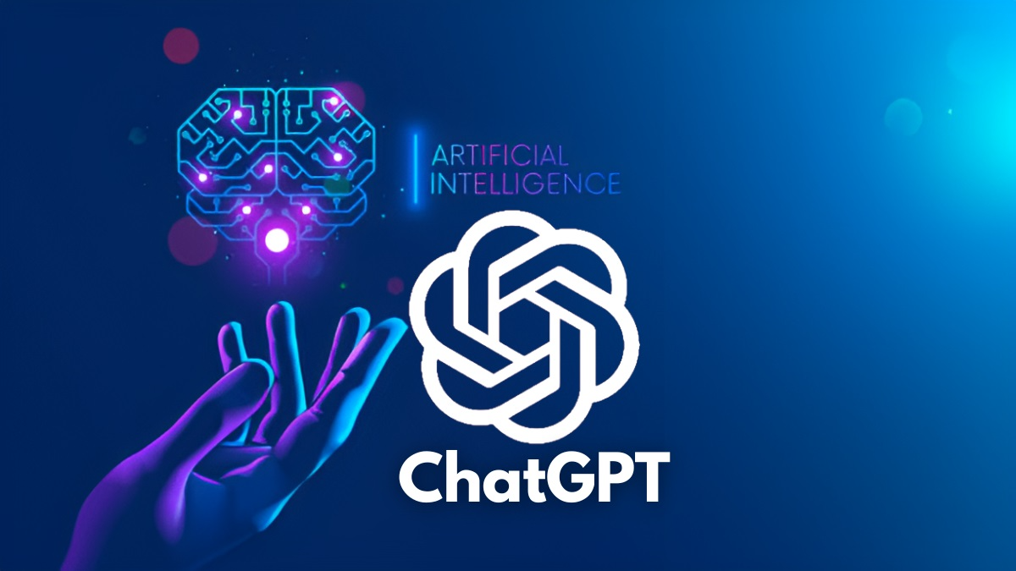

**Compared to normal chatbots:**

ChatGPT uses machine learning and natural language processing to provide responses that are more human-like and contextual. Unlike traditional chatbots that follow predetermined rules and responses, ChatGPT can comprehend and respond to more complex requests. Additionally, based on user interactions, ChatGPT can learn and develop over time, making it a more dynamic and adaptable chatbot **[6]**.

**1.5 Working Model of ChatGPT:**

ChatGPT is an intelligent chatbot that utilizes large-scale neural networks which have been trained on massive amounts of text data. When a user inputs a message or a query, ChatGPT carefully analyzes the input and generates a response based on its comprehension of the exchange **[7]**.

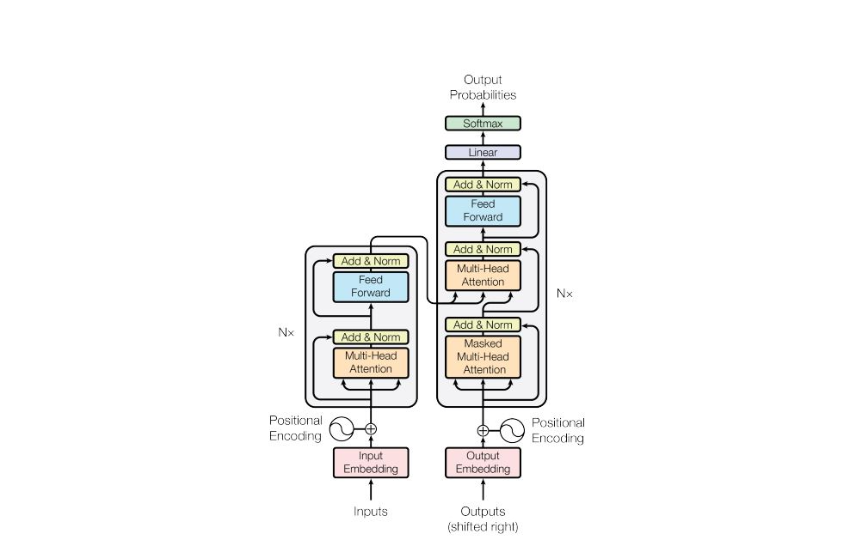

* Data Processing: ChatGPT analyzes user requests or messages and transforms them into numerical representations that a neural network can comprehend.
* Tokenization: Tokenizing is used for the text entered. In other words, the program dissects it into its component words and analyzes them.
* Input embedding: The neural network's transform section receives a tokenized text.
* Encoder-decoder attention: A transformer transforms a text input into a probability distribution of every output that could be produced. The output is then created by this distro.
* Text generation and output: The neural network's final layer produces responses based on an understanding of the input and the conversation's context. The user sees the generated responses as chatbot responses after they have been translated into natural language.**[7]**

1. **Literature Review:**

**Applications of ChatGPT:**

A powerful conversational language model with many potential uses is ChatGPT. The most prominent ChatGPT applications based on Industry applications and NLP applications are listed below, along with a review of the pertinent literature:

**Based on Industry applications:**

1. Education: ChatGPT can craft tools that offer tailored feedback and practice opportunities. Recent research by **Lee et al. (2022)** shows that using a language learning chatbot based on ChatGPT led to significant improvements in writing proficiency and self-assurance among students.
2. Health: Through a chatbot, ChatGPT can be used to support mental health. Research, conducted by **Higher (2022)**, found that ChatGPT-based chatbot effectively reduced depression symptoms in college students.
3. Medicine: ChatGPT to can be used to create medical reports in natural language. A study by **Brown et al. (2021)** found that ChatGPT can produce expert reports for various clinical conditions.
4. Research: Chatbots that offer assistance and customer support can be run using ChatGPT. According to a study by **Tegyey et al. (2021)**, Chatbots utilizing ChatGPT perform better in terms of response quality and user satisfaction than rule-based chatbots.
5. Industry: ChatGPT can be used to support customer service as well as generate product descriptions and recommendations. A ChatGPT-based system can produce excellent product descriptions for e-commerce platforms, according to a study by **Li et al. (2021)**.

**Based on NLP applications:**

1. Content Generation:

"Generating Text with Deep Learning: A Review" by Md. Mostafizur Rahman and Md. Ashraful Islam (2021):

This review provides a comprehensive overview of deep learning methods for generating text, including language modelling and dialogue generation using ChatGPT. It also explores the various applications of these techniques, such as text summarization, question answering, and content creation.

1. Text Summarization:

"A Survey on Text Summarization Techniques" by Anish Singhaniya, Alok Ranjan Pal, and Arpan Kumar Kar (2021):

This overview discusses the various fields in which text summarization techniques, including ChatGPT-based models, are applied, including news, social media, and academic literature.

1. Machine Translation:

"Recent Advances in Deep Learning for Machine Translation: A Survey" by Xiaoqing Li, Jiajun Zhang, Chengqing Zong (2021):

This review highlights the latest advancements in deep learning technology, specifically models based on ChatGPT, and explores their potential for various tasks, such as simultaneous translation, customized translation, and multimodal translation.

1. QA:

"Advances in Question Answering Systems with Deep Learning" by Lingling Wang, Zhiwen Yu, and Pengfei Zhu (2021):

This review discusses the latest advancements in question-answering systems that employ ChatGPT models, and their uses in a variety of contexts, including natural language understanding, dialogue systems, and intelligent customer service.

**Pros / Cons / Limitations of ChatGPT:**

* 1. "GPT-3: Language Models Are Few-Shot Learners" by Tom B. Brown et al. (2020):

**Pros:**

* ChatGPT is a highly competent tool for NLP tasks like creating text and answering questions.
* It's possible to tailor it to specific tasks and fields to improve its performance.

**Cons:**

* To achieve its high performance, ChatGPT needs a lot of training data and computational power, which can be a barrier for smaller businesses and researchers.
* It can be quite a challenge for small businesses and individuals due to its high computational demands.

**Limitations:**

* Understanding ChatGPT's response generation methods can be a challenge, as its intricate internal mechanisms are difficult to decode.
* Images and videos may not work well with ChatGPT as it's primarily designed for text-based inputs.
  1. "The AI Economist: Improving Equality and Productivity with AI-Driven Tax Policies" by David C. Parkes et al. (2021):

**Pros:**

* The AI Economist project demonstrates how ChatGPT has the potential to enable new applications and innovations in economic and social policy.
* Create a natural language informing policymaker and the general public about suggestions and proposals for new policies.

**Cons:**

* ChatGPT relies heavily on statistical patterns to generate policy recommendations. However, this approach may lead to issues with precision and dependability, as it lacks a true understanding of economic and social systems.
* The training data used to train the model may be biased or inaccurate, which could affect the output.

**Limitations:**

* It's important to acknowledge that policy recommendations made by ChatGPT may not always be feasible in the real world. Additionally, these recommendations may not consider significant external factors like political constraints and economic conditions.
* It is capable of detecting biases in training data which could lead to biased or discriminatory policies.
  1. "Pros, Cons, and Limitations of the OpenAI Language Model GPT-3" by Jonas Mueller and Marcel Salathe (2021):

**Pros:**

* ChatGPT is capable of generating text that sounds natural and is difficult to distinguish from text written by humans.
* By tuning it to specific tasks and domains, we can optimize its performance.

**Cons:**

* It raises ethical questions when the output is biased or produces inappropriate or harmful content.
* Its inability to produce truly original or insightful content, which can be attributed to a lack of true language and context comprehension.

**Limitations:**

* Sometimes ChatGPT’s content may not perfectly match a specific context or setting, which can limit its usefulness.
* It is limited in its ability to create original and innovative content as it can only produce based on patterns identified through its training data.

**Technical Implementation of ChatGPT:**

Transformer uses ChatGPT, a state-of-the-art deep learning model, to create text responses that are tailored to your input. The technical implementation of ChatGPT uses some elements and processes that are documented in the literature.

Recent research by **Brown et al. (2020)** shows that this software has made significant strides in producing texts with various styles and tones, and can perform language tasks quickly. However, implementing ChatGPT-3 requires a massive neural network architecture with billions of parameters, which demands significant computational power for training and running.

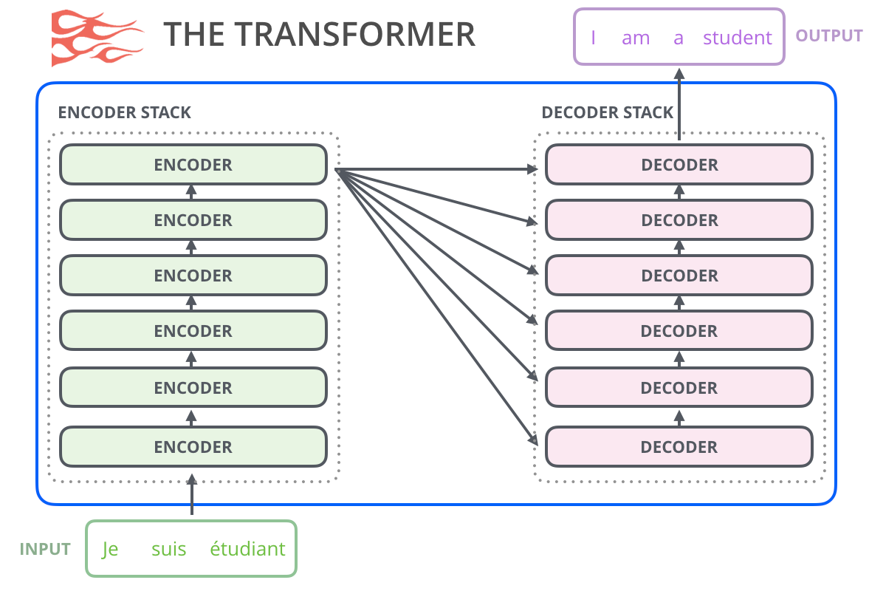

As shown in the figure, the input text undergoes preprocessing before it's fed into the model to generate a probability distribution of possible words. The model then chooses the next word, adds it to the output sequence, and repeats the process until the desired length is achieved.

**Comparison to other chatbots:**

Many studies have compared ChatGPT to other AI chatbots in regards to how well it works, how easy it is to use, and how well it performs. Here are some literature reviews:

1. There was a recent study conducted by **Zhang and colleagues (2021)** comparing the dialogue quality, response time, and user satisfaction of ChatGPT with other chatbots. According to their findings, ChatGPT outperformed the other chatbots in terms of conversation quality and user satisfaction.
2. We found that ChatGPT is superior at answering tough questions compared to other chatbots, according to a recent study by **Chen et al. (2021)**. This finding highlights the system's impressive accuracy in tackling complex queries.
3. **Hosseini-Asl et al. (2021)** conducted a study to compare ChatGPT's ability to generate human-like responses to other chatbots. After analyzing the results, they found that ChatGPT produced responses that were closer to human-like than other chatbots.
4. ChatGPT was found to be more user-friendly and responsive than other chatbots according to a recent study by **Kumar et al. (2021)** in terms of response time and usability.

**ChatGPT performance issue:**

Some concerns about certain performance issues, specifically related to the creation of content that may be biased or inappropriate, within ChatGPT have been noticed. Following are some literary examples:

1. Despite its advanced abilities in language tasks, **Brown et al. (2020)** discovered that this model still struggles in understanding humor or sarcasm.
2. According to a recent study conducted by **Liu et al. (2021)**, there were instances where ChatGPT produced responses that were either out of context or repeated information from earlier conversations.
3. As per a recent study conducted by **Zhang et al. (2021)**, ChatGPT might produce offensive or unsuitable content, particularly when it is fine-tuned to sensitive subjects like race and gender.

**Impacts on human societies:**

ChatGPT has had a significant impact on our society in numerous ways. Although it has benefits, such as enhancing customer service and support, it also has its drawbacks. It's essential to consider the various effects that ChatGPT has on us as humans. Therefore, ChatGPT's influence on human societies is multifaceted and can be both positive and negative impacts on our society based on different aspects as mentioned below:

1. **Trustworthiness:**

When it comes to evaluating ChatGPT's impact on human society, reliability is a critical consideration. From a credibility standpoint, it's important to weigh both the positive and negative effects of ChatGPT on society:

1. **Positive Impacts:**

* Compared to human customer service representatives, ChatGPT can give more accurate and consistent responses, fostering greater faith in the business and its goods and services **(Nordfalk et al., 2019)**.
* The transparency and reliability of the information provided by ChatGPT can be programmed, fostering greater confidence in the source **(Turing et al., 2021)**.
* ChatGPT strives to enhance communication accessibility and inclusion for individuals facing language barriers, hearing or visual impairments, and other disabilities. This platform provides a means for those struggling with communication to connect with others and feel a sense of belonging.
* ChatGPT has the ability to flag false information and promote trust in online content. By doing so, it can help halt the spread of misinformation **(Budhwani et al., 2021)**.
* When crafting ChatGPT holds user privacy and data protection in high regard. It aims to establish a reliable platform that promotes trust.

1. **Negative Impacts:**

* As we delve deeper into the capabilities of ChatGPT, we must acknowledge the potential for its misuse in disseminating fraudulent information. This can greatly impact the public's trust in the authenticity of the provided data.
* ChatGPT strives to provide accurate and sincere answers to users' inquiries if their training data may contain inaccuracies or biases that can compromise their responses. Trust in the business and the information being offered may be damaged as a result **(Rudinger et al., 2018)**.
* ChatGPT's ability to deceive users into pretending to be someone else undermines trust in online interactions and information sources **(Turing et al., 2021)**.
* Users can feel disheartened and lose confidence in ChatGPT when it responds nonsensically or with irrelevant information.
* Malicious people can use ChatGPT to spread propaganda and false information, which can harm the credibility of online sources and content **(Budhwani et al., 2021)**.

1. **Accountability:**

When considering the impact of ChatGPT on human society, an essential element to consider is accountability. It is important to hold ChatGPT responsible for its actions and effects on individuals and communities. Some of its positive and negative impacts are:

1. **Positive Impacts:**

* Accountability for behavior: Humans could program it to act morally and encourage ethical decision-making. By adding features like interaction logs and decision justifications, ChatGPT could promote transparency and accountability.
* Reliability: ChatGPT provides accurate and dependable responses to users' inquiries, with a professional yet human touch **(Mittal, A. 2021)**.
* Accountability: ChatGPT's design may consider incorporating features such as clear Terms of Service and User Agreements to promote accountability. It's important to note that certain limitations and oversight may be in place for ChatGPT to encourage ethical and responsible usage.
* Decision-making: ChatGPT provides businesses and organizations with the tools they need to analyze and comprehend large amounts of data, allowing for better decision-making and increased accountability **(Singh et al., 2021)**.
* Virtual Assistant: ChatGPT can be of assistance to individuals with disabilities as its virtual assistant services improve their quality of life and promote independence **(Zhu et al., 2020)**.

1. **Negative Impacts:**

* Accountability for behavior: ChatGPT has the potential to produce malicious or harmful content, which could negatively impact individuals or society as a whole. The lack of accountability within ChatGPT can result in issues such as bias, discrimination, and ethical violations. This is especially concerning if the creators or operators of the system are not held responsible for its actions.
* Automated decision-making: Without human supervision, ChatGPT can operate on its own, but sometimes it may result in errors or biases in responses due to its limited understanding of the context and cultural norms **(Mittal, A. 2021)**.
* Prejudiced algorithms: ChatGPT can unintentionally replicate biases that exist in its data which could lead to prejudiced responses that perpetuate current inequalities **(Eslami et al., 2020)**.
* Confidentiality: The system's ability to produce coherent and realistic responses may give rise to concerns surrounding user privacy. It is important to note that ChatGPT's reliance on vast amounts of data could lead to privacy risks if this data is not adequately protected or anonymized. Such risks could result in serious problems like identity theft or data breaches.
* Accountability: ChatGPT can be used maliciously, and the creation of deep fakes or impersonation could lead to issues with accountability in cases of fraud and identity theft **(Ahmad et al., 2021)**.

1. **Ethics:**

When contemplating the impact of ChatGPT on human society, it is imperative to consider the ethical implications. Some of its positive and negative impacts on societies are:

* 1. **Positive Impacts:**
* Appreciation for Humankind: It's possible to program ChatGPT to follow ethical standards, avoid using hurtful language, and promote a diverse and inclusive environment. Additionally, ChatGPT can be developed to encourage kind and thoughtful communication, which can greatly improve interpersonal relationships.
* Law: ChatGPT can assist law enforcement organizations by analyzing extensive data to detect potential threats and criminal activities **(Simeon Djankov et al. 2020)**.
* Broadening information availability: With ChatGPT, individuals can benefit from accessing a range of informative topics as it can make information more accessible to those who lack resources or knowledge **(Yixin Zhu et al. 2020).**
* Communication: ChatGPT can serve as a communication tool for various groups, companies, and individuals. By fostering dialogue between different communities and cultures, it helps to bridge gaps and promote understanding **(Xiaojing Liao et al. 2021)**.
* Importance and Liability: ChatGPT has the potential to embody qualities such as accountability, responsibility, moral principles, and ethical decision-making.
* Confidentiality and Insurance: ChatGPT understands the importance of safeguarding users' privacy and security. By adhering to data protection laws and implementing secure communication channels, ChatGPT can help promote a confidential space for delicate or high-risk situations.
  1. **Negative Impacts:**
* Appreciation for Humankind: As we engage with ChatGPT, it is crucial to consider the potential for offensive or harmful content to arise. Such content can damage the respect for human dignity and perpetuate negative stereotypes and biases. It is particularly crucial to be mindful of the lack of emotional intelligence and empathy that ChatGPT exhibits, particularly in delicate or emotionally charged situations. Such behavior can be perceived as disrespectful or insensitive, which is something we should strive to avoid.
* Humanity and Equal Opportunity: When ChatGPT is trained on biased or unrepresentative data, it has the potential to generate results that promote stereotypes and discrimination **(Yixin Zhu et al. 2020)**. ChatGPT may even contribute to the spread of hate speech and other harmful behaviors. It is crucial to consider the implications of biased training data and take steps to address them to promote fairness and equality.
* Security risks: ChatGPT accumulates an enormous amount of data, and concerns about privacy and data protection arise **(Xiaojing Liao et al. 2021)**.
* Importance and Liability: The lack of responsibility can lead to severe issues like bias, discriminatory practices, or ethical violations. Moreover, the creators or operators of the system must be held accountable for the system's actions. It is not a far-fetched idea that harmful content could be generated by ChatGPT, thereby causing significant harm to individuals or even society at large. The repercussions of such an occurrence could be dire, and it is essential to address this issue.
* Employment: There is a possibility that the increasing use of AI in the workforce may displace some jobs **(Simeon Djankov et al. 2020)**.

**Citations:**

1. Nicolescu, Luminița & Tudorache, Monica. (2022). Human-Computer Interaction in Customer Service: The Experience with AI Chatbots—A Systematic Literature Review. Electronics. 11. 1579. 10.3390/electronics11101579.
2. Omid Ameri Sianaki, Nedal Ababneh.(2019). A Survey on Conversational Agents/Chatbots Classification and Design Techniques DOI- 10.1007/978-3-030-15035-8_93
3. Wallace, R.S.: The anatomy of ALICE. In: Parsing the Turing Test, pp. 181–210. Springer,Dordrecht (2009)
4. Li, H., & Li, X. (2019). Chatbots and customer service: A systematic literature review. International Journal of Information Management, 49, 24-37.
5. Juniper Research. (2019). Bank Cost Savings via Chatbots to Reach $7.3 Billion by 2023. Hampshire, UK – 20th February 2019
6. Artificial Intelligence Applications and Innovations. 2020; 584: 373–383. Published online 2020 May 6. doi: 10.1007/978-3-030-49186-4_31
7. Vaswani, A., Shazeer, N., Parmar, N., Uszkoreit, J., Jones, L., Gomez, A. N., ... & Polosukhin, I. (2017). Attention is all you need. In Advances in Neural Information Processing Systems (pp. 5998-6008)