This task will attempt to create a working Car Rental System using fundamental software engineering principles and object-oriented programming (OOP) techniques. The product is designed to streamline the outdated, manual car rental process to eliminate human error and improve operations. Enhanced with appropriate software development methodologies and design patterns, the project will deliver a reliable, easy-to-use, and easily scalable solution that meets companies' business requirements for customers and the entire managed customers and administrative staff. The solution will allow you to automate your rental operations, reduce human error, and increase customer satisfaction.

**Actors:**

* **Admin**
* **Customer**

**Use Cases (System Functions):**

**Admin Can:**

* Register a user (Admin/Customer)
* Add car
* Update car
* Delete car
* View all bookings
* Approve/reject bookings

**Customer Can:**

* Register
* Login
* View available cars
* Book a car (specify duration)
* View own bookings

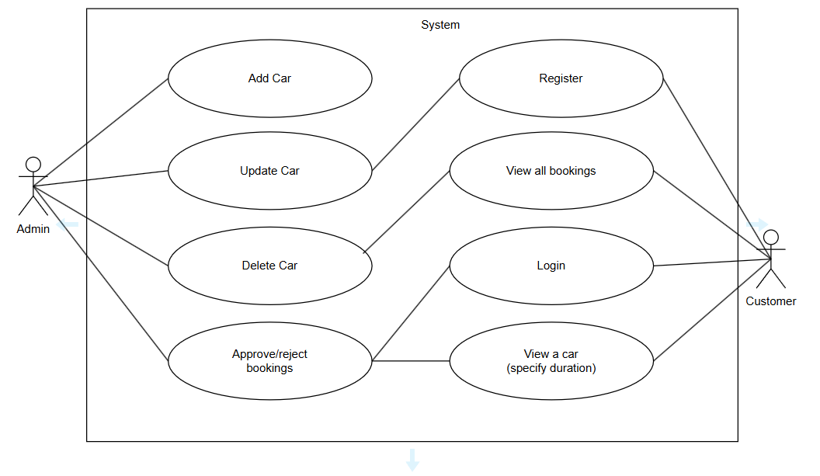

*Figure: Use Case Diagram*