This is the title of the article
Jane Q. Smith | Departments of Psychology and Neurobiology and Brain Research Institute, UCLA, Los Angeles, CA, USA | 
John J. Jones | Center for Neural Science, New York University  New York, NY, USA
This document is a template to be used to create a suitably formatted submission for the Journal of Vision. It contains some instructions, style definitions, and illustrations of the use of those styles. The complete instructions for manuscript preparation are available at http://journalofvision.org/info/instructions.pdf. This is the text of the abstract. It has the style jovAbstract. This version of the template is dated 1/11/05.
Keywords: reverse correlation, triggered correlation, primate, recursive least squares, linear-nonlinear model, system identification

Introduction
This template incorporates the following styles, which should be used where possible.
jovTitle
jovAuthor
jovAffiliation
jovAbstract
jovKeywords
jovBodyText
jovBodyTextContinue
jovHeading1
jovHeading2
jovHeading3
jovFigure
jovFootnoteNumber1
jovReference
jovCaption
jovTable
jovEquation
jovBlockText
jovHeader
jovAbstract
jovList
jovNumberedList
Two columns vs one column?
This template contains two Microsoft Word “sections;” the break between them is just after the keywords. This template is designed with the first section in single column format, and the second section in two column format, and with the text justified and hyphenated as it will appear in the PDF version of the article. Composing your paper with these formats will help you to judge proper size for figures, will show whether equations fit in a single column, and may make the draft more pleasing to look at and read for the reviewers. However, if you find it simpler to work in single column format, the paper can be composed and submitted in that format. To convert this template to single column format in Microsoft Word, place the cursor anywhere in section two (for example, right here), and then under the “Format” menu, chose “Columns…” and select 1 column (or use the column icon on the toolbar, if it is visible).
To create a new manuscript
To create a new manuscript for Journal of Vision, do the following.
- Open the template in your word-processing program (e.g. MS Word).
- Save the file under a new name.
- Enter content into the appropriate sections, and apply the styles as described above. If you are using a recent version of Word, and you are using a version of the template with a “.doc” extension, a toolbar should appear with many of the styles in it as buttons.
To format an existing manuscript
To format an existing manuscript, do the following.
- Open the template in your word-processing program (e.g. MS Word).
- Position the cursor at the start of the file.
- From "Insert" menu, choose "File" and select the rtf file of your existing manuscript. Its contents will be inserted at the location of the cursor.
- Save the result under a new name.
- Begin applying the styles as they are described in the template. If you are using a recent version of Word, and you are using a version of the template with a “.doc” extension, a toolbar should appear with many of the JOV styles in it as buttons.
The headings should have the styles jovHeading1, jovHeading2, jovHeading3. The body text should have the style jovBodyText. Bibliographic citations should if possible be made hyperlinks to the corresponding reference at the end of the paper, as in this example (Roorda & Williams, 2002). This is done with the “Insert Hyperlink” command. Note that only the year is hyperlinked.
Figures
Here is a figure.
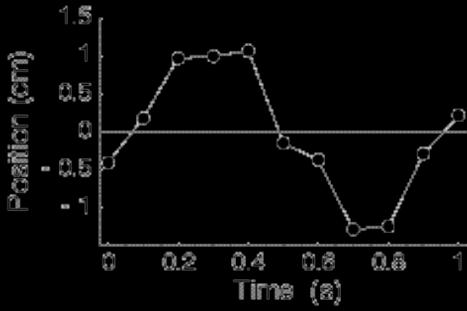
Figure 1. This is a figure caption. The caption should be given the style jovCaption.
When you refer to a figure in the text, use the “Insert Cross-reference” command, as in this example (see Figure 1). This will create a link between the cross-reference and the figure, and will keep the figure number updated correctly. If the link does not appear as blue text, apply the style jovHyperlink.
Block Text
Block text like this should be used for program code or other literal text. It should be accompanied by a caption
Figure 2. This is an example of a caption for block text.
Equations
Display equations
When we have a display equation, we use Equation Editor or MathType to create it. The paragraph should have the style jovEquation.
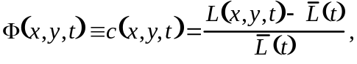
The equations should be followed by a tab and an equation number in parentheses. A paragraph following a display equation with a continuation of the sentence should have the style jovBodyTextContinue.
In-line math
For math within a line of text, L(x,y,t) = w^{T}I(x,y,t), where possible use plain text in the Times and the Symbol font. In general, variables should be in italics, while numbers and function names should be in normal (Roman) font. Refer to the instructions.pdf for more guidance on how to format math. Where it is not possible to use text, use Equation Editor or MathType.
A level 3 heading
This is here just to illustrate a level 3 heading.
Tables
Tables should be created with the “Insert Table” command. The table itself should have style jovTable. The caption can be created using the “Insert Caption” command. It should have the style jovCaption.

Wavelength (nm) | log L-cone spectral sensitivity, log L2(λ) | log M-cone spectral sensitivity, log M2(λ) | log S-cone spectral sensitivity, log S2(λ)
400 | -2.61828 | -2.64399 | -1.2468
405 | -2.31575 | -2.32789 | -0.91204
410 | -2.05942 | -2.05583 | -0.63263
580 | -0.01348 | -0.1849 | -3.96077
585 | -0.01972 | -0.24215 | -4.16116
590 | -0.03261 | -0.30751 | -4.35751
595 | -0.05258 | -0.3859 | -4.5494
600 | -0.07884 | -0.4757 | -4.73646
Table 1. Interesting data about vision. This is a caption for the table. It has the style jovCaption. The caption may include notes about the table.
Conclusions
More text.
Appendix A
If there is more than a single appendix, name them Appendix A, Appendix B, etc.
Acknowledgments
This research was supported by National Institutes of Health Grants EY-12345 (J.Q.S), EY-678910 (JJJ). The acknowledgements should contain a statement on commercial relationships, like the following.

Commercial relationships: none.
Corresponding author: John J. Jones.
Email: jjj@cns.nyu.edu.
Address: 6 Washington Place, New York NY 10003.
Footnotes
¹This is an example of a footnote. It has been made an anchor (bookmark) and hyperlinked to from its in-text reference. Journal of Vision strongly discourages footnotes.
References
The following references are formatted using the jovReference style. Make each reference an anchor (called a bookmark in MS Word). Then hyperlink each in-text citation to its reference anchor. The examples in this template function in this way. If you can, insert the [PubMed] link as well using the example given here (see instructions.pdf). If the full text is available from an archival on-line source (e.g. Journal of Vision), that should also be provided as a link to the string [Article] at the end of the reference.
Andrews, B. W., & Pollen, D. A. (1979). Relationship between spatial frequency selectivity and receptive field profile of simple cells. Journal of Physiology, 287, 163-176. [PubMed]
Roorda, A., & Williams, D. R. (2002). Optical fiber properties of individual human cones. Journal of Vision, 2(5), 404-412, http://journalofvision.org/2/5/4/, doi:10.1167/2.5.4. [PubMed][Article]

