1.We can do our React project without downloading node module package or without installing any other package

We have to add React CDN link to our Html file that we can able to use React command to create React application

(Note: What is CDN?

A content delivery network (CDN) is a geographically distributed group of servers that caches content close to end users. A CDN allows for the quick transfer of assets needed for loading Internet content, including HTML pages, JavaScript files, stylesheets, images, and videos.

What is crossorigin or CORS?

Cross-Origin Resource Sharing, is a mechanism that uses additional HTTP headers to tell browsers to give a web application running at one origin, access to selected resources from a different origin.

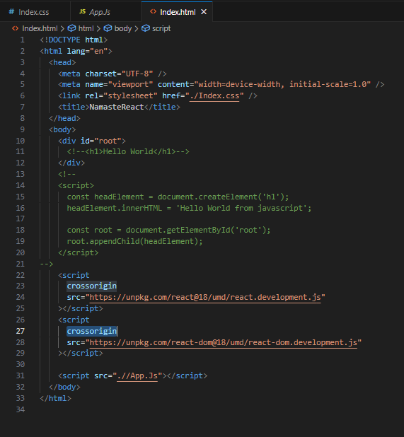

2.We can write our Javascript file which we call in our main html file(for example: App.Js).In Javascript file we use React command.

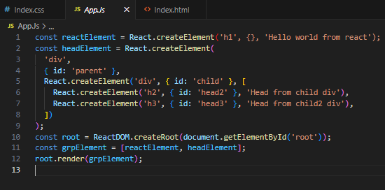

i) React.createElement method is used to create element which return object.

ii) ReactDOM.createRoot method is used create root to enter the html file.

iii) render method used to render the create element object to Html file.